Title: Component 1(Case study 1)

STUDENT NUMBER: 2407682

STUDENT NAME: SAIMA KAUSAR

LECTURER NAME: ROBERT NARTOWSKI

MODULE: INTRODUCTION TO PHYSIOLOGY

MODULE CODE: BMHP5023

Contents
INTRODUCTION 3
The Role of Insulin and Blood Glucose Regulation 3
Causes and Risk Factors 3
Signs and Symptoms 4
Diagnosis and Testing 4
Evidence-Based Recommendations on Lifestyle Changes for Diabetes Management 5
Treatment and Management 7
Complications of Diabetes 7
Prevention and Health Promotion 8
Living with Diabetes 9
Oxygen and Glucose are used to produce energy: 10
Conclusion 11
References 12

INTRODUCTION
Diabetes is a long-term medical condition which affects a person’s glucose levels (Diabetes Control and Complications Trial Research Group, 1993; WHO, 2023). An average person’s pancreas produces insulin (a hormone which balances the sugar levels in the body), which then gets absorbed into the blood for the person’s sugar levels to remain stable (Haist, 1944; NHS, 2024). However, a person who has been diagnosed with diabetes does not have the natural ability for this to happen; therefore, they will be on medication long-term to stabilise it.
There are two main types of diabetes: Type 1, Type 2 and Gestational Diabetes (CDC, 2022; International Diabetes Federation, 2023). Although they all require similar attention, they vary based on when a person can be diagnosed with it and who it affects.
Type 1 Diabetes – Commonly diagnosed in childhood or early adulthood. It begins when the immune system attacks the pancreas, so it can’t produce insulin.
Type 2 Diabetes – The body cannot use insulin effectively, commonly due to genetics, poor diet and lifestyle. This develops mainly in adults.
Gestational Diabetes – A type of diabetes which occurs during pregnancy but usually goes away after birth; however, research has shown that it may increase the chance of Type 2 Diabetes later in life.

The Role of Insulin and Blood Glucose Regulation
Insulin is made in the pancreas, an organ which is located behind the stomach. After a person eats, the food turns into glucose, and insulin helps move this glucose into the body’s cells. When insulin is missing or not working well, glucose builds up in the blood, leading to high blood sugar (Haist, 1944; NHS, 2024). Over time, this can cause serious health problems if not controlled.

Causes and Risk Factors
The causes of diabetes vary depending on the type and individual factors. Type 1 diabetes is an autoimmune condition in which the body’s immune system mistakenly attacks the insulin-producing cells of the pancreas, leading to little or no insulin production (American Diabetes Association, 2023; CDC, 2022). It often develops in childhood or adolescence but can occur at any age.
Type 2 diabetes is primarily associated with insulin resistance, where the body does not use insulin effectively. Contributing factors include being overweight or obese, physical inactivity, and a family history of diabetes. Other risk factors include advancing age, high blood pressure, heart attacks, high cholesterol levels, and unhealthy eating habits, particularly diets high in sugar and saturated fats.
Certain ethnic groups, such as South Asian and African-Caribbean populations, may also have a higher risk. Additionally, women who develop gestational diabetes during pregnancy are more likely to develop Type 2 diabetes later in life. Maintaining a healthy lifestyle greatly reduces these risks.

Signs and Symptoms
Diabetes often presents with several noticeable symptoms, though they may develop gradually, particularly in Type 2 diabetes. Common signs include excessive thirst (polydipsia) and frequent urination (polyuria) due to high blood sugar levels, causing fluid loss. Individuals may also experience increased hunger (polyphagia), persistent fatigue, and blurred vision as glucose affects the eyes (Mayo Clinic, 2024; NHS, 2024). Slow healing of cuts or wounds is another indicator, as elevated glucose levels can impair circulation and immune function. Some people may remain unaware of these symptoms for a long period, making regular health check-ups essential for early detection and effective management.

Diagnosis and Testing
Doctors use various blood tests to diagnose diabetes and assess how well the body regulates blood sugar levels (American Diabetes Association, 2023; CDC, 2022). The most common tests include:
- Fasting Blood Glucose Test: Measures blood sugar after not eating for at least eight hours. High results may indicate diabetes or prediabetes.
- HbA1c Test: Reflects the average blood sugar level over the past two to three months and helps monitor long-term glucose control.
- Oral Glucose Tolerance Test (OGTT): Measures how the body processes sugar after drinking a sweet solution.
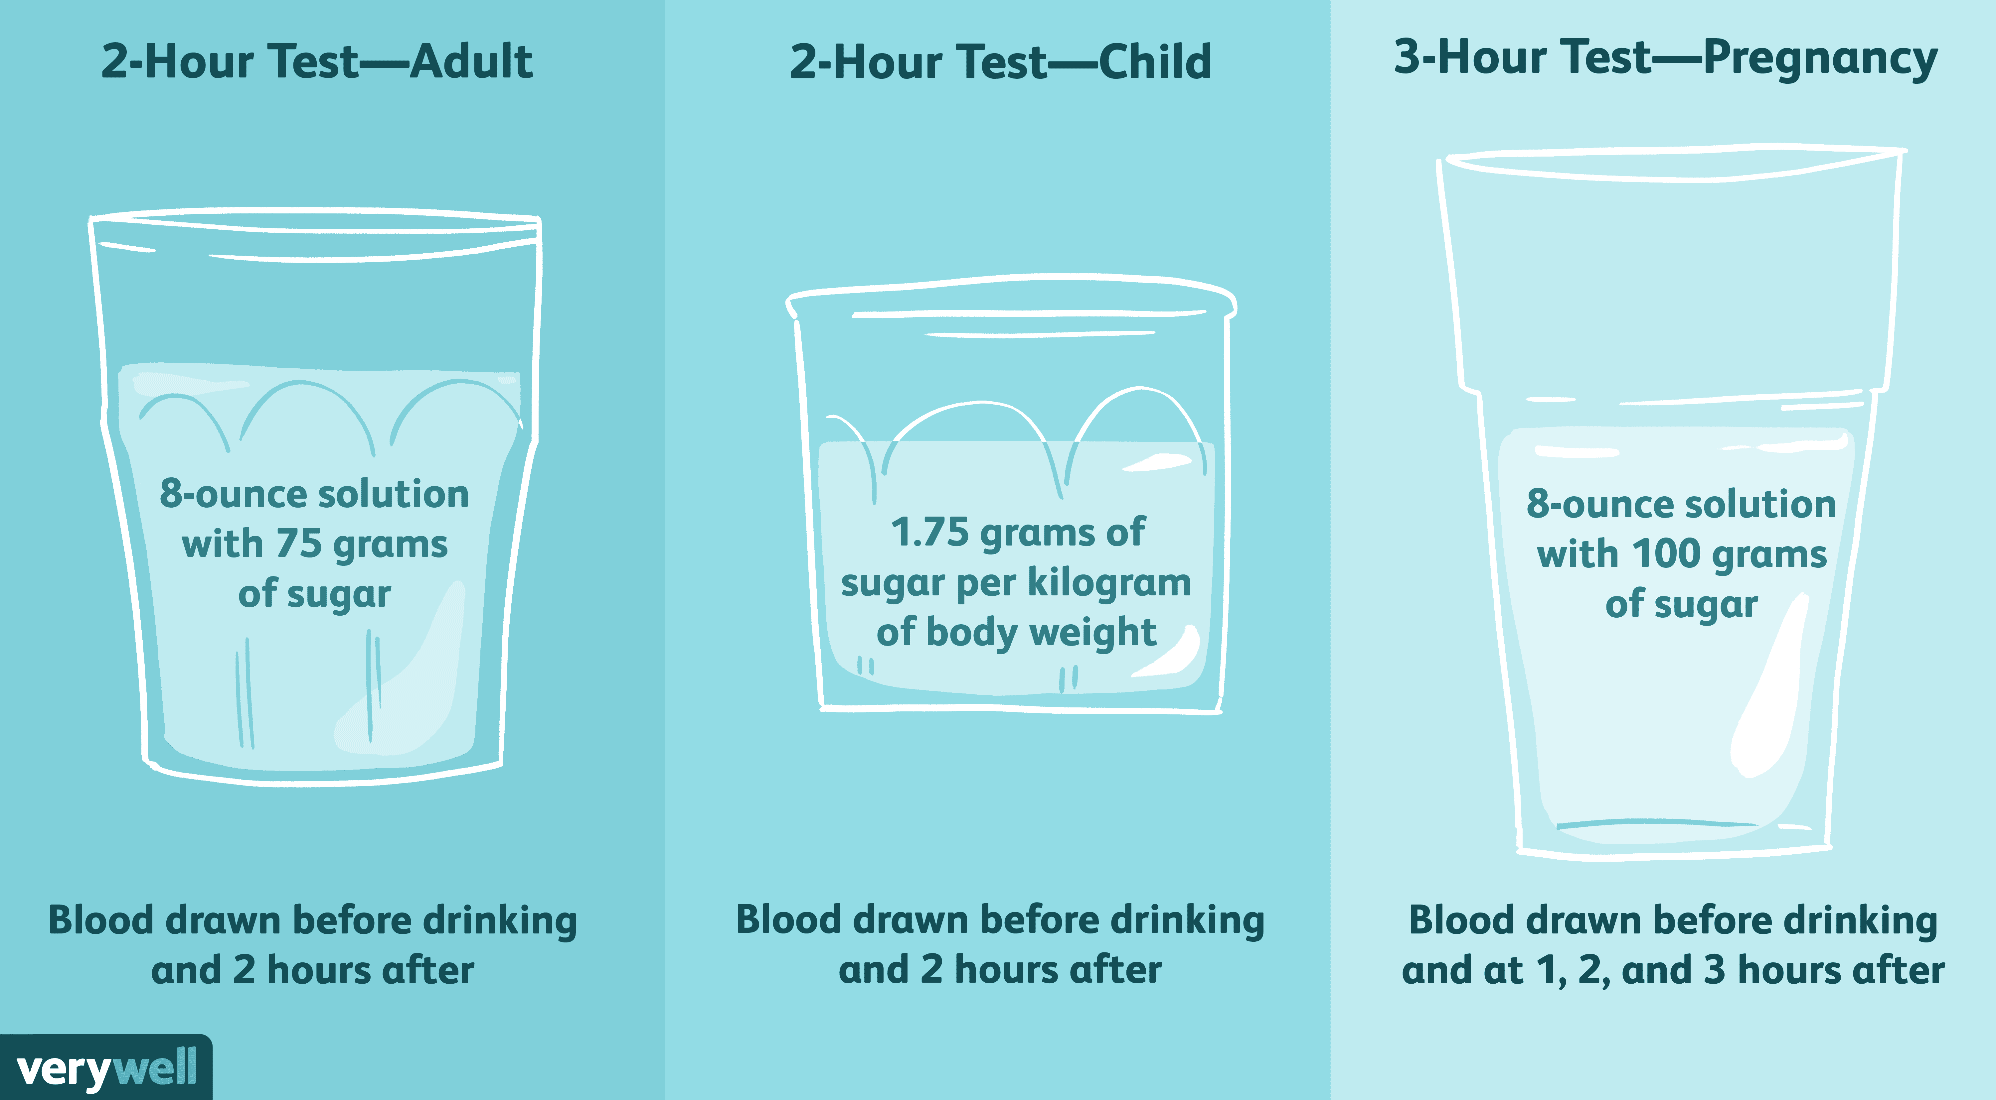
Figure 1: Comparison of oral glucose tolerance tests for adults, children, and pregnancy screening (Very well Health, 2024)
Figure 1 compares OGTT procedures across different groups. It visually clarifies how blood glucose levels are measured after consuming a sugar solution, which is essential for diagnosing diabetes and gestational diabetes.
In some cases, a random blood glucose test or urine test may also be used to detect high sugar levels or ketones. Early diagnosis is crucial, as it allows for timely treatment and lifestyle changes to prevent serious complications such as heart disease, kidney damage, and vision problems.

Evidence-Based Recommendations on Lifestyle Changes for Diabetes Management
Lifestyle modification plays a vital role in managing diabetes and improving overall health outcomes. Evidence from numerous clinical studies has shown that adopting healthy habits can significantly reduce blood glucose levels, enhance insulin sensitivity, and prevent long-term complications (American Diabetes Association, 2023; WHO, 2023).
Balanced Diet: A well-planned diet is fundamental in diabetes control. Individuals should focus on consuming whole grains, fruits, vegetables, lean proteins, and healthy fats while limiting refined sugars and processed foods. Portion sizes and carbohydrate intake are also essential. The DASH (Dietary Approaches to Stop Hypertension) diet promotes balanced nutrition by emphasising fruits, vegetables, whole grains, lean proteins, and low-fat dairy as depicted in Figure 2. This diet is often recommended for individuals with diabetes to help manage blood glucose, blood pressure, and weight effectively
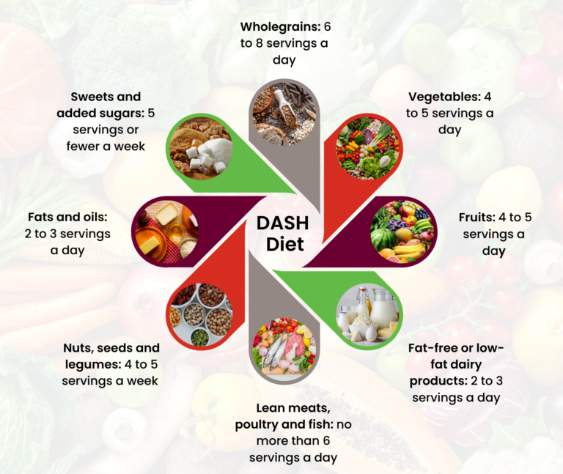
Figure 2: The DASH Diet guidelines showing recommended daily and weekly servings for different food groups (Very well Health, 2024)
Regular Physical Activity: Engaging in at least 150 minutes of moderate exercise per week, such as brisk walking, cycling, or swimming, helps lower blood sugar levels and improve insulin efficiency. Resistance training twice a week further supports muscle strength and glucose regulation.
Weight Management: Maintaining a healthy body weight reduces insulin resistance and improves metabolic balance. Even a modest weight loss of 5–10% can lead to significant health benefits for individuals with Type 2 diabetes.
Stress Management: Chronic stress increases blood sugar levels through hormonal changes. Techniques such as mindfulness, meditation, deep breathing exercises, and adequate sleep can help maintain emotional balance and glucose stability.
Regular Monitoring and Medical Support: Frequent blood glucose monitoring, routine check-ups, and adherence to prescribed medications are essential for effective diabetes management.
In summary, adopting a healthy lifestyle through balanced nutrition, physical activity, stress management, and consistent monitoring can significantly improve a diabetic person’s condition, enhance quality of life, and reduce the risk of complications. These evidence-based strategies form the cornerstone of long-term diabetes care and prevention.

Treatment and Management
Although there is currently no cure for diabetes, it can be effectively managed with proper treatment and lifestyle adjustments. Individuals with Type 1 diabetes require daily insulin injections to maintain normal blood glucose levels, while those with Type 2 diabetes may manage their condition through oral medication, insulin therapy, or lifestyle modifications such as a balanced diet and regular physical activity (NHS, 2024; American Diabetes Association, 2023). Monitoring blood sugar levels regularly helps prevent complications and ensures optimal control. A diet rich in whole grains, fruits, vegetables, and lean proteins, along with professional medical guidance and strong family support, greatly enhances diabetes management and overall well-being.

Complications of Diabetes
Uncontrolled diabetes can lead to serious complications affecting various parts of the body. These may include cardiovascular disease and hypertension, kidney impairment, and nerve damage, particularly in the hands and feet. Vision problems, including potential loss of sight, may also occur (Diabetes Control and Complications Trial Research Group, 1993; WHO, 2023). Additionally, individuals with poorly managed diabetes may experience delayed wound healing and increased susceptibility to infections. Maintaining good blood sugar control, along with regular monitoring and a healthy lifestyle, significantly reduces the risk of these complications and promotes overall well-being
Figure 3 visually maps how persistent hyperglycaemia can damage blood vessels and nerves throughout the body, leading to complications such as stroke, cardiovascular disease, nephropathy, neuropathy, retinopathy and foot ulcers. This reinforces the importance of strict blood glucose control and regular screening to prevent or delay long-term harm.
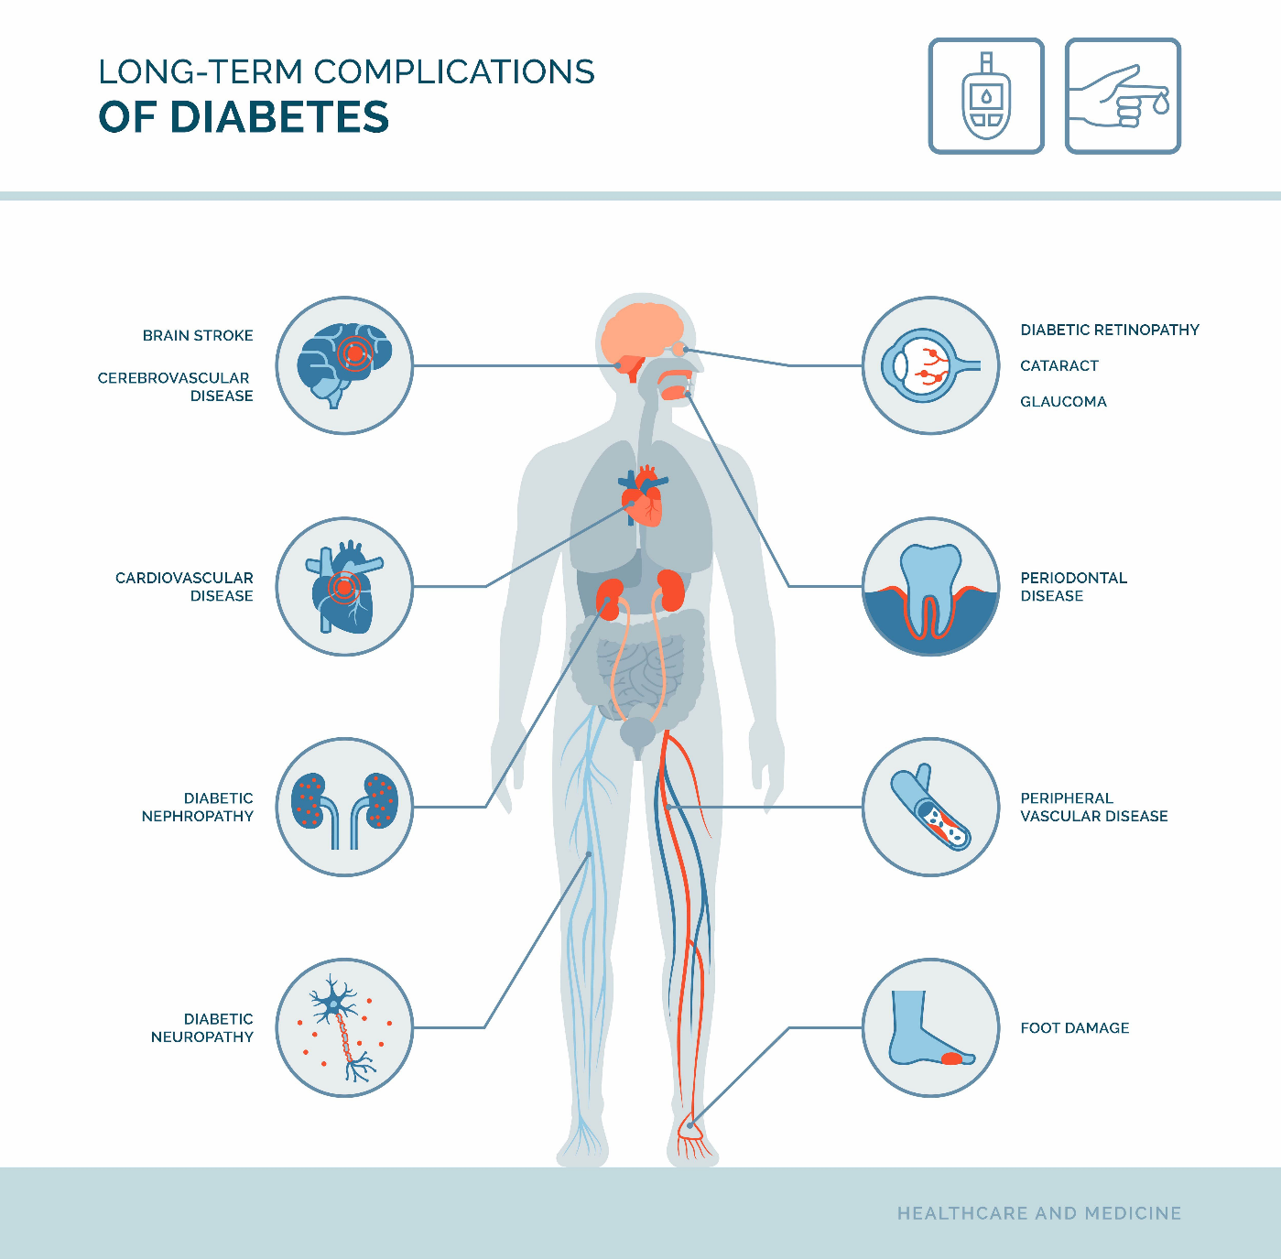
Figure 3: Long-term complications of diabetes affecting multiple organ systems, including cardiovascular, renal, ocular, neurological and peripheral complications (Healthcare and Medicine, 2024)

Prevention and Health Promotion
Type 2 diabetes can often be prevented or delayed through healthy lifestyle choices and regular medical monitoring (WHO, 2023; CDC, 2022; NHS, 2024). Prevention focuses on maintaining a balanced diet rich in fruits, vegetables, whole grains, and lean proteins while reducing the intake of sugary, processed, and high-fat foods. Engaging in regular physical activity, such as walking, cycling, or swimming for at least 30 minutes most days of the week, helps improve insulin sensitivity and supports weight management. Maintaining a healthy body weight significantly lowers the risk of developing diabetes.
Regular health check-ups are recommended, especially for individuals with a family history of diabetes or other risk factors such as high blood pressure or obesity. Health education and community awareness programmes play a vital role in promoting early detection, lifestyle changes, and self-care practices.

Living with Diabetes
Living with diabetes means learning how to manage it every day through careful monitoring and lifestyle adjustments (NHS, 2024; Mayo Clinic, 2024). People need to pay close attention to what they eat, take their medication as prescribed, and regularly check their blood sugar levels. A balanced diet that includes whole grains, fruits, vegetables, lean proteins, and limited sugary foods helps maintain stable glucose levels. Regular physical activity, such as walking or light exercise, also plays a key role in improving insulin sensitivity and overall health. Figure 4 provides information on regular exercise helps lower blood sugar and improves insulin sensitivity. Activities such as cycling, swimming, and strength training are effective in maintaining a healthy weight and preventing long-term diabetes complications.

Figure 4: Examples of physical activities such as cycling, swimming, football, and weight training that help manage diabetes (Centres for Disease Control and Prevention, 2023).
At first, managing diabetes can feel challenging, but with proper education and support from doctors, nurses, dietitians, and family members, it becomes easier to handle. Regular medical check-ups are important to monitor progress and prevent complications such as nerve damage, eye problems, or heart disease. Emotional well-being is equally important, as stress can affect blood sugar control.

Oxygen and Glucose are used to produce energy:
Oxygen and glucose are essential for producing energy in cells through a process called cellular respiration. This process takes place mainly in the mitochondria, often referred to as the powerhouse of the cell (American Diabetes Association, 2023; WHO, 2023). It involves a series of chemical reactions that convert glucose (a type of sugar) and oxygen into energy, carbon dioxide, and water.
The overall reaction can be summarised as:
Glucose + Oxygen → Carbon dioxide + Water + Energy (ATP)
Cellular respiration occurs in three main stages: glycolysis, the Krebs cycle, and the electron transport chain. In glycolysis, glucose is broken down in the cytoplasm to form pyruvate and a small amount of energy. The pyruvate then enters the mitochondria, where the Krebs cycle releases carbon dioxide and transfers high-energy electrons to carrier molecules. Finally, in the electron transport chain, oxygen is used to accept these electrons, producing water and generating large amounts of ATP (adenosine triphosphate), the cell’s main energy currency.
This energy is vital for all cellular activities, such as muscle contraction, nerve transmission, and cell repair. Without oxygen or glucose, cells would not be able to produce enough ATP, leading to reduced function or cell death.

Conclusion
In conclusion, diabetes is a chronic condition that affects how the body regulates blood sugar (glucose), which is the main source of energy for cells. Normally, insulin produced by the pancreas helps glucose enter cells for energy. However, in diabetes, either the body does not make enough insulin or cannot use it effectively, leading to high blood sugar levels. Understanding the cellular process of glucose regulation helps in recognising why maintaining balance is vital for good health. Effective management of diabetes depends on healthy lifestyle changes such as balanced eating, regular physical activity, maintaining a healthy weight, and taking prescribed medication (WHO, 2023; NHS, 2024; American Diabetes Association, 2023). Monitoring blood sugar levels regularly and avoiding excessive sugar or processed foods also play a key role. With proper knowledge, self-care, and medical support, individuals with diabetes can successfully control their blood sugar and prevent long-term complications, leading to a healthier and more active life.

References
American Diabetes Association (2023) Standards of medical care in diabetes—2023. Diabetes Care, 46(Supplement_1), pp. S1–S291. [Accessed 8 November 2025].
Centres for Disease Control and Prevention (CDC) (2022) What is diabetes? Available at: https://www.cdc.gov/diabetes/basics/diabetes.html [Accessed 8 November 2025].
Centres for Disease Control and Prevention (CDC) (2023) Physical activity and exercise for diabetes. Available at: https://www.cdc.gov/diabetes/managing/active.html [Accessed 8 November 2025].
Diabetes Control and Complications Trial Research Group (1993) ‘The effect of intensive treatment of diabetes on the development and progression of long-term complications in insulin-dependent diabetes mellitus’, New England Journal of Medicine, 329(14), pp. 977–986. [Accessed 8 November 2025].
Haist, R.E. (1944) ‘Factors affecting the insulin content of the pancreas’, Physiological Reviews, 24(4), pp. 409–444. [Accessed 8 November 2025].
Healthcare and Medicine (2024) Long-term complications of diabetes [Online infographic]. [Accessed 8 November 2025].
International Diabetes Federation (2023) IDF Diabetes Atlas, 10th edh. Brussels: International Diabetes Federation. [Accessed 8 November 2025].
Mayo Clinic (2024) Diabetes: Symptoms and causes. Available at: https://www.mayoclinic.org/diseases-conditions/diabetes [Accessed 8 November 2025].
National Health Service (NHS) (2024) Diabetes. Available at: https://www.nhs.uk/conditions/diabetes [Accessed 8 November 2025].
Very well Health (2024) DASH Diet chart and oral glucose tolerance test illustrations. Available at: https://www.verywellhealth.com [Accessed 8 November 2025].
World Health Organization (WHO) (2023) Diabetes fact sheet. Available at: https://www.who.int/news-room/fact-sheets/detail/diabetes [Accessed 8 November 2025].

