
Task 1: Business plan, and Reflection

Managing Enterprise (BMSW4011)

Student Name: Andrei Silviu Popina

Student number: 2332738

Lecturer Name: Mel Squire

Submission Deadline: 21.03.2025

Business Plan Word Count: 1093

Individual Reflection Word Count: 533

Table of Contents

MATART BUSINESS PLAN…………………………………………………………….3
1.0 Business Description and Origin Story……………………………………………3
1.1 Business Structure……………………………………………………………….….3
2.0 Mission, Aims and USP……………………………………………………………..4
2.1 SMART Objectives ………………………………………………………………….4
2.2 Physical Location…………………………………………………………………....5
2.3 Human Resources…………………………………………….………………….....6
3.0 Marketing Activities………………………………………………………………….7
3.1 Digital Marketing………………………………………………………………….....7
3.2 Physical Marketing…………………………………………………………………..8
3.3 Phygital Marketing…………………………………………………………………...9
3.4 Market Research…………………………………………………………………….10
4.0 Financial Resources…………………………………………………………………10
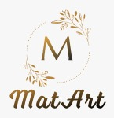
4.1 Cash Flow FORECAST MatArt…………………………………………….………11
5.0 SWOT Analysis………………………………………………………………………11
6.0 Conclusion……………………………………………………………………………12
7.0 Individual Reflection…………………………………………………………………13
8.0 References………………………………………………………………………..….15

MatArt BUSINESS PLAN

1.0 Business Description and Origin Story
Custom photo engravings can be made to a wooden gift, home decoration or anything else with the laser precision technology of MatArt. McKinsey & Company (2023) quoted that, the business turns the normal wooden materials into extraordinary art pieces in an eco-friendly way that matches the current environmentally aware consumers. I have always been a fan of warmth and permanence of the wooden engraved gift, so I started to study the techniques and market opportunities. This gave birth to the initial idea. After responding well, the hobby of making gifts for friends and family became a vision for a sustainable wooden art business.

1.1 Business Structure
Initially, MatArt will run as a Sole Trader, which will be simple, with complete control and few legal requirements (Federation of Small Businesses, 2023).
Pros as a Sole Trader
- Full Control: I make all decisions without needing approval from partners or shareholders.
- Keep All Profits: No need to share profits; all earnings belong to you.
- Close Customer Relationships – A personal approach can build stronger customer loyalty.
But at the same time there are some cons as well for example workload and stress, I need to handle all aspects of the business, from finances to marketing. In the end I have chosen the Sole Trader as I have found more advantages then disadvantages for me.

2.0 Mission, Aims and USP
Mission:
Turning precious memories into everlasting wooden keepsakes that convey sentimentality and individuality to events and keep homes warm.
Mission Statement: To build MatArt as London’s leading wooden engraved product customized company.
Aims:
Turn MatArt into one of its kind in London for personalized wooden engraved products with high quality, sustainability, and customer satisfaction
The business differentiates itself through a signature combination of craftsmanship and technology. The pieces are custom artistic enhanced, made from ethically sourced material in competitive markets with increasing value for uniqueness and sustainability, such differentiation is essential, as Kotler and Armstrong (2023) state.
USP:
Bringing your ideas to life with precision, craftsmanship, and versatility.

2.1 SMART Objectives
- Improve Customer Retention with Loyalty Programs
- Launch a loyalty program for repeat customers.
- Get at least 100 returning customers enrolled.
- Offer discounts, referral bonuses, and exclusive designs.
- Customer retention increases lifetime value.
- Implement within 4 months.

- Reduce Production Time to Improve Efficiency
- Streamline the engraving process to reduce turnaround time.
- Cut production time from 4 days to 2 days per order.
- Invest in better equipment & workflow optimization.
- Faster delivery boosts customer satisfaction and reviews.
- Implement in 6 months.

2.2 Physical Location
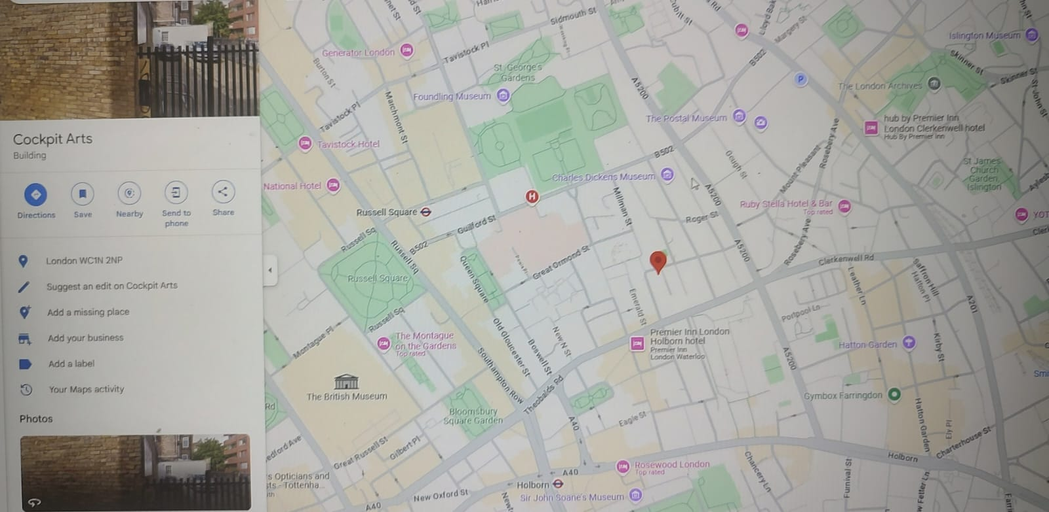
Cockpit Arts London WC1N 2NP
https://www.google.com/maps/place/Cockpit+Arts,+London+WC1N+2NP/@51.5216933,-0.1167309,21z/data=!4m6!3m5!1s0x48761b49c329a929:0x41e5049c4a91cef9!8m2!3d51.5217364!4d-0.1166106!16s%2Fg%2F11bw3_75nx?entry=ttu&g_ep=EgoyMDI1MDMxOC4wIKXMDSoASAFQAw%3D%3D
The operations will be in a 400 square foot workshop at, Southeast London. With over 165 independent businesses hosted by this creative incubator, connections can be made, and businesses can be grown (Cockpit Arts, 2023).

2.3 Human Resources
For our owner/head artisan is responsible for the design, production, business development and customer service. and our assistant artisan takes orders, prepares, records, sorts, closes paperwork for each sale and finishing packaging creating a clean bill of lading and provides production records.
Freelance Graphic Designer: Complex design customization, online inquiries, order processing, social media.
This structure mirrors the increasing craft sector tendency to use casualised staffing patterns to manage costs throughout the initial growth phase (i.e. no full–time roles) (Craft Council, 2023).
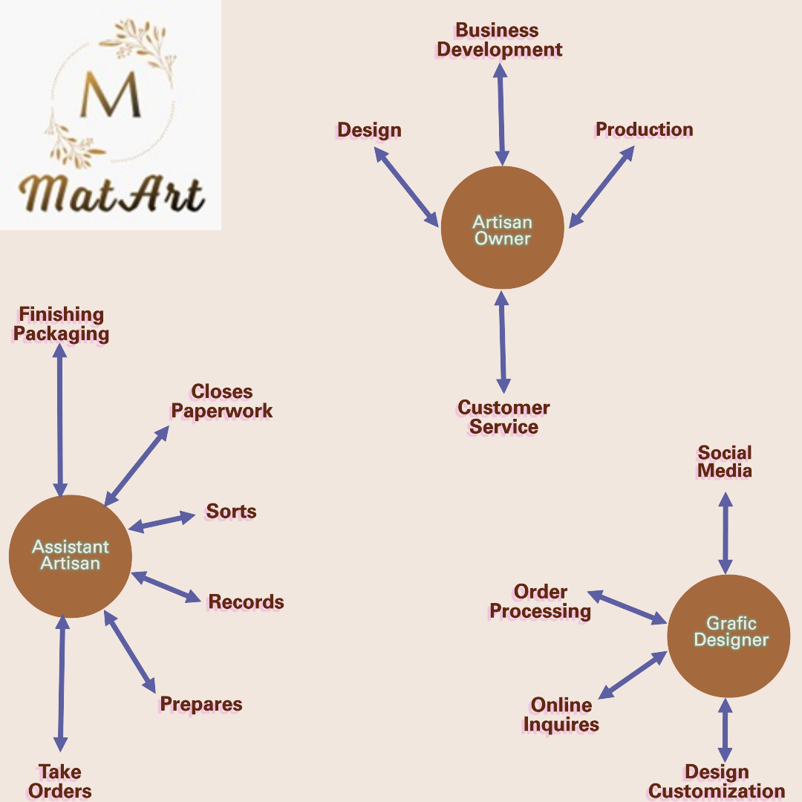

3.0 Marketing Activities
Therefore, MatArt’s marketing strategy consists of the effective combination of digital presence and physical marketing actions, respecting the principles of integrated marketing communication (Baines et al., 2022).
3.1 Digital Marketing
Social media presence across Instagram, Pinterest, Facebook, and TikTok
Content marketing through blog features and email newsletters
E-commerce optimization with SEO-optimized listings


3.2 Physical Marketing
Regular stalls at the top London craft markets
Metal engraved business cards are among premium branded materials.
Statista (2023) states that companies with the ability to merge online and offline marketing channels retain their clients 37% more often than those that are limited to one channel.

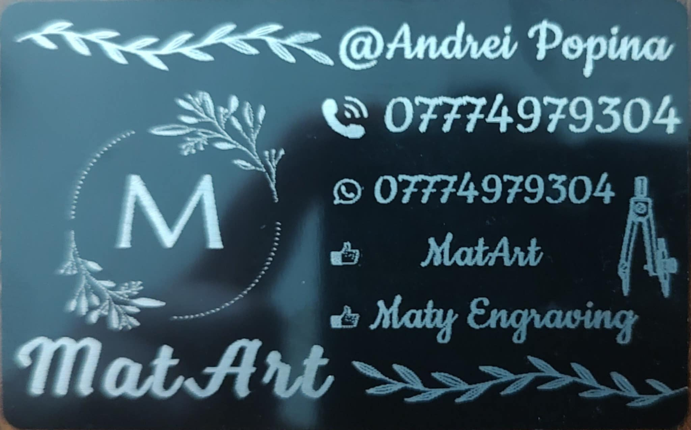

3.3 Phygital Marketing (a mix of physical and digital experiences) it is a powerful strategy for my business. It blends online engagement with real-world experiences.
- Augmented Reality (AR) for Virtual Previews
- Allow customers to preview engravings digitally before purchase.
- Use AR filters on Instagram where users can upload their images and see how they look on wood/metal.



3.4 Market Research
The business concept was comprehensively researched in the market to validate it.
According to Technavio, the personalized gift market is expected to record a market growth of just over 8.1% CAGR from 2020–2026
The main UK wooden homeware market is growing at 9.7% annually (Mintel, 2023).
Eco-friendly consumers who have a willingness to pay 25% premium for eco-friendly products (McKinsey & Company, 2023)
I have conducted research on the demand for personalized engraving services both locally and online, identifying wood and metal as the most popular materials. In analyzing the target audience, I found that individuals aged 23 to 35 are the primary consumers of personalized engraving products. Additionally, a competitive analysis allowed me to establish appropriate pricing strategies.
After comparing the costs, durability, and efficiency of various laser engraving technologies, I selected the diode laser due to its high precision and lower operational expenses and I have sourced reliable suppliers with fast shipping through Amazon.

4.0 Financial Resources
Previous business experience strengthens the Start Up Loan application, and this wide covering business plan (British Business Bank, 2023). The Cockpit Arts grant was given because it reflects a focus on sustainability and growth potential.

4.1 Cash Flow FORECAST MatArt
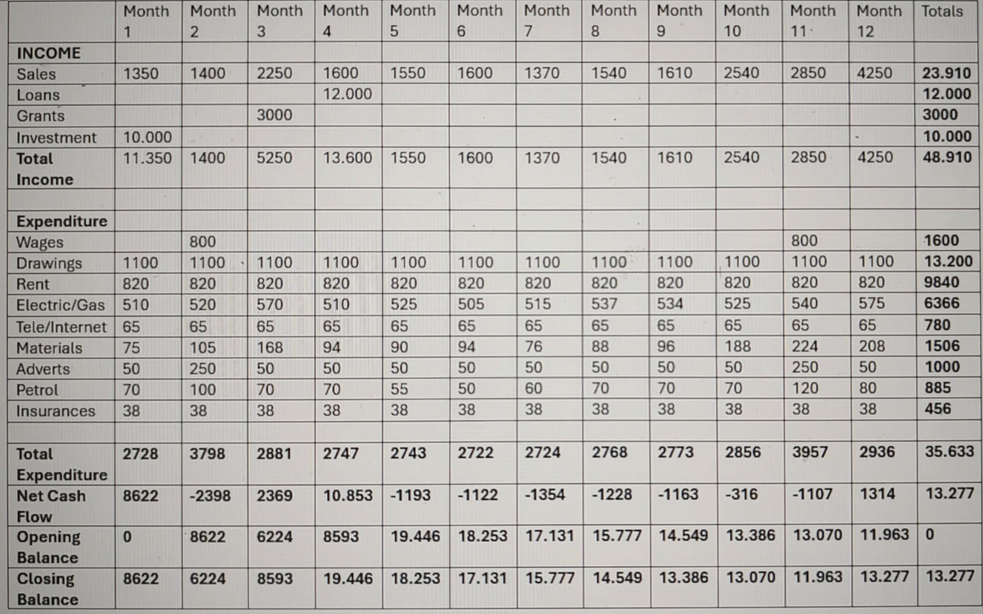

5.0 SWOT Analysis
Strengths:
- Uniquely different artistic enhancement process as compared to competitive brands.
- A way to reduce purchase hesitation through innovative AR preview technology.
- Versatile product range serving multiple market segments
Weaknesses:
- Limited production capacity in early stages
- Reliance on single production equipment
- Higher price point than mass-market alternatives

Opportunities:
- An increasing trend of sustainable, personalized gifts by consumers.
- Increasing markets of wedding and corporate gifts
- E-commerce growth allowing nationwide scaling
Threats:
- Economic uncertainty impacting discretionary spending
- Potential equipment failure disrupting production
- New market entrants with similar positioning
The emergence of a growth and changing sharing economy and sustainability has given craft businesses both opportunity and challenge (Frenken and Schor, 2023).

6.0 Conclusion
Drawing on McDonnell (2023), material culture is increasingly valuing the idea of authenticity and sustainability. Inspired by the Etsy (2022) success model, which is focused on selling unique, handcrafted products, MatArt desires to draw a customer base of its own by offer its products with quality, sustainability, and personalization.

7.0 Individual Reflection
Developing the MatArt business plan has been a process that has enriched my professional development. Before such a gigantic thing like this, I so much had an idealistic view of how business operates but practically bringing this creative idea while learning has endowed me with skills that are not only applicable in only one sphere or area.
Financial planning and forecasting are the most significant skills that I have gained. I had to research real prices for equipment, materials, and workshop space to make a comprehensive cash flow projection. I found the right way to balance optimism with pragmatism, to project ahead revenue growth with seasonal fluctuations, but also allowing for unwanted budgetary surprises. This exercise gave numbers tangible for planning the business.
Another area that has grown valuably has been the article methodology of market research. I faced the challenge of having no idea where to start working on the concept, and when you don't know how you validate business assumptions, the first point from which to start is almost nothing, except trying to find a way to get people talking about it at least.
For me, creative problem-solving is my strongest entrepreneurial attribute. In the market differentiation challenge of MatArt, I created the proprietary finishing process and AR preview tool that were innovations that filled in the gaps of customer pain points and created a competitive advantage.
This journey has proven to be a resilient and adaptive core strength. After following initial research about price sensitivity, I did not give up the idea but steered it to develop a tiered product strategy that keeps the quality, while also offering entry-level products.
The third strength that I have is relationship building. I gained valuable connections through the process of researching supplier partnerships, exploring Cockpit Arts community opportunities and developing the wholesale strategy mostly by using the natural interpersonal skill. To develop the collaborative partnerships that will help push MatArt to a higher elevation organization, the ability to build these authentic relationships with a stakeholder however will be of utmost importance.
Although this is not without the strengths identified, the business planning process has identified delegating and building a team as my most area of development for entrepreneurship. My habit was revealed of centralizing control on the organizational structure and the financial planning, with could create a bottleneck limiting business growth.
I am a perfectionist by nature and tend to personally deal with all operational and customer-related matters, which leaves me no time for anything else. However, with this it ensures quality control, but the business model is vulnerable and scalable. This weakness is understood by the current plan.
I will first enrol in the Cockpit Arts leadership development program which focuses on and addresses the challenges that creative entrepreneurs face in delegation. The framework will provide an effective structure for task assignment and team empowerment.
Second, I will use a phased delegation procedure where I will start with the standard production jobs, which are accompanied by extensive process documentation and built quality control checks. This will be done gradually, in such a way that I build my comfort with delegation, while at the same time keeping up quality standards.

8.0 References
- Baines, P., Fill, C. and Rosengren, S. (2022) Marketing. 6th edn. Oxford: Oxford University Press.
- British Business Bank (2023) Start Up Loan Scheme: Terms and Conditions. London: British Business Bank. https://www.british-business-bank.co.uk/business-guidance/guidance-articles/finance/start-up-loan
- Cockpit Arts (2023) Seedbed Fund Application Guidelines. London: Cockpit Arts. https://cockpitstudios.org/apply/awards-and-bursaries/
- Craft Council (2023) Market for craft. [online] Available at: https://www.craftscouncil.org.uk/insight-and-advocacy/research-library/market-for-craft. Deloitte (2023) Global Powers of Luxury Goods. London: Deloitte. https://www.deloitte.com/global/en/Industries/consumer/analysis/gx-cb-global-powers-of-luxury-goods.html
- Etsy, Inc. (2022) Annual Report 2022. Brooklyn: Etsy. https://investors.etsy.com/financials/annual-reports-and-proxy/default.aspx
- Federation of Small Businesses (2023) Small Business Index, Quarter 2, 2023. [online] www.fsb.org.uk. Available at: https://www.fsb.org.uk/resource-report/small-business-index-quarter-2-2023.html.
- Frenken, K. and Schor, J. (2023) 'Putting the sharing economy into perspective', Environmental Innovation and Societal Transitions, 23, pp. 3-10. https://ideas.repec.org/h/elg/eechap/18253_8.html
- Kotler, P. and Armstrong, G. (2023) Principles of Marketing. 19th edn. London: Pearson.
- McDonnell, T.E. (2023). Cultural Objects, Material Culture, and Materiality. Annual Review of Sociology, 49(1). https://doi.org/10.1146/annurev-soc-031021-041439.
- McKinsey & Company (2023) The State of Fashion 2023: Sustainability First. New York: McKinsey & Company. https://www.mckinsey.com/~/media/mckinsey/industries/retail/our%20insights/state%20of%20fashion/2023/the-state-of-fashion-2023-holding-onto-growth-as-global-clouds-gathers-vf.pdf
- Mintel (2023) UK Home Accessories Market Report. London: Mintel Group Ltd. https://store.mintel.com/report/uk-homewares-retailing-market-report
- Statista (2023) Craft and Handicraft Market in the United Kingdom. London: Statista Research Department. https://www.statista.com/statistics/284985/crafts-industry-gross-value-added-gva-in-the-united-kingdom-uk/
- Technavio (2022) Global Personalized Gifts Market 2022-2026. London: Technavio. https://www.technavio.com/report/personalized-gifts-market-size-industry-analysis

