Learning in the Digital Era
UNIVERSITY OF WALES TRINITY SAINT DAVID
LONDON CAMPUS
Assignment 2

Module Code: ACCA 4025
Student Name: Rachel Pereira de Oliveira Almeida
Student ID: 2544584
Group: 03
Lecture’s Name: Anees Aquir

Table of Contents
Introduction 2
Main Body 2
References 10

Introduction
This is a presentation on my Self-Evaluation, for Professional Development Plan and Assigned Topic Summary. Below I will demonstrate how I used my self-reflection and methods.

Main Body

Video Link: A presentation on Self-Evaluation, Professional Development Plan and Topic Summary.pptx

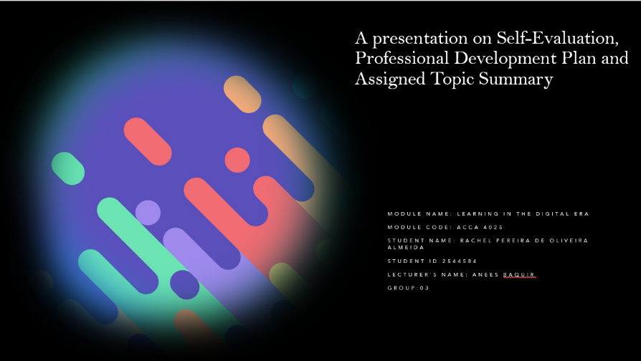
Slide 1

Slide 2
GIBB’s REFLECTIVE MODEL

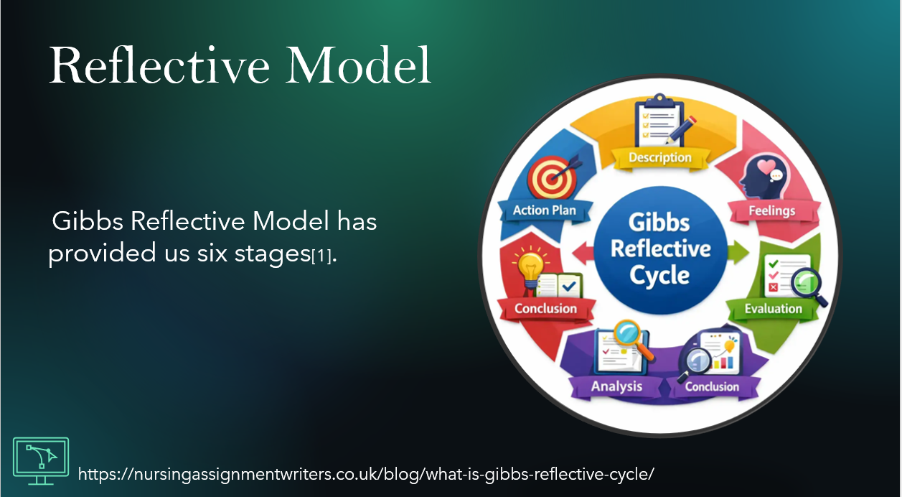
Gibbs has provided this reflective model framework used to learn from experience. It goes through six stages to understand emotions, how we judge what went well or not, and plan for act different next time.

Slide 3
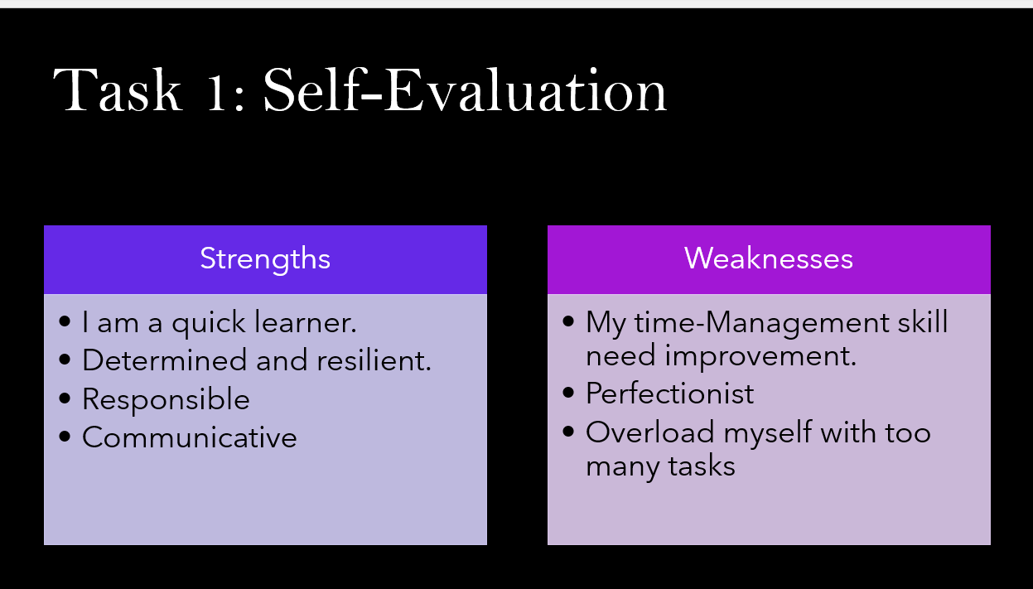
TASK 1: SELF EVALUATION

In this self-evaluation I have reflected on my strengths and weaknesses. I reflected that I am a person who learners quick, I am determined and resilient, responsible and communicative. While in my Weakness I need to improve my Time-Management, Perfectionist and I tend to overload myself with too many tasks.

Slide 4
TRAITS GAINED FROM THE SELF EVALUATION
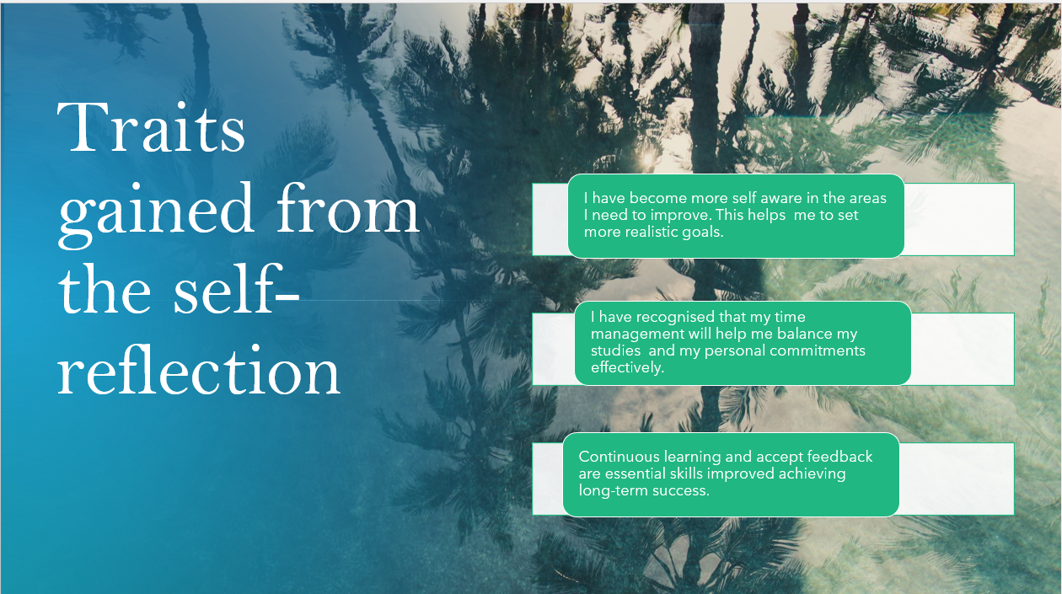

After Self-reflecting, the traits I have gained showed me that I am more self-aware in the areas I need to improve. Recognizing I need more balance to improve my time management to balance my studies and personal commitments, and I will continue learning and accepting feedback to improve and achieve long-term success

Slide 5
PROFESSIONAL DEVELOPMENT PLAN
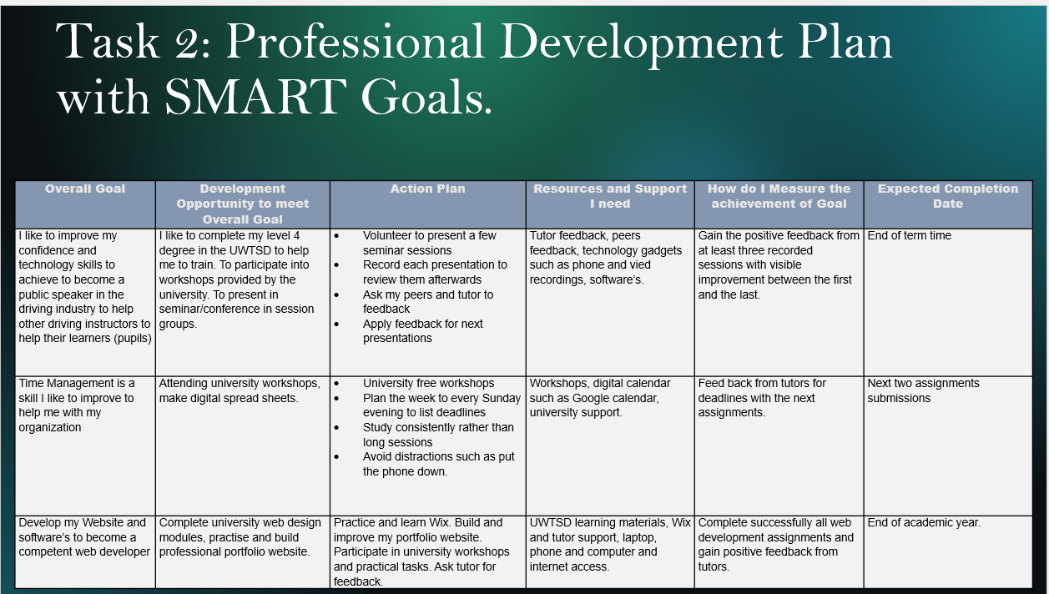

During my SMART goals chart my overall goal is to improve my confidence and tech skills for public speaking, my time and the skills for Web designing and software's. I have scheduled an action plan such as presenting a few seminars, asking for feedback, using resources and support with tech gadgets, recording and videos and taking advantage the University materials. I expect to gain positive feedback from at least three recorded sessions between the first and the last. I set an expected completion date, such as end of academic year.

Slide 6
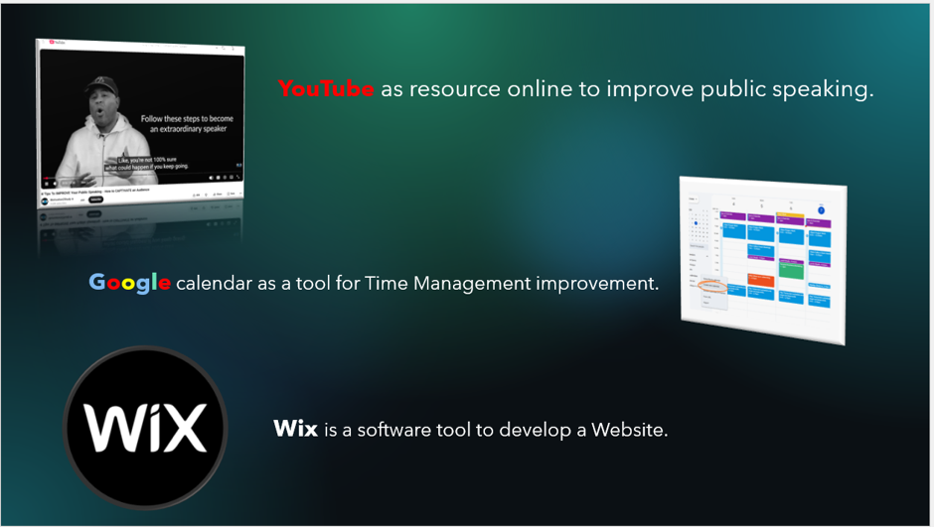

This slide is about the resources that can be used as tools to improve overall goals.

Slide 7
UNIT 4 TOPIC SUMMARY
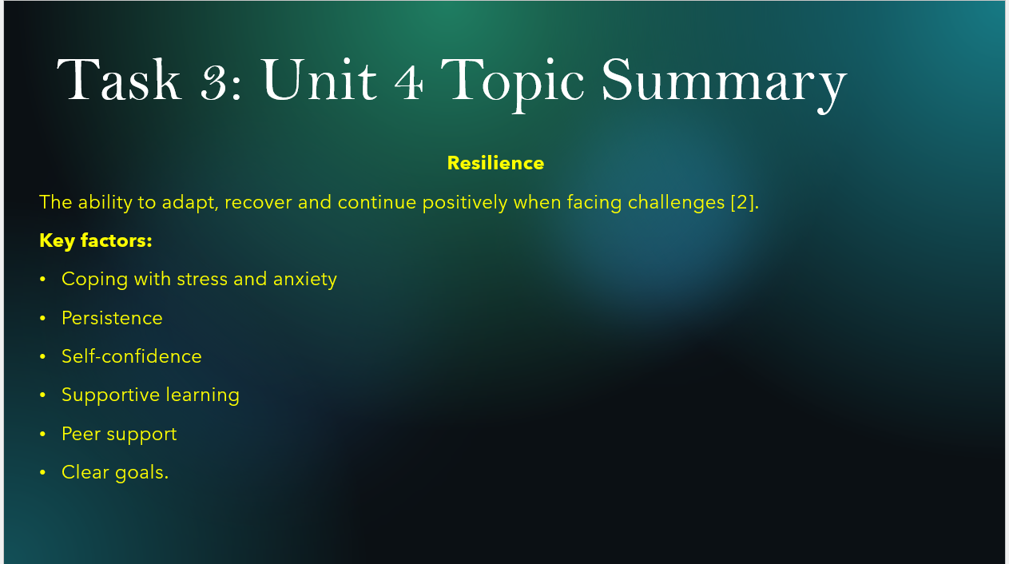

Resilience is the capability to recover from adversities and to adapt to challenges. University students must cope with the stress and anxiety, be persistent, have self-confidence, be supportive to learn – seek for help finding support on peers and having clear goals. Socializing and maintaining a balance health and nutrition and exercising helps keeping resilience.

Conclusion

Slide 8

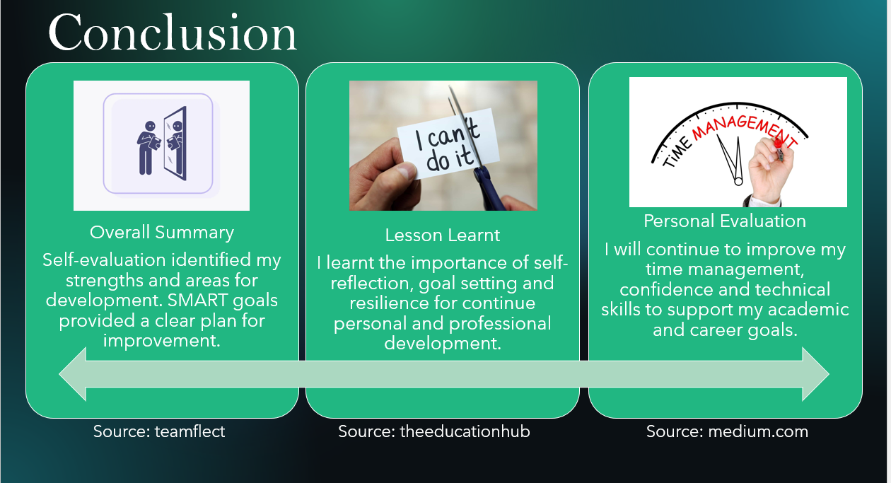
CONCLUSION

In conclusion with my Self-reflection slides I can confidently summarize I have identified my strengths and areas for development. The SMART framework has provided a clear plan path.
I have learnt the lesson on the importance of self-reflection and the resilience for continue to grow.
My personal evaluation has shown me my way to continue to improve my time management, confidence and tech skills to support my academic and career goals.

References
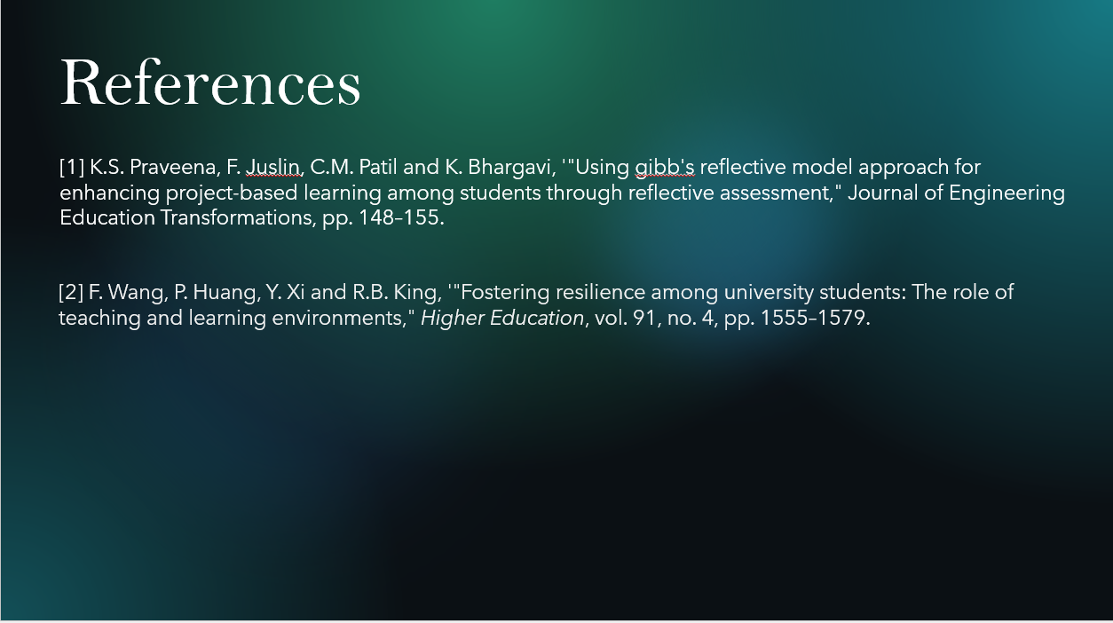

Copy and paste the sources from your reference slide.
1] K.S. Praveena, F. Juslin, C.M. Patil and K. Bhargavi, '"Using gibb's reflective model approach for enhancing project-based learning among students through reflective assessment," Journal of Engineering Education Transformations, pp. 148–155.
[2] F. Wang, P. Huang, Y. Xi and R.B. King, '"Fostering resilience among university students: The role of teaching and learning environments," Higher Education, vol. 91, no. 4, pp. 1555–1579.

