

Assignment Title: Individual Blog Marketing Fundamentals Analysis and Evaluation

Name: Viktoria Ivanova
Student ID: 2219320
Module code: LCBB4004
Module name: Marketing Fundamentals
Lecturer: Tushara Balendran

Introduction
This report will cover marketing fundamentals including (7ps) product, price, promotion, place, people, process and physical evidence as well as it will provide a critical analysis and evaluation of Sainsbury’s segmentation, targeting and positioning strategies. To make critical analysis and evaluation, this report has been preferred Sainsbury which is the largest supermarket chains in the UK. The report formation will be based on blogging where all required of information will be presented in a way of proper structure. The blog report focuses on different segmentation variables and their utilization in the context of Sainsbury (Verhage and Visser, 2017). It also describes the current targeting and positioning strategies as well as the marketing mix strategies should be presented with detailed examples.

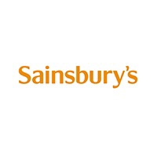

An Overview of Sainsbury
Sainsbury's is a leading supermarket chain in the United Kingdom, with a history that dates back to 1869. The company was founded by John James Sainsbury and his wife Mary Ann Sainsbury in London, and it has since grown to become one of the UK's largest retailers. Sainsbury's operates over 1,400 stores across the country, including supermarkets, convenience stores, and online delivery services. The company offers a wide range of products, including groceries, clothing and financial services. Sainsbury's is known for its commitment to sustainability and social responsibility. The company has set ambitious targets to reduce its carbon footprint,
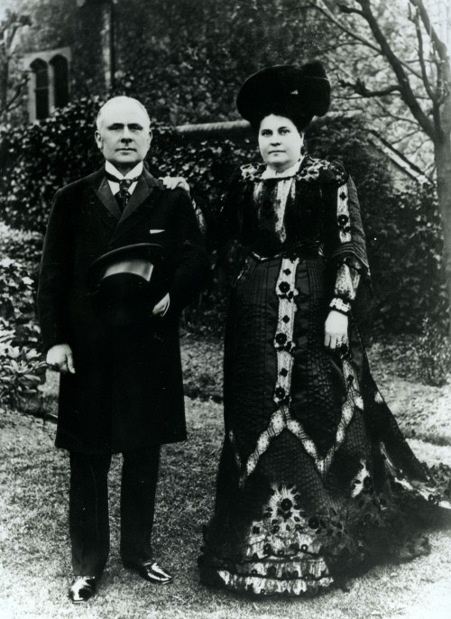

eliminate food waste, and support local communities. Sainsbury's also supports a number of charitable organizations, including Comic Relief and the Royal British Legion (Karim et al., 2012).

Explain the different segmentation variables that Sainsbury uses
Any businesses or markets can be segmented on various factors including geographic, demographic, psychographic and behavioral factors. According to previous research of Sainsbury, they use almost all types of variables because it has stores almost in every city of the UK; it markets also uses demographic segments where it focuses some demographic factors such as sex, age, income source, preferences, education, religion, occupation, race and nationality. The most used segmentation variables at Sainsbury are listed below (Kwak et al., 2018).

Geographic Segmentation
In case of geographic segmentation, Sainsbury focuses on many geographic areas around the world. It includes different continent, countries, trade blocks, cities and neighborhoods. Geographic segmentation is considered as the most effective variables for Sainsbury because company can make an effective attachment with the variety of customer’s culture, attitude, interest, preferences, capabilities and administrative systems. At this context, Sainsbury mainly focuses on three crucial factors including regional preferences, urban vs rural areas and socio-economic factors. By segmenting its market geographically, Sainsbury's is able to better understand the needs and preferences of its customers and offer a more personalized shopping experience (Kahle 2016). This approach also enables the company to remain competitive in a crowded marketplace by tailoring its product offerings to meet the specific demands of each local market.

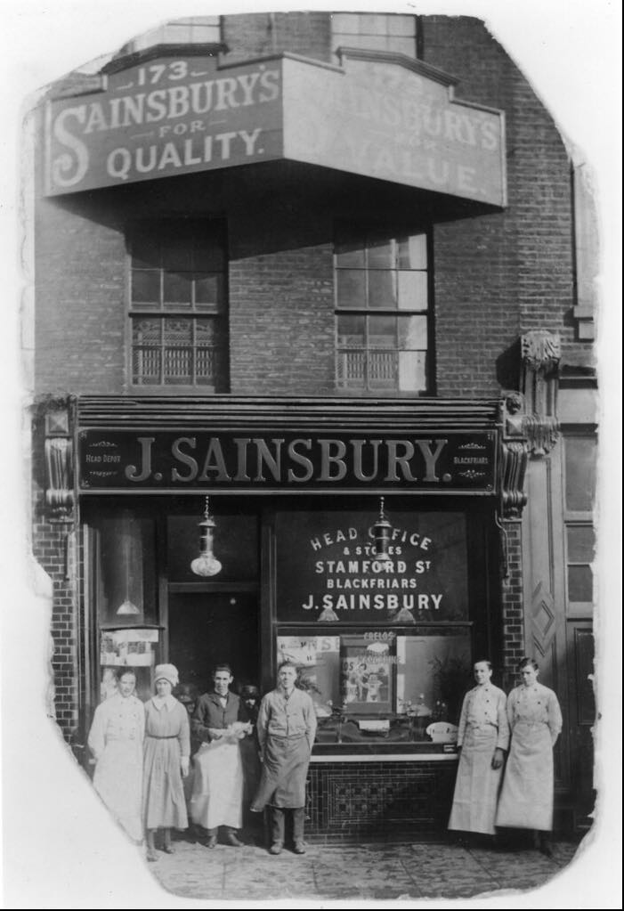

Demographic Segmentation
It is based on sex, income, life cycle, nationality, religion, community, culture, ethnicity and occupation of the particular region or countries. Sainsbury is segmented on two main criteria such as income and life cycle styles of the customers. The demographic segmentation aspect helps Sainsbury to understand the customer behavior, their needs, the current consumer trends and it helps marketers identify and reach the customer’s prospect. By using demographic segmentation, Sainsbury's is able to target its marketing messages and product offerings towards specific customer groups, creating a more personalized and effective shopping experience. This approach also enables the company to remain competitive in a crowded marketplace by tailoring its product offerings to meet the specific needs and preferences of its diverse customer base.

Behavioral Segmentation
Behavioral segmentation is a marketing strategy that involves dividing customers based on their behavior, such as their purchasing patterns, product usage, brand loyalty, and buying frequency. Sainsbury's is a British supermarket chain that can benefit from behavioral segmentation to target their customers more effectively.
By using the following segmentation, Sainsbury's can create targeted marketing campaigns and promotions that cater to the specific needs and interests of their customers, resulting in increased customer satisfaction and loyalty (Sexton and Britney 2018).

Critical discussion the current targeting and positioning strategies at Sainsbury
The company has a strong brand reputation and has been implementing different targeting and positioning strategies to attract and retain customers. In this critical discussion, we will analyze the current targeting and positioning strategies at Sainsbury's. 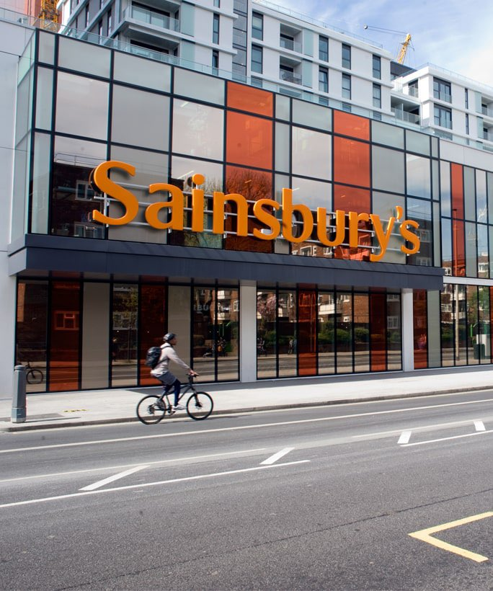

Targeting Strategy
Sainsbury's targets a broad customer base, including families, professionals, and seniors. The company aims to appeal to customers who are looking for quality products at reasonable prices. Sainsbury's offers a wide range of products, including groceries, household essentials, and clothing, catering to the different needs of customers.
One of the recent targeting strategies implemented by Sainsbury's is its partnership with Deliveroo, a food delivery service. This partnership aims to target customers who prefer to order food online, offering a convenient and fast way to get their groceries delivered to their doorsteps. Additionally, Sainsbury's has been targeting customers who are environmentally conscious by reducing its plastic packaging and introducing eco-friendly alternatives.

Positioning Strategy
Sainsbury's has positioned itself as a customer-focused supermarket, offering quality products at reasonable prices. The company emphasizes its commitment to customer service and aims to provide a positive shopping experience to its customers. Sainsbury's also focuses on providing a convenient shopping experience, offering online shopping, click-and-collect, and home delivery services (Maljers, 2012).
One of the key positioning strategies implemented by Sainsbury's is its "food-first" approach. The company emphasizes its commitment to providing fresh and high-quality food, sourcing its products from local suppliers and farmers. Sainsbury's also aims to position itself as an ethical and sustainable supermarket, committing to reduce food waste and carbon emissions.
There are some potential drawbacks to Sainsbury's targeting and positioning strategies. While targeting a broad customer base can increase the company's customer base, it may also lead to a lack of focus and differentiation compared to other supermarkets. Additionally, the partnership with Deliver may not appeal to all customers, especially those who prefer to shop in-store. Finally, while the "food-first" approach is an effective way to differentiate from competitors, it may not resonate with all customers who prioritize other factors such as convenience or price.
However, there may be some potential drawbacks to these strategies, and Sainsbury's will need to continually review and adjust its strategies to meet the evolving needs and preferences of its customers.

Explain the current Marketing Mix Strategies for Sainsbury with examples
The marketing mix strategies, also known as the 4 Ps of marketing, are essential elements in a company's marketing plan. They include product, price, promotion, and place. The marketing strategy of Sainsbury helps a company to staying the ahead of competitor in the market and achieves its organizational goals and objectives.

Product strategy
Sainsbury's offers a wide range of products, including groceries, household essentials, clothing, and electrical goods. The company aims to provide quality products that cater to the different needs of its customers. For example, Sainsbury's offers its own-brand products such as "Taste the Difference" for customers who prioritize quality and premium products.

Pricing strategy
Sainsbury's pricing strategy aims to offer reasonable prices to its customers while still maintaining profitability. The company regularly offers discounts and deals to attract and retain customers. For instance, Sainsbury's offers "Nectar Card" rewards to customers who shop regularly, providing them with points that can be redeemed for discounts or free products. Sainsbury's pricing strategy is focused on giving the customers "value for money," which upholds the quality of the company's goods and services while promoting customer loyalty. It uses a competitive pricing strategy as opposed to a price reduction strategy because the latter only temporarily increases market share (Tien, 2019). With its strategic positioning in the high-end market, Sainsbury's makes excellent use of the price discrimination policy to typically obtain a premium price. Value for money can be found in Sainsbury's selection of inexpensive, high-quality basics and children's items.

Promotion and advertisement strategy
Sainsbury maintains several promotional programs that help Sainsbury to draw consumer’s attention to their product or service. Sainsbury's marketing strategy emphasizes its commitment to customer service and convenience. The company uses various promotional strategies such as advertising campaigns, in-store promotions, and social media to communicate its brand values and offers to its customers. For example, Sainsbury's Christmas advertising campaigns have become a tradition in the UK, featuring heartwarming messages and celebrity endorsements(Andaleeb, 2016).

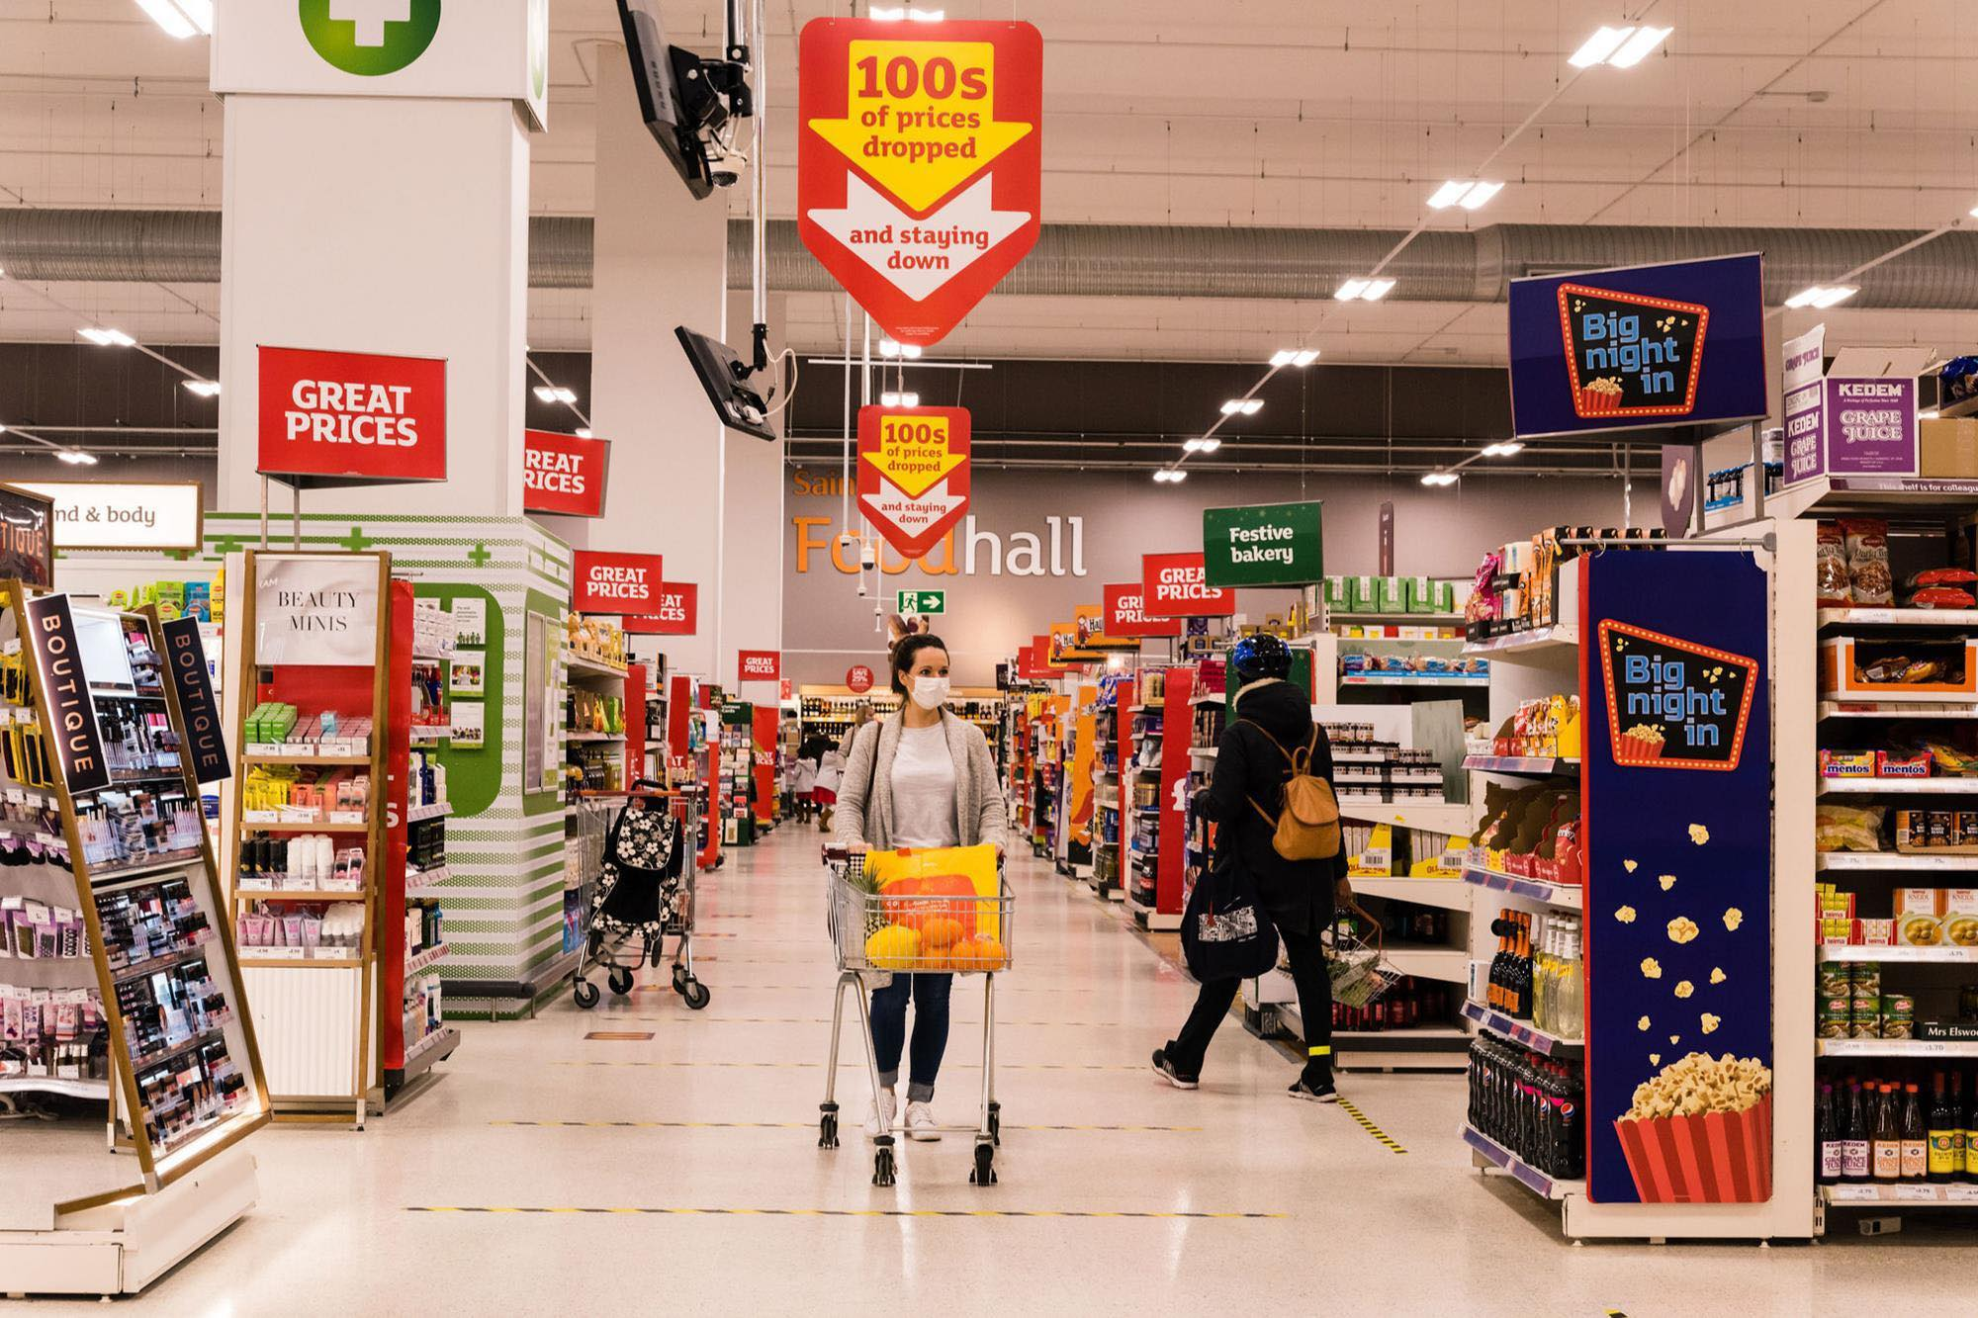

Place and distribution
Sainsbury's operates over 500 supermarkets and 700 convenience shops, some of which are open around-the-clock and others of which stay open until midnight on Fridays. Additionally, home delivery is available, and customers can make their orders online or over the phone at the company's website. At first, Sainsbury's managed its distribution on its own, but following the disagreement with the drivers in 1970, it contracted out its distribution to experts like DHL, NFT, etc. Sainsbury's has a large network of physical stores, providing customers with a convenient and accessible shopping experience. The company has also invested in its online platforms, offering online shopping, click-and-collect, and home delivery services. For example, Sainsbury's recently partnered with Deliveroo to provide customers with fast and convenient delivery services (Stone, 2017).
There are also three other marketing mix strategies (Ps) people, process and physical evidence. By focusing on these three key strategies, Sainsbury's can remain competitive in the retail industry and continue to meet the evolving needs of its customers. To succeed in the highly competitive retail industry, Sainsbury's must have effective people, process, and physical strategies.
In people strategy context, Sainsbury's must attract, hire, and retain talented individuals who are passionate about customer service, sales, and merchandising. The company must offer competitive wages, benefits, and opportunities for career growth to keep its workforce engaged and motivated.
In process strategy, Sainsbury's must manage its inventory effectively to ensure that it has the right products in stock at the right time. The company can achieve this through demand forecasting, order management, and supply chain optimization.
The third one physical strategy, Sainsbury's must prioritize sustainability in its physical strategy by reducing its environmental impact and promoting eco-friendly practices. This may include implementing energy-efficient lighting, reducing packaging waste, and promoting responsible sourcing practices.
According to above statement we can say that Sainsbury's marketing mix strategies aim to provide customers with quality products at reasonable prices, while emphasizing convenience and customer service. The company uses various promotional strategies to communicate its brand values and offers to its customers, and its physical stores and online platforms provide a convenient shopping experience.

Conclusion
At the end of this blog we can say that it highlighted some key business fundamentals including segmentation, targeting, positioning and marketing mix strategy. The blog explained the some main key variables that Sainsbury uses for their management. These are included geographic, demographic and behavioral. It has critically discussed the targeting strategy and positioning strategy of Sainsbury where it target all types consumers from different country, gender, religion, social status and ethnicity. The blog report also explained the marketing mix strategy which focuses on pricing strategy, product strategy, promotion and distribution strategy and place strategy.

Reference:
Verhage, B. and Visser, M., 2007. Marketing fundamentals. Wolters-Noordhoff.
Karim, M.R., Huda, K.N. and Khan, R.S., 2012. Significance of training and post training evaluation for employee effectiveness: An empirical study on Sainsbury's Supermarket Ltd, UK. International Journal of Business and Management, 7(18), p.141.
An, J., Kwak, H., Jung, S.G., Salminen, J. and Jansen, B.J., 2018. Customer segmentation using online platforms: isolating behavioral and demographic segments for persona creation via aggregated user data. Social Network Analysis and Mining, 8(1), p.54.
Kahle, L.R., 1986. The nine nations of North America and the value basis of geographic segmentation. Journal of Marketing, 50(2), pp.37-47.
Sexton, D.E. and Britney, K., 1980. A behavioral segmentation of the arts market. ACR North American Advances.
Lancaster, G. and Withey, F., 2006. Marketing fundamentals. Routledge.
Verhage, B. and Visser, M., 2007. Marketing fundamentals. Wolters-Noordhoff..
Stone, M.A., 2017. Fundamentals of marketing. Routledge.
Maljers, F.A., 1992. Inside Unilever: The evolving transnational company. Harvard Business Review, 70(5), pp.46-52.
Tien, N.H., 2019. Comparative Analysis of Multidomestic Strategy of P&G and Unilever Corporation. International journal of foreign trade and international business, 1(1), pp.5-8.
Yaakub, N.S., Mohd Susaimi, N.D. and Mohd Salleh, N.N., 2008. Unilever Company.
Andaleeb, S.S., 2016. Market segmentation, targeting, and positioning. In Strategic Marketing Management in Asia (pp. 179-207). Emerald Group Publishing Limited.
Natter, M., Mild, A., Wagner, U. and Taudes, A., 2008. Practice prize report—Planning new tariffs at tele. Ring: The application and impact of an integrated segmentation, targeting, and positioning tool. Marketing Science, 27(4), pp.600-609.

