

Strategic Management for SMEs!
BMSW 6104
Jannat Firdausi Rahman
Student ID: 1817067
Tutor: Paul Bocij

Contents
1 Introduction 3
2 Mission and vision of Olympia fitness centre 4
3 Value chain analysis 5
3.1 Porter’s 5 forces 7
4 SWOT analysis for Olympia fitness centre 9
4.1 PESTEL analysis 11
4.2 Stakeholder analysis 14
5. Strategic growth options 16
5.1 Introducing new products to create differentiation and add value 16
5.1.1 promotions and special deals 17
5.1.2 Re-location 17
5.2 SFA Matrix 18
5.2.1 The chosen strategy 19
5.2.2 VRIO analysis 20
6. Recommendations for the gym based on chosen strategy 21
6.1 Resistance to change 22
7. Competitor reaction 23
8. Conclusion 24
References 25

1 Introduction

The swiftly changing environment and rise in competition had called for businesses to create the need for strategies. Two vital factors for this need were to keep up with the rapid scientific and technological developments effecting management and the speed in which firms were bringing in change (Bracker, 1980). Therefore, strategic management entails the conceptualisation of crucial aims that emphasize on developing and executing a pathway for the successful growth and survival of the organization (Tapera, 2014).
This report will analyse the strategic management processes in a small enterprise located in the area of Small heath in Birmingham. The organization performs its service in the travel and leisure industry called Olympia fitness centre. A Gym specifically for men located in a multi-cultural ethnic environment. Its main service is men’s heavy weight training, dietary plans along with selling a small variety of fitness nutritional drinks and supplements. The organization has been running for 14 years with qualified trainers, good gym equipment and a good local customer base. They offer an average membership price with limited opening hours and the standard gym facilities. The gym operates in a multi-cultural environment where demographics and attitude towards fitness are changing swiftly, as population is growing with age, so are customers. The current generation are now following trends that are popular, for example, a gym that is more trending on social media has become the gym for the youth.
The main issues with the gym are that they are only popular amongst the minority of the location due to low marketing and advertisement strategies and also located very closely to its competitive rival, Fitness for Life. Another growing rival is the Gym group. The gym also offers nothing different to its competitors. The report will entail various analysis through tools such as Porter’s value chain, PESTEL, SWOT and stakeholder analysis which will highlight some of the key issues hiding that could cause potential damage such as no differentiation from competitors and no value for money. It will also bring out any opportunities that can be exploited like taking up the advantage of creating unique women’s facilities that would stand out within the region. The report will conclude with discussions on the best-chosen strategy and how the organization can grow further into the future successfully by adopting to differentiation and better promotions.

2 Mission and vision of Olympia fitness centre

The mission and vision of an enterprise goes hand in hand with strategic management. While the vision foresees the company’s future, the mission summarises its basic purpose and direction in creating its identity (Papulova, 2014).
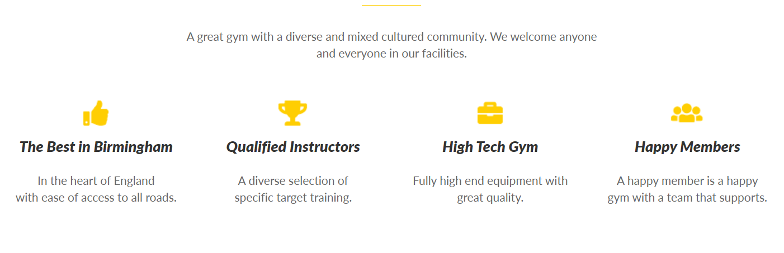
The mission statement of Olympia fitness centre is:

The statement clearly defines that they are a highly equipped gym with qualified trainers and the best in the city. It states that they welcome anyone and everyone in their facility which can be argued as the gym is specifically for men only. They also claim to be the best in Birmingham which contradicts the fact that they are not so familiar in other areas. The mission states that they are determined to fulfil the passion of looking after one’s body.
Where the mission seems very clear about what they do and how, it cannot be ignored that the business has no vision statement. A vision enables a business to determine where it wants to be and how it wants to be seen in the future. The vision carves a pathway with clear goals, a sense of direction, motivation and coherent activities that lead to the future state of the business (Suranga, 2014). Being without a vision clarifies that the business does not have a successful strategic plan and has no intention to grow and serve the community better. However, the gym has the potential and ability to grow in many ways and strengthen the gyms competitive position in the market. The current internal resources of Olympia fitness centre such as their staff and skills, equipment’s, products and services have been identified through a VRIO analysis to hold competitive disadvantage. This is because the resources bring no value to the organization, are not rare as they are the basic resources available at any gym, can be very easily imitated at low-cost and unorganised as they have no proper strategic planning for the future. A proposed vision statement for Olympia fitness centre can be “ Working together to encourage inclusion and diversity and creating a strong and enjoyable environment to all ages to relax your mind and body”. This gives a view of a vision that the business wants to grow further, bring in diversity and wants to offer services that suit all age.

3 Value chain analysis

Porter argues, competitive advantage is derived from developing value for customers that can be generated from three sources, cost reduction, differentiation and focus. Value chain analysis is a method that breaks down the vital activities of the firm to enable a better understanding of where the negative and positive impacts lie and how it can be dealt with to achieve value (Hergert and Morris, 1989). A disadvantage of this tool is the requirement of extensive information to perform the analysis, which can be minimal and difficult to collect from specific business areas such as outbound logistics. Furthermore, by focusing too deeply into the micro details can easily lose sight of the linkages between specific areas within the chain (Hergert and Morris 1989).
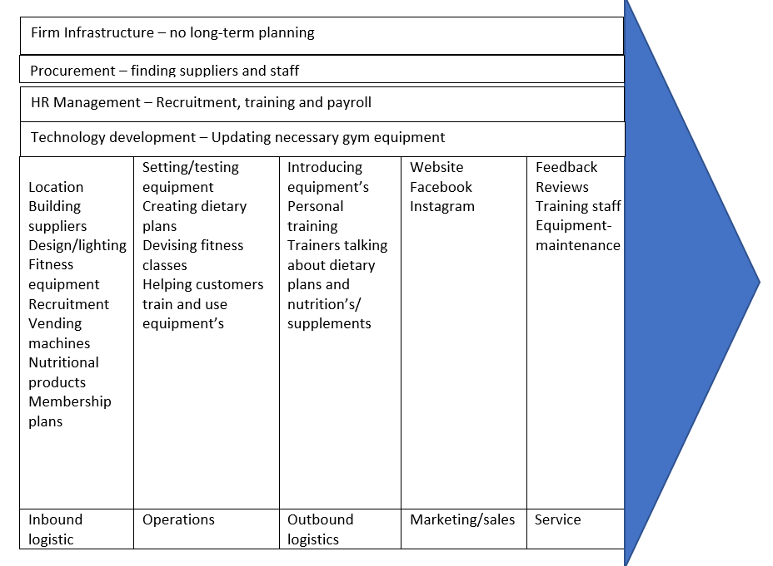

Table 1. Value chain analysis

Key findings
Initially the current strategy involved buying equipment’s which then later changed to hiring due to continuous equipment and technology improvement. This has required the need for regular staff training and equipment testing before service can be delivered. Other points to be noted are:
- Marketing strategies are very weak compared to rivals and needs updating.
- The firm infrastructure lacks vision, planning and strategic management.
- By joining with multiple suppliers, the gym can negotiate prices and reduce overhead costs and create competitive membership prices and offers to strengthen competitive advantage.
- HR management can further look into providing training during the recruitment process saving operational time.
- Technological development can take a step further by integrating with a CRM package that will enable better planning of customer needs and offer differentiation through unique products.

3.1 Porter’s 5 forces

In 1979 Porter created a tool that distinguished five competitive forces of the business industry that shape and predict its strengths and weaknesses. The analysis is then used to determine a corporate strategy that can build a strong position and defend the business against the predictable threats and its impacts and achieve maximum value (Bruijl, 2018). The table below displays the level of threat and its impact on the gym and what mitigation strategies can be made to reduce or eliminate the affects.

Force | Threat | Impact | Mitigation
Bargaining Power of customers | High | High | Increase switching costs by introducing a joining fee. Getting customers to register information every time they use the gym to create a larger customer base. Keep offering deals and discounts on established products to keep customer interest high.
Bargaining Power of suppliers | High | High | Build relations with multiple gym equipment suppliers to negotiate prices that can allow cost reduction in the services
Rivals | High | High | Add services unique to theirs such as women’s facilities, parking and other fitness classes
Threat of New entrants | High | Medium | Invest in marketing to create a strong brand identity. Offer new services like a sauna and steam room and personal 1-1 training sessions to create differentiation
Threat of substitute products | High | Medium | Become service oriented by giving personal 1-1 training sessions, create more value for money by offering 1-month free membership every time you complete 6 months and increase marketing strategies
Table 2 Porters 5 forces on Olympia fitness centre

Key findings
Analysis from the above Porters 5 force’s emphases on the high level of threat that is predictable within all the crucial aspects of the business. Bargaining power of customers imposes the threat of losing existing and new customers. Customers want good facilities for cheap and also expect value for their money, so it’s inevitable that they will get attracted to good promotions. Therefore, it is important to offer customers what they want. Customer relationship management is the process of collecting valuable customer information about their focused activities that enables to identify the needs and on-going trends that customers want and can be lured in by discounts and incentives (Hasan and Parves, 2013). Creating value for money through collaboration with calorie counting meal companies like Diet chef and Hello fresh to offer extra support with training on discounted prices can also benefit by increasing customer base. Finding a complimenting service to training under one roof, will attract members easily to buy the service. Threats from rivals and its impact can be seen high as the gyms main rival, Fitness for Life is offering differentiation through unique services such as Taekwondo, karate, kickboxing classes etc for a variety of age groups as well as pre-ordered meals that compliment your workout. This gives Olympia fitness centre the opportunity to also provide unique facilities such as a women’s segment in the gym with good parking facilities which will differentiate the gym from its rival drawing more customers.

4 SWOT analysis for Olympia fitness centre

A SWOT is a strategic management tool that is used to do an internal scan of an organization’s strengths, weaknesses, opportunities and threats, to identify the current state, factors and resources effecting the organizations performance either positively or negatively. This information then allows the organization to plan, develop and implement new strategic processes to deal with current and potential problems (GURL, 2017). However, a SWOT can over produce information which maybe unnecessary and does not prioritise issues leaving you to generate too many ideas and solutions (Pickton and Wright 1998).
Table 3. Advanced Swot analysis
Key findings
The above analysis has identified an important key factor (highlighted in yellow) from each area of the advanced SWOT through its importance and rating of impact it has on the organization. The gym holds a strong position within the locality as they have been running successfully for a long time. However, the organization is located in an area with growing change. Once where men were only interested in fitness, trend and health concerns has created awareness for staying fit in all generations and sex. The area is in need for a place where women can be offered similar facilities. One more similar facility is available in the locality which also serves men only making competition very high as they offer more than just gym facilities. This creates an opportunity to differentiate through different products. No parking facilities and a densely populated area means people from outer areas find it difficult to find parking nearby to attend the gym and therefore majority of the members are local residents travelling by foot, also a reason why the gym is not very popular or familiar in the outer areas
Many opportunities are derived from the analysis starting with expanding the building or re-locating and adding services for women with parking facilities. Many threats are visible and need to be dealt with swiftly such as the online training platforms like Peloton that have taken the nation by storm. However, such classes have been under bad reviews for their high monthly membership fee of £39p/m and has put off customers due to the additional payment on their bike purchase. The gym needs to start looking into plans where fitness classes can be provided online through cheaper options such as Zoom videos in the case of any social distancing rules that are bought back into place due to covid-19 and for the customers who wish to train away from social contact. The calorie counting meals that are substituting physical training can also be included into the organization’s strategies through mergers and paid partnerships by including them as part of membership plans and subscriptions that compliment physical training. With the new trend of working from home, it has become important that gyms are promoting jobs through recruiting by providing training and short-term educational courses to educate staff to new regulation and laws as people are looking for jobs that are easily accessible. It is very important that people are back to socialising with the new norms that covid has created.

4.1 PESTEL analysis

PESTEL is a tool used to scan the external surroundings, also knowns as the macro environment of an organization. This technique involves the analysis of six vital factors that can hugely impact the organization either positively and/or negatively. The benefits of a Pestel analysis are that it is quick and simple and provides an in-depth scanning of the major factors allowing to anticipate potential threats and opportunities that can be exploited (Yüksel, 2012).

factors | Potential impact | Time frame | Type | Impact | importance
Political-  - Brexit effects markets having high impact on equipment prices and trade tariffs  - Ukraine-Russia war has increased living costs such as gas/electric/petrol/diesel  - National lockdown can force the leisure industry to close down again  - Tax policies- taxation rise can increase cost of products and services effecting revenue  - National insurance rise will affect employment of staff | medium | 12-24months | Both | Increasing | Important
Economic-  - GDP growth rates will decide the gyms potential to achieve long term strategies  - Inflation/Interest rate increase  - Decreased interest rates  - Growth of unemployment will bring staffing issues  - High competition within the industry  - Consumer spending power will determine luxury services | High | 12-24 months | unknown | increasing | critical
Social-  - Change in demographic trends- aging population, sex and income can reduce and increase gym memberships  - Changes towards Lifestyle attitudes is creating a larger market  - Growth in obesity and mental health influencing people to join the gym  - Culture and societal norms  - Skills and education level are a growing trend for people to understand new innovations and adjust with new technology | High | 24months + | unknown | increasing | critical
Technological-  - Constant and rapid change in product developments can affect service offerings  - New fitness apps and health trackers substituting gyms  - New methods of advertising attracting the youth  - New technological changes  - Higher expectations to meet customer needs and so new innovations are a must to keep ahead of competitors  - Shortened life cycle of products | High | 24month+ | Negative | increasing | critical
Environmental-  - Pandemic can cause consciousness again in people to come in social contact with others  - Laws impacting on environmental pollution  - Waste management regulations  - Energy price rise  - Recycling and packaging | Low | 12-24 months | Negative | Unchanged | Unimportant
Legal-  - Changes to HSE standards  - Licensing regulations on fitness products and drugs  - Fire safety regulations  - Health and safety laws  - Consumer data protection laws  - Business laws  - Recruitment/ employment laws  - Food safety and hygiene laws | Low | 24 months+ | Unknown | Unchanged | Important

Table 4. Pestel analysis

Key findings
The above analysis clearly displays the critical factors that have a high impact on the gym. The rise in inflation/interest rates will affect trade on equipment’s, products and rents, as well as forcing people to give up on luxury memberships and cut back on spend. However, decreased interest rates will bring opportunities to barrow further and invest in the company. Due to covid, consumer spending power has increased. People have become more health conscious and therefore investing more in physical and mental health well-being. Demographics in the social aspect has huge impact, as population is aging it will affect memberships and the youth are moving towards and attracted to new trends and bigger brands. Changes towards lifestyle attitude for health and fitness has created a larger market for the industry and busy lifestyles and more self-conscious people have created demand for convenience and so online classes and personal trainers are growing in trend.
Due to covid-19, many changes have escalated in rapid speed such as the increase in new technological advancement which would have taken months or even years to innovate. The analysis clearly identifies the threats for the gym if developing technologies are not adopted in time it could result in detrimental effects. For example, new fitness apps and health trackers are self-educating people to become self-trainers and to work out from home. However, gyms are also investing in integrated mobile gym apps that are engaging customers more than ever and increasing retention rates as well as reaching out to a wider audience.

4.2 Stakeholder analysis

A stakeholder analysis separates the people involved within an organization into 2 categories- internal stakeholders who enter the company willingly for an advantageous outcome and the external stakeholders who hold little or no power in its success but keep high interest in its progress (Winch et al., 2007). The grid below displays the key stakeholders of Olympia fitness centre and their level of power and interest in the organizations progress.
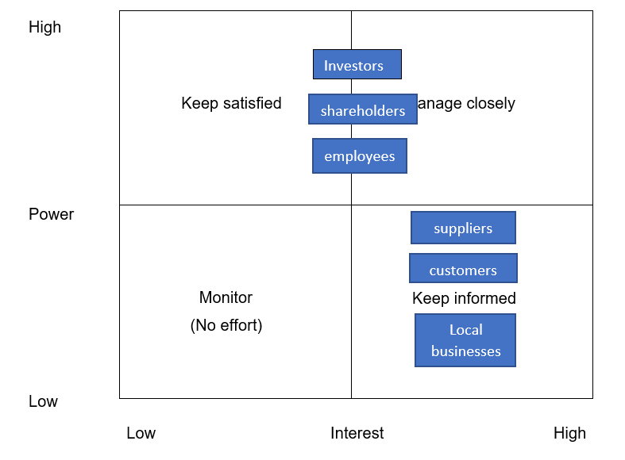

Table 5 stakeholder grid

Key findings

Olympia fitness centre hold six key stakeholders who play vital roles in the organizations progress and development.
- Shareholders and investors are internal stakeholders who are financially connected and therefore have a high impact on the gym. They can decide to withdraw any shares or even invest further. They have a final say in all decisions regarding the gym and any changes. Therefore, must be kept satisfied with the gyms development and progress and also managed closely through annual meetings, emails and letters with comprehensive information communicated properly.
- Employees are vital internal stakeholders who possess high interest and high power. They hold an operational authority on the organization and so the lack of employees can slow down operational activities. Their high power is reflected in the level of customer service they offer and so predicts the gyms reputation and future customers. Employees need to be managed closely through efficient communication about their shifts, training requirements and kept informed about issues and organizational changes through staff meetings, portals and emails. They must also be kept motivated through job satisfaction, promotions and bonuses.
- Customers and local businesses are the external stakeholders who have low power but high interest in the gym. Customers need to be kept informed about any changes in gym structure, membership offers, prices and equipment change. Local businesses are interested in the economy boost and increase in customer traffic. They must be aware of any gym development and change that could affect their business and so their feedback is very important. This is usually best done through newsletters and emails.
- Equipment suppliers keep high interest in the gyms progress as they receive a huge amount of business from them and so need to be informed of any potential changes. However, their power can be high at times depending on the amount of supplies they provide the gym with or even through the supply of specific gym machinery.

5. Strategic growth options

In the swiftly changing business environment, it has become vital to stand out and to stay ahead of competition, therefore businesses need to offer customers with differentiation and unique reasons to choose your business.

5.1 Introducing new products to create differentiation and add value

First growth option for Olympia fitness centre would be to offer what their closest rival and competition are not offering, differentiation through women’s gym facilities and unique health classes. Health is as important for women as it is for men and therefore given that opportunity will capture the majority of female customers from the region as it is local and can be reached by foot. Women are always in search of places where they can socialise and network and even better if the place is benefiting the health. This strategy will draw customers swiftly as word-of-mouth communication will spread very quickly.
Mental health well-being has been a huge subject post-covid. Millions across the world have been victims of mental health due to the loss of loved ones, social distancing and stress. The BAME community has been significantly affected by coronavirus (Mind, 2020). Therefore, there has never been a better time to offer yoga and meditation classes that can help relieve stress and relax the soul and mind. This new product will reduce the need to approach specialists when they can receive similar support near home.
Coronary heart disease, diabetes, anxiety and depression are the most common amongst the ethnic population in England. Evidence suggests a combination of factors as contributors such as environmental, physiological and the deprivation of sufficient knowledge (Raleigh and Holmes, 2021). Exercise can reduce the risk of such ailments and expand life expectancy, therefore, the gym can offer specially designed classes where along with regular daily exercises, value can be added by delivering knowledge on health and eating habits to better educate the community. These classes can aim at the older generation, providing them an opportunity to stay fit, enjoy the company of others alike, and improve mental health by socialising and staying active. The first classes can be offered free on trial bases to get feedback and see how customers feel. Positive feedback will bring in more customers through word-of-mouth communication.

5.1.1 promotions and special deals

Create deals that are too good to miss and that easily motivate people to become your customers and focus on retaining existing members. Customer retention is the procedure of keeping existing customers engaged to continue buying your service (Nasır, 2015). Promotional offers such as bring a friend to join and receive a month-membership free and introductory deals offering half price membership for the first six months, benefiting existing and new members. Make existing memberships fun and enjoyable and maximise their benefits by throwing in monthly prize draws, merchandise giveaways and fitness challenges. Create customer loyalty bonuses to increase retention by providing half price massage sessions every month with memberships. These offers will be planned each year along with a loyalty scheme offering incentives and rewards with levels of silver, bronze, gold and VIP members based on points collected every time customers use the gym.
Fitness apps are a great way to keep members engaged and keep track of their fitness and health lifestyles on the go and take advantage of tips and tools available on the app. As well as creating extra value to the product, check-into-social media built-in-app will also boost the gyms online visibility by allowing members to post gym activities and photos as they workout. Constant trending on social media will further increase and create brand awareness and expand the reach to a larger market. It costs 6/7 times more to acquire a new customer than to retain an existing member. This holds many benefits for the business- with time you are developing loyal customers who yield higher profits by using their spend largely in purchases at higher rates and contribute towards bringing in referrals largely by word-of-mouth (Nasır, 2015).

5.1.2 Re-location

The third strategy for the gym is to re-locate. As the current location does not provide potential for a car park, it is important the gym can provide this facility to enable easy access for people and convenience when they are travelling by car. This will be a plus point on the gyms attraction for new customers who live a distance away and therefore make it easier for them to choose the gym as an option. Re-location will also provide the gym an opportunity to find a building that has potential to expand for future developments. A building with potential and large space will create convenience for new products, such as the separate women’s gym area, meditation and yoga classes that require space and quietness, relaxation areas like sauna and steam rooms and extra rooms for additional fitness classes that can be provided at the same time as other services without compromising on time.

5.2 SFA Matrix

Johnson and Scholes created the Suitability, Feasibility and Acceptability model to evaluate and score the strategic choices against the criteria and to help determine and select the best strategy for the organization. However, Zolfani et al., (2021) note, that the efficiency of the SFA model decreases as the complexity of a problem rises and the model does not provide a sub criterion and a systematic approach to prioritize options.
.


Table 6. SFA matrix

According to the SFA Matrix, scaled from 1-10, with 10 meeting the criteria levels and one failing to meet the criteria level for the best strategy, the option that best meets the criteria levels for Olympia fitness centre is option 1, the introduction of new products that will differentiate the gym and add value. Option 1 is suitable because it is strengthening the gyms position in the market by offering something different to its rival and focuses on improving competitiveness. The strategy is aiming to reach its vision by meeting future customer demands and offering what the community needs by addressing the key factors highlighted in the swot analysis. The strategy is feasible because it is practical, and majority of the resources are available. The building structure is fit to offer the new products, however, will need further financing for equipment’s and interior designing for the new facilities. The new products will require new staff with the appropriate knowledge and qualified female trainers to work in the women’s area of the gym which can be easily obtained. Acceptability score is high as this strategy focuses on generating high profit with very low risk and emphasis on attracting a completely new audience who will enter with positivity and increase customer traffic. This strategy is assured to satisfy internal and external stakeholders. The matrix also identifies option 2 as a potential strategy due to its high scores meeting the criteria levels, therefore, parts of this option can be integrated into option 1 to create a better strategy through enhanced marketing. This will require the gym to invest further in advanced technology to assist with option 2.

5.2.1 The chosen strategy

The strategy that will best serve the gym will be strategy number 1, adding differentiation and value through unique products. This strategy will be assisted by introducing better marketing through promotional and introductory deals from option 2 and creating brand awareness through the assistance of an integrated gym fitness app.

5.2.2 VRIO analysis

The key attributes for assessing an organizations internal resources and capabilities to be the lead for sustained competitive advantage has been organized into a VRIO framework. These can be the tangible and intangible assets of a company, keeping in mind, the intangible assets hold more value, are rare and more difficult to imitate, therefor can satisfy the VRIO scale (Kim et al., 2015).
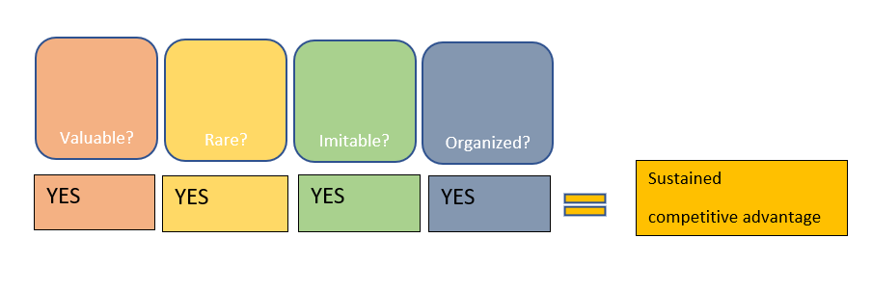

Table 6. VRIO analysis on Olympia fitness centre new strategy

A VRIO analysis on the new strategy for the gym has identified to gain a sustained competitive advantage. The new unique products, along with improved marketing and brand awareness will create value for the gym and customers. The gym is taking the opportunity to meet the future needs of customers and providing them with services that are not available with nearby competitor’s and reducing competition by offering differentiation.
- Valuable- the only gym within the area providing facilities to women.
- Specialised classes offering meditation and yoga focusing on the community to reduce mental health.
- Unique classes for the elderly emphasising on health and nutrition coaching.
Rarity and imitability- the products and services are rare within the locality as main competitor and rival is not offering any similar product. However, advantage will be temporary as competitors can imitate them easily by creating similar products.
Organisation-The delivering of these products all relies on the organisation of an efficient skilled workforce with the technological resources required to be running successfully, which are already available within the organization. The gym will look into ways to retain memberships and foster customer loyalty through excellent customer service in order to generate profit and value, thus the new strategy will have a sustained competitive advantage keeping in mind that these products will need to be reviewed and changed with time as competition rises and as customer demands change.

6. Recommendations for the gym based on chosen strategy

As the current building already has the potential to provide further products, the chosen strategy will require a maximum of 6 months to be fully implemented.
Key steps for strategy implementation-
Step 1- discussions with internal stakeholders regarding the chosen strategy and how the introduction of new products and offers through better marketing can prove to be profitable and sustainable.
Step 2- to create a financial plan for the cost of further resources and marketing that will be required.
Step 3-
- Re-designing gym to create a unisex interior
- A separate area to be designed for women’s gym facilities with separate wash/shower rooms
- Approach suppliers for new equipment
- Create sound-proof rooms for yoga and meditation classes
- Recruit new staff- for special programmes they can be freelancers as classes are expected to run a few hours during the week, and female training instructors for the women’s gym.
- Approach software developer regarding fitness app for the gym to keep customers engaged with personalized contents and to create and execute loyalty programmes for every year
Step 4- Create marketing strategies to advertise new products on social media through an updated Facebook/ Instagram page and twitter account that can display good contents regarding the gym and its developments. Leaflets are always a great way to advertise and easily noticed and picked by potential customers as they can be left at local shops, libraries, schools, playgroups/nurseries GP surgeries, and hospitals.
Step 5- to measure and control the effects of the new strategy. This can be easily done by focusing on the number of new members growing each month, rate of customer retention and on the sales of popular products. Also, the number of followers on social media pages can determine how many people are interested in your business and this can allow to target the potential customers by introducing promotions and offers.

6.1 Resistance to change

With the rapidly changing world, organizations must also learn to adapt this change quickly in order to thrive. Lewin created a 3-step change theory, unfreeze, change and re-freeze, focusing on the organization’s key activities of change management (Hussain et al., 2018). The Lewin’s change model is a great way to prepare the existing gym to understand and take on change.
Unfreeze- Melting the existing status quo of the masculine gym. This is a huge step for the gym, to introduce a completely new change. Resistance to change can easily generate negative outcomes. This stage will involve mentally preparing the organization and its key people to see a difference. New products involve the introduction of new people, staff and customers with a mixture of different feelings regarding change. Meetings are a great way to discuss the competitive challenges the gym is going through and the reasons behind these changes with the support of the various analysis that were carried out. This stage involves conveying the vision of the company and where it wants to be seen in the future and the strategies that will be involved in the mission to reach the vision.
Change- This stage is the process of accepting change with time. New staff and new members with new technological advancements will become the new norm and therefore to prepare existing staff is vital and so need to be guided through the change journey through motivation and job satisfaction. It’s crucial for the organization to determine the impacts of the change and who its effecting, this could clearly be a case of existing staff struggling with new technology systems and to becoming familiar with gym fitness app which can affect customer service. This can be dealt with by providing support, training and knowledge where needed to mitigate impacts. Knowledge sharing is also vital amongst individuals as knowledgeable people have the ability to share tacit knowledge such as experiences, skills, beliefs and wisdom that can benefit the organization hugely (Hussain et al., 2018). Creating an effective internal source of communication network within the organization is crucial so important messages and changes can be shared and delivered swiftly.
Refreeze- This stage happens when the gym has successfully completed the transition period and the new norms have been accepted by everyone. Feedback is vital at this stage from staff and customers to enable better service according to demands. Management needs to continuously motivate staff through intrinsic and extrinsic incentives and inspire staff about the vision and also communicate all progress and developments regarding the strategies. It is important that this stage measures the effects of change and can analyse how effective the new strategies are by evaluating progress and controlling anything that needs changing

7. Competitor reaction

Generally new innovative products and services will create a high level of threat for competitors and therefore it is vital the business can determine the competitor’s reaction. Olympia fitness centre has one main competitor, Fitness for life who are very well established with their product offerings. The obvious reaction to the new strategy for them will be threatening as the new products are aiming to generate profit and create brand positioning. According to Waarts (1999), where some managers fear highly innovative productions, others believe that low and medium innovations and products that are very closely related through similar characteristics to existing ones, carry higher threat levels. However, the level of threat would be low to them as this new strategy is aiming to target a completely new audience without effecting their existing members.
Competitor’s will react in the most obvious way by trying to imitate the new products. Waarts (1999) noted that threats can be manged through active signalling by communicated with competitors the pre- announcement of products, clarifying the aim of these products, intended brand position and the targeted segment. This will reduce threat levels in competitors by creating stress that the gym’s intentions are cooperative such as to expand the market and clearly not positioning the brand over theirs. Their reaction can also be dealt with by discussing a merger of the two gyms. This can mean Olympia fitness centre to provide Fitness for life with customers for their calorie counting meals and their unique products like taekwondo and kick boxing, and the gym receiving more members for the lady’s gym and the special classes through their member referrals and by expanding the marketing of the new products through their website and social platforms to reach out to a wider audience.

8. Conclusion

It can be drawn from this report, that the strategic management process within a business requires many essential tools in order to achieve the correct information surrounding your business. The tools have enabled to discover vital information about the gym and its current state that were used to analyse and create strategies that would benefit the business. The advanced PESTEL analysis gave clear indications through the ratings of which aspects of the external environment were more of a threat then others and the SWOT did the same by highlighting the strengths and weaknesses and clarifying through high ratings as to which areas carry opportunities and threats. Strategies were made based on the results of these tools and then further examined through the VRIO and SFA matrix to select the best option that would carry a sustainable competitive advantage for the gym. To introduce differentiation through new products and enhancing marketing strategies was chosen above all options as it was feasible, had low risks involved that met stakeholder assurance and was suitable for the current state of the gym against its competitor. Change management was another area that required to understand the needs of the key people involved within the business and how dealing with this change with positivity is crucial for them as they hold the key to delivering outstanding customer service that can increase future memberships and create brand loyalty. The obvious reactions of competitors were also noted and how it can be dealt with through cooperation rather than aggressive tactics. To conclude, every aspect of an organization has an input in the success of a business, from a clarified vision and clear goals of a mission, a proper strategic plan looking ahead to the future, the macro and micro- environment, internal and external stakeholders, competitors, resources and continuous motivation and inspiration.

References

Bracker, J., 1980. The historical development of the strategic management concept. Academy of management review, 5(2), pp.219-224.
Bruijl, G.H.T., 2018. The relevance of Porter's five forces in today's innovative and changing business environment. Available at SSRN 3192207.
GURL, E., 2017. SWOT analysis: A theoretical review.
Hassan, A. and Parves, M., 2013. A Comparative Case Study Investigating the Adoption of Customer Relationship Management (CRM) The Case of Tesco and Sainsbury's. International Journal of Managing Value and Supply Chains, 4(1), p.1.
Hergert, M. and Morris, D., 1989. Accounting data for value chain analysis. Strategic Management Journal, 10(2), pp.175-188.
Hussain, S.T., Lei, S., Akram, T., Haider, M.J., Hussain, S.H. and Ali, M., 2018. Kurt Lewin's change model: A critical review of the role of leadership and employee involvement in organizational change. Journal of Innovation & Knowledge, 3(3), pp.123-127.
Kim, S.C., Lee, J.S. and Shin, K.I., 2015. The impact of project management assets on the VRIO characteristics of PM process for competitive advantage. International Journal of Productivity and Quality Management, 15(2), pp.153-168.
Mind, 2020. The mental health emergency. How has the coronavirus pandemic impacted our mental health?.
Nasır, S., 2015. Customer relationship management strategies in the digital era. Business Science Reference.
Papulova, Z., 2014. The significance of vision and mission development for enterprises in Slovak Republic. Journal of Economics, Business and management, 2(1), pp.12-16.
Pickton, D.W. and Wright, S., 1998. What's swot in strategic analysis?. Strategic change, 7(2), pp.101-109.
Raleigh, V. and Holmes, J., 2021. The health of people from ethnic minority groups in England. The King’s Fund.
Suranga, J.M., 2014. Importance of corporate vision. In Proceedings of International HR Conference (Vol. 1, No. 1).
Tapera, J., 2014. The importance of strategic management to business organizations.
Waarts, E., 1999. Managing competitive response to new product introductions: Making use of effective market signals. Corporate Reputation Review, 2(2), pp.137-150.
Winch, G.M., Morris, P. and Pinto, J., 2007. Managing project stakeholders. The Wiley guide to project, program, and portfolio management, pp.271-289.
Yüksel, I., 2012. Developing a multi-criteria decision-making model for PESTEL analysis. International Journal of Business and Management, 7(24), p.52.
Zolfani, S.H., Bazrafshan, R., Akaberi, P., Yazdani, M. and Ecer, F., 2021. COMBINING THE SUITABILITY-FEASIBILITY-ACCEPTABILITY (SFA) STRATEGY WITH THE MCDM APPROACH. Facta Universitatis, Series: Mechanical Engineering, 19(3), pp.579-600.

