Title Page
Name | Kallum Doyle
Student Number | 2237962
Date | 09/05/2023
Module | Introduction to Web and Database Concepts
Assignment | HTML & CSS Web Development
Submit by | May 15th, 15:00

Table of Contents

Title Section | Header of this document
Index Section | Section index numbers and section descriptions
Introduction Section | Summary of the report contents
Requirements Section | Brief introduction to the website
Implementation Section | Screenshots of website pages/validation
Evaluation Section | Evaluation of the website’s quality
References Section | Information sources used in IEEE format
Appendices Section | HTML & CSS appendices

Introduction Section

This report contains relevant documentation on the creation of my website alongside other relevant information. Regarding my website, this includes:
- a quick insight into my website and all details regarding it, such as its purpose, the topic my website is centred around and the audience my website is suited for.
- screenshots of all the pages and information my website contains, alongside proof of valid code and a brief description of any error I encountered, the steps I took the solve the error alongside why that error could have been caused.
- evaluation of the functionality of my website, i.e., how the website has been optimized for search engines, how it has been optimized for accessibility, how easy it Is to navigate and use the website alongside how does it look and finally how useful the content is alongside any recommendations for future improvements.
Other relevant information is included in this report for the purpose of ensuring all information within this report is accurate and reliable, alongside a section containing the HTML/CSS of my website. Within this report also includes the title page, table of contents and this section, which all serve the purpose of beginning the report and providing valuable context going forward.

Requirements Section

I have created this website based upon my interest/hobbies, and the purpose of my website is to provide information on myself to any potential employers so they can understand some of my goals and skills to a greater degree than showcased in a regular CV. Practically, the website will serve as an insight into my goals/interests. Another potential audience other than potential employers could be friends/family who would want to see some of the goals I have and any updates on any interests I currently have. The website has a welcome page, a hobbies/interest’s page, an educational interest page, a contact page, and a life goals page.

Implementation Section

Website Pages:
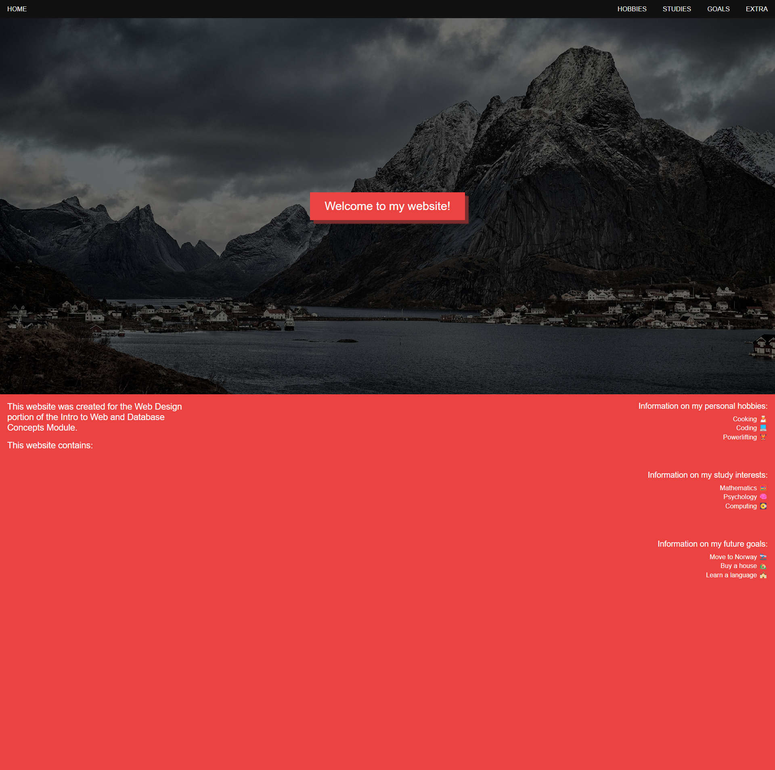
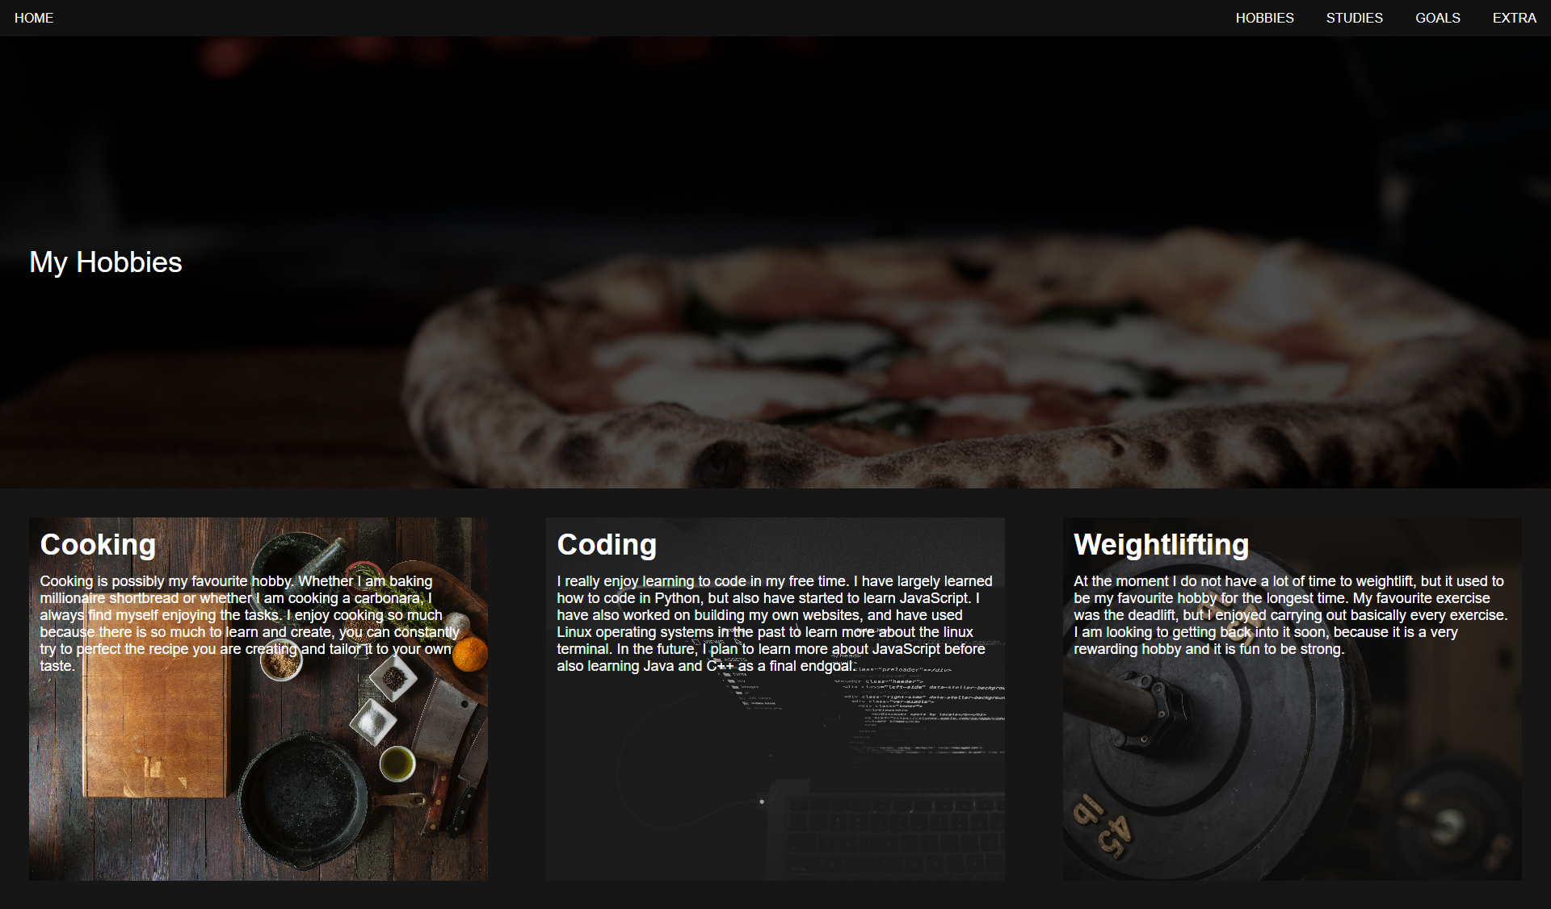
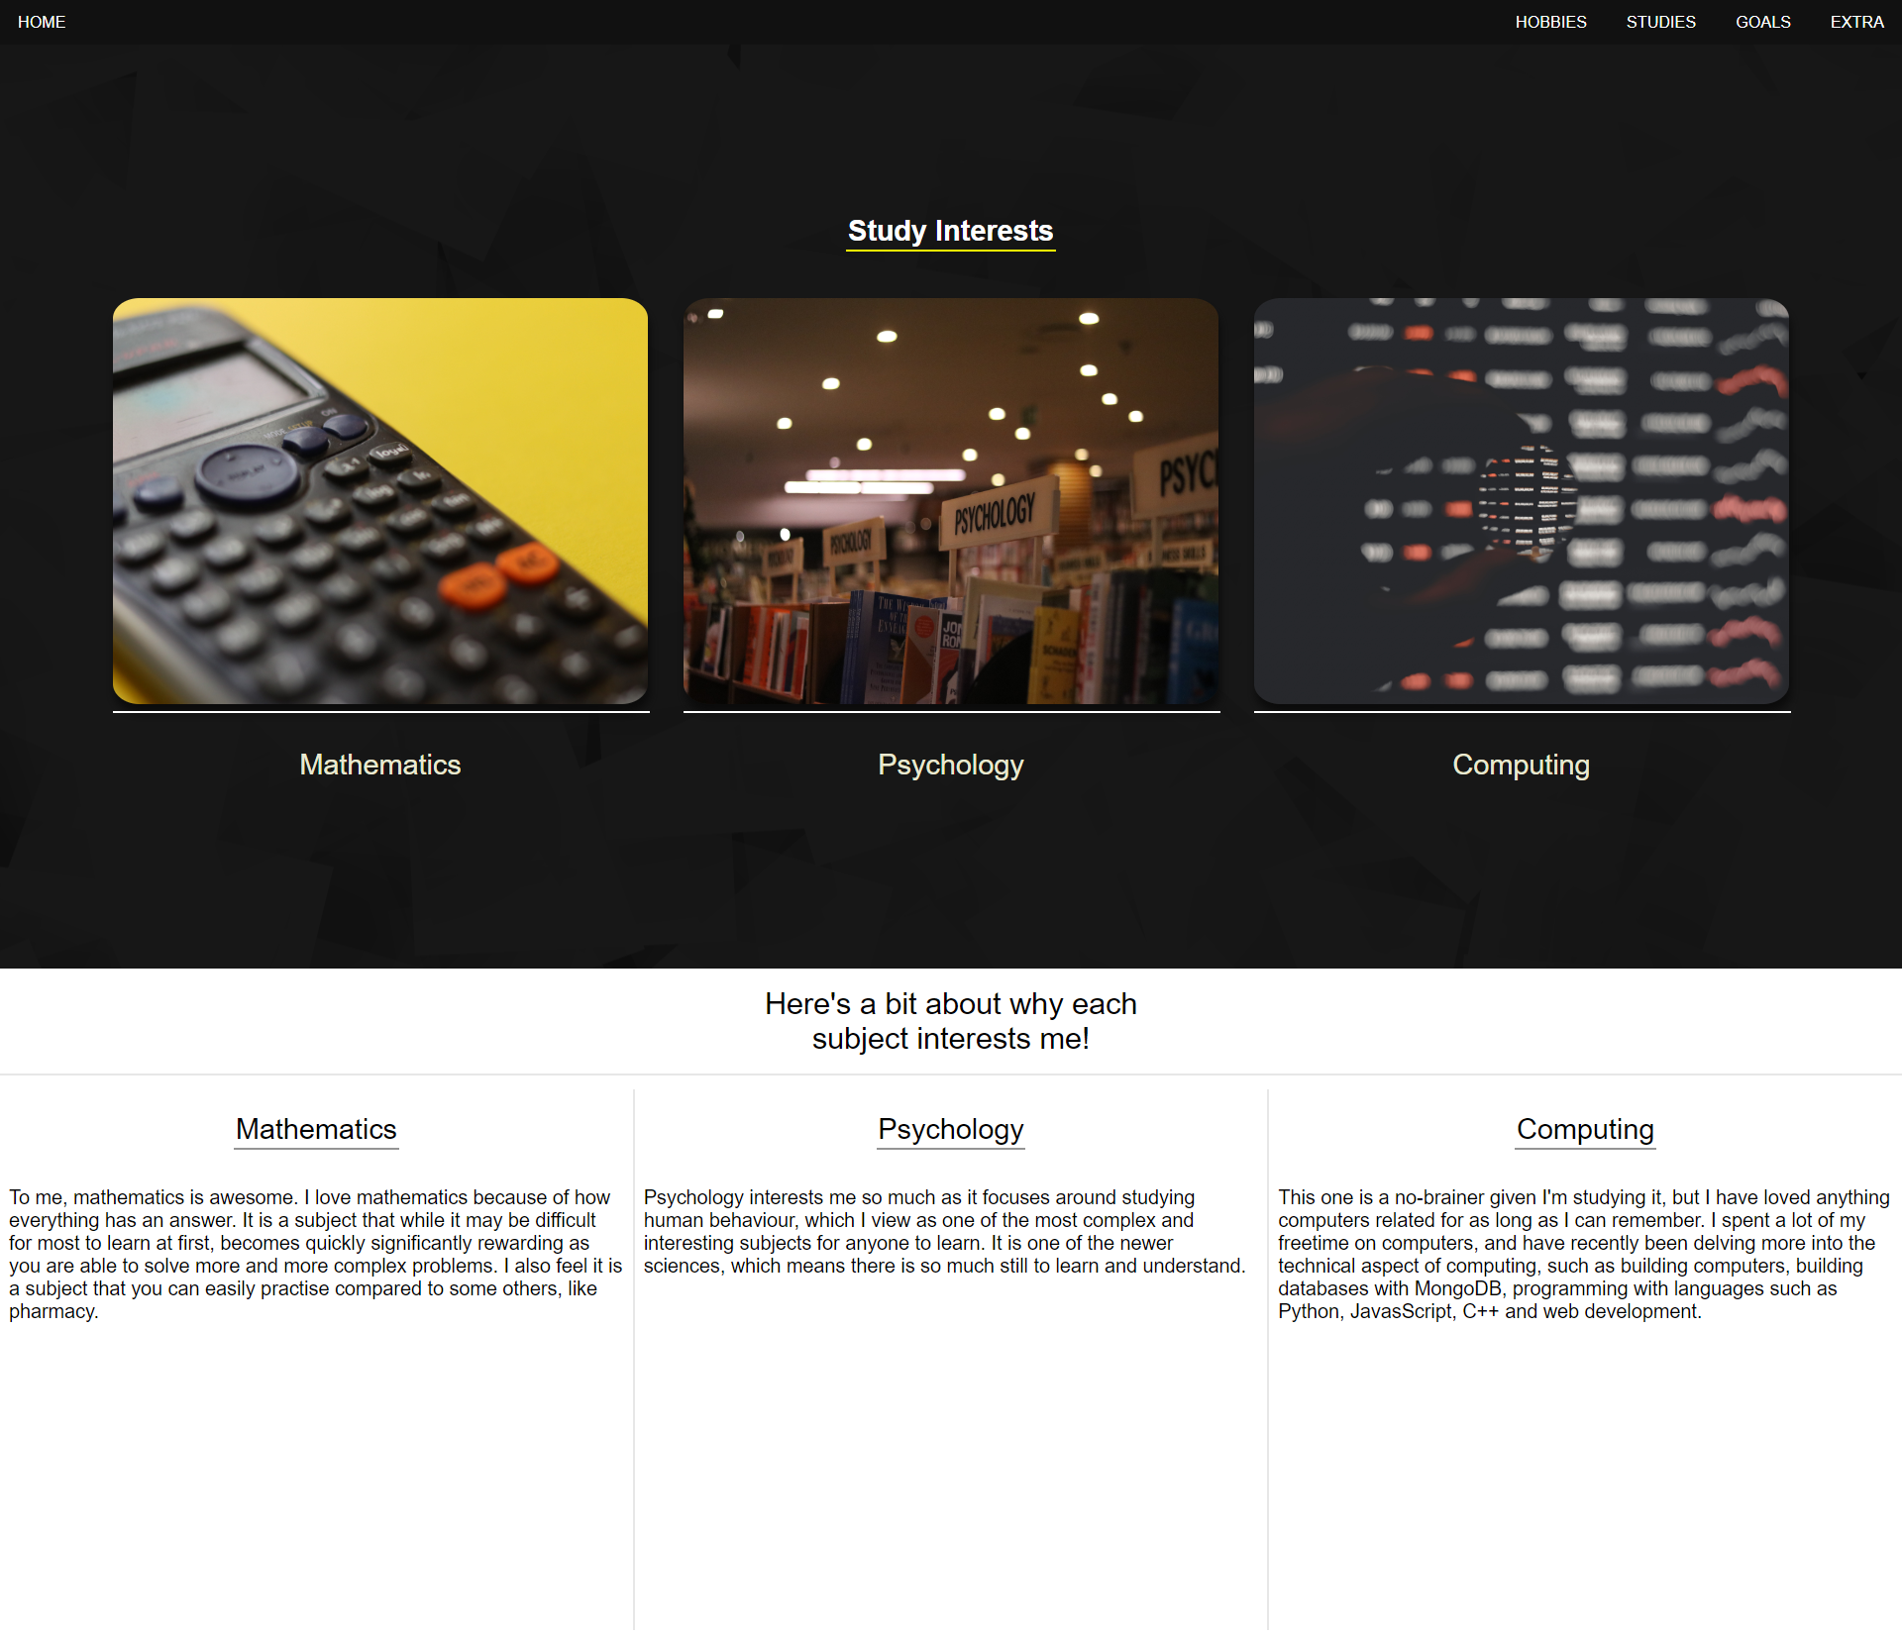
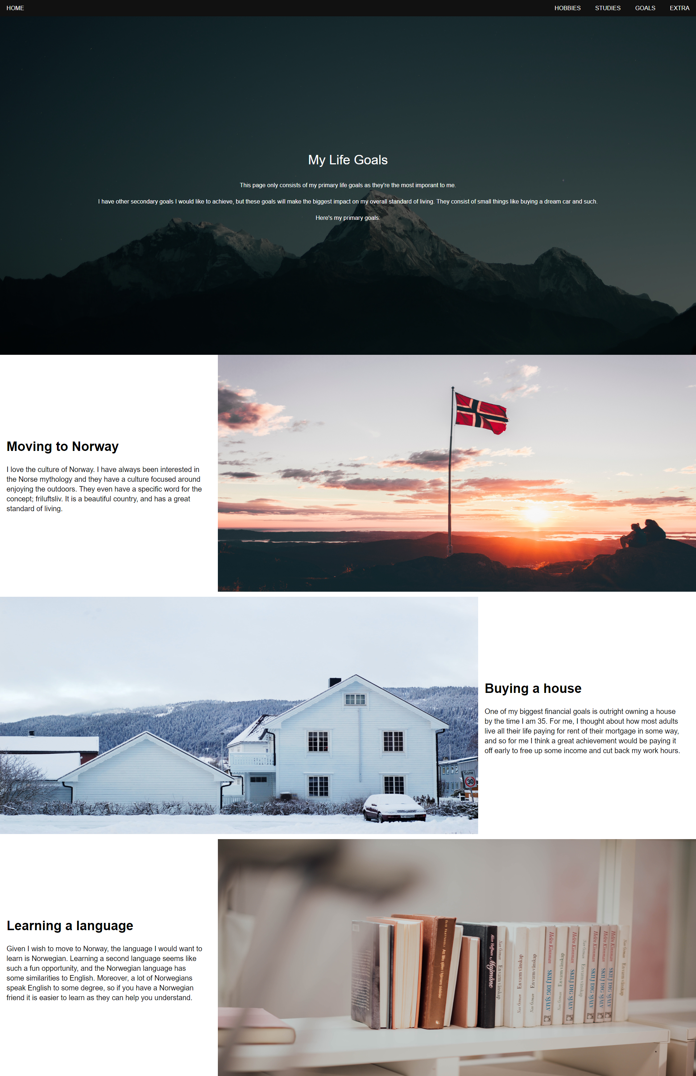
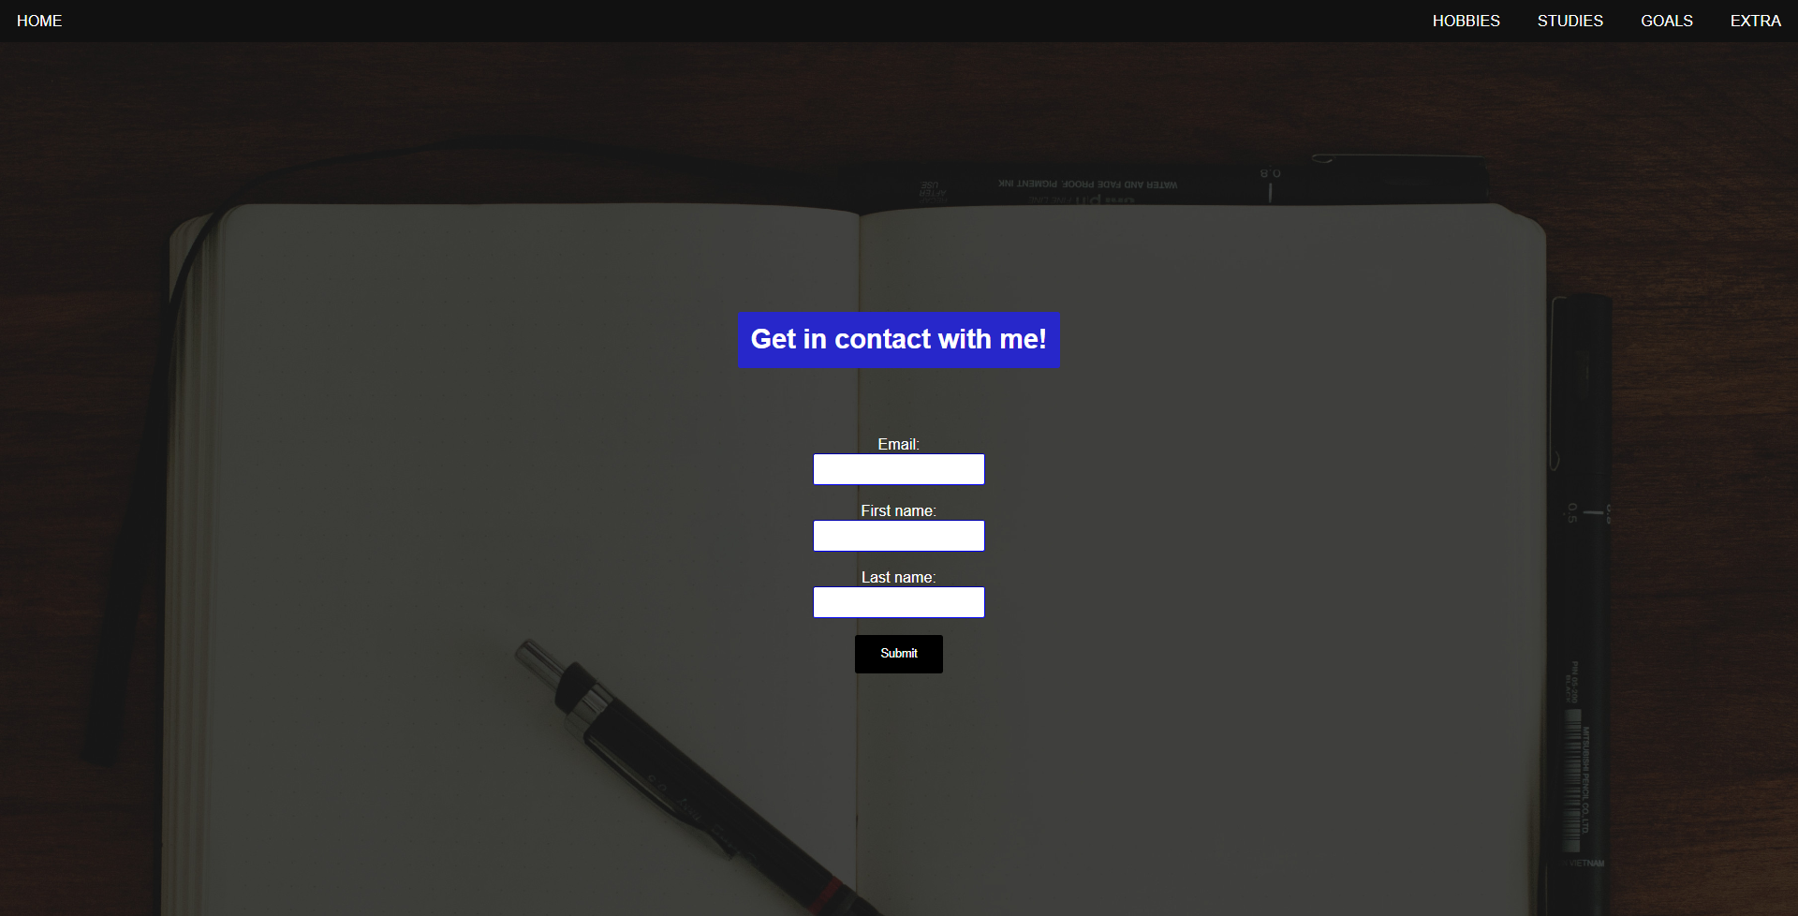

Validation

For the home, hobby and life goals pages, there were no validation errors detected. However, for the page regarding my study interests there were three errors, which included:
- A trailing slash on void elements has no effect and interacts badly with unquoted attribute values.
- End tag for body seen but there are unclosed elements.
- Unclosed element div.
I resolved each of these errors by performing the following:
- Removed the trailing slash from my code [the code went from <br /> to just <br>].
- Second error and third error are fixed together by adding </div> on line 61 of the page.
The next and final page that returned errors in the HTML validator was the contact page. The error that was returned was that there was not a space in between attributes on line 27. I resolved this issue by simply adding a space in between the class name and for section.
There is only a singular CSS file within my website as they all follow a similar format, and this file was validated with no errors to be found.

Evaluation Section

Term Definition

For this section of my report, I will be determining the usability/utility and accessibility of my website alongside how well my website is optimized for search engines. To do this, it is important to understand what each of these terms mean:
- [1] When talking about website usability, usability refers to how easy it is to use something you can interact with. In this instance, as I am analysing the usability of my website, this means how easy is it to interact with my website? To analyse how efficient my website is to interact with, I will look at:
  - How quickly can a user navigate the website?
  - Is it easy to make mistakes on the website? If mistakes are made, can they be corrected with ease?
  - How easy is it to navigate the website?
  - How easily can the website content be memorised, and how well can it be retained?
  - Does the user have a satisfying experience with the design of the website?
- [2] Having high quality accessibility of a website is important to ensure that everyone can use the website, which drives more traffic and ensures no one is excluded. Accessibility allows for individuals with a wide array of disabilities to use the website and refers to designing the website so it can be interacted with and understood by everyone who uses the website. Accessibility generally refers to ensuring the website can be used under a wide umbrella of uses, which also includes the website being accessible by different mediums such as a smart phone or mobile phone, and allowing for easy navigation of the website even if someone has a broken arm or such. To analyse the accessibility of the website, I will evaluate: [3]
  - The titles of the pages [Does the page title suitably describe the page? Is it unique on the website?]
  - Image alternative text [Does every image have alternative text for when the image is unavailable?]
  - Headings [Does every page have a heading? Are all headings marked up as a heading?]
  - Text Resizing [Can the text be enlarged without disappearing or being cut from the page?]
  - Keyboard access [Can you use tab to navigate elements? Is there a focus style for forms?]
  - Error handling [Does your form check for errors?]
- [4] Search Engine Optimization [SEO] refers to making your website optimized for search engines, which allows for your website to be more visible on search engines which will ultimately drive more traffic to your website. This can be done through a few ways, of which I will analyse if they have been implemented correctly within my website: [5]
  - Page titles that accurately describe the contents of a page and are unique.
  - Meta tags included in your HTML page files to describe each page uniquely.
  - Creating a simple navigational page that displays how your website has been structured for navigation.
  - Ensure your website’s content is easy to read and organised clearly.
With this information in mind, I can now easily evaluate my website for usability/utility, accessibility, and search engine optimization. The below section will delve into whether I have sufficiently implemented each of these elements.

Evaluation

Usability/Utility

Firstly, a user can navigate my website with sufficient speed. Every page has been optimized for length, so no user will have to scroll down for long periods of time to reach information they’re looking for, alongside the header bar allowing for easy navigation across all five pages of my website.
It is very hard and very rare a user will make a mistake on my website as there is only one section for user input (the contact page), however if a user was to make an error such as visiting the wrong page, this could be easily corrected by using the header bar to navigate back to the page they wanted. For the contact form, if the user were to accidentally not include a full email address, they would be warned when they click submit that the email address is not complete and allow the user to edit the email before submitting again.
Any user will have no issue navigating my website, as all the content is laid out clearly and each page can be accessed easily by using the header bar available at the top of the web page.
All the information can be easily memorised/retained. I have aimed for a minimalistic design of the website, so it is as simple as possible, and all information I have provided has been provided with readability and simplicity in mind. Regarding memorising navigation, the header bar remains the same in all pages, and the content on each page accurately reflects the page so a user can easily find the information again if they need assistance remembering information.
Given I have designed the website to be minimalistic and modern, I believe most users should have a satisfactory time navigating the website and should enjoy the visuals I have provided on the website. I have ensured each page has a unique design, while still retaining a similar theme unique to my website. It is simple and has some responsive capability so all users will have an enjoyable visual experience.

Accessibility

Each page on my website has a page title that accurately describes the contents of each of the pages. The page headings include Doyle’s Website (home page), Doyle’s Hobbies, Doyle’s Goals, Doyle’s Studies, Doyle’s Contact. These titles show they are on my website show relative to the page the contents of each. They are all unique to ensure there is no confusion about which page they are navigating.
Every image tag has an alternative text. Some images included on the website are background images, which do not contain any alternative text, however this does not impede the functionality of the website. Each alternative text accurately describes the image it represents, for example on my goals page, I have alternative text describing a house in Norway for my goal of buying a house/moving to Norway.
All pages on my website have headings, and they all follow a heading hierarchy making good use of the h1, h2 and h3 tags. They are all marked up as headings and can clearly be seen as heading as they all use bold text.
You can easily navigate the website by using the tab key, which will allow you to select each interactable element on the page in the correct hierarchical order. For example, the header will go from left to right for each element if you are using the tab key. Additionally, when you click on a form input section, that input box will gain an outer line to show the user that box has been highlighted.
Within my website I have a contact form, and as previously mentioned, if you were to incorrectly insert a string within the email address field (e.g., the address is missing an @) the website will warn the user of the mistake and will allow the user to edit and allow the user to resubmit their details.

Search Engine Optimization [SEO]

To ensure the page has been accurately optimized for search engines, every page title is unique and accurately describes the content present on each page. Every title is also brief, for the title to be fully shown in the browser tabs and for the website to remain simplistic.
Additionally, I have included a meta tag on each page so that search engines that support the meta tag are able to have a brief description of what the page contains. This allows the search engine to take this data into consideration when a user is searching something similar or equivalent to your meta description, and certain search engines may use this tag as a snippet for displaying to users. The description is an accurate summary of each page’s content, which will draw in my target audience.
Regarding the navigational page, the home page of my website serves to introduce all users to my website and the information they can source on each page. The header bar also allows for quick, easy, and simple navigation of my website with a well-designed hierarchy. All hyperlinks to each page are text based as well, which allows for clear navigation.
I’ve ensured my website’s content is easy to use by keeping it as simple as I possibly can and ensuring that all relevant information is bundled together. This means keeping descriptions as simple and understandable as possible and ensure that all page data is close to each other and not stretched across multiple pages.

References Section

[1] ‘Usability | Definition | Elements | Guidelines | Website design’, UserReport, Feb. 24, 2015. https://www.userreport.com/blog/usability/ (accessed May 15, 2023).
[2] W. W. A. Initiative (WAI), ‘Introduction to Web Accessibility’, Web Accessibility Initiative (WAI). https://www.w3.org/WAI/fundamentals/accessibility-intro/ (accessed May 15, 2023).
[3] W. W. A. Initiative (WAI), ‘Easy Checks – A First Review of Web Accessibility’, Web Accessibility Initiative (WAI). https://www.w3.org/WAI/test-evaluate/preliminary/ (accessed May 15, 2023).
[4] ‘Documentation to Improve SEO | Google Search Central | Google Developers’. https://developers.google.com/search/docs (accessed May 15, 2023).
[5] ‘SEO Starter Guide: The Basics | Google Search Central | Documentation | Google Developers’. https://developers.google.com/search/docs/fundamentals/seo-starter-guide (accessed May 15, 2023).

Appendices Section

Home Page
<!DOCTYPE html>
<html lang="en">
<head>
<meta charset="UTF-8">
<meta http-equiv="X-UA-Compatible" content="IE=edge">
<meta name="viewport" content="width=device-width, initial-scale=1.0">
<title>Doyle's Website</title>
<meta name="description" content="Home page of Kallum Doyle's website, describes what is on the website.">
<link rel="stylesheet" href="style.css">
<link rel="icon" type="image/x-icon" href="images/favicon/favicon.ico">
</head>
<body>
<div class="header">
<div class="headerdiv1">
<a href="index.html" class="headerlink">HOME</a>
</div>
<div class="headerdiv2">
<a href="hobbies.html" class="headerlink">HOBBIES</a>
<a href="studies.html" class="headerlink">STUDIES</a>
<a href="goals.html" class="headerlink">GOALS</a>
<a href="extra.html" class="headerlink">EXTRA</a>
</div>
</div>
<div class="welcomepage">
<h1 class="welcomepara">Welcome to my website!</h1>
</div>
<div class="page2">
<div class="indextopdiv">
<p class="page2para">This website was created for the Web Design portion of the Intro to Web and Database Concepts Module.</p>
<p class="page2para">This website contains: </p>
</div>
<div class="moreinfodiv">
<div class="page2para1div">
<h2 class="page2para1">Information on my personal hobbies:</h2>
<p class="page2para2">Cooking 👨‍🍳<br>Coding 💻<br>Powerlifting 🏋️
</p>
</div>
<div class="page2para1div">
<h2 class="page2para1">Information on my study interests:</h2>
<p class="page2para2">Mathematics 🧮<br>Psychology 🧠<br>Computing 💽
</p>
</div>
<div class="page2para1div">
<h2 class="page2para1">Information on my future goals:</h2>
<p class="page2para2">Move to Norway 🛬<br>Buy a house 🏡<br>Learn a language 🏫
</p>
</div>
</div>
</div>
</body>
</html>

Hobbies Page

<!DOCTYPE html>
<html lang="en">
<head>
<meta charset="UTF-8">
<meta http-equiv="X-UA-Compatible" content="IE=edge">
<meta name="viewport" content="width=device-width, initial-scale=1.0">
<title>Doyle's Hobbies</title>
<meta name="description" content="Information on all of Kallum Doyle's hobbies.">
<link rel="stylesheet" href="style.css">
<link rel="icon" type="image/x-icon" href="images/favicon/favicon.ico">
</head>
<body>
<div class="header">
<div class="headerdiv1">
<a href="index.html" class="headerlink">HOME</a>
</div>
<div class="headerdiv2">
<a href="hobbies.html" class="headerlink">HOBBIES</a>
<a href="studies.html" class="headerlink">STUDIES</a>
<a href="goals.html" class="headerlink">GOALS</a>
<a href="extra.html" class="headerlink">EXTRA</a>
</div>
</div>
<div class="hobbiespage">
<h1 class="hobbiespara">My Hobbies</h1>
</div>
<div class="allhobbiesdiv">
<div class="cookingdiv">
<h2 class="hobbyheadings">Cooking</h2>
<p class="hobbypara">Cooking is possibly my favourite hobby. Whether I am baking millionaire shortbread or whether I am cooking a carbonara, I always find myself enjoying the tasks. I enjoy cooking so much because there is so much to learn and create, you can constantly try to perfect the recipe you are creating and tailor it to your own taste.</p>
</div>
<div class="codingdiv">
<h2 class="hobbyheadings">Coding</h2>
<p class="hobbypara">I really enjoy learning to code in my free time. I have largely learned how to code in Python, but also have started to learn JavaScript. I have also worked on building my own websites, and have used Linux operating systems in the past to learn more about the linux terminal. In the future, I plan to learn more about JavaScript before also learning Java and C++ as a final endgoal.</p>
</div>
<div class="weightliftingdiv">
<h2 class="hobbyheadings">Weightlifting</h2>
<p class="hobbypara">At the moment I do not have a lot of time to weightlift, but it used to be my favourite hobby for the longest time. My favourite exercise was the deadlift, but I enjoyed carrying out basically every exercise. I am looking to getting back into it soon, because it is a very rewarding hobby and it is fun to be strong.</p>
</div>
</div>
</body>
</html>

Studies Page

<!DOCTYPE html>
<html lang="en">
<head>
<meta charset="UTF-8">
<meta http-equiv="X-UA-Compatible" content="IE=edge">
<meta name="viewport" content="width=device-width, initial-scale=1.0">
<title>Doyle's Studies</title>
<meta name="description" content="A page describing the subjects Kallum Doyle is interested in.">
<link rel="stylesheet" href="style.css">
<link rel="icon" type="image/x-icon" href="images/favicon/favicon.ico">
</head>
<body>
<div class="header">
<div class="headerdiv1">
<a href="index.html" class="headerlink">HOME</a>
</div>
<div class="headerdiv2">
<a href="hobbies.html" class="headerlink">HOBBIES</a>
<a href="studies.html" class="headerlink">STUDIES</a>
<a href="goals.html" class="headerlink">GOALS</a>
<a href="extra.html" class="headerlink">EXTRA</a>
</div>
</div>
<div class="gamespage">
<h1 class="gamespara">Study Interests</h1>
<div class="topiccontainers">
<div class="topicdiv">
<img class ="topicimg" alt="A picture of a calculator" src="images/gamesimgs/clayton-robbins-ihqB-c8C7Bc-unsplash.jpg" alt="">
<hr class="topicline">
<h2 class="topicheading">Mathematics</h2>
</div>
<div class="topicdiv">
<img class ="topicimg" alt="A picture of some psychology books" src="images/gamesimgs/alicia-christin-gerald-zm4CcBeBbp8-unsplash.jpg" alt="">
<hr class="topicline">
<h2 class="topicheading">Psychology</h2>
</div>
<div class="topicdiv">
<img class ="topicimg" alt="A picture of a computer server" src="images/gamesimgs/sajad-nori-21mJd5NUGZU-unsplash.jpg" alt="">
<hr class="topicline">
<h2 class="topicheading">Computing</h2>
</div>
</div>
</div>
<div class="topicspage2">
<h2 class="topicspage2header">Here's a bit about why each<br>subject interests me!</h2>
<hr class="topicdescline">
<div class="topicdescdivs">
<div class="topicdescpage">
<h3 class="topicheading2">Mathematics</h3>
<p class="topicdescription">To me, mathematics is awesome. I love mathematics because of how everything has an answer. It is a subject that while it may be difficult for most to learn at first, becomes quickly significantly rewarding as you are able to solve more and more complex problems. I also feel it is a subject that you can easily practise compared to some others, like pharmacy.</p>
</div>
<hr class="topicdescline">
<div class="topicdescpage">
<h3 class="topicheading2">Psychology</h3>
<p class="topicdescription">Psychology interests me so much as it focuses around studying human behaviour, which I view as one of the most complex and interesting subjects for anyone to learn. It is one of the newer sciences, which means there is so much still to learn and understand.</p>
</div>
<hr class="topicdescline">
<div class="topicdescpage">
<h3 class="topicheading2">Computing</h3>
<p class="topicdescription">This one is a no-brainer given I'm studying it, but I have loved anything computers related for as long as I can remember. I spent a lot of my freetime on computers, and have recently been delving more into the technical aspect of computing, such as building computers, building databases with MongoDB, programming with languages such as Python, JavasScript, C++ and web development.</p>
</div>
</div>
</div>
</body>
</html>

Goals Page

<!DOCTYPE html>
<html lang="en">
<head>
<meta charset="UTF-8">
<meta http-equiv="X-UA-Compatible" content="IE=edge">
<meta name="viewport" content="width=device-width, initial-scale=1.0">
<title>Doyle's Goals</title>
<meta name="description" content="A page describing all of Kallum Doyle's life goals.">
<link rel="stylesheet" href="style.css">
<link rel="icon" type="image/x-icon" href="images/favicon/favicon.ico">

</head>
<body>
<div class="header">
<div class="headerdiv1">
<a href="index.html" class="headerlink">HOME</a>
</div>
<div class="headerdiv2">
<a href="hobbies.html" class="headerlink">HOBBIES</a>
<a href="studies.html" class="headerlink">STUDIES</a>
<a href="goals.html" class="headerlink">GOALS</a>
<a href="extra.html" class="headerlink">EXTRA</a>
</div>
</div>
<div class="goalspage">
<h1 class="goalspara">My Life Goals</h1>
<p class="goalspara2">This page only consists of my primary life goals as they're the most imporant to me.
<br>I have other secondary goals I would like to achieve, but these goals will make the biggest impact on my overall standard of living. They consist of small things like buying a dream car and such.
<br>Here's my primary goals:</p>
</div>
<div class="goalpage">
<div class="goalmaininfo">
<h2 class="goalheader">Moving to Norway</h2>
<p class="goaldesc">I love the culture of Norway. I have always been interested in the Norse mythology and they have a culture focused around enjoying the outdoors. They even have a specific word for the concept; friluftsliv. It is a beautiful country, and has a great standard of living.</p>
</div>
<img class="goalimg" alt="A picture of Norway" src="images/goalsimgs/mikita-karasiou-HO6aBrYi3kE-unsplash.jpg" alt="">
</div>
<hr class ="goalsline">
<div class="goalpage">
<img class="goalimg1" alt="A picture of a house in Norway" src="images/goalsimgs/adrianna-kaczmarek-RvRNPZ97Nuo-unsplash.jpg" alt="">
<div class="goalmaininfo">
<h2 class="goalheader">Buying a house</h2>
<p class="goaldesc">One of my biggest financial goals is outright owning a house by the time I am 35. For me, I thought about how most adults live all their life paying for rent of their mortgage in some way, and so for me I think a great achievement would be paying it off early to free up some income and cut back my work hours.</p>
</div>
<img class="goalimg2" alt="A picture of a house in Norway" src="images/goalsimgs/adrianna-kaczmarek-RvRNPZ97Nuo-unsplash.jpg" alt="">
</div>
<hr class ="goalsline">
<div class="goalpage">
<div class="goalmaininfo">
<h2 class="goalheader">Learning a language</h2>
<p class="goaldesc">Given I wish to move to Norway, the language I would want to learn is Norwegian. Learning a second language seems like such a fun opportunity, and the Norwegian language has some similarities to English. Moreover, a lot of Norwegians speak English to some degree, so if you have a Norwegian friend it is easier to learn as they can help you understand.</p>
</div>
<img class="goalimg" alt="A picture of a bookshelf and books" src="images/goalsimgs/chuttersnap-Zf64Osndqvc-unsplash.jpg" alt="">
</div>
</body>
</html>

Extra Page

<!DOCTYPE html>
<html lang="en">
<head>
<meta charset="UTF-8">
<meta http-equiv="X-UA-Compatible" content="IE=edge">
<meta name="viewport" content="width=device-width, initial-scale=1.0">
<title>Doyle's Contact</title>
<meta name="description" content="A page for getting in contact with Kallum Doyle.">
<link rel="stylesheet" href="style.css">
<link rel="icon" type="image/x-icon" href="images/favicon/favicon.ico">
</head>
<body>
<div class="header">
<div class="headerdiv1">
<a href="index.html" class="headerlink">HOME</a>
</div>
<div class="headerdiv2">
<a href="hobbies.html" class="headerlink">HOBBIES</a>
<a href="studies.html" class="headerlink">STUDIES</a>
<a href="goals.html" class="headerlink">GOALS</a>
<a href="extra.html" class="headerlink">EXTRA</a>
</div>
</div>
<div class="extrapage1">
<h1 class="extrawelcomepara">Get in contact with me!</h1>
<div class="contactmethod">
<form class="extraform" action="actionpage.js" method="post">
<label class="formheader" for="email">Email:</label><br>
<input class="forminput" type="email" id="email" name="email" required><br>
<label class="formheader" for="fname">First name:</label><br>
<input class="forminput" type="text" id="fname" name="fname"><br>
<label class="formheader" for="lname">Last name:</label><br>
<input class="forminput" type="text" id="lname" name="lname"><br>
<input class="formsubmit" type="submit" value="Submit">
</form>
</div>
</div>
</body>
</html>

CSS File

body {
display: flex;
flex-direction: column;
justify-content: center;
font-family: Arial, Helvetica, sans-serif;
margin: 0;
}

.header {
display: flex;
justify-content: space-between;
align-items: center;
height: 50px;
width: 100%;
background-color: rgb(17, 17, 17);
}
.welcomepage {
background-image: url("images/norway.jpg");
}
.welcomepage, .hobbiespage, .gamespage, .goalspage, .extrapage1 {
display: flex;
justify-content: center;
align-items: center;
height: 100vh;
width: 100%;
background-repeat: no-repeat ;
background-position: center;
background-size: cover;
}

.welcomepara {
background-color: rgb(235, 66, 66);
box-shadow: 10px 10px 2px rgb(126, 45, 45);
}

.welcomepara, .hobbiespara, .gamespara, .goalspara{
font-size: 32px;
color: white;
padding: 20px 40px 20px 40px;
}

.headerlink {
text-decoration: none;
margin: 0px 10px 0px 10px;
color:white;
font-size: 18px;
padding: 10px;
transition: 0.25s;
}

.headerlink:hover {
background-color: rgb(196, 53, 53);
}

.page2 {
display: flex;
justify-content: space-between;
height: 100vh;
width: 100%;
background-color:rgb(235, 66, 66);
}

.page2para1div {
margin: 20px;
margin-bottom: 80px;
}

.page2para, .page2para1, .page2para2 {
color: white;
margin: 20px;
text-align: left;
font-size: 24px;
width: 500px;
}

.page2para1, .page2para2 {
margin: 0;
margin-bottom: 10px;
width: auto;
font-size: 22px;
text-align: right;
line-height: 25px;
}
.page2para2 {
font-size: 18px;
}

.headerlink {
height: 100%;
}

@media screen and (max-width: 850px) {
.page2 {
flex-direction: column;
justify-content: center;
align-content: space-evenly;
height: 100%
}

.welcomepara {
font-size: 24px;
}

.paga2parastartdiv {
justify-content: center;
}
.page2para {
text-align: center;
width: auto;
}

.page2para1, .page2para2 {
text-align: left;
}

.headerlink {
font-size: 14px;
}

.page2para {
font-size: 26px;
}

.indextopdiv {
margin-bottom: 60px;
}
}

@media screen and (max-width: 500px) {
.headerlink {
font-size: 12px;
}

.welcomepara {
font-size: 18px;
}

}

@media screen and (max-width: 430px) {
.header {
height: 60px;
}
.headerdiv1 {
width: 20%;
display: flex;
}
.headerdiv2 {
width: 80%;
display: flex;
justify-content: right;
flex-wrap: nowrap;
}
.headerlink {
margin: 0px;
font-size: 65%
}
}

/* Start of Hobbies Page */
.hobbiespage {
background-image: url("images/food.jpg");
height: 60vh;
justify-content: left;
}

.hobbiespara {
font-size: 40px;
}

.allhobbiesdiv {
display: flex;
justify-content: space-between;
height: auto;
background-color: rgb(22, 22, 22);
}

.cookingdiv {
background-image: url("images/hobbiesimgs/cooking.jpg");
}

.codingdiv {
background-image: url("images/hobbiesimgs/nate-grant-QQ9LainS6tI-unsplash.jpg")
}

.weightliftingdiv {
background-image: url("images/hobbiesimgs/delaney-van-I72QeY20Q7o-unsplash.jpg");
}

.hobbydiv, .cookingdiv, .codingdiv, .weightliftingdiv {
color: white;
text-align: left;
font-size: 20px;
margin: 40px;
background-size: cover;
height: 500px;
width: 30%;
}

.hobbyheadings, .hobbypara {
margin: 15px 15px 0px 15px;
}

@media screen and (max-width: 1120px) {
.allhobbiesdiv {
flex-direction: column;
align-items: center;
}

.hobbydiv, .cookingdiv, .codingdiv, .weightliftingdiv {
width: 75%;
text-align: center;
}

.hobbyheadings {
font-size: 26px;
}
}

/* Start of Games Page */

.topicsmainpage {
display: flex;
flex-direction: column;
}

.gamespage {
background-image: url("images/gamesbackground.png");
flex-direction: column;
}

.gamespara {
color: white;
font-weight: bold;
padding: 2px;
border-bottom: 3px solid yellow;
}

.topiccontainers {
display: flex;
width: 90%;
}

.topicdiv {
margin: 20px;
display: flex;
flex-direction: column;
align-items: center;
}

.topicimg {
height: 100%;
width: 100%;
border-radius: 5%;
box-shadow: 2px 10px 10px rgb(10, 10, 10);
}

.topicline {
width: 100%;
border: 2px solid white;
}
.topicheading {
font-size: 32px;
color: rgb(233, 233, 209)
}

.topicdescdivs {
display: flex;
flex-direction: row;
}

.topicdescpage {
display: flex;
flex-direction: column;
align-items: center;
height: 60vh;
width: 100%;
}

.topicheading2 {
font-size: 32px;
padding: 2px;
border-bottom: 3px solid rgb(148, 148, 148);
}

.topicdescription {
margin: 10px;
font-size: 22px;
text-align: left;
}

.topicdescline {
border: 2px solid rgb(231, 231, 231);
}

.topicspage2header {
font-size: 34px;
margin: 20px;
text-align: center;
}

@media screen and (max-width: 800px) {
.topiccontainers {
flex-direction: column;
}

.topicdiv {
height: 100%;
}

.gamespage {
height: auto;
}

.topicdescpage {
height: auto;
}
.topicdescdivs {
flex-direction: column;
}

.topicdescription {
text-align: center;
width: 90%;
}

.topicimg {
width: 75%;

}
.topicline {
width: 75%;
}

.topicheading {
margin-top: 10px;
}

}

@media screen and (max-width: 400px) {
.topicspage2header {
font-size: 28px;
}

.topicdescription {
font-size: 20px;
}
}

/* Start of goals page */
.goalspage {
justify-content: center;
flex-direction: column;
background-image: url("images/goals.jpg") ;
height: 100vh;

}

.goalspara {
color: white;
font-size: 40px;
padding: 0px;
margin-bottom: 10px;
}

.goalspara2 {
color: white;
font-size: 18px;
padding: 0px;
text-align: center;
line-height: 50px;
}

.goalpage {
margin: 0px 0px 0px 0px;
display: flex;
height: 70vh;
flex-direction: row;
}

.goalmaininfo {
margin: 20px;
display: flex;
flex-direction: column;
width: 30%;
justify-content: center;
}

.goalheader {
color: black;
font-size: 40px;
font-weight: bold;
padding: 0px;
margin-bottom: 10px;
}

.goaldesc {
line-height: 30px;
font-size: 22px;
margin-right: 20px;
}

.goalimg, .goalimg1, .goalimg2 {
height: 100%;
width: 70%;
}

.goalimg2{
height: 0;
display: none;
}

.goalsline {
border: 0px solid white;
width: 100%;
}

@media screen and (max-width: 1000px) {
.goalspara2 {
margin: 20px;
}

.goalpage {
flex-direction: column;
height: 100%;
}

.goaldesc {
text-align: center;
width: 100%;
}

.goalheader {
text-align: center;
font-size: 34px;
}

.goalmaininfo {
width: auto;
}

.goalimg, .goalimg2 {
width: 100%;
height: 50%;
}

.goalimg1 {
display: none;
height: 0;
}

.goalimg2 {
display: block;
}
}

@media screen and (max-width: 500px) {
.goalspara {
font-size: 26px;
}

.goalspara2 {
font-size: 16px;
}

.hobbypara {
font-size: 18px;
}

}

/* beginning of extra */

.extrawelcomepara {
font-size: 32px;
font-weight: bold;
background-color: rgb(39, 39, 202);
padding: 15px;
border-radius: 3px;
color: white;
margin-bottom: 80px;

}

.extrapage1 {
flex-direction: column;
justify-content: center;
}

.extraform {
text-align: center;
}

.formheader {
font-size: 18px;
color: white;
}

.forminput {
border-radius: 3px;
box-sizing: border-box;
border-color: blue;
margin-bottom: 20px;
padding: 10px 20px 10px 20px;
}

.formsubmit {
background-color: black;
font-size: 14px;
color: white;
padding: 15px 30px 15px 30px;
border-radius: 3px;
border: none;
cursor: pointer;
transition: 0.25s;
}

.formsubmit:hover{
box-shadow: 2px 2px 5px rgb(77, 76, 76);
}

.formsubmit:active {
background-color: white;
color: black;
}

.extrapage1 {
background: url("images/mike-tinnion-3ym6i13Y9LU-unsplash.jpg");
background-size: cover;
background-repeat: no-repeat;
width: 100%;
}

