University of Wales Trinity Saint Davids
Wales Institute of Science and art


Material Selection Report
ACHA4001 Engineering Design and Materials

Cody Surridge
2304028
21/04/24

Table of Contents
1 Introduction 2
2 Component Design Specificstion 3
3 Material Selection 4
4 Manufacturing process Selection 5
5 Conclusion 6
6 References 7

Introduction
In this technical report, there will be a design specification of a component which will cover aspects such as the environment (where it will be used), material requirements (such as durability and flexability), cost and it’s ability to be maintained. Furthermore, there will be an investigation into suitable materials for the part and therefore an ivestigation into how the material can be manufactured and identifying the most suitable one while following the design specification.

Component Design Specificstion
The component that I have chosen is a piston used on a …………
To start, the ideal environment for the piston is concealed away whithin the shell of the engine and enclosed within the cylinder head. This then means that the piston will become very hot and therefore won’t encounter any liquids apart from the oil within the engine. Furthermore, the pistons are constantly moving meaning that they are under constant force and are therefore wearing down.
Next, the material of the piston must have a high melting point/ be able to withstand a high temperature before deforming. This is because the piston will be working in a high temperature environment. This means that a large quantity of energy is produced meaning that the bonds that make the material will break and cause the material to deform and/or break. The material must must have a high tensile strength so that when a force is applied on the piston it doesn’t deform under stress and therefore cause the piston to break or fail and negatively affect the whole engine. Additionally, the material must have low elastic potentail to prevent unintentional deformation. The material should also not be ductile so that the material isn’t being unvoltaraly strectched. Finally, the material must be inflexible so that there isn’t any deformation and so that there isn’t a chance of the engine breaking use endangaring people who use the engine and others around it.
The cost of the material must be resonably low. This is so that if someone would need to replace the piston it is easily replaceable by the user as it should be cheaper and therefore more readily accessable for others. The material being cheaper means that it can be more readily available for commercial and manufacturing use. Continuing, the cheaper material means that it is easier to mass produce the piston as less expenses will be needed to pay for that material so that more can be produce for the same price and that it will be easier to replicate.
Finally, the piston can have some difficulty in being maintained. This is because as a result of the piston being in an enclosed environment it will need to be made from a material that won’t degrade as a result of weathering and wear easily. Meaning, that the piston is secluded away and only replaced or repaired when it is removed from the engine.

Material Selection
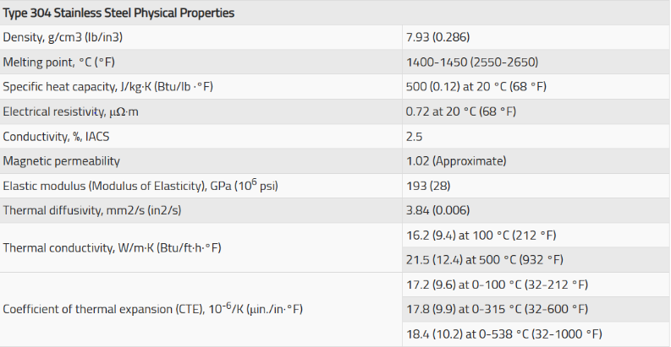
One material that could be used is stainless steel. This is because steel, as a metal, Approximate melting point of stainless steel is 2550-2790 °F (1400-1530 °C) (Material, N/A). This then means that stainless steel won’t begin to melt when put into a high temperature environment and therefore doesn’t deform in high temperatures. Furthermore, this also means that more energy is required to break the bonds within the metal before it deforms as well as, if it were to to snap and or create cracks on the piston which would weaken the entire system. Stainless steel also has low elastic potential meaning that a high quantity of force is required to stretch thye material. This then allows the piston to function as inteneded due to its ability to withstand the high quantity of force that the engine is required to produce. Stainless steel is also very dense meaning that it may be heavier than other materials. This may result in the engine’s pistons working slower due to a larger force required to move each piston. As a result, they may be inefficient and other materials could be chosen.
Figure 1- table of Stainless-steel Properties Values (Material, N/A)
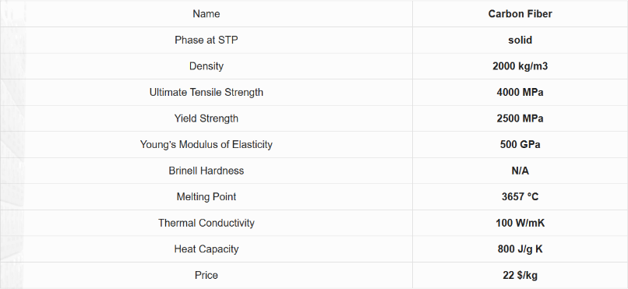
Another material that could be considered is Carbon Fiber. To start, carbon fiber has a high melting point. This means that carbon fiber is able to withstand large temperatures before the internal bonds begin to break down, which would cause the piece to deform and cause the engine not to work. Carbon fiber also has a higher modulus of elasticity this means that carbon fiber is able to stretch more when applied with a force. Furthermore, carbon fiber can be brittle and therefore break easily. This would act as a negative as when applied with a constant force as the load upon the engine may snap the piston breaking the whole system and as a result be expensive to repair and maintain.
Figure 2-table of Carbon Fiber Properties Values (Properties, N/A)

Manufacturing process Selection
One manufacturing process that could be used is casting. This is where the material is melted down, at a high temperature, into a liquid. Then it is poured into a pre-determined cast which is in the shape of the piston. The cast must be made from any material that can withstand high temperature and won’t negatively react with the material of the piston. The material in the cast is then cooled and removed. It is then buffered down to an acceptable level so that there are no sharp points, and the piston can work as intended. The positive of casting is that is that it allows for a viarity of shapes to be made regardless of its complexity. Other positives are that moulds are easily interchangeable meaning that you could use moulds of different sizes to fit different engines and purposes. Despite this, some negatives of casting are that high temperatures are required to melt down the materials. This means that it is expensive to continuously do due to the cost to heat it up. Furthermore, this would make mass producing the pistons more expensive and would drive up the cost to sell them.
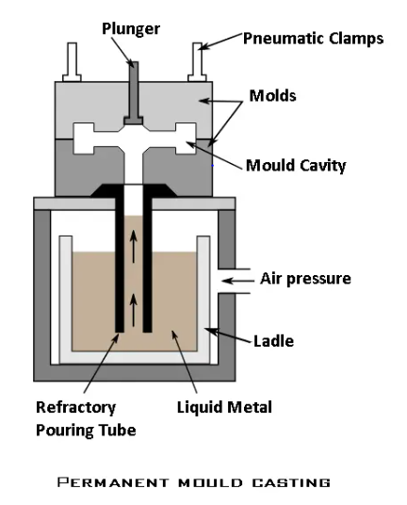
An example would be:
Figure 3-Permanent mould casting (M, 2023)
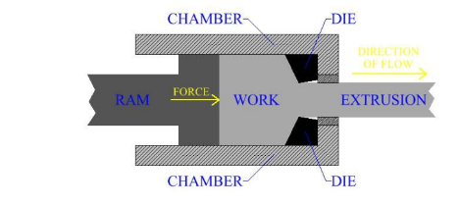
Another manufacturing method is extrusion forming. This is where material is melted down and pushed stored in a tank/secured area. The material is then pushed through through a die which will cut the material into a simple shape (rod or prism). Once pushed through the die it is then chopped to the required size. The positives of extrusion is it is easier to mass produce meaning that the piston would be easier to replace and maintain than other methods. Another positive is that it is more cost effiecient as you aren’t having to heat the material as much as other methods. However, some negatives of extrusion is that you can’t make complex shapes. This limits the use of extrusion and will prevent the piston being made correctly and to the level required.

Conclusion
To conclude, stainless steel is the material I have chosen to make the piston out of. This is because steel has melting point meaning that within the high temperature of the engine the piston won’t begin to deform and break. Furthermore, steel is more suitable because it has a lower modulus of elasticity meaning that when applied under a force it is less likely to deform from its original shape than other materials. Additionally, the steel can withstand a high quantity of force applied to it without it breaking or snapping. Moreover, it is partially light meaning that there isn’t a lot of force required to osciallate the piston. Finally, the stainlesss steel can be cheaper to manufacture than other materials due to its high availability.
Furthermore, Mass production casting will be a preffered of manufacture. This is because it will allow the complex shape of the piston to be easily replicated if the mould is made from a suitable material the mould can be reused repeatedly and can be recreated for more machines. Despite this it could be expensive to maintain and use repeatedly due to costs of heating the materials.

References
Material, W., N/A. AISI 304 Stainless Steel Properties: Tensile Yield Strength & Hardness. [Online]
Available at: https://www.theworldmaterial.com/type-304-grade-stainless-steel/
[Accessed 19 April 2024].
Material, W., N/A. Melting Point Of Stainless Steel 304, 316 Melting Temperature In °F (Fahrenheit) & °C (Celsius). [Online]
Available at: https://www.theworldmaterial.com/melting-point-of-stainless-steel/
[Accessed 19 April 2024].
M, S., 2023. 15 DIFFERENT TYPES OF CASTING PROCESS EXPLAINED. [Online]
Available at: https://www.theengineerspost.com/metal-casting-process-types/
[Accessed 20 April 2024].
Properties, M., N/A. Carbon Fiber – Density – Strength – Melting Point. [Online]
Available at: https://material-properties.org/carbon-fiber-density-strength-melting-point/?utm_content=cmp-true
[Accessed 20 April 2024].

