Programme: BA Business Management (BABM)

Module: Accounting Fundamentals

Module Code: LCBB4001

Assignment Title: Assignment-1

Student Name: Eleana Mateva

Student ID: 2030421

Tutor Name: Emad Elkhashen

Table of contents

Introduction 3
QUESTION 1 Kedison Plc 3
Profit and loss statement 3
Statement of financial position 6
Why does statement of financial position balance 10
QUESTION 2 Chocco plc 11
Calculate the following ratios for Chocco plc for 2020 and 2019, showing the formulas and workings 11
Comment on the financial performance and position of Chocco plc 15
Conclusion 18
References 19

Introduction
The research would include a detailed discussion and analysis upon the financial and organizational performances of two different companies. The research would conduct detailed financial performance analysis and evaluate the financial statements in order to identify the financial position and values of the firm in the current period. In the first section of the research it will develop the financial statements for Kedison Plc and also discuss causes and importance of balancing the statement of financial position. The determined profit and financial value of Kedison Plc will be evaluated in the section. On the other hand the second section will identify the financial performance of Chocco Plc by conducting suitable financial ratios analysis of recent two years. The ratio shows the financial performance and stability of the firm and would help to judge the financial condition of the firm in the current period.

QUESTION 1: Kedison Plc
The section would include a detailed discussion of the financial statements of Kedision Plc. For this a income statement and ba;ance sheet is to be prepared and the detailed analysis of the financial figures of the firm for the year would be done. Also the discussion would include elaboration on why balance sheet is to be balanced.

Profit and loss statement
The profit and loss statement is the financial statement that shows the income and expenditures of a company. It manly shows whether the firm is making profit or loss for a specified period. The income statement along with balance sheet and cash flow statements shows the financial health of the business for the year (Firdaus, and Endri, 2020).
The income statement is very essential for the firms to perform every year; this is mainly because the income statement helps in determining the financial health of the firm. There are sustained numbers of importance of an income statement for a firm, thee are discussed as follows:
- The income statements help in determining the actual profit or loss gained by the firm in the current year. With the help of the the data and information the firm can strategies the us in applications of the profit for future betterment
- The statement includes the expenses that the firm has incurred and thus the management can identify the cost heads and manage their expenses to increase the net profit margins for the future years (Monahan, 2018).

Kedison Plc
Revenue |  | 2020
 | Sales revenue | £ 826,650.00
 | (Less sales returns and allowances) | £ -
 | Service revenue | £ -
 | Interest revenue | £ -
 | Other revenue | £ -
Total Revenues | Total | £ 826,650.00
Expenses
 | Administration expense | £ 30,000.00
 | Shop Lease | £ -
 | Wages and salaries | £ -
 | Cost of goods sold | £ 578,650.00
 | Dividend Paid | £ 20,000.00
 | Pref. Div paid | £ 30,000.00
 | Directors Remuneration | £ 5,000.00
 | Prepaid Insurance | £ -
 | Interest expense | £ 2,000.00
 | Maintenance and repairs | £ -
 | Distribution costs | £ 28,000.00
 | Payroll taxes | £ -
 | Travel | £ -
 | Rent | £ -
 | Utilities | £ -
 | Other | £ -
Total Expenses | Total | £ 693,650.00
 | Net Income Before Taxes | £ 133,000.00
 | Income tax expense | £ 68,000.00
Income from Continuing Operations |  | £ 65,000.00
Net Income |  | £ 65,000.00

From the income statement it is observed that the profit for Kedison Plc is 65000 GBP which is quite high reflecting positive returns for the firm in the current financial period. This shows that their financial strategies and cost management has been quite good.

Statement of financial position
A balance sheet is mainly the financial statement that reflects the company's assets and liabilities liabilities and also the equity funds at a specific period of time. Not only that, the balance sheet also provides data and a basis for computing rates of return and evaluating the capital structure of the company.
The balance sheet consists of various importance and the firms in the international market are required to prepare a detailed balance sheet at the end of the year to present their financial performances and financial figures accurately. There is a certain importance of the balance sheet that needs to be evaluated for better understanding and implications.
- The balance sheet is crucial to analyze the debt and equity margins of the fir as it includes the detailed figures valuations of the debts and equity possessed by the firm
- It reflects the assets and resources of the firm hence the fir can use the information of the balance sheet to decide on asset creation margins and implications
- Current assets and liability status can be acquired by balance sheet through which the firm short term capabilities can be evaluated (Robinson, 2020).
 | Balance Sheet
Assets |  |  | 2020
Current Assets
 | Cash |  | £ 12,900.00
 | Accounts receivable |  | £ 171,105.00
 | Inventory |  | £ 330,600.00
 | Prepaid expenses |  | £ -
 | Short-term investments |  | £ -
 | Total current assets |  | £ 514,605.00
Fixed (Long-Term) Assets
 | Receivables |  | £ -
 | Long-term investments |  | £ -
 | Property, plant, and equipment |  | £ 632,730.00
 | (Less accumulated depreciation) |  | £ -
 | Vehicles |  | £ -
 | Total fixed assets |  | £ 632,730.00
Other Assets
 | Deferred income tax |  | £ -
 | Other |  | £ -
 | Total Other Assets |  | £ -
 | suspense |  | £ -
Total Assets |  |  | £ 1,147,335.00
Liabilities and Owner's Equity
Current Liabilities
 | Accounts payable |  | £ 171,355.00
 | Short-term loans |  | £ -
 | Income taxes payable |  | £ -
 | Accrued commission |  | £ 3,000.00
 | Current portion of long-term debt |  | £ -
 | Total current liabilities |  | £ 174,355.00
Long-Term Liabilities
 | Long-term debt |  | £ -
 | Deferred income tax |  | £ -
 | Other
 | Total long-term liabilities |  | £ -
Owner's Equity
 | Equity investment |  | £ 710,000.00
 | Retained earnings |  | £ 132,000.00
 | Other |  | £ -
 | Total owner's equity |  | £ 842,000.00
 | Suspense |  | £ 131,000.00
Total Liabilities and Owner's Equity |  |  | £ 1,147,355.00

Why does statement of financial position balance?
Before understanding why the balance sheet should match it is important to understand what the balance sheet is. A balance sheet is also called the statement of financial position; this is mainly because the statement provides a detailed snapshot of the firm’s financial assets and resources and liabilities for the year. Hence the firm's net worth is reflected through the balance sheet at a single point of time which can not be observed from other financial statements such as income statements and cash flow statements.
The balance sheet is the statement that is prepared to measure the exact financial position of a firm on a certain date. In this text it is to be added that a balance sheet should always match because every asset of the firm is claimed by someone. The organizational Assets = abilities + Net Worth. There is another reason for which the balance sheet matches, it is mainly because the liabilities are sources of funds for the firm it means from where it gained its funds and other other hand the assets are the applications of the fund it means the firm has applied the funds. Thus it can be said that the sources of funds applications of funds should be equal as the gathered funds are applied in the business operations. This both liabilities and assets of the firm should be equal, that's why the balance sheet should always match (Easton, McAnally, Sommers, and Zhang, 2018).

QUESTION 2: Chocco plc

Calculate the following ratios for Chocco plc for 2020 and 2019, showing the formulas and workings

Ratio | Formulas |  | Chocco PLC
Ratio | Formulas |  | Year
 |  |  | 2020 | 2019
Liquidity Ratios
Current Ratio | (Current Assets / Current Liabilities) |  | 0.917164476 | 0.773145108
Quick Ratio | (Current Assets - Inventories)/ Current Liabilities |  | 0.635205098 | 0.556795798
Cash Ratio | Cash and Cash equivalent / Current Liabilities |  | 0.08004779 | 0.058108995
Efficiency | Days
Days of Sales Outstanding (DSO) | (Average Receivables /Net Revenue)x365 |  | 68 | 73
Days of Inventory on Hand (DOI) | (Average Inventory /Cost of Sales)x365 |  | 80 | 78
Days of Payables (DOP) | (Average Payables /Cost of Sales)x365 |  | 66 | 77
Cash Conversion Cycle (CCC) | DSO + DOI - DOP |  | 82 | 73
Profitability Ratios | %
Gross Profit Margin (GPM) | (Gross Profit / Revenue) |  | 52% | 52%
Operating Profit Margin (OPM) | (Operating Profit / Revenue) |  | 52% | 52%
Net Profit Margin (NPM) | (Net Income / Revenue) |  | 6% | 6%
Return on Capital Employed (ROCE) | (operating profit/ Average Total Capital employed) |  | 93% | 91%
Return on Equity (ROE) | (Net Income / Average Equity) |  | 14% | 13%
Return on Assets (ROA) | (Net income / Average total assets) |  | 74% | 70%
Leverage Ratios
Debt-to-Equity Ratio (D/E) | (Total Debt / Total Equity) |  | 1.34 | 1.42
Debt-to-Assets Ratio | (Total Debt / Total Assets) |  | 0.42 | 0.41
Gearing | (Total debt / (Total debt+Total Equity) |  | 0.57 | 0.59
Interest Coverage | (EBIT / Interest) |  | 29.81 | 35.59
Investor Ratios
EPS | Net profit attributable to ordinary shareholders / WANS |  | 0.43 | 0.37
Dividend Yield | Dividend per share / share price |  | 49.80 | 60.50
Dividend Payout | Dividend per share / EPS |  | 591.65 | 661.20
Price-Earnings | Share price / EPS |  | 11.88 | 10.93
Notes | Current Assets |  | £  2,303.00 | £  2,355.00
 | Current Liabilities |  | £  2,511.00 | £  3,046.00
 | Inventories |  | £  708.00 | £  659.00
 | Cash |  | £  201.00 | £  177.00
 | Accounts Receivables |  | £  1,249.00 | £  1,287.00
 | Net Revenue |  | £  6,738.00 | £  6,441.00
 | Cost of Sales |  | £  3,235.00 | £  3,096.00
 | Accounts Payables |  | £  583.00 | £  655.00
 | Gross Profit |  | £  3,503.00 | £  3,345.00
 | Net Profit |  | £  431.00 | £  366.00
 | Capital Employed(Total Assets - Current Liabilities) |  | £  7,225.00 | £  7,041.00
 | Equity |  | £  3,088.00 | £  2,912.00
 | Debt |  | £  4,137.00 | £  4,129.00
 | Total Assets |  | £  9,736.00 | £ 10,087.00
 | Interest |  | £  226.00 | £  181.00
 | Distributable Profit |  | £  431.00 | £  366.00
 | Shares |  | £ 1,000.00 | £ 1,000.00
 | DPS |  | £ 255.00 | £ 242.00
 | Share Price |  | £ 5.12 | £ 4.00
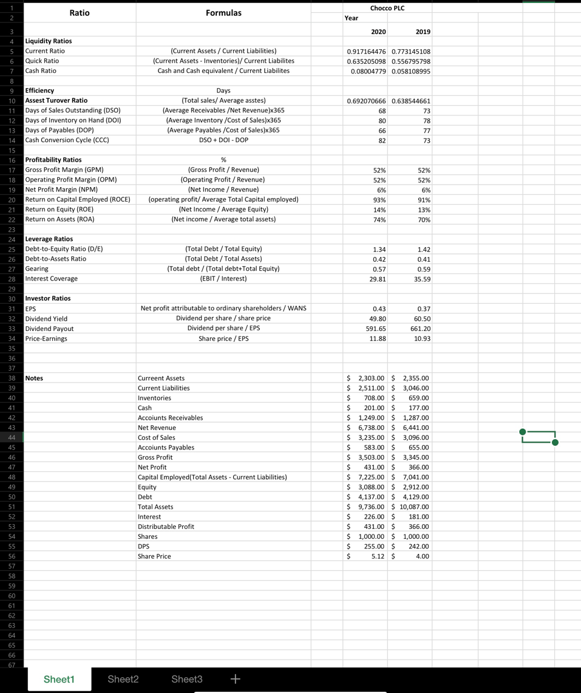

Comment on the financial performance and position of Chocco plc
- ROCE
Return on capital employed is a profitability ratio that shows the company's profitability in their business operations. In order to measure the profitability of a company like Chocco PLC there is a requirement of evaluating the returns that are being generated on the capital employed by the firm in its business activities. Return on capital employed is an important profitability ratio that signifies the returns that are generated by the company on different capitals that are employed by the firm in the business operations of the company. In the table above it can be seen that in the year 2019 the return on capital employed was 91% whereas in the year 2020 the return on capital employed is measured at 93%. This shows an increase of 2% in the return on capital employed which is a positive sign for the increasing profitability of the company in terms of generating returns of the capital which is required by the firm in their business operations.
- ROE
Return on equity is also a profitability ratio that shows the profit earning capacity of a company by generating return on the equity capital that is employed by the following in their business operations (Haralayya, 2021). Through this ratio the company will be able to understand the returns that are generated on the equity capital employed by the firm in their business operations. Looking at the above calculation in the table it can be seen that in the year 2019 the return on equity was 13% whereas in the year 2020 it is measured at 14% which shows an overall increase of 1% in the return on equity showing a positive sign for the company. This means the return on equity capital has increased in recent times which is a positive sign for the profitability growth of Chocco Limited.
- Earnings per share
Earning per share is an investor's ratio through which the investor's or investment related financial growth of the company can be measured in an efficient manner. The performance of the company's shares and the attractiveness of the investment within the company is measured through this type of ratio. This shows the benefits that the share investment within the company provides to the shareholders of the company. As seen above in the calculation of ratios the Earning per share that has been generated by the company in the year 2019 was 0.37 whereas in the year 2020 the earnings per share was valued at 0.43. Henec an increase of 0.06 percent is seen in the recent year which is a positive sign for the attractiveness of shares and related earnings that are associated with the investment within shares of the firm.
- Net profit margin
Net profit margin is a profitability ratio that shows the margin of profit that a company like Chocco Limited has incurred in the recent financial operations conducted by the following. It is one of the significant profitability ratios used by the management of a firm to identify the financial profitability index and trends that has happened in the recent business operations of the firm. It is important to understand that net profit margin of Chocco Limited in the year 2019 was 6% whereas in the year 2020 it has also been measured at 6% which shows no growth in the profitability of the company in the recent time but also shows the stability of profit incurred by the company in its business operations.
- Asset turnover
Asset turnover ratio is a ratio that shows the financial efficiency of a company in different financial operations that is conducted by the company in their business operations (Omar et al. 2014). It is important to understand the asset turnover ratio helps in undertaking the recent financial efficiency ratio providing information related to the efficiency of the company in terms of conducting its financial operations. Looking at the calculation done in the above table it can be seen that the asset turnover ratio of Choco Limited in the year 2019 was 0.63 whereas in the year 2020 it was 0.69 which shows a decrease in the financial efficiency of the company in recent times. This is not a positive sign for the company e as the financial extension of the company has decreased in recent times.
- Stock holding days
Stock holding days or days of inventory on hand is a financial efficiency ratio which shows the efficiency of a company in terms of using its inventory for the business activities of the firm. The following ratios will show the financial efficiency of the company to manage its inventory and financial expenses that are related to the Inventory of the firm to conduct its business operations. The days of inventory on hand was 80 days whereas in the year 2019 it was 78 days which means the overall number of days has increased by 2 days marking a decrease in the financial efficiency of the company in recent times (Aman, 2016). It is important to understand that the financial efficiency decrease in managing Inventory of the firm is a negative sign for the overall financial efficiency of the company which is not a positive sign for the financial performance of the firm.
- Debtors collection period
Debtors collection period or days of sales outstanding is a financial efficiency ratio used by the management of a company to effectively identify the financial efficiency of the firm in its business activities. Debtors’ collection period is a financial efficiency ratio that measures the amount of days taken by the company to recollect debt from the debtors of the company for the credit sales done by the firm in its business operations. This shows the efficiency of the company to recollect all its debt from the debtors of the organisation making sure the company is able to liquidate its current business operations. In the calculation that has been done above it can be seen that in the year 2019 the debtors collection period was 73 days whereas in the year 2020 that collection period has decreased to 68 days which is a positive sign showing an increase in the financial efficiency of the firm in their business activities.
- Current ratio
Current ratio is a liquidity ratio which shows the liquidity status of a company or the financial position of an organisation to cover its short-term expenses and liabilities within the business operations of the following (Kalabukhovа and Kuzminska, 2015). The current ratio is a very important ratio showing the overall financial stability and strength of the firm to effectively conduct its daily business operations. In order to measure the liquidity of the firm the use of current ratio is done extensively within an organisation like Chocco Limited. It is important to understand that in the calculations that have been done above the current ratio measured for Chocco Limited in the year 2019 was 0.77 whereas in the year 2020 it is measured at 0.91 showing an increase in the current ratio of the firm which means that the current assets has increased whereas the current liabilities of the firm have proportionally decreased in the recent times.
- Gearing ratio
Gearing ratio is a financial leverage ratio which shows the amount of financial risk that is associated with an organisation, especially with the capital structure of the organisation in their respective business operations. It is important to understand that gearing ratio is a very important ratios showing the financial risk and stability of a firm like Chocco Limited looking at the gearing ratio that has been calculated in the ratio table above it can be seen that in the year 2019 it was 0.59 whereas in the year 2020 it is 0.57 showing an slight decrease in the overall risk associated with the capital structure of the firm although currently the risk is higher and the company should look to mitigate some amount of financial risks associated with the financial structure of the firm (Subalakshmi et al. 2018).

- Interest coverage
Interest coverage ratio is an ratio which shows the coverage of interest incurred by the firm taken on the long-term debt by the firm in their business operations. It is important to understand that in the current analysis the interest coverage ratio that has been measured for Chocco Limited in the year 2019 was 35.59 whereas in the year 2020 it was 29.81 which mean that interest coverage ratio of the firm decreased and this is not a positive sign for the company's financial structure.

Conclusion
Concluding in the light of the above context it can be said that financial statements and financial analysis is one of the most important aspects of business management to make sure the company is able to effectively manage the financial operations of the firm to make sure the management is able to effectively plan for the future financial operation to achieve sustainable growth in the business operations of the firm.

References

Aman, S.M., 2016. Analysis of financial statements using ratio analysis for the last 5 years
.
Easton, P.D., McAnally, M.L., Sommers, G.A. and Zhang, X.J., 2018. Financial statement analysis & valuation. Boston, MA: Cambridge Business Publishers.

Firdaus, F. and Endri, E., 2020. Financial Statement Analysis: Evidence from Indonesian Bank BUKU IV. International Journal of Innovative Science and Research Technology, 5(4), pp.455-461.

Haralayya, B., 2021. Ratio Analysis at NSSK, Bidar. Iconic Research And Engineering Journals, 4(12), pp.170-182.

Kalabukhovа, S.V. and Kuzminska, O.E., 2015. Ratio analysis of financial statements for decision making in risk management.

Monahan, S.J., 2018. Financial statement analysis and earnings forecasting. Foundations and Trends® in Accounting, 12(2), pp.105-215.

Omar, N., Koya, R.K., Sanusi, Z.M. and Shafie, N.A., 2014. Financial statement fraud: A case examination using Beneish Model and ratio analysis. International Journal of Trade, Economics and Finance, 5(2), p.184.

Robinson, T.R., 2020. International financial statement analysis. John Wiley & Sons.
Subalakshmi, S., Grahalakshmi, S. and Manikandan, M., 2018. Financial Ratio Analysis of SBI [2009-2016]. ICTACT Journal on Management studies, 4(01), pp.2395-1664.

