Name: Carol Evans

Student Number:1700327

Course: 3D Computer Animation

Word Count: 2361

Tutor: Scott Smith

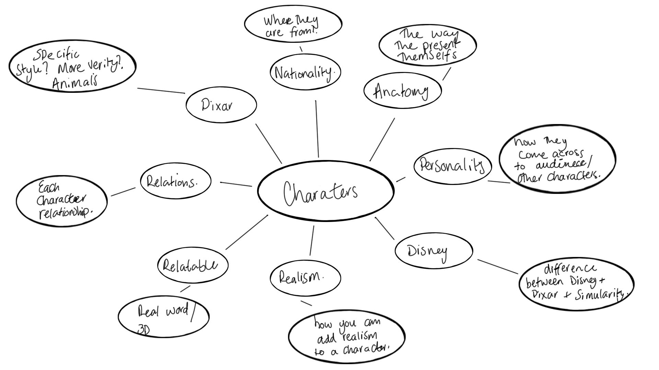

Before pursuing this paper I created this mind map in order to work out my 3 Key words and how I could possibly break them down.

In this paper I will begin to discuss and break down what makes an appealing animated character. I will use the industry that explains to draw on methods they had and why they used them, in order to captivate their audience with appealing and lovable character. My 3 key words I will be researching are, Anatomy, Personality and Relatable. Within this paper I will unearth my question for my dissertation and a build up of research towards this. I will discuss characters created by Walt Disney, Danny Mac and Dreams works and how they share similarities on how they are presented to an audience, and yet have differences in their style. These artists all make appealing animated characters in the own unique way.

The history of Disney started in 1923 in Los angeles, and then moved to Burbank in 1937
After releasing “Snow White and the Seven Dwarfs” in 1937, only then did the company start growing a considerable amount.

Pixar was founded in 1986 and first created Luxo Jr in 1986, this was an animated short based on two lamps one large and one small, this did not kick start their business as well as they wanted but they had made ‘ Toy Story’ which was released in 1995, which was the world's first ever 3D Animated film. This film was very popular and made £373 million.

Disney have a very specific way of formulating appealing characters such as big eyes for female’s and that they have more of a hourglass figure, and for male’s they tend to have oversized shoulders and more of a upside down triangular figure (Wasko, 2017) says ‘Disney played it safe and followed the traditional narrative style.’ Personally, I feel they kept their original character design due to major success and wanted to keep this going, they also may not have wanted to take a big risk in creating something different incase any audience did not like the outcome. As it was still early days for animation and still a rather new thing the audience would still get used to visualising animated films therefore anything that has not been referenced from any creatures or this planet may have been to early from them to even think about stepping out of their comfortzone. (The Imagineers., 1998) quote ‘Learning and succeeding by dreaming and doing’’ This is very much a quote inspired by something Disney himself would say during the process of his work. This philosophy was and is something that would highly influence Disney’s work then and now.

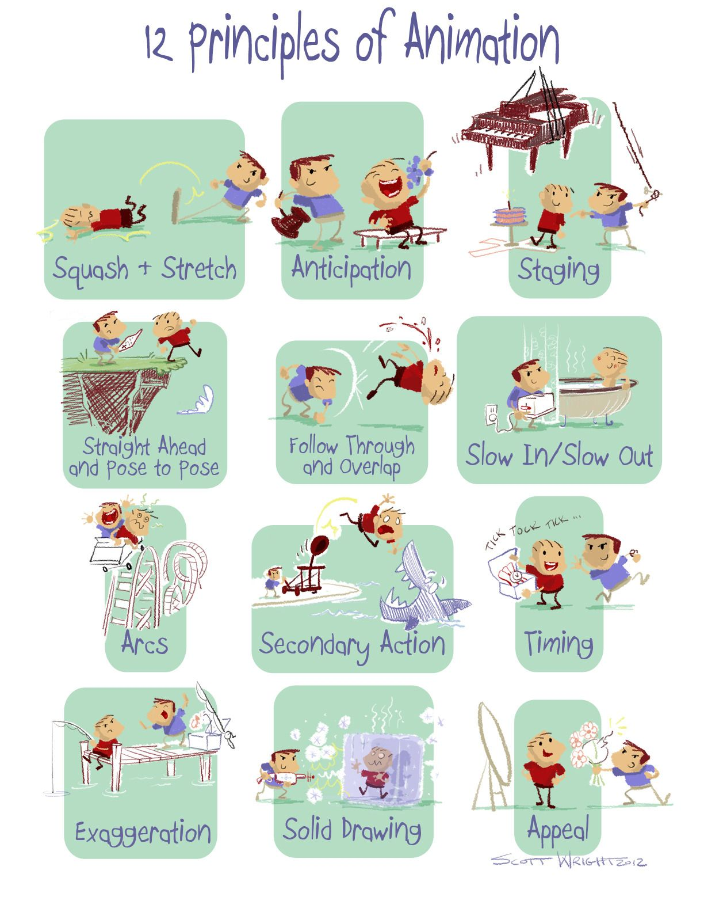
(Pinterest, 2019)

Behind every animated movie the 12 principles of animation show themselves as a huge part of creating a character not only in the design phase but also when animating as this truly brings a character to life. You can really over do the principles but each time a subtle movement can completely change the way you see a character and how they can appear to the audience. (Merritt and Kaufman, 2000) says ‘ value in this one comes from the antics disney makes his figures perform good with or without sound’ this shows how well he creates a character and how much emphasis is given to really sell all emotions in only using animations with no sound, the sequences are so well put together you can most definitely watch the playthrough and picture what they would say in the situation you see. For example when Mickey Mouse first came out there was no dialog or effects added to the film, just music, but later on down the line they made him whistle and even further down the line they eventually made him talk. Mickey mouse is a mischievous and adventurous mouse who is overly cheerful, you can see this early on even in the movie without any sound but as the development went on you could understand how relatable he was to us. This developed Mickey into an appealing character as his mischievousness and cheerfulness was relatable to an adventurous child. Always looking to smile and on the same hand have a bit of fun even though that might mean a little bit of trouble every once in a while. I believe this was the main reason why everyone warmed up to his character so well and why is has been long lasting, is that even though Mickey is the same character he was when it started, him being so relatable to such a vast number of the audiences really did set him apart from anything else that was on screen at the time.

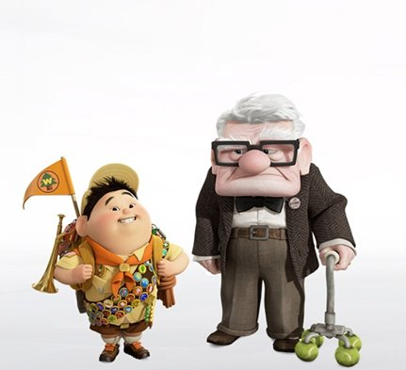
(Menarik, 2019)

Pixar take on the general guidelines for Disney characters, however they have a much more vast range of character types such as monsters and fish. Although when they do human characters they do not tend to stick to the hourglass figure like Disney had done but experiment more to push the characters to fit the story they were trying to tell and not to much create a standard male/female character with similar characteristics. Pixar was general the one to expand more into a larger variety of size and shape. For example the film ‘Up’ created by Pixar the main characters Carl and Russell convey specific shapes such as round and square giving a unique look, as well bring out their personalities as Carl is blunt and sharp which corresponds with his square and almost sharp appearance, and Russell is more soft and sensitive which in relation helps create his personality with him being so rounded. (Wasko, 2017) demonstrates that ‘ Escape, fantasy, magic, imagination many disney plots revolve around characters wishing to escape from their current settings or situation’ although this is a quote by Disney, I personally feel this quote could describe any movie by today's standards as this again relates so much with what the average Joe is feeling and wanting to do. This quote is a strong example displayed in the film ‘Up’ due to Carl wanting to achieve his goal by getting to paradise fall for his late wife Ellie. It shows that the character wanted to escape from the current environment and fulfil a dream to find what he thought was paradise. This can also link into being relatable as during some time through life we have all had a goal we wish to have achieved. The easy thing with animation is you can put a lot of your personality into a character and connect instantly with the audience whether it is a hero or villain as we have all experienced this is some way or another whether big or small.

Personality
I think that personality is a large section of a character, as this is something that we can pinpoint in other people which parts of their personality we like or dislike. Whether is be a negative trait or a positive one, some may be drawn to either. This is the same reason a antagonist can be so evil yet we find them all so appealing and we gravitate towards that character in the movie.Traits such as charisma and being witty tend to go hand in hand with being the bad guy. (Techfak.uni-bielefeld.de, 2019) Says ‘Lifelike means convincing the audience an animated character has intelligence, personality, and emotion while inhabiting a physical world.’ Personality can be something that alters when interacting with other people/characters, and so can swing how appealing the character is at one time or another. This can be used to aid storytelling to convey how the audience should be feeling towards a character at any given time.

Relatable

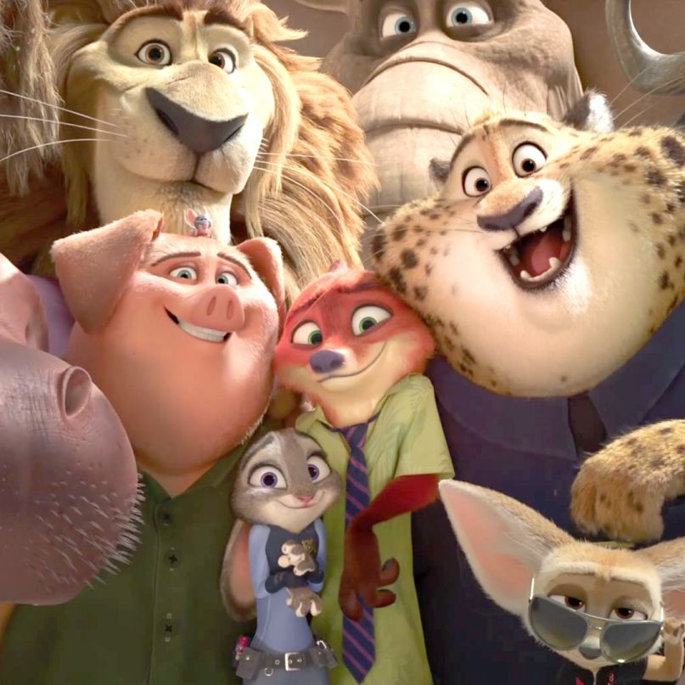
(Lang, 2019)

In each animated film there is always a likeable character, whether they are a good or bad character you always find yourself liking them in some sort of way.This is normally a big part of being relatable such as putting yourself into that characters shoes. Every animated character has connections to us people which is why they tend to make everything more human-like so that we can snap onto certain social cues that we’ve learnt from conversing with other people. May films have used animals however morphed them into a more humanoid shaped character. This is true for films such as Zootopia where most of the animals were designed so that they could stand on two legs and wore clothes as this for more inline as to how a human would act in the same situation. This also made is quite simple to put them in a situation that we would find ourselves in and react as a human would instead of an animal. This is because generally we understand social cues of other people.
For example if a character was to stand on something sharp you would also feel the pain of the character as we’ve all probably trodden on Lego and shrieked with pain.

Anatomy
The anatomy can tell you many different things from strength to weakness this is very obvious throughout animation and creation of character although as time has moved forward there are a lot more animations where you may be able to see a slightly larger character who can show signs of weakness and emotion due to having a ‘story’ this could be anything from losing their ‘love’ or ‘family’. As we have so many stereotypes of larger men this does not mean that they can not have emotion. This is tied somewhat to reality and so we understand it all the better. Due to the emphasis that is put on these huge hulking characters who have mental and emotional issues this has also shed light on the real life issues that the world is facing. Anatomy can also make the character appealing in many different ways.
(Wasko, 2017) quotes ‘A villian, who is typically the opposite of the hero/heroine, often ugly, extremely fat or extremely thin, with exaggerated facial features’ There are specific things that can define a character and features is the biggest one with especially the facial features, Eyes and skin tones of a character can tell a lot about where they are from and what their culture is. The stereotypical “fit” Male and Female tend to be a good start to making a star character however many companies are findly a lot of ground in making sub optimal protagonists and antagonists which give the characters more flaws which we tend to link to being human.

(Wasko, 2017) says ‘Disney heroines are always beautiful, sharpley, and often sexually attractive, while female villains are typically ugly and either extremely thin or grossly fat’
I think being beautiful and attractive has always been something that appeals to a large portion of the population, it is a very relatable situation to reality we see a lot of males and females very toned with the “perfect” body although these days they are a lot more pressure and judgement on the shapes and sizes. A lot of this to do with so many celebrities wanting to be perfect because from young ages when watching Disney films all you would see is a smaller build princess with a hourglass figure or a prince with the wide shoulders and small waist. These earlier animated movies started the drive to a much more reflective world, one if which self criticism has crept in due to comparing yourselves to the “perfect” person. There has been much more emphasis put on characters being non perfect to make them more appealing to a wider audience as they will relate so much better to the audiences. Having different characters is very important to everyone, it has taught the world that nobody matter what you are and how you do it you can achieve anything.

Over the years animators and creators started by using characters and creatures found on this planet to create animations largely based on wildlife but later on as you go down the line designs have found ways to create animals which are morphed and then sometimes their imagination has gone wild and created something never seen before. Using the general rules set before them by artists and animators many studios have managed to create appealing monsters as using the guidelines helped make the creatures more believable and relatable. Certain features such as keeping the facial structure largely similar to that of a human or an animal will increase the likelihood that people can understand interactions.

People may say they hate a character but this actually means they like them and they show this through their hate and criticism in the design.This would make more of an appeal for the character with their disgust at a character. Generally when you dislike the character is because the creators want you to dislike them and so create appeal by being a really good bad guy.

Conclusion
Over all, I think the reason animation had been such a big hit through the years is mainly because of appealing characters some especially with the younger generation how they look up to certain character and that they would some day wish to be the same as them, but not only for younger generation but older as well is because we have such a resemblance to some character its very relatable how a small situation can impact your daily life from an animated movie all because an artist may have gone through a similar experience and wanted to make a visual representation of their experience and to capture their emotion through an animation whether it is through a hero, villian or animal you can still feel the emotion. After finding out much of this research and a need to dig deeper into the techniques and uses for these characters my question for my dissertation will be ‘What makes an appealing character within the 3D industry?` I feel like this is a question that would necessarily get a single straight answer but more of a general understanding as to why certain characters have done so well in the public's eye and why some have not quite hit the mark.

Bibliography

Lang, N. (2019). How Disney’s Zootopia Gets Racism Wrong. [online] Consequence of Sound. Available at: https://consequenceofsound.net/2016/03/how-disneys-zootopia-gets-racism-wrong/ [Accessed 9 May 2019].

Menarik, B. (2019). Sinopsis Film Up - Kisah Mengharukan Seorang Kakek Jelajahi Paradise Falls dengan Rumah Terbang - TribunStyle.com. [online] TribunStyle.com. Available at: https://style.tribunnews.com/2016/11/20/sinopsis-film-up-kisah-mengharukan-seorang-kakek-jelajahi-paradise-falls-dengan-rumah-terbang [Accessed 9 May 2019].

Merritt, R. and Kaufman, J. (2000). Walt in wonderland. Baltimore. Md.: Distributed by Johns Hopkins University Press.

Pinterest. (2019). My Sketchbook: Photo | Rigging in 2019 | Animation, 12 principles of animation, Character design animation. [online] Available at: https://www.pinterest.co.uk/pin/92675704817550038/?lp=true [Accessed 9 May 2019].

Techfak.uni-bielefeld.de. (2019). [online] Available at: https://www.techfak.uni-bielefeld.de/ags/wbski/lehre/digiSA/S03/CAVR-Seminar/Material/Introduction/p25-porter.pdf [Accessed 8 May 2019].

The Imagineers. (1998). Walt Disney imagineering. New York: Hyperion.

Wasko, J. (2017). Understanding Disney. Cambridge: Polity Press, p.115.

Wasko, J. (2017). Understanding Disney. Cambridge: Polity Press, p.116.

Wasko, J. (2017). Understanding Disney. Cambridge: Polity Press, p.117.

