Poster on:
Empowering Older People to Live Independently Through Person-Centred Care in the UK

Student Name: Carmine Malan
Student ID:2313071
Module: BMHP6020 Independent Project
Programme: BSc (Hons) Health and Social Care
Module Name: Independent Project
Module Code: BMH6020
Lecture Name: Bianca Sanfilippo

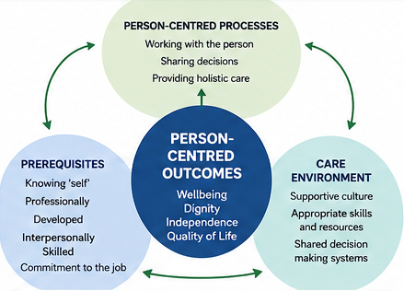 |  | AIM & OBJECTIVES  Aim:  To explore how person-centred care empowers older people to live independently within the UK health and social care system.  Objectives:  1. Examine the key principles of person-centred care for older adults.  2. Explore how person-centred care supports independence and wellbeing.  3. Identify barriers to implementing person-centred care in the UK.  4. Provide recommendations for improving person-centred care practices.  These objectives are consistent with the project proposal and dissertation.  KEY FINDINGS  The evidence indicates that personalised care planning, autonomy, choice, participation and supportive relationships can contribute to independence and wellbeing. However, workforce shortages, limited staff time, inadequate training, resource constraints, fragmented services and organisational pressures can restrict effective implementation. Strengthening staff development, continuity of care, multidisciplinary working and older people's involvement in decisions is therefore important. |  | 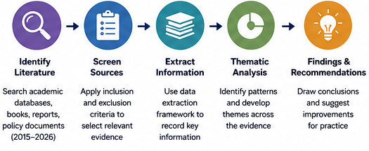
BACKGROUND & RATIONALE  The UK has an ageing population, increasing demand for health and social care. Older people may experience chronic illness, functional limitations and social isolation, which can affect independence. Person-centred care focuses on individual needs, preferences, dignity, choice and participation. Evidence suggests that personalised approaches can support autonomy, wellbeing and quality of life, while individualised care planning and regular review may help older people maintain independence (Crocker et al., 2024; Udkunta et al., 2026). However, implementation can be affected by workforce shortages, time pressures, limited resources and organisational barriers (Liao et al., 2023). |  |  |  | DATA ANALYSIS METHOD  A thematic analysis approach was used to identify recurring patterns across the literature. Five major themes emerged:  1. Person-centred care as a driver of independence  2. Autonomy, choice and shared decision-making  3. Wellbeing, quality of life and meaningful living  4. Barriers to person-centred care in the UK  5. Strategies for strengthening person-centred practice
METHODOLOGY  A qualitative secondary research design was used. No primary participants were recruited. Evidence was obtained from peer-reviewed journal articles, academic books, NHS England publications, Care Quality Commission documents, government publications and credible international organisations. Literature published between 2015 and 2026 was considered, with UK evidence prioritised and selected international evidence used for comparison. |  |  |  | ETHICAL CONSIDERATIONS  The research used secondary and publicly available evidence, with no interviews, questionnaires or direct participant involvement. Academic integrity was maintained through accurate citation, appropriate use of published evidence and consistent Harvard referencing.

DATA COLLECTION METHOD
Relevant literature was identified through academic databases and supplementary searching. Search terms combined concepts relating to older people, person-centred care, independence, autonomy, wellbeing, participation and UK health and social care. Boolean operators such as AND and OR were used. Sources were screened using predefined inclusion and exclusion criteria, and relevant information was recorded using a study-characteristics framework.

References
Crocker, T.F. et al. (2024) ‘Community based complex interventions to sustain independence in older people: systematic review and network meta-analysis’, The BMJ, 384, e077764. doi: 10.1136/bmj-2023-077764.
Liao, L. et al. (2023) ‘Experiences of older people, healthcare providers and caregivers on implementing person-centered care for community-dwelling older people: a systematic review and qualitative meta-synthesis’, BMC Geriatrics, 23, 207. doi: 10.1186/s12877-023-03915-0.
Udkunta, K., Efstathiou, N. and Guo, P. (2026) ‘Models of Care and Interventions to Improve Person-Centred Care for Older People in Long-Term Care Facilities: A Mixed Methods Systematic Review’, Journal of Advanced Nursing, pp. 1–34. doi: 10.1111/jan.70527.

