Title Page
University of Wales Trinity Saint David
School of Engineering
Title of the coursework: Major Project Proposal
Your Name: Loaghan Slade
Your Student Number: P151151
Date: 30/10/19
Module Name and Code: Advanced Engine Design M6X00410
Lecturer name: Malcolm McDonald

Abstract
The purpose of this report is to write a detailed account of the work carried out to build a functional con-rod force simulator in excel, this is then used to compare a standard Ford Sigma 1.6L naturally aspirated engine to a modified engine.
Contents
Abstract II
1 Introduction. 1
2 Engines used 2
3 Simulation Process. 3
3.1 Cylinder gas force. 3
3.2 Inertia loads. 3
3.2.1 First order inertia loads 4
3.2.2 Second order inertia loads 4
3.2.3 Results 4
3.3 Highest net compressive and tensile loads 5
3.4 Maximum compression and tensile stresses 6
3.5 Static safety factors 6
3.6 Maximum compression and stretch distances. 7
4 References 10

Introduction.

The purpose of this assignment is to create a system in Excel that can present an accurate model of the forces exerted on a piston at a range of RPM starting at 1000 and ending at 6000 increasing in increments of 500 RPM. This data can then be compared to a modified engine to evaluate the differences between the two engines.

Engines used
The engines used for this simulator were from a 1.6L naturally aspirated Ford Sigma, this was used as the standard non-modified engine. The modified engine used was the same Ford Sigma, however the cylinder volume was increased by 10%, including the needed piston masses. The engine has also been turbo-charged with 1.4 BAR (20PSI) of boost. These modifications were chosen as they give an obvious change to performance which is ideal to illustrate the differences between the two engines.
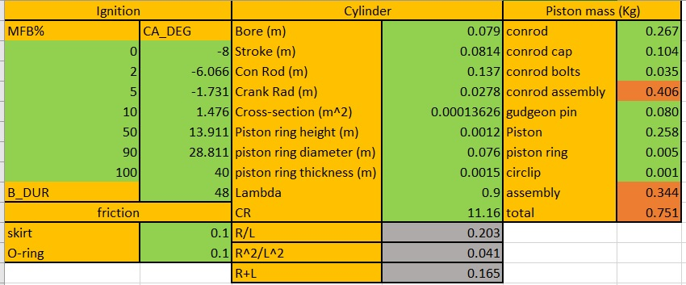
Table 1 standard engine information (Slade, 2018)
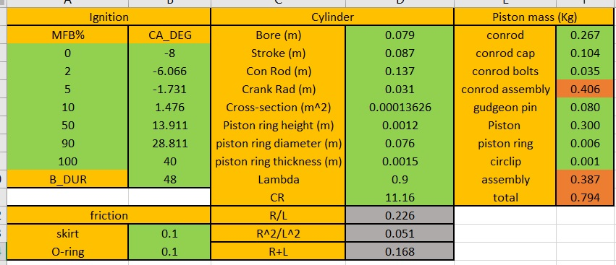
Table 2 Modified engine information

Simulation Process.

Cylinder gas force.
The gas force within the cylinder is calculated by taking the average pressure value across all cylinders in the engine; the pressure values given were measured in BAR, as such the values are required to be converted into SI units (N/M^2). The gas force is then calculated by multiplying the given pressure by the area on top of the piston, shown in the equation below.
$$\frac{Pressure(Bar)×{10}^{5}}{\frac{N}{M^{2}}}×π×\frac{{Piston diameter}^{2}}{4}=Gas force$$
The peak gas force was then calculated for both engines, for each RPM range that data was provided for; this is shown in the tables below.
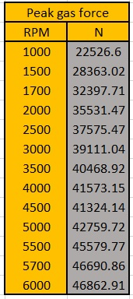
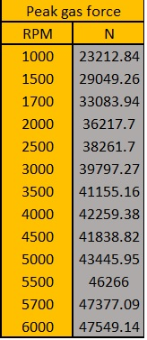

Table 3 standard engine peak gas pressures Table 4 modified engine peak gas pressures

Inertia loads.
The inertia load exerted on the piston as it reciprocates in the cylinder bore is split into first and second order inertia loads. This is due to the nature of the firing order of the cylinders. To calculate these values the speed at which the engine is turning must be converted from RPM into radians per second, this is done by multiplying the RPM value by 2pi and dividing by 60. $ω=RPM×\frac{2π}{60}$.

First order inertia loads
The first order inertia loads can be calculated with the following equation, $M_{Piston}×R×ω^{2}\cos{θ}$, where $M_{Piston}$ is the total mass of the piston assembly, R is the radius of the crank shaft, $ω$ is the rotational speed of the crank measured in radians per second, and $θ$ is the angle of the con-rod at the piston cap end. This can be displayed graphically with half the frequency of second order inertia loads.
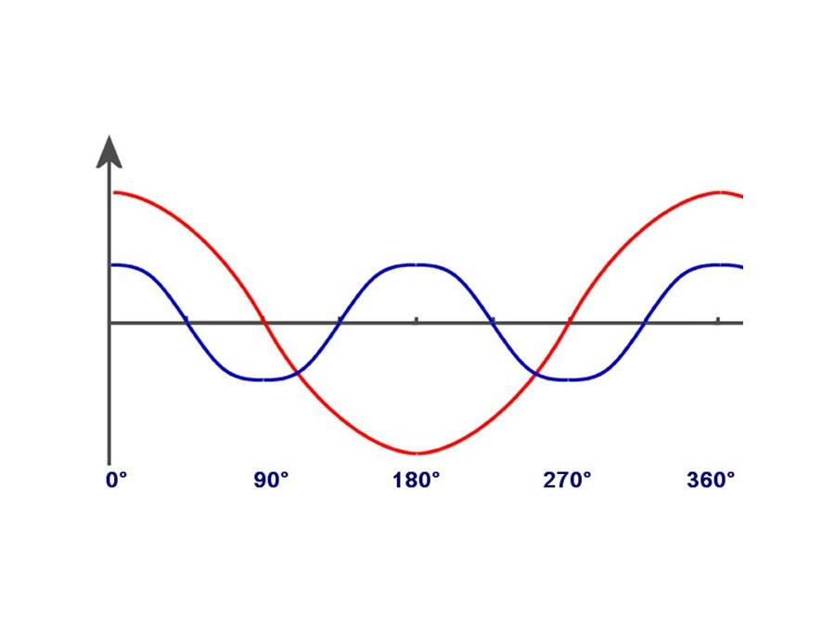
Graph 1 first versus second order inertia forces (KZF-Tech, 2019)

Second order inertia loads
The second order inertia loads can be calculated using the following equation, $\frac{R}{L}×M_{Piston}×R×ω^{2}×\cos{2 (θ) }$, where “ $\cos{2 (θ) }$“ is equal to the crank angle plus 180 or 360 degrees.

Results
After these values are calculated they must be added together in order to get the actual inertia load on the piston. These values were plotted in a graph against crank angle for each RPM range.
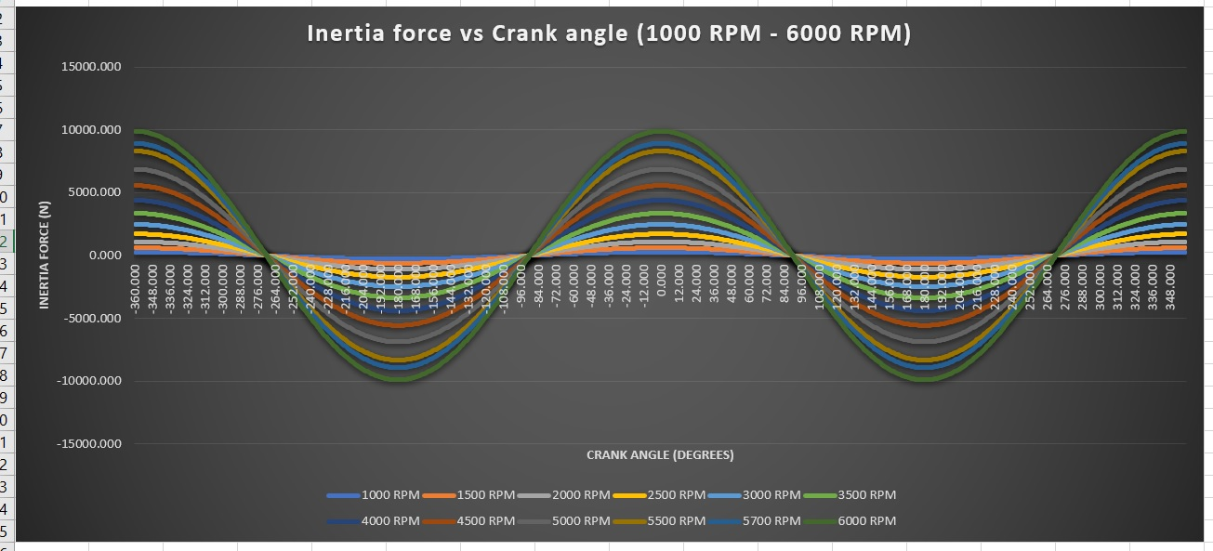
Graph 2 standard engine inertia loads
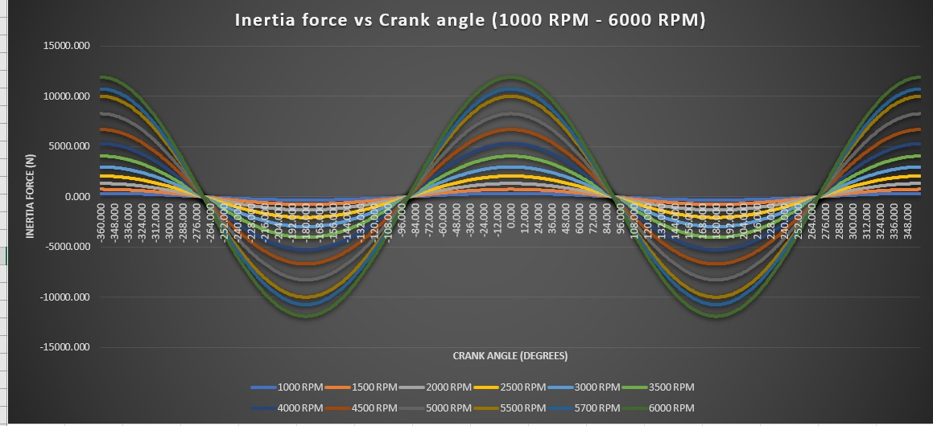
Graph 3 Modified engine inertia loads

Highest net compressive and tensile loads
Before the con-rod compressive and tensile loads can be calculated the angle of the con-rod at the piston cap is calculated. The angle of the piston cap is calculated using the equation $θ=\sin^{-1}{(\frac{L}{R}}\sin{φ)}$ where $θ$ is the angle of the con-rod, L is the length of the con-rod, R is the radius of the piston cap and $φ$ is the crank angle.
When the con-rod angle has been found the forces on the con-rod can be found; this is done using the equation $\frac{F_{Gas}-F_{Inertia}}{\cos{θ}}=F_{Rod}$, This was performed for the highest and lowest values (negative values are used to denote direction), only the values for the highest RPM range have been used as this is where the peak load can be found.
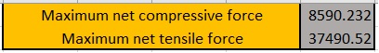
Table 5 Maximum compressive and tensile force for standard engine
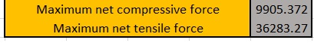
Table 6 Maximum compressive and tensile force for modified engine

Maximum compression and tensile stresses
The highest compressive and tensile stresses are found by dividing the maximum net tensile and compressive loads by the cross-sectional area of the con-rod shank at its smallest point, $σ=\frac{F}{A}$. Where $σ$ is stress, F is force and A is area.
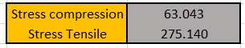
Table 7 Highest tensile and compressive stresses for standard engine
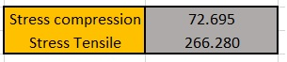
Table 8 Highest tensile and compressive stresses for modified engine

Static safety factors
The static safety factor of the con-rod is found by first calculating the nominal stress values, which are found by dividing the peak gas forces by the cross-sectional area of the con-rod shank; the UTS (Ultimate Tensile Strength) is then divided by this value to end with the static safety factor. This was repeated for each RPM range.
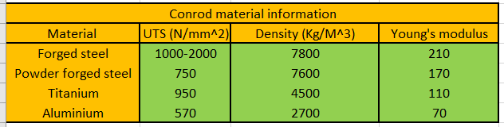
Table 9 Con-rod material information (Toolbox, 2003)
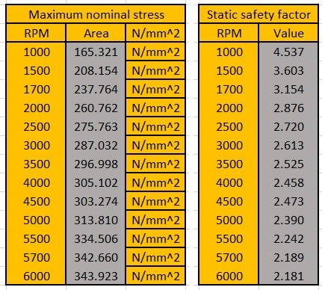
Table 10 Maximum nominal stress and static safety factors for standard engine
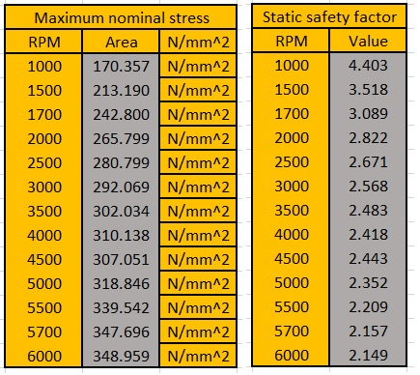
Table 11 Maximum nominal stress and static safety factors for modified engine

Maximum compression and stretch distances.
The distance that the con-rod is compressed or stretched at the peak forces exerted on it is calculated by first finding the stiffness of the con-rod, this is done using the equation $\frac{E×A}{F_{Rod}}$ . This was repeated for each of the materials used in the study.
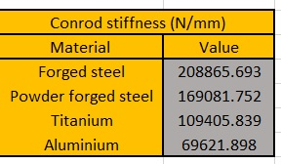
Table 12 Con-rod stiffness values
The maximum distances were then calculated by dividing the maximum compression and tension forces by the stiffness of the chosen material. This was done for all materials used.
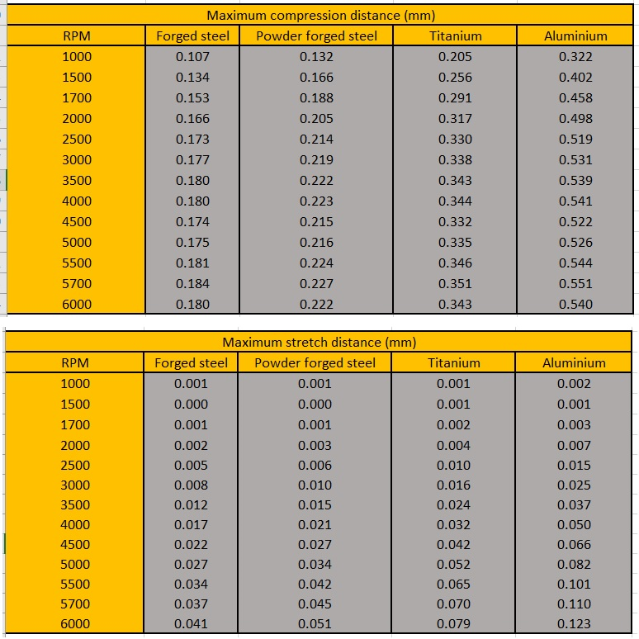
Table 13 Maximum compression and stretch distances for standard engine
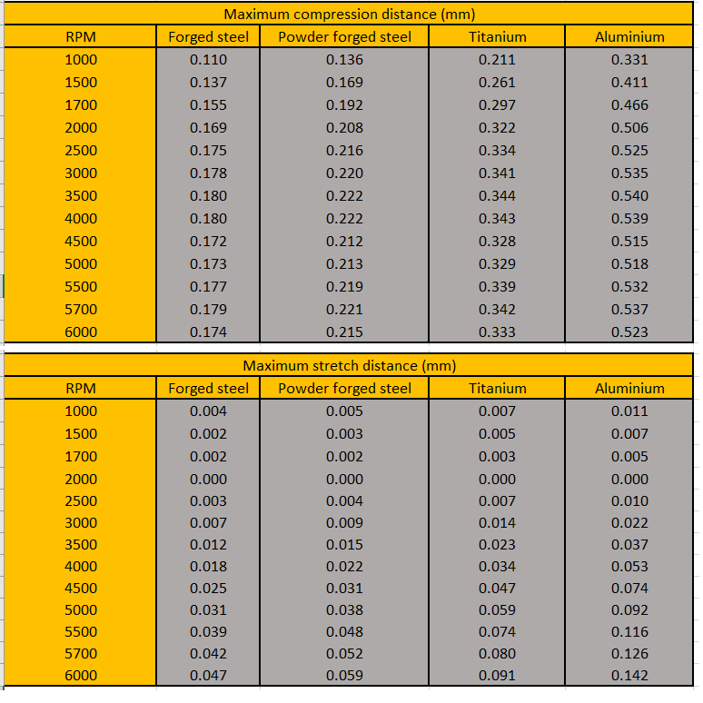
Table 14 Maximum compression and stretch distances for modified engine

Evaluation and discussion
The results shown when comparing the standard engine to the modified engine illustrate the importance of correctly selecting which components to use, a small increase in any value has a dramatic effect on the forces acting in the engine when it is running across a range of RPM values. The importance of correctly tuning the engine when a turbocharger is fitted is also shown when even a comparatively low level of boost is forced into the engine; at 1.4 BAR of pressure the internal pressure of the cylinders, especially at lower RPM, is doubled or more across all of the data collected and calculated by the simulator. A small change to any of the core components of the piston and crank has a dramatic knock-on effect.

Suggested further work
Further work could be done to expand the uses of the excel simulator; it could be incorporated into a full thermo-dynamic simulator to provide a far more in-depth view of what is happening inside an engine, mathematically, as it is running. A range of pressure data could also be imported to compare different engines side by side as opposed to having separate versions of the same simulator running at once.

References
Table 1 standard engine information 2
Table 2 Modified engine information 2
Table 3 standard engine peak gas pressures Table 4 modified engine peak gas pressures 3
Table 5 Maximum compressive and tensile force for standard engine 6
Table 6 Maximum compressive and tensile force for modified engine 6
Table 7 Highest tensile and compressive stresses for standard engine 6
Table 8 Highest tensile and compressive stresses for modified engine 6
Table 9 Con-rod material information 6
Table 10 Maximum nominal stress and static safety factors for standard engine 7
Table 11 Maximum nominal stress and static safety factors for modified engine 7
Table 12 Con-rod stiffness values 8
Table 13 Maximum compression and stretch distances for standard engine 8
Table 14 Maximum compression and stretch distances for modified engine 9

Graph 1 first versus second order inertia forces 4
Graph 2 standard engine inertia loads 5
Graph 3 Modified engine inertia loads 5

Bibliography
KZF-Tech. (2019). Inertial forces and -torques. Retrieved from http://www.kfz-tech.de: http://www.kfz-tech.de/Engl/Biblio/Verbrennung/Massenkraefte01.htm
Slade, L. (2018). Engine cycle simulator. Swansea: UWTSD.
Toolbox, E. (2003). Young's Modulus - Tensile and Yield Strength for common Materials. Retrieved from EngineeringToolbox.com: https://www.engineeringtoolbox.com/young-modulus-d_417.html

Appendix
Please note in the printed paper copy, the icon above is the Excel spreadsheets embedded in this report. I have done this as I could not find a way to include the Excel in a way that was readable. To see the full Excel workings please double click the icon on the report submitted via turn-it-in. Each page on the Excel contains roughly 22,000+ cells, this would be impractical and far too expensive to print fully. Please see below the results, and graph pages produced in Excel.


