

LOCATION: Swansea | LLEOLIAD: abertawe
LEVEL 6 | LEFEL 6
EXAMINATION PERIOD | CYFNOD ARHOLIADAU
May 2023 | MAI 2023

MODULE CODE: ACDA5006
Power Electronics and Drives
TIME: 2 HOURS
answer all questions

Equipment or materials required – Calculator
Adnoddau neu ddefnyddiau sydd eu hangen – Cyfrifiannell

ANSWER ALL QUESTIONS

- Compare and contrast the working principles of a three-phase synchronous motor, and a three-phase induction motor.
[10 Marks]
Description should include:
- Rotating magnetic field in stator produced by three coils 120° apart.
- Induction motor uses squirrel cage. Voltage induced in squirrel cage by RMF.
- Squirrel cage forms closed circuit so current flows.
- Currents in squirrel cage create magnetic field opposing RMF.
- Forces generated between RMF and squirrel cage turn rotor.
- Induction motor relies on slip and does not run at fixed speed.
- Speed of induction motor is dependent on load
- Synchronous motor starts as induction motor using squirrel cage.
- Near full speed induced currents in the squirrel cage are low and torque is now from forces between field from rotor windings and RMF.
- Synchronous motor speed governed by line frequency.

- Control of several operational parameters of an induction motor may be achieved by an inverting motor controller. Assuming a controller is using PWM as its control mechanism:

  - Provide a block diagram of an inverting motor drive and give a brief explanation of the operation of each of the sections.
[2 Marks]
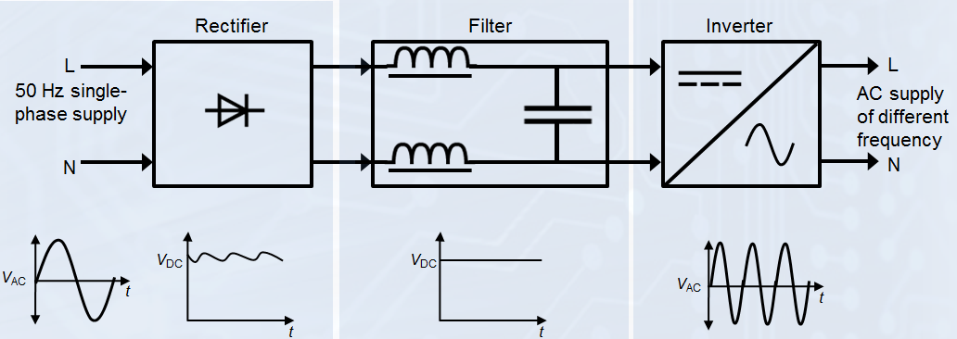
The rectifier converts the incoming AC to DC
The filter is used to smooth the previously rectified DC.
The inverter is used to convert the previously rectified and smoothed DC back into an AC form at a frequency and amplitude required by the motor.

  - Describe the operation of an inverting motor controller to accelerate and decelerate a motor while maintaining torque.
[6 Marks]
An inverting controller may control the acceleration/deceleration of an induction motor by manipulating both the speed of the motor (by AC power frequency variation) and torque of the motor (by AC power amplitude variation) simultaneously.
Acceleration is achieved by ramping up of the frequency to the desired level whilst deceleration is achieved by ramping down of the frequency to the desired level. The torque when producing drive or braking may be controlled by controlling the voltage/current applied to the motor.

  - Describe how an inverting PWM motor controller may control the speed of an induction motor and the torque it produces, and sketch the waveforms of the control input and power output of the output stage of a single phase variable frequency drive to help explain your answer.
[12 Marks]
The speed of an induction motor is directly controlled by the frequency of the AC supply. Thus, to vary the speed of the motor the frequency of the output of the inverter must be varied.
To achieve modification of the frequency, the PWM period is varied but the mark / space ratio remains. i.e. if the PWM period is 0.5mS and the number of periods is 40 per cycle the cycle period is 20mS or 50Hz. Should the PWM period be halved to 0.25ms and the number of periods remains at 40 per cycle the cycle period is now 10mS or 100Hz. As can be seen extending the PWM period will lower the output frequency while shortening the PWM period will increase the frequency, the speed will change proportionally with the change in frequency.
The torque of an induction motor may be controlled by limiting the voltage / current supplied to the motor. This type of control may be derived from a PWM based controller by modifying the mark/space ratio.
i.e.
To achieve max V output of the system would be given by
$$V_{out}=V_{in}×(mark/space ratio)$$
To achieve an 80% max V output, multiply the mark time by 0.8. =
$$V_{out}=0.8×V_{in}×(mark/space ratio)$$
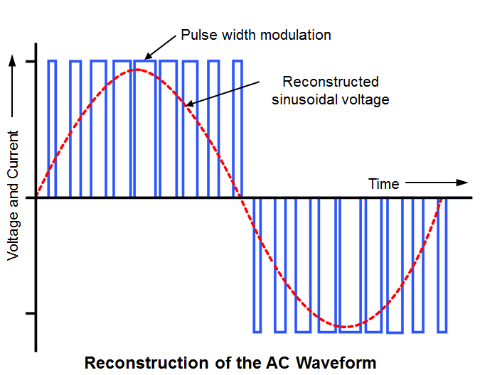
- Given the effective output resistance of photovoltaic solar panels is highly temperature dependant, explain what maximum power point tracking is and how it can be used to address this problem.
[20 Marks]
As the temperature of a solar panel increases, so does its resistance. This increase in resistance reduces the current drive capability of the solar panel. As reduced current output results in reduced power output and hence lower efficiency maximum power point tracking is employed to counter these effects. Maximum power point tracking allows a solar PV inverter to adjust its input resistance in response to changes in solar panel performance to maintain maximum power transfer. This is done by measuring the current and voltage produced by the panel and using this information to modify the input resistance of the inverter to match the output resistance of the solar panel ensuring maximum power transfer. Algorithms are then employed to determine the best way of adjusting the input resistance. These algorithms include perturb and observe whereby the inverter measures the solar panel voltage and current then the input resistance is changed, and the measurements repeated. If an increase in power is observed, then further changes in that direction are performed until no more gains in power are achieved.
- A eight-pole alternator is required to operate at 50Hz. What is the required rotation speed in r.p.m?
[2 marks]
8 poles = 4 pole pairs
$$\frac{50}{4}=12.5 Hz$$
$$12.5×60=750 rpm$$

- A coil of 1800 turns with a coil of width 120mm and active depth of 200mm rotates in a uniform magnetic field between the poles of a magnet with an air gap flux density of 0.8T. If the coil rotates at a speed of 3000rpm calculate:

- The maximum e.m.f. induced in the coil.
[4 Marks]
$$A=120×{10}^{-3}×200×{10}^{-3}=0.024 m^{2}$$
$$f=\frac{rpm}{60}=\frac{3000}{60}=50 Hz$$
$$E_{Max}=1800×0.8×0.024×2×π×50=10857.344 V$$

- The maximum amount of flux cutting the coil.
[4 Marks]
Maximum flux cuts coil when coil is at 90°
$$Φ_{Max}=BA=0.8×0.024=0.0192 Wb$$
$$=19.2 mWb$$

Diwedd/End

