BSc Health and Social Care

Student Name: Collette Fahy
Student Number: 2425001
Module Code: BMHP5014
Module: Changemakers Creativity and Value Creation
Assignment Title: Component 2
Lecturer: Tomy Adattu Chacko

Poster

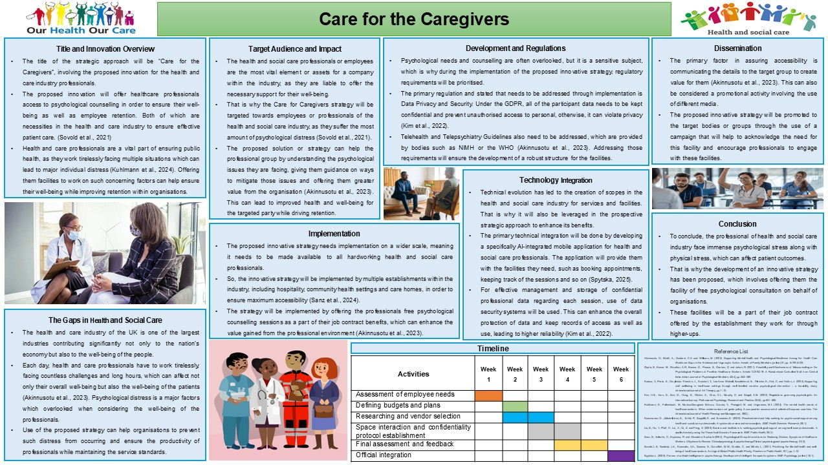

Pitch

Title and Innovation Overview
The health and wellbeing of the UK population are fundamental to the nation’s social and economic development, with a healthy workforce contributing to improved productivity, quality of life, and sustainable healthcare services (Kuhlmann et al., 2024). Health and social care professionals play a vital role in delivering safe, effective, and person-centred care. However, the increasing pressures experienced within the sector, including workforce shortages, rising patient demand, and emotionally challenging working environments, have significantly affected staff wellbeing. Supporting the mental health of health and social care professionals is therefore essential to maintaining high standards of patient care and ensuring the long-term sustainability of the workforce.
This innovation proposes the introduction of a free and confidential psychological counselling service for health and social care professionals across the UK. The service aims to provide timely access to professional mental health support, enabling staff to manage work-related stress, anxiety, compassion fatigue, and burnout before these issues become more severe. Early psychological intervention has been shown to improve emotional resilience, reduce sickness absence, enhance job satisfaction, and promote staff retention within healthcare organisations (Liu et al., 2025).
In addition to improving the wellbeing of individual employees, the proposed innovation is expected to create value for healthcare organisations by reducing staff turnover, lowering recruitment and absence-related costs, and improving workforce productivity. By investing in employee mental health, organisations can foster a healthier working environment, strengthen staff morale, and ultimately improve the quality and safety of patient care. Consequently, this innovation represents a proactive and sustainable approach to addressing one of the most significant workforce challenges currently facing the UK health and social care sector.

The Gaps in Health and Social Care
Health and social care professionals work in highly demanding environments where they are regularly exposed to heavy workloads, staff shortages, emotional distress, and increasing service demands. These pressures contribute to high levels of work-related stress, anxiety, burnout, and poor mental wellbeing, which can negatively affect both employees and the quality of care provided to patients (Akinnusotu et al., 2023). Despite growing awareness of mental health in the workplace, many organisations continue to have limited access to timely and confidential psychological support. Long waiting lists, lack of dedicated counselling services, concerns about confidentiality, and the stigma associated with seeking mental health support often prevent staff from accessing the help they need. Recent evidence also indicates that many health and social care professionals recognise their need for psychological support but delay seeking help because of workplace culture, concerns about confidentiality, and limited-service availability (Kuosmanen et al., 2025).
As a result, many healthcare professionals continue working while experiencing poor mental health, leading to increased sickness absence, reduced productivity, lower job satisfaction, and higher staff turnover. These workforce challenges place additional pressure on already stretched health and social care services and can compromise patient safety and the overall quality of care.
The proposed innovation aims to address this gap by introducing free psychological counselling for health and social care professionals. Providing accessible and confidential counselling services would enable staff to seek early support, improve resilience, reduce stress and burnout, and enhance both personal wellbeing and professional performance. In the long term, this innovation has the potential to improve staff retention, reduce absenteeism, and contribute to a healthier, more sustainable workforce.
.

Target Audience and Impact
The proposed innovation is specially targeted at health and social care professionals working in hospitals, care homes, GP practices and community healthcare settings. Focusing on this workforce ensures that investment is directed towards employees who experience high levels of occupational stress and who’s wellbeing directly influences patient outcomes (Karkou et al., 2024) These professionals are regularly exposed to high workloads and emotionally demanding situations that can negatively affect their mental health. So, individuals who are working in the health and social care industry will be targeted as a group regarding the implementation of the proposed innovation. The reason being they are the ones who influence patient outcomes and fulfil operational duties that keep an establishment and the industry operational. Confidential counselling services would allow staff to discuss workplace challenges in safe environment while receiving professional support to improve their emotional wellbeing and coping strategies. The added benefits can create greater value, leading to job satisfaction, which can foster higher retention and stability of care quality in the industry.

Implementation
The counselling programme would be implemented across NHS organisations, care homes and community health services as part of existing employee wellbeing initiatives. Employers would partner with qualified counselling providers to ensure all health and social care staff have free and confidential access to psychological support. Integrating counselling into employee wellbeing programmes is expected to improve job satisfaction, reduce sickness absence and increase staff retention while maintaining high standards of patient care. The healthcare sector is diverse, comprising hospitals, care homes, GP practices, community healthcare services and other organisations that provide specialised care. Therefore, the proposed innovation should be implemented across all healthcare settings rather than focusing on a single type of organisation (Sanz et al., 2024). Providing free psychological counselling as part of employee wellbeing programmes would ensure that healthcare professionals, regardless of their workplace, have access to confidential mental health support. This approach is expected to improve job satisfaction, reduce sickness absence, increase staff retention and maintain high standards of patient care (Kuhlmann et al., 2024).

Timeline
Implementing a staff counselling programme requires careful planning to ensure its long-term effectiveness and sustainability. A structured six-week implementation period has therefore been proposed, allowing sufficient time for planning, preparation, staff engagement, and evaluation while accounting for any potential delays. Each stage has been designed to ensure the service is introduced safely, efficiently, and in accordance with organisational and legal requirements.

Week 1: Needs Assessment
A comprehensive staff wellbeing needs assessment will be conducted to identify the demand for counselling services. Surveys, staff feedback, and discussions with managers will be used to determine the most common mental health concerns, preferred methods of accessing support, and any barriers to engagement. The findings will help ensure that the service is tailored to the needs of health and social care professionals.
Weeks 2–3: Planning and Service Development
Funding will be secured to support the implementation and long-term sustainability of the counselling programme. Qualified and accredited counselling providers will be appointed, and service level agreements will be established. During this stage, a detailed implementation plan will also be developed, outlining staff responsibilities, referral pathways, appointment systems, and communication strategies to ensure the programme is delivered effectively.
Weeks 4–5: Preparation and Pilot Testing
Counselling facilities will be prepared to provide a safe, confidential, and accessible environment for staff. Confidentiality procedures, data protection policies, and safeguarding protocols will be established in accordance with UK GDPR and the Data Protection Act 2018. A pilot phase will then be carried out with a small group of staff to test the service, identify any operational issues, and gather feedback before the full launch. Any improvements identified during the pilot will be implemented to enhance the quality of the service.
Week 6: Programme Launch and Evaluation
The counselling service will be officially launched across the organisation. Staff will be informed through internal communications, including emails, team meetings, posters, and the organisation’s intranet, to encourage awareness and participation. Following implementation, staff engagement, satisfaction, service uptake, and programme outcomes will be monitored regularly using feedback questionnaires and performance indicators. Continuous evaluation will allow the organisation to identify areas for improvement and ensure that the counselling programme continues to meet the needs of the workforce.

Development and Regulations
The proposed programme will comply with the UK General Data Protection Regulation (UK GDPR) and the Data Protection Act 2018 to ensure the secure management and confidentiality of employees’ personal information. Counselling services will also comply with professional ethical standards, NHS guidance, and regulations governing psychological practice to ensure safe, ethical, and high-quality care (Kim et al., 2022).
A key legal consideration is ensuring compliance with data protection and privacy legislation when collecting, storing, and processing sensitive health information. In addition, telehealth and telepsychiatry guidance published by organisations such as the World Health Organization (WHO) and the National Institute of Mental Health (NIMH) will inform the implementation of digital counselling services (Kuhlmann et al., 2024). Compliance with these regulations will minimise legal risks while increasing employees’ confidence in using the service and discussing sensitive mental health concerns.

Technology Integration
Advances in digital technology have created significant opportunities to improve healthcare delivery across the UK. As part of the proposed solution, an AI-supported digital application will be introduced to enhance the effectiveness and accessibility of counselling services (Søvold et al., 2021; Spytska, 2025). The application will enable healthcare professionals to schedule appointments, monitor counselling progress, record session notes securely, and manage follow-up activities. Automated reminders will notify users of upcoming appointments and outstanding actions, reducing missed sessions and improving continuity of care. In addition, research will be demonstrated that tele counselling can effectively improve access to psychological support for healthcare professionals while maintaining positive mental health outcomes, making digital counselling a practical and evidence-based approach (Gupta et al., 2021). The platform will also incorporate advanced cybersecurity measures, including encrypted data storage and secure authentication, to protect confidential information. Strengthening data security will increase users’ trust in the system and encourage greater engagement with counselling services. Furthermore, strengthening data security through advanced cybersecurity systems will increase users’ confidence in the platform, encouraging greater engagement with counselling services while ensuring that confidential information remains protected.”

Dissemination
Dissemination refers to promoting a service to increase awareness and communicate its value to the intended audience. Effective promotion will play a key role in encouraging the successful implementation of the proposed counselling programme (Sanz et al., 2024).
A targeted communication campaign will therefore be developed to raise awareness of workplace mental health, reduce stigma associated with seeking psychological support, and educate health and social care professionals about the services available. Promotional materials may include staff briefings, email newsletters, posters, intranet announcements, and training workshops. Increasing awareness of the programme and its benefits is expected to improve staff participation, encourage early access to mental health support, and contribute to a healthier, more productive workforce.
That is why, as a medium, specialised campaigns will be developed that aim to improve the knowledge of targeted health and social care professionals of the need for managing psychological or mental health. The campaign will also improve their knowledge of the proposed solutions and the facilities that it will offer, and it can encourage participation of the professionals to participate more.

Conclusion
The proposed innovation of providing free psychological counselling for health and social care professionals offers a practical and sustainable solution to the growing challenges of stress, burnout and poor mental wellbeing within the UK healthcare workforce. By ensuring that employees have access to confidential psychological support, organisations can improve staff wellbeing, increase job satisfaction and reduce staff turnover. A healthier workforce is more likely to deliver safe, compassionate and high-quality care, ultimately benefiting patients and the wider health and social care system.
The successful implementation of this initiative requires careful planning, including a phased six-week rollout, compliance with UK data protection legislation, and adherence to professional and ethical standards. The integration of secure digital technology, including an AI-supported application, will improve accessibility by allowing staff to manage appointments, receive reminders and monitor their wellbeing while maintaining confidentiality. In addition, targeted awareness campaigns and organisational support will encourage staff engagement and help reduce the stigma often associated with seeking mental health support.
Overall, this innovation has the potential to create lasting value for healthcare organisations by supporting employee wellbeing, strengthening workforce retention and contributing to a more resilient and effective health and social care sector. Investing in the mental health of healthcare professionals is not only beneficial for employees but is also essential for improving patient outcomes and ensuring the long-term sustainability of healthcare services in the UK.

Reference List

Akinnusotu, O., Bhatti, A., Doubeni, C.A. and Williams, M. (2023). Supporting Mental Health and Psychological Resilience Among the Health Care Workforce: Gaps in the Evidence and Urgency for Action. Annals of Family Medicine, [online] 21, pp. S100–S102.
Gupta, S., Kumar, M., Rozatkar, A.R., Basera, D., Purwar, S., Gautam, D. and Jahan, R. (2021). Feasibility and Effectiveness of Telecounseling on the Psychological Problems of Frontline Healthcare Workers Amidst COVID-19: A Randomised Controlled Trial from Central India. Indian Journal of Psychological Medicine, 43(4), pp.343–350.
Karkou, V., Perris, E., Omylinska-Thurston, J., Konstant, T., Lee-Anne Widnall, Brocklehurst, S., Fletcher, K., Hird, C. and Hutton, J. (2024). Supporting staff wellbeing in healthcare settings through multi-levelled creative psychological intervention – a feasibility study. International Journal of Art Therapy, pp.1–12.
Kim, H.S., Yoon, S., Son, G., Hong, E., Clinton, A., Grus, C.L., Murphy, D. and Siegel, A.M. (2022). Regulations governing psychologists: An international survey. Professional Psychology, Research and Practice, 53(6), pp.541–552.
Kuhlmann, E., Falkenbach, M., Monica‐Georgiana Brînzac, Correia, T., Panagioti, M. and Ungureanu, M.I. (2024). The mental health needs of healthcare workers: When evidence does not guide policy. A comparative assessment of selected European countries. The International Journal of Health Planning and Management, 39(3).
Kuosmanen, O., Jääskeläinen, E., Torkki, P., Seppälä, K. and Tuunainen, E. (2025). Perceived need and help-seeking for psychosocial support among health and social care professionals: A systematic review and meta-analysis. BMC Health Services Research, 25(1).
Liu, S., Hu, Y., Pfaff, H., Lei, X., Qi, Z. and Feng, X. (2025). Barriers and facilitators to seeking psychological support among healthcare professionals: A qualitative study using the Theoretical Domains Framework. BMC Public Health, 25(1).
Sanz, S., Valiente, C., Espinosa, R. and Almudena Trucharte (2024). Psychological Group Interventions for Reducing Distress Symptoms in Healthcare Workers: A Systematic Review. Clinical psychology & psychotherapy/Clinical psychology and psychotherapy, 31(3).
Sovold, L.E., Naslund, J.A., Kousoulis, A.A., Saxena, S., Qoronfleh, M.W., Grobler, C. and Münter, L. (2021). Prioritising the Mental Health and well-being of healthcare workers: An Urgent Global Public Health Priority. Frontiers in Public Health, 9(1), pp.1–12.
Spytska, L. (2025). The use of artificial intelligence in psychotherapy: Development of intelligent therapeutic systems. BMC Psychology, [online] 13(1).

