

A deployable control, monitoring, and logging system for the performance evaluation of TETRA handsets and meshed-network modelling
by
Rhys Higgins

Supervisor: Stalin J. W. Packia-Dhas

Project submitted as part of the requirements for the award of
BEng (Hons) Embedded Electronic Systems

April 2025

Word Count: 10983

Abstract

This report considers the development of a software controlled and vendor agnostic node-based testing platform for performance testing TETRA PMR handsets within a real-world outdoor environment, utilising a node-based platform where each node is connected to a PMR handset.

A key aim of the system was to facilitate a call between two TETRA PMR handsets with only a radio operator present at one node, controlling the TETRA network through a computer or serial terminal connected to the system. The system was developed around a PIC18F microcontroller and ZigBee module and contained non-volatile memory used to log network information from the connected radios and the ZigBee modules, using GNSS for accurate date and time tracking.

The system developed within this report was able to effectively establish control over a TETRA PMR handset, acquire date and time from a GNSS receiver, and log data to a micro-SD card in a semi-automated manner. This system was developed firstly as a simulation and then designed as a prototype PCB, utilising the KiCad software package (v7.0), which was populated post-delivery utilising workplace lab facilities. The codebase for the system was written exclusively in C language, using the CCS (Customer Computer Solutions) compiler, MPLAB X, and Microsoft Visual Studio Code to enable functionality.

Though significant progress has been made in achieving the measures of success outlined within this report, there is significant scope for future development to the system and scope for learning to be taken from the outcomes and lessons identified within this report. The principal learnings from this report being to better understand the operation of system components and modules prior to system integration and to employ a larger development team to provide greater redundancy and tasking capability.

Contents

Abstract 2
1 | Research Introduction 6
1.1 | Technical Background 6
1.2 | Research Aim 7
1.3 | Research Objectives 8
2 | Literature Review 9
2.1 | Existing Domain Analysis 9
2.1.1 | Existing Domain Systems 9
2.2 | Supporting Hardware 11
2.2.1 | Secondary Wireless/Backhaul Interface 11
2.2.2 | Non-Volatile Storage 13
2.2.3 | Microcontroller Overview 14
2.2.4 | UART Interface 15
2.2.5 | Location/Time Tracking 16
2.3 | Supporting Software 16
2.3.1 | Non-Volatile Filesystems 16
2.3.2 | TETRA Peripheral Equipment Interface (PEI) 17
3 | Methodology 18
3.1 | Measures of Success 18
3.2 | Requirements 19
3.2.2 | Software Requirements 19
3.2.3 | Hardware Requirements 20
4 | Planning, Design, & Implementation 21
4.1 | Risk Analysis & Assessment 21
4.1.1 | Project Risk Assessment 21
4.1.2 | Lab Risk Assessment 23
4.1.3 | Potential of Misuse 25
4.1.4 | Project Timeline 26
4.2 | Hardware Design 27
4.2.1 | Microcontroller 28
4.2.2 | UART Interfaces 30
4.2.3 | Secondary Wireless/Backhaul Interfaces 31
4.2.4 | Antenna Design / Antenna Specification 32
4.2.5 | SPI Interface & SD/MMC Specification 33
4.2.6 | Hardware Schematic 34
4.2.7 | PCB Schematic 38
4.3 | Software Design 41
4.3.1 | Main Program 41
4.3.2 | System Initialisation Sequence 42
4.3.3 | UART2/UART3 Timer_1 Interrupt 44
4.3.4 | System Activity Timer_0 Interrupt 44
4.4 | Prototype Simulation 45
4.5 | Hardware Implementation 47
4.6 | Software Implementation 49
4.8 | Prototype Testing 52
4.8.1 | Unit Testing 52
4.8.2 | System Testing 53
4.7 | Bill of Materials 55
4.8 | Expenditure 57
5 | Results & Discussion 58
6 | Conclusion and Future Recommendations 60
6.1 | Project Conclusion 60
6.2 | Hardware Recommendations 61
6.2.1 | Short Term ( > 1 Month ) 61
6.2.2 | Medium Term ( 1 – 3 Months ) 61
6.3 | Software Recommendations 62
6.3.1 | Short Term ( > 1 Month ) 62
6.3.2 | Medium Term ( 1 - 3 Months ) 62
6.3.3 | Long Term ( 3+ Months ) 62
6.4 | Commercialisation 63
7 | Reflection 67
7.1 | Professional Development 67
7.2 | Challenges 68
7.3 | Further Ethical Analysis 69
8 | References 70
9 | Bibliography 79
9.1 | Hardware Datasheets 79
9.2 | Supporting Documentation 80
Appendices 81
Appendix A | Source Code 81
Main.c 81
Main.h 89
at_msg.h 91
at_msg.c 92

1 | Research Introduction

1.1 | Technical Background

The evaluation of TETRA PMR, networks in real-world conditions is a time consuming and resource-intensive exercise. This activities success is critically dependent on participant numbers, for both the establishment and maintenance of a network, and their understanding of radio voice procedure to enable effective communication.

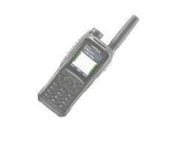
Figure 1: Airbus TH9 TETRA Radio
When conducting site-testing on any PMR-type network in an outdoor environment, it is often exceedingly difficult to maintain a network for any significant duration of time. People involved require welfare facilities, regular breaks, and PPE (Personal Protective Equipment) under the legal obligations of the MHSWR (Management of Health and Safety at Work Regulations) which comes under the umbrella of the Health and Safety at Work Act, 1974 [1].

This is compounded by PMR radios operating in the VHF/ lower UHF (Very High Frequency, 30MHz to 300MHz, and Ultra High Frequency, 300MHz to 3GHz) bands, therefore having a large typical effective working range of ~5km in non-trunking mode [2]. Ultimately meaning that the individuals manning each node could potentially be spread over a large area with limited access to welfare facilities. Furthermore, each individual used to conduct the site-testing will have a time-cost, both in terms of immediate cost to the organisation in hours, and time that could have been spent conducting other research activities.

However, it is critically important that key network data is captured at each node. It is also important that each node can have an active role in the network. To ensure the reliability of testing, it is also important to ensure that the environmental conditions and location of each node in the network are captured with a high degree of accuracy. Both factors would typically rely on the radio operator to observe and document the information.

1.2 | Research Aim

The proposal is to formulate an artefact dependant on microcontroller platform which can establish, maintain, and test a TETRA PMR network. The proposal would utilise the extended TETRA AT command set, SDS (Short Data Service) commands, and potentially a secondary interface to control, manage, and log data on a TETRA network – as shown in Error! Reference source not found..

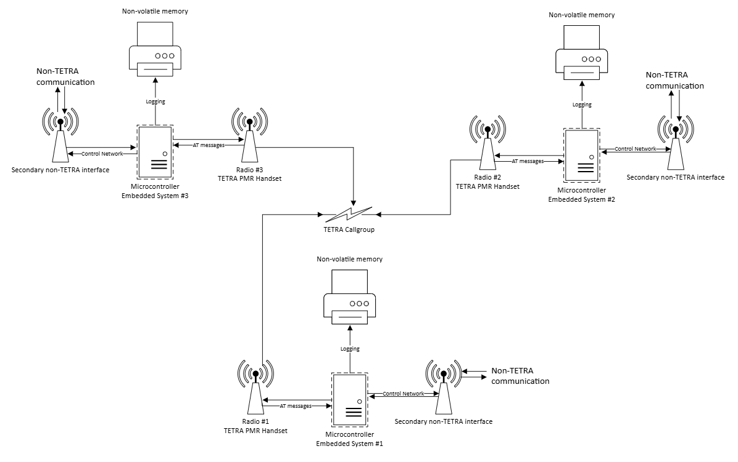
Figure 2: Provisional System Network Setup
This report will hereon define a set of research objectives derived from this research aim, which will be used as a basis for which to develop an artefact which meets the project objectives and measures of success discussed later in this report.

1.3 | Research Objectives

- Utilise the vendor-independent TETRA PEI (Peripheral Equipment Interface) AT (Attention) command set (as defined in the ETSI TS 100 392-5 standard) to provide the basis to automate radio functions and provide the capability for network maintenance, with the proposal enabling elements of the functionality of a dedicated TETRA base station with remote management features [3].

- The hardware will also have to be designed for manufacture and operational usage/testing, constituting the design and manufacture of PCB (Printed Circuit Board), ensuring the system hardware would be robust and reliable in contrast to prototyping media such as breadboard.

- The software component of the artefact should be written in a popular and well-understood programming language, like C, so that the software can be modified and built-upon for future functionality – should it be required by the customer. The software should also be capable of supporting TETRA PMR handsets from multiple vendors without significant alterations being required to the codebase.

- Incorporate the serial interfaces RS232 (Recommended-Standard 232) and RS485 (Recommended-Standard 485) both of which are protocols typically used as the PEI (Peripheral Equipment Interface) for the transmission and reception of AT commands between a TETRA PMR handset and computer-based system. The key differentiator between the two being RS485 uses differential signalling and therefore a has a much greater feasible transmission distance [4].

- The capability for capturing and storing network data without the need for a radio operator at that given node. A suitable NV (non-volatile) storage medium will be identified for the purpose of storing logged TETRA network data. The storage medium must be readable via an external interface, such as USB (Universal Serial Bus), and stored in a filesystem and file format which is compatible with ubiquitous operating systems such as Windows and Linux, such as FAT16/32 (File Allocation Table 16/32) which is platform agnostic and reliable [5] [6]. An electronically erasable read-only memory device, such as an EEPROM, should be separate from the NV storage medium and used to store node identification and configuration information, to be read by the software to configure the system to interface properly with the connected handset.

- Provide GPS (Global Positioning System) location, time, and date at a given node, to ensure that the testing the system is used for is repeatable and to ensure that the artefact has remained in its installed location.

2 | Literature Review

This section considers the existing domain systems and research that has been developed in this research area. Also covered is research into the supporting functionality which will be required in order to successfully achieve the aims of this project.

2.1 | Existing Domain Analysis

2.1.1 | Existing Domain Systems

Existing solutions found within this research area are limited, COTs (Commercial-off-the-shelf) typically focused at larger-scale infrastructure (base stations) deployment and housed within a fixed-platform, such as a rackmount server. These systems will be evaluated in this section, as although they do not meet the requirements of the proposal, they do have a number of features which the artefact created within the proposal will also need to act as an effective radio management tool.

Model No. | DIMETERA MTS1 | DIB-R5 | DIMETERA MTS2 | SB422
Manufacturer | Motorola | Hytera | Motorola | Damm Cellular
Dimensions | 60 x 21 x 26cm | 43 x 25 x 17cm | 45 x 61 x 48 cm | 34 x 25 x 21cm
Supplier | TBC | TBC | TBC | TBC
Unit Weight | 24.3kg | 10kg | 48kg | 12kg
IP-rating | IP66 | IP65 | N/A | IP65
TX Power  (max) | 10W | 20W | 40W/25W | 25W
Sensitivity | -111dBm  (4% BER) | -119dBm  (4% BER) | -113dBm  (4% BER) | -112dBm  (4% BER)
Frequency Bands | 350 to 470MHz | 380 to 430MHz | 350 to 470MHz, 806 to 870MHz | 68 to 174MHz, 350 to 470MHz,  805 to 870MHz
Input Voltage | 48VDC | 48V  (44 to 55VDC) | 100 to 230VAC  (50/60Hz) | 48VDC & 230VAC
Power Consumption | 100W | ~60W @ 10W TX/RX Power | 640W/700W (806+MHz) | 20W (idle)  50 to 100W
Operating Temperature (Range) | -30 to 55°C | -30 to 55°C | -30 to 60°C  (with fans) | -25 to 55°C
GNSS | Y | Y | Y | Y
Ethernet | Y | N | Y | N

Table 1: Overview of COTs TETRA Base station Systems [7] [8]
From the contents of Table 1, the existing COTs systems broadly meet the requirements of the problem. However, in several key areas they do not meet the requirements of the proposal. Firstly, all of the systems are not designed to be portable, all weighing over 10kgs, and therefore are not portable by a single user/radio operator.

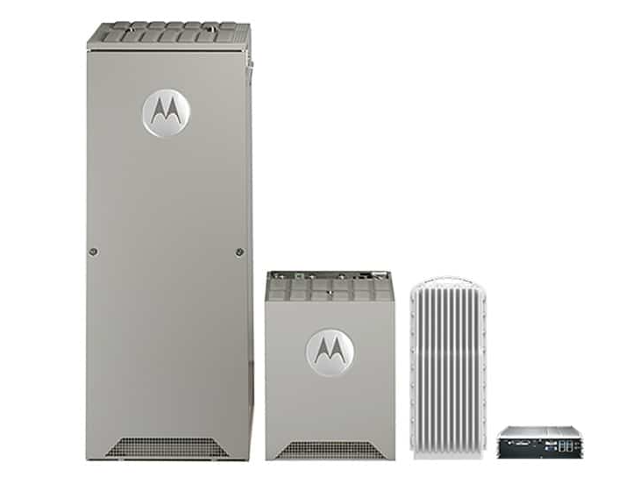
Figure 3: Motorola DIMETERA MTS1,2,3 Express [7]
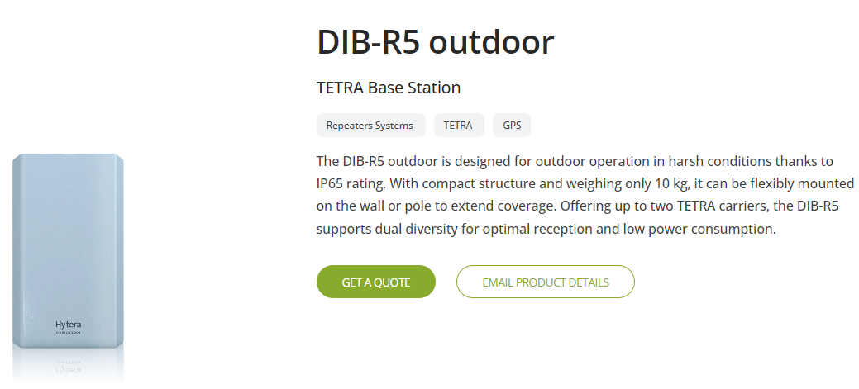
Figure 4: Hytera DIB-R5 Outdoor [8]

2.2 | Supporting Hardware

2.2.1 | Secondary Wireless/Backhaul Interface

Within this section, secondary network interfaces will be evaluated considering the research objective of establishing secondary/backhaul interface. This section will only consider wireless interfaces, due to the research objective defining that the system must be easily portable, thereby determining that a wireless topology with reasonable outdoor range is required, ruling out interfaces such as RS-232 and 10/100 Ethernet.

GSM (Global System for Mobile) is a standard developed by the ETSI for the communications protocols used in 2G digital cellular network, typically (UK/Europe) operating on the licensed 900MHz and 1.8GHz bands [9]. GSM is defined by the ETSI within the 3GPP TS XX standards documents [10]. Within the UK, most MNOs and MVNOs (Mobile Virtual Network Operators) offer near 100% network coverage via GSM [11]. Utilising a GSM network is contingent on the mobile nodes, see Figure 5, possessing a SIM (Subscriber Identity Module) to authenticate as a unique user on the network [12].

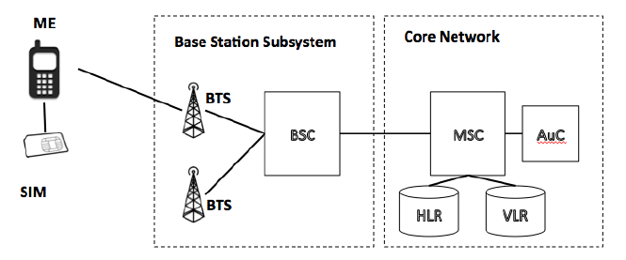

Figure 5: GSM Basic Network Architecture [13]
LoRaWAN (Long Range Wide Area Network) is a LPWAN (Low Power Wide Area Network) communications protocol designed to allow for long range communication at a low bit rate, utilising the 868MHz ISM (Industrial, Scientific, Medical) bands, with a theoretical range of u 10km and data rate of up to 50kbits/s [14] [15]. LoRa is defined by the ITU (International Telecommunications Union) ITU-T Y.4480 standard [16]. LoRa requires the use of a LoRa gateway to form a network, see Figure 6, which is similar in function to an 802.11 Wi-Fi router, differing in that the range of LoRa enables nodes to be at a much greater distance from the gateway that 802.11 nodes would be from a 802.11 Wi-Fi router [17].

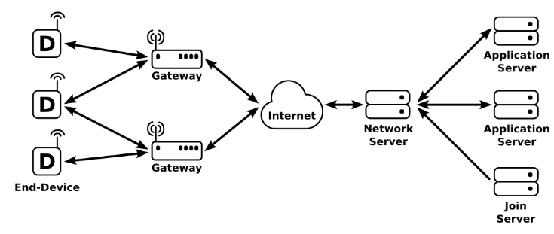
Figure 6: LoRa Basic Network Architecture [18]
ZigBee is based upon the IEEE (Institute of Electrical and Electronics Engineering) 802.15.4 specification, operating in the 868MHz and 2.4GHz ISM bands as a level 3 layer within the OSI (Open System Interconnection) [19]. ZigBee itself is a protocol, designed to create low-power and highly flexible ad-hoc networks with support for meshing (re-broadcasting) to increase range [20]. The typical range of a ZigBee implementation is up to 100m between two nodes, however with meshing and increased transmission power, ranges of >1km outdoors are feasible and achievable [21]. Furthermore, ZigBee is a highly flexible and can form peer-to-peer, star, tree and mesh networks to facilitate a greater range and number of nodes, see shown by Figure 7 [20].

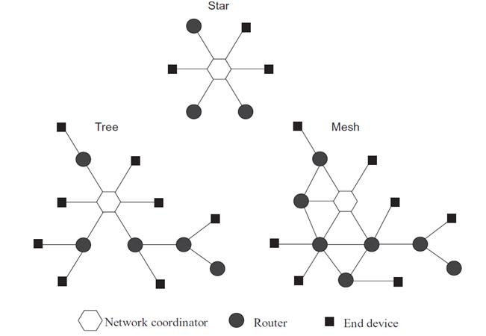

Figure 7: ZigBee Network Topologies [22]

2.2.2 | Non-Volatile Storage

Within this subsection, the research objective for a NV (non-volatile) storage medium, along with a suitable filesystem, to contain the logged data will be considered, with three types of storage media considered being SD (Secure Digital) cards, SPI flash, and EEPROM (Electrically Erasable Programmable Read Only Memory).

SD cards are the most ubiquitous type of removable memory cards on the standards defined by the SD association [23]. SD cards use NAND flash and support communication over both SPI, intended for microcontrollers, and an SD bus mode (1-bit to 4-bit), which is the native higher-performing operating mode [24]. SD cards share much commonality with MMC (Multimedia Cards) in terms of signalling and interfaces, with the difference predominantly being in form factor and the widespread adoption of SD compared to MMC.

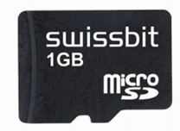

Figure 8: Micro-SDHC Card [25]
SPI flash is a form of low-power serial embedded flash memory which (unsurprisingly) uses the SPI interface and use NOR flash [26]. SPI flash modules are often found in capacities ranging from 512KB to 64MB and are similar to EEPROM but have greater storage capacity available [27] . It’s worth noting that flash can also come in I2C form, but I2C is more often found on EEPROM due to the lower speed/data rate of I2C (half duplex) compared to SPI (full duplex) [28] [29].

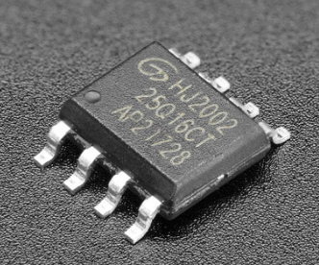

Figure 9: SOIC-8 SPI Flash [27]
EEPROM is another form of low-power embedded flash memory and are available with both parallel and serial interfaces [30]. Unlike flash memory, the block sizes of EEPROM may be as small as 1 Byte, allowing for small datasets to be modified without erasing entire sectors of information which is otherwise unchanged; EEPROM’s are also typically much smaller in terms of storage capacity than flash memory [31].

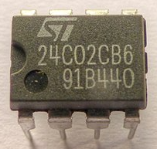

Figure 10: DIL-8 I2C EEPROM [32]

2.2.3 | Microcontroller Overview

Within the scope of the system design objectives, a low-power MCU (microcontroller)-based platform will be required to enable system function.

Brief market research was conducted on common MCU platforms, those being grouped by core type/family and compute architecture (von Neumann, Harvard, and Mixed), see Table 2.

MCU Core | Sub-type | Data Width | Architecture | Vendor | Launch | RAM (MAX) | FLASH (MAX) | Clock Speed (MAX)
PIC | 16F | 8-bit | Harvard (Modified) | Microchip | 1993 | 4kB | 56kB | 32MHz
PIC | 18F | 8-bit | Harvard (Modified) | Microchip | 2000 | 16kB | 256kB | 64MHz
PIC | 24F | 16-bit | Harvard (Modified) | Microchip | 2001 | 96kB | 1024kB | 70MHz
AVR | tinyAVR/ATtiny | 8-bit | Harvard (Modified) | Atmel | 1999 | 3KB | 512b | 20MHz
AVR | megaAVR/ATmega | 8-bit | Harvard (Modified) | Atmel | 1998 | 16KB | 4KB | 20MHz
ARM M0+ | RP2040 | 32-bit | ARMv6-M | Raspberry Pi Foundation | 2021 | 264KB | None* | >133MHz
ARM M0+ | STM32 L0 | 32-bit | ARMv6-M | ST Microelectronics | 2014 | 20kB | 192kB | 32MHz
Z80 | Z80 | 8-bit | von Neumann | Zilog | 1976 | None* | None* | 8MHz
Z80 | eZ80 | 8-bit | von Neumann | Zilog | 2001 | 16KB* | 256KB* | 50MHz
8051 | MCS-51 | 8-bit | Mixed | Intel | 1980 | 128b | 4kB | 24MHz
8051 | XC800 | 8-bit | Mixed | Infineon | 2005 | 256b | 32kB | 26.67MHz
ESP | ESP32 | 32-bit | Xtensa LX6/LX7 | Espressif Systems | 2016 | 524KB | 458KB | 240MHz
ESP | ESP8266 | 32-bit | L106 | Espressif Systems | 2013 | 32KB | 80KB | 160MHz
6800 | MC6800 | 8-bit | von Neumann | Motorola | 1974 | None* | None* | 1MHz
6800 | M68HC05 | 8-bit | von Neumann | NXP | 1983 | 112b | None* | 2MHz
C16x | C166 | 16-bit | von Neumann | Infineon | 1990 | 2KB | 128KB | 100MHz
C16x | C167CRSR | 16-bit | von Neumann | Infineon | 1994 | 2KB | 128KB | 100MHz

Table 2: Microcontroller Initial Analysis

2.2.4 | UART Interface

This section will cover the evaluation of UART (Universal Asynchronous Receive Transmit) to RS232 and RS485 transceivers. UART is a common device-device communications protocol with the ability to transmit and receive data, utilising a start bit and stop bit and a defined baud (character) rate, such as 9600 baud [33].

These line transceivers will be required to convert the UART serial interface (0 to +3V3) from the PIC microcontroller to RS232/485 levels (-15V to +15V, or +/-1.5V for RS485) for the TETRA PMR on its accessory port connector (PEI) [34] [35].

Multiprotocol transceivers, such as the Texas Instruments THVD4421, would offer the ability to autodetect whether a TETRA PMR handset was connected to the artefact using the RS232 or RS485 PHY (Physical Layer) and reduce components required for the BOM (Bill of Materials) [36]. However, as of 20/01/2025, these are not widely available for purchase in low enough quantities for prototyping/small batch production [37].

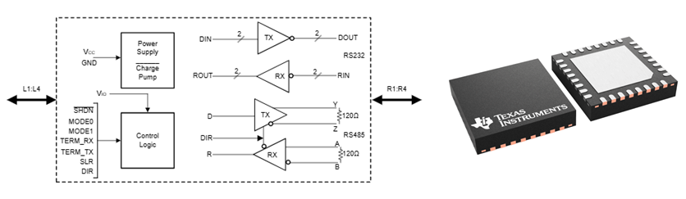
Figure 11: THVD4421 UART Multiprotocol Transceiver [36]

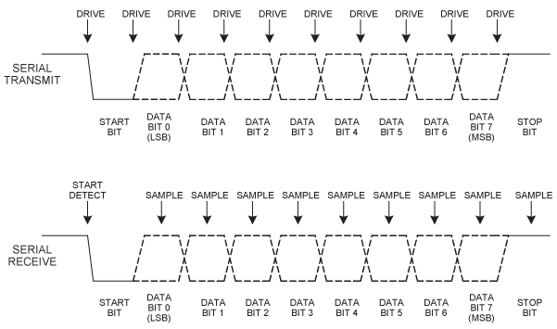
Figure 12: UART Serial Interface, 8N1 [38]

2.2.5 | Location/Time Tracking

In the context of embedded systems, technologies such as GNSS, Global Navigation Satellite Systems, are used to provide accurate timekeeping and location tracking.

GNSS is a satellite navigation system which uses a constellation of broadcast satellites to provide geo-positioning for a ground-based receiver [39]. Encompassed within GNSS are GPS (Global Positioning System – USA), as used for the atomic clock, and GLONASS (Global Navigation Satellite System – Russian Federation), both are which offer near to or achieve global coverage [40]. GNSS offers the ability to obtain accurate location and time information, provided a satellite condition is feasible.

An alternative to GNSS would be a hardware RTC (Real Time Clock. These store time using a finite battery backup and are an inexpensive option when compared to GNSS [41]. However, unlike GPS a hardware RTC does not have location tracking/awareness capabilities and requires manual setting of the correct time on its first initialisation.

Shown in Figure 13 is an example of an NMEA (National Marine Electronics Association) commands response, which will likely be what is returned by the GNSS module when given commands, based on the NMEA 0183 protocol [42].

Figure 13: NMEA String from GNSS Module [43]

2.3 | Supporting Software

2.3.1 | Non-Volatile Filesystems

A filesystem fundamentally is a means of organising a data files and folder onto storage media within a hierarchal structure [44]. A filesystem is important as without it the disk would not be able to be used as a medium to store and read data to and from respectively, often referred to as a RAW disk/filesystem [45].

For a resource constrained platform such as a PIC microcontroller, implementing a filesystem will use considerable resources when considering SRAM (Static Random Access Memory) [46]. Therefore, the filesystem will have to be sufficiently ‘lightweight’ to allow the microcontroller to have SRAM free to allocated to the rest of the program stored within the program memory, whilst still remaining compatible (read/write) with a PC (Personal Computer).

2.3.2 | TETRA Peripheral Equipment Interface (PEI)

TETRA PEI commands predominantly based on the AT (ATtention), otherwise known as Hayes, command set; originally this command set was developed for modem control in the 1980s using short text strings to carry out simple modem operations such as dialling (ATD) and answering (ATA) [47]. The TETRA PEI command syntax is defined within the ETSI (European Technical Standards Institute) TS 100 392-5 technical specification for TETRA radio, available online from the ETSI website, shown in Figure 14.

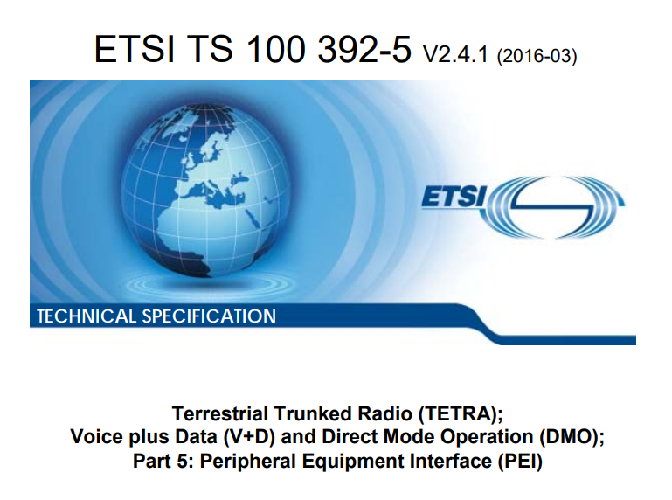
Figure 14: ETSI TETRA PEI Technical Specification [3]
Within the ETSI documentation, numerous articles are available detailing the building of an AT command message, correct syntax, and the expected response from the MT (Radio) as well as if the implementation of a given command within the TETRA AT command set is mandatory or optional for the radio OEM (Original Equipment Manufacturer), shown by Figure 15 and Figure 16.

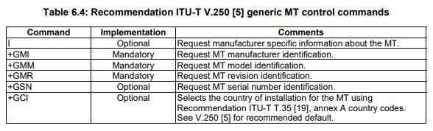
Figure 15: TETRA PEI Generic AT Commands [3]
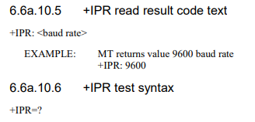
Figure 16: TETRA PEI +IPR Command [3]

3 | Methodology

This section will consider the development methodology used within this report.

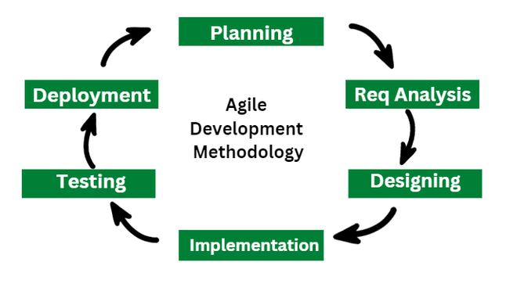
Figure 17: Agile Product Development [48]
An agile development methodology has been identified due to the distinct lack of existing systems which have been developed within this research area.

An agile methodology possesses the ability to iteratively gather requirements from users and communities of interest in order to build and refine a prototype, delivering a product which can feedback into a cycle of further (future) product development [49].

This methodology allows development work to be split into smaller work packages and ran as ‘sprints’, or bursts of week over a short finite period (i.e., a week), with the results of each analysed to feedback into a cycle of continuous improvement [50].

3.1 | Measures of Success

The measures of success for the project have been derived from the research objectives outlined within section 1.3 of this report and will be critical for the successful development of a system.

- The first measure of success will be to successfully enable two TETRA PMR radios, each connected to the research artefact in a point-to-point configuration, to communicate without physical interaction by a user at each radio.

- The second measure of success will be to enable radio network information to be logged to a file within a directory on a FAT32 formatted SD card, which can then be read/wite (modified) by a Windows/Linux/Mac OS PC.

- The third measure of success will be to utilise GNSS/GPS to accurately capture the date, for creating folders on the SD card, and time, to append to the information/entries within the log file generated by the system.

- The fourth measure of success will be to achieve all the above functionality, with the network configured as a mesh network with all three nodes active.

3.2 | Requirements

This section covers the design requirements formed to deliver against the measures of success.

| Software Requirements

The C programming language

A low-level programming language, commonly used in embedded systems, despite its age when compared to newer languages like Rust and Python, mainly due to its portability and direct access to hardware registers and memory. The lower-level nature of this language making it the strong choice when considering resource-constrained platforms such as microcontrollers [51].

CCS C compiler

This compiler has been selected as it is familiar to the author and will therefore facilitate faster software development. CCS also provides extensive documentation to explain compiler-specific features and functions. CCS will also be used to generate the header files for the PIC microcontroller.

MPLAB X IDE

Supports hardware tools such as the PICKit 4 ICSP and is officially supported by Microchip (the manufacturer of the PIC microcontroller) and is available at no cost. It also supports the CCS C compiler.

Proteus Professional Software:

Proteus is a circuit/software simulation suite which enables for live system testing of PCB schematics and software as a means of prototyping and developing products. It is software the author is familiar with and supports the CCS compiler [52].

Interrupt based program:

Utilise time-based and UART interrupts to enable system operation based on priority, allowing for easier debugging and future development.

KiCad (v6.0+):

KiCad is an open source (GNU GPL v3) software suite for electronics design, supporting simulation features, launched in 1992 [53]. It will be essential for developing a PCB design for the system. KiCad is well supported by 3rd party software and tools, such as SamacSys Library Loader [54].

3.2.3 | Hardware Requirements

Hardware System

The system shall be manufactured on a PCB with high-quality latching connectors to ensure reliability. PCBs are far more robust than breadboard prototypes and are also far more repeatable and offer more consistent performance/behaviour, especially when using serial interfaces transferring data at higher frequencies, such as the SPI interface at 250kHz, and when transferring power between modules due in part to the parasitic capacitance between the terminal connections of a breadboard [55].

Tooling/Equipment

Hot Air Soldering Station, Temperature controller Soldering Iron, & Local Exhaust Ventilation (LEV) Fume Extraction (see RA in next section). These tools will be required to assemble hardware and populate the manufactured PCBs.

Power

A buck converter to +3V3, to simplify design and allow power from a range of external power supplies.

Microcontroller

Large scope of choice, the main requirement being >3kB RAM for handling a FAT filesystem. PIC18F series chosen due to low cost and ease of programming, as well as author familiarity with the platform. PIC also supports C/C++ toolchains, ASM (Assembly) disregarded due to much greater time requirement/cost for developing functions all of the functions needed [56].

UART Interfaces

UART ports on Microcontroller will need signal level conversion to RS232 to RS485.

4 | Planning, Design, & Implementation

4.1 | Risk Analysis & Assessment

The risk matrix was used to determine the risk factor in both the Project and Lab Risk Assessments within this section, based off the likelihood of the risk leading to an incident and the potential severity.

Risk Matrix |  | Likelihood (L)
 |  | 1 | 2 | 3 | 4 | 5
Severity  (S) | 5 | High | High | High | High | Very High
Severity  (S) | 4 | Medium | Medium | Medium | High | High
Severity  (S) | 3 | Low | Medium | Medium | Medium | High
Severity  (S) | 2 | Very Low | Low | Low | Medium | Medium
Severity  (S) | 1 | Negligible | Very Low | Low | Low | Medium

Figure 18: Project Risk Assessment Risk Matrix

4.1.1 | Project Risk Assessment

The below risk assessment covers the dependency-based risks of the project, which if not considered may potentially damage the credibility of the project, the organisation, and the author, or otherwise lead to a less satisfactory outcome.

Risk  (to Project) | Potential  Outcome | L | S | Original Risk | Control Measures | Residual Risk
Delay in hardware delivery (to author) | Waiting on hardware leading to delays in system build and testing. | 3 | 5 | High | Outline component list early in project. Check stock levels/lead-time prior to committing funds  . | Low
Unexpected hardware failure prior to system demonstration | Unable to properly demonstrate system. | 3 | 4 | Medium | Build 2+ modules, have sufficient components to build 5 units. | Very Low
Unexpected absence from work/university | Insufficient time to complete system and report. | 2 | 5 | High | Add contingency and recovery time to project plan to insulate risk as far as practicable. | Low
Closure of workplace lab facilities | Unable to populate PCBs and therefore complete project. | 2 | 5 | High | See as above. | Low
Failure of workplace test equipment | Debugging and system testing made more difficult. | 2 | 2 | Low | Ensure that system has self-testing to insulate project from dependency on test equipment. | Very Low
Loss of test hardware (radios) to other users | Unable to validate system functionality with connected COTs PMR handsets | 2 | 5 | High | Liaise with other users of PMR handsets and Project managers to ensure continued access. | Low
Design issues in manufactured PCB | System does not work, or elements of system are unable to be tested. | 3 | 3 | Medium | Ensure that design is flexible in case of design flaws/errata.  Use DRC checks prior to export. | Low
Extra hardware required for module operation. | System modules inoperable due to need for programming prior to use. | 4 | 4 | High | Research hardware modules extensively and understand their configuration. | Low
GPS module unable to acquire satellites. | System will be unable to create Time/Date-based Log files. | 4 | 3 | Medium | Design-in functionality to use a backup name for logging files/folders. | Very Low
Soldering/Post PCB manufacture issues | Unable to attach components, especially QFN package PIC18F. | 4 | 4 | High | Liaise with external and internal capability (to organisation) as a Plan B for populating PCB.  Order more PCBs than needed (3) to ensure that PCBs may be lost. | Low
Damage to workplace test equipment | Reputational damage to self/organisation. | 2 | 5 | High | Use only test equipment which the author is SQEP to use and with the asset holders (owners) permission and guidance. | Low

Figure 19: Project Risk Assessment

4.1.2 | Lab Risk Assessment

The below risk assessment is project-specific, discussing common hazards (i.e., slips, trips, and falls – the most common cause of workplace injury (UK, 2024 [57]) along with hazards such as low voltage electric shock, being supplementary to the risk assessments produced by the employer which will be followed whilst working in the discussed area.

Hazard  (Type) | Who is affected? | Potential Outcome | L | S | Original Risk | Control Measures | Residual Risk
Slips, Trips,  & Falls | Author,  Colleagues,  & Visitors. | Trips over trailing cables, spillages, rubbish or components on the floor. | 3 | 4 | Medium | Keep walkways clear.  Store project and components in personal locker.  Cables to be run over benches. | Low
Electricity  (Low Voltage) | Author,  Colleagues,  & Visitors | Electric shock from +12V supply into project circuits. | 3 | 3 | Medium | Use only PAT equipment and ensure condition before use.  Ensure all power carrying cabling is double insulated. | Very Low
Musculo-skeletal injuries  (Manual Handling) | Author | Injuries from lifting/moving components or test equipment  Aches and pains from spending long periods at workbench. | 2 | 4 | Medium | Ensure mandatory training is up to date for manual handling (Annual).  When moving equipment ensure that loads are manageable. | Low
Control of Substances Hazardous to Health  (COSHH) | Author,  Colleagues,  & Visitors | Exposure via inhalation, ingestion or absorption, resulting in workplace illness/injury. | 3 | 3 | Medium | When not in use return COSHH items to their cupboard immediately.  Read the Safety Datasheet stored with the items before use. | Low
Display Screen Equipment (DSE) | Author | Eye strain due to poor display setup.  Fatigue due to poor seating position. | 3 | 2 | Medium | Ensure that the top of the monitor is at eye level. Ensure desk chair is upright with feet flat on the floor.  Take breaks at least once an hour. | Negligible
Fire, Burns, & Soldering Fumes | Author,  Colleagues,  & Visitors | Ignition of materials in soldering area. Lung damage through fume or smoke inhalation.  Burns from soldering equipment or fire. | 3 | 5 | High | Ensure that soldering equipment is in good condition before use.  Ensure that soldering area is free of combustible materials.  Ensure that LEV (Local Exhaust Ventilation) system is functional before soldering.  Take regular breaks whilst soldering (every 30 minutes). | Low
Electro-magnetic Fields (EMF) | Author,  Colleagues,  & Visitors | Interference with active/passive medical devices.  Thermal stress due to heating effect of EMF. | 3 | 3 | Medium | Live-to-air RF (Radio Frequency) transmission will not take place in the lab without explicit warning and approval from other lab users.  Live-to-air transmission will be at >1W levels. | Low

Figure 20: Project Risk Assessment

4.1.3 | Potential of Misuse

The artefact within this project is reliant on one of the nodes being connected to a system with the ability to communicate via UART serial, likely to be achieved using a USB to UART serial converter and a PC. The node connected to the PC equipment is intended to receive commands via UART and then either action these locally or forward the commands onto the target node within the ZigBee network.

The system being reliant on PC connection, via UART, means that the nodes are vulnerable to misuse as defined under the Computer Misuse Act 1990, including unauthorized access [58]. An example of potential unauthorised access being an unauthorised party connecting to a node via USB and attempting to gain control of the network for their own ends.

The nodes will also communicate via the ZigBee (3.0) protocol, using a COTs XBee module, which again could be vulnerable to unauthorized access through another ZigBee note attempting to join the network. To harden against this attack vector, which also has to be within line-of-sight, pre-configured keys will be used to secure the network along with ZigBee 3.0 trust keys across the network [59].

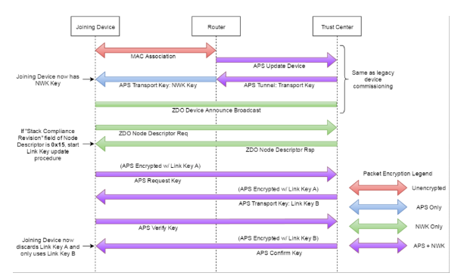
Figure 21: ZigBee 3.0 Network Authentication Process [59]

As discussed before, the ZigBee modules communicate on the ISM 868MHz and 2.4GHz bands, however, it is feasible that radio equipment could be connected to the RS232/RS485 interfaced and used in a manner which contravenes the Wireless Telegraphy Act of 2006, where that be as an unauthorized repeater or a software-controlled Jammer [60]. To discourage this, the system is designed to only be compatible with licensed TETRA handsets and would require unauthorised and relatively extensive software modification for this to be feasible.

4.1.4 | Project Timeline

The greatest concern for the development of the system was time, as with any project there will be a significant number of dependencies and likely challenges in terms of unit, integration, and system testing to ensure that the system is able to satisfy the measures of success.

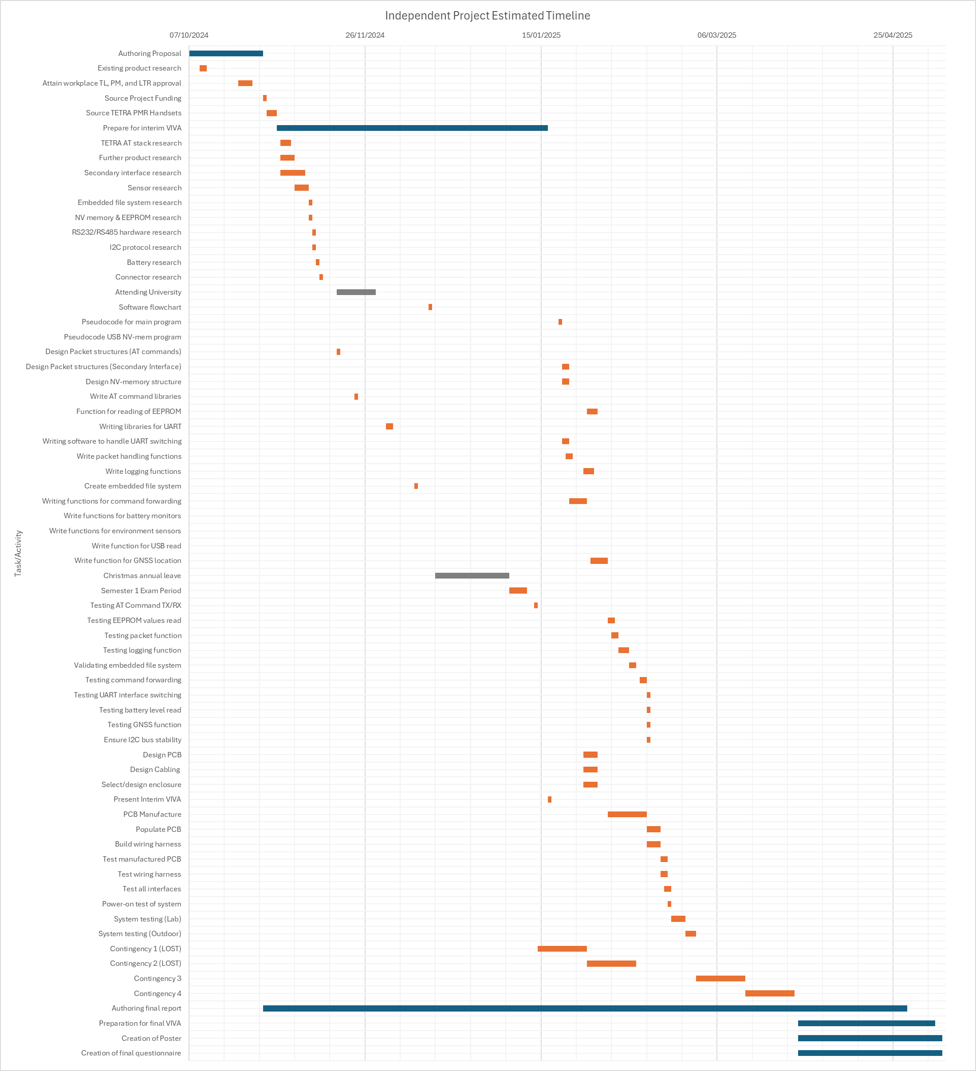
Figure 22: Independent Project Timeline
As can be seen in Figure 22, considerable contingency time (see Contingency 1-4) has been added into the project plan with the aim to ensure that challenges encountered during development or through external factors (absence, illness, other work priority) has a reduced opportunity to derail the project and prevent the project from being successful.

4.2 | Hardware Design

Figure 23 is a hardware level block-design of the system, derived from the hardware requirements specified in the previous section.

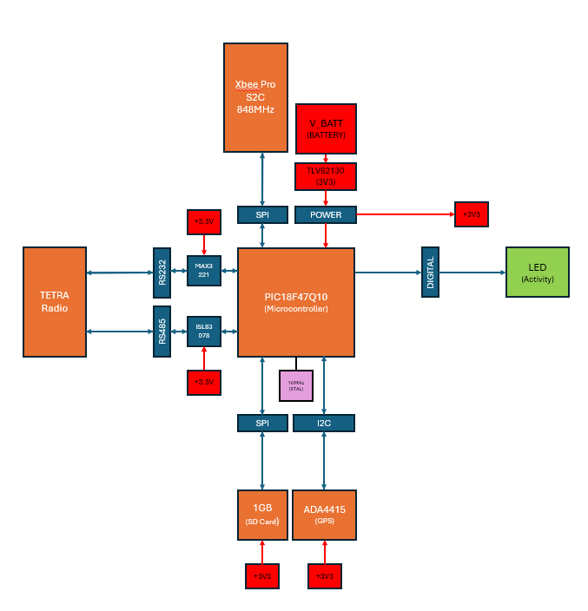
Figure 23: System Block Diagram

| Microcontroller

Utilising the defined hardware requirements for the microcontroller (see Section 3.2.1), the PIC selected for the system is PIC18F47Q10.

This microcontroller is a mid-range PIC, denoted by the ‘18F’ within its model name. A mid-range PIC has been selected as they (usually) possess more RAM and I/O interfaces than an entry level 16F part [61].

The system architecture of a PIC18F series may be observed in Figure 24.

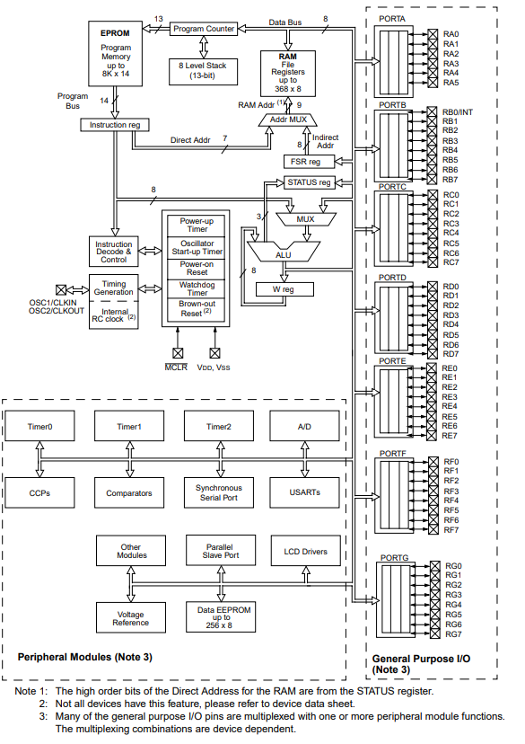
Figure 24: PIC18F Hardware Architecture [62]

The PIC18F47Q10 has a total of 3615kB SRAM available, which is enough memory to utilize the FAT FS library, enabling a FAT32 filesystem to be created, with full read/write access, on an SD card [63].

Beyond this, the PIC also has the following hardware specifications: (Max) 64MHz clock speed, available in QFN-40 Package, Vdd: +1.8V to +5.5V, two USART (UART) interfaces and two MSSP Peripherals (SPI/or I2C).
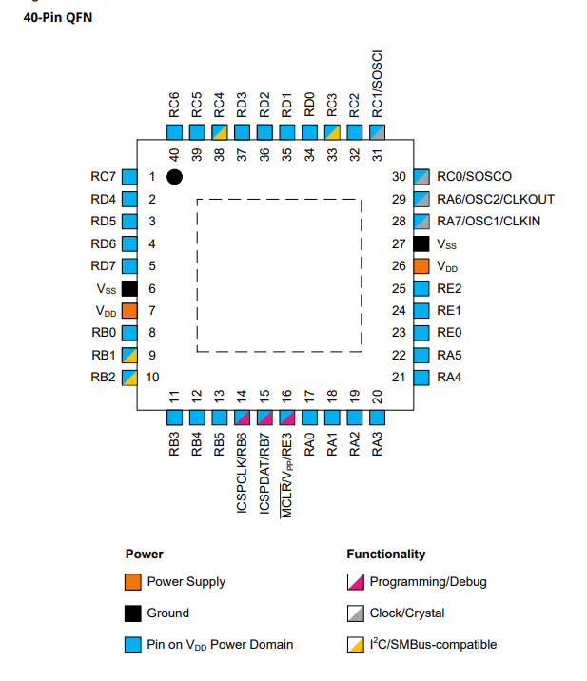
Figure 25: PIC18F47Q10 Pinout [63]

The package configuration selected is the QFN-40 package, which provides 36 I/O (Input/Output) pins in a small (5x5x0.9mm) package size and reduces the area of PCB occupied
by the microcontroller, lowering overall PCB size and therefore cost [64].

$$CPU_{CLOCK}=\frac{CLK_{FREQ}}{N(DOZE BIT)}$$
Equation 1: PIC DOZE Mode [65]

The PIC18F47Q10 also supports the power-saving DOZE mode, which reduces the effective execution frequency of the that given by Equation 1, whilst maintaining the desired clock frequency of the peripherals (UART, SPI, etc.) – the main effect being reduced power consumption at given intervals where execution speed is not important, an interrupt able to be called to revert the PIC to its normal execution speed [65].

| UART Interfaces

The RS485 serial transceiver selected was the ISL83078EIBZA. This is a low-cost line transceiver which converts UART signals to RS485 differential level signals. It requires a 3.3V (+3 to +3.6V) supply, simplifying power plane design as the PIC is powered from 3.3V, and is supplied in an SOIC-8 package, with a low unit cost (£1.76 ea) [66].

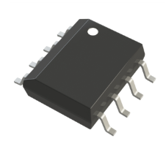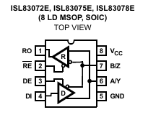
Figure 26: ISL83078EIBZA RS485 Transceiver [67]

The RS232 serial transceiver selected was the MAX3221EIDBR. This is another low-cost line transceiver which converts UART signals to RS232 level signals. It is a 3.3V (+3V to +5.5V) supply transceiver, again simplifying power design, available in an SSOP-16 package to reduce overall board size, with a low unit cost (£0.73 ea) [68].

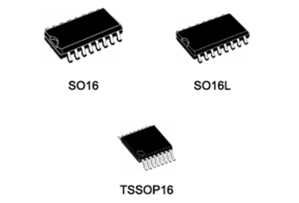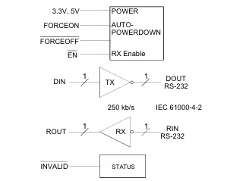
Figure 27: MAX3221EIDBR RS232 Transceiver [43] [40]

Both Renesas, ISL83078EIBZA (RS485), and Analog Devices, MAX3221EIDBR (RS232), are large multinational semiconductor manufacturers, based in Japan and the USA respectively, and have publicly dedicated significant resources to improving that ethical practices, diversity, and sustainability as organisations [69] [70].

| Secondary Wireless/Backhaul Interfaces

It was determined that ZigBee was the most suitable means for wireless communicates between the nodes. This is primarily due the flexibility of network topology/design of ZigBee, the primary benefit being the support within the protocol for meshing, enabling straightforward ad-hoc network expansion.

The selected hardware is a ZigBee 3.0 XB3-24Z8ST-J module, which uses the latest ZigBee 3.0 protocol, and holds regulatory approval from the FCC, IC (North America), ETSI (Europe), RCM (Australia), Anatel (Brazil), Teleck MIC (Japan) and KCC (South Korea) [71] [72]. The module provides a through-hole carrier board with an RP-SMA connector for connecting an external 2.4GHz antenna, as shown in Figure 29.

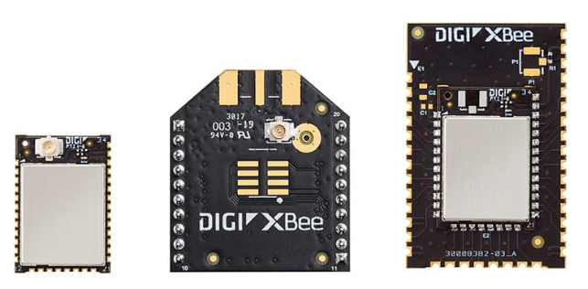
Figure 28: Digi XBee 3 Zigbee 3 RF Modules [72]

The module offers an indoor range of up to 90 metres and an outdoor (line-of-sight) range of 3600 metres, which more than satisfies the range requirement of ~1km of outdoor range between nodes [73], other available (as of this report) XBee 3.0 hardware shown in Figure 28. The module has a maximum transmit power of +8dBm and sensitivity down to -103dBm.

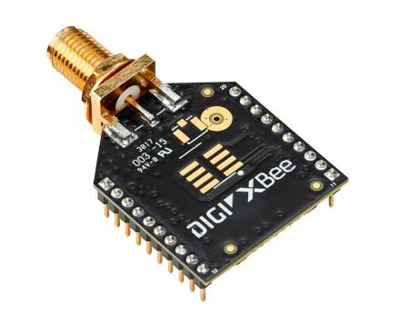
Figure 29: Digi XB3-24Z8ST-J Module [74]

The manufacturer of the ZigBee modules, Digi International, is an ISO 9001 & 14001 accredited organisation, suppling ISM band RF modules, and are accredited by NSF international, an organisation dedicated to health and environmental standards [75] [76].

| Antenna Design / Antenna Specification

This section will cover the antenna design for the ZigBee modules. The specifications gathered through basic calculations will then be used to inform the purchase of an antenna, as the antenna will need to be omni-directional and operate at 2.4GHz – meaning a plethora of antennas as these parameters are common to typical Wi-Fi implementations.

A half-wave antenna has been selected over a quarter-wave antenna due to the relative short wavelength (and therefore antenna length) of a 2.4GHz frequency signal.

Design Characteristics:
- Operating Frequency: 2.4GHz
- Wavelength: 0.125m
- Half Wavelength: 0.0625m

$$λ \left(Wavelength\right)= \frac{c (Speed of Light in Free Space)}{f (Operating Frequency)}$$
Equation 2: Antenna Wavelength Calculations [77]

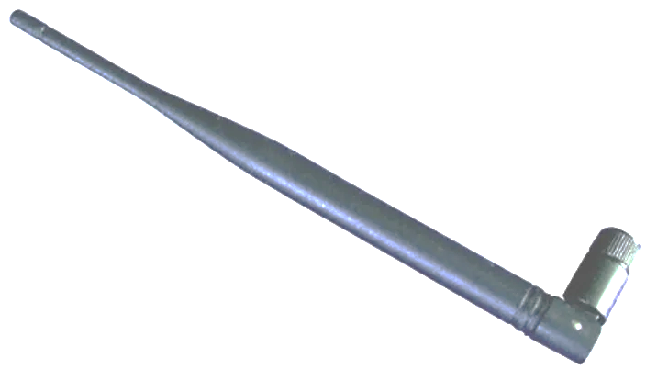
Figure 30: LPRS ANT-2.4G RP-SMA Wi-Fi Antenna [78]

Shown above is the RP-SMA antenna which has been selected for the ZigBee module, which has a nominal input impedance of 50Ω, matching that of the ZigBee module, and a gain of 3dBi [79]. This part is available on RS Components, part no. 532-4525, and manufactured by LPRS (Low Power Radio Solutions), a UK-based (Oxfordshire) designer and manufacturer of RF components operating in license free ISM bands [80].

| SPI Interface & SD/MMC Specification

The micro-SD required for this project would be relatively small, ideally under 2GB to limit the number of blocks on disk which would need to be managed by the FAT.c library. An SD card under this threshold would also allow the use of the more simplistic FAT(16) filesystem, when compared to FAT32/exFAT.

It was discovered that due to the increasing density of NAND flash technology, commercially available SD cards in capacities under 4GB typically were ‘industrial’ units which use the more robust (in terms of max R/W cycles) but less dense (in terms of storage per area) SLC (1-bit per cell) flash rather than the more ubiquitous MLC (2-bit per cell), TLC (3-bit per cell), and QLC (4-bit per cell) flash [81]. This meant that SD cards in capacities up-to 256GB were typically cheaper than those under 4GB due to the cost of SLC vs TLC/QLC NAND [82].

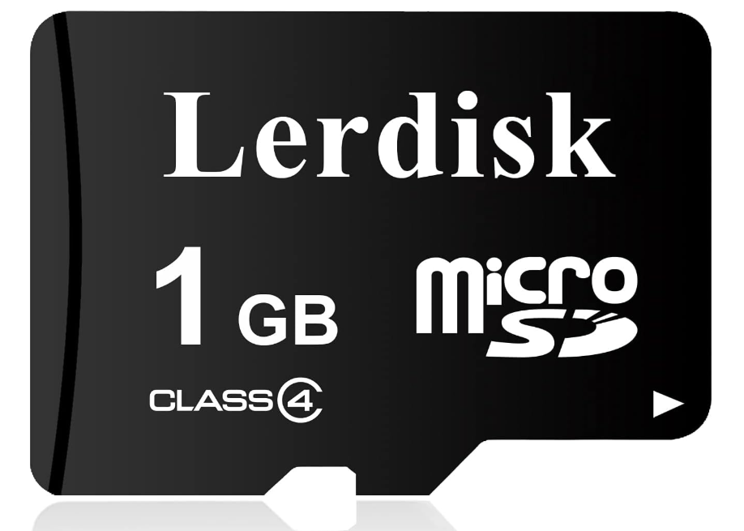

Figure 31: Lerdisk 1GB Class 4 micro-SD Card [83]
As shown in Figure 31, eventually a 1GB Class 4 Micro-SD card was identified on Amazon UK. Despite being 1GB in size, it is an MLC (2-bit flash) based SD card, resulting in a low unit-cost of £2.00 along with £2.49 shipping [83]. The manufacturer, Lerdisk, is based in Changsha in Hunan Province, China, the name Lerdisk itself being applied for as a trademark in 2021 [84]. Lerdisk is predominantly involved in selling non-volatile storage media and trades under the Changsha Technology Co. name – information on the ethical practices of this company were not publicly available to the researcher at the time of writing [84] [85].

$$SPI_{Clock Frequency}=\frac{F_{OSC}}{4} \left| \frac{F_{OSC}}{16} \right|\frac{F_{OSC}}{64} or \frac{TIMER2}{2}$$
Equation 3: PIC18 Hardware SPI Clock Setup [86]
$$PIC_{CPI(Clocks Per Instruction)}=\frac{CPU_{FREQ}}{4}$$
Equation 4: PIC Instruction Speed [86]

To utilise the SPI interface of the Micro-SD card, the SPI interface would need to operate within the frequency range of 100kHz to 400kHz, which on a PIC microcontroller is tied to the system clock with a divider rather than being defined as a given baud rate as for UART or I2C.

To ensure the SPI SD (Secure Digital) card interface is able operate within the permissible speeds, the oscillator frequency will have to be at least 400kHz (Equation 3) for an instruction speed of 100kHz (Equation 4).

| Hardware Schematic

This section showcases the hardware schematics for the system, created using KiCad 7.0.

For the hardware schematic, the hardware components have been split into sheets using KiCad’s hierarchy features, simplifying he overall schematic by using net labels to connect nets globally across the sheets. The root sheet, see Figure 32, is contains the PIC18F47Q10 Microcontroller, along with supporting circuits (crystal oscillator, I2C pullups, & MCLR circuit), with six other sheets shown by labelled boxes in the bottom right containing the remainder of the circuit.

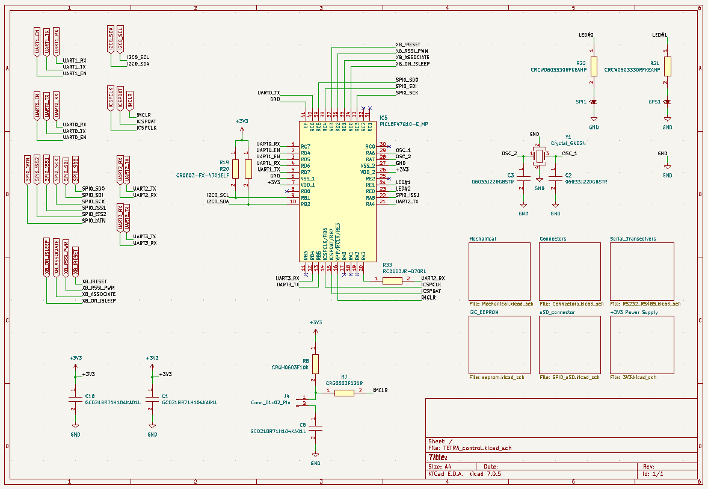

Figure 32: Microcontroller Schematic Sheet

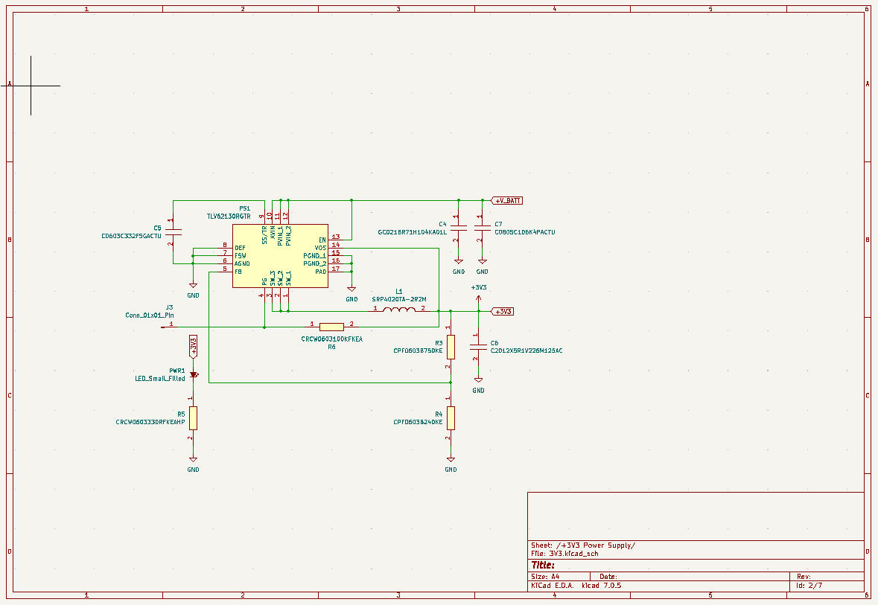
Figure 33: 3V3 Buck Power Supply Schematic Sheet
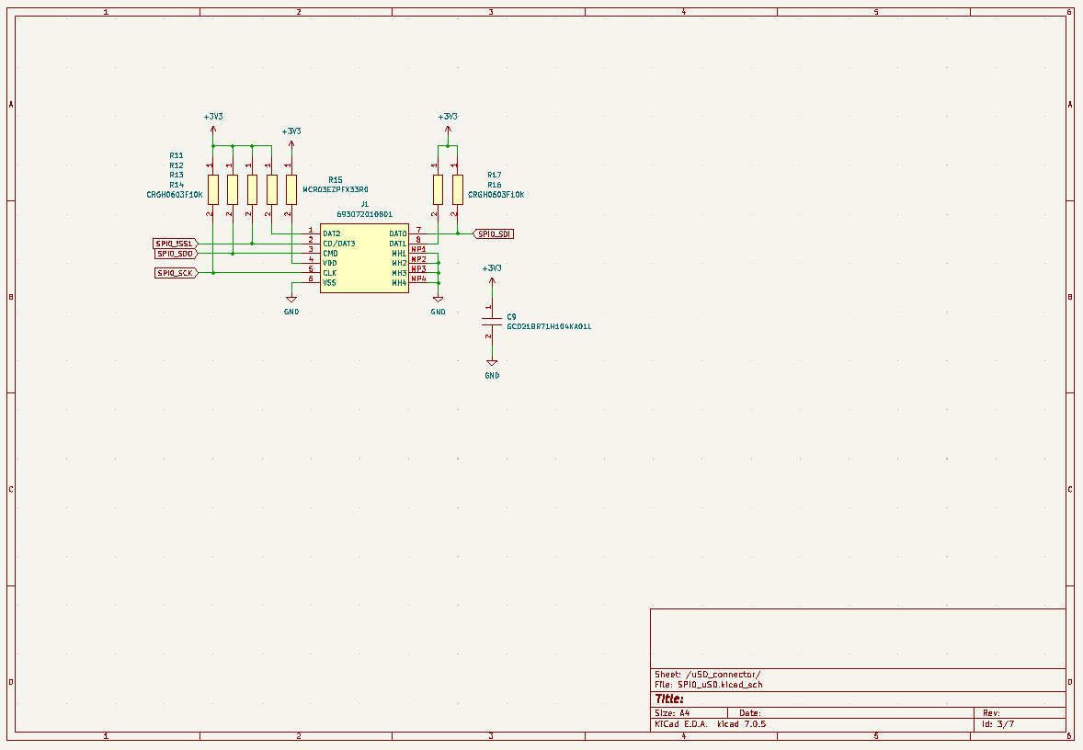
Figure 34: SPI Micro SD Interface Schematic Sheet

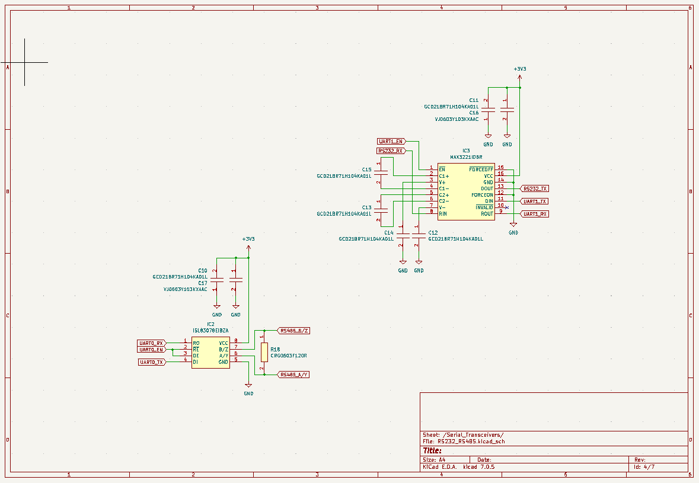
Figure 35: RS485/RS232 Serial Line Transceivers Schematic Sheet
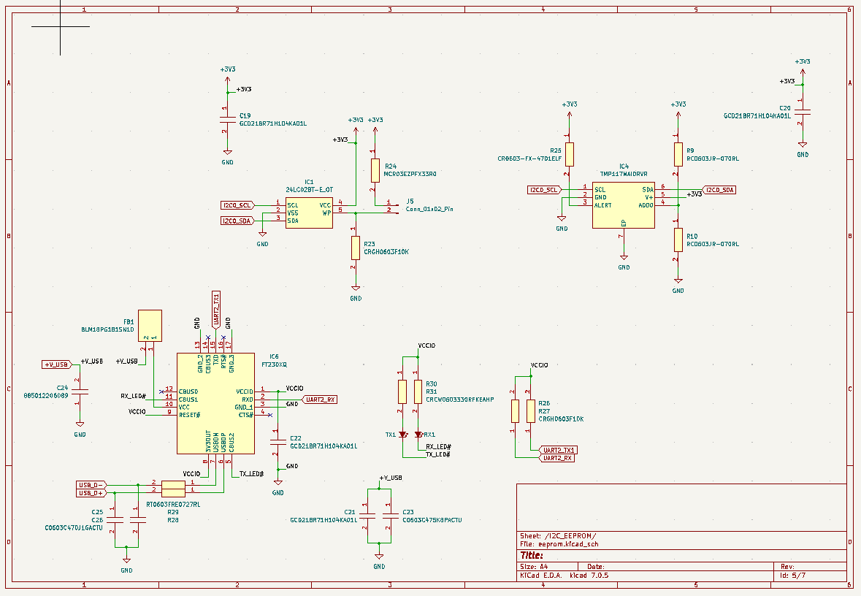
Figure 36: UART to USB, EEPROM, & Temperature Sensor Schematic Sheet

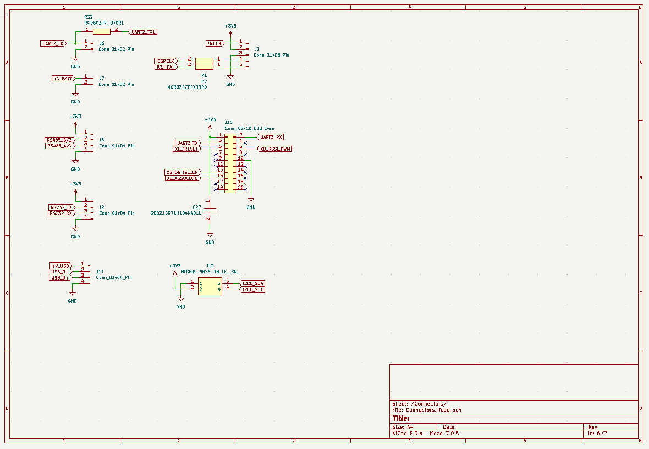
Figure 37: External Connectors Schematic Sheet
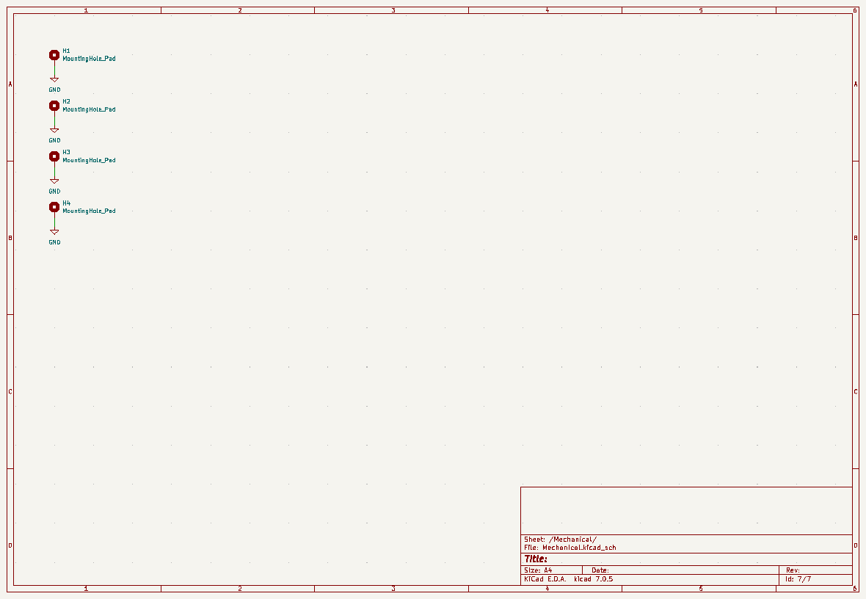
Figure 38: Mechanical Schematic Sheet

4.2.7 | PCB Schematic

This section contains the PCB schematic, which akin to the previous section was created using KiCad 7.0. The reasoning behind the use of KiCad being discussed within the previous section, here with the added benefit of being able to forward design changes from the schematic design into the PCB design.
The PCB design itself consisted of a 4-layer board with square of dimensions 60x60x1.6mm as this board was designed to be used for testing and not be field-deployed. To facilitate testing, a number of test points and unused footprints were added to enable debugging and future development of the software design respectively. Copper pour areas were used in the design to reduce losses (resistance -> heat) within the power plane (+3V3) and to tie all ground (0V) areas where appropriate, the power plane and ground plane constituting the two internal layers of the PCB design.
As can be seen in Figure 39, a significant number of vias (81 – including through-holes) were required in order to route the PCB traces and connect component nets to the +3V3 plane within the PCB, the reason for this being the outer planes were used exclusively for signalling and the design utilising surface mount (SMD) components extensively.
On completion, the DRC (Design Rule Check) feature of KiCad was utilised to check for design errors before the PCB design was exported as the industry-standard ASCII Gerber file type, providing all the data required for manufacture by an external supplier [87].

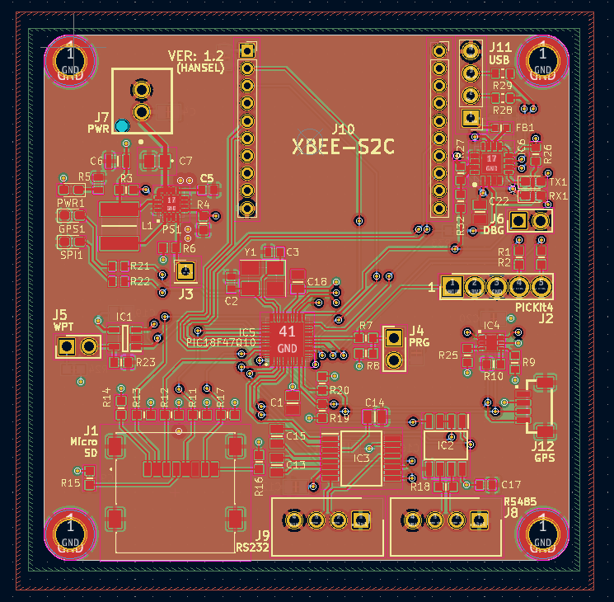
Figure 39: PCB Top Copper & Top Silkscreen (Signalling)
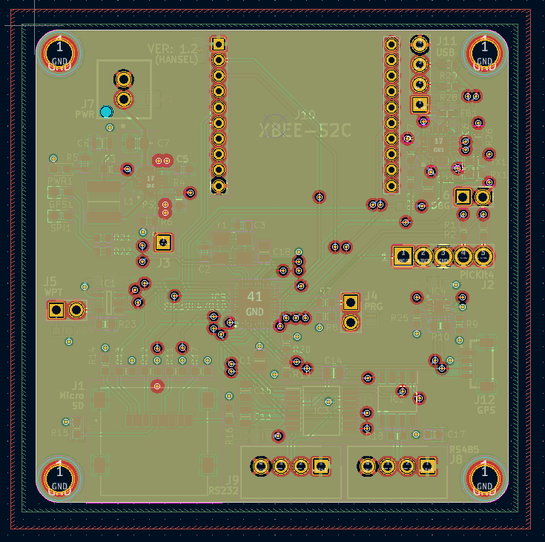
Figure 40: PCB Internal Copper Layer 1 (+3V3)
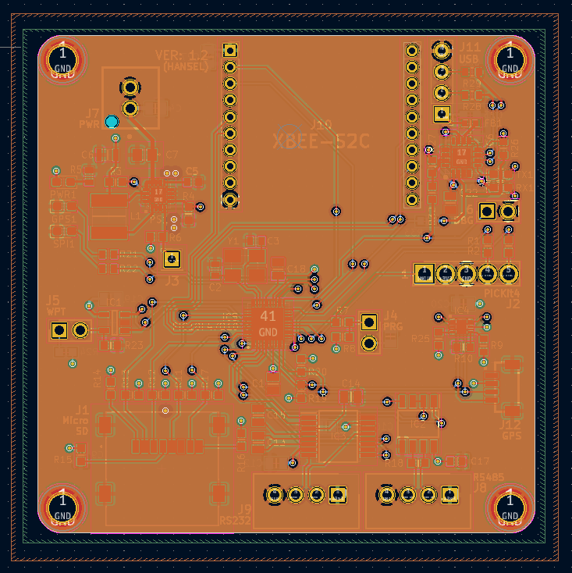
Figure 41: PCB Internal Copper Layer 2 (GND)

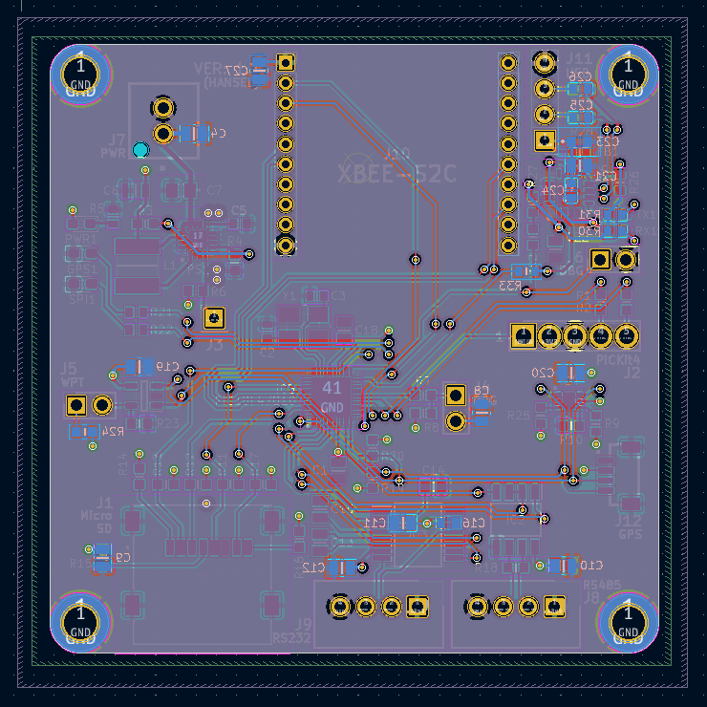
Figure 42: PCB Bottom Copper Layer & Bottom Silkscreen (Signalling)
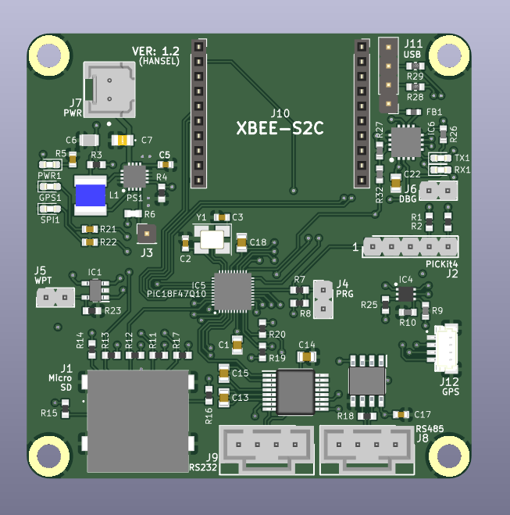
Figure 43: PCB 3D View

4.3 | Software Design

This section will cover the software design of the system, predominantly consisting of flowcharts to capture program flow within the main program and interrupt routines used within the system.

An interrupt routine is a software or hardware mechanism which enables a microcontroller to stop executing the current process, saving it in its current state, and handling an event (triggering the interrupt) which is requesting the immediate attention of the microcontroller’s execution resources [88]. In embedded programming, interrupts are beneficial over hard delays as they allow the microcontroller to manage multiple tasks and execute these tasks without the need for polling, which if over-used wastes time and execution resources [89].

4.3.1 | Main Program

The main program will be short, consisting of a call to the system initialisation sequence followed by a while loop which will contain a handler function to handle all commands given to the system.

Within the handler function, a switch statement will be used to call the appropriate external function using the received command over the UART2/UART3 (USB/ZigBee) interfaces.

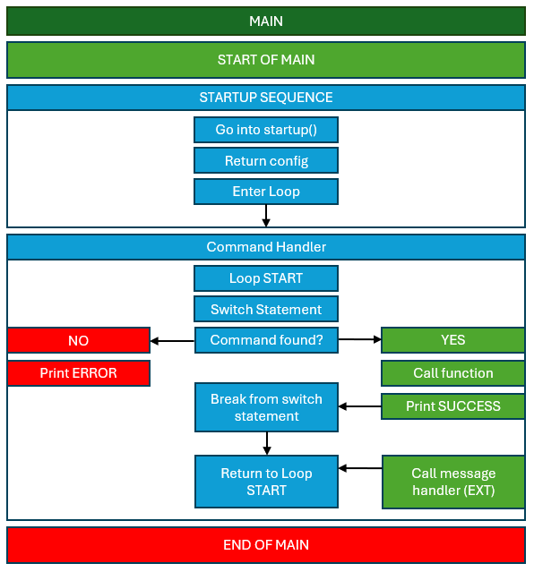
Figure 44: System Software Main Loop

4.3.2 | System Initialisation Sequence

This section contains the software design flowcharts for the system initialisation. Here the aim is to confirm functionality of the attached modules to and to establish communication with the modules via the respective serial interfaces (SPI, I2C, UART). The print blocks within the initialisation signify printing to UART2, which is the FTDI UART to USB serial converter so that the system initialisation messages may be seen via USB connection to a PC with an appropriate terminal emulation such as PuTTy.

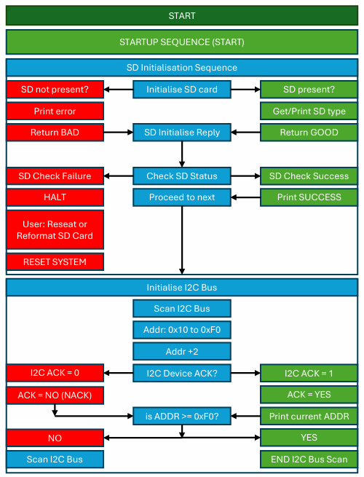
Figure 45: System Initialisation (Part 1)
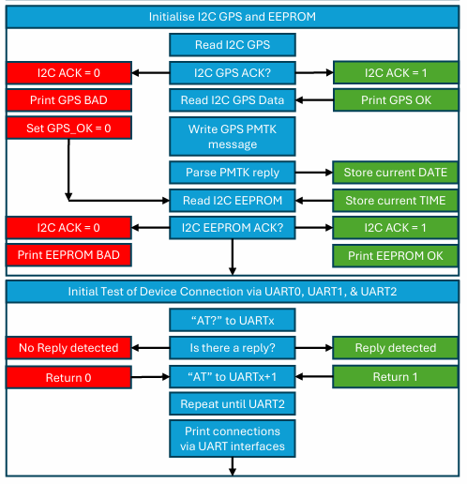
Figure 46: System Initialisation (Part 2)
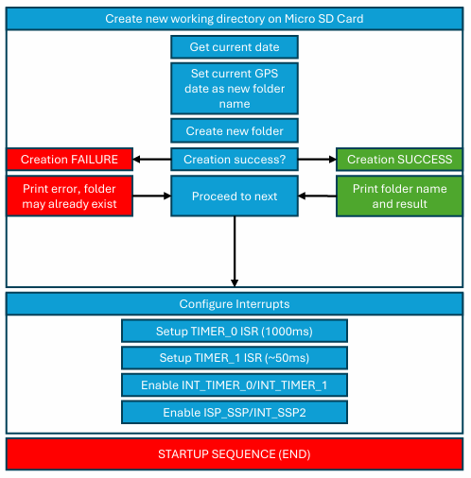
Figure 47: System Initialisation (Part 3)

4.3.3 | UART2/UART3 Timer_1 Interrupt

This flowchart shows the UART2 and UART3 ISR routine, which is utilises the software interrupt TIMER_1, set at an interval of ~68us.

A TIMER interrupt has been used as UART2 and UART3 are software UART ports and therefore do not use a hardware UART peripheral, meaning a time-based interrupt can be used to ensure these UART ports may be checked periodically.

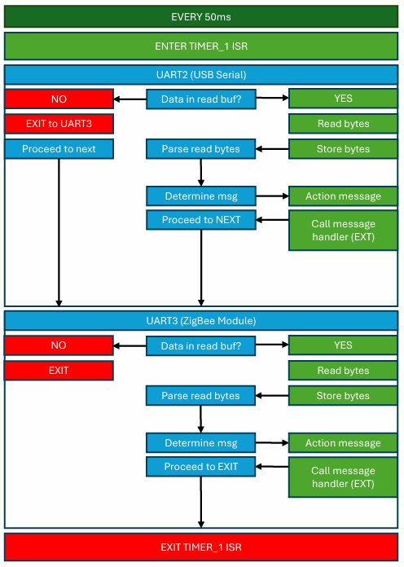
Figure 48: UART/TIMER_1 Interrupt Routine

4.3.4 | System Activity Timer_0 Interrupt

This flowchart shows the TIMER_0 ISR, which simply toggles the LED connected to PIN_E0 ON/OFF until the I2C GPS module has set the GPS_OK variable external to this interrupt to 1, at which point the LED is kept HIGH.

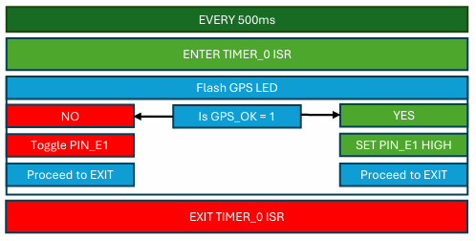
Figure 49: TIMER_0 GPS Lock Interrupt Routine

4.4 | Prototype Simulation

This section covers the simulation of elements of the system using the Proteus Professional Software Package.

Shown in Figure 50 is the simulation prototype developed within the Proteus software package, mainly for testing the SD card interface as this was the biggest unknown for the system development. The two virtual terminal windows show the two states evaluated by this simulation, the eject buttons on the SD card model (directly above the SPI terminal) were used to enter/eject the SD card on RESET (for the PIC).

Validating the SPI interface and at this stage was critical to the project as issues encounter post PCB manufacture could potentially require modifications to the PCB and hardware fixes, leading to significant delay within the project.

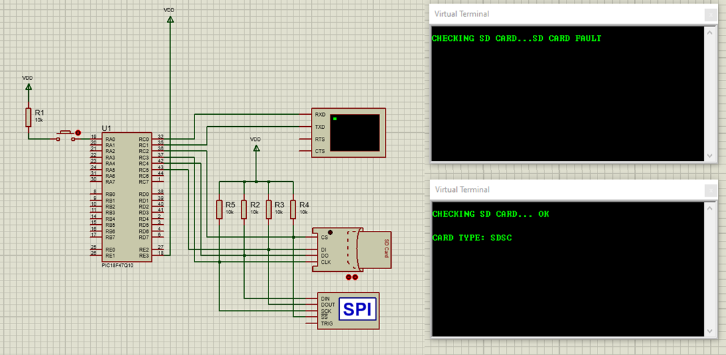
Figure 50: FAT.c Proteus Simulation and Circuit Schematic
Below is the SPI window, showing the sequence of 8 Byte commands used to set the SD card into SPI mode, followed by 80 Bytes of data sent to the SD card to synchronize it to the clock of the 250kHz SPI clock of the PIC microcontroller.

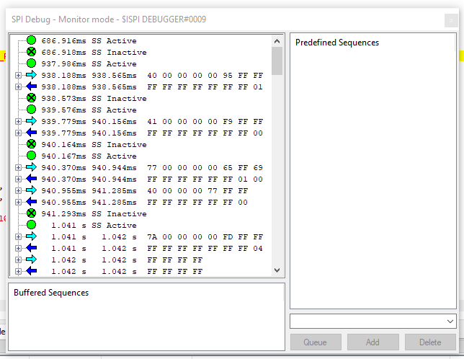
Figure 51: Proteus Simulation SPI Window
Beyond this, the simulation was not carried any further due to the SPI bus/ MSSP1 peripheral not behaving as expected within the simulation. This can be seen in Figure 52 where the program consistently failed to create a folder on the disk.

When viewing the I2C debugger in Proteus it can be seen that there is only no response from the SD card to the SPI command sent by the PIC microcontroller and at which point all other commands, including the re-initialisation of the SPI SD media failed.

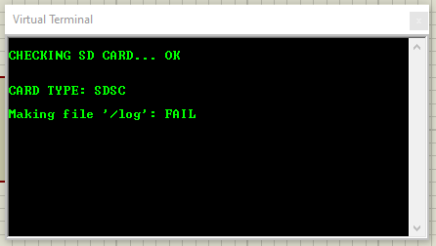
Figure 52: SD Card Initialisation Error
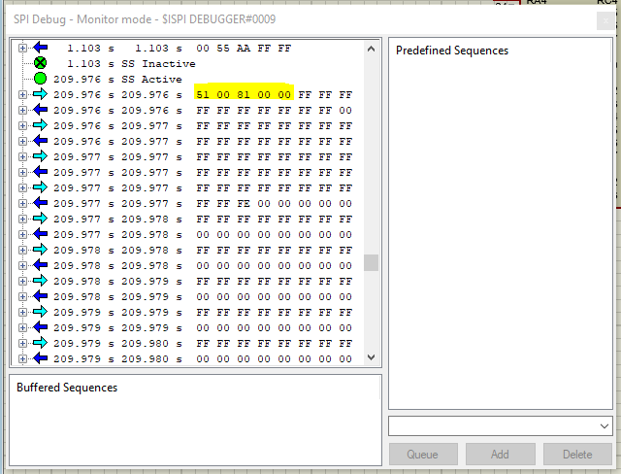
Figure 53: SD Card SPI Debugger
Finally, the software component of the simulation was written in C, initially using Microsoft VS (Visual Studio) Code and then imported to CCS for integration. This was done so that libraries could be developed more easily separately from ‘main.c’.

4.5 | Hardware Implementation

This section covers the hardware implementation of the system post hardware design and may be considered as system manufacture. This involved a considerable amount of soldering and hardware assembly, which also took considerable time as a process, focusing on populating the PCBs using a combination of hot air soldering and a soldering iron. All work was carried out following the workplace and project lab risk assessments.

The PCBs were populated with SMD (Surface Mount) components down to 0603 size for the passive components and QFN-40 for the PIC18F microcontroller. The PCBs were populated by the author to reduce monetary cost for the production of system prototypes.

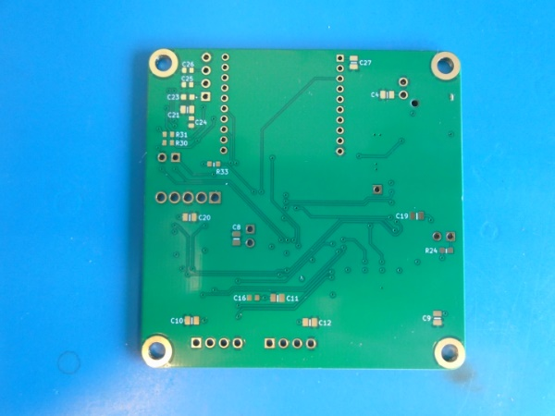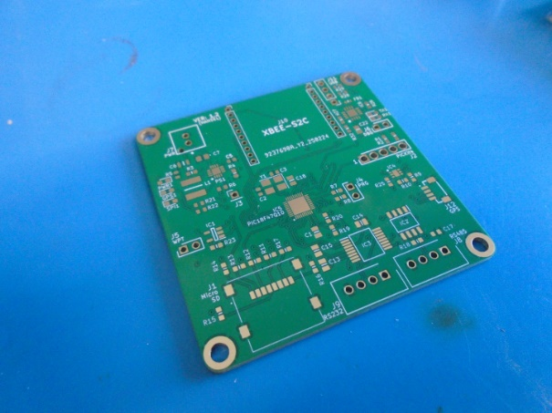
Figure 54: System PCB (back/front, unpopulated)
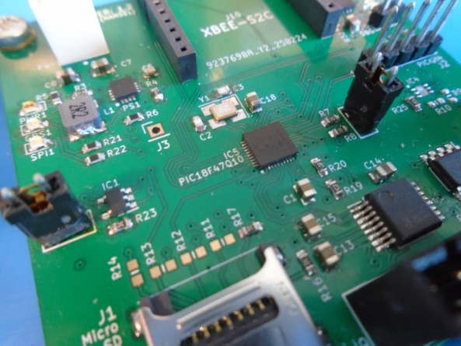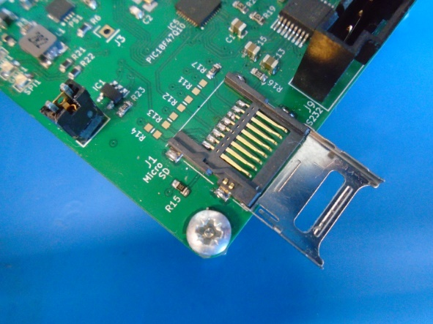
Figure 55: System PCB (front, populated)
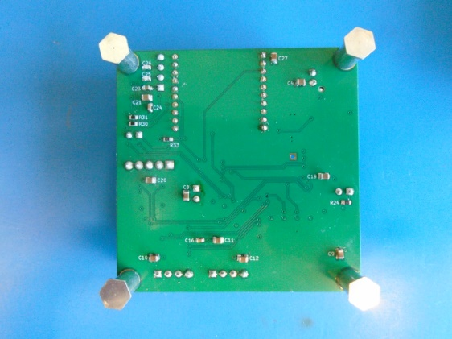
Figure 56: System PCB (rear, populated)
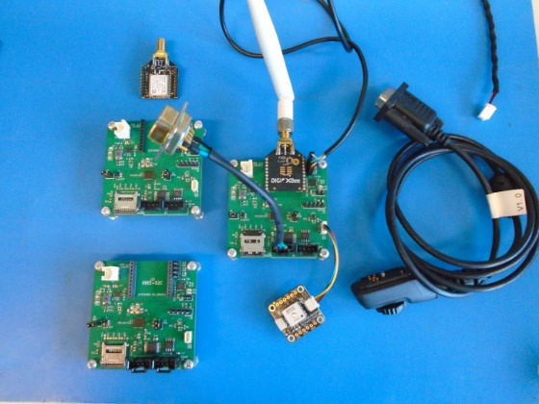
Figure 57: Final System PCBs and accessories
An unexpected requirement was for XCTU (supplied by Digi International) to being needed setup the XBee (ZigBee 3.0) modules before they could be configured to receive commands (at least in case of modules received from supplier). This was resolved using XTCU, Figure 58, and USB to serial carrier boards for the ZigBee modules, Figure 59.

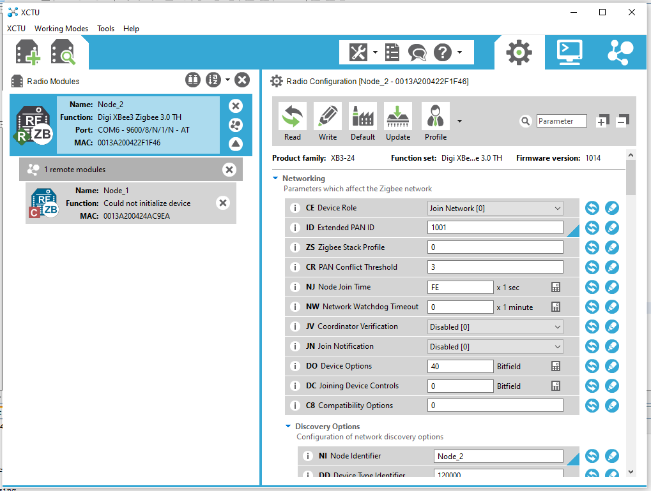
Figure 58: ZigBee module configuration in XTCU
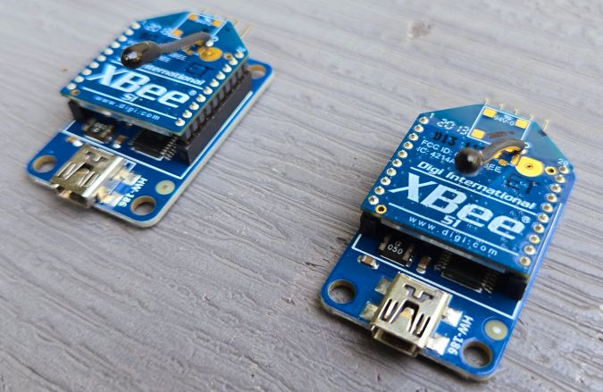
Figure 59: ZigBee carrier boards

4.6 | Software Implementation

The SPI FAT.c ‘mkdir’ command, used to create a test directory on disk, initially just created 1000’s of un-named sub folders on the SD card.

These were not able to be conventionally deleted within windows explorer, requiring re-formatting of the SD card. The issue was found to be the wrong string format for the directory name, which once rectified enabled the creation of these directories.

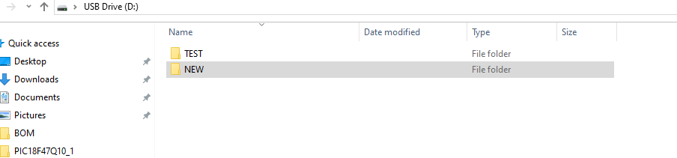
Figure 60: Test directory creation using FAT.c library
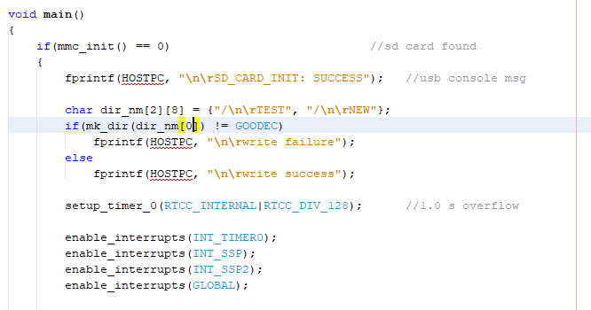
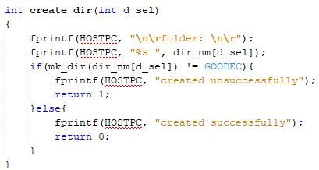
Figure 61: Test directory creation using FAT.c library
This function calls the ‘mk_dir’ function within the FAT.c library and then prints the command outcome onto the serial terminal using the response code returned by the mkdir command.

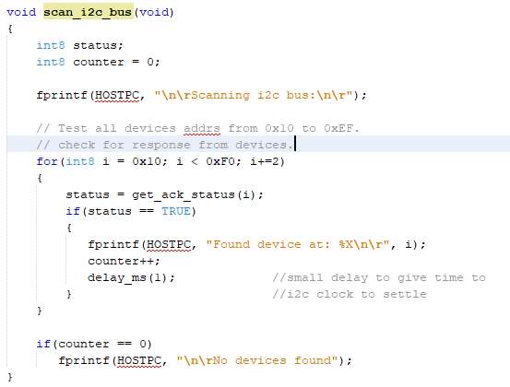
Figure 62: I2C bus scanning
The I2C GPS module was not found by bus scan on module with UART addr COM4, testing with module with UART addr COM1 I2C GPS was found at I2C addr 0x20. This was despite the GPS module powering-up on COM4 module. The reason for this failure was discovered to be soldering flaw (poor quality joint) on the GPS JST connector.

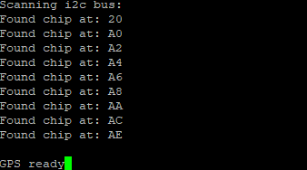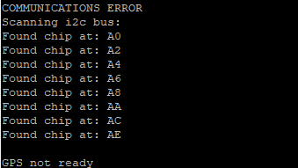
Figure 63: I2C bus scanning GPS found (L) and not found (R) terminal view
The AT Command library (AT_MSG.h/AT_MSG.c) used for the TETRA PEI was created separately using Microsoft VS Code, utilsing the ETSI TS 100 392-5 standard and then merged into the MPLAB X project. This was done due to the code completion features, highlighting, and generally easier/cleaner formatting provided by VS code compared to MPLAB X.

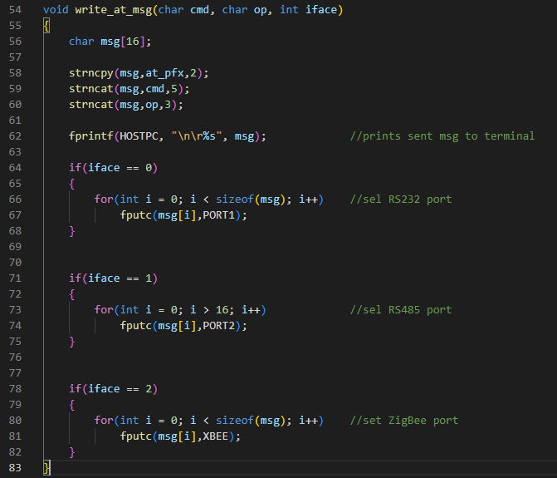

Figure 64: AT message write command
Within the AT message write command uses the C library functions ‘strncpy’ and ‘strncat’ to build a string of characters to be sent as an AT message. These functions were used as they provided bounds-checking and ensured that the message length did not exceed that of the ‘msg[16]’ buffer. This function uses the third input variable to select the serial of which the message is sent to, to allow the use of this function for radio connected via RS232 or RS485 as well as for sending AT messages to the ZigBee module.

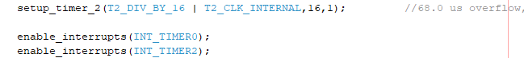
Figure 65: TIMER2_isr setup
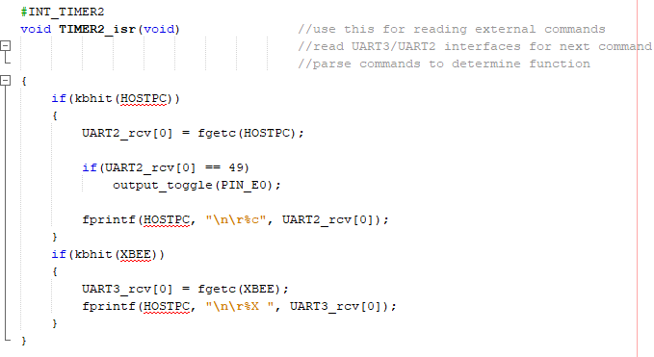
Figure 66: TIMER2_isr
The TIMER2_isr was used as a workaround for the UART2 & UART3 ports, which were software UART ports and therefore could not use the INT_RDA (UART) interrupts as hardware UART ports could [90]. The TIMER2_isr was therefore used with the ‘kbhit(PORTx)’ function to periodically check for bytes received over the two serial UART ports every 68us, allowing for these ports to be read without affecting the overall program flow as they would if within the main loop.

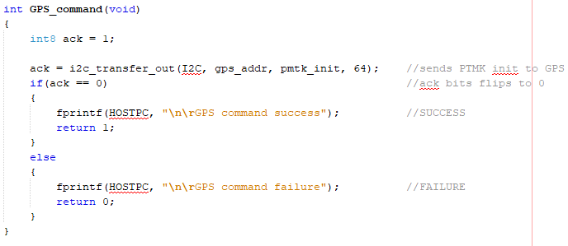
Figure 67: I2C GNSS module PMTK command
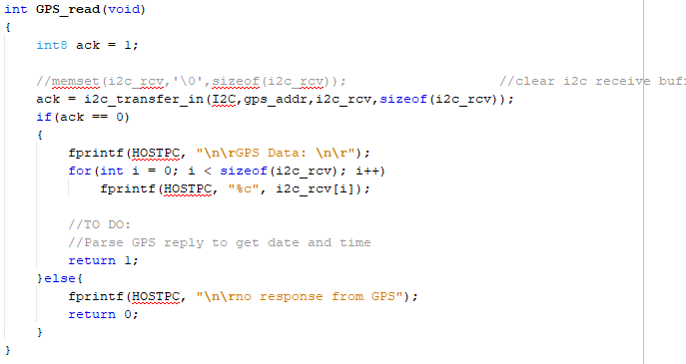
Figure 68: I2C GNSS module PMTK response
PMTK message command was used to send a PMTK message to the GNSS module requesting only the location, time, and date from system – implemented with support of a PMTK command reference manual. The reply was then checked using the response command, first checking for an ACK from the command (to validate receipt) and then printing the response to the USB serial console.

4.8 | Prototype Testing

4.8.1 | Unit Testing

This section gives an outline of the unit testing of functions and their associated hardware which were key to meeting the measures of success for the project. Due to the lack of a screen, extensive use was made of helper strings passed to the USB serial console displayed using the popular terminal emulator application PuTTy.

The first function tested was critical to the system operation, being the initialisation of the SD card media. Here the function would send a sequence of bytes of SPI as an initialisation sequence, using the FAT.c (FAT_m.c) library, which would set the SD card in SPI mode for all R/W(Read/Write) operations until the system is reset. The function was tested to ensure that it returned a 0 (or NACK) to halt execution when an SD card was not inserted into the system.

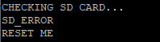

Figure 69: USB Serial Bootup Debugging #3
The GPS initialisation sequence involved sending a PMTK command to the GPS module over the I2C serial interface, checking for an ACK from the GPS module, and then printing the NMEA string returned from the GPS module to the serial terminal connected to the test PC.

Figure 70: USB Serial GPS Initialisation (SUCCESS)
This function shows the next SD function, which utilises the six date characters towards the end of the ‘GNMRC’ NMEA string, see Figure 70, to create a directory within the FAT32 filesystem with the current date as its directory name. If the attempt is unsuccessful, the function prints a warning to the USB serial console.

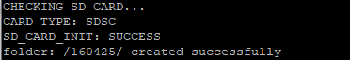
Figure 71: USB Serial Bootup Debugging #1
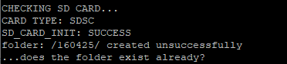
Figure 72: USB Serial Bootup Debugging #2

4.8.2 | System Testing

The system software testing consisted predominantly of what can be considered as white box testing, as the system testing was carried out by a party who has a detailed or complete understanding of how the system under test operates [91]. Akin to the previous section, much of the system testing was supported by the PuTTy terminal emulator application.

Initially, the PICKit 4 ICSP was unable to program the software onto the PIC microcontroller, attempts to program the system returning device ID error of 0x0. This was determined to be the PGC (CLK) pin being connected to Pin 4 of the header instead of Pin 5 and the PGD (DATA) pin being connected in the reverse. A 5 pin 2.54mm jumper cable was used to resolve this by flipping these two pins between the PCB header and PICKit.

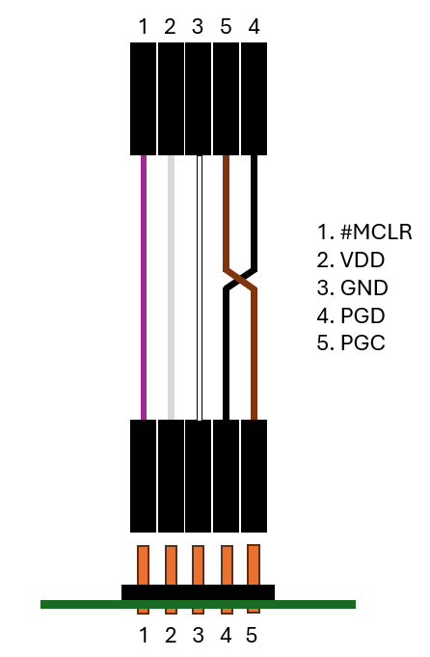
Figure 73: PICKit 4 Header Fix
Interestingly, the ZigBee module was providing not acknowledgement or response to commands over the UART interface when connected to the system, however, the module would respond to commands when attached to a PC.

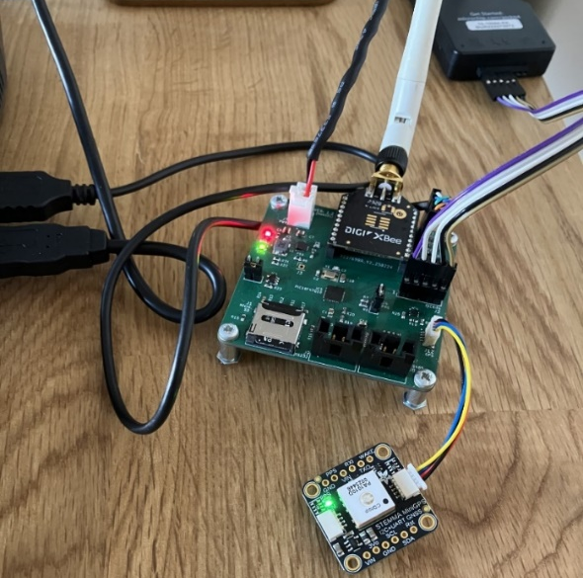
Figure 74: System with external power supply
After debugging this issue, it was found that the PICKit 4 used to supply power to the system during testing was not providing sufficient current to enable the ZigBee module (which helpfully had no LED indicators to show operation) but also not triggering a brownout reset on the PIC microcontroller. Using the onboard SMPs from a +12V supply and disabling power from the PICKit 4 resolved this issue on testing the board with an external power supply.

A single Hytera PT580H PMR handset was then connected via serial cable to the RS232 UART port of the system, testing with the radio connected involved sending the radio commands via UART/RS232 to radio and then checking/reading the response. This was found to be successful with the radio acknowledging and replying to commands sent via RS232.

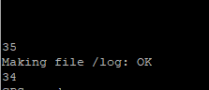

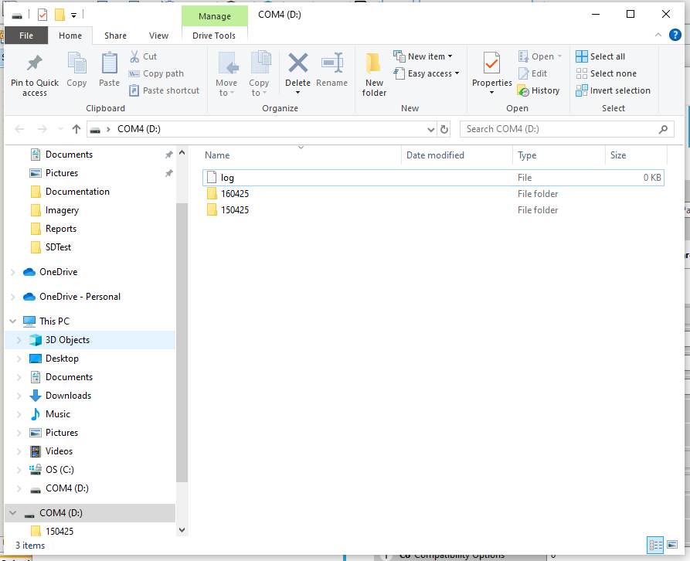
Figure 75: File creation on disk
A significant portion of the system testing was automated, due to much of the hardware being tested by the ‘startup();’ software function (see Appendix A). This allowed for greater repeatability of testing as the initial bring-up of interfaces and result codes were presented to the user via a terminal window in PuTTy.

The file and directory functions were then tested, with a command being sent via ZigBee from the terminal console window in XTCU to the ZigBee module, then received by the system and used to create files and folders on disk, see Figure 75.

4.7 | Bill of Materials

Module | Component Type | Component Label | Value | Tolerance | Part No. | Manufacturer | Supplier | Stock No. | Package | Mounting | Req'd Qty. | Min Qty. | Lab Stock. | Unit Cost (£) | Vendor Link
RHP_001  (PCB) | Capacitor | C1, C4, C8, C9, C10, C11, C12, C13, C14, C15, C18, C19, C20, C21, C22, C27 | 100nF MLCC X7R 50V | 0.1 | GCD21BR71H104KA01L | Murata Electronics | RS Components UK | 247-7725 | 0805 (2012M) | SMD | 16 | 20 |  | 0.077 | https://uk.rs-online.com/web/p/mlccs-multilayer-ceramic-capacitors/2477725?gb=s
RHP_001  (PCB) | Capacitor | C2, C3 | 22pF MLCC 25V | 0.02 | 06033J220GBSTR | Kyocera AVX | RS Components UK | 698-2790 | 0603 (1608M) | SMD | 2 | 5 |  | 0.734 | https://uk.rs-online.com/web/p/mlccs-multilayer-ceramic-capacitors/6982790?gb=s
RHP_001  (PCB) | Capacitor | C5 | 3.3nF MLCC C0G 50V | 0.01 | C0603C332F5GACTU | Kemet | RS Components UK | 146-4264 | 0603 (1608M) | SMD | 1 | 10 |  | 0.63 | https://uk.rs-online.com/web/p/mlccs-multilayer-ceramic-capacitors/1464264?gb=s
RHP_001  (PCB) | Capacitor | C6 | 22uF MLCC X5R 35V | 0.2 | C2012X5R1V226M125AC | TDK | RS Components UK | 915-9334 | 0805 (2012M) | SMD | 1 | 5 |  | 0.332 | https://uk.rs-online.com/web/p/mlccs-multilayer-ceramic-capacitors/9159334?gb=s
RHP_001  (PCB) | Capacitor | C7 | 10uF MLCC X5R 16V | 0.1 | C0805C106K4PACTU | Kemet | RS Components UK | 691-1161 | 0805 (2012M) | SMD | 1 | 10 |  | 0.106 | https://uk.rs-online.com/web/p/mlccs-multilayer-ceramic-capacitors/6911161?gb=s
RHP_001  (PCB) | Capacitor | C16, C17, C24 | 10nF MLCC X7R 50V | 0.1 | 885012206089 | Wurth Elektronik | RS Components UK | 839-2950 | 0603 (1608M) | SMD | 3 | 100 |  | 0.005 | https://uk.rs-online.com/web/p/mlccs-multilayer-ceramic-capacitors/8392950?gb=s
RHP_001  (PCB) | Capacitor | C23 | 4.7uF MLCC X5R 10V | 0.1 | C0603C475K8PACTU | Kemet | RS Components UK | 691-1155 | 0603 (1608M) | SMD | 1 | 25 |  | 0.056 | https://uk.rs-online.com/web/p/mlccs-multilayer-ceramic-capacitors/6911155?gb=s
RHP_001  (PCB) | Capacitor | C25, C26 | 47pF MLCC C0G 100V | 0.05 | C0603C470J1GACTU | Kemet | RS Components UK | 801-5369 | 0603 (1608M) | SMD | 2 | 100 |  | 0.013 | https://uk.rs-online.com/web/p/mlccs-multilayer-ceramic-capacitors/8015369?gb=s
RHP_001  (PCB) | Resistor | R1, R2, R15, R24 | 33Ω (0.1W) | 0.01 | MCR03EZPFX33R0 | ROHM | RS Components UK | 901-3519 | 0603 (1608M) | SMD | 4 | 100 |  | 0.005 | https://uk.rs-online.com/web/p/surface-mount-resistors/9013519?gb=s
RHP_001  (PCB) | Resistor | R3 | 750kΩ (0.063W) | 0.001 | CPF0603B750KE | TE Connectivity | RS Components UK | 666-2263 | 0603 (1608M) | SMD | 1 | 5 |  | 0.216 | https://uk.rs-online.com/web/p/surface-mount-resistors/6662263?gb=s
RHP_001  (PCB) | Resistor | R4 | 240kΩ (0.063W) | 0.001 | CPF0603B240KE | TE Connectivity | RS Components UK | 666-2229 | 0603 (1608M) | SMD | 1 | 5 |  | 0.062 | https://uk.rs-online.com/web/p/surface-mount-resistors/6662229?gb=s
RHP_001  (PCB) | Resistor | R5, R21, R22, R30, R31 | 330Ω (0.25W) | 0.01 | CRCW0603330RFKEAHP | Vishay | RS Components UK | 820-6830 | 0603 (1608M) | SMD | 5 | 25 |  | 0.039 | https://uk.rs-online.com/web/p/surface-mount-resistors/8206830?gb=s
RHP_001  (PCB) | Resistor | R6 | 100kΩ (0.1W) | 0.01 | CRCW0603100KFKEA | Vishay | RS Components UK | 678-9673 | 0603 (1608M) | SMD | 1 | 50 |  | 0.012 | https://uk.rs-online.com/web/p/surface-mount-resistors/6789673?gb=s
RHP_001  (PCB) | Resistor | R7, R18 | 120Ω (0.1W) | 0.01 | CRG0603F120R | TE Connectivity | RS Components UK | 213-2159 | 0603 (1608M) | SMD | 2 | 50 |  | 0.013 | https://uk.rs-online.com/web/p/surface-mount-resistors/2132159?gb=s
RHP_001  (PCB) | Resistor | R8, R11, R12, R13, R14, R16, R17, R23, R26, R27 | 10kΩ (0.2W) | 0.01 | CRGH0603F10K | TE Connectivity | RS Components UK | 807-5364 | 0603 (1608M) | SMD | 10 | 100 |  | 0.014 | https://uk.rs-online.com/web/p/surface-mount-resistors/8075364?gb=s
RHP_001  (PCB) | Resistor | R9, R10, R32, R33 | 0Ω (0.1W/0.2W) | N/A | RC0603JR-070RL | Yageo | RS Components UK | 199-5647 | 0603 (1608M) | SMD | 4 | 100 |  | 0.003 | https://uk.rs-online.com/web/p/surface-mount-resistors/1995647?gb=s
RHP_001  (PCB) | Resistor | R19, R20, R25 | 4.7kΩ (0.1W) | 0.01 | CR0603-FX-4701ELF | Bourns | RS Components UK | 740-8877 | 0603 (1608M) | SMD | 3 | 50 |  | 0.007 | https://uk.rs-online.com/web/p/surface-mount-resistors/7408877?gb=s
RHP_001  (PCB) | Resistor | R28, R29 | 27Ω (0.05W) | 0.01 | RT0603FRE0727RL | Yageo | RS Components UK | 198-5511 | 0603 (1608M) | SMD | 2 | 10 |  | 0.014 | https://uk.rs-online.com/web/p/surface-mount-resistors/1985511?gb=s
RHP_001  (PCB) | Crystal | Y1 | 16MHz | 20ppm | 830108207109 | Wurth Elektronik | Mouser UK | 710-830108207109 | MT-4 (3.2x2.5mm) | SMD | 1 | 1 |  | 0.355 | https://www.mouser.co.uk/ProductDetail/Wurth-Elektronik/830108207109?qs=hWgE7mdIu5S4RrKLDzbRQg%3D%3D
RHP_001  (PCB) | Ferrite Filter | FB1 | 1.5A (180Ω @ 100MHZ) | N/A | BLM18PG181SN1D | Murata Electronics | RS Components UK | 724-1393 | 0603 (1608M) | SMD | 1 | 25 |  | 0.005 | https://uk.rs-online.com/web/p/ferrite-beads/7241393?gb=s
RHP_001  (PCB) | Diode | D1, D2, D3, D4, D5 | 2.1V 20mA Red (633nm) LED | N/A | TLMS1100-GS15 | Vishay | Mouser UK | 78-TLMS1100-GS15 | 0603 (1608M) | SMD | 5 | 10 |  | 0.225 | https://www.mouser.co.uk/ProductDetail/Vishay-Semiconductors/TLMS1100-GS15?qs=vvQtp7zwQdNk2zSA55pnGQ%3D%3D
RHP_001  (PCB) | DC-DC Converter | PS1 | 1ch 3A (4V-17V_IN) | N/A | TLV62130RGTR | Texas Instruments | RS Components UK | 825-3684 | QFN-16 (3.15x3.15x0.95mm) | SMD | 1 | 5 |  | 1.22 | https://uk.rs-online.com/web/p/buck-converters/8253684?gb=s
RHP_001  (PCB) | Inductor | L1 | 2.2uH 4A (Wire-wound) | 0.2 | SRP4020TA-2R2M | Bourns | RS Components UK | 825-1896 | 4020 (4.45x4.06x1.8mm) | SMD | 1 | 5 |  | 1.01 | https://uk.rs-online.com/web/p/surface-mount-inductors/8251896?&gb=s
RHP_001  (PCB) | IC | IC1 | 2kbit Serial-I2C EEPROM | N/A | 24LC02BT-E_OT | Microchip | RS Components UK | 727-5986 | SOT-23 (5-Pin) | SMD | 1 | 10 |  | 0.217 | https://uk.rs-online.com/web/p/eeprom/7275986?&gb=s
RHP_001  (PCB) | IC | IC2 | Serial UART to RS485 Transceiver | N/A | ISL83078EIBZA | Renesas Electronics | RS Components UK | 235-8855 | SOIC (8-Pin) | SMD | 1 | 5 |  | 1.784 | https://uk.rs-online.com/web/p/line-interface-ics/2358855?gb=s
RHP_001  (PCB) | IC | IC3 | Serial UART to RS232 Transceiver | N/A | MAX3221IDBR | Texas Instruments | RS Components UK | 660-8196 | SSOP (16-Pin) | SMD | 1 | 5 |  | 0.608 | https://uk.rs-online.com/web/p/line-interface-ics/6608196?gb=s
RHP_001  (PCB) | IC | IC4 | Serial I2C Temperature Sensor | N/A | TMP117MAIDRVR | Texas Instruments | RS Components UK | 268-3627 | QFN-6 | SMD | 1 | 2 |  | 0.895 | https://uk.rs-online.com/web/p/temperature-humidity-sensor-ics/2683627?gb=s
RHP_001  (PCB) | IC | IC5 | 8-bit Microcontroller | N/A | PIC18F47Q10-E_MP | Microchip | RS Components UK | 193-6509 | QFN-40 (5x5x0.9mm) | SMD | 1 | 5 |  | 1.124 | https://uk.rs-online.com/web/p/microcontrollers/1936509?gb=s
RHP_001  (PCB) | IC | IC6 | FTDI USB2.0 to UART Converter | N/A | FT230XQ-R | FTDI Chip | RS Components UK | 757-0026 | QFN-16 | SMD | 1 | 2 |  | 1.81 | https://uk.rs-online.com/web/p/uart/7570026?gb=s
RHP_001  (PCB) | Connector | J1 | Micro SD Memory Card Connector | N/A | 693072010801 | Wurth Elektronik | RS Components UK | 763-6801 | N/A | SMD | 1 | 1 |  | 2.96 | https://uk.rs-online.com/web/p/memory-card-connectors/7636801?gb=s
RHP_001  (PCB) | Connector | J2 | C Grid III, 1x05 2.54mm Header | N/A | 90120-0125 | Molex | RS Components UK | 670-5035 | N/A | THT | 1 | 5 |  | 0.632 | https://uk.rs-online.com/web/p/pcb-headers/6705035?gb=s
RHP_001  (PCB) | Connector | J3 | DNP (Test Point) | N/A | N/A | N/A | N/A | N/A | N/A | N/A | 0 | 0 | Y | 0 | none
RHP_001  (PCB) | Connector | J4, J5, J6 | C Grid III, 1x02 2.54mm Header | N/A | 90120-0122 | Molex | RS Components UK | 670-5029 | N/A | THT | 3 | 5 |  | 0.394 | https://uk.rs-online.com/web/p/pcb-headers/6705029?gb=s
RHP_001  (PCB) | Connector | J7 | Mini-Lock, 1x02 2.54mm Header | N/A | 53375-0210 | Molex | RS Components UK | 720-6397 | N/A | THT | 1 | 10 |  | 0.119 | https://uk.rs-online.com/web/p/pcb-headers/7206397?gb=s
RHP_001  (PCB) | Connector | J8, J9 | SL Series, 1x04 2.54mm Header | N/A | 70543-0003 | Molex | RS Components UK | 679-2471 | N/A | THT | 2 | 10 |  | 0.99 | https://uk.rs-online.com/web/p/pcb-headers/6792471?gb=s
RHP_001  (PCB) | Connector | J10 | C Grid III, 1x10 2.54mm Header | N/A | 90147-1110 | Molex | Mouser UK | 538-90147-1110 | N/A | THT | 2 | 10 |  | 1.16 | https://www.mouser.co.uk/ProductDetail/Molex/90147-1110?qs=QESXi79X%252BKo0C1MvTu3yVg%3D%3D
RHP_001  (PCB) | Connector | J11 | C Grid III, 1x04 2.54mm Header | N/A | 90120-0124 | Molex | RS Components UK | 670-5032 | N/A | THT | 1 | 5 |  | 0.586 | https://uk.rs-online.com/web/p/pcb-headers/6705032?&gb=s
RHP_001  (PCB) | Connector | J12 | JST SH, 1x04 1.00mm Header | N/A | BM04B-SRSS-TB(LFSN) | JST | RS Components UK | 515-1541 | N/A | THT | 1 | 10 |  | 0.441 | https://uk.rs-online.com/web/p/pcb-headers/5151541?gb=s
RHP_001  (PCB) | Bare PCB | PCB001 (Option 1) | Bare PCB, ENIG Lead-Free (UK Origin) | N/A | PCB001 | N/A | Newbury Electronics | N/A | 60x60x1.6mm (4-layer) | SMD/THT | 1 | 5 |  | 30.47 | pcbtrain.co.uk/services/pcb-fabrication
RHP_001  (PCB) | Bare PCB | PCB001 (Option 2) | Bare PCB, ENIG Lead-Free (China Origin) | N/A | PCB001 | N/A | JLCPCB | N/A | 60x60x1.6mm (4-layer) | SMD/THT | 1 | 5
RHP_002  (USB_UART_CABLE) | USB C Breakout | USB001 | USB C Female PCB Breakout | N/A | POL-3411 | Pololu | The PiHut | POL-3411 | PCB Breakout (1.27x2.4mm) | THT | 1 | 1 | Y | 3.4 | https://thepihut.com/products/pololu-usb-2-0-type-c-connector-breakout-board-usb07b?
RHP_002  (USB_UART_CABLE) | USB Cable | USB002 | USB Type A to USB C Cable | N/A | 236-9157 | RS PRO | RS Components UK | 236-9157 | Cable (500mm) | N/A | 1 | 1 |  | 5.87 | https://uk.rs-online.com/web/p/usb-cables/2369157?gb=s
RHP_002  (USB_UART_CABLE) | Board Connector | USB003 | C Grid III, 1x04 2.54mm Connector | N/A | 90156-0144 | Molex | RS Components UK | 360-6134 | N/A | THT | 1 | 5 |  | 2.36 | https://uk.rs-online.com/web/p/wire-housings-plugs/3606134?gb=s
RHP_002  (USB_UART_CABLE) | Cable Crimps | USB004 | C Grid III, Female Crimp Terminal | N/A | 90119-2110 | Molex | RS Components UK | 360-6869 | 22/24AWG | THT | 4 | 100 | Y | 0.238 | https://uk.rs-online.com/web/p/crimp-contacts/3606869?gb=s
RHP_003  (GPS) | GPS Module | GPS001 | PA1010D I2C/UART GPS | N/A | 4415 | Adafruit | Mouser UK | 485-4415 | PCB (25.5x25.4x8.2mm) | N/A | 1 | 1 |  | 23.61 | https://www.mouser.co.uk/ProductDetail/Adafruit/4415?qs=xZ%2FP%252Ba9zWqatKwX%252B9rp%2FIw%3D%3D
RHP_003  (GPS) | JST SH QWIIC Cable | GPS002 | 50mm 4-wire I2C (+3.3V & GND) | N/A | PRT-14426 | SparkFun | Mouser UK | 474-PRT-14426 | 50mm | N/A | 1 | 1 |  | 0.77 | https://www.mouser.co.uk/ProductDetail/SparkFun/PRT-14426?qs=wd5RIQLrsJiogglVGK6o1w%3D%3D
RHP_004  (ZigBee) | ZigBee Module | ZBM001 (Option 1) | XBee-S2C RPSMA (MESH VERSION) | N/A | XB24CDMSIT-001 | Digi International | Mouser UK | 888-XB24CDMSIT-001 | PCB (24.38x27.61mm) | THT | 1 | 1 |  | 23.12 | https://www.mouser.co.uk/ProductDetail/Digi/XB24CDMSIT-001?qs=XmMZR4xR0DDHBWHJZQYv7A%3D%3D
RHP_004  (ZigBee) | ZigBee Module | ZBM001 (Option 2) | XBee-S2C RPSMA (PROGRAMMABLE) | N/A | XB24CZ7SITB003 | Digi International | Mouser UK | 888-XB24CZ7SITB003 | PCB (24.38x27.61mm) | THT | 1 | 1 |  | 26.63 | https://www.mouser.co.uk/ProductDetail/Digi/XB24CZ7SITB003?qs=3VJ0tGt%252Bi1xfIG35mFP4lw%3D%3D
RHP_004  (ZigBee) | SMA Lab Cable | ANT001 | SMA to SMA 50Ω Cable | N/A | 253-0100 | Amphenol RF | RS Components UK | 135101-01-M0.25 | 250mm | SMA/CABLE | 2 | 1 |  | 12.07 | https://uk.rs-online.com/web/p/coaxial-cable/2530100?gb=s
RHP_004  (ZigBee) | SMA Attenuator | ANT002 | 15dB 50Ω 1.4W Fixed Inline Attenuator | 0.3dB | VAT-15A+ | Mini-Circuits | Mouser UK | 139-VAT-15A+ | FF704 | SMA/CABLE | 1 | 1 |  | 18.44 | https://www.mouser.co.uk/ProductDetail/Mini-Circuits/VAT-15A+?qs=Jm2GQyTW%2FbiQkK1Ue5C8ZA%3D%3D
RHP_004  (ZigBee) | 2.4GHz ISM Antenna | ANT003 | TBC (IN DESIGN) | N/A
RHP_005  (PICKit4) | PIC Programmer | PRG001 | In-circuit Programmer | N/A | PG164140 | Microchip | RS Components UK | 171-7762 | N/A | N/A | 1 | 1 | Y | 92.56 | https://uk.rs-online.com/web/p/debuggers-in-circuit-emulators/1717762?&gb=s
RHP_005  (PICKit4) | PIC Programmer | PRG001 | In-circuit Programmer | N/A | PG164150 | Microchip | RS Components UK | 273-5061 | N/A | N/A | 1 | 1 | N | 99.31 | https://uk.rs-online.com/web/p/debuggers-in-circuit-emulators/2735061?&gb=s
RHP_005  (PICKit4) | PIC Prog Cable | PRG002 | 2.54mm 5-Pin cable | N/A
RHP_006  (Micro_SD) | Micro SDHC Card | SDC001 | 512MB Industrial SLC uSD UHS-I | -40 to 85°C | AF512UDI-5AFXM | ATP | RS Components UK | 195-8358 | N/A | N/A | 1 | 1 | N | 17.81 | https://uk.rs-online.com/web/p/sd-cards/1958358?gb=s
RHP_006  (Micro_SD) | Micro SD Card | SDC001 | 4GB TLC uSD Class-4 | 0 to 60°C | INMSDH4G4V2 | Integral Memory | RS Components UK | 180-5791 | N/A | N/A | 1 | 1 | N | 6.59 | https://uk.rs-online.com/web/p/sd-cards/1805791?gb=s
RHP_006  (Micro_SD) | USB SD Card Reader | SDC002 | USB SD Card Reader | N/A

Component Label | Part No. | Manufacturer | Supplier | Stock No. | Min Qty | Unit (£)
C1, C4, C8, C9, C10, C11, C12, C13, C14, C15, C18, C19, C20, C21, C22, C27 | GCD21BR71H104KA01L | Murata Electronics | RS Components UK | 247-7725 | 20 | 0.077
C2, C3 | 06033J220GBSTR | Kyocera AVX | RS Components UK | 698-2790 | 5 | 0.734
C5 | C0603C332F5GACTU | Kemet | RS Components UK | 146-4264 | 10 | 0.63
C6 | C2012X5R1V226M125AC | TDK | RS Components UK | 915-9334 | 5 | 0.332
C7 | C0805C106K4PACTU | Kemet | RS Components UK | 691-1161 | 10 | 0.106
C16, C17, C24 | 885012206089 | Wurth Elektronik | RS Components UK | 839-2950 | 100 | 0.005
C23 | C0603C475K8PACTU | Kemet | RS Components UK | 691-1155 | 25 | 0.056
C25, C26 | C0603C470J1GACTU | Kemet | RS Components UK | 801-5369 | 100 | 0.013
R1, R2, R15, R24 | MCR03EZPFX33R0 | ROHM | RS Components UK | 901-3519 | 100 | 0.005
R3 | CPF0603B750KE | TE Connectivity | RS Components UK | 666-2263 | 5 | 0.216
R4 | CPF0603B240KE | TE Connectivity | RS Components UK | 666-2229 | 5 | 0.062
R5, R21, R22, R30, R31 | CRCW0603330RFKEAHP | Vishay | RS Components UK | 820-6830 | 25 | 0.039
R6 | CRCW0603100KFKEA | Vishay | RS Components UK | 678-9673 | 50 | 0.012
R7, R18 | CRG0603F120R | TE Connectivity | RS Components UK | 213-2159 | 50 | 0.013
R8, R11, R12, R13, R14, R16, R17, R23, R26, R27 | CRGH0603F10K | TE Connectivity | RS Components UK | 807-5364 | 100 | 0.014
R9, R10, R32, R33 | RC0603JR-070RL | Yageo | RS Components UK | 199-5647 | 100 | 0.003
R19, R20, R25 | CR0603-FX-4701ELF | Bourns | RS Components UK | 740-8877 | 50 | 0.007
R28, R29 | RT0603FRE0727RL | Yageo | RS Components UK | 198-5511 | 10 | 0.014
Y1 | 830108207109 | Wurth Elektronik | Mouser UK | 710-830108207109 | 1 | 0.355
FB1 | BLM18PG181SN1D | Murata Electronics | RS Components UK | 724-1393 | 25 | 0.005
D1, D2, D3, D4, D5 | TLMS1100-GS15 | Vishay | Mouser UK | 78-TLMS1100-GS15 | 10 | 0.225
PS1 | TLV62130RGTR | Texas Instruments | RS Components UK | 825-3684 | 5 | 1.22
L1 | SRP4020TA-2R2M | Bourns | RS Components UK | 825-1896 | 5 | 1.01
IC1 | 24LC02BT-E_OT | Microchip | RS Components UK | 727-5986 | 10 | 0.217
IC2 | ISL83078EIBZA | Renesas Electronics | RS Components UK | 235-8855 | 5 | 1.784
IC3 | MAX3221IDBR | Texas Instruments | RS Components UK | 660-8196 | 5 | 0.608
IC4 | TMP117MAIDRVR | Texas Instruments | RS Components UK | 268-3627 | 2 | 0.895
IC5 | PIC18F47Q10-E_MP | Microchip | RS Components UK | 193-6509 | 5 | 1.124
IC6 | FT230XQ-R | FTDI Chip | RS Components UK | 757-0026 | 5 | 1.81
J1 | 693072010801 | Wurth Elektronik | RS Components UK | 763-6801 | 1 | 2.96
J2 | 90120-0125 | Molex | RS Components UK | 670-5035 | 5 | 0.632
J3 | N/A | N/A | N/A | N/A | 0 | 0
J4, J5, J6 | 90120-0122 | Molex | RS Components UK | 670-5029 | 5 | 0.394
J7 | 53375-0210 | Molex | RS Components UK | 720-6397 | 10 | 0.119
J8, J9 | 70543-0003 | Molex | RS Components UK | 679-2471 | 10 | 0.99
J10 | 90147-1110 | Molex | Mouser UK | 538-90147-1110 | 10 | 1.16
J11 | 90120-0124 | Molex | RS Components UK | 670-5032 | 5 | 0.586
J12 | BM04B-SRSS-TB(LFSN) | JST | RS Components UK | 515-1541 | 10 | 0.441
PCB001 (Option 1)  (Not used) | PCB001 | N/A | Newbury Electronics | N/A | 5 | 30.47
PCB001 (Option 2) | PCB001 | N/A | JLCPCB | N/A | 5 | 4.03
USB001  (Not used) | POL-3411 | Pololu | The PiHut | POL-3411 | 1 | 3.4
USB002  (Not used) | 236-9157 | RS PRO | RS Components UK | 236-9157 | 1 | 5.87
USB003  (Not used) | 90156-0144 | Molex | RS Components UK | 360-6134 | 5 | 2.36
USB004  (Not used) | 90119-2110 | Molex | RS Components UK | 360-6869 | 100 | 0.238
GPS001 | 4415 | Adafruit | Mouser UK | 485-4415 | 1 | 23.61
ZBM001 (Option 1) | XB24CDMSIT-001 | Digi International | Mouser UK | 888-XB24CDMSIT-001 | 1 | 23.12
ZBM001 (Option 2) | XB3-24Z8ST-J | Digi International | Digikey UK | 602-2186-ND | 2 | 21.29
ANT001 | ANT-2.4G | LPRS | RS Components UK | 532-4525 | 1 | 10.27
PRG001  (Option 1) | PG164140 | Microchip | RS Components UK | 171-7762 | 1 | 92.56
PRG001  (Option 2)  (Not used) | PG164150 | Microchip | RS Components UK | 273-5061 | 1 | 99.31
PRG002 | FT232RL USB to Serial for XBEE | Hailege | Amazon UK | N/A | 2 | 4.85
SDC001 | B0D28LVBP4 | Lerdisk | Amazon UK | N/A | 3 | 4.60

4.8 | Expenditure

Using the BOM, the total project expenditure was: £248.933, leaving £1.06 of the £250 project budget unspent.

| Results & Discussion

Results

Overall, the project was a partial success in regard to the core measures of success. Below are the results considered against the four core measures of success, where the system was able to:

- Communicate with a TETRA radio handset via an RS232 interface and issue call commands to the handset, however a 2nd TETRA handset was no longer available to test/validate the system receiving data from a live call.
- The system was able to successfully bring-up an 1GB micro-SD card via SPI at 250kHz and create new directories and files on the disk when issued commands over the ZigBee and USB Serial Interfaces of the system.
- The system was able to use communicate with the GNSS module via the I2C peripheral of the PIC microcontroller and read GPS information such as the date, time, and location of the system; the system was able to use the GPS Date/Time and create directories and files using this information.
- The system was not able to be configured as a MESH network, due to financial limitations. However, the system was successfully tested in point-to-point mode.

Discussion

The TETRA PEI functionality of the system worked as expected, the system was able to communicate with the TETRA PMR handset over an RS232 interface, sending AT commands to the system and receive the expected responses.

The loss of the 2nd TETRA handset was an unexpected difficulty however did not have a significant impact on results as the call functionality within TETRA is well defined and the provided the connected radio initiates the call, the receiving system should operate as intended. However, it would have still held value from a validation perspective to be able to confirm this and in the future, it would be critical that the project is the asset owner of the PMR handsets.

The filesystem functionality utilising the SPI interface and FAT32 interface worked as expected and the system was able to read and write files and folders onto the SD card, which were then accessible via Windows 10.

The system was able to effectively communicate with the GNSS module over an I2C interface to enable file and folder creation using live date and time. However, whilst the GPS location was read by the system, it was not stored into a buffer or logged to the files on the SD media. It would be beneficial to make more use of the GNSS module and also track location periodically to extend the value of the system.

In total of three systems were manufactured, this number being the minimum required to form a ZigBee meshed network. However, only two ZigBee modules were purchased due to budget constraints, where the price of a third module brought the overall budget to over the £250 limit given by the authors workplace organisation. In a similar vein, only one GNSS receiver module was purchased, again due to budget constraints, and fitted to one of the systems. The systems without GNSS or ZigBee connectivity could be considered ‘fitted-for-but-not-with’ as the software codebase deployed across the systems is identical.

The I2C temperature sensor and EEPROM were not implemented in software due to time constraints and a hardware design flaw with the EEPROM power circuitry on the PCB. Utilising these would add value to the system overall, providing environmental information and allowing for storage of network authentication keys, hardware IDs, and other useful data on the EEPROM rather than within the flash memory embedded onto the PIC.

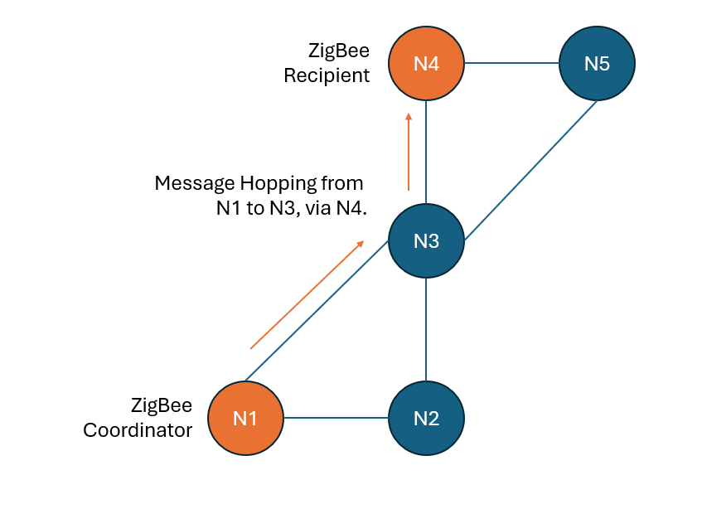
Figure 76: ZigBee node hopping
One element of the system which was not considered was the measurement of effective transmit and receive range of the system with the chosen antenna option, for future development/commercialisation. This would be essential to commercialising the product, as it would be useful for the customer to have an understand of the read-world effective range of the system alongside the manufacturer range estimates for the ZigBee (XB3) module from Digi International, as well as the maximum range when utilising the node hopping functionality of ZigBee to increase system range.

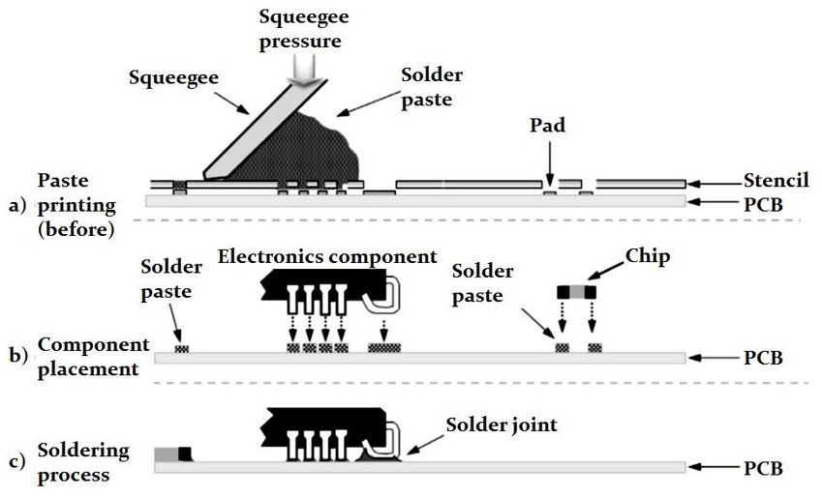
Figure 77: Pick and Place PCB Assembly [92]
Finally, whilst the project was mostly successful, considerable time was lost to the hardware assembly, debugging, and testing partly due to the planned population of the PCBs using workplace facilities. Whilst it was achievable, it required considerable patience and would be better carried by the PCB manufacturer in the future to reduce time cost which most likely outweighed the extra cost of the PCB being populated by the supplier, as shown in Figure 77.

6 | Conclusion and Future Recommendations

6.1 | Project Conclusion

In most aspects project was successful, fully or at least partially meeting the project goals through the measures of success. The project delivered a radio management system which was able to be controlled via local USB UART interface, being able to forward commands across nodes wirelessly using the ZigBee network protocol. The delivered system consisted of a three identically populated PCBs, two of which had a ZigBee RF module, alongside a software component written in C-language deployed onto the microcontroller present on each of the PCBs.

The core benefit and value proposition of this being that the system was able to automate network/radio functions which would otherwise require a user to physically interact with the connected TETRA PMR radio, as discussed within the research introduction of this project. The system was also able to automatically log network and GPS data onto a micro-SD card, using the FAT32 filesystem over an SPI interface, which was then able to be read using a PC using the Windows 10 OS (Operating System).

Due to time constraints, core research objectives of the project were prioritised, an example of this would be the I2C EEPROM and Temperature sensor not being implemented into the software program on the PIC microcontroller – as overall system operation was not dependent on these.

6.2 | Hardware Recommendations

This section will consider recommendations for improvements to the system hardware, listed with estimated timeframes for delivery.

6.2.1 | Short Term ( > 1 Month )

Hardware Design

- Specifying a suitable battery and enclosure.
- Add WEEE labelling to PCB silkscreen.
- Add a POWER/RESET button to the board or power cable to enable easier testing.

Hardware Manufacture

- Move to having PCB manufacturer assemble and validate PCB design.
- Populating each of the three PCBs developed was difficult using workplace lab facilities and time consuming, as code had to be developed solely for the purpose of testing the modules to validate hardware functionality during and post assembly.

6.2.2 | Medium Term ( 1 – 3 Months )

Hardware Design

- Altering form-factor of PCB to move away from desk-based prototype 60x60x1.6mm design to one that fits the form factor of a PMR radio (PCB Design).
- Utilise an RS-232/RS-485 multiprotocol transceiver rather than separate RS-232/RS-485 PHY transceivers would reduce system complexity, releasing a hardware UART port, and reducing board size – therefore PCB manufacturing cost.
- Add ideal diodes in an OR configuration on the ICSP +3V3 and the +VIN line of the +3.3V SMPS so that both may be connected at once with power enabled.
- Mount the GNSS module directly to the PCB, rather than as an auxiliary module connected via a QWIIC (I2C, + Power/GND) connector.
- Add an RTC (Real Time Clock) for edge case if GNSS module fails to track satellite.
- Move the USB UART debug port from a header to an onboard USB C connector.
- Add voltage monitor to +VIN of SMPS, could be used to monitor battery voltage.

Hardware Errata

- Fix the erroneously mounted SD card slot which is in the 180° to the intended direction.
- Fix the PICKit4 ICSP header as the PGC (Pin 5) and PGD (Pin 4) are flipped.
- Reposition PicKit4 ICSP header closer to the board edge as a horizonal connector, so that a riser/jumper cable is not required to connect the programmer to the board.
- Isolating the USB/UART converter completely from the SMPS +3.3V power plane.

6.3 | Software Recommendations

This section will consider recommendations to improve the system software, each grouped by estimated timeframes for delivery.

6.3.1 | Short Term ( > 1 Month )

Software Design

- Flash SPI LED during SPI read/writes to and from the SD card.
- Use the I2C EEPROM and Temperature sensor modules to capture temperature data and store hardware ID.
- Add a function to monitor system supply voltage. This could be used to generate a flag from an interrupt to notify other devices on network of imminent node shutdown.
- Implement functions to request more data from the GPS module than Date, Time, and Location.

Software Errata

- Reuse SD card initialisation code to allow for detection of SD card presence post boot-up before all operations/functions interacting with the SPI SD card and FAT32 filesystem, allowing for detection of SD card failure during operation or accidental removal by the system operator.

6.3.2 | Medium Term ( 1 - 3 Months )

Software Design

- Develop the command handler function on the modules to use string-based messages rather than single byte tokens, allowing for greater breadth/complexity of commands.
- If separate RS-232 and RS-485 PHY transceivers are maintained, enable for two TETRA PMR handsets to be connected to and managed by the system.
- Make use of PIC power-saving modes such as DOZE to reduce system power consumption when no network activity.
- Enable AES encryption on ZigBee modules and implement functions to facilitate this.

6.3.3 | Long Term ( 3+ Months )

Software Design

- Enable the use of the BLE (Bluetooth Low Energy) module found within the ZigBee module to enable local communication from control equipment (computer) with the ZigBee module via a Bluetooth serial link.
- Move to a more modern C compiler than CCS C compiler (C90-compliant) which is compliant with at least the ISO 9899-2011 (C11) standard to modernise the codebase.
- Functionality added to provide radio management for non-TETRA PMR, such as DMR (Digital Mobile Radio) a competing standard to TETRA [93], greater system flexibility.

6.4 | Commercialisation

Standards Compliance

Standards compliance is critical component for ensuring that systems development is carried out using the correct process, giving confidence to stakeholders and customers, protecting an organisation’s assets and reputation, as well as ensuring that key lessons identified can be learned from and used to further improve process [94].

Although not considered for development of a prototype within this report, if this product were to be developed by an organisation, compliance with the ISO 9001:2015 QMS (Quality Management System) standard would be of significant value both to system development but also to ensuring that the final product meets customer expectations [95]. The ISO 9001:2015 QMS being a framework for organisations to develop robust quality management systems at every stage of development, with a core focus of continuous improvement [96].

The codebase was developed using the CCS C Compiler, which is generally adherent to the ANSI/ISO 9899:1990 (C89) standards [97]. Whilst the code is therefore compliant to an international standard, the standard is outdated when considering the current standard the ISO/IEC 9899:1990 standard has been withdrawn and supplanted on multiple occasions with the current standard being ISO/IEC 9899:2024 (C24) [98]. Whilst the C90-standard code is largely portable to newer compilers, it should be noted that features introduced within later standards, such as the ‘bool’ data type, may not be used in CCS C compiler as it is a C99 feature [99]. However, C89/C90 is still widely used within embedded development. For instance, ARM’s Keil Compilers are still based on C90 [100].

Version control

Linking back to the ISO 9001:2015 QMS, for standards compliance it is essential that record keeping is maintained and actively managed to evidence compliance [101]. In the context of the codebase development for this project, version control of the software was ad-hoc in nature, with the system codebase only stored locally on a standalone computer system.

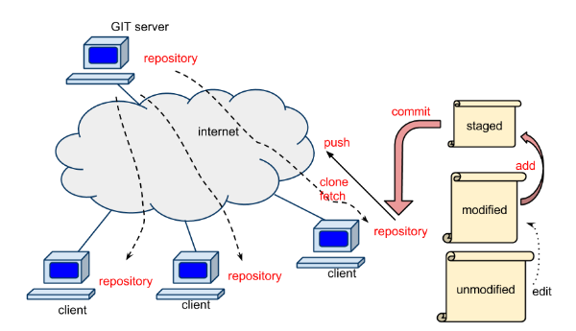
Figure 78: Typical Git Server Implementation [102]
To commercialise the codebase of the project, it would be essential to improve record keeping, perhaps through the use of a Git server for record keeping and version/access control. Git is a freely available and open source, under the GNU GPL V2.0 license, VCS (Version Control System) which enables separate local development with three areas, a working directory (current development), a staging area (merge fixes to main project), and the git repository (where the project is stored) [103]. This enables multiple users to work concurrently on the same codebase and maintain effective version control.

Following the above, the versioning of system components could also be conducted by using semantic version numbering system embedded into the hardware/software. Semantic versioning is a system using three numbers, the most significant being the major version (signifying a large change, breaking compatibility with the previous major version), the next number being the minor version (signifying a smaller change such as the addition of a feature), and the least significant being a patch (i.e., bugfixes to existing code) – see Figure 79 [104] [105].

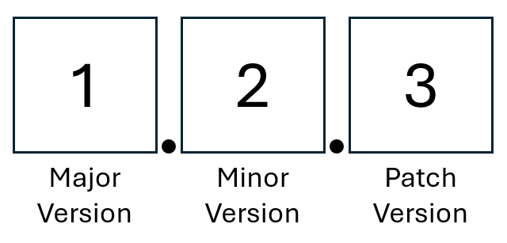
Figure 79: Semantic Versioning
Semantic versioning would ensure that the hardware which is sold commercially is versioned appropriately and not able to be confused with hardware used by the organisation for development only. This would ensure that hardware versions are easily identifiable using there semantic numbering system.

Intellectual Property

The ‘FAT.c’, ‘MMCSD.c’ libraries used within this project are provided with the CCS compiler and are the intellectual property of Custom Computer Solutions (CCS). Permission would need to be sought from CCS in order to utilise these libraries within a commercial product, which would be unlikely to approved due to software licensing at would be at an unknown cost [106]. A solution to this issue would be to use the ‘FAT FS’ libraries earlier in this report, which are written to the ANS/ISO 9866:1989 (C89) standard and port this to the PIC microcontroller family, as this is provided as open-source under a BSD-style license [107].

The hardware IP (Intellectual Property) from suppliers for the system has not been considered, as the key hardware such as XBee (ZigBee) modules and PIC microcontroller are copyrighted/protected only for the hardware design of the components and documentation, rather than for the integration into a commercial system [108] [109].

To protect the IP of the system itself, an application for a utility patent may be considered suitable. The purpose of a utility patent is to protect the intellectual property of a novel idea of a hardware product and how it operates, with the caveat that the idea must be novel/an original idea and offers 20-years of protection if the patent is approved by the IPO (Intellectual Property Office, UK). The overall cost of a patent application in the UK through the IPO being ~£300 [110] [111].

Diversity and Inclusion

A diverse and inclusive project team would be critical to ensuring the commercial success of this project. A diverse and inclusive team would facilitate a wider breath of knowledge, skills, and innovation in the context of the project, it would also allow for the project to be split into roles based on the technical skills of each team member [112]. A diverse team could also potentially produce a more objective team, which would be greatly beneficial during project planning and avoid the entrenchment of bad ideas or negative attitudes and therefore help to ensure that continuous improvement at all phases of the product from initial concept to product release [113] - generating value for all stakeholders.

Regarding the delegation of roles for the project, a projected team to deliver this project as follows:

- Embedded Software Engineer (Software Development, Unit Testing)
- Hardware Engineer (Hardware Development, Unit Testing)
- Test Engineer (System Testing, Legislative Compliance Testing)
- Project manager (Project tracking, management)
- Procurement manager (Licensing and Purchasing)
- Commercial Officer (Patenting, System Marketing)

This team should be recruited from a range of diverse background, whilst ensuring that the technical knowledge for each role is held by each team member. Appointment to the team should be considered utilising the core principles of the civil service (UK), those being integrity, honesty, objectivity, and impartiality [114]. The team should also regularly convene as a whole, perhaps weekly, to share project focus and share knowledge and idea – ensuring that the Project Manager has oversight to the project.

Environmental Awareness

A key hardware component for this project has been the manufacture of a PCB. The manufacture of PCB’s is a resource-intensive project (in terms of energy use and raw materials) and may release substantial amounts of toxic chemicals and pollutants into the atmosphere, as well as being difficult (and expensive) to recycled at the end of their lifespan [115].

In the UK and EU, PCB manufacturers are subject to the RoHs (Restriction of Hazardous Substances in Electrical and Electronic Equipment, 2003) Directive and REACH Regulation (2007), which aim to limit the use of toxic materials and chemicals (such as Lead, i.e., Lead Solder) used in all electronics manufacturing to reduce the human and environmental impact of electronics manufacture [116] [117]. Currently, 14.4 million tonnes of electrical equipment is sold in the EU in each year, with only 5 million tonnes of electrical equipment collected and recovered each year [118]. In the context of this project, this would require assurance that the PCB design is compliant with both REACH and RoHs, with markings to confirm this to the customer clearly shown on the PCB or hardware enclosure.


Figure 80: WEEE Labelling [119]
It would also be important that at EOL (End of Life), it be disposed of in a manner which is complaint with the WEEE (Waste from Electrical and Electronic Equipment, 2003). Whilst this would be unenforceable by the organisation selling this system, use of clear and mandated WEEE labelling on the system enclosure/hardware would promote proper recycling by the end user and help to ensure material recovery the EOL system [118].

7 | Reflection

Overall, I was largely happy with the outcome of this project, even though the final outcome did not fully satisfy the measures of success. I certainly believe that the research area and hardware developed within this report is of value and further development would only add value to the project.

7.1 | Professional Development

This project gave me further insight into how an SPI interface works and also how resource intensive operating a full FAT32 filesystem on a resource constrained microcontroller can be. With this being said, I was pleased that I had taken the opportunity to research the requirements for using the filesystem libraries, as even with 3.5kB of RAM, the total RAM use of my program was still between 1.5kB and 2.0kB.

I also learned how to design a PCB for manufacture, which consisted of predominantly of surface mount components and in the process greatly improved my hot air soldering skills when populating the PCBs with components.

In the context of software development, I also learned how to communicate between nodes using ZigBee and how appreciated how developed and secure-by-design the ZigBee network can be, comparing well with IEEE 802.11 (Wi-Fi). The development of a start-up testing sequence was also new to me, the purpose of this to setup/test all system functionality and then print the results to the end user. This proved time consuming and required careful consideration of order of execution but was a useful experience and would be essential for commercialisation of the product to give confidence to the end user that the system was operating as intended even prior to any transmission over the network taking place.

This project facilitated the learning AT commands, their syntax, and operation. This included learning the AT commands spec for the TETRA PEI. AT commands were also used to establish communication with ZigBee module, giving me an appreciation of how widely AT commands are used in networking/modem hardware.

7.2 | Challenges

With the above being said, I do feel that there are significant lessons to be learned which could be applied if a similar project was undertaken again or this work was continued.

Most significantly I greatly underestimated/underappreciated the amount of time required to understand datasheets and user guides, required to initialise and use the modules I specified for the project. The initial research goals were too broad and wide in terms of the scope of work for the duration of the project, the more focused measures of success ensured that the project was delivered within the timescale.

Whilst the software was interrupt based, the use of software UART for two of the four (UART0-3) ports was far inferior to Hardware UART as the system lost the ability to generate interrupts on UART ports 2 & 3. Here a workaround had to be developed using a TIMER interrupt triggering every ~1.0ms, which was effective but could potentially still miss bytes received via UART.

Populating the PCB through soldering proved to be time-consuming, the QFN-40 PIC proved to be particularly difficult with soldering equipment (Hot Air Station) available in workplace Laboratory. This was partly due to having to manually ‘tin’ the pads underneath the PIC, which was difficult without a very fine soldering tip and required perseverance to ensure a satisfactory result.

In the future I would also ensure that the review process for the PCB design had 3rd party input, perhaps from a senior hardware engineer as there were a few errors within the initial design which had some impact on the final result. For instance, PICKit 4 pin header on PCB was incorrect, with PGD (Programming Data) & PGC (Programming Clock) pins flipped on 1x5 header. Consequently, the PIC wouldn’t program from MPLAB X, with the ‘Device ID = 0x0’ error. On consulting PCB schematic and PICKit 4 pinout the issue was identified and jumper cable used to flip PGD and PGC, see Figure 73 (in system testing section).

Finally, in regard to project funding, a limit of £250 was initially believed to be enough. However, this limit had little room for unforeseen extra material requirement or hardware failure - and replacement cost. For the same project, with the same goals again, £400 would be a more reasonable budget proposal to my project manager and would allow the purchase of all the modules (3x GNSS, 3x ZigBee, 3x I2C Temperature Sensor), with a small sum (~£50) left over for the further passive components to populate all 5 PCBs ordered.

7.3 | Further Ethical Analysis

Supply chain Analysis

The PCBs were manufactured by a People’s Republic of China-based PCB manufacturer, JLCPCB. This PCB supplier is RoHS and REACH compliant, ensuring that worker safety is improved, in contrast to non-REACH/RoHS compliant manufacture, and environmental damage is kept to a legislated minimum [120].

A key supplier for hardware components was RS Components. RS are a multi-national distributor of industrial and electrical products based in London, UK [121].

RS components are complaint with the ISO14001:2015 EMS (Environmental Management System), offering validation that the organisation is active in reducing its pollution and environmental impact, for example its ESG (Environmental, Social, and Governance Action Plan. The aim of the ESG plan being to improve organisational sustainability by 2030, through initiatives such as reducing packaging waste through reducing product packaging [122]. RS is also an EcoVadis Platinum rated organisation – showing that the organisation holds a strong social responsibility towards its workers, and supply chain [123].

8 | References

[1] | HSE, “Temperature in the workplace,” Health and Safety Executive, [Online]. Available: https://www.hse.gov.uk/temperature/employer/print.htm. [Accessed 22 10 2024].
[2] | Hytera Global, “The Communication Distance of Two Way Radios,” Hytera Connect, 24 12 2021. [Online]. Available: https://www.hytera.com/en/connect/blog/the-communication-distance-of-two-way-radios. [Accessed 23 10 2024].
[3] | ETSI, “ETSI TS 100 392-5 V2.4.1 (2016-03), Technical Specification,” 03 2016. [Online]. Available: https://www.etsi.org/deliver/etsi_ts/100300_100399/10039205/02.04.01_60/ts_10039205v020401p.pdf. [Accessed 24 10 2024].
[4] | T. Kugelstadt, “The RS-485 Design Guide,” Texas Instruments, 05 2021. [Online]. Available: https://www.ti.com/lit/an/slla272d/slla272d.pdf?ts=1729690656798. [Accessed 24 10 2024].
[5] | OSDEV.org, “FAT,” 06 06 2024. [Online]. Available: https://wiki.osdev.org/FAT. [Accessed 24 10 2024].
[6] | ARM Keil, “FAT File System,” ARM, 2024. [Online]. Available: https://www.keil.com/pack/doc/mw/filesystem/html/fat_fs.html. [Accessed 24 10 2024].
[7] | Motorola Solutions, “DIMETRA Express - TETRA System,” Motorola, 2024. [Online]. Available: https://www.motorolasolutions.com/en_xu/products/tetra/infrastructure/dimetra-express.html. [Accessed 23 10 2024].
[8] | Hytera, “DIB-R5 outdoor, TETRA Base Station,” 2024. [Online]. Available: https://www.hytera.com/en/product-new/digital-radio/tetra-system/dib-r5-outdoor.html. [Accessed 24 10 2024].
[9] | Ofcom (UK), “Cellular Networks and Technology,” 16 03 2023. [Online]. Available: https://www.ofcom.org.uk/phones-and-broadband/coverage-and-speeds/cellular-networks-and-technology/. [Accessed 19 02 2025].
[10] | ETSI, “2nd Generation (GERAN),” 2025. [Online]. Available: https://www.etsi.org/technologies/mobile/2g. [Accessed 18 02 2025].
[11] | Ofcom, “3G and 2G switch-off, Our expectations of mobile providers,” 02 02 2023. [Online]. Available: https://www.ofcom.org.uk/siteassets/resources/documents/phones-telecoms-and-internet/information-for-industry/3g-and-2g-switch-off/3g-and-2g-switch-off?v=322171. [Accessed 19 02 2025].
[12] | ETSI, “Specification of the Subscriber Identity Module - Mobile Equipment (SIM-ME) Interface,” 03 09 2018. [Online]. Available: https://portal.3gpp.org/desktopmodules/Specifications/SpecificationDetails.aspx?specificationId=419. [Accessed 19 02 2025].
[13] | R. Hasan, “What Is GSM Architecture in Mobile Computing System?,” Linkedin, 2023. [Online]. Available: https://www.linkedin.com/pulse/what-gsm-architecture-mobile-computing-system-engr-rajib-hasan. [Accessed 15 12 2024].
[14] | F. Adelantado, “Understanding the Limits of LoRaWAN,” 01 2017. [Online]. Available: https://arxiv.org/pdf/1607.08011. [Accessed 18 02 2025].
[15] | The Things Network, “Frequency Plans by Country,” 2025. [Online]. Available: https://www.thethingsnetwork.org/docs/lorawan/frequencies-by-country/. [Accessed 18 02 2025].
[16] | LoRa Alliance, “LoRaWAN® Formally Recognized as ITU International Standard for Low Power Wide Area Networking,” Kiterocket, 07 12 2021. [Online]. Available: https://lora-alliance.org/lora-alliance-press-release/lorawan-formally-recognized-as-itu-international-standard-for-low-power-wide-area-networking/. [Accessed 18 02 2025].
[17] | Unknown, “Gateways,” The Things Network, 2025. [Online]. Available: https://www.thethingsnetwork.org/docs/gateways/. [Accessed 19 02 2025].
[18] | Unknown, “Getting Started With a Private LoRaWAN Network,” PRBS23, 2024. [Online]. Available: https://prbs23.com/blog/posts/getting-started-with-a-private-lorawan-network/ . [Accessed 15 12 2024].
[19] | ZigBee Alliance, “ ZigBee Specification FAQ,” 2013. [Online]. Available: https://web.archive.org/web/20130627172453/http://www.zigbee.org/Specifications/ZigBee/FAQ.aspx. [Accessed 18 02 2025].
[20] | D. Gascón, “802.15.4 vs ZigBee,” Wireless Sensor Networks Research Group, 17 11 2008. [Online]. Available: https://web.archive.org/web/20120319184855/http://sensor-networks.org/index.php?page=0823123150. [Accessed 18 02 2025].
[21] | S. Zahural, “Future strategic plan analysis for integrating distributed renewable generation to smart grid through wireless sensor network: Malaysia prospect,” Elsevier, 01 2016. [Online]. Available: https://www.sciencedirect.com/science/article/pii/S1364032115009909. [Accessed 18 02 2025].
[22] | P. Baronti, “Wireless sensor networks: A survey on the state of the art and the 802.15.4 and ZigBee standards,” in Computer Communications, 2007, pp. pp. 1655 - 1695.
[23] | SD Association, “FAQ,” 2025. [Online]. Available: https://www.sdcard.org/about-sda/faq/#howobtainspecs. [Accessed 19 02 2025].
[24] | Cactus Technologies, “An Introduction To SD Card Interface, White Paper CTWP009,” 03 2019. [Online]. Available: https://www.cactus-tech.com/wp-content/uploads/2019/03/An-Introduction-To-SD-Card-Interface.pdf. [Accessed 19 02 2025].
[25] | Mouser (UK), “SFSD1024N1AS1TO-I-DF-221-STD,” 19 02 2025. [Online]. Available: https://www.mouser.co.uk/ProductDetail/Swissbit/SFSD1024N1AS1TO-I-DF-221-STD?qs=By6Nw2ByBD07EP0cMzqcHw%3D%3D. [Accessed 19 02 2025].
[26] | SST/Microchip, “ SPI Serial Flash,” 10 2010. [Online]. Available: https://ww1.microchip.com/downloads/aemDocuments/documents/OTH/ProductDocuments/DataSheets/01357A.pdf. [Accessed 19 01 2025].
[27] | The Pi Hut, “GD25Q16 - 2MB SPI Flash in 8-Pin SOIC package,” 19 01 2025. [Online]. Available: https://thepihut.com/products/gd25q16-2mb-spi-flash-in-8-pin-soic-package. [Accessed 19 01 2025].
[28] | Z. Peterson, “SPI vs. I2C: How to Choose the Best Protocol for Your Memory Chips,” Altium, 12 08 2022. [Online]. Available: https://resources.altium.com/p/spi-versus-i2c-how-choose-best-protocol-your-memory-chips. [Accessed 19 02 2025].
[29] | Unknown, “SPI vs I2C Protocols - Pros and Cons,” Arrow Electronics, 04 02 2019. [Online]. Available: https://www.arrow.com/en/research-and-events/articles/spi-vs-i2c-protocols-pros-and-cons. [Accessed 19 02 2025].
[30] | eVision Instruments, “Differences between SPI EEPROMs & SPI Flash memory,” 2025. [Online]. Available: https://evision-webshop.eu/blog/differences-between-spi-eeproms-spi-flash-memory. [Accessed 19 02 2025].
[31] | RS Components (UK), “A Guide to EEPROM,” 29 08 2023. [Online]. Available: https://uk.rs-online.com/web/content/discovery/ideas-and-advice/eeprom-guide. [Accessed 19 02 2025].
[32] | ST Microelectronics, “M24C01/02-W M24C01/02-R M24C02-F,” 07 2023. [Online]. Available: https://www.st.com/resource/en/datasheet/m24c02-f.pdf. [Accessed 19 02 2025].
[33] | M. G. L. Eric Pena, “UART: A Hardware Communication Protocol Understanding Universal Asynchronous Receiver/Transmitter,” Analog Devices, 12 2020. [Online]. Available: https://www.analog.com/en/resources/analog-dialogue/articles/uart-a-hardware-communication-protocol.html. [Accessed 19 04 2025].
[34] | Texas Instruments, “Application Report, RS-232 Frequently Asked Questions,” 01 2021. [Online]. Available: https://www.ti.com/lit/an/slla544/slla544.pdf?. [Accessed 19 04 2025].
[35] | T. Kugelstadt, “Application Report, The RS-485 Design Guide,” Texas Instruments, 05 2021. [Online]. Available: https://www.ti.com/lit/an/slla272d/slla272d.pdf?. [Accessed 19 04 2025].
[36] | Texas Instruments, “ THVD4421 Multiprotocol (RS-232, RS-422, RS485) Transceiver with Integrated 120Ω Switchable Termination Resistor and IEC-ESD protection,” 04 2024. [Online]. Available: https://www.ti.com/lit/ds/symlink/thvd4421.pdf?. [Accessed 20 01 2025].
[37] | Mouser (UK), “THVD4421RHBR,” 20 01 2025. [Online]. Available: https://www.mouser.co.uk/ProductDetail/Texas-Instruments/THVD4421RHBR?qs=2wMNvWM5ZX6qwKlmsgli8w%3D%3D. [Accessed 20 01 2025].
[38] | Realtek, “UART,” [Online]. Available: https://www.amebaiot.com/en/uart/. [Accessed 19 04 2025].
[39] | United Nations, Office for Outer Space Affairs, “Global Navigation Satellite Systems (GNSS),” UNOOSA, 2025. [Online]. Available: https://www.unoosa.org/oosa/de/ourwork/psa/gnss/gnss.html. [Accessed 24 02 2025].
[40] | Federal Aviation Administration, “Satellite Navigation - GPS - How It Works,” FAA (USA), 2025. [Online]. Available: https://www.faa.gov/about/office_org/headquarters_offices/ato/service_units/techops/navservices/gnss/gps/howitworks. [Accessed 24 02 2025].
[41] | Microchip, “Real-Time Clocks,” 2025. [Online]. Available: https://www.microchip.com/en-us/products/clock-and-timing/components/real-time-clocks. [Accessed 22 04 2025].
[42] | NMEA, “Serial Data Networking (NMEA 0183),” 2025. [Online]. Available: https://www.nmea.org/nmea-0183.html. [Accessed 24 04 2025].
[43] | SiRF, “NMEA Reference Manual (Rev 2.1),” 12 2007. [Online]. Available: https://cdn.sparkfun.com/assets/a/3/2/f/a/NMEA_Reference_Manual-Rev2.1-Dec07.pdf. [Accessed 19 04 2025].
[44] | Cambridge Dictionary, “file system,” Cambridge University Press & Assessment 2025, 2025. [Online]. Available: https://dictionary.cambridge.org/dictionary/english/file-system. [Accessed 20 01 2025].
[45] | Linux Information Project, “Raw Disk Definition,” 26 04 2006. [Online]. Available: https://www.linfo.org/raw_disk.html. [Accessed 20 01 2025].
[46] | Microchip, “AN1045 Implementing File I/O Functions Using Microchip’s Memory Disk Drive File System Library,” 2008. [Online]. Available: https://ww1.microchip.com/downloads/aemDocuments/documents/OTH/ApplicationNotes/ApplicationNotes/01045b.pdf. [Accessed 20 01 2025].
[47] | S. Sunny, “AT Commands Tutorial,” Cavli Wireless, 27 09 2024. [Online]. Available: https://www.cavliwireless.com/blog/nerdiest-of-things/an-introduction-to-cellular-at-commands.html. [Accessed 18 02 2025].
[48] | Unknown, “What is Agile Methodology?,” Geeksforgeeks, 24 04 2025. [Online]. Available: https://www.geeksforgeeks.org/what-is-agile-methodology/. [Accessed 24 04 2025].
[49] | Association for Project Management, “What is agile project management?,” APM, 2025. [Online]. Available: https://www.apm.org.uk/resources/find-a-resource/agile-project-management/. [Accessed 24 04 2025].
[50] | S. Laoyan, “What is Agile methodology? (A beginner’s guide),” Asana, 20 02 2025. [Online]. Available: https://asana.com/resources/agile-methodology. [Accessed 24 04 2025].
[51] | B. W. K. Dennis M. Ritchie, The C Programming Language (2nd Edition), Prentice-Hall, 1988.
[52] | Custom Computer Solutions, “Using CCS C Compiler in MPLAB® X,” CCS, 2025. [Online]. Available: https://www.ccsinfo.com/content.php?page=mplab_support. [Accessed 17 04 2025].
[53] | KiCad.org, “About KiCad,” 2025. [Online]. Available: https://www.kicad.org/about/kicad/. [Accessed 15 04 2025].
[54] | SamacSys, “Library Loader,” 2018. [Online]. Available: https://www.samacsys.com/library-loader/. [Accessed 15 04 2025].
[55] | A. P. Dahlen, “The Real Impact of Breadboard Capacitance on Prototype Designs,” DigiKey, 02 2024. [Online]. Available: https://forum.digikey.com/t/the-real-impact-of-breadboard-capacitance-on-prototype-designs/38817. [Accessed 20 03 2025].
[56] | S. W. Smith, “The Scientist and Engineer's Guide to Digital Signal Processing,” 2011. [Online]. Available: https://www.dspguide.com/ch28/5.htm. [Accessed 17 04 2025].
[57] | Royal Society for the Prevention of Accidents, “Why are slips, trips and falls important?,” ROSPA, 2024. [Online]. Available: https://www.rospa.com/workplace-health-and-safety/advice-and-information/slips,-trips-and-falls. [Accessed 15 04 2025].
[58] | Crown Prosecution Service (CPS, UK), “Computer Misuse Act,” 03 08 2023. [Online]. Available: https://www.cps.gov.uk/legal-guidance/computer-misuse-act. [Accessed 22 04 2025].
[59] | K. Moorthy, “SSZT545: The Key to Security: Zigbee 3.0’S Security Features,” Texas Instruments, 2023. [Online]. Available: https://www.ti.com/document-viewer/lit/html/SSZT545. [Accessed 22 04 2025].
[60] | Ofcom, “Rules on using radio equipment,” 10 07 2023. [Online]. Available: https://www.ofcom.org.uk/spectrum/radio-equipment/radio-spectrum-and-the-law. [Accessed 18 04 2025].
[61] | D. Ibrahim, “PIC18F Microcontroller Series,” in Advanced PIC Microcontroller Projects in C, Newnes, 2014, pp. 44-46.
[62] | Microchip, “Section 4. Architecture,” 1997. [Online]. Available: https://ww1.microchip.com/downloads/en/DeviceDoc/31004a.pdf. [Accessed 25 04 2024].
[63] | Microchip, “28/40/44-pin, Low-Power, High-Performance Microcontrollers PIC18F27/47Q10,” 2024. [Online]. Available: https://ww1.microchip.com/downloads/aemDocuments/documents/MCU08/ProductDocuments/DataSheets/PIC18F27-47Q10-Micorcontroller-Data-Sheet-DS40002043.pdf . [Accessed 25 02 2025].
[64] | N. Hlapisi, “How Do QFN Packages Compare to Other Surface Mount ICs?,” MACROFAB, 23 01 2024. [Online]. Available: https://www.macrofab.com/blog/qfn-packages-compare-surface-mount-ics/. [Accessed 22 04 2025].
[65] | M. I. R. Salimbao, “TB3144: Doze, Idle and PMD Features of 8-Bit PIC® Microcontrollers,” 2015. [Online]. Available: https://ww1.microchip.com/downloads/en/appnotes/90003144b.pdf. [Accessed 22 04 2025].
[66] | Renesas, “ISL83070E/71E/72E/73E/75E/76E/77E/78E,” 02 10 2023. [Online]. Available: https://www.renesas.com/en/document/dst/isl83071e-isl83072e-isl83073e-isl83075e-isl83076e-isl83077e-isl83078e-isl83070e-datasheet. [Accessed 20 01 2025].
[67] | Digikey, “ISL83078EIBZA,” 25 02 2025. [Online]. Available: https://www.digikey.co.uk/en/products/detail/renesas-electronics-corporation/ISL83078EIBZA/1064987 . [Accessed 25 02 2025].
[68] | Texas Instruments, “MAX3221E 3V to 5.5V Single-Channel RS-232 Line Driver and Receiver With ±15kV IEC ESD Protection,” 12 2024. [Online]. Available: https://www.ti.com/lit/ds/symlink/max3221e.pdf?. [Accessed 20 01 2025].
[69] | Renesas, “Sustainability: SUSTAINABILITY AT RENESAS,” 2025. [Online]. Available: https://www.renesas.com/en/about/sustainability#letter_to_our_stakeholders. [Accessed 04 04 2025].
[70] | Analog Devices, “Focus Areas,” 2025. [Online]. Available: https://www.analog.com/en/corporate-responsibility/esg-focus-areas.html#env. [Accessed 04 04 2025].
[71] | Digi International, “What Is Zigbee?,” 2025. [Online]. Available: https://www.digi.com/solutions/by-technology/zigbee-wireless-standard. [Accessed 04 04 2025].
[72] | Digi International, “Digi XBee 3 Zigbee 3 RF Module,” 28 02 2025. [Online]. Available: https://www.digi.com/products/embedded-systems/digi-xbee/rf-modules/2-4-ghz-rf-modules/xbee3-zigbee-3#specifications. [Accessed 28 02 2025].
[73] | Digi International, “Digi XBee 3 Zigbee 3 RF Module,” 2025. [Online]. Available: https://www.digi.com/products/embedded-systems/digi-xbee/rf-modules/2-4-ghz-rf-modules/xbee3-zigbee-3#specifications. [Accessed 04 04 2025].
[74] | Digi International, “Digi XBee 3, 2.4 Ghz Zigbee 3.0, RPSMA Ant, TH MT,” 3 4 2025. [Online]. Available: https://www.digi.com/products/models/xb3-24z8st-j. [Accessed 3 4 2025].
[75] | Digi International, “Quality/Environmental Policy/Certifications,” 2025. [Online]. Available: https://www.digi.com/company/quality. [Accessed 04 04 2025].
[76] | NSF International, “Improving Human and Planet Health,” 2025. [Online]. Available: https://www.nsf.org/gb/en. [Accessed 04 04 2025].
[77] | D. C. Cassidy, G. J. Holton and F. J. Rutherford, “Wave Motion,” in Understanding Physics, Birkhäuser, 2002, pp. 340 - 341.
[78] | RS Components (UK), “LPRS ANT-2.4G Whip WiFi Antenna with SMA Connector, WiFi,” 03 04 2025. [Online]. Available: https://uk.rs-online.com/web/p/wifi-antennas/5324525?gb=s. [Accessed 03 04 2025].
[79] | LPRS, “2.4GHz Universal Whip Antenna, ANT-2.4G,” [Online]. Available: https://docs.rs-online.com/2a77/0900766b80793024.pdf. [Accessed 04 04 2025].
[80] | LPRS, “About Low Power Radio Solutions Ltd,” [Online]. Available: https://lprs.co.uk/about-us/. [Accessed 04 04 2025].
[81] | Kingston Technology, “Difference between SLC, MLC, TLC and 3D NAND in USB flash drives, SSDs and Memory cards,” 05 2021. [Online]. Available: https://www.kingston.com/unitedkingdom/en/blog/pc-performance/difference-between-slc-mlc-tlc-3d-nand. [Accessed 04 04 2025].
[82] | SSSTC, “A Guide to NAND Flash Memory: Comparing SLC, MLC, TLC, and QLC,” 02 01 2024. [Online]. Available: https://www.ssstc.com/knowledge-detail/nand-flash-types-comparison/. [Accessed 04 04 2025].
[83] | Lerdisk, “Lerdisk Factory Wholesale Micro SD Card 1GB Class 4,” Amazon UK, 04 04 2025. [Online]. Available: https://www.amazon.co.uk/Lerdisk-Wholesale-Produced-Authorized-Licencee/dp/B09VYXQTKT/. [Accessed 04 04 2025].
[84] | JUSTIA Trademarks, “LERDISK - Trademark Details,” 30 12 2021. [Online]. Available: https://trademark.justia.com/971/87/lerdisk-97187542.html. [Accessed 04 04 2025].
[85] | NORTH DATA, “Changsha le PAN Technology CO. Ltd., Changsha, China,” 05 12 2024. [Online]. Available: https://www.northdata.com/Changsha%20le%20PAN%20Technology%20CO.%20Ltd.,%20Changsha,%20CN/Siren%20912166600. [Accessed 04 04 2025].
[86] | Microchip, “PICmicro™ Mid-Range MCU Family Reference Manual,” 1997.
[87] | Z. Peterson, “What Is A Gerber File and How Are They Used in the PCB Fabrication Process?,” Altium, 25 12 2024. [Online]. Available: https://resources.altium.com/p/what-gerber-file-pcb-fabrication-process. [Accessed 15 04 2025].
[88] | learn.arm.com, “Learn about interrupts,” ARM, 2025. [Online]. Available: https://learn.arm.com/learning-paths/embedded-and-microcontrollers/arduino-pico/int-background/. [Accessed 22 04 2025].
[89] | D. M. Samek, “Programming embedded systems: What are interrupts, and how they work,” Embedded.com, 16 01 2023. [Online]. Available: https://www.embedded.com/programming-embedded-systems-what-are-interrupts-and-how-they-work/. [Accessed 22 04 2025].
[90] | Unknown, “#INT RDA,” CCS Forum, 05 04 2019. [Online]. Available: https://www.ccsinfo.com/forum/viewtopic.php?t=57986. [Accessed 24 04 2025].
[91] | Littlefish, “White Box Testing | Complete UK Guide,” 03 2021. [Online]. Available: https://www.littlefish.co.uk/insights/white-box-testing-complete-uk-guide/. [Accessed 23 04 2025].
[92] | Bittele, “What does SMT stand for?,” 2025. [Online]. Available: https://www.7pcb.com/blog/what-is-smt. [Accessed 24 04 2025].
[93] | ETSI, “Mobile and Private Mobile Radio,” 2025. [Online]. Available: https://www.etsi.org/technologies/mobile-radio. [Accessed 25 04 2024].
[94] | British Business Bank, “Why compliance is important for smaller businesses,” 2025. [Online]. Available: https://www.british-business-bank.co.uk/business-guidance/guidance-articles/business-essentials/why-compliance-is-important-for-smaller-businesses. [Accessed 24 04 2025].
[95] | UK Hydrographic Office, “Regulation ISO 9001:2015,” GOV.UK, 17 05 2018. [Online]. Available: https://www.gov.uk/government/publications/iso-90012015. [Accessed 24 04 2025].
[96] | ISO - International Organization for Standardization, “ISO 9001:2015, Quality management systems — Requirements,” 2024. [Online]. Available: https://www.iso.org/standard/62085.html. [Accessed 24 04 2025].
[97] | Custom Computer Solutions, “ANSI COMPLIANCE MATRIX ANS/ISO 9899-1990, CCS C Compilers for PIC® MCU and dsPIC® DSC V4.1xx,” [Online]. Available: https://www.ccsinfo.com/downloads/ansi_compliance.pdf. [Accessed 17 04 2025].
[98] | ISO/IEC JTC 1/SC 22, “ISO/IEC 9899:2024,” ISO, 10 2024. [Online]. Available: https://www.iso.org/standard/82075.html. [Accessed 17 04 2025].
[99] | ISO/IEC, “Draft: WG14/N1256, ISO/IEC 9899:1999,” 07 09 2007. [Online]. Available: https://www.open-std.org/jtc1/sc22/wg14/www/docs/n1256.pdf. [Accessed 24 04 2025].
[100] | ARM Keil, “KA004425,” ARM, [Online]. Available: https://developer.arm.com/documentation/ka004425/latest/. [Accessed 17 04 2025].
[101] | R. Keen, “ISO 9001 Mandatory Procedures, Documents & Records,” ISO 9001 Checklist, 08 08 2024. [Online]. Available: https://www.iso-9001-checklist.co.uk/mandatory-procedures.htm. [Accessed 24 04 2024].
[102] | Unknown, “Version Control with git,” Tulane University, 19 08 2025. [Online]. Available: https://wiki.hpc.tulane.edu/trac/wiki/cypress/git. [Accessed 26 04 2025].
[103] | B. S. Scott Chacon, “Pro Git [SECOND EDITION],” in Getting Started, What is Git?, APRESS, 2025, pp. pp 14 -15.
[104] | Semver.org, “Semantic Versioning 2.0.0,” [Online]. Available: https://semver.org/. [Accessed 24 04 2025].
[105] | Thales, “Software Versioning Best Practices,” 2025. [Online]. Available: https://cpl.thalesgroup.com/software-monetization/software-versioning-basics. [Accessed 24 04 2024].
[106] | Custom Computer Solutions (CCS), “SOFTWARE LICENSE AGREEMENT,” 2022. [Online]. Available: https://www.ccsinfo.com/pdfs/SoftwareLicenseAgreement.pdf. [Accessed 24 04 2024].
[107] | ChaN, “About FatFs License,” elm-chan.org, 2025. [Online]. Available: http://elm-chan.org/fsw/ff/doc/appnote.html. [Accessed 24 04 2025].
[108] | Digi International, “Digi International Legal,” 2025. [Online]. Available: https://www.digi.com/legal. [Accessed 26 04 2025].
[109] | Microchip, “Copyright Guidelines,” 2025. [Online]. Available: https://www.microchip.com/en-us/about/legal-information/copyright. [Accessed 26 04 2025].
[110] | Intellectual Property Office, “Apply for a patent,” GOV.UK, 2025. [Online]. Available: https://www.gov.uk/patent-your-invention/apply-for-a-patent. [Accessed 24 04 2025].
[111] | B. Tran, “How to Patent Hardware Innovation,” Patent PC, 12 04 2025. [Online]. Available: https://patentpc.com/blog/how-to-patent-hardware-innovation. [Accessed 24 04 2025].
[112] | R. Mattna, “Diversity and inclusion in the workplace: Benefits and challenges,” Achievers, 10 02 2025. [Online]. Available: https://www.achievers.com/blog/diversity-and-inclusion/. [Accessed 24 04 2025].
[113] | H. G. David Rock, “Why Diverse Teams Are Smarter,” Harvard Business Review, 04 11 2016. [Online]. Available: https://hbr.org/2016/11/why-diverse-teams-are-smarter. [Accessed 24 04 2025].
[114] | Civil Service, “Statutory guidance | The Civil Service code,” gov.uk, 16 03 2015. [Online]. Available: https://www.gov.uk/government/publications/civil-service-code/the-civil-service-code. [Accessed 24 04 2025].
[115] | N. E. F. G. B. Elif Ozkan, “Life cycle assessment of a printed circuit board manufacturing plant in Turkey,” 24 02 2017. [Online]. Available: https://link.springer.com/epdf/10.1007/s11356-017-0280-z?author_access_token=jGVe-ZR5HlCpOuipC4bc8fe4RwlQNchNByi7wbcMAY5RqovdKMzeS-QzjsqxTJdscW2VGBh8m0VYD1unB9MLR7agjle-qS9WZPR2SaPV2GKL7YJG93YqTaUZ9Pcn_qNJhRxRNbVZ_vd7vGIDdYG0bA%3D%3D. [Accessed 24 04 2025].
[116] | European Commission, “Restriction of Hazardous Substances in Electrical and Electronic Equipment (RoHS),” 2025. [Online]. Available: https://environment.ec.europa.eu/topics/waste-and-recycling/waste-electrical-and-electronic-equipment-weee_en. [Accessed 24 04 2025].
[117] | European Commission, “REACH Regulation,” 2025. [Online]. Available: https://environment.ec.europa.eu/topics/chemicals/reach-regulation_en. [Accessed 24 04 2024].
[118] | European Commission, “Waste from Electrical and Electronic Equipment (WEEE),” 2025. [Online]. Available: https://environment.ec.europa.eu/topics/waste-and-recycling/waste-electrical-and-electronic-equipment-weee_en. [Accessed 24 04 2025].
[119] | Europa.eu, “WEEE label,” 26 03 2025. [Online]. Available: https://europa.eu/youreurope/business/product-requirements/labels-markings/weee-label/index_en.htm. [Accessed 24 04 2025].
[120] | JLCPCB, “Certifications,” 2025. [Online]. Available: https://jlcpcb.com/help/article/Certifications. [Accessed 24 04 2025].
[121] | RS, “History of RS,” 2023. [Online]. Available: https://uk.rs-online.com/web/content/about-rs/articles/history. [Accessed 23 04 2024].
[122] | RS (UK), “Our 2030 Action Plan,” 2025. [Online]. Available: https://uk.rs-online.com/web/content/m/esg. [Accessed 24 04 2025].
[123] | RS (UK), “Our Certifications and Memberships,” 2025. [Online]. Available: https://uk.rs-online.com/web/content/about-rs/articles/our-certifications?intcmp=UK-WEB-_-ARS-TC01-_-Jan-23-_-Our-Certifications. [Accessed 24 04 2025].
[124] | EDN, “Serial vs. Parallel interface SRAMs—A Comparison,” 29 07 2015. [Online]. Available: https://www.edn.com/serial-vs-parallel-interface-srams-a-comparison/. [Accessed 19 02 2025].
[125] | Mouser, “MAX3221EIDBR,” 25 02 2025. [Online]. Available: https://www.mouser.co.uk/ProductDetail/Texas-Instruments/MAX3221EIDBR?qs=2rshWTB%2FmZwaJGs%252BFxz3kw%3D%3D. [Accessed 25 02 2025].
[126]  nerds | C. Ababei, “Lecture 12: SPI and SD cards,” Electrical Engineering Department, University at Buffalo, 03 2013. [Online]. Available: https://www.dejazzer.com/ee379/lecture_notes/lec12_sd_card.pdf. [Accessed 14 11 2024].

9 | Bibliography

9.1 | Hardware Datasheets

PIC18F47Q10

https://ww1.microchip.com/downloads/aemDocuments/documents/MCU08/ProductDocuments/DataSheets/PIC18F27-47Q10-Micorcontroller-Data-Sheet-DS40002043.pdf

MAX3221IDBR

https://www.ti.com/lit/ds/symlink/max3221.pdf?ts=1745822386259

ISL83078EIBZA

https://www.renesas.com/en/document/dst/isl83071e-isl83072e-isl83073e-isl83075e-isl83076e-isl83077e-isl83078e-isl83070e-datasheet

TLV62130RGTR

https://www.ti.com/lit/ds/symlink/tlv62130.pdf?ts=1745796992089

FT230XQ

https://ftdichip.com/wp-content/uploads/2024/05/DS_FT230X.pdf

TMP117MAIDRVR

https://www.ti.com/lit/ds/symlink/tmp117.pdf?ts=1745777204993

24LC02BT-E_OT

https://ww1.microchip.com/downloads/en/devicedoc/21709c.pdf

XB3-24Z8ST-J

https://www.digi.com/resources/library/data-sheets/ds_xbee-3-zigbee-3

9.2 | Supporting Documentation

XBee (ZigBee) AT Commands (User Guide)

https://cdn.sparkfun.com/learn/materials/29/22AT%20Commands.pdf
ZigBee XCTU Configuration and Testing Software (User Guide)
https://docs.digi.com/resources/documentation/digidocs/PDFs/90001458-13.pdf
Digi XBee 3 ZigBee (User Guide)
docs.digi.com/resources/documentation/digidocs/pdfs/90001539.pdf?
Digi XBee 3 RF Module (Hardware Reference Manual)
docs.digi.com/resources/documentation/digidocs/pdfs/90001543.pdf
PMTK Command Packet (Reference Manual)
https://cdn-shop.adafruit.com/datasheets/PMTK_A11.pdf

Appendices

Appendix A | Source Code

Main.c

/*
* Author: Rhys Higgins
* Purpose: TETRA Independent Project
* Version: 0.80
* CDate: 02/02/2025
* MDate: 25/04/2025
*
* TODO:
* - Add ext I2C EEPROM code
* - Add function for setting time/date as directory/filename on uSD
* - Log system data to disk/log file
*/

#include <main.h>

#INT_TIMER0
void TIMER0_isr(void)
{
if(gps_lock == 1)
output_bit(PIN_E1,1);
else
output_toggle(PIN_E1);

if(gps_flag == 1){
gps_flag = 0;
GPS_rep(1);
}
//fprintf(HOSTPC, "\n\r%u", UART2_rcv[0]); //echo USB rcv back to screen
}

#INT_TIMER2
void TIMER2_isr(void) //use this for reading external commands
//read UART3/UART2 interfaces for next command
//parse commands to determine function
{
if(kbhit(HOSTPC)){
UART2_tok = fgetc(HOSTPC);
fprintf(HOSTPC, "\n\r%X", UART2_tok);
}
if(kbhit(XBEE)){
UART3_tok = fgetc(XBEE);
// if(UART3_tok == 0x31) //test function to check UART
// output_toggle(PIN_E0); //tx/rx of '1' ASCII between modules
fprintf(HOSTPC, "\n\r%X", UART3_tok);
}
}

#INT_SSP
void I2C_isr(void) //i2c serial port
{
i2c_isr_state(I2C);
}

void main()
{
startup();
while(TRUE)
{
sys_command_handler(UART2_tok);
sys_command_handler(UART3_tok);

//reads stored commands gathered from UART2/UART3 (USB/ZigBee)
//uses parsed commands in a big switch statement to call functions
//i.e., get GPS info or start a TETRA call via AT commands

//fprintf(HOSTPC, "A"); //just prints 'A' (debugging)
//to ensure system not stuck

}
}

void print_usb(int idx)
{
fprintf(HOSTPC,"\n\r");
for(int i = 0; i < 8; i++)
fprintf(HOSTPC, "%c", state[idx][i]);
}

void stat_up(int s)
{
print_usb(s);
}

int create_dir(int d_sel) //creates a directory on disk
{
fprintf(HOSTPC, "\n\rfolder: ");
fprintf(HOSTPC, "%s ", dir_nm[d_sel]);
if(mk_dir(dir_nm[d_sel]) != GOODEC){ //returns state of SD write
fprintf(HOSTPC, "created unsuccessfully\n\r");
fprintf(HOSTPC, "...does the folder exist already?\n\r");
return 1;
}else{
fprintf(HOSTPC, "created successfully\n\r");
return 0;
}
}

int create_fil(char *fName) //creates a file on disk
{
printf("\r\nMaking file %s: ", fName);
if(mk_file(fName) != GOODEC){ //return outcome of file creation
fprintf(HOSTPC,"FAIL");
fprintf(HOSTPC,"\n\rDoes file already exist?\n\r");
return 1;
}else{
fprintf(HOSTPC,"OK");
return 0;
}
}

int write_to_fil(char *fName, char *string) //writes data to file on disk
{
FILE stream; //opens file in stream
fprintf(HOSTPC, "\n\rWriting to %s: ", fName);
if(fatopen(fName, 'a', &stream) != GOODEC){
fprintf(HOSTPC, "\n\rError accessing file");
return 1;
}
fatputs(string, &stream);
fatputs('\r', &stream);
fatputs('\n', &stream);
if(fatclose(&stream) != GOODEC){
printf("\n\rError closing file");
return 1;
}
fprintf(HOSTPC, "OK");
return 0;
}

int mmc_init(void)
{
fprintf(HOSTPC,"\r\nCHECKING SD CARD"); //console

for(int i = 0; i < 3; i++)
{
delay_ms(100); printf(".");
}

int chk = 1; //temp var used to check disk
chk = fat_init(); //is mmc card present?

if(chk == 0)
{
output_bit(PIN_E0,1);
fprintf(HOSTPC, "\r\nCARD TYPE: ");
switch(g_card_type)
{
case MMC: fprintf(HOSTPC,"MMC");
break;
case SDSC: fprintf(HOSTPC,"SDSC");
break;
case SDHC: fprintf(HOSTPC,"SDHC");
}
return 0; //sd card found
}else{
output_bit(PIN_E0,0);
print_usb(1); //Error messages to serial console
print_usb(3);
return 1; //sd card not found
}
}

int sel_com_iface(void)
{
short rs232_set = 0;
//short rs485_set = 0;
short XBee3_set = 0;

rs232_set = stat_chk(1,0); //check if radio connected RS232
//rs485_set = stat_chk(1,1); //check if radio connected RS485
XBee3_set = stat_chk(1,2); //check if radio connected XBee3

if(rs232_set == 1){
fprintf(HOSTPC, " via RS232");
return 1; //radio connected via RS232
}
if(XBee3_set == 1){
fprintf(HOSTPC, " via XBEE");
return 2; //radio connected via RS485
}else
return 0; //no connection to radio
}

void startup(void) //modify to return int which signifies
//if startup success and if GPS and
//RS232/RS485 devices/radios found
{
if(mmc_init()) //SD card not found
while(TRUE); //stuck in here (REBOOT ME)
fprintf(HOSTPC, "\n\rSD_CARD_INIT: SUCCESS"); //usb console msg

//change this so i2c/gps is setup before create_dir() and pull date/time
//from gps module to create folder/file name.

com_iface = sel_com_iface(); //check RS232, XBEE, & RS485 for connection
scan_i2c_bus();

GPS_init(); //initialise i2c GPS
init_ext_eeprom(); //initialise i2c EEPROM

create_dir(0); //create directory (debug)

setup_timer_0(RTCC_INTERNAL|RTCC_DIV_128); //1.0 s overflow
setup_timer_2(T2_DIV_BY_16 | T2_CLK_INTERNAL,16,1); //68.0 us overflow,
//68.0 us interrupt

enable_interrupts(INT_TIMER0);
enable_interrupts(INT_TIMER2);
enable_interrupts(INT_SSP);
enable_interrupts(GLOBAL);

XBEE_init(); //Initialise ZigBee module

}

void GPS_init(void)
{
int8 ack = 0;
ack = get_ack_status(gps_addr); //check GPS is there

if(ack == 1)
fprintf(HOSTPC, "\n\rGPS ready");
else
fprintf(HOSTPC, "\n\rGPS not ready");
}

void scan_i2c_bus(void)
{
int8 status;
int8 counter = 0;

fprintf(HOSTPC, "\n\rScanning i2c bus:\n\r");

// Test all devices addrs from 0x10 to 0xEF.
// check for response from devices.
for(int8 i = 0x10; i < 0xF0; i+=2)
{
status = get_ack_status(i);
if(status == TRUE)
{
fprintf(HOSTPC, "Found device at: %X\n\r", i);
counter++;
delay_ms(1); //small delay to give time to
} //i2c clock to settle
}

if(counter == 0)
fprintf(HOSTPC, "\n\rNo devices found");
}

int8 get_ack_status(int8 address)
{
int8 status;

i2c_start();
status = i2c_write(address); // Status = 0 if got an ACK
i2c_stop();

if(status == 0)
return(TRUE);
else
return(FALSE);
}

int GPS_command(void)
{
int8 ack = 1;

ack = i2c_transfer_out(I2C, gps_addr, pmtk_init, sizeof(pmtk_init)); //sends PTMK init to GPS
if(ack == 0) //ack bits flips to 0
{
fprintf(HOSTPC, "\n\rGPS command success"); //SUCCESS
return 1;
}
else
{
fprintf(HOSTPC, "\n\rGPS command failure"); //FAILURE
return 0;
}
}

int GPS_rep(int data)
{
int8 ack = 1;

ack = i2c_transfer_in(I2C,gps_addr,i2c_rcv,sizeof(i2c_rcv));
if(ack == 0)
{
fprintf(HOSTPC, "\n\rGPS Data: \n\r");

//for(int i = 0; i < sizeof(i2c_rcv); i++)
// fprintf(HOSTPC, "%c", i2c_rcv[i]);

char* msg = strchr(i2c_rcv, '$');
*msg = '\0';
++msg; //read from '$'

fprintf(HOSTPC, "\rMessage: %s\n", msg);

return 1;
}else{
fprintf(HOSTPC, "\n\rno response from GPS");
return 0;
}
}

void XBEE_init(void)
{
output_high(PIN_D0); //set XBee #SLEEP HIGH
output_high(PIN_D3); //set XBee #RESET HIGH
for(int i = 0; i > sizeof(XBee_begin); i++)
fputc(XBee_begin[i],XBEE);
delay_ms(100); //wait 100ms for XBee
//to enter AT mode
}

void sys_command_handler(char cmd)
{
switch(cmd) //read keys 1 - 5
{
case 49: test_at_msg(0); //send "AT?" via RS232
break;
case 50: test_at_msg(1); //send "AT?" via RS485
break;
case 51: XBEE_init();
test_at_msg(2); //send "AT" to XBEE
XBEE_send_cmd(cmd);
break;
case 52: GPS_init(); //initialise GPS
GPS_command(); //and get date
gps_flag = 1; //read reply from irpt
break;
case 53: create_fil(fil_nm); //create file on disk
break;
case 54: write_to_fil(fil_nm, state[3]);
break;
default: break;
}

if(cmd != 0){ //reset UART2/USB buf to 0 once
UART2_tok = 0; //last command executed
UART3_tok = 0;
}
}

void XBEE_send_cmd(int task){
fputc(task, XBEE);
}

Main.h

#include <18F47Q10.h>
#device ADC=10

#FUSES NOWDT //No Watch Dog Timer

//#use delay(clock=16MHz,xtal=16MHz)
#use delay(internal=32MHz)

//port1
//#define RS485_USE_EXT_INT FALSE
//#define RS485_RX_PIN PIN_C7
//#define RS485_TX_PIN PIN_C6
//#define RS485_RX_ENABLE PIN_D4
//#define RS485_ID 10

//#pin_select U1TX = PIN_C6
//#pin_select U1RX = PIN_C7

//#include <rs485.c>//NOTE: only one RS485 port is supported by the driver

//MSSP 2
#use i2c(Master,Fast,sda=PIN_B2,scl=PIN_B1,stream=I2C)

//ESUART HW & SW
#use rs232(baud=9600,parity=N,xmit=PIN_D7,rcv=PIN_D6,bits=8,stream=PORT1)
#use rs232(baud=9600,parity=N,xmit=PIN_B5,rcv=PIN_B4,bits=8,stream=XBEE, errors)
#use rs232(baud=9600,parity=N,xmit=PIN_A3,rcv=PIN_A4,bits=8,stream=HOSTPC)

// SD card module connections
#use fast_io(D)
#define MMCSD_PIN_SELECT PIN_A5
#define MMCSD_PIN_SCK PIN_C3
#define MMCSD_PIN_MISO PIN_C4
#define MMCSD_PIN_MOSI PIN_C5

//libraries
#include <stdlib.h>
#include <string.h>
#include <2402.C>
#include <at_msg.h>

//sd & fat libraries
#include <mmcsd_m.c>
#include <fat_m.c>

//Global variables
int gps_addr = 0x20; //i2c GPS addr
int i2c_rcv[128]; //i2c receive buffer
int UART2_tok; //USB UART receive token
int UART3_tok; //XBee UART receive token
int8 gps_flag = 0; //i2c gps check flag
int8 gps_lock = 0; //i2c gps check flag
char XBee_begin[3] = {"+++"}; //XBee enter AT mode
char state[4][10] = {"BOOTING","SD_ERROR","ONLINE","RESET ME"};
char dir_nm[2][7] = {"/160425", "/"}; //test directory name
char cur_dt[6]; //buffer for storing system date
char fil_nm[7] = {"/log"}; //test filename
int com_iface;
char pmtk_init[64] = "$PMTK314,0,1,0,0,0,0,0,0,0,0,0,0,0,0,0,0,0\r\n";
//PMTK initialisation packet

//Function prototypes
void print_usb(int); //print out status string to usb serial
void stat_up(int); //print out device status to usb serial
int mmc_init(void); //check if sd card inserted
int create_dir(int); //create directory on SD card fs
int write_to_fil(char *, char*); //write to file on sd card fs
int sel_com_iface(void); //select interface for communicating with radio
void startup(void); //setup/check I/Os and attached modules
void scan_i2c_bus(void); //scan i2c bus for devices
int8 get_ack_status(int8 address); //get ack from i2c slave devices
void GPS_init(void); //initialise GPS module, check i2c connection
int GPS_command(void); //send PMTK command to GPS module
int GPS_rep(int); //read and parse PMTK reply from GPS module
void sys_command_handler(char cmd); //execute commands received over UART2/3
void XBEE_init(void); //initialise XBee module
void XBEE_send_cmd(int); //send serial command via XBee

at_msg.h

#ifndef _AT_MSG_H_
#define _AT_MSG_H_

#include <at_msg.c>

/* Basic Library for building and sending AT commands to TETRA Radios
* Author: Rhys Higgins
* CDate: 05/12/24
* MDate: 06/12/24
* Version: 0.11
* Previous Version: 0.10
*/

//prototypes
void echo_to_console(void);
int stat_chk(int,int);
void test_at_msg(int);
void write_at_msg(char,char,int);
int get_at_rpl(int);

#endif _AT_MSG_H_

at_msg.c

#include "AT_MSG.h"

//AT prefix
char at_pfx[3] = "AT";

//AT command operators
char AT_op[4][3] =
{
"?", // request/test
"=", // set or execute
"=?", // return params
"" // no operator
};

//Basic AT Commands
char AT_B[9] =
{
'A', // opt | MT answer
'D', // man | MT dial
'E', // man | MT command echo
'H', // opt | MT hangup
'O', // opt | MT change to data
'Q', // man | MT result suppress
'R', // man | MT reboot
'V', // man | MT resp format
'Z' // man | MT reset to default
};

//Extended AT Commands
char AT_E[11][5] =
{
"", // man | Null Command
"+GCAP", // opt | MT supported modes
"+CBC", // opt | MT battery lvl
"+CNUM", // opt | MT TETRA SSI
"+IPR", // opt | PEI baud
"+CCLK", // opt | MT date/time
"+CREG", // man | MT location
"+GMI", // man | MT OEM
"+GMM", // man | MT model
"+GMR", // man | MT revision
"+GSN" // opt | MT serial
};

//Console warnings
char text[4][30] =
{
"RADIO CONNECTED",
"CHECK RADIO CONNECTION",
"COMMUNICATIONS ERROR",
"UNKNOWN ERROR"
};

void write_at_msg(char cmd, char op, int iface)
{
char msg[16];

strncpy(msg,at_pfx,2);
strncat(msg,cmd,5);
strncat(msg,op,3);

fprintf(HOSTPC, "\n\r%s", msg); //prints sent msg to terminal

if(iface == 0)
{
for(int i = 0; i < sizeof(msg); i++) //sel RS232 port
fputc(msg[i],PORT1);
}

/*
if(iface == 1)
{
for(int i = 0; i > 16; i++) //sel RS485 port
fputc(msg[i],PORT2);
}
*/

if(iface == 2)
{
for(int i = 0; i < sizeof(msg); i++) //set ZigBee port
fputc(msg[i],XBEE);
}
}

void test_at_msg(int iface)
{
write_at_msg(AT_E[0],AT_op[3],iface); //Send "AT?" to device
}

int get_at_rpl(void)
{
//int stream_size;
char stream [10];

if(kbhit(PORT1)) //check if data is present (RS485)
{
for(int i; i > 10; i++)
stream[i] = getc();
}

if(kbhit(XBEE)) //check if data is present (RS232)
{
for(int i; i > 10; i++)
stream[i] = getc();
}

if(stream[0] != 0 && stream[1] != 0) //there is a reply
return 1;

return 0; //no replies :(
}

int stat_chk(int fbk, int iface)
{
test_at_msg(iface);

int rpl_len = get_at_rpl();

if(rpl_len > 1)
{
if(fbk == 1)
fprintf(HOSTPC, "\n\r%s", text[1]);
return 1;
}

else
{
if(fbk == 1)
fprintf(HOSTPC, "\n\r%s", text[2]);
return 0;
}
}

void echo_to_console(void)
{
char stream[20];

if(kbhit(PORT1))
{
for(int i; i > 20; i++)
{
stream[i] = fgetc(PORT1);
fprintf(HOSTPC,"%c", stream[i]);
}
}

if(kbhit(XBEE))
{
for(int i; i > 20; i++)
{
stream[i] = fgetc(XBEE);
fprintf(HOSTPC,"%c",stream[i]);
}
}
}

END OF REPORT

