

Student name : Cristian Lazar

Student ID : 2113774

Module code : BMSW4003

COMPONENT 2 RESEARCH METHODS

“How I can use the DIKW and CRAAP frameworks to confirm or refute my collected Academic GRIT test result (Primary Data) compared to the UWTSD GRIT Result (secondary Data) based on the work of Angela Duckworth TED Talk lecture”.

Slide 1

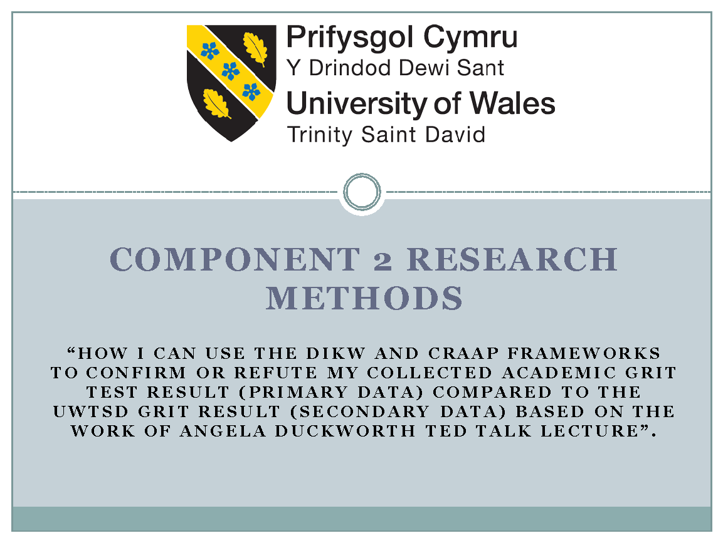

Slide 2

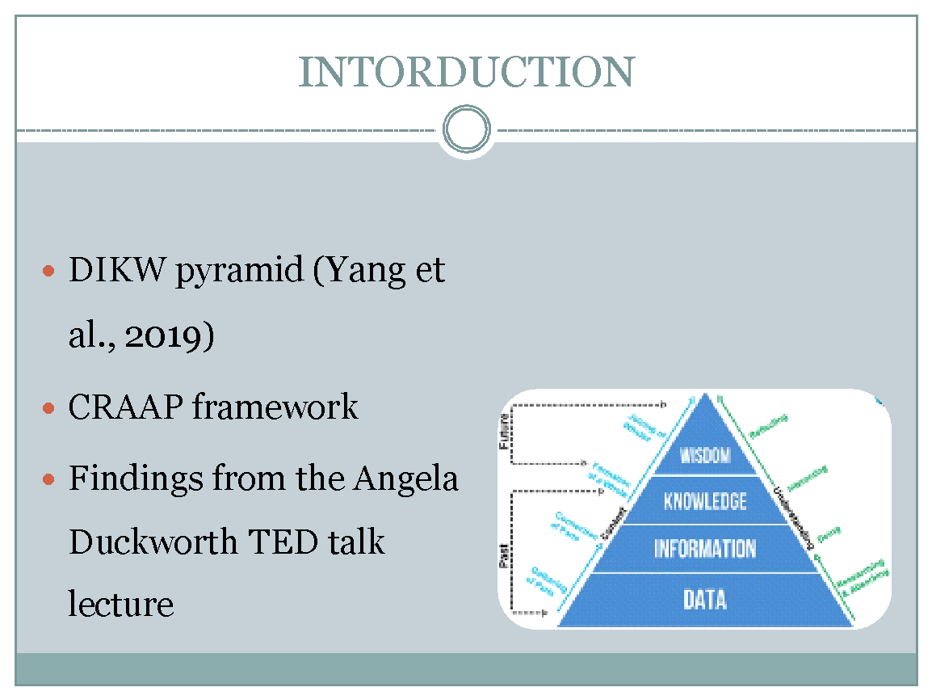

The DIKW model explains how knowledge is generated through the daily activities of teams and it also represents the transformation of the information and data into knowledge, information and wisdom by showing the relationship between them. It is also called the DIKW pyramid (Yang et al., 2019). . It analyses the data to conclude and meet the needs and desires of the organisation. The essential feature of the management of information is to assist in finding other solutions for the contexts of the organisation rather than only answering the questions. The CRAAP Test is the framework for evaluating the web source. It is a handy checklist that provides the list of questions to use deciding the reliability of the source before using its data and information in research (Kilcrease, 2021). The professor of the University of Pennsylvania, Angela Duckworth realised when teaching the seventh-grade students in school that not the best students of her are not necessarily the smartest students (Duckworth, 2019). This presentation will discuss the concept and use of the DIKW and CRAAP framework and the findings from the Angela Duckworth TED talk lecture and the use of both frameworks in the GRIT test. Further, it will explain the mean, mode, median comparison of the primary data from academic GRIT test result which is primary data and UWTSD GRIT result secondary data based on the TED talk lecture by Angela Duckworth.

Slide 3

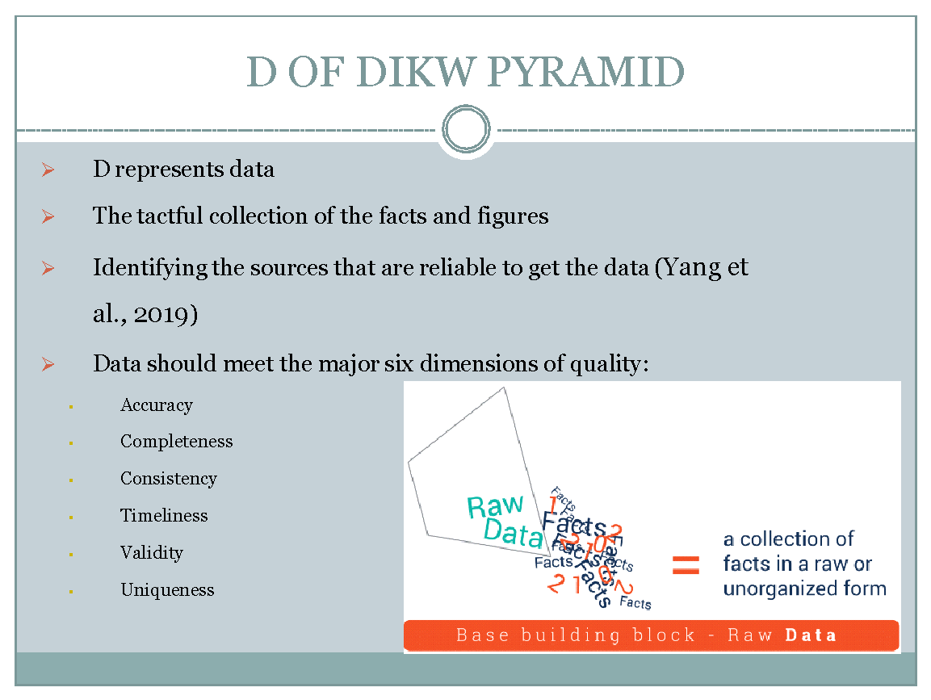

The D represents data on the DIKW model. The tactful collection of the facts and figures in the form of numerical values, characters or any specific value gathered by an organisation about an event is termed as, Data (Yang et al., 2019). This is the first stage in the pyramid which includes performances like identifying the sources that are reliable to get the data and archiving and deleting the appropriate data. The data collected is valuable for the firm only when it is of high quality (Frické, 2019). To access high-quality data, the data should meet the major six dimensions of quality; these are accuracy, completeness, consistency, timeliness, validity and uniqueness. The accuracy is measured by how well the reality is reflected by the data (Van Meter, 2020). Completeness will be measured by the expectation fulfilment of the organisation if the data is comprehensive or not. The stored data matches at one and place or not will measure the consistency of the data. The timeliness can be calculated by if the information can be accessed whenever needed by the individual. The data collected is valuable for the firm only when it is of high quality. Validity is measured by the specific format of data and uniqueness by the database appearance (Yang et al., 2019).

Slide 4

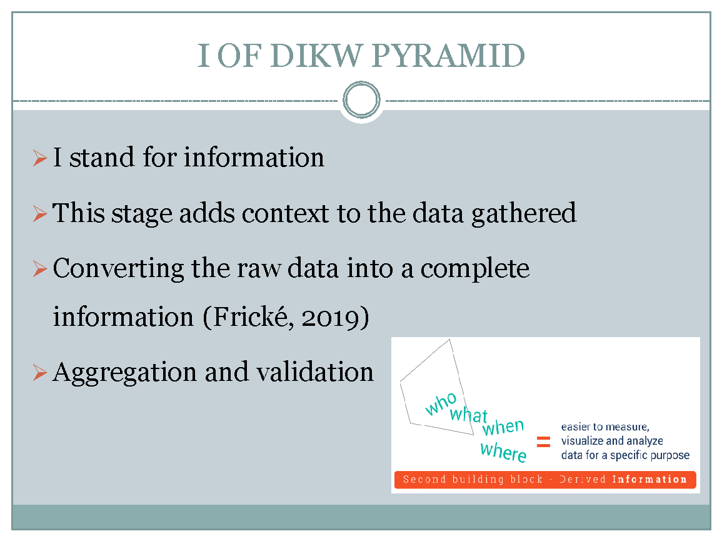

I stand for information in the DIKW pyramid. This stage adds context to the data gathered. The information can be said as the prepared data, which adds sense to the raw data by giving it background and importance. It involves key performance like converting the raw data into complete information while maintaining the integrity of the data and manages the information in the right way by building it easy for the search and use of the end-user (Van Meter, 2020). It analyses the data to conclude and meet the needs and desires of the organisation. This knowledge is often an advantage of a company over its competitors.The essential feature of the management of information is that to assist in finding other solutions for the contexts of the organisation rather than only answering the questions (Frické, 2019). Depending upon the purpose of the information gathered, the processing of data consists of various operations like merging the various sets of data called aggregation and validation which means making sure gathered data is accurate and reliable. When the organisation gets to know the how question for this stage, this will make the leap to the next step of the pyramid, which is knowledge (Yang et al., 2019).

Slide 5

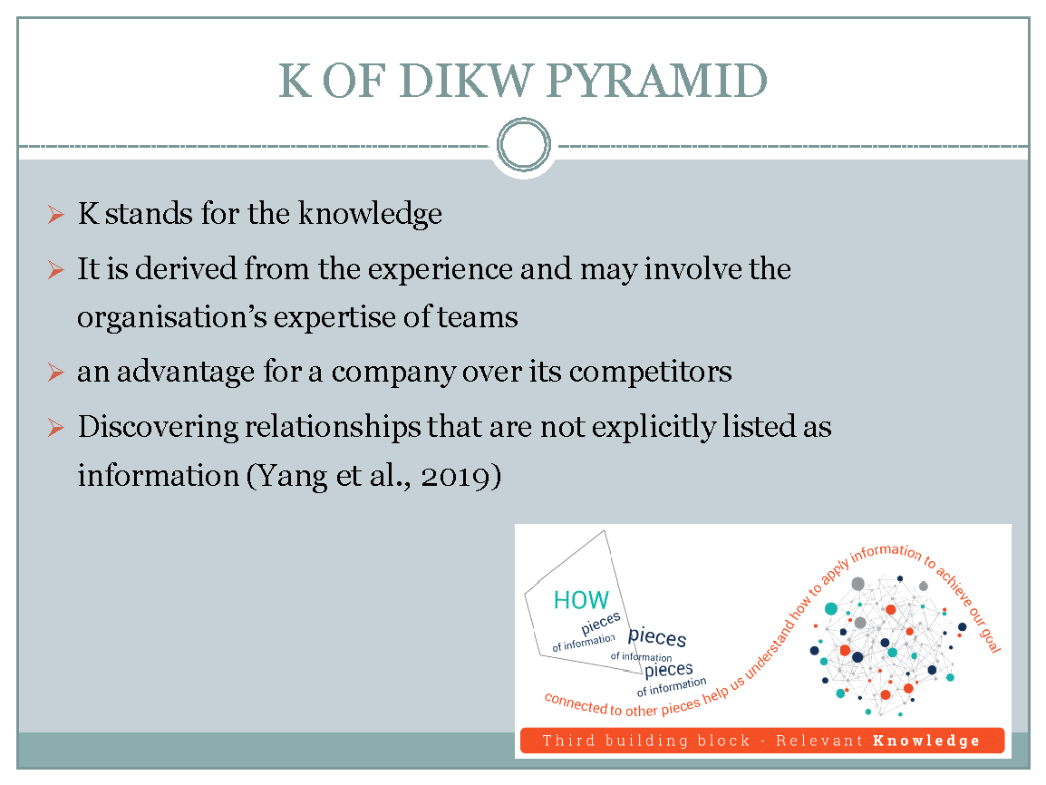

Knowledge is the next stage of the model. It is derived from the experience and may involve the organisation’s expertise of teams, judgements and values. It is the capability and ability to use the information to achieve any objective strategically. This includes the manager of knowledge, subject matters expert, technicians and the end-users of the knowledge (Yang et al., 2019). The created knowledge in this stage of the model makes it easy for smart decision making. How to remember something and to apply information by the individual is determined by the knowledge. The organisation turns information into knowledge by not only seeing it as a description of the facts gathered but by understanding how to apply it to achieve organisational goals. This knowledge is often an advantage of a company over its competitors. Discovering relationships that are not explicitly listed as information will give the company deeper insight moving up the DIKW pyramid. However, it can be said that organisations have reached the final stage of the knowledge pyramid, only when the company uses the knowledge and insights gained from information to make active decisions (Van Meter, 2020).

Slide 6

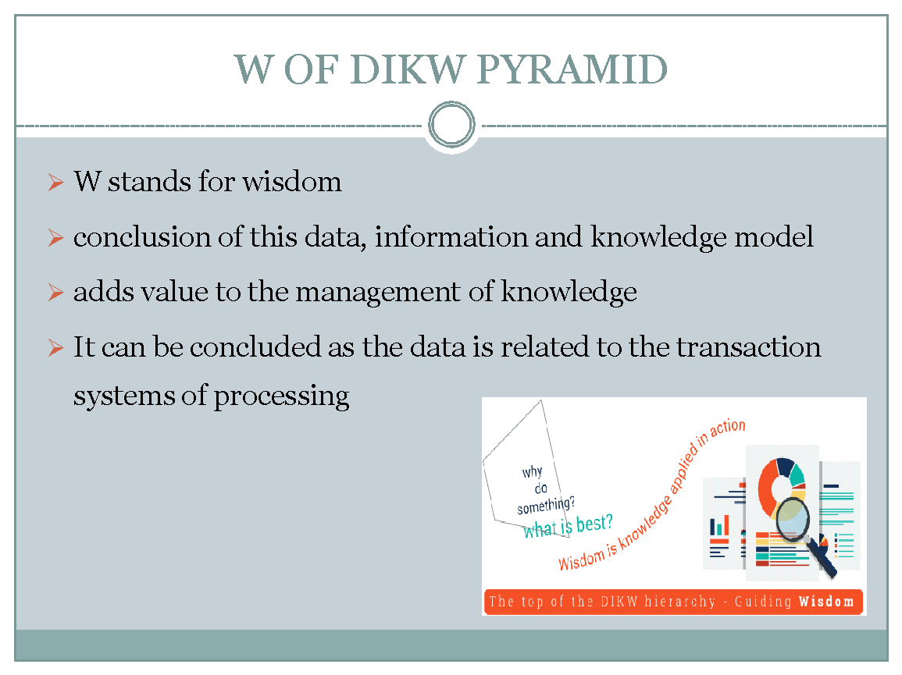

Wisdom refers to the conclusion of this data, information and knowledge model. It adds value to the management of knowledge, which is shaped by dynamic planning and problem solving with strategic planning and judgment. It is the capacity to select objectives and goals of an individual's value in the larger context. It involves finding the reasons behind the decision making by the individual when applying derived knowledge in a specific way (Van Meter, 2020). It is on the top of the pyramid of the DIKW framework, to reach that point the organisation needs to answer what to do and what is best. It is the knowledge applied in action. In case the data and information are like looking into the past then the knowledge and wisdom are connected with what the organisation is doing now and what it wants to achieve in the future as a long term plan. It can be concluded as the data is related to the transaction systems of processing, information related to the management systems of information, knowledge is related to the support systems of decision making and related to expert systems (Yang et al., 2019).

Slide 7

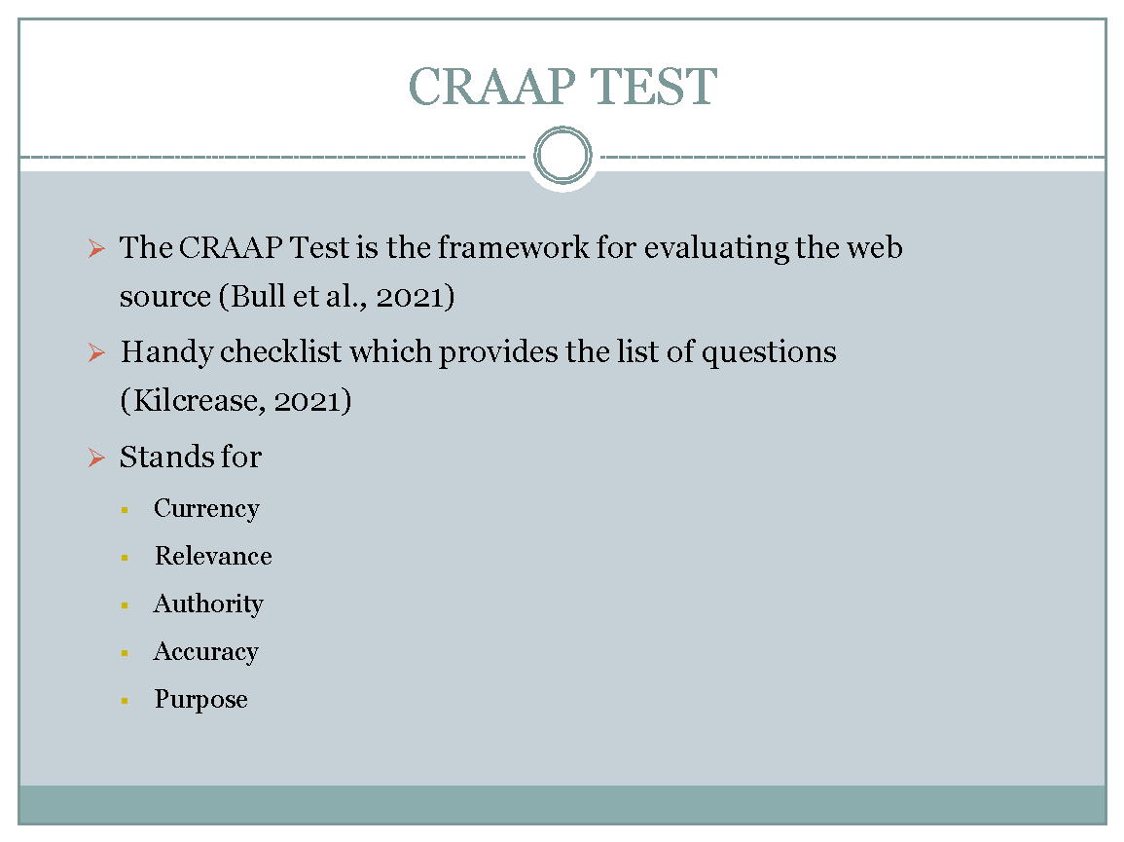

The CRAAP Test is the framework for evaluating the web source. It is a handy checklist that provides a list of questions to use deciding the reliability of the source before using its data and information in research. It stands for the currency, relevance, authority, accuracy and purpose (Bull et al., 2021). The CRAAP test of Angela Duckworth's GRIT test is as follows:
Currency: It was given by Duckworth in a TED talk in 2013 and there has been no revision after it was published. The topic of the GRIT test has current as well as old information for authenticity and the links of the websites are functional (Kilcrease, 2021).
Relevance: The information in the TED talk is highly related to the topic and the provided information is of the appropriate level of research.
Authority: The researcher of this data is Angela Duckworth. Angela Duckworth is an American academic psychologist and a popular science author and has studied at Harvard College (Esparrago-Kalidas, 2021).
Accuracy: The information is published through a TED talk lecture, and has been reviewed. It has no grammatical and language barriers (Bull et al., 2021).
Purpose: The purpose is to assist the individual in analysing the factors that impact student learning. Duckworth has represented the clear purpose of the findings in the TED talk lecture (Kilcrease, 2021).

Slide 8

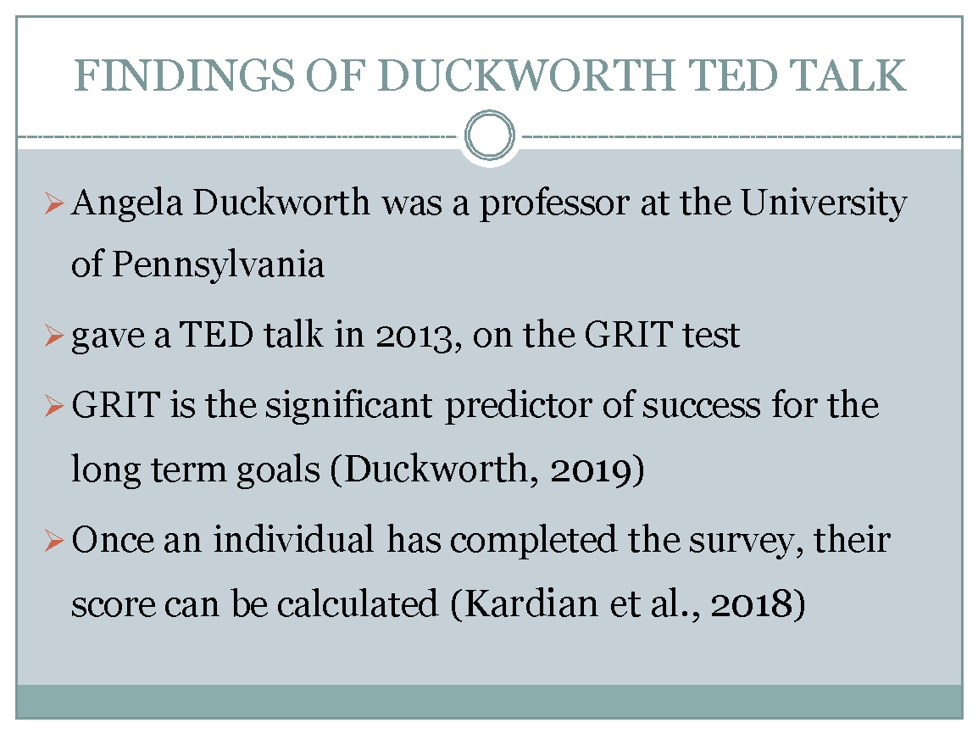

The professor of the University of Pennsylvania, Angela Duckworth realised when teaching the seventh-grade students in school that not the best students of her are not necessarily the smartest students. She gave a TED talk in 2013 explaining that GRIT is the significant predictor of success for long term goals (Duckworth, 2019). Dr. Angela Duckworth defined GRIT as "passion and tenacity for long-term objectives, especially in the face of hardship." Courage, according to Dr. Duckworth, is a prevalent trait among successful achievers. Grain, according to his research, is unrelated to IQ but is linked to the Big Five test's consciousness component. Duckworth and her team for measuring the GRIT developed the Grit scale which is a self-reported questionnaire for the evaluation of the focused effort and interest over a time period. Once an individual has completed the survey, their score can be calculated and used to determine the link between courage and other measures of success. Duckworth and his team found that braver juniors were more likely to graduate from high school than their less serious peers, even when accounting for these predictors, in addition to test scores to benchmarking and demographic data. Students are known to predict school graduation, including school safety, teacher support, peer support, parental support, integrity, and school motivation, in addition to the four items on the grit scale. An individual has completed a survey that includes questions that measure various factors (Kardian et al., 2018).

Slide 9

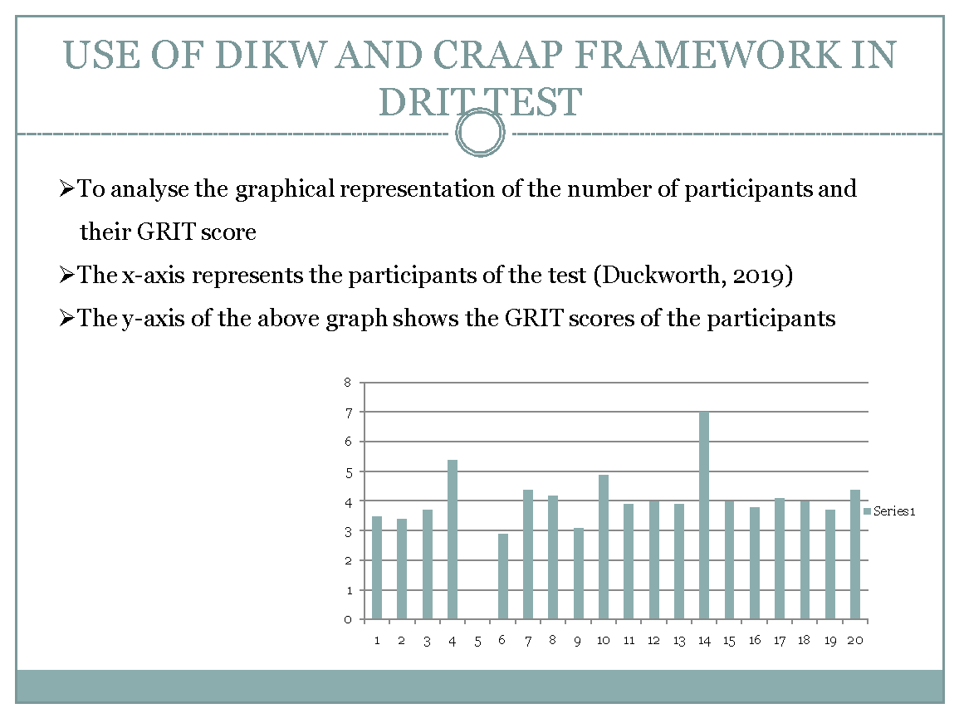

The use of DIKW and CRAAP framework in the GRIT test is to analyse the graphical representation of the number of participants and their GRIT score. Dr. Angela Duckworth defined GRIT as "passion and tenacity for long-term objectives, especially in the face of hardship." Courage, according to Dr. Duckworth, is a prevalent trait among successful achievers. Grain, according to his research, is unrelated to IQ but is linked to the Big Five test's consciousness component. According to the above graph, the x-axis represents the participants of the text (Duckworth, 2019). Twenty students have been given the GRIT test to predict the success of the long term goals. The y-axis of the above graph shows the GRIT scores of the participants. The bar graph shows the comparison of the scores of the students who performed the grit test. It can be determined by the above graph, the highest score is 7 by participant number 14. And the average score of participants is 3.8 to 4.0 (Duckworth, 2019).

Slide 10

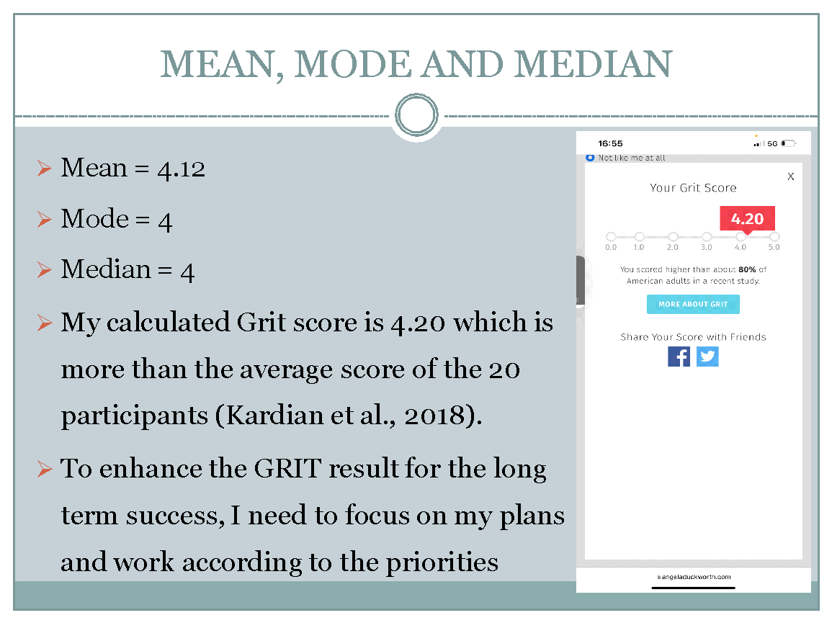

Participants = 1, 2, 3, 4, 5, 6, 7, 8, 9, 10, 11, 12, 13, 14, 15, 16, 17, 18, 19, 20
GRIT Score = 3.5, 3.4, 3.7, 5.4, not sure, 2.9, 4.4, 4.2, 3.1, 4.9, 3.9, 4, 3.9, 7, 4, 3.8, 4.09, 4, 3.7, 4.4

The mean, mode and median are the three principles in the statistics to analyse average values of the list of numbers. Mean is calculated by the total sum of the numbers divided by the frequency that is a number of lists of the participants. Median is the middle value of the list after sorting in ascending or descending order. And mode is the most frequently occurred value in the list (Duckworth, 2019).

Mean = Sum of Observations ÷ Total Numbers of Observations
i.e., x̄ = Σfx/N
Median = Lm+[n2−F/fm]I
Mode formula = L + h * (fm−f1) / (fm−f1)+(fm−f2)
The above data shows that the total numbers of participants in the grit tests were 20. And the solution of mean, mode and median is:
Mean = 4.12
Mode = 4
Median = 4
My calculated Grit score is 4.20 which is more than the average score of the 20 participants. But as compared to the highest score of 7, my score is less. To enhance the GRIT result for long term success, I need to focus on my plans and work according to the priorities (Kardian et al., 2018).

Slide 11

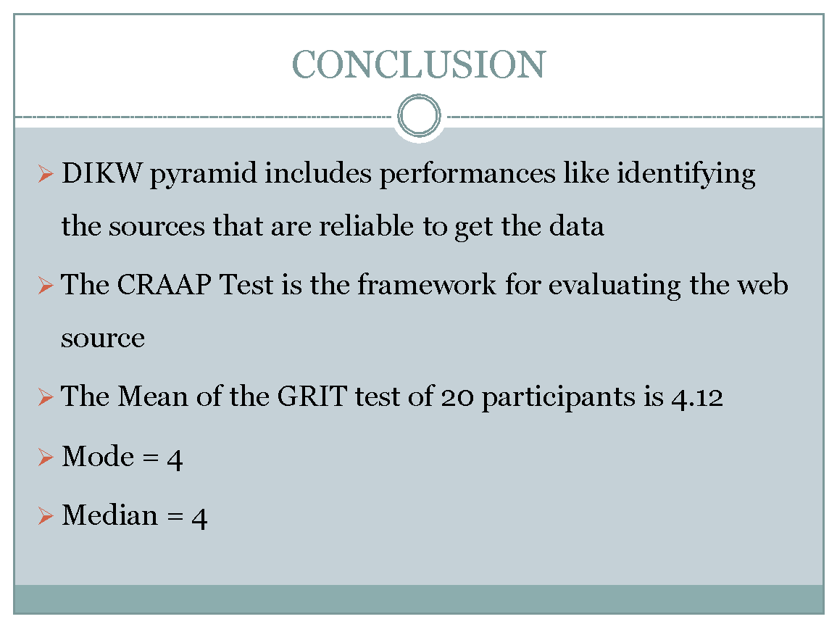

This presentation concludes the first stage in the DIKW pyramid includes performances like identifying the sources that are reliable to get the data and archiving and deleting the appropriate data, next stage adds context to the data gathered. The information can be said as the prepared data, which adds sense to the raw data by giving it background and importance. Knowledge is derived from the experience and may involve the organisation’s expertise of teams, judgments and values and wisdom refers to the conclusion of this data, information and knowledge model. The CRAAP Test is the framework for evaluating the web source. The findings of Duckworth's TED talk is that once an individual has completed the survey, their score can be calculated and used to determine the link between courage and other measures of success. Further, it concluded the use of DIKW and CRAAP framework in the GRIT test is to analyse the graphical representation of the number of participants and their GRIT score. The mean of the GRIT test of 20 participants is 4.12, the model is 4, and the median is also 4. My calculated Grit score is 4.20 that is more than the average score of the 20 participants.

Slide 12



