Your Name: Abdul Rasool

Student Number: 2238467

Topic: My Digital Life

Introduction
Digital tools are now a natural part of my everyday life, helping me stay organised and productive. I use them for everything from staying in touch with my family and friends to managing my studies and personal plans. Below I have listed the tools I rely on most, what I feel confident doing, and the areas I want to develop further.

Digital tools I use daily
Communication tools
WhatsApp Messenger is my main way to talk to people. I use it to send messages, make calls and share photos or updates quickly. I also use email through Gmail for more formal messages, like contacting my tutors or handling personal administration.

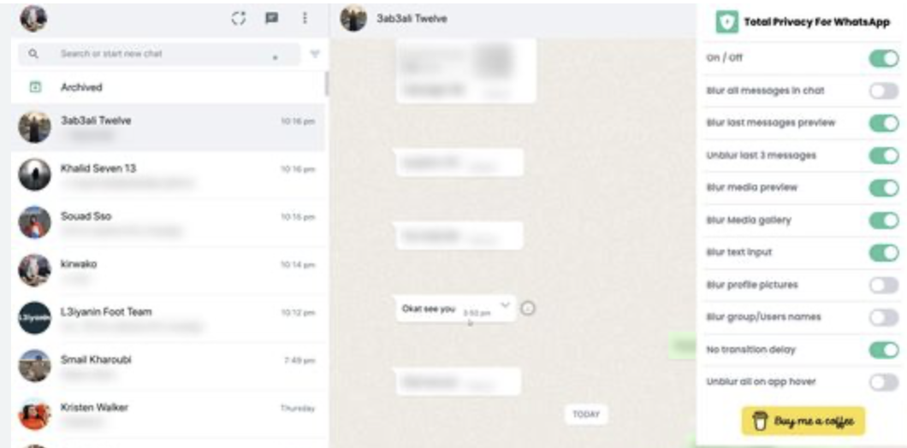
Whatsapp messenger

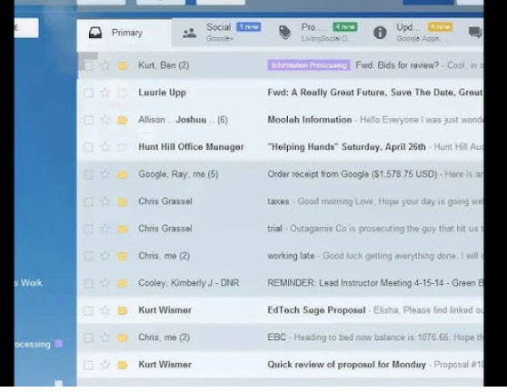

GMAIL screenshot

Study and organisation tools
Microsoft Word and PowerPoint are essential for my university work. I use them to write assignments and create presentations. Google Calendar helps me keep track of deadlines, classes and personal appointments, so I never miss anything important. I also use Google Drive to save files, which means I can access my work from any device and share it easily with others.

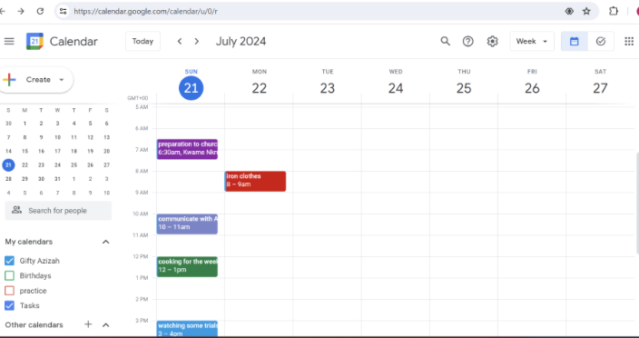
Google Calendar screenshot

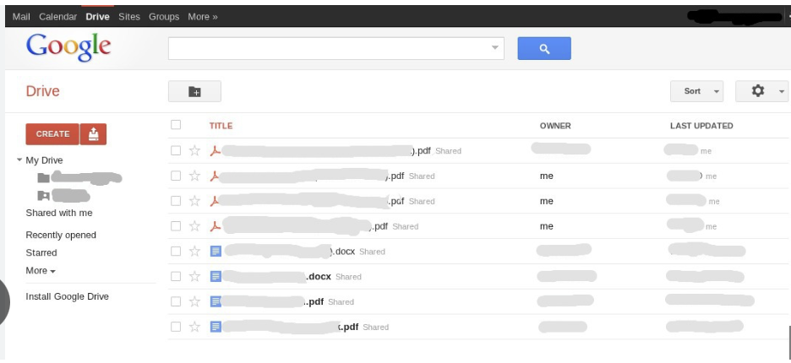
Google Drive screenshot

Information and learning tools
Google Search is my first step when I need to find information, whether it is for coursework or just to answer a question. YouTube is also really useful. I watch tutorials to learn new things, like how to use features in software or understand difficult topics.

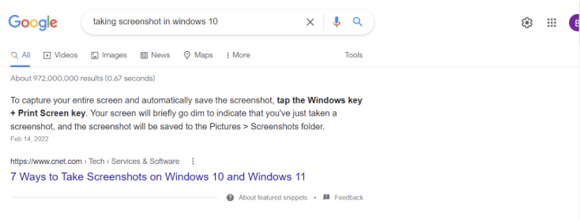
Google Search screenshot

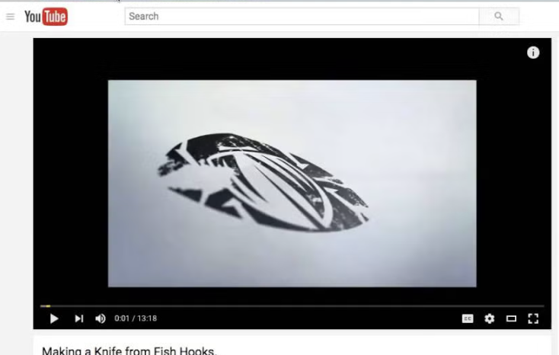
YouTube screenshot

Entertainment and daily tasks
I use Spotify for music and Netflix for relaxation when I need a break from studying. I also use banking apps to check my balance, pay bills or transfer money safely and easily, which saves me a lot of time.

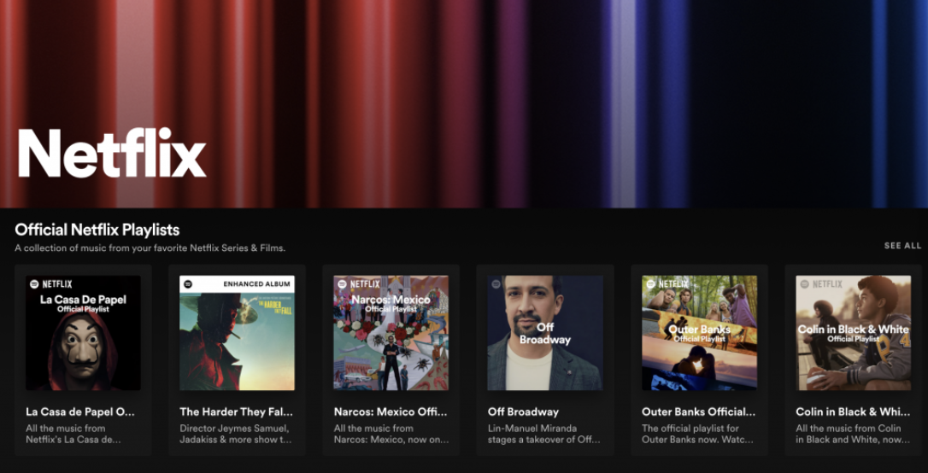
Netflix screenshot

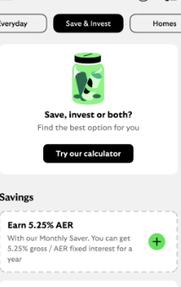
banking app screenshot

What I feel good at
I am confident in using communication tools. I can send messages, share files and organise group chats easily. I am also comfortable with basic office software. I know how to format documents, create presentations and save or share files properly. I can search for information online. I also find it easy to learn how to use new apps or websites because I am used to exploring and working things out on my own.

What I want to improve
My objective is to increase my understanding of internet safety. I am familiar with the fundamentals of creating secure passwords, but I would like to learn more about issues like phishing, privacy settings, and how to protect my personal data online. Additionally, since this would be helpful for my future business career, I want to improve my Excel skills with numbers and data.

Why these skills matter
These digital skills will be helpful in my future employment and help me excel academically. Practicing these abilities today will benefit me in the workplace because most companies want their employees to use digital technologies with confidence. For both college and the workplace, the ability to communicate, manage my work, and locate information online is crucial.

