

Student name: Danielle Henry
Student ID: 2516166

Module name: Introduction to Health and Social Care
Module code: LCHS4003
Lecturer name: Ping Wu

Content page

Element 1 …………………………………………………………….. page

Element 2…….
References
BMA. “Failing Mental Healthcare System.” The British Medical Association Is the Trade Union and Professional Body for Doctors in the UK., 28 June 2024, www.bma.org.uk/what-we-do/population-health/supporting-peoples-mental-health/failing-mental-healthcare-system.

foundation trust, NHS. “Kensington and Chelsea South Community Mental Health Hub :: Central and North West London NHS Foundation Trust.” Cnwl.nhs.uk, 2025, www.cnwl.nhs.uk/services/mental-health-services/adult-and-older-adult/south-kensington-and-chelsea-community-mental-health-team.

NHS England. “NHS England Community Mental Health Services.” England.nhs.uk, 2024, www.england.nhs.uk/mental-health/adults/cmhs/.

NICE. “Mental Health and the NHS.” Indepth.nice.org.uk, 2018, indepth.nice.org.uk/mental-health-and-the-nhs/index.html.

royal college of psychiatrists. “The Community Mental Health Framework for Adults and Older Adults | Royal College of Psychiatrists.” RC PSYCH ROYAL COLLEGE of PSYCHIATRISTS, 2021, www.rcpsych.ac.uk/improving-care/nccmh/service-design-and-development/community-framework.

History
The History of mental health services is very different to the framework we have today. Treatment for mental health before the NHS was established was clouded by stigma often referred to as “lunacy” or other derogatory connotations, these were even used in parliament. Patients suffering from mental health issues were kept away from communities in mental asylums. Surprisingly many remained open until the 1970s, resulting in patients being treated in main hospitals and eventually being cared for within the community. (NICE, 2018).
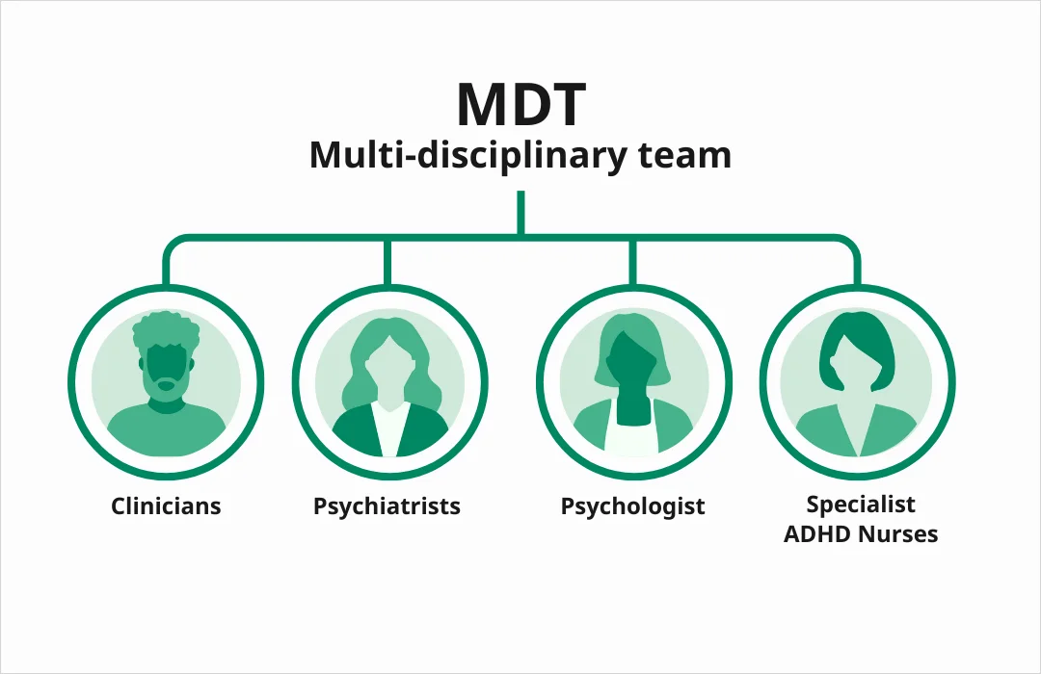
Challenges
The main Challenges faced by community mental health services are funding and training for the workforce. (BMA, 2024).

Community Mental Health Services
Danielle Leigh Henry, Student number- 2516166

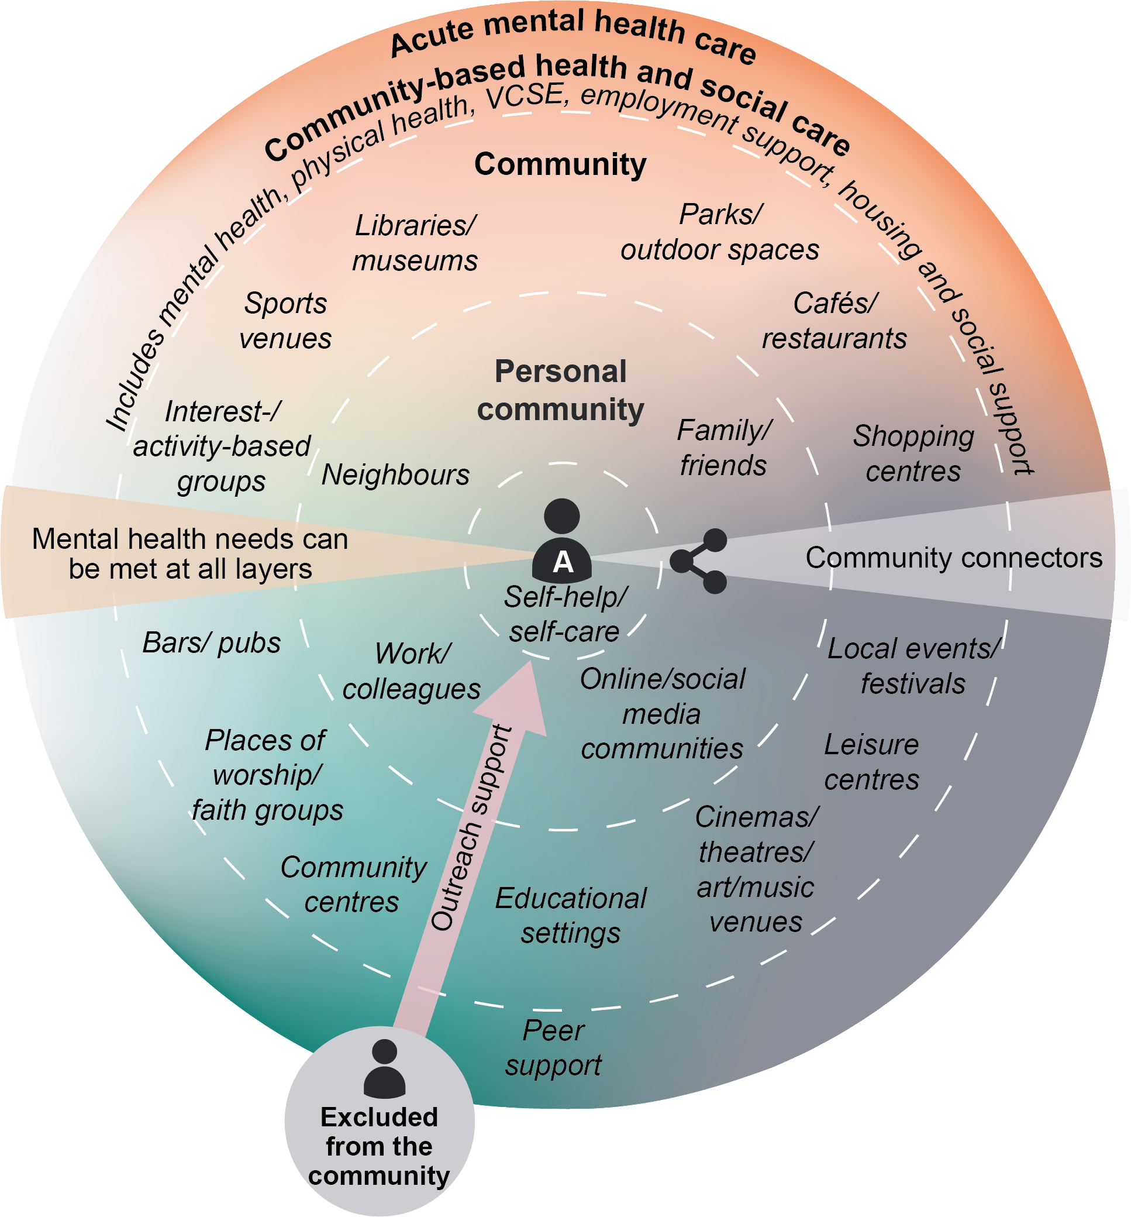
Mental health care, support and treatment is achievable if all service providers work together keeping the patient in the centre within their own community. (royal college of psychiatrists, 2021).
Community Mental Health Services
Community Mental health Services aim to keep people at home and treated in the community by specialised service teams to deliver integrated care that is recovery focused. (NHS foundation trust, 2025). Community Mental Health services are made up of multi-disciplinary teams (MDHTs) which usually consists of mental health nurses, social workers, occupational therapists, psychologists, psychiatrists, support workers.

Current Function of service
The current function of the service is to deliver a wraparound care individual for each patient. With their own plan, the service aim is to deliver care for adults suffering with severe mental health needs. (NHS England, 2024).

Ambulance Services

Danielle Henry 2516166

The Ambulance service is an integral part of patient care within the NHS they not only transport patients to hospital they provide emergency care to the patients with skilled trained paramedics.
The Ambulance service was originally formed to transport patients with infectious diseases by volunteers. In the 19th century ambulances were horse drawn, the move to motor vehicles was made by 1912, they would have only fitted one stretcher inside and travelled up to 15 miles per hour. Before the Ambulance service was formed you would have likely been transported for medical help by firefighters, taxi drivers or the police on wheeled stretcher known as ‘litters’. During the second world war auxiliary Ambulances were created with many of the providers being women, these were formed as part of the governments civil defence service. It wasn’t until the National Health Service act of 1948 that the Ambulance service was required to be available for anyone needing the service. With time and innovation there has been great change to the Ambulance Service to what we have today (NHS, 2025).
The function of the NHS Ambulance service in the UK today has been greatly developed since being established. The function is not only to transport the patients needing medical care but also treating the patients at the scene and while traveling to the hospital. This results in some patients not needing emergency care at hospital as emergency services are in high demand in a growing population. However, the Ambulance service still face problems today. With the Ambulance service integrated with 111 and 999 and localised dispatch centres the ambulance service can attend and treat the most unwell first this also to distinguish who can be treated at other settings such as GPs freeing up the service to other users more in need (NHS England,2023). The main concerns within the Ambulance service are still waiting times as the aging population have more need for emergency services, also the ambulance staff are prone to burnout after long hours and heavy workloads can cause staff shortages, another problem is that the A&E waiting times are long as there are so many service users, this can back up paramedics waiting on hand overs. (college of paramedics,2022).
The NHS Ambulance Service significantly enhance the service user’s life as they provide lifesaving innovated treatments, they play a vital role to not only the individual but the wider community. It closes the gap of health inequalities as the NHS Ambulance service is free for everyone including vulnerable patients such as those from deprived areas, the elderly and those with ongoing medical conditions so they can always get the care they need (NHS ENGLAND, 2023). Another point is that ambulances are equipped with digitised patient records so they can access patient’s records making decision making better regarding there clinical care and saving time (NHS England, 2021). Also, service users with chronic illness can feel like they have a safety net regarding their health knowing that the Ambulance service is available may feel like a sense of relief for the user and reassure them trying to live a more fulfilled life, it gives a more psychological effect (health foundation, 2022).
In conclusion the Ambulance service enhances patient care carrying out life saving treatments giving patients the care they need in times of emergency including physical and psychological. Although there are challenges within the ambulance service, without this service patient outcomes could be very different.

References

