Digital Skills for Personal and Professional Growth (BMSW4008)

Evidence of Learning (E-Portfolio)

Student ID: 2330383

Student Name: Noemi Bagi

Table of Contents
Introduction 3
Task 1: Questionnaire analysis 3
Task 2: Design of the website and marketing materials 7
Task 3: Financial analysis of small business 10
Task 4: Advertisement of Furniturebox (Tailor-made furniture) 13
Conclusion 21
Reference 22
Appendices 25

Introduction
In the current study a portfolio of varied tasks that illustrate the application of excel, finance, PowerPoint and similar other skills. The market research is based on Furniturebox, a SME in UK that provides furniture and home decor accessories to consumers, and whose results reflect within the portfolio of tasks performed.

Task 1: Questionnaire analysis
The market research conducted with thirty participants that form the target audience of Furniturebox involves inquiry of a range of questions that illustrate consumer trends and patterns. As per the results gathered, the following trends and evidence within the target audience responses of Furniturebox:
Furniturebox’s products align with fashionable and in-trend designs
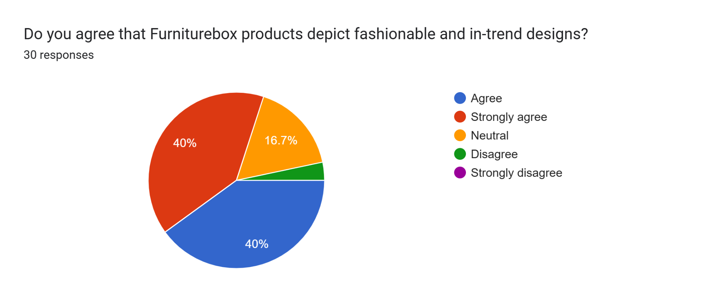
Figure 1: Response to question three
The responses gathered from the survey conducted affirm that a majority of participants believe that the company’s product offerings are in line with fashionable and market-trend designs. The attribute uncovers the consumer preferences within the furniture industry in UK, wherein evolving designs and trends drive consumer decisions. Consumer perceptions are evolving, and businesses are required to depict innovation in their product or service offerings to meet their inherent needs. As stated by Reedy and Parker (2018), an alignment of product development practices with evolving consumer trends provides businesses with an edge against their competitors. The concerned approach enables the business to attract trend-conscious consumers, boost their sales offerings, as well as stay competitively relevant in the market. It enables Furniturebox to reflect its commitment towards quality and an ability to drive innovation within inherent production practices. The need for product evolution is central to the furniture industry in UK as high competition from established brands like IKEA significantly affects the growth aspirations of small firms like Furniturebox.
Key factors that influence consumer purchase decisions
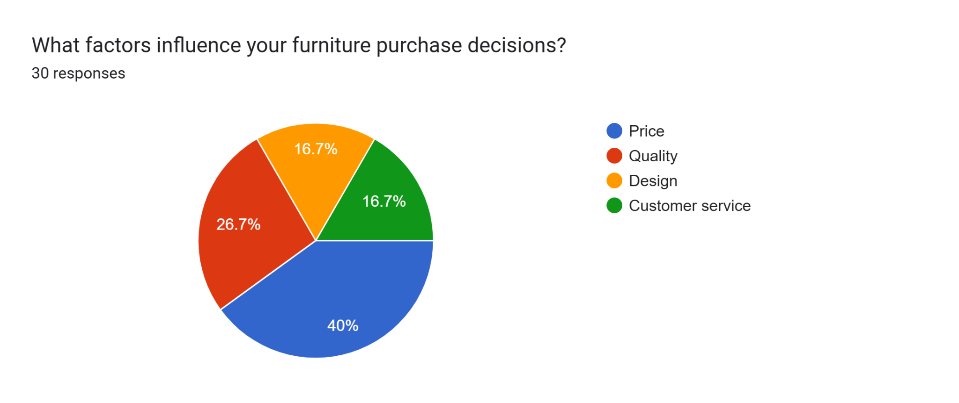
Figure 2: Response to question six
According to Byrd (2021), a range of factors due to its multifaceted nature influences the consumer purchase decision-making process, and its understanding is necessary to achieve business growth. In response to the above question, it evidences that the target audience of Furniturebox has differing opinions on the factors that influence their purchase decisions. The results reflect that price and quality are key factors that they account for, followed by design and customer service. As per the views of Sandhu (2020), price plays a crucial role in shaping consumer perception about the product or service as it reflects the value associated with the offering. Consequently, quality metrics related to the reliability and durability of the furniture products offered by Furniturebox drive consumer decisions. The other imperatives associated with design or customer service are attributes that influence brand loyalty and engagement factors and thereby drive sales trends. Attaining the attributes of consumer purchase decisions is necessary since it can help the business in planning its operational and communication strategies to achieve business goals.
Personalised support and aftersales services influence consumer perception
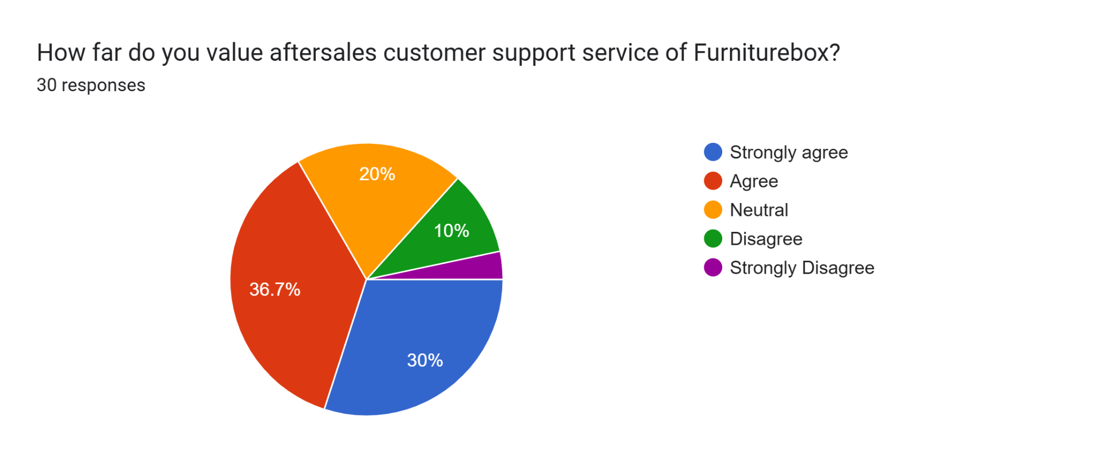
Figure 3: Response to question seven

As stated by Kanaveedu and Kalapurackal (2024, p. 561), consumer satisfaction relates to the measure of content of consumers on using the products or services of a business and their overall experience of engaging with it. A significant attribute drives sales and revenue prospects while also reflecting its ability to meet consumer needs. In response to the above question, it evidences that the target audience of Furniturebox values aftersales customer support and personalised support. Aftersales support reflects in its view the assistance provided to consumers in terms of logistics, installation or product-related queries and services after the sale has been completed (Mahmud, 2021, p. 391). It reflects the value a business associates to their consumers and is significant in shaping brand perception as well as overall experience with the business. It significantly influences the consumer satisfaction metric, which in turn drives brand loyalty and sales growth (Lim et al., 2023, p. 219). Similarly, personalisation in service support reflects catering to individual consumer needs by adapting the service dynamics to influence consumer perception.
Consumer engagement serves as key to consumer loyalty
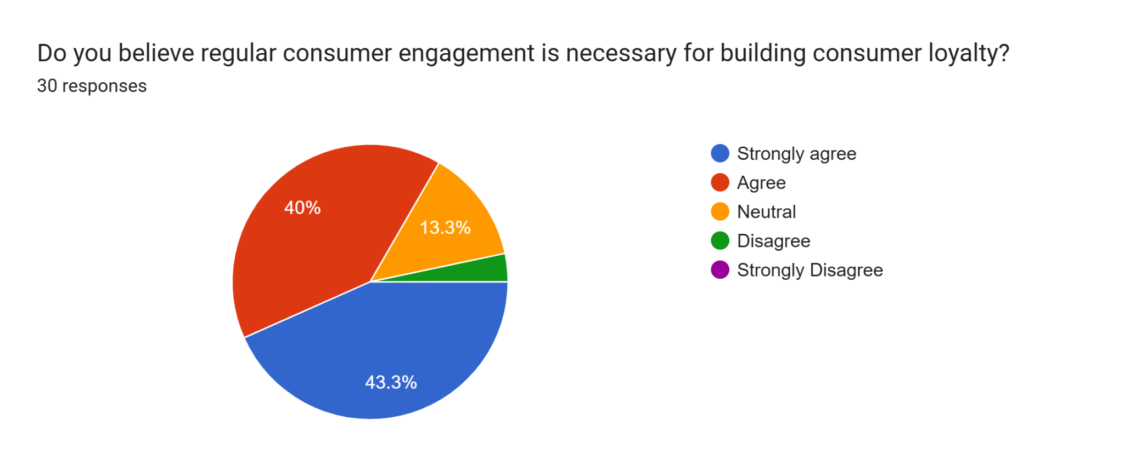
Figure 4: Response to question nine
As mentioned by Khatri (2021, p. 525), consumer engagement relates to the practice of building relationships with consumers by creating a consistent experience across multiple channels. The response to the above question evidences that consumer engagement is imperative to drive consumer loyalty at Furniturebox. By establishing efficient lines of communication and engagement, organisations can connect with the consumers, which leads them to make repeated purchases and referrals. This approach supports the business in driving their sales, creating higher brand awareness, as well as enhancing consumer satisfaction. Engagement can be achieved by integration of digital technologies such as social media, email, and customer relation management systems.

Task 2: Design of the website and marketing materials
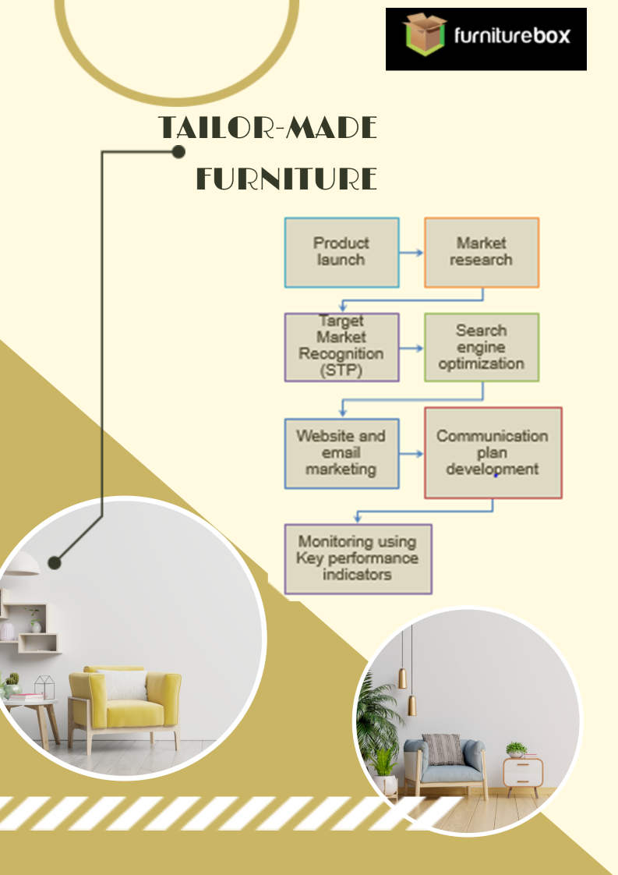
Figure 5: Marketing material
(Source: Self-developed)
Integration of questionnaire data into creation of website and marketing materials
The questionnaire data has supported the recognition of consumer needs and preferences and the analysis of the attributes that shape their purchasing decisions. The results of the questionnaire reflect that the consumers prefer personalised support, price as well as quality products in their choice of furniture products. Based on these elements, the suggested business idea is to develop an application that allows consumers to curate personal furniture designs. The designs selected by the consumers will form the basis of the furniture products and services that will be offered by Furniturebox.
In order to create the business idea, distinct concepts of marketing have been applied to recognise the target segment from the audience. As stated by Pinto and Guarda (2020), segmentation refers to the process of grouping the audience based on common trends and characteristics depicted by them. The process of segmentation enables businesses to recognise consumer trends along the variables of demographic, geographic, psychographic, and behavioural. The questionnaire data enabled the demographic variables of age as well as behavioural attributes linked to engagement needs and factors that drive consumer purchase decisions. By incorporation of these insights, it has been recognised that the target audience of the business prefers personalised services as well as values quality along with pricing attributes. The introduction of the tailor-made furniture service as a business idea is to support the company in offering personalised services to the consumers where they have the power to curate unique and innovative designs based on the palettes and design templates available on the application. Subsequently, ensuring quality product delivery derives from the merits of consumers' behavioural inclination towards quality as a characteristic that influences their purchase decision. In the marketing materials, the sequential flow of activities reflects the conduction of market research to identify the target audience by using the STP or segmentation, targeting and positioning framework. The targeting and positioning attributes enable the business to specifically recognise the characteristics of the target audience as well as evaluate the entity’s positioning within the industry of operations (Soltanifar et al., 2021). The data derived from the questionnaire has supported the analysis of consumer views and trends that reflect in the formation of the marketing materials and the website. Consumers' alignment towards the need for advisory support to make the right furniture choice has driven the creation of the proposed business idea.
The preparation of the marketing materials reflects in its view the application of SEO or search-engine-optimisation techniques. As stated by Burgess et al. (2018), SEO techniques enable businesses to enhance the visibility of their websites and search engine pages, which lead to increased organic traffic and improved brand awareness. The SEO techniques offer immense benefits to businesses, including higher rankings, increased organic traffic, improved user experiences, as well as brand credibility and visibility. The application of SEO techniques has helped in enhancing the visibility of the website and ensuring its outreach among the target audience. By application of the keyword search technique, relevant words, and phrases are incorporated into the website content of the company. As mentioned by Paulus (2003), the keyword search technique allows for the inclusion of words or phrases that have resemblance or relevance to the product or service being offered, which makes the website appear on higher rankings when a user searches the same keywords or phrases. Subsequently, the use of on-page optimization techniques where relevant keywords in titles, headings, Meta descriptions, and the content itself help develop website visibility. SEO provides a cost-effective marketing alternative for businesses and is a long-term, sustainable way to attract potential customers. Its application also evidences within the marketing material prepared where after recognition of the target audience, their preferences and trends are incorporated within the SEO approach to achieve higher brand visibility. As mentioned by Bencsik (2017), optimum SEO also links with enhancing user experience through optimisation of website structure and reflection of an easy navigation approach. The incorporation of SEO within the website design and marketing materials foray has supported the recognition of the structure and navigation panel that needs to develop to enhance user experience. The survey results gathered from the participants have reflected in its view of the foray of website and social media interactions by its target audience. In order to enhance their user experience and ease of website access, the SEO techniques integration has reflected within the present premise. The questionnaire results have indicated the need for higher consumer engagement and the inclusion of an approach to personalised communications. SEO allows the business to incorporate consumer trends and preferences within the website content by using keyword search techniques.
The website and marketing materials creation has consistently reflected the application of the insights gathered from the questionnaire, as well as incorporated the concepts of SEO and segmentation. The major implications of the questionnaire link to the recognition of the target audience, their demographic and behavioural attributes that have shaped the merits of website content and marketing materials. The materials it is evidence of how the business concept takes shape through a sequential flow wherein, in the end, monitoring aspects linked to key performance indicators or KPI evidence. The inclusion of KPI parameters also derives from the insights gathered from the questionnaire results, where there is a need for consistent engagement with the consumers' evidence (Nagpal and Petersen, 2021). In order to track the impact the marketing approaches and communication tactics have on the target audience of a business, the inclusion of key performance indicators such as bounce rate, number of visits, duration of stay on the page and similar others is beneficial. As stated by Das (2021), the personalisation of service or product offerings supports higher conversion rates and improved revenue generation. The application of this imperative, as derived from the questionnaire results, has supported the shaping and development of the business idea, which also reflected within the steps listed in the marketing material.

Task 3: Financial analysis of small business

 | January | February | March | April | May | June | July
Sales Income | £25,000 | £26,250 | £27,563 | £28,941 | £31,835 | £35,019 | £38,520
Wages | £5,000 | £5,000 | £5,000 | £5,000 | £5,000 | £5,000 | £5,000
Salaries | £3,000 | £3,000 | £3,000 | £3,000 | £3,000 | £3,000 | £3,000
Production costs | £3,000 | £3,030 | £3,060 | £3,091 | £3,122 | £3,153 | £3,185
Rent, Rates & Taxes | £4,000 | £4,000 | £4,000 | £4,000 | £4,000 | £4,000 | £4,000
Raw materials | £2,500 | £2,700 | £2,500 | £3,000 | £3,500 | £3,000 | £3,600
Transportation | £5,500 | £5,610 | £5,722 | £5,837 | £5,953 | £6,072 | £6,194
Total Expenses | £23,000 | £23,340 | £23,283 | £23,928 | £24,575 | £24,225 | £24,978
Profit | £2,000 | £2,910 | £4,280 | £5,013 | £7,259 | £10,793 | £13,542
Total Income | £45,797

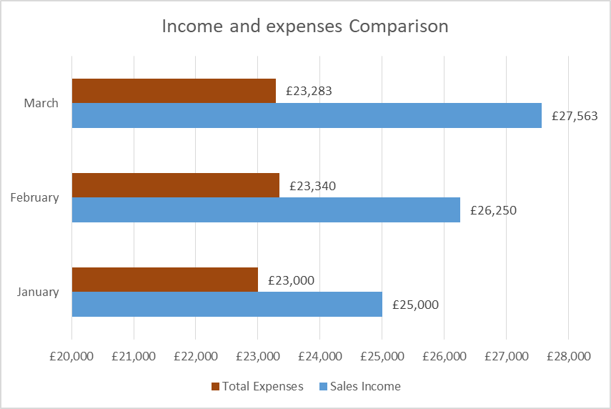
Figure 6: Income and Expenses comparison
(Source: Self-developed)
Topic: Importance of Excel in the digital era
Introduction
The evolving landscape of the business environment reflects the integration of digital technologies and tools that have revolutionised the foray of operations and business management. In this dynamic scenario, excel has undertaken a significant role in supporting business activities and enhancing the accuracy and pace of reporting within organisational purview. Based on the same merits, the current essay discusses the significance of Excel in the contemporary digital era using real-life examples.
Discussion
As stated by Remenyi et al. (2022), Excel is a versatile tool prepared by Microsoft, which enables its users to format, organise, and calculate data in a spreadsheet format. The software allows users to record interpret and visualise data in an easy, comprehensible manner to guide their objectives of business analysis. In the present digital scenario where automation is driving business processes, including finance, marketing, human resources, operations and similar others, there is an increasing need for data recording and visualisation to guide the decision-making process. Excel allows users to meet these imperatives through the prevalence of in-built tools that can assist in performing mathematical and statistical evaluations as well as their visualisations to recognise the trends evident within the data. Its application in the finance department enables businesses to record expenses, calculate income, and profit levels to formulate business strategies and financial targets.
As mentioned by Kholmuminov et al. (2021, p. 777), in the digital era, Excel is an essential tool for analysing, visualising, and organising data that allows the user to manage large datasets for making informed decisions. Data management and analysis is the primary and most common use of Excel in the digital age and enables users to store, sort, filter, and manage large amounts of data. Thus, addressing the patterns becomes easy, along with extracting meaningful insights from the data to make decisions. Along with allowing the users to keep track of the data and manage data, Excel also includes visualisation tools. The different graph and chart options in Excel help the users present the complicated or huge dataset in a pictorial format, which helps them understand the data patterns easily (Yau, 2024). For example, the use of Excel helped to perform the graphical illustration of the expense and income of Furniturebox, which helps to understand the overall profit of the firm easily for making further decisions. On the other hand, as opposed to Rebman et al. (2023, p. 30), the function and formula capabilities of Excel are helpful for businesses in the digital era for conducting advanced statistical analysis. In other words, the wide range of built-in functions, from basic arithmetic to advanced statistical analysis, allow the users to perform complicated calculations without any detailed knowledge of coding.
In the digital era, teamwork becomes important for rapid problem-solving, effective sharing of knowledge, and diverse prospects (Fang et al., 2021, p. 5). Excel files can also be shared easily with multiple users for real-time data updates and teamwork. These features of Excel make this platform widely accepted in the digital era, along with making it a universal standard for data management. Small to large organisations all over the world in this digital world use Excel for different purposes like financial management, project management, scientific research, business analysis, and marketing analysis. Excel allows for the analysis of budget forecasting, sales trends, performance metrics, and customer demographics for business analysis (Roque, 2022). For example, the use of Excel allowed us to address the sales trends of Furniturebox so that the firm could understand its performance over a particular period. Along with this, many large financial firms such as Barclays, HSBC, Aviva, and Citigroup use Excel for making financial statements and managing customer data. Along with the financial firms, many other large, small, and medium-sized firms in UK, like Unilever, Shell, AstraZeneca, GSK, and Diageo, use Excel in the digital era for making their financial statements, tracking expenditures, and managing investments. In project management, Excel also allows the tracking of resource allocation, tracking of project timelines, and task dependencies. Enterprises with the help of Excel can also analyse the marketing campaign performance, ROI, and customer acquisition costs (Dadwal, 2020).
Conclusion
As per the overall analysis, it is evident that in the digital era, Excel plays an important role in analysing huge datasets and tracking data patterns. This allows businesses to make informed decisions based on their sales performance and profitability. Excel can be used for various purposes such as financial management, business analysis, marketing analysis, and project management.

Task 4: Advertisement of Furniturebox (Tailor-made furniture)
Slide 1: Title slide
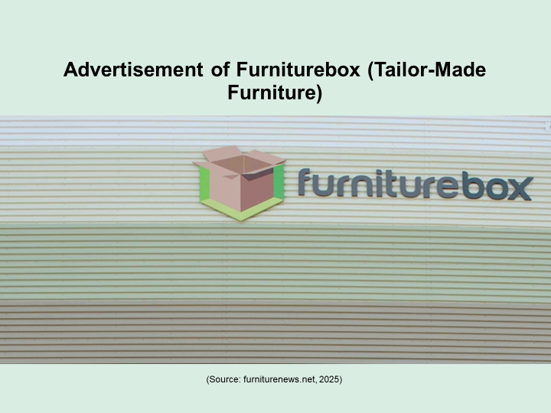
Slide 2: Introduction
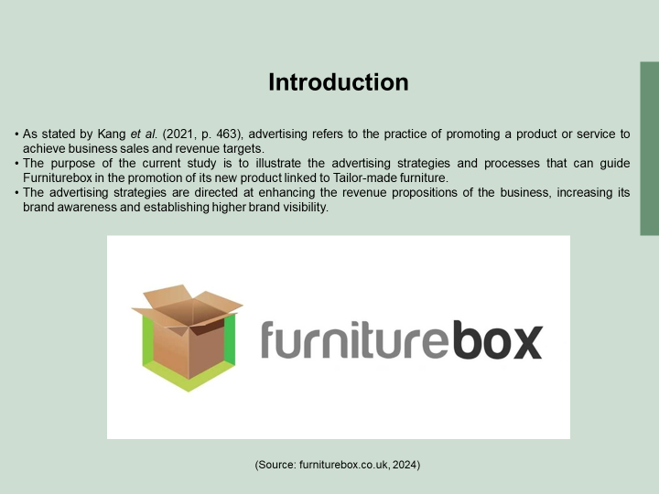
- As stated by Kang et al. (2021, p. 463), advertising refers to the practice of promoting a product or service to achieve business sales and revenue targets.
- The purpose of the current study is to illustrate the advertising strategies and processes that can guide Furniturebox in the promotion of its new product linked to Tailor-made furniture.
- The advertising strategies are directed at enhancing the revenue propositions of the business, increasing its brand awareness, and establishing higher brand visibility.
Speaker Notes
The planning of advertising strategies can help me in outlining the steps that I need to undertake for promoting the brand’s product as well as ensure progression in line with the defined objectives. The study depicts the strategic interventions that I plan to deploy to engage the audience as well as enhance brand visibility among the target audience of Furniturebox.
Slide 3: Overview of the brand and the product offered
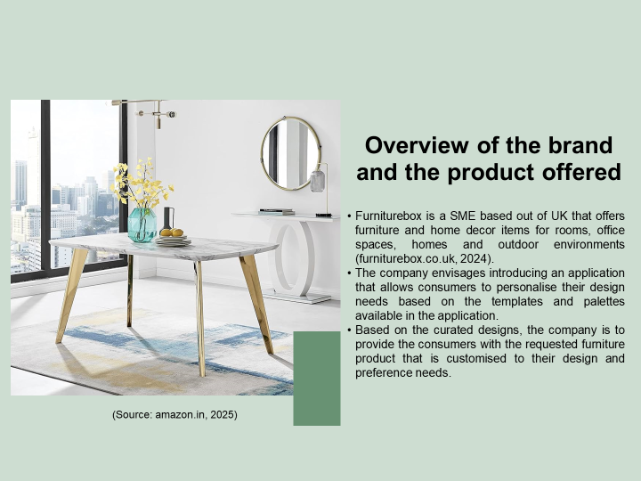
- Furniturebox is a SME based out of UK that offers furniture and home decor items for rooms, office spaces, homes and outdoor environments (furniturebox.co.uk, 2024).
- The company envisages introducing an application that allows consumers to personalise their design needs based on the templates and palettes available in the application.
- Based on the curated designs, the company is to provide the consumers with the requested furniture product that is customised to their design and preference needs.
Speaker Notes
The company’s offerings reflect a push to meet the evolving trends of consumer needs and aspirations. Personalisation in offerings empowers the consumer with an enhanced liberty to make product design-related decisions and achieve higher satisfaction through the alignment of inherent perceptions. I believe that this aspect is the unique proposition on which the advertisement and communication plan of the business is to develop and support its promotion plans.
Slide 4: Steps that guide advertisement plan development
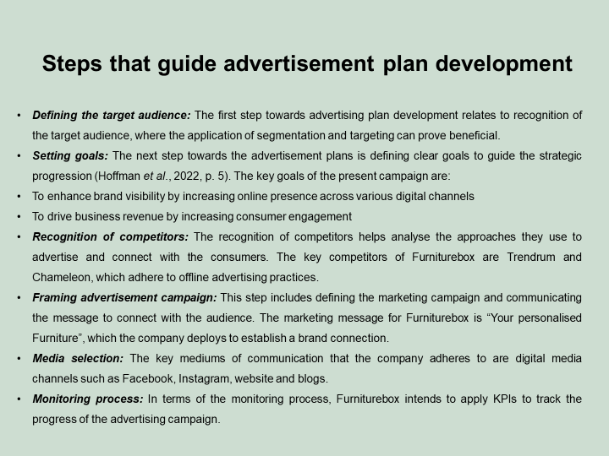
- Defining the target audience: The first step towards advertising plan development relates to recognition of the target audience, where the application of segmentation and targeting can prove beneficial.
- Setting goals: The next step towards the advertisement plans is defining clear goals to guide the strategic progression (Hoffman et al., 2022, p. 5). The key goals of the present campaign are:
- To enhance brand visibility by increasing online presence across various digital channels
- To drive business revenue by increasing consumer engagement
- Recognition of competitors: The recognition of competitors helps analyse the approaches they use to advertise and connect with the consumers. The key competitors of Furniturebox are Trendrum and Chameleon, which adhere to offline advertising practices.
- Framing advertisement campaign: This step includes defining the marketing campaign and communicating the message to connect with the audience. The marketing message for Furniturebox is “Your personalised Furniture,” which the company deploys to establish a brand connection.
- Media selection: The key mediums of communication that the company adheres to are digital media channels such as Facebook, Instagram, website, and blogs.
- Monitoring process: In terms of the monitoring process, Furniturebox intends to apply KPIs to track the progress of the advertising campaign.
Speaker Notes
In order to execute the advertisement plan, adherence to a sequential approach can prove beneficial. The steps listed above showcase the approach that Furniturebox envisages to adopt to meet its advertising targets. The diversification of channels can enable the company to enhance its outreach among the target audience and establish distinct channels of communication. Subsequently, the prevalence of a clear message enables the business to clearly state its marketing campaign as well as educate the consumers about the purpose of communication. Lastly, the inclusion of key performance indicators or KPIs is to direct the advertisement progression through regular checks to plan interventions accordingly, The common KPIs that can find applicability in the present scenario relate to bounce rate, consumer engagement score, consumer feedback, number of visits and similar others.
Slide 5: Strategies for advertisement of the brand
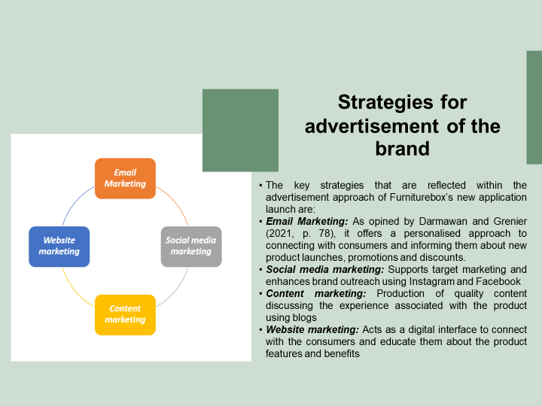
The key strategies that are reflected within the advertisement approach of Furniturebox’s new application launch are:
- Email Marketing: As opined by Darmawan and Grenier (2021, p. 78), it offers a personalised approach to connecting with consumers and informing them about new product launches promotions and discounts.
- Social media marketing: Supports target marketing and enhances brand outreach using Instagram and Facebook
- Content marketing: Production of quality content discussing the experience associated with the product using blogs
- Website marketing: Acts as a digital interface to connect with the consumers and educate them about the product features and benefits
Speaker Notes
The advertisement strategies are to reflect diversity in its purview to achieve the defined targets and ensure connecting with the target audience. I have detailed the key strategies that Furniturebox intends to deploy in its advertising approach, which includes the use of social media platforms, content creation through blogs, email marketing, and website marketing. Social media platforms entail businesses with unique value propositions of engaging consumers using graphics, images, and videos and thus support enhancing the brand outreach and visibility among the target audience. Similarly, the website marketing approach is to assist the business in the integration of a cost-effective and engaging approach to brand awareness (Varadarajan et al., 2022, p. 500). The key benefit of choosing a host of channels of advertisement is to support the advertisement campaign in reaching out to a larger audience as well as connecting with varied age groups. The content marketing approach is to prove beneficial in driving consumer perception, which shapes their purchase decision. The advertising strategy of the company is to highlight the clear message of “Your personalised Furniture,” which can easily connect with the consumers who are trend-conscious and appreciate a higher say in the purchase decision-making process.
Slide 6: Conclusion
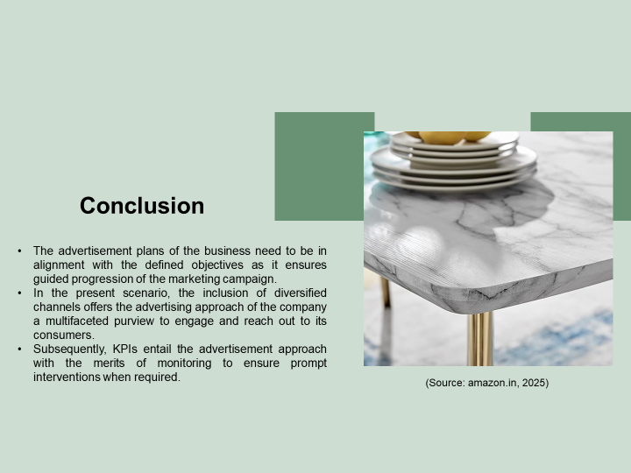
- The advertisement plans of the business need to be in alignment with the defined objectives as it ensures guided progression of the marketing campaign.
- In the present scenario, the inclusion of diversified channels offers the advertising approach of the company a multifaceted purview to engage and reach out to its consumers.
- Subsequently, KPIs entail the advertisement approach with the merits of monitoring to ensure prompt interventions when required.
Speaker Notes
I have detailed the advertisement plan that the company plans to implement to meet its defined objectives. The sequential steps enlist the manner in which the business will develop and implement the advertisement plan along with the strategies that will guide it in meeting its objectives.
Slide 7: References
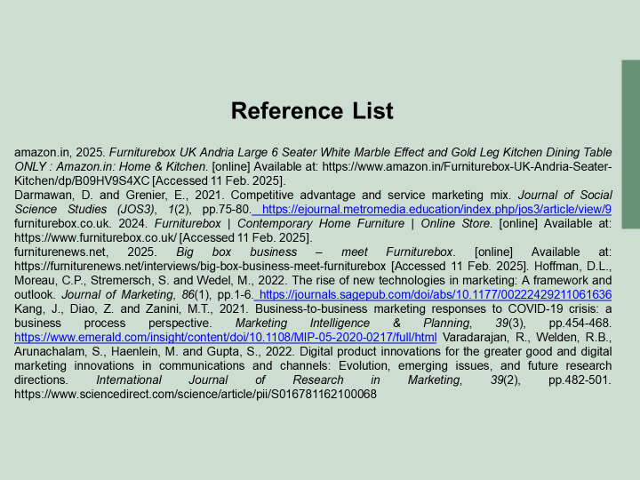
Slide 8: Thank You


Conclusion
The present study provides a description of SEO and segmentation approaches and the manner in which it has guided the marketing materials preparation. The results gathered from the questionnaire have served as crucial in shaping the understanding of consumer trends that have guided various activities of the current portfolio.

YouTube video like
https://youtube.com/shorts/JciMJ56c1ek?si=WHi5ySELb0oDjoNt

Reference
Task 1
Byrd, L. S. 2021. Cultivating Entrepreneurial Changemakers Through Digital Media Education. IGI Global. http://doi:10.4018/978-1-7998-5808-9
Kanaveedu, A. and Kalapurackal, J.J., 2024. Influencer marketing and consumer behaviour: A systematic literature review. Vision, 28(5), pp.547-566. https://journals.sagepub.com/doi/abs/10.1177/09722629221114607
Khatri, M., 2021. How digital marketing along with artificial intelligence is transforming consumer behaviour. International Journal for Research in Applied Science and Engineering Technology, 9(VII), pp.523-527. https://www.researchgate.net/profile/Manas-Khatri/publication/353156555_How_Digital_Marketing_along_with_Artificial_Intelligence_is_Transforming_Consumer_Behaviour/links/60e9e76b1c28af34585e60e6/How-Digital-Marketing-along-with-Artificial-Intelligence-is-Transforming-Consumer-Behaviour.pdf
Lim, W.M., Kumar, S., Pandey, N., Verma, D. and Kumar, D., 2023. Evolution and trends in consumer behaviour: Insights from Journal of Consumer Behaviour. Journal of Consumer Behaviour, 22(1), pp.217-232. https://onlinelibrary.wiley.com/doi/abs/10.1002/cb.2118
Mahmud, A., 2021. The Intervening of Purchase Decision Between Marketing Mix, Consumer Behaviour and Brand Image on Costumer Statisfaction. Jurnal Manajemen Bisnis, 8(2), pp.382-396. http://repository.umi.ac.id/1569/1/18.%2BRamli%2B382-396.pdf
Reedy, K. and Parker, J., 2018. Digital literacy unpacked. Facet.
Sandhu, K. ed., 2020. Digital Transformation and Innovative Services for Business and Learning. IGI Global.
Task 2
Bencsik, A. ed., 2017. Knowledge management initiatives and strategies in small and medium enterprises. IGI Global.
Burgess, J., Marwick, A. and Poell, T. eds., 2018. The SAGE handbook of social media. Sage.
Das, S., 2021. Search engine optimization and marketing: A recipe for success in digital marketing. Chapman and Hall/CRC.
Nagpal, M. and Petersen, J.A., 2021. Keyword selection strategies in search engine optimization: how relevant is relevance?. Journal of retailing, 97(4), pp.746-763. https://www.sciencedirect.com/science/article/pii/S0022435920300944
Paulus, P.B., 2003. Group creativity: Innovation through collaboration. Oxford university press.
Pinto, F. M., and Guarda, T. 2020. Digital Marketing Strategies and Models for Competitive Business. IGI Global. http://doi:10.4018/978-1-79982963-8
Soltanifar, M., Hughes, M. and Göcke, L., 2021. Digital entrepreneurship: Impact on business and society (p. 327). Springer Nature.
Task 3
Dadwal, S. S. (Ed.). 2020. Handbook of Research on Innovations in Technology and Marketing for the Connected Consumer. IGI Global. http://doi:10.4018/978-1-7998-0131-3
Fang, M., Jandigulov, A., Snezhko, Z., Volkov, L. and Dudnik, O., 2021. New technologies in educational solutions in the field of STEM: The use of online communication services to manage teamwork in project-based learning activities. International Journal of Emerging Technologies in Learning (iJET), 16(24), pp.4-22. https://www.learntechlib.org/p/220559/
Kholmuminov, S., Tursunov, B., Saidova, M., Abduhalilova, L. and Sadriddinova, N., 2021, December. Improving the analysis of business processes in digital era. In Proceedings of the 5th International Conference on Future Networks and Distributed Systems (pp. 775-789). https://dl.acm.org/doi/abs/10.1145/3508072.3508222
Rebman Jr, C.M., Booker, Q.E., Wimmer, H., Levkoff, S., McMurtrey, M. and Powell, L.M., 2023. An Industry Survey of Analytics Spreadsheet Tools Adoption: Microsoft Excel vs Google Sheets. Information Systems Education Journal, 21(5), pp.29-42. https://eric.ed.gov/?id=EJ1409034
Remenyi, D., Onofrei, G. and English, J., 2022. An introduction to statistics using Microsoft Excel. UJ Press.
Roque, F., 2022. Data Forecasting and Segmentation Using Microsoft Excel: Perform data grouping, linear predictions, and time series machine learning statistics without using code. Packt Publishing Ltd.
Yau, N., 2024. Visualize this: the FlowingData guide to design, visualization, and statistics. John Wiley & Sons.
Task 4
Darmawan, D. and Grenier, E., 2021. Competitive advantage and service marketing mix. Journal of Social Science Studies (JOS3), 1(2), pp.75-80. https://ejournal.metromedia.education/index.php/jos3/article/view/9
furniturebox.co.uk. 2024. Furniturebox | Contemporary Home Furniture | Online Store. [online] Available at: https://www.furniturebox.co.uk/ [Accessed 11 Feb. 2025].
Hoffman, D.L., Moreau, C.P., Stremersch, S. and Wedel, M., 2022. The rise of new technologies in marketing: A framework and outlook. Journal of Marketing, 86(1), pp.1-6. https://journals.sagepub.com/doi/abs/10.1177/00222429211061636
Kang, J., Diao, Z. and Zanini, M.T., 2021. Business-to-business marketing responses to COVID-19 crisis: a business process perspective. Marketing Intelligence & Planning, 39(3), pp.454-468. https://www.emerald.com/insight/content/doi/10.1108/MIP-05-2020-0217/full/html
Varadarajan, R., Welden, R.B., Arunachalam, S., Haenlein, M. and Gupta, S., 2022. Digital product innovations for the greater good and digital marketing innovations in communications and channels: Evolution, emerging issues, and future research directions. International Journal of Research in Marketing, 39(2), pp.482-501. https://www.sciencedirect.com/science/article/pii/S016781162100068

Appendices
Appendix 1: Questionnaire
Q1: What age group do you fall in?
1. 18-24
2. 25-30
3. 31-35
4. Above 35 years
Q2: Have you recently purchased any furniture products from Furniturebox?
1. Yes
2. No
Q3: Do you agree that Furniturebox products depict fashionable and in-trend designs?
1. Strongly agree
2. Agree
3. Neutral
4. Disagree
5. Strongly Disagree
Q4: Do you think that a personalised advisory support is necessary to make the right furniture choices?
1. Yes
2. No
3. Maybe
Q5: Have you interacted with Furniturebox’s social media pages and website?
1. Yes
2. No
3. Do not remember
Q6: What factors influence your furniture purchase decisions?
1. Price
2. Quality
3. Design
4. Customer service
Q7: How far do you value aftersales customer support service of Furniturebox?
1. Strongly agree
2. Agree
3. Neutral
4. Disagree
5. Strongly Disagree
Q8: How likely are you to recommend Furniturebox to other consumers?
1. Strongly agree
2. Agree
3. Neutral
4. Disagree
5. Strongly Disagree
Q9: Do you believe regular consumer engagement is necessary for building consumer loyalty?
1. Strongly agree
2. Agree
3. Neutral
4. Disagree
5. Strongly Disagree
Q10: How far do you agree with the need of personalised communications through email marketing?
1. Strongly agree
2. Agree
3. Neutral
4. Disagree
5. Strongly Disagree
Appendix 2: Graphs
Q1:
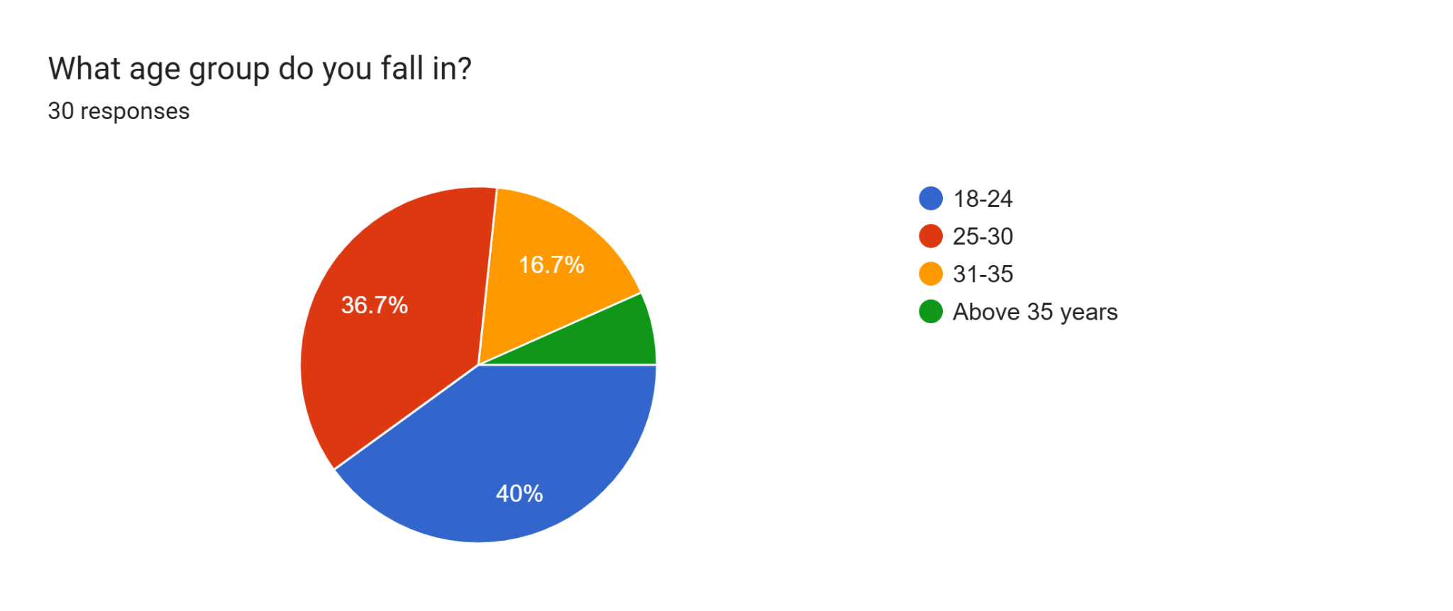
Q2:
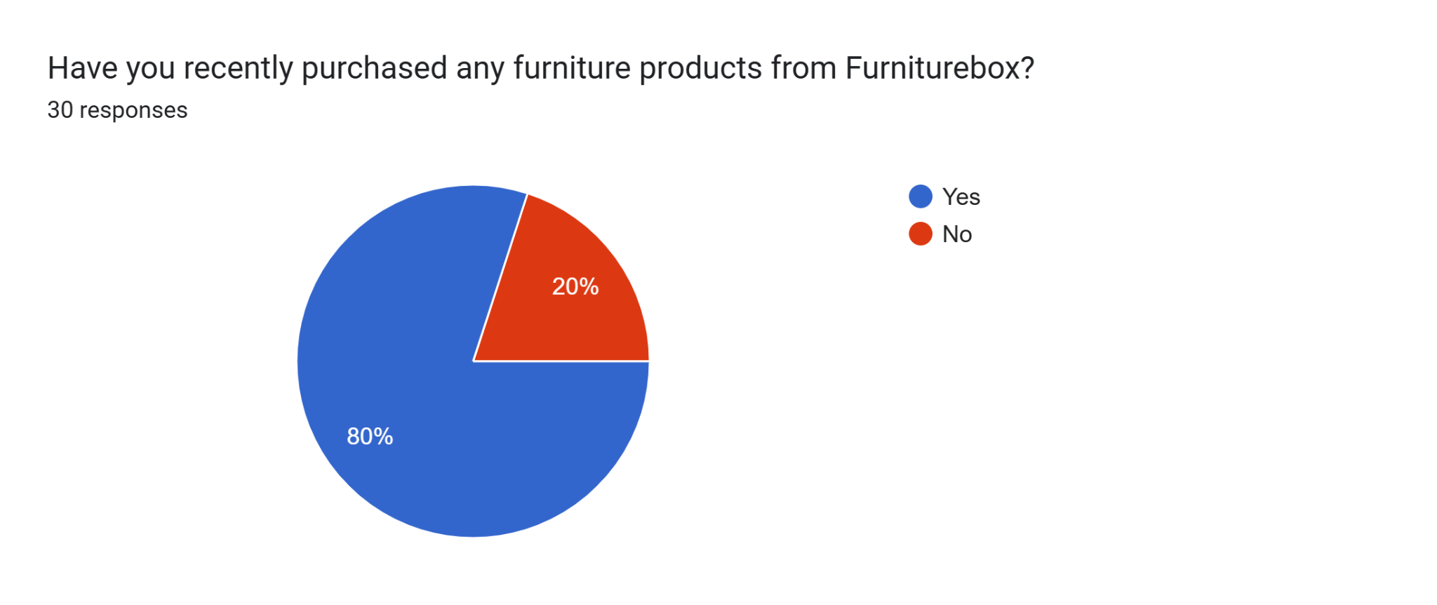
Q3:
Q4:
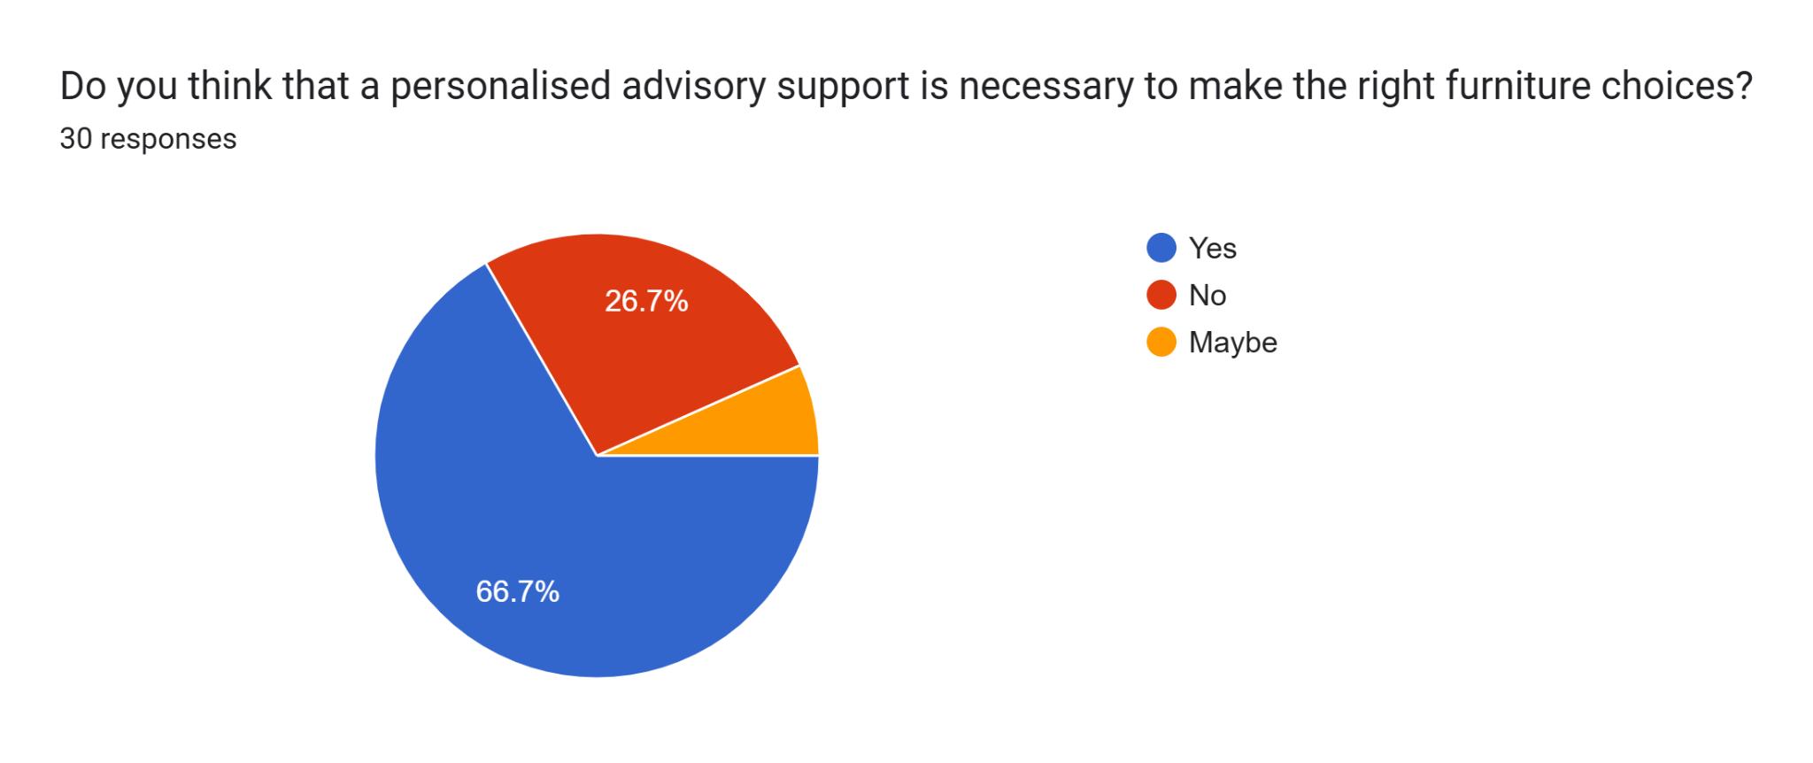
Q5:
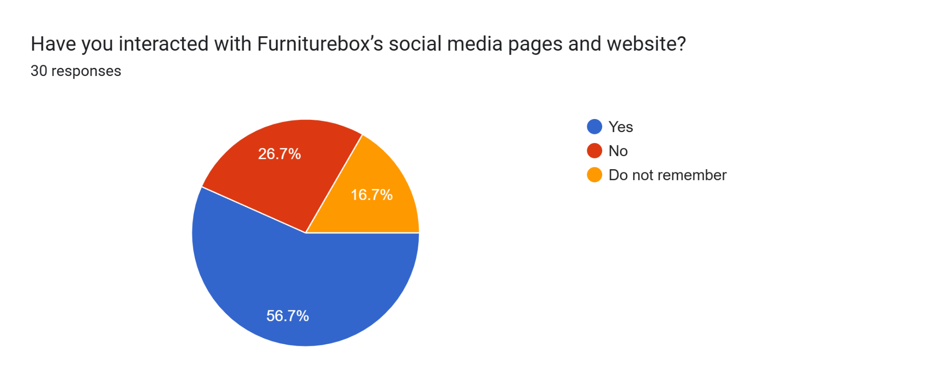
Q6:
Q7:
Q8:
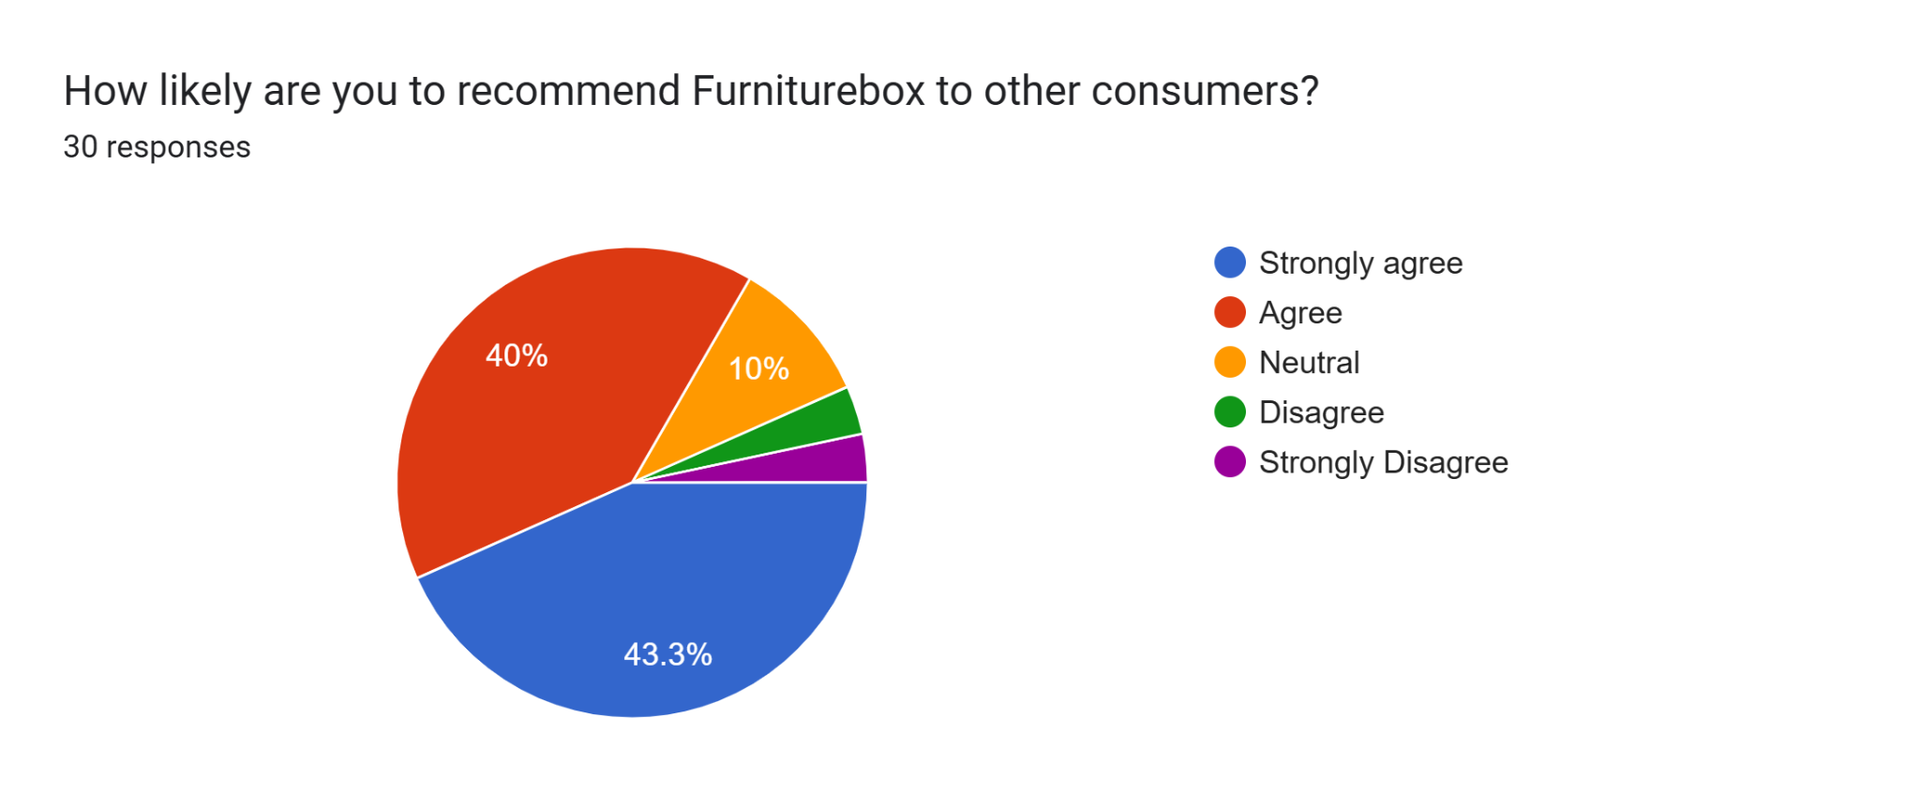
Q9:
Q10:


