Programme: BSc (Hons.) Health and Social Care
Module Title: Health, Wellbeing and Sustainable Development
Module Code: BMHP6030
Component 2: Written Assignment Report
Student Name: Dorothy Tweneboah
Student ID: 2314173
Lecture Name: Junaid Shaikh
Table of Contents
Introduction 3
Overview of SDG 3 and SDG 10 4
Analyse impact of SDG 3 on Health and Wellbeing 6
Analyse impact of SDG 10 on Health and Wellbeing 9
Evaluation of national and local health and wellbeing initiatives 11
Recommendations 12
Conclusion 13
Reference List 14

Introduction
Health and Wellbeing are the major components of a sustainable development and are important for improving the quality of life and also reducing inequalities within the society (Lakioti et al., 2025). This following report will be providing information regarding the impact of SDG3 and SDG10 on the health and overall wellbeing of the people. After this, it will also be evaluating the effectiveness of national and local initiatives for the betterment of the people. Lastly, this report will be providing some appropriate recommendations, which can be used for improving the health of an individual within local, national and global levels.

Overview of SDG 3 and SDG 10
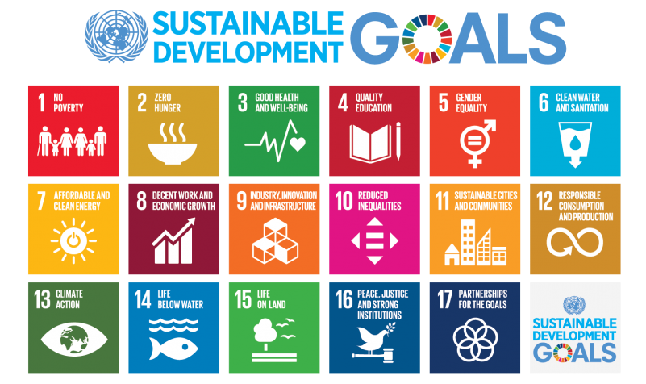
Figure No.1: UN SDG Goals
(Source: UnitedNation, 2026)
The United Nation Sustainable development goals provide an available framework for promoting sustainable development and improving quality of life. Among the 17 SDGS, SDG 3 (Good Health and Wellbeing) and SDG 10 (Reduced Inequality) are Especially important because it directly influences the population's well-being and health. This goal recognizes that they have outcomes not only by the health care service but also by the economics, social and environmental factors.
SDG 3 aims to promote wellbeing and ensure healthy lives for people of different age brackets. The main focus of these goals is to focus on reducing child and maternal mortality, preventing non-communicable and communicable diseases (Long, 2022). Within the UK, SDG 3 has been reflected in healthcare policies, such as the NHS long Term plan, which focuses on prevention, mental health support and early intervention. The Government of the UK has a different monitoring framework which has demonstrated key indicators related to the mental health mortality rates, disease preventions and health care access, which demonstrate the commitment of the country for improving the population over all health outcomes (SDGdata, 2026). For instance, the SDG 3 has indicators like mortality ratio and access to significant health services (Joosse et al., 2023).
SDG 10 focuses on reducing inequalities within and among the countries. The health inequalities are one of the significant challenges within the UK where an individual living in the deprived community often experiences poor health outcomes (Lorenzo, 2022). Limited access to health service and reduced life expectancy. To mitigate such issues, the NHS organisation have introduced Core 20PLUSS initiatives, which is targeting a deprived 20% of the total populations and various other vulnerable groups (EnglandNHS, 2026). This program has focused on the area, such as maternity care, mental health, cancer diagnosis and cardiovascular health to reduce the overall Health Care inequalities in the UK.
Overall, the relationship between SDG3 and SDG 10 is closely interconnected. Poor health is often directly linked with deprivation, poverty and social exclusion, while the reduction of inequalities can help in improving proper access to healthcare and improving wellbeing. To achieve SDG there needs to be progress towards SDG 10 through different policies and intervention which helps in addressing the social determinants of a health and promoting equitable health and social care access for all the people.

Analyse impact of SDG 3 on Health and Wellbeing
The SDG goal 3 aims to ensure healthy life and promote wellbeing for individuals living at all ages. This goal emphasises reducing mortality rates, preventing non communicable and communicable diseases and ultimately improving mental health and achieving universal health coverage (SDGdata, 2026). In the context of the UK, SDG 3 has a major influence on the health policies made by the government, especially through the NHS different practices and preventative healthcare practices. One of the major impacts of SDG 3 has been promotion of preventive healthcare and disease management systems within the UK. The NHS Long Term plan emphasises on the prevention of major health conditions, such as diabetes, cardiovascular disease and or respiratory illness (Raleigh, Jefferies and Wellings, 2022). It has been found that cardiovascular disease remains one of the major priorities because of their contribution to long-term health complications and premature mortality. However, there still remain some challenges. It has been found that in the UK 27% of the total adults are engaged less in physical activity and more than 10% are having a habit of smoking frequently (DigitalNHS, 2026).
The mental health improvement also represents another important contribution of SDG3. Over the past decades the Government of UK and NHS have increased the investment into the mental health service so different programs like the NHS mental health implementation plan. This initiative aims for improving the access to the psychological therapist, community base support and early intervention services (SDGdata, 2026). The improved recognition of a mental health program as the fundamental component of a will reflect a holistic perspective promoted by the SDG3. However, the increasing demand for the service and long waiting times continues to limit the access to care for many people. This has demonstrated that they required a future investment in order to achieve the goal objectives.
At the local level. SDG 3 has also supported the development of community-based health programmes and also integrated care systems. For instance, Integrated Care System across all over England, they work collectively with the local community organisation and authorities for addressing a health requirement and improving all over outcomes (England, 2022). The South and Mid Essex ICS have executed some of the health inequality initiatives, which properly aligns with the NHS core 20PLUS5 framework, emphasising on enhancing the overall access to healthcare and ultimately reducing the level of disparities among the vulnerable populations (England, N.H.S, 2022). Such programmes demonstrated how SDG 3 principles have been translated into local action for improving health and wellbeing outcomes.

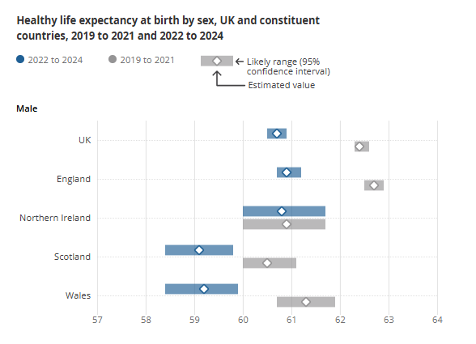
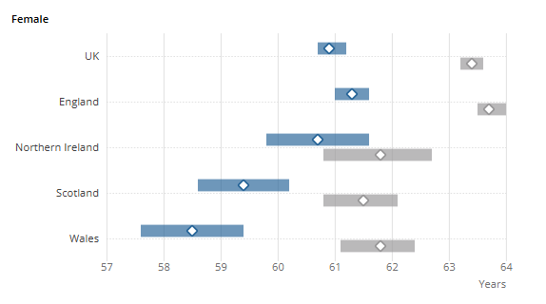
Figure No.2: Healthy life expectancy in the UK
(Source: ONS, 2026)
Despite this achievement, there still remain certain challenges. The recent data published by Office for National Statistics highlighted that a healthy life expectancy in the UK has declined between the year 2019 and 2024, with the male expected to spend 60.7 years and a female around 60 years are in good health (ONS, 2026). This has suggested that although people are living for longer periods of time, many of them are spending more years with disabilities and some kind of illness. Overall, it can be seen that SDG 3 has had some substantial positive impact on the health and wellbeing in the UK through the development in disease management, preventative healthcare and community-based care.

Analyse impact of SDG 10 on Health and Wellbeing
Sustainable Development Goal 10 aims to reduce inequality within and among the people living in the countries by promoting economic, social and political inclusion for every individual. The goal has been closely linked with health and wellbeing because the social economic inequalities are significantly influencing access to the living condition, health care and employment opportunities (Fitawek and Hendriks, 2024). In the context of the UK, reducing inequalities has become a major priority within the health policy because of persistent disparities in the health outcomes between the different populations groups. One of the significant impacts of the SDG10 on health and wellbeing is their major focus on addressing help inequalities.
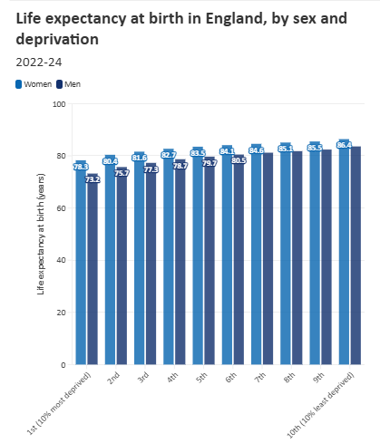
Figure No.3: Life Expectancy at birth in England, by Sex and Deprivation
(Source: TheBMA, 2026)
According to the above figure it has highlighted that people living in most of the deprived areas are experiencing poor health outcomes and lowering of life expectancy as compared to those who are in affluent communities. Males living in deprived areas within England can expect to live 10 years less as compared to the males who are living in proper or least deprived areas (TheBMA, 2026). These kinds of disparities have showcased a strong relationship between socio-economic conditions and overall health outcomes. Furthermore, at the national level, initiatives like the Levelling UP Agenda programme have been developed for reducing socioeconomic and regional inequalities which can influence the overall health outcomes (Davey et al., 2022). By targeting the population and different other vulnerable groups. These programmes have emphasis on improving the outcomes in the areas, such as including mental health, maternity care, cardiovascular, cancer and respiratory disease.
By prioritising more on the disadvantaged communities, the initiative contributed to improving access to healthcare services and supporting an objective of a SDG10. This goal has a major influence on the local health intervention aimed at supporting the vulnerable population (Fitawek and Hendriks, 2024). Many of the local authorities have implemented community outreach programmes, targeted public health and social prescribing schemes. For example, NHS England has referred around 2 million to the social prescribing line worker since the year 2019 (England, 2022). These initiatives can help in addressing barriers, which are often faced by the ethnic minorities, low-income groups and individuals living in the socially deprived areas. When the access to the preventive services is increased and community support, then it can also help in improving both mental and physical wellbeing. Although different support services have been provided, there still remain some challenges. The report published by Health Foundation (2024) reports that the inequality in employment, income and education continue to contribute directly to the unequal health outcomes across the UK. People living in the deprived areas are much more likely to experience long-term health conditions (Ayres et al., 2024). Overall, SDG 10 has a positive influence on the health and wellbeing in the UK by motivating initiatives and policies which can address the health and social inequalities.

Evaluation of national and local health and wellbeing initiatives
The UK has seen a number of national and local health and wellbeing campaigns have contributed to progress on SDG 3 and SDG 10. There have been positive results across the nation with the NHS Long Term Plan helping to prioritise preventive health, expand access to mental health services and help tackle the burden of chronic diseases. The Core20PLUS5 programme has been focussed on the most deprived 20% of the population and vulnerable groups, in order to tackle inequality in the following health areas: maternity, cardiovascular disease, respiratory illness, cancer and mental health. This reflects a high commitment to the reduction of health disparities and to the improvement of wellbeing of populations (Bhandari, 2024). The Levelling Up Agenda has also helped to drive work to and investment in disadvantaged communities, with an aim to closing the regional and socioeconomic gaps. These efforts have helped to make health care more accessible and promote health education on healthy lifestyles.
Despite gains, there remains significant gaps in income, education and employment levels which still affect health outcomes and reduce the effectiveness of these programmes. Integrated Care Systems (ICSs) and community-based health programmes have facilitated the improvement of working together at local level between health providers, local authorities and voluntary services. Social prescribing schemes have also helped to get people referred to community services, enhancing their physical and mental health (Mazzi, 2025). In addition, outreach programmes have been conducted specifically for vulnerable groups to improve access to health care services. Although these have been accomplished, there are still challenges including lack of workforce, extended wait times and inequities in access to services. Thus, whilst there are positive health outcomes as a result of national and local efforts, investment and coordination will be necessary for sustainable health and wellbeing.

Recommendations
- Invest more into preventive health care programs such as smoking cessation programs, physical activity campaigns, and education programs to decrease the prevalence of long-term health conditions and improve overall wellbeing of populations (Mazzi, 2025).
- Increase capacity of mental health services through recruitment of more healthcare workers, less waiting time and more access to early intervention programmes, especially in vulnerable communities and youth.
- Expand community-based healthcare, by enhancing support for Integrated Care Systems and social prescribing schemes, allowing people to access local support networks and be provided with personalised care (Foláyan et al., 2025).
- Strengthen action to overcome health inequalities by allocating more funding to disadvantaged communities, and through better access to health care and planning for broader determinants of health including education, employment, housing and income inequalities.

Conclusion
The report has looked at the importance of SDG 3 and SDG 10 for promoting health and wellbeing in the UK. It examined the impact of these objectives on health policies, preventative health strategies, mental health care and programmes for combating inequalities. The discussion also assessed the impact of national and local health and wellbeing programmes to reduce health inequalities and increased access to health services. There were still some obstacles to overcome, but the results showed improvements towards sustainable health outcomes. Overall, the aims and objectives of the report were successfully achieved.

Reference List
Ayres, S., Newman, J., Bates, G., Le Gouais, A., McClathey, R. and Pearce, N., (2024). Are we any closer to tackling health inequalities in England?. Contemporary Social Science, 19(4), pp.531-554.
Bhandari, M.P., (2024). What is next for the sustainable development goals, what are the challenges concerning SDG 10—reduced inequalities?. Sustainable Earth Reviews, 7(1), p.23.
Davey, F., McGowan, V., Birch, J., Kuhn, I., Lahiri, A., Gkiouleka, A., Arora, A., Sowden, S., Bambra, C. and Ford, J., (2022). Levelling up health: a practical, evidence-based framework for reducing health inequalities. Public health in practice, 4, p.100322.
DigitalNHS (2026). [online]. Available at: https://digital.nhs.uk/data-and-information/publications/statistical/health-survey-for-england/2024 (Accessed: 3 June 2026).
England, N.H.S., (2022). NHS Choices. NHS. [online] Available at: https://www.england.nhs.uk/personalisedcare/social-prescribing/ (Accessed: 4 June 2026).
England, N.H.S., (2022). NHS Choices. NHS. [online] Available at: https://www.england.nhs.uk/about/equality/equality-hub/national-healthcare-inequalities-improvement-programme/core20plus5/ (Accessed: 4 June 2026).
England, N.H.S., (2022). Working in partnership with people and communities: statutory guidance. Care DoHS.
England, NHS., (2026). NHS Choices. NHS. [online] Available at: https://www.england.nhs.uk/about/equality/equality-hub/national-healthcare-inequalities-improvement-programme/core20plus5/core20plus5-cyp/ (Accessed: 4 June 2026).
Foláyan, M.O., de Barros Coelho, E.M.R., Feldens, C.A., Gaffar, B., Virtanen, J.I., Abodunrin, O.R., Duangthip, D., Al-Batayneh, O.B., Vukovic, A., El Tantawi, M. and Schroth, R.J., (2025). A scoping review on early childhood caries and inequalities using the Sustainable Development Goal 10 framework. BMC Oral Health, 25(1), p.219.
Joosse, I.R., Wirtz, V.J., Van Mourik, A.T., Wagner, B.A., Mantel-Teeuwisse, A.K., Suleman, F. and van den Ham, H.A., (2023). SDG indicator 3. b. 3–an analysis of its robustness and challenges for measuring access to medicines for children. BMC Health Services Research, 23(1), p.574.
Lakioti, E., Pagonis, N., Flegkas, D., Itziou, A., Moustakas, K. and Karayannis, V., (2025). Social factors and policies promoting good health and well-being as a sustainable development goal: current achievements and future pathways. Sustainability, 17(11), p.5063.
Long, D., (2022). SDG 3: Ensure healthy lives and promote well-being for all at all ages. EU Centre and Social and Global Studies Centre at RMIT University.
Lorenzo, J.A., (2022). SDG 10-Reduce Inequality Within and Among Countries. The UN Sustainable Development Goals: A Commentary (Ilias Bantekas and Francesco Seatzu, eds.), Oxford University Press (2023).
Mazzi, F., (2025). Evaluating the normative implications of national and international artificial intelligence policies for Sustainable Development Goal 3: good health and well-being. Health Affairs Scholar, 3(6), p.qxaf108.
ONS (2026). Healthy life expectancy, UK: between 2011 to 2013 and 2022 to 2024, Healthy life expectancy, UK - Office for National Statistics. Office for National Statistics. [online] Available at: https://www.ons.gov.uk/peoplepopulationandcommunity/healthandsocialcare/healthandlifeexpectancies/bulletins/healthstatelifeexpectanciesuk/between2011to2013and2022to2024 (Accessed: 4 June 2026).
Raleigh, V., Jefferies, D. and Wellings, D., (2022). Cardiovascular disease in England. Fund TK,(ed).
SDGdata (2026). Goal 3 - Good Health and Well-Being (no date) Goal 3 - Good Health and Well-Being - U.K. Indicators For The Sustainable Development Goals. Available at: https://sdgdata.gov.uk/3/ (Accessed: 3 June 2026).
TheBMA (2026) UK Health Inequalities and Life Expectancy: BMA, The British Medical Association is the trade union and professional body for doctors in the UK. British Medical Association. [online] Available at: https://www.bma.org.uk/what-we-do/population-health/addressing-social-determinants-that-influence-health/health-inequalities-in-england (Accessed: 4 June 2026).
UnitedNation (2026). [online] Available at: https://social.desa.un.org/issues/disability/sustainable-development-goals-sdgs-and-disability (Accessed: 4 June 2026).

