

MBA – Master of Business Administration
Strategic Management (LCMB7003)

Strategic Analysis of Airbnb


Student name: Aswathy Vadakkedath Appu
Student Number: 2217024

Table of Contents
1. Introduction 3
2. The Company Overview 3
2.1. The Mission and Objectives of Airbnb 4
3. The Macro Environment Analysis 5
4. The Micro Environment Analysis 6
4.1. The Industry Life Cycle 7
4.2. Porter's Five Forces Analysis 7
5. Internal Analysis 9
5.1. Strategic Resources and Capabilities of Airbnb 9
5.2. Value Chain Analysis 10
5.2.1. The Primary Activities of Airbnb 10
5.2.2. The Secondary Activities of Airbnb 10
5.3. VRIO Analysis of Distinctive Resources and Capabilities 11
5.4. SWOT Analysis 12
6. The Competitive Upper hand 13
6.1. Porter’s Generic Strategy 13
6.2. Planned approach for Competitive Advantage 14
6.3. Emergent Approach for Competitive Advantage 15
7. The Growth Strategy 16
7.1. The Ansoff Metrix 18
7.2. The International Strategies 19
7.3. Entry Mode Strategies 19
7.3.1. The Market Penetration 21
8. The Green Strategy and CSR 22
9. Conclusion 23
10. Recommendations 23
REFERENCES 25
APPENDIX 28

1. Introduction
This strategic analysis comprehensively evaluates Airbnb, a popular online lodging marketplace. The analysis consists of a micro-environmental analysis to evaluate immediate environmental factors that may impact the company's operations, a macro-environmental analysis to assess the broader external factors that may affect Airbnb's operations, an internal analysis to evaluate the company's strengths and weaknesses, and a strategic analysis to evaluate how Airbnb deals with central issues it faces. The micro-environmental analysis focuses on competitors, suppliers, customers, and other stakeholders. The macro-environmental analysis examines economic, social, technological, political, and environmental factors. The internal analysis assesses Airbnb's resources, capabilities, and core competencies. Finally, the strategic analysis evaluates the company's strategic decisions and assesses the effectiveness of its implementation. Overall, this analysis provides a comprehensive evaluation of Airbnb's business environment, strategic position, and performance, which is useful for understanding the company's current position and potential future directions.

2. The Company Overview
Airbnb is a privately held company founded in 2008, headquartered in San Francisco, California, USA. As of 2021, the company has approximately 14,000 employees globally. According to its most recent financial statements, as of December 31, 2022, Airbnb had a net income of $219.3 million on revenues of $3.4 billion. Airbnb operates in more than 220 countries and regions worldwide, offering over 7 million unique accommodations, including apartments, houses, villas, and unique stays like treehouses and castles. The company also offers experiences and activities hosted by local experts in over 1,000 cities globally. The main source of Airbnb's revenue is derived from commissions on bookings made through its platform. (Qiu, et al., 2022).
Airbnb has changed the game for both hosts and visitors by disrupting the traditional hospitality industry. The company's business model is based on the concept of the sharing economy, in which hosts can earn money from their extra space and visitors can find affordable and distinct lodging options. Airbnb also offers a variety of Experiences and Adventures, which enable visitors to participate in a variety of activities and excursions provided by residents. Airbnb has achieved accelerated growth and global success due to its innovative business model, making it one of the most well-known and highly valued companies in the sharing economy (Gyódi, 2022). The financial analysis of Airbnb is given in Annex A.

2.1. The Mission and Objectives of Airbnb
The objective of Airbnb is to establish a global community where individuals can feel a sense of belonging regardless of their location. The company's aim is to offer guests a distinctive, reasonably priced, and convenient travel experience, while simultaneously providing hosts with the chance to generate additional income by sharing their homes and communities.
The purpose of strategy incorporates the vision statement, mission statement, statements of corporate values and objectives. Figure 2.1 shows the purpose of strategy for Airbnb.

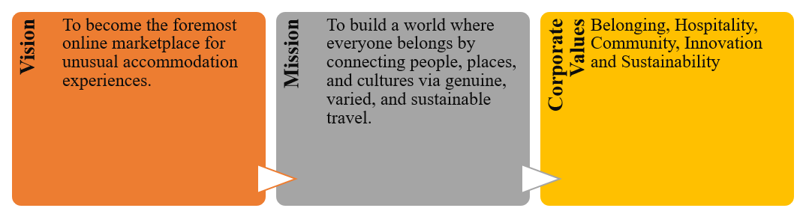
Figure 2.1 The purpose of Strategy at Airbnb (Created by Author).

From the above diagram, representing the model for the purpose of strategy analysis at the Airbnb, it is seen that,
Vision Statement: To become the world’s leading and most trusted online marketplace for unique accommodation experiences.
Mission Statement: To create a world where anyone can belong anywhere by providing authentic, diverse, and sustainable travel experiences that connect people, places, and cultures.
Statements of Corporate Values
- Belonging – Creating a sense of belonging for guests and hosts alike, regardless of their background or culture.
- Hospitality – Providing exceptional hospitality to guests and maintaining a respectful and collaborative relationship with hosts.
- Community – Fostering a sense of community among guests and hosts by facilitating meaningful connections and interactions.
- Innovation – Continuously innovating and improving the platform to enhance the guest and host experience.
- Sustainability – Promoting sustainable travel practices and environmentally responsible hosting.
Objectives of Strategy
- To maintain Airbnb’s position as the leading player in the online lodging market and expand the business globally through partnerships with governments, organizations, and DMOs.
- To attract and retain millennial customers by offering a wide range of unique and authentic accommodation experiences.
- To enhance the guest and host experience through continuous innovation and improvements to the platform.
- To promote sustainable travel practices and environmentally responsible hosting.
- To generate positive social impact by supporting non-profit organizations and communities in need.
Airbnb's strategic partnerships and community initiatives have helped the company expand its global reach and increase its market value. Despite facing some criticism, Airbnb continues to focus on providing unique accommodation options and promoting tourism growth while adhering to its core values and objectives.

3. The Macro Environment Analysis
The macro-environmental analysis of Airbnb is focused on examining the broader external factors that may affect the company's operations. The analysis will be done using the PESTEL framework, which evaluates the Political, Economic, Social, Technological, Environmental, and Legal factors that may impact a company's operations (Mody, et al., 2022). Table 3.1 shows the PESTLE analysis framework of Airbnb.

Table 3.1 PESTLE Analysis of Airbnb (Created by Author)
Factor | Description
Political | Regulatory challenges in several cities worldwide, concerns over short-term rentals and zoning laws, scrutiny over issues like data privacy, discrimination, and taxation.
Economic | Impact of economic cycles, including the COVID-19 pandemic that led to a significant decline in global travel, changes in exchange rates and inflation that can affect pricing strategies, and global economic uncertainties impacting consumer spending on travel.
Social | Focus on offering unique, local travel experiences that align with changing consumer preferences for unique, personalized travel, emphasis on diversity and belonging.
Technological | Leveraging technology to enhance the guest and host experience, improve safety, ensure compliance with local regulations, with its website and mobile app being key platforms for bookings and communications.
Environmental | Focus on initiatives like offering environmentally friendly accommodations and experiences, promoting sustainable tourism practices.
Legal | Regulatory issues and concerns over compliance with local laws affecting the company's operations, lawsuits related to data privacy, discrimination, and other legal issues.

The aforementioned table presents a comprehensive summary of the primary determinants that influence the operational activities of Airbnb within the PESTLE framework.

4. The Micro Environment Analysis
The micro-environmental analysis of Airbnb is focused on examining the internal factors that directly impact the company's operations, including its competitors, customers, suppliers, and other stakeholders. By analyzing these factors, we can gain a better understanding of how Airbnb's internal operations and relationships affect its ability to achieve its strategic objectives and maintain a competitive advantage in the market.

4.1. The Industry Life Cycle
Airbnb operates in the hospitality industry, which has experienced significant growth in recent years. As a relatively new player in the industry, Airbnb is in the growth stage of the industry life cycle (Li & Tsai, 2022). Figure 4.1 shows the industry life cycle of Airbnb.

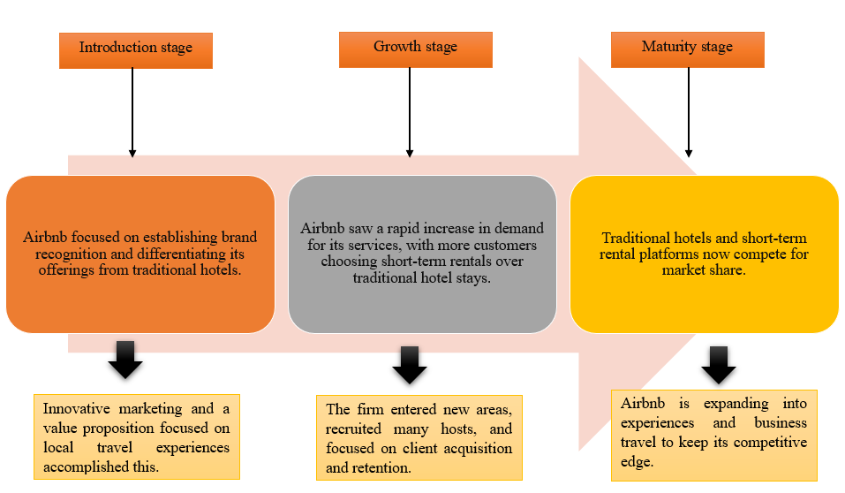
Figure 4.1 The Industry life cycle of Airbnb (Created by Author).

Although Airbnb is currently in the maturity stage of the industry life cycle, the industry itself is still in the growth stage, with a significant potential for further expansion. As such, Airbnb is well-positioned to capitalize on this growth and continue to maintain its competitive advantage in the coming years.

4.2. Porter's Five Forces Analysis
Porter's five forces analysis was a useful tool for evaluating the competitive forces in the industry and how Airbnb could achieve competitive advantage by responding to these forces. By conducting a Porter's five forces analysis, Airbnb could identify the strength of the competitive forces that shaped the industry, including the threat of new entrants, the bargaining power of suppliers and buyers, the threat of substitute products or services, and the intensity of competitive rivalry (Budiharso, et al., 2022).
This analysis helped Airbnb identify the areas where it could differentiate itself from competitors and gain a competitive advantage, such as through product innovation, pricing strategy, branding, and marketing efforts. By responding strategically to the competitive forces identified in the analysis, Airbnb positioned itself in a way that allowed it to gain market share and maintain profitability. In this way, Porter's five forces analysis helped Airbnb achieve competitive advantage through its particular choice of strategic management, in this case, the prescriptive/planned approach. The Porter's five forces analysis utilized by the Airbnb is given as,
Threat of new entrants: Airbnb faced the threat of new entrants in the online accommodation booking industry. However, the prescriptive/planned approach taken by Airbnb allowed them to establish themselves as a dominant player in the market. Their first-mover advantage, strong brand image, and extensive network of hosts and guests made it difficult for new entrants to compete.
Bargaining power of suppliers: Airbnb's suppliers were the hosts who provided accommodations on their platform. The prescriptive/planned approach allowed Airbnb to establish a large network of hosts, which gave them bargaining power over the suppliers. Additionally, the platform allowed for easy communication between hosts and guests, which helped to establish a sense of community and loyalty to the platform (De Widt, et al., 2022).
Bargaining power of buyers: The buyers on Airbnb's platform were the guests who booked accommodations. The prescriptive/planned approach taken by Airbnb allowed them to establish a large customer base and build a strong brand image. This gave them bargaining power over the buyers as they had a range of accommodation options to choose from (Madsen & Grønseth, 2022).
Threat of substitute products or services: Airbnb faced the threat of substitute products or services such as traditional hotels or other vacation rental platforms. However, the prescriptive/planned approach allowed Airbnb to establish a unique value proposition that differentiated them from their competitors. This included offering a wider range of accommodations, lower prices, and a more personalized experience.
Intensity of competitive rivalry: Airbnb faced intense competition from other vacation rental platforms and traditional hotels. However, the prescriptive/planned approach taken by Airbnb allowed them to differentiate themselves from competitors and establish a strong brand image. This helped them to maintain a competitive edge over their rivals (Baxter, 2019).
By analyzing these five competitive forces and responding strategically, Airbnb was able to achieve competitive advantage through their particular choice of strategic management, which was a prescriptive/planned approach.

5. Internal Analysis
An internal analysis of Airbnb focuses on examining the company's internal operations and resources to identify its strengths and weaknesses, as well as opportunities for improvement.

5.1. Strategic Resources and Capabilities of Airbnb
The strategic resources and capabilities of Airbnb are critical to the company's success in the highly competitive hospitality industry (Gao, et al., 2022). Key resources and capabilities that give Airbnb a competitive advantage include:
- Strong brand recognition: Airbnb has established a strong brand image, which has helped the company to differentiate itself from traditional hotels and other short-term rental platforms. The brand is built around the concept of providing unique and local travel experiences, which resonates with many travelers.
- Technology platform: Airbnb's technology platform is a critical resource that enables the company to connect hosts with guests and facilitate transactions. The platform is easy to use and has a wide range of features that enhance the user experience. This includes tools for host and guest communication, payment processing, and dispute resolution.
- Network of hosts and suppliers: Airbnb's network of hosts and suppliers is another critical resource that gives the company a competitive advantage. The network is composed of millions of hosts worldwide who offer a wide range of unique and diverse accommodation options. This enables Airbnb to offer travelers a more authentic and personalized experience than traditional hotels (Gao, et al., 2022).
- Data analytics: Airbnb leverages its extensive data analytics capabilities to gain insights into consumer behavior, preferences, and trends. This enables the company to optimize its marketing and sales strategies, improve the user experience, and make more informed business decisions.
Overall, these strategic resources and capabilities have helped Airbnb to establish a strong position in the hospitality industry and compete effectively with traditional hotels and other short-term rental platforms. By continuing to leverage these resources and capabilities, Airbnb can maintain its competitive advantage and continue to drive growth in the years ahead.

5.2. Value Chain Analysis
A value chain analysis includes both primary and secondary activities. The primary activities are the core activities that create value for the customer, while the secondary activities provide support for the primary activities (Ricardo, et al., 2022).

5.2.1. The Primary Activities of Airbnb
Below is a value chain analysis for Airbnb, including both primary and secondary activities. Figure 5.1 shows the primary activities of Airbnb.

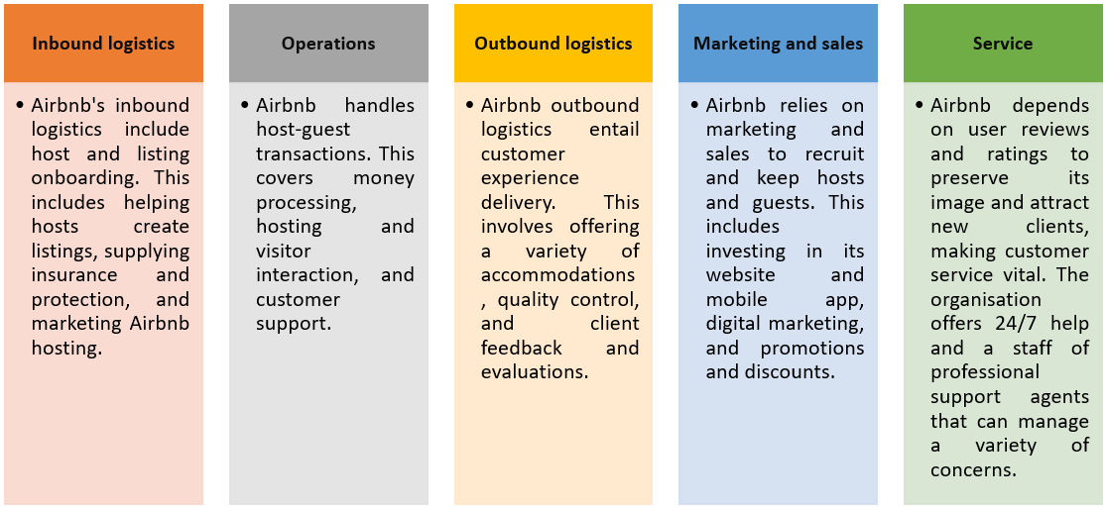
Figure 5.1 The Primary Activities of Airbnb (Created by Author).

5.2.2. The Secondary Activities of Airbnb
According to (Bogers, et al., 2019), these activities support the primary activities of the company by enabling the creation and delivery of a high-quality user experience, including developing and maintaining a user-friendly platform, sourcing suppliers and partners, and fostering a positive and inclusive work environment.
- Procurement: The procurement function for Airbnb involves sourcing suppliers and partners that can help the company to deliver its products and services. This includes acquiring technology and equipment, as well as sourcing insurance and other services to support the company's operations.
- Technology development: The technology development function for Airbnb is critical to the company's success since it enables hosts and guests to communicate and interact with each other. The company invests heavily in platform development to ensure that it remains easy to use and has a wide range of features to enhance the user experience.
- Human resources: The human resources function for Airbnb is responsible for recruiting, training, and retaining employees who can support the company's operations. This includes developing policies and programs that foster a positive and inclusive work environment.
- Infrastructure: The infrastructure function for Airbnb involves maintaining the physical and digital infrastructure required to support the company's operations. This includes managing data centers, servers, and other technology equipment, as well as managing the physical infrastructure of the company's offices and other facilities (Hitt, et al., 2019).
Through a thorough examination of the primary and secondary activities within its value chain, Airbnb can discern opportunities to generate supplementary value for its clientele and streamline its operations to sustain its competitive edge. The proposed measures encompass the allocation of resources towards technological advancements, broadening the scope of marketing and sales initiatives, and enhancing the quality of customer service and support operations.

5.3. VRIO Analysis of Distinctive Resources and Capabilities
VRIO analysis is a strategic tool used to evaluate a company's resources and capabilities to determine their value, rarity, inimitability, and organization. In the case of Airbnb, some of its distinctive resources and capabilities include its online platform, brand reputation, global network of hosts and guests, and data analytics capabilities (Teece, 2019).
The online platform is valuable as it allows for easy and seamless booking and payment processes, which is a critical factor in the travel and tourism industry. The brand reputation of Airbnb is also valuable, as it is widely recognized and trusted by consumers, which enhances the company's market position and competitive advantage. The global network of hosts and guests is a rare resource, as it is difficult for competitors to replicate the scale and reach of Airbnb's community. This network also creates switching costs for users, making it harder for them to switch to other platforms (Wang, et al., 2019).
The data analytics capabilities of Airbnb are also rare, as the company is able to analyze large amounts of data to improve user experiences and make informed business decisions. However, this capability may be imitable by competitors with similar resources and expertise. Overall, the resources and capabilities of Airbnb are valuable, rare, and inimitable, which gives the company a sustained competitive advantage. The organization of these resources and capabilities within Airbnb is also effective, as the company is able to leverage them to create a unique and successful business model (Mahase, 2020).

5.4. SWOT Analysis
By conducting a SWOT analysis, Airbnb can gain insights into its current position in the market and identify areas where it can improve its competitive advantage. Figure 5.2 shows the SWOT Analysis of Airbnb.

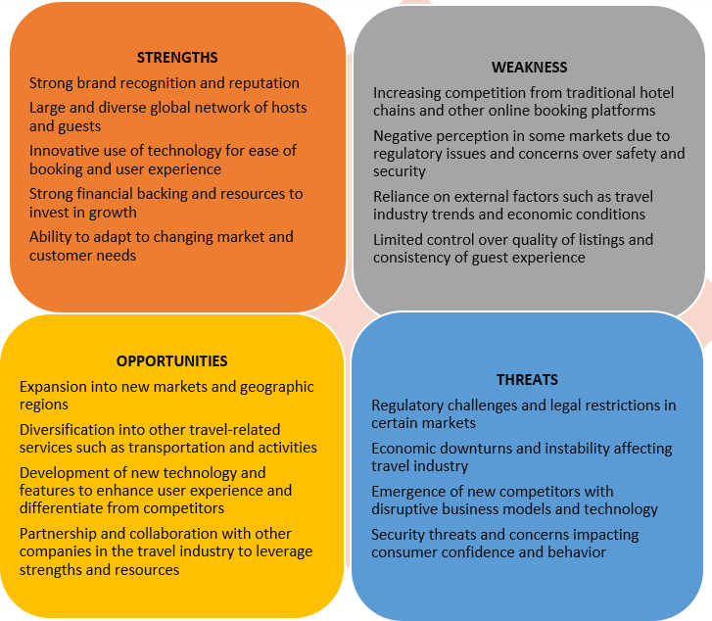
Figure 5.2 The SWOT Analysis of Airbnb (Created by Author).

Airbnb can maintain its competitive advantage by recognizing its strengths, such as a solid brand reputation and an innovative approach to the sharing economy. Airbnb can also maintain its competitive advantage by proactively adapting its strategies in response to potential threats, such as regulatory changes or new market entrants. In addition, by analyzing its weaknesses, such as safety and security concerns, Airbnb is able to address these issues and increase customer satisfaction. Airbnb can increase its customer base and revenue by identifying opportunities, such as expanding into new markets or offering new services. Overall, SWOT analysis provides a comprehensive overview of the company's position and aids Airbnb in making informed strategic management decisions (Alagarsamy, et al., 2022).

6. The Competitive Upper hand
Airbnb's strategic management is notable for its use of a hybrid strategy that incorporates both prescriptive/planned and emergent/incremental tactics, which has allowed the company to gain a competitive edge.

6.1. Porter’s Generic Strategy
There are several strategies that Airbnb can employ to sustain its competitive advantage, including Porter's generic strategies, which are a set of three strategies that a company can use to gain a competitive advantage (Yang, et al., 2020)..
- Cost Leadership Strategy: Airbnb can continue to pursue a cost leadership strategy by focusing on cost efficiency and minimizing expenses while still delivering high-quality services to customers. This could include optimizing the use of its resources, such as improving supply chain management or leveraging economies of scale to reduce costs.
- Differentiation Strategy: Airbnb can maintain its competitive advantage through a differentiation strategy by offering unique and distinctive services that set it apart from competitors. This could include providing customized experiences for guests, investing in technology to improve the user experience, or offering unique and exclusive properties for rent.
- Focus Strategy: Airbnb can use a focus strategy by targeting a specific market segment or niche and tailoring its services to meet the specific needs and preferences of that segment. For example, Airbnb could focus on business travelers or luxury travelers and offer services and amenities tailored to their needs.
Additionally, Airbnb can also pursue other strategies to sustain its competitive advantage, such as expanding into new markets, investing in research and development, and creating strategic partnerships with other companies in the travel and hospitality industry. By continuously analyzing and adapting to changes in the industry and consumer preferences, Airbnb can maintain its competitive advantage and stay ahead of its competitors (Greene, et al., 2019)..

6.2. Planned approach for Competitive Advantage
Airbnb utilized a planned approach by establishing a clear corporate-level strategy and objectives, conducting SWOT analysis, Porter's Five Forces Analysis and implementing specific tactics to achieve their goals. For example, they strategically focused on market penetration and product and service development to overcome central issues like regulatory challenges, competition, and trust issues. By doing so, they were able to increase their market share, expand their offerings, and maintain their competitive edge (Isaac & Saha, 2023).
The Competitive Landscape
When Airbnb first appeared on the scene in 2008, it presented a novel approach to the rental of short-term lodging. Figure 6.1 shows the competitive landscape of Airbnb after the strategic management.

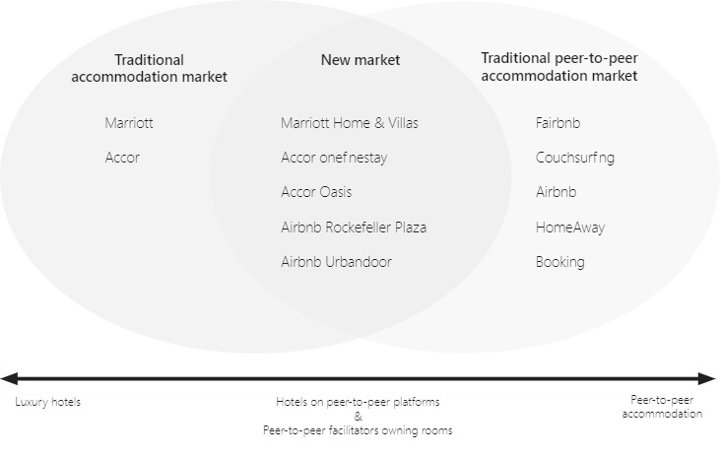
Figure 6.1 The Competitive landscape of Airbnb (Vlados & Chatzinikolaou, 2019).

Since Airbnb and similar peer-to-peer accommodation facilitators do not own or hold leases for the properties they are trading, they cannot guarantee that guests will get the advertised accommodations. Airbnb listings tended to be less expensive than identical services from professional, licensed housing providers, which helped grow adoption despite early skepticism from tourists. With the introduction of Airbnb Rockefeller Plaza and Airbnb Urban door, the company shifted its focus from providing only short-term rentals to longer-term stays with hotel-style amenities. To be competitive in the new market environment, hotels have begun providing peer-to-peer space trading–inspired room types (Marriott Home & Villas, Accor one fine stay, Accor Oasis, etc.).

6.3. Emergent Approach for Competitive Advantage
Airbnb also utilized an incremental approach to strategic management in addition to a prescriptive/planned approach. This approach involved gathering feedback from a variety of stakeholders, such as hosts, visitors, and regulators, and using that feedback to test new ideas and modify their strategy. Figure 6.2 shows the way in which the Airbnb achieved competitive advantage through their particular choice of strategic management.

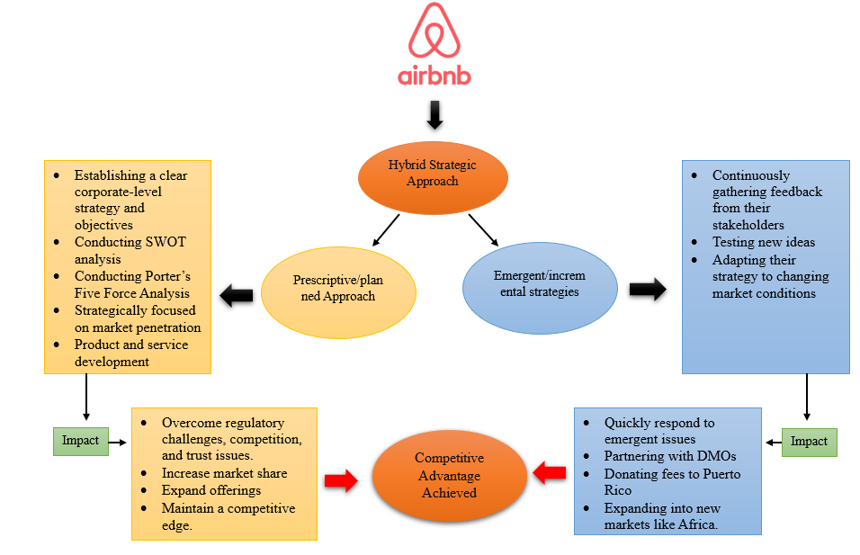
Figure 6.2 The Achievement of a Competitive Advantage (Created by Author).

By continuously monitoring and adjusting to the ever-shifting realities of the industry, Airbnb was able to promptly address newly arising issues and make the most of newly emerging possibilities. Airbnb eliminated all host fees in the wake of Hurricane Maria's devastation in Puerto Rico in 2017, and the company also contributed a part of its booking fees to local recovery efforts. Airbnb was able to show their commitment to social responsibility and maintain excellent ties with the community via the implementation of this campaign. Additionally, Airbnb effectively expanded into new markets, such as Africa, by adopting a gradual approach. They initially tested the market by forming partnerships with local hosts and launching targeted marketing campaigns to increase brand awareness. Airbnb was able to minimize risk and establish a solid footing in previously unexplored regions by progressively establishing a presence in these new markets (Caballero-Morales, 2021). The strategic management of Airbnb is shown in Annex B.
Airbnb was able to gain an edge in the market because of its management team's hybrid approach to strategic planning and execution. This strategy helped them succeed in the competitive online housing industry, adapt to guests' needs as they evolved, and provide ongoing value to their stakeholders and consumers.

7. The Growth Strategy
A crucial corporate strategy decision is the company's growth direction. Businesses operating in expanding industries must expand to endure. The most prevalent corporate directional strategies are those that aim to increase sales, assets, profits, or a combination thereof.
According to (Torres & Godinho, 2022), Airbnb's expansion strategy centered on expanding its global presence and entering new markets. This was accomplished through targeted marketing campaigns and product development initiatives, as well as through partnerships with governments, tourism agencies, and non-profit organizations. Key to Airbnb's development strategy was the introduction of new listing categories, such as treehouses, yurts, and igloos, that went beyond traditional accommodations like hotels and apartments. This enabled the company to differentiate itself from competitors and appeal to a broader spectrum of travelers. Figure 7.1 shows the way by which the growth strategy model helped to overcome the central issues of Airbnb.

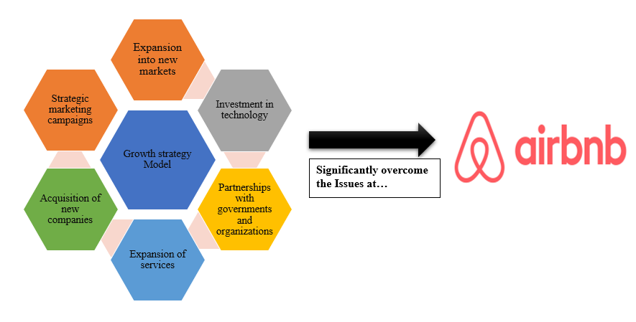
Figure 7.1 The Growth Strategy Model (Created by Author).

Additionally, Airbnb made substantial investments in its technology platform to enhance the user experience and streamline operations. This included the development of mobile applications, the improvement of search algorithms, and the incorporation of new safety features to resolve concerns regarding fraud and security. Airbnb was able to maintain a competitive advantage and attract more consumers by continuously innovating and enhancing its product. Airbnb's development strategy also included capitalizing on emerging tourism trends such as experiential travel and sustainable tourism. Offering eco-friendly listings and partnering with local communities to provide one-of-a-kind cultural experiences are two of the company's initiatives to encourage responsible travel. Airbnb was able to differentiate itself from conventional travel companies and appeal to travelers seeking more authentic and sustainable travel experiences as a result of these efforts. The overall growth strategy of Airbnb centered on expanding its reach, diversifying its offerings, and differentiating itself from competitors through innovation and a commitment to responsible travel. By implementing this strategy, the company was able to surmount its numerous core challenges and emerge as a dominant player in the online lodging market (Mukhuty, et al., 2022).

7.1. The Ansoff Metrix
The Ansoff Matrix is a strategic tool used to identify growth opportunities for a company. It consists of four growth strategies: Market Penetration, Market Development, Product Development, and Diversification (Oehlhorn, et al., 2020). Figure 7.2 shows the Ansoff Metrix of Airbnb.

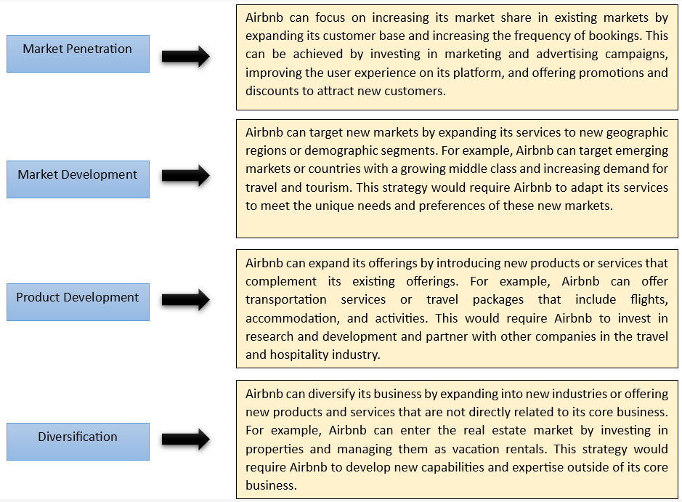
Figure 7.2 The Ansoff Metrix of Airbnb (Created by Author).

In essence, the utilization of the Ansoff Matrix can enable Airbnb to discern avenues for growth and devise tactics to amplify its enterprise and uphold its competitive edge.

7.2. The International Strategies
International expansion is a growth strategy that involves entering new foreign markets to increase a company's customer base and revenue (Perifanis & & Kitsios, 2023). Here are some international growth strategies that Airbnb could consider:
- Exporting: To expand its reach to international markets, Airbnb may initiate by enabling its platform to support diverse currencies and languages. This approach necessitates a limited investment and enables Airbnb to conduct a preliminary assessment before undertaking a comprehensive expansion.
- Licensing and Franchising: Airbnb has the option to grant licenses or franchises of its brand to local partners situated in various nations. The implementation of this particular approach would enable Airbnb to utilize the proficiency and familiarity of the local populace to customize its offerings in order to cater to the demands and inclinations of individual markets (Yu, et al., 2022).
- Joint Ventures and Strategic Alliances: Airbnb has the potential to establish collaborative partnerships or strategic alliances with indigenous firms across various nations, thereby facilitating the sharing of resources, risks, and expertise. The implementation of this particular approach may aid Airbnb in surmounting regulatory and cultural obstacles, thereby enabling the company to establish a robust foothold in novel markets.
- Direct Investment: Airbnb has the option to engage in direct investment activities within foreign markets through the acquisition of local companies or the establishment of subsidiaries. By implementing this approach, Airbnb is able to exercise complete authority over its business activities and establish a robust brand presence in novel territories.
Incorporating international growth strategies can enable Airbnb to achieve global expansion, augment its revenue streams, and attain a competitive edge vis-à-vis its competitors.

7.3. Entry Mode Strategies
The term entry mode strategy pertains to the approach adopted by a company when venturing into a new market. The following are potential entry mode strategies that Airbnb may contemplate:
- Greenfield Investment: The Greenfield Investment approach pertains to the establishment of a novel enterprise in a foreign market without any prior existing infrastructure or resources. Establishing a robust market presence, tailoring its services to local needs, and capitalizing on indigenous resources could be a viable strategy for Airbnb. The implementation of this particular strategy may aid Airbnb in circumventing the limitations imposed by established enterprises, adjusting to regional market circumstances, and attaining a competitive edge. Notwithstanding, greenfield investment necessitates substantial investments in terms of time, finances, and resources. In order to successfully establish a presence in a new market, Airbnb would be required to undertake comprehensive market research, identify an optimal location, engage in talent acquisition from the local community, establish a robust supply chain, and adhere to all pertinent local regulations (Yang, et al., 2022).
- Acquisition: Acquisition involves buying an existing company in a foreign market to enter new markets quickly and gain access to local expertise and resources. This strategy can be suitable for Airbnb to acquire market share, customer base, and local knowledge. Through acquisitions, Airbnb can benefit from economies of scale, reduce risks, and enter markets where local players have established a strong presence. However, acquisitions can be costly and risky, as Airbnb may face cultural differences, regulatory barriers, and integration challenges. Also, Airbnb may not be able to retain the existing customer base and brand reputation of the acquired company (Airbnb, 2023).
- Joint Venture: Joint venture is a business strategy that entails establishing a collaborative partnership with a domestic entity in a foreign market with the aim of sharing risks, costs, and expertise. The implementation of this particular strategy may prove to be a viable solution for Airbnb in its efforts to surmount regulatory and cultural impediments, thereby enabling the company to establish a robust foothold in novel markets. By means of collaborative partnerships, Airbnb has the potential to capitalize on the expertise, familiarity, and assets of its regional associates, distribute liabilities and expenditures, and gain entry to previously untapped consumer demographics. Notwithstanding their potential benefits, joint ventures may encounter obstacles such as divergent interests, disparities in cultural norms, and complications related to adherence to legal and regulatory requirements. The joint venture between Airbnb could potentially encounter challenges pertaining to control and governance (Mendecka, et al., 2022).
- Franchising: Franchising involves granting local partners the right to use Airbnb's brand and business model in a foreign market. This strategy can be suitable for Airbnb to grow rapidly in new markets with minimal investment. Franchising allows Airbnb to expand its business without the costs of opening new locations or managing operations in foreign markets. Through franchising, Airbnb can benefit from the local partner's knowledge, experience, and investment, and focus on its core competencies. However, franchising may lead to a loss of control over the quality of service, customer experience, and brand reputation. Also, Airbnb may face issues of compatibility and consistency across different franchises.
- Licensing: Licensing involves granting a local partner the right to use Airbnb's intellectual property, such as trademarks and patents, in a foreign market. This strategy allows Airbnb to earn revenue from its intellectual property without making significant investments in foreign markets. Licensing can be a suitable option for Airbnb to enter markets where local players have a strong presence, and the demand for Airbnb's services is high. However, licensing may lead to a loss of control over the use of intellectual property, quality standards, and brand reputation. Also, licensing may not provide Airbnb with the same level of profits as other entry mode strategies.
By considering different entry mode strategies, Airbnb can expand its business globally and increase its market share in new markets. It is important for Airbnb to select an entry mode strategy that aligns with its business goals, resources, and capabilities, as well as the local market conditions and regulations.

7.3.1. The Market Penetration
Penetration of the market is a growth strategy that entails gaining a larger portion of an already established market using the present offerings. To address the core problems it was experiencing, Airbnb shifted to this approach (Erlangga, 2022). An in-depth explanation of Airbnb's success in expanding into other markets is as follows:
- Increased Brand Awareness: By penetrating deeper into existing markets, Airbnb was able to create more awareness about its brand. This helped the company to attract more customers and increase bookings.
- Improved User Experience: Airbnb made continuous efforts to improve the user experience on its platform. The company introduced new features and services, which helped to attract more customers and retain existing ones. This also helped to increase the market share of Airbnb in existing markets (Ben-Abdallah, et al., 2022).
- Competitive Advantage: By increasing its market share in existing markets, Airbnb was able to create a competitive advantage over its competitors. This helped the company to attract more hosts and guests, which in turn helped to increase the revenue and profitability of the company.
- Enhanced Customer Loyalty: By providing better services and experiences, Airbnb was able to enhance customer loyalty. This helped the company to retain its customers and attract new ones, which helped to increase its market share (Erlangga, 2022)..
- Reduced Marketing Costs: According to (Jatmiko, et al., 2022), by focusing on market penetration, Airbnb was able to reduce its marketing costs. The company was able to leverage its existing customer base to attract new customers, which helped to reduce the cost of acquiring new customers.
Airbnb was able to tackle its key issues by expanding its market share, upgrading its user experience, developing a competitive advantage, growing its customer loyalty, and reducing its spending on marketing.

8. The Green Strategy and CSR
Green strategy and corporate social responsibility (CSR) are becoming increasingly important for companies as stakeholders are placing more value on sustainability and ethical practices. Airbnb has recognized the significance of these issues and has developed various green and CSR initiatives (Dolnicar & Zare, 2020).
According to (Bresciani, et al., 2021), one of Airbnb's green strategies is to reduce the carbon footprint of its hosts and guests. The company has partnered with Carbonfund.org to offset the carbon emissions from the energy used in Airbnb listings. The initiative is aimed at reducing the environmental impact of travel and encouraging more sustainable travel practices. Airbnb also has several CSR initiatives, including the Open Homes program. This program connects hosts with refugees, disaster survivors, and individuals with medical needs who require temporary accommodation. The company also offers disaster response services, allowing hosts to offer their homes for free to people affected by natural disasters such as hurricanes, earthquakes, and wildfires. In addition, Airbnb has implemented a non-discrimination policy that prohibits discrimination based on factors such as race, gender, sexual orientation, and religion. This policy helps to promote social inclusion and ensure that everyone has equal access to the services offered by Airbnb. The corporate level strategy of Airbnb is given in Annex C.
In general, Airbnb's ecological approach and corporate social responsibility endeavors showcase the organization's dedication to promoting sustainability and fulfilling its societal obligations. The aforementioned endeavors not only yield ecological and societal advantages, but also foster a favorable corporate reputation and augment the firm's competitive edge.

9. Conclusion
The hybrid strategic management plan that Airbnb employs, which combines prescriptive and emergent tactics, contributed to the company's success in the internet lodging industry and provided it a competitive advantage. Airbnb was able to successfully manage the complex and ever-changing market environment, outperform its competitors, and generate value for the company's consumers and stakeholders by combining long-term planning with short-term adaptability and innovation. The firm was able to keep its hold on the market leadership position, expand into new sectors, manage newly developing challenges, and react to changing market conditions thanks to this approach. Airbnb's strategic management approach was a contributing factor in the company's rapid expansion and leading position in the industry.

10. Recommendations
The present study offers strategic recommendations for Airbnb based on a thorough analysis of the company.
- Airbnb should continue to innovate and use technology to improve its services and enhance the customer experience. The company should invest in research and development to develop new products and services that meet the changing needs and preferences of its customers.
- Airbnb should continue to prioritize sustainability and CSR initiatives, including reducing carbon footprint, promoting social inclusion, and providing disaster response services. These efforts will help to build a positive brand image and improve the company's reputation among stakeholders.
- Airbnb should investigate opportunities to expand its services into new markets, such as Asia and Africa, where the sharing economy has substantial development potential. Additionally, the company should consider acquiring or partnering with local businesses in order to establish a foothold in these markets.
- In order to help hosts, provide a better guest experience, Airbnb should deepen its ties with hosts by offering additional assistance and resources, such as tools and training. This will contribute to raising the quality of listings and enhancing the company's reputation.
- As the sharing economy faces increasing scrutiny from regulators, Airbnb should take proactive measures to manage regulatory risks and comply with local laws and regulations. The company should work closely with governments and policymakers to develop regulatory frameworks that are favorable to the sharing economy.
Overall, by implementing these recommendations, Airbnb can continue to grow and maintain its competitive advantage in the sharing economy while contributing to the sustainability and social responsibility of the industry.

REFERENCES
- Airbnb, 2023. Airbnb. [Online] Available at: https://www.airbnb.co.in/?locale=en&_set_bev_on_new_domain=1681533623_NzNmMjA3ZTNkMmU3.
- Alagarsamy, S., Mehrolia, S. & Paul, J., 2022. Masstige scale: An alternative to measure brand equity.. International Journal of Consumer Studies..
- Baxter, G., 2019. A strategic analysis of Cargolux Airlines International position in the global air cargo supply chain using Porter’s Five Forces Model. Infrastructures. p. 6..
- Ben-Abdallah, R., Shamout, M. D. & Alshurideh, M., 2022. Business Development Strategy Model Using Efe, Ife and Ie Analysis in a High-tech Company: An Empirical Study.. Academy of Strategic Management Journal , pp. 1-9..
- Bogers, M., Chesbrough, H., Heaton, S. & Teece, D. J., 2019. Strategic management of open innovation: A dynamic capabilities perspective.. California Management Review, pp. 77-94..
- Bresciani, S. et al., 2021. The seven lives of Airbnb. The role of accommodation types.. Annals of Tourism Research, Volume 88, p. 103170.
- Budiharso, T., Makruf, I. & Mujahid, I., 2022. Porter’s Five Forces: Evaluating Education Management Practices in the Postgraduate Program of UIN RM Said Surakarta, Indonesia.. Journal of Social Studies Education Research,, pp. 164-192..
- Caballero-Morales, S. O., 2021. Innovation as recovery strategy for SMEs in emerging economies during the COVID-19 pandemic.. Research in international business and finance, p. 101396..
- De Widt, D., Llewelyn, I. & Thorogood, T., 2022. Liberalising audit markets for local government: The five forces at work in England and the Netherlands.. Financial Accountability & Management,, pp. 394-425..
- Dolnicar, S. & Zare, S., 2020. COVID19 and Airbnb–Disrupting the disruptor. Annals of tourism research, Volume 83, p. 102961.
- Erlangga, H., 2022. Micro Financial Sharia Non-bank Strategic Analysis: a Study at BMT Beringharjo, Yogyakarta.. Budapest International Research and Critics Institute-Journal (BIRCI-Journal), pp. 1677-1686..
- Gao, B., Zhu, M., Liu, S. & Jiang, M., 2022. Different voices between Airbnb and hotel customers: An integrated analysis of online reviews using structural topic model.. Journal of Hospitality and Tourism Management, pp. 119-131..
- Greene, C., Hanley, N. & Campbell, M., 2019. Claudin-5: gatekeeper of neurological function.. Fluids and Barriers of the CNS, pp. 1-15..
- Gyódi, K., 2022. Airbnb and hotels during COVID-19: Different strategies to survive.. International Journal of Culture, Tourism and Hospitality Research, pp. 168-192..
- Hitt, M. A., Ireland, R. D. & Hoskisson, R. E., 2019. Strategic management: Concepts and cases: Competitiveness and globalization.. Cengage Learning..
- Isaac, N. & Saha, A. K., 2023. A Review of the Optimization Strategies and Methods Used to Locate Hydrogen Fuel Refueling Stations.. Energies, p. 2171..
- Jatmiko, B. et al., 2022. Key-Factor Strategy of Creative Industry in Distribution Channel: A SWOT Analysis Method. Int J. Sus Dev. Plan, , pp. 1895-1904..
- Li, C. Y. & Tsai, M. C., 2022. What makes guests trust Airbnb? Consumer trust formation and its impact on continuance intention in the sharing economy.. Journal of Hospitality and Tourism Management, pp. 44-54..
- Madsen, D. Ø. & Grønseth, B. O., 2022. Five Forces Model. In Encyclopedia of Tourism Management and Marketing. Edward Elgar Publishing., pp. 250-252.
- Mahase, E., 2020. Covid-19: WHO declares pandemic because of “alarming levels” of spread, severity, and inaction.. Bmj, , p. m1036..
- Mendecka, B., Di Ilio, G., Krastev, V. K. & Bella, G., 2022. Technical assessment of phase change material thermal expansion for passive solar tracking in residential thermal energy storage applications.. Journal of Energy Storage, p. 103990..
- Mody, M. A., Jung, S., Dogru, T. & Suess, C., 2022. How do consumers select between hotels and Airbnb? A hierarchy of importance in accommodation choice.. International Journal of Contemporary Hospitality Management, (ahead-of-print)..
- Mukhuty, S., Upadhyay, A. & Rothwell, H., 2022. Strategic sustainable development of Industry 4.0 through the lens of social responsibility: The role of human resource practices.. Business Strategy and the Environment, pp. 2068-2081..
- Oehlhorn, C. E., Maier, C., Laumer, S. & Weitzel, T., 2020. Human resource management and its impact on strategic business-IT alignment: A literature review and avenues for future research.. The Journal of Strategic Information Systems, p. 101641..
- Perifanis, N. A. & & Kitsios, F., 2023. Investigating the Influence of Artificial Intelligence on Business Value in the Digital Era of Strategy:. A Literature Review. Information, p. 85.
- Qiu, H. et al., 2022. The construction of the affinity-seeking strategies of Airbnb homestay hosts.. International Journal of Contemporary Hospitality Management, pp. 861-884..
- Ricardo, J. E., Fernández, A. J. R. & Vázquez, M. Y. L., 2022. Compensatory Fuzzy Logic with Single Valued Neutrosophic Numbers in the Analysis of University Strategic Management.. International Journal of Neutrosophic Science,, pp. 151-159..
- Teece, D. J., 2019. A capability theory of the firm: an economics and (strategic) management perspective.. New Zealand Economic Papers, pp. 1-43..
- Torres, P. & Godinho, P., 2022. Levels of necessity of entrepreneurial ecosystems elements.. Small Business Economics,, pp. 29-45..
- Vlados, C. & Chatzinikolaou, D., 2019. Methodological redirections for an evolutionary approach of the external business environment. J. Mgmt. & Sustainability, , p. 25.
- Wang, W. et al., 2019. A survey on consensus mechanisms and mining strategy management in blockchain networks.. Ieee Access, pp. 22328-22370..
- Yang, X., Zou, Y. & Chen, L., 2022. Operation analysis of freeway mixed traffic flow based on catch-up coordination platoon.. Accident Analysis & Prevention, p. 106780..
- Yang, Y. et al., 2020. Plasma IP-10 and MCP-3 levels are highly associated with disease severity and predict the progression of COVID-19.. Journal of Allergy and Clinical Immunology, pp. 119-127..
- Yu, X., Liu, T., He, L. & Li, Y., 2022. Micro-foundations of strategic decision-making in family business organisations: A cognitive neuroscience perspective.. Long Range Planning, p. 102198.

APPENDIX
A. FINANCIAL ANALYSIS OF AIRBNB
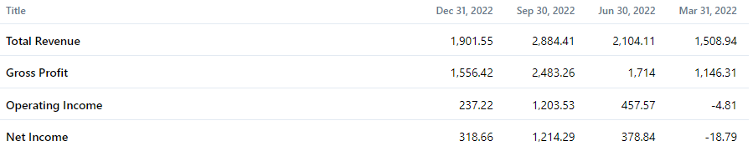
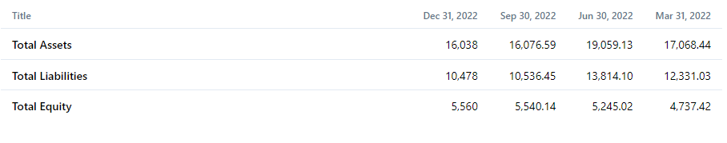
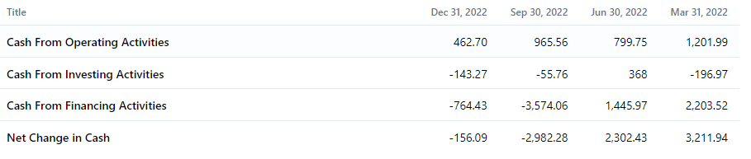
Airbnb, Inc. has disclosed its financial results for the fourth quarter of 2022, which concluded on December 31. The firm claimed that its sales for the fourth quarter were USD 1,902 million, which is an increase over the previous year's fourth quarter sales of USD 1,532 million. The company reported a net income of 319 million US dollars, compared to 55 million US dollars the previous year. The ongoing activities contributed to a basic profits per share of $0.50, which is an increase from $0.09 in the prior year. In comparison to the previous year's figure of $0.08, continuing operations resulted in a diluted profits per share of $0.48.

B. STRATEGIC MANAGEMENT OF AIRBNB
The following figure analyses the way the central issues were dwelt after the incorporation of the emergent strategy by the Airbnb.

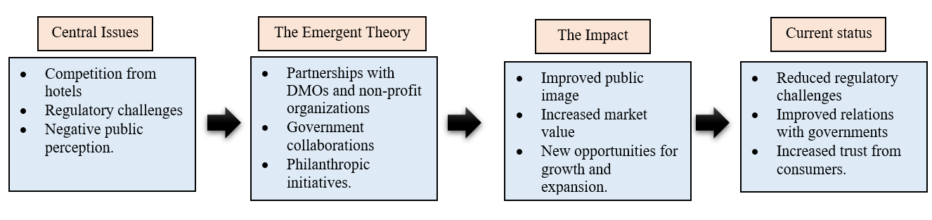

The flowchart illustrates how Airbnb's implementation of the emergent strategy enables it to resolve its most pressing issues. By evaluating and modifying the strategy on a regular basis, the company can become more effective at addressing the issues, thereby reducing their significance. However, as the business environment evolves, new challenges may emerge, necessitating a review of the strategy development procedure. Prior to the implementation of the strategy, Airbnb faced significant obstacles, including competition from hotels, regulatory hurdles, and negative public perception. Airbnb's emerging strategy, which may include partnerships with DMOs and non-profit organizations, government collaborations, and philanthropic endeavors. The effect of the emerging strategy on Airbnb's core issues, such as enhanced public image, increased market value, and new growth and expansion opportunities. The current status of Airbnb's most pressing issues, such as reduced regulatory challenges, improved relations with governments, and increased consumer trust, following the implementation of the emergent strategy.

C. CORPORATE LEVEL STRATEGY OF AIRBNB
Increasing their emphasis on community and sustainability, forging stronger ties with local governments and destination management organizations (DMOs), and broadening their product offerings have all been essential to Airbnb's corporate-level approach for addressing the core challenges. To begin, Airbnb has diversified its income sources and attracted a larger spectrum of clients by broadening its product offerings beyond only home-sharing to include activities, restaurants, and even luxury rentals. Its growth has allowed the firm to better compete with conventional hotel chains and other online travel agencies, while also giving hosts new ways to make money and contribute to their communities
Second, Airbnb has attempted to strengthen relationships with municipal and tourism boards. We have worked closely with these organisations to resolve their concerns about regulation and compliance while promoting responsible hosting and sustainable tourism. Airbnb's collaborations have helped it grow and gain trust. Airbnb has also increased community and environmental activities. Airbnb's Community Tourism Program and commitment to create a carbon-neutral platform by 2025 strive to mitigate tourism's environmental and community impacts. Airbnb's focus on community and sustainability has set it apart from competitors and attracted ethical vacationers. Figure shows the corporate level strategy adopted by the Airbnb to overcome the central issues.

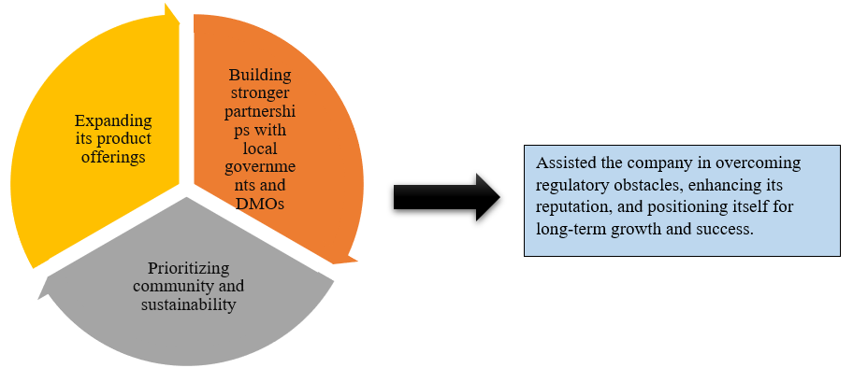

In order to address these systemic challenges, Airbnb has prioritized community and sustainability at the corporate level by broadening its product offerings and forging better collaborations with local governments and DMOs. These initiatives have helped the firm face down regulatory hurdles, boost its image, and set itself up for sustainable development and success.
The corporate level strategic management also incorporates the directional strategy, portfolio analysis and parenting strategy associated with the corporate level strategy at Airbnb to overcome the various issues faced by the organization.
Directional Strategy: Airbnb's strategy focuses on expanding its business internationally while resolving local concerns and fostering stronger relationships with local governments and communities.
Portfolio Analysis: Airbnb has implemented a tiered system to differentiate itself from its competitors and appeal to a wider range of travelers.
Parenting Strategy: Airbnb seeks to create a sustainable business model through initiatives such as Host Advisory Boards and Super host programs.

