Assessment Form

Module: Preparing for the Role of Constable BMPL6013
Student Name: C. Grota
Module Tutor (s): Jane /Kelly
Date: 21/07/2025
Question | 1.  Situation | 2.  Task | 3.  Action | 4.  Result |  | Total Mark
1 | 4 /5 | 4/5 | 13/15 | 4/5 |  | 25/30
2 | 4/5 | 4/5 | 13/15 | 4/5 |  | 25/30
3 | 4/5 | 4/5 | 13/15 | 4/5 |  | 25 /30
Total Mark
75/90

83 % This will be capped at 40%
Key
No Reference | Minimum | Satisfactory | Exceptional
0 | 0-4 | 5-10 | 11-15

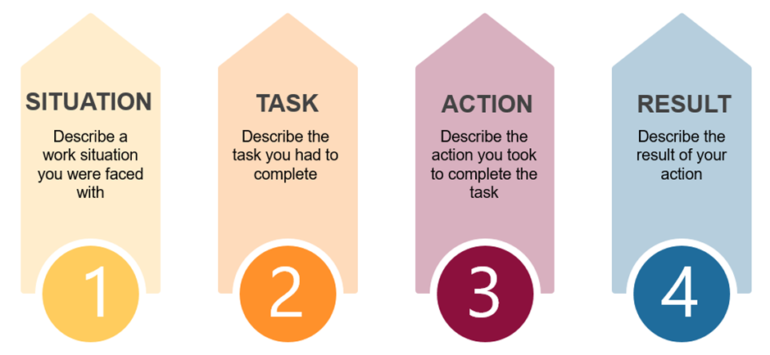

Question | Comments
1 | Question 4 used - In 2019 was a team leader at a big event / summer fair attended with work with deadlines to meet. Staff member was stressed and made inappropriate comments to a younger member of staff. I took them away privately and asked if all was OK. Balance of work and home issues was making them stressed. I addressed the behaviour and gave solutions regarding work such as giving work out to others and monitoring them. Also spoke to victim and split the 2 members so that they worked away from each other. staff tasks were delegated and both staff members which made them feel that they were supported and deadlines were completed.
2 | Question 2 used – I was a social media assistant where I was presenting to a large team/ meeting with new buyers. My task was to present current stats that was developed from all the company’s department. However, a report was missing which caused stress and arguments between team members. I decided to reach out to all the different teams to get the information so I could update the presentation.  On the day I arrived early to have a pre-presentation with manager who was happy.  Buyers were happy with the meeting, and they invested.  I took a Proactive approach taken which managers were happy with.
3 | Question 6 used – role social media marketing campaigns there was a decrease in marketing. Looked into this but there was an issue that I had not done I forgot to ‘fully optimise the campaign’ for the mobile users. This meant that the campaign was not reaching through the mobile network.  Took the information to my manager where I was honest about the mistake stating that I would rebuild the campaign to make up for this. I rebuild all the images and campaign so that people could see the correct details and worked overtime to support this.  A few weeks later engagement increase 40%.  My Manager was happy with the result and outcome

Question Bank (Interviewer to select 3 questions from the below)
1. Police Constables are accountable for their decision making. Describe a time where you have had to take ownership of a situation and be the decision maker.
2. Police Constables often have to make the decision to take positive action to influence a situation. Describe a time when you have had to use your initiative to ensure a positive outcome.

3. Police Constables face challenging situations on a daily basis. Describe a time when you have taken ownership of a challenging situation and explain the steps you took to resolve it.

4. Police Constables must challenge and report improper behaviour. Describe a time where you have challenged inappropriate behaviour.

5. Police Constables must be able to adapt to changing situations. Describe a time where you have shown your ability to adapt and be open to change.

6. Police Constables must ensure that they act with honesty and integrity. Explain a situation where you have demonstrated honesty and integrity through your decisions and actions.

7. Police Constables must be able to take the lead in any situation when required to do. Describe a situation where you have had to take the lead and explain your decision making and actions.

8. Police Constables are required to selfless in many situations. Describe a time where you feel you have shown selflessness.

