Introduction
My journey through this module has significantly contributed to the strengthening and development of my knowledge on academic skills, particularly paraphrasing, note taking and reflection skills. Using Gibbs’ Reflective Cycle (1988) as a framework, I will reflect on how these skills were developed, my experiences while learning them and how they will benefit my future academic endeavours. Through various tasks, activities and class discussions, I improved my ability to rephrase information effectively, capture key ideas through note-taking and critically evaluate my own learning process. This reflection will provide enough evidence of my progress and the impact these skills have had on my academic performance.
Paraphrasing Skills
Paraphrasing Skills were introduced as part of the academic writing sessions during week 4 of the module. One specific task involved paraphrasing sections of a research article to include in an essay while trying to avoid plagiarism. Initially, I found this challenging because it required me to understand the text before rewording it in my own words. The activity in class focused on identifying key ideas in a paragraph, changing sentence structure and using synonyms to convey the same meaning without copying the original text.
At first, I found paraphrasing challenging, as I hadn’t practiced it in quite some time. I felt unsure about my ability to accurately rephrase ideas, especially when dealing with technical concepts and I was concerned about the risk of unintentional plagiarism. However, I also saw it as a valuable skill for academic writing and a necessary refresher that boosted my confidence.
I faced challenges in the beginning, but the topics taught in the course, such as breaking down sentences, identifying keywords and using symptoms helped me improve. I realized that paraphrasing was not just about changing words but understanding the content of the text thoroughly before rewriting it. My first attempts were not perfect, but feedback from my lecturer highlighted areas for improvement. Gradually, I became more confident and I noticed that my rewritten texts were clearer and better integrated into my work.

Paraphrasing is a critical skill because it allows writers to include external ideas without directly quoting large sections of text. This skill is particularly important for avoiding plagiarism. I learned to use strategies such as identifying the main ideas, restructuring sentences and using tools like a thesaurus to find synonyms. Practicing paraphrasing also enhanced my ability to critically analyse texts, as I had to fully comprehend the content before rewording it. Through this process, I developed better reading comprehension and critical thinking skills.
I improved significantly in paraphrasing over the duration of the module. I can now paraphrase texts confidently while maintaining academic integrity. This skill will be essential for future assignments, especially research-based essays and reports, where paraphrasing is necessary for referencing and integrating evidence.
To further develop my paraphrasing skills, I will practice regularly by rewriting short academic texts. Additionally, I will use tools like plagiarism checkers to ensure my paraphrasing meets academic standards. I also plan to review paraphrased sections with peers or instructors to get constructive feedback.

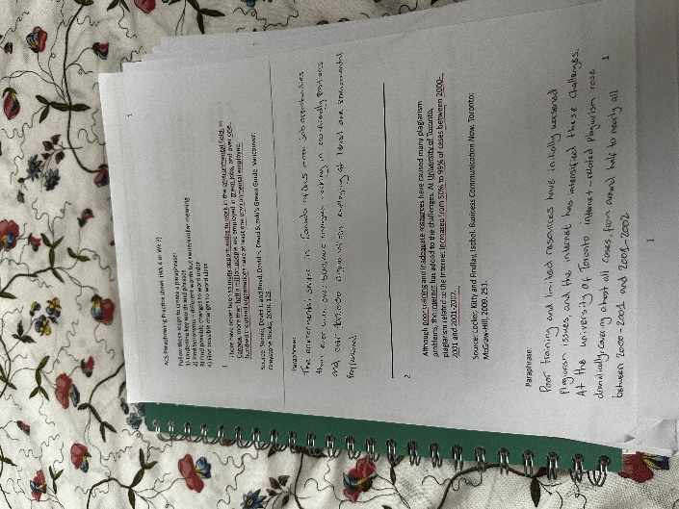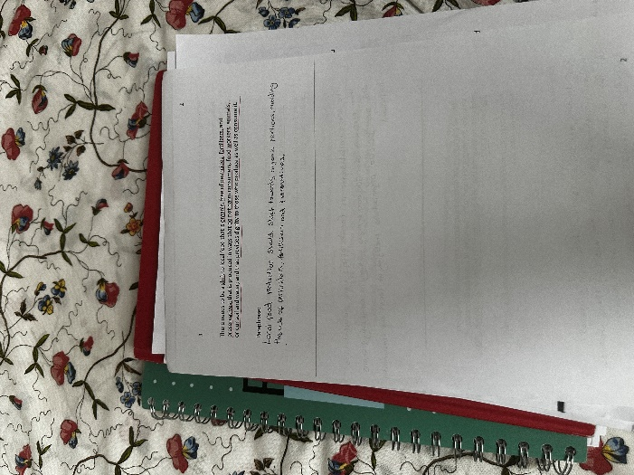
Note Taking Skills
Note-taking skills were emphasized during lectures and independent research tasks. One notable activity involved using types of note-taking to extract key information to summarize key points for discussion. Initially, I used the diagrammatic note-taking method which consists of creating notes by making a mind map. As a result, my notes were somewhat organised and I was able to identify the key concepts during review.
I felt frustrated because my initial note-taking method was inefficient. I often missed key information while trying to write everything down. However, I also realized that improving my note-taking would save me time and make studying more effective. I was eager to improve my note-taking techniques.
The introduction of structured note-taking methods, such as the Cornell Method and mind mapping, transformed how I approached lectures and readings. The Cornell Method allowed me to organize my notes into key points, details, and summaries, making it easier to review later. Additionally, mind mapping helped me visualize relationships between ideas, particularly for complex topics. These techniques improved my ability to focus on main concepts rather than irrelevant details.
Note-taking is crucial for active learning, as it allowed me to engage with material during lectures and readings. Effective notes serve as a foundation for assignments, revision, and deeper understanding of concepts. I learned that note-taking is not about transcribing everything but about identifying key ideas and summarizing them in my own words. Using tools like abbreviations, symbols, and highlighting also made my notes clearer and easier to review.
My note-taking skills have improved significantly. I can now filter essential information from lectures and readings, organize it effectively, and use it for further study or assignments. These skills have made me a more efficient learner.
To continue improving, I will practice taking notes using different methods, such as combining mind mapping with linear notes for complex topics. I will also review my notes regularly to ensure they are accurate and useful. Additionally, I plan to explore digital note-taking tools like OneNote to enhance organization and accessibility.
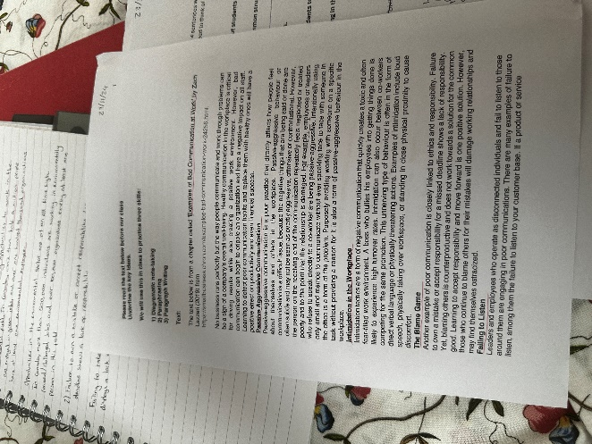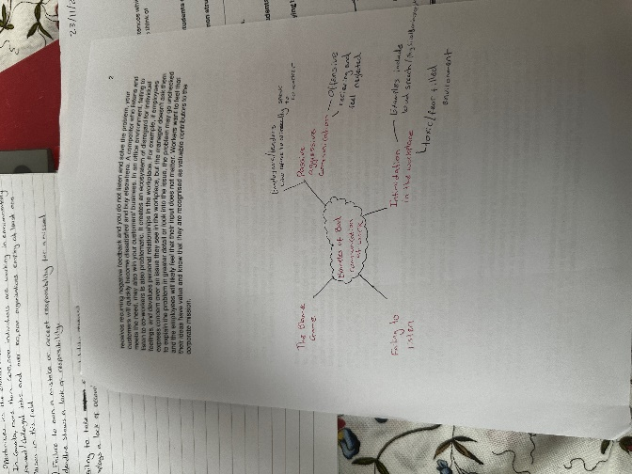
Reflection Skills
Reflection skills were developed through various self-assessment activities and reflective writing exercises. One specific task involved writing a weekly reflection on what I had learned in class, including challenges faced and strategies used to overcome them. Initially, I struggled to reflect critically because I was unfamiliar with the process of evaluating my own learning.
At first, I found it uncomfortable to reflect on my challenges and weaknesses. I felt unsure about how to articulate my thoughts clearly and critically. However, I realized that reflection is a valuable skill for identifying areas of improvement and planning effective solutions.

As I practiced reflective writing, I became more comfortable with analysing my experiences. Using structured frameworks like Gibbs’ Reflective Cycle helped me break down the reflection process into clear stages—description, feelings, evaluation, analysis, conclusion, and action plan. This made it easier to assess what I had learned and identify how to improve. Reflective practice also helped me become more aware of my progress and boosted my confidence.
Reflection is essential for personal and academic growth because it allowed me to assess my strengths, weaknesses, and learning strategies. By reflecting on my challenges, I was able to identify specific actions to improve, such as dedicating more time to paraphrasing practice or trying new note-taking techniques. Reflection also encouraged me to take responsibility for my learning and set realistic goals.
I have significantly improved my ability to reflect on my learning experiences. Reflection has enabled me to understand my progress and identify effective strategies for overcoming challenges.
To further enhance my reflection skills, I will continue to write weekly reflections and use structured models like Gibbs’ Cycle. I will also seek feedback from instructors to ensure my reflections are meaningful and constructive. Over time, I aim to make reflection a regular part of my academic and personal development process.
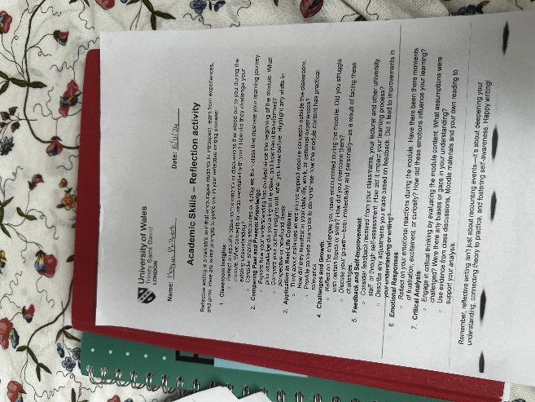
Conclusion
In conclusion, this module has significantly contributed to my development of paraphrasing skills, note-taking skills, and reflection skills. Through practice, feedback, and the use of structured methods, I improved my ability to paraphrase accurately, take organized and effective notes, and reflect critically on my learning experiences. These skills are essential for academic success and will be invaluable in future assignments, research, and professional settings. Moving forward, I will continue to refine these skills through regular practice, feedback, and self-assessment, ensuring continuous improvement in my academic journey.

