ASSIGNMENT
For
Marketing Fundamentals
LCBB4004
Assessment-1
……………………………………………………………………………….

Topic Name

Blogging to communicate

COCA COLA
Student Name – Davinder Singh
Student Id – 2221905
Submitted To- Tushara Blenderan

Introduction

The coca cola organization is famous beverage company. This brand sold their
products in 200 countries and many union territories. This company have main objective to refresh people and create a difference. Coca cola have its subsidiary
brand such as Fanta, Sprite and other sugar drinks.
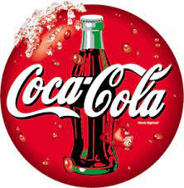
Founder of coca cola
Mr. Johan s. was a pharmacist in Atlanta, Georgia, made liquied for coca cola. After that he created sample which was pronounced “excellent” as well as sale for a Soda drink of five cents per glass.
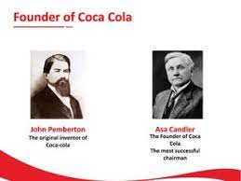

Equipments use in Coca cola
Firstly, filteration and sophistication process is started of fresh water and disinfected and remove all harmful particulars and infections from water.
Secondly, sugar is mixed in this water with main recipes syrup after that fizziness procedure has been started under with the help of high pressure these liquids renowned fizziness. Nextly,
Automatic computerized machine dispenses these liquids then quantities are calculated. Hence, all these drinks are packed according to company’s packaging style. In next step, the containers load to another machine which helps labels, barcode, price details and expiry information. After, final observations bottles and cans transport to another machine. Last but not least, all packaged beverages load into trucks and other delivery sources.
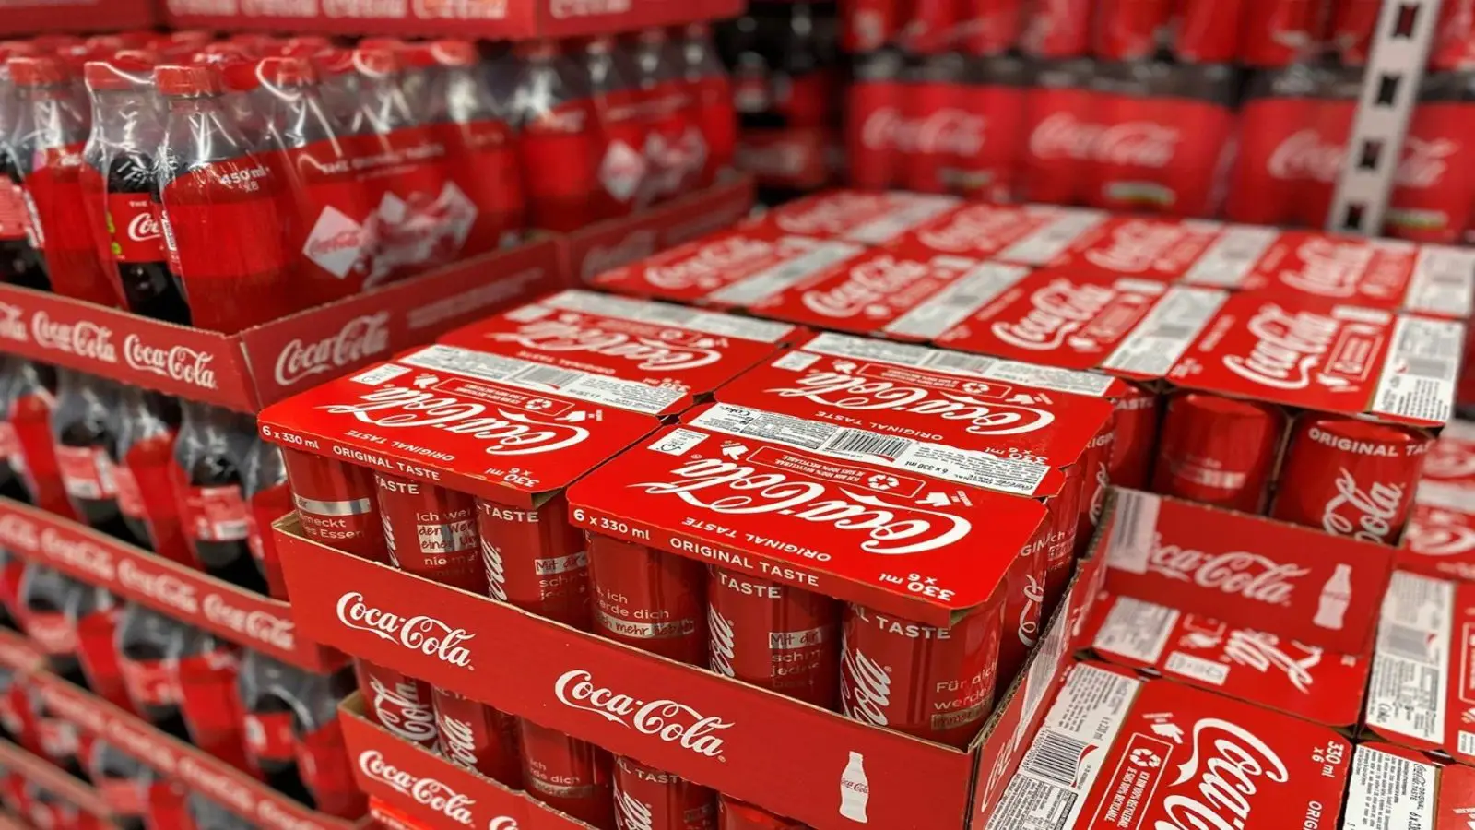

Mission Statement
Coca cola want to stasify their consumers with good experience. Moreover, the coca cola become the popular global beverage company, creating sustainable powers with great economies environmental values and social aspects by innovative ideas and strategic business models with suitable and loyal employees on earth. The coca cola behavior will be best as compare to other beverage companies.

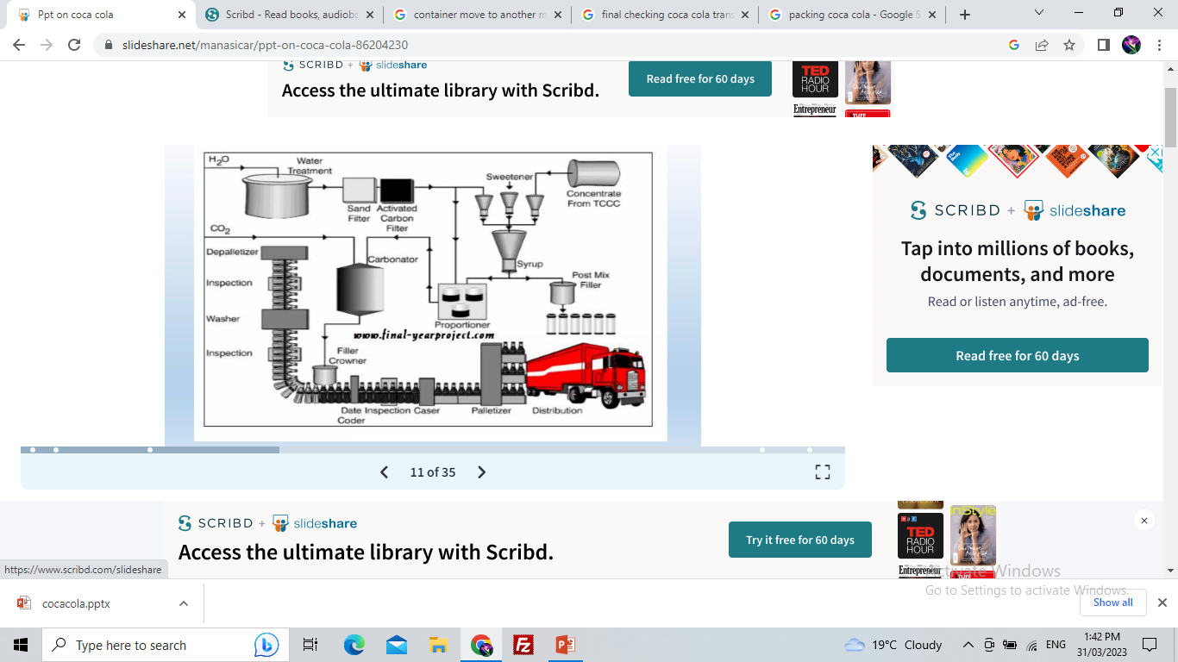

- CEO


(James Quince)

Targeting
Basically, targeting strategy is very different as compare to other companies. Coca cola is intended to campaigns to attract grown-ups and their family members. In addition,
Coke wants to establish relationships with their customers.

Major products of coca cola
Coca cola make many kinds of soft drinks. In 2013, coke sold their products over 190 nations worldwide.
Coca cola plant establish in India in 1956. Coca cola is best and largest company in India is forty percent share in branded soft drink companies.
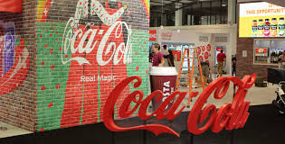

Thums up
Thums up is an Indian rand of coke in India. In 2021, Thums up becomes billion – dollers brand in worldwide. The turn over of this company is increasing day by day. The brand ambasdar of thumps up of Shah Rukh Khan who is famous bollywood flim actor. This brand included gold spot and Limca. Thumps up brand created a big boom in Indian market. This company have a good growth by 17 percent.
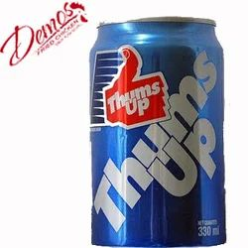
Thums up bottle 300 ml 1.29 pound

Fanta
Well this drink is bright and bubbly fanta is a soft drink which includes fun it introduced in 1930. Fanta is second oldest and largest brand name of the coke organizations. One 100 ml bottle of fanta contains 79kj energy zero gram protins, 4.5 gram sugars and sodium 6.8 gram. Additionally, it contains zero gram total fat and zero gram saturated fat respectively, it is the mixture of carbonated water plus grape juice and apple and vegetable. Its parent company is the coca cola. Fanta is American based Germany brand name with flavoured mixed. It have more than 200 flavours around the world. It was introduced 83 years ago. It is kind of mixed fruit of juice.
Lots of people like to drink fanta because they think that it is good for their health and contains energy with the help of Fanta.
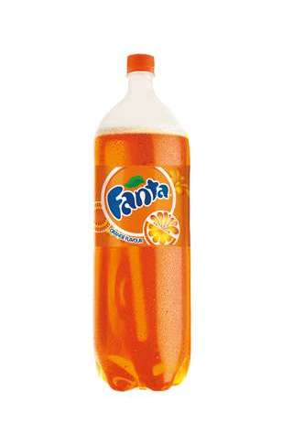
(Fanta organge available on 69p)

Kinley Soda
Kinley water is mixed of carbonated water which is under the coca cola company. Kinley soda mostly sell into numerous European and Asian Pacific countries. It have a large variety of fruit taste flavour. It includes various kinds of flavours like raspevery ginger ale, bitter, lemon, apple, club soda, and bitter rose. It is kind of cocktail stubs. It is a sparlking water with magnesium and salts. It was origined in India. Kinley soda soft 750ml packaged bottle contains zero percent alcohol. Kinley name had orginied from the village name is kinley which is located saskatchewal, Canada. Well, this water have some taste with sparkling sweetness. It is available on twenty rupess in India of one litter bottle. But in UK its rate is 9.35 pounds.
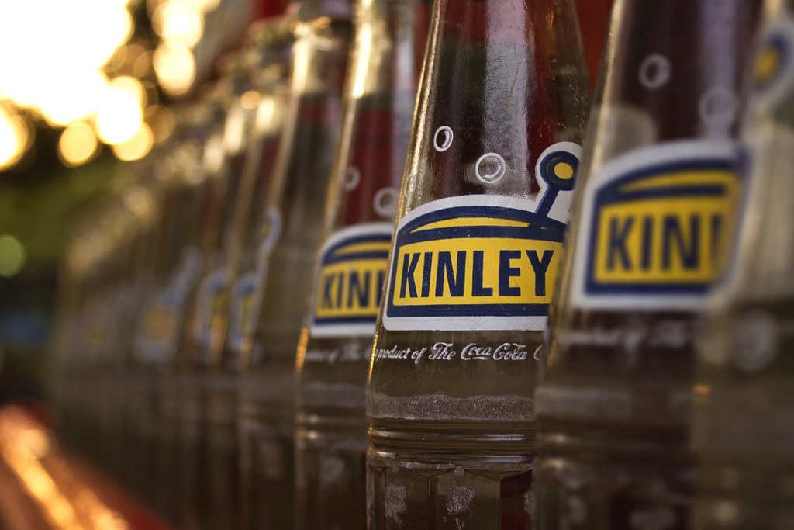
Market segmentation of Coca- Cola
Cokes segmentation have divided into several groups according to consumers need and wants. It haves different market segmentation strategies according its consumers preferences. In addition to this, this segmentation focusing on many elements such as demographic behavioral, psyschographic and geographic. Coca cola originated from USA. However, it expends company popularity into various countries. It includes all developed, developing and undeveloped countries. Coca cola is confidential towards its market segmentation. Coca cola make its products by analyzing customer desires, taste and preference. For example, coca cola provides to kinds of soft drinks the one is with sugar and second one is without sugar. So, who have diabetes persons and who have some kind of allergy from sugar as a consequence, that kinds of individuals can consume without sugar. Coca cola drinks as well as its segmentation has been made based on consumers lifestyle and values. Nowadays, majority of the teenagers are drinking coca cola products because it becomes the fashion to drink a coca cola.

Targeting strategies of Coca Cola
Targeting strategies of coca cola so wider because it have a global value so many targeting strategies have to attract the customers. Coca cola makes strategies to consider health consciousness of their consumers. The main objective is youngster within the ages of 10-25 as well as secondary market of dwellers who are aged 25-40. Meanwhile, diet coca cola have good and healthy varients focus those consumers who have joined gym and who are health consciousness. A coca cola brand like sprite is made to attract teens and universities learners.

Positioning of coca cola
Positioning of coca cola is on very high level due to higher competition. So, companies offer same brands and services in market and mind set up of buyers. This excellent positioning strategies are very helpful and beneficial. It creates curiosity among consumers.

Advantages of Positioning
- Increase profit
- More customers
- Reliable
- Effectiveness
- Efficiency
Disadvantages of Positioning
- Costly
- Complex
- Long process
- More men power
- More market knowledge and deep research work

Direct distribution method of coca cola

Coca cola have availability direct distribution of their products because coca cola products are availability on E-commerce websites such as, Amazon and Flipkart. These companies provide discounts to their loyal customers and it is very easy and smooth procedure. Discounts like fifty percent off and buy one get one free. With the help of these kinds of discounts and offers, hence, customers will increase and they will more attract and buy coca cola products, so their turn over will be increased. Consequently, customers will be happy and become loyal consumers.
In this contemporary era, every individual hectic in their work life so that’s why they drink the Coca cola and enjoy this drink with their friends.

In direct distribution of coca cola
In this distribution systems, few years ago this system was so popular but it was too complex.
Moreover, in this process so many parties are included and it is very lengthy process. First of all, company produced products then these goods transported to wholesellers and warehouses. In next, wholesellers and warehouses owners sell these items to retailers. Lastly, retailers sell such goods to real customers and consumers but this process is expensive for consumers because due to the involvement number of the parties take some charges from another parities. So, it will to costly for another parties. That’ s why every brand of coca cola is easily available on every small or big retail store like ASDA, SAINSBURY and Tesco express.
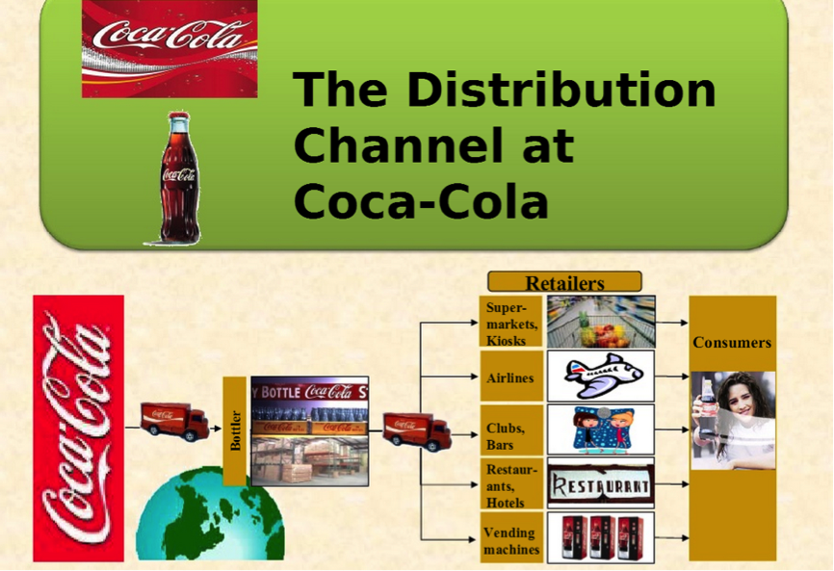 https://www.google.com/imgres

Availability of Coca cola products in retail store
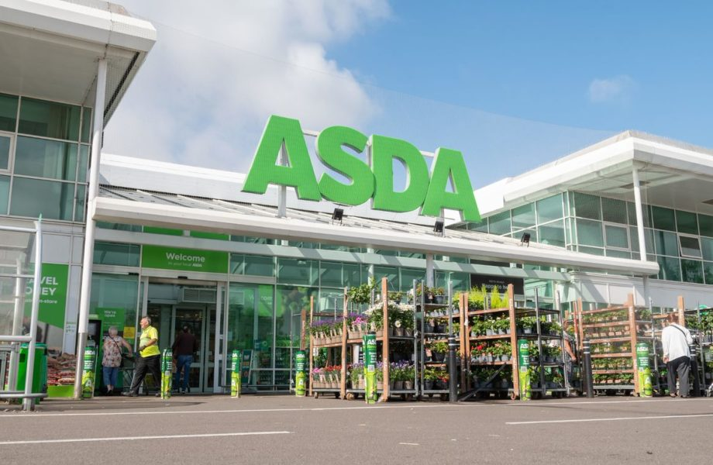
https://www.google.com/imgres?imgurl=https%3A%2F%2Fcdn.corporate.walmart.com%2Fdims4%2FWMT%2F6ab574e%2F2147483647%2Fstrip%2Ftrue%2Fcrop%2F1156x754%2B4%2B0%2Fresize%2F920x600!%2Fquality%2F90%2F%3Furl%3Dhttps%253A%252F%252Fcdn.

Coca cola business strategy
Business strategy was implemented in 2006. The coca cola business model is following with five large bottling companies in 2019. These partner show forty percent share of the total turn over until volume the organization sold. Coca cola have seperate agrements and contracts with bottling partners. To produce and selling the organization product’s. For long time coca cola will investor its stock as bottling organization therefore the system and bottling companies are worked as a hybrid on higher level approach between local and international franchise system and distribution chain system. Trade mark of coca cola maintained forty three percent of United States. In 2018, for example, coca cola had hundred million in re-franchised its on Canadian as well as Latin American bottling partners. Nowadays, every individual ten out of nine individual consuming coca cola brands in their daily life.

Social media links of coca cola
Coca cola Facebook page
https://www.facebook.com/cocacolaGB/?locale=en_GB
Coca cola Twitter account
https://twitter.com/CocaCola?ref_src=twsrc%5Egoogle%7Ctwcamp%5Eserp%7Ctwgr%5Eauthor
Coca cola You Tube page
https://www.youtube.com/user/cocacola
Coca cola Instagram account
https://www.instagram.com/cocacola/?hl=en

Reference
https://www.yourcoca-cola.co.uk/brands/coca-cola-original-taste
https://www.fanta.com/

