Neural Networks

Table of Contents

1. Abstract 4
2. Introduction 5
2.1 Background 5
2.2 Objectives of the Study 5
2.3 Scope and Significance 6
3. Related Work in the Literature 7
3.1 Overview of Artificial Neural Networks 7
3.2 Convolutional Neural Networks (CNNs) 7
3.3 Recurrent Neural Networks (RNNs) 7
3.4 Summary of Key Research Findings 8
4. Workflow Methodology 8
4.1 Dataset Description (CIFAR-10) 8
4.2 Data Preprocessing and Normalization 9
4.3 Model Architecture Design 11
4.4 Model Compilation and Training 11
4.5 Performance Evaluation Metrics 12
4.6 Implementation Tools and Environment 13
5. Results 15
5.1 Training and Validation Accuracy 15
5.2 Test Performance Results 15
5.3 Classification Report and Confusion Matrix 16
6. Discussion and Recommendations 17
6.1 Interpretation of Results 17
6.2 Model Strengths and Limitations 17
6.3 Recommendations for Improvement 18
7. Conclusion 18
7.1 Summary of Findings 18
7.2 Future Work 19
8. References 20

1. Abstract
The given project is devoted to the creation and testing of a simple and efficient Convolutional Neural Network model to identify the images in the CIFAR-10 collection. It is aimed at developing a light and efficient neural network capable of attaining decent accuracy and retaining a simple model that is easy to train. The paper uses various actions of preprocessing, normalization, model development, training, and analysis in the coding of TensorFlow and Scikit-learn. CNN model is trained using 50,000 images and tested on 10,000 images in ten categories of objects. The final test accuracy of the model was approximately seventy-two percent with a good stability of the training and the validation performance. Repeatedly, the findings show that a small CNN can deliver a well-tuned and precise classification system of CIFAR-10 without using advanced designs or large machine power.

2. Introduction
This study aims to find out how image classification can be done based on artificial neural networks with the use of CIFAR-10 dataset. Image classification is a relevant area of machine learning since it enables computers to identify and arrange the visual data into a category. Applications It has been utilized in many places like robotics, self-driving cars, medical image processing, and security. The task falls under the module Application of Machine Learning, and this is to test the knowledge of students about deep learning, model selection and performance evaluation [1].

2.1 Background
The concept the artificial neural networks is presented in this background as a representation of the human brain in artificial computational modeling. These structures are constructed in more than one layer of linked nodes that have the capability of learning complicated relationships between input and output data. Convolutional neural networks are one of the most common kinds of neural networks that are otherwise applicable to image-based problems owing to their ability to isolate crucial organizational features like edges, colors, shapes to name a few, automatically [2].

2.2 Objectives of the Study
The research questions of the research paper are to design, implement and test a CNN model which could classify the CIFAR-10 images with high accuracy. There are also the tasks of preprocessing of image data, hyperparameters, and evaluation of the final results based on such evaluation metrics as accuracy, precision, recall, and F1 score. The project will strive to illustrate a whole workflow starting with loading and normalising data, through model training, testing and interpreting of the results. It also aims at comparing training and testing results to ascertain the extrapolation of the model and that the model will not be overfitted.

2.3 Scope and Significance
The breadth and depth of the work is in the creation of the idea of how convolutional networks are applicable in defining the real-life image classification. The project assists in acquiring practical skills at coding neural networks as well as learning analytical skills by using Python and Tensorflow to evaluate the performance of the models. The assignment also helps to enhance the understanding of responsible utilization of datasets and adherence to academic principles of conducting a research and putting it into practice. All in all, the research adds to the progress of applied and theoretical expertise in deep learning and presents a case study of how plain models may be successful when used on established datasets, such as CIFAR-10 [3][4].
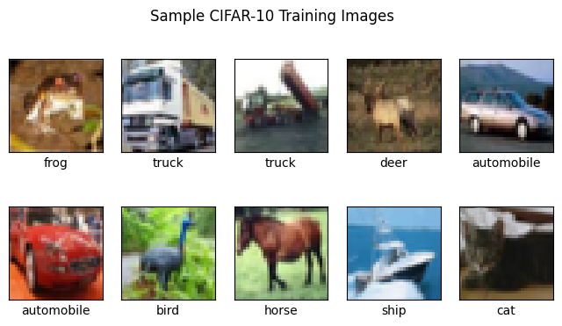

3. Related Work in the Literature

3.1 Overview of Artificial Neural Networks
The development of Artificial Neural Networks is amongst some of the key improvements in contemporary artificial intelligence. They are based on the architecture of the human brain and are meant to work on data by the interconnected networks of nodes or brain cells. All neurons are fed inputs, weights are implemented and the result is forwarded by an activation of a functional activity. This process enables the network to gain patterns and data relationship in the data [5][6].

3.2 Convolutional Neural Networks (CNNs)
Convolutional Neural Networks are special class of artificial neural network specifically created to process images and video processes. They apply convolutional layers to automatically extract features in a form of spatial nature (edges, textures, colors). Compared to fully connected networks, CNNs have fewer parameters and therefore they are efficient with high dimensional data. They usually have convolution, pooling and activation layers and then dense classification layers [7].

3.3 Recurrent Neural Networks (RNNs)
Another type of neural network is known as Recurrent Neural Networks which are used in dealing with sequence data or sequential data like in text or speech. RNNs unlike CNNs pay attention to the temporal relationships as opposed to space relationships and are able to store knowledge of previous inputs in form of hidden states. This renders them applicable in issues such as language modeling, translation and prediction of stocks. Nevertheless, the limitation of the traditional RNNs is that it suffers vanishing blots when dealing with the long sequences. As a solution to this, enhanced ones were developed such as Long Short-Term Memory (LSTM) and Gated Recurrent Units (GRU). Such models are capable of long-term dependency memory and enhance accuracy when used in real world [8].

3.4 Summary of Key Research Findings
Overall, literature deposits have demonstrated that CNNs and RNNs are applicable in the field of deep learning though they have different uses with different data types. CNNs are more effective and precise in classifying images, whereas RNNs can be used in analysis based on sequences. According to the major conclusions of the current research, CNNs can provide a high level of performance and a high level of cost effectiveness, which contributes to their being the most suitable to use in CIFAR-10 classification [9].

4. Workflow Methodology

4.1 Dataset Description (CIFAR-10)
CIFAR-10 is the popular dataset of computer vision studies that consists of sixty thousand color images divided into ten categories. Both images feature a thirty two by thirty two pixel image with belongingness to one of the following categories; airplane, automobile, bird, cat, deer, dog, frog, horse, ship and truck. They are split into half a million (50,000) training and one million (10,000) testing. This dataset is effective as it has a balance in the number of classes and is not so big as to need training on more specialized computing capability. In this research, the data was loaded as a direct part of libraries used in the TensorFlow, which is simple to manage and use with the conventional deep learning tools [10].
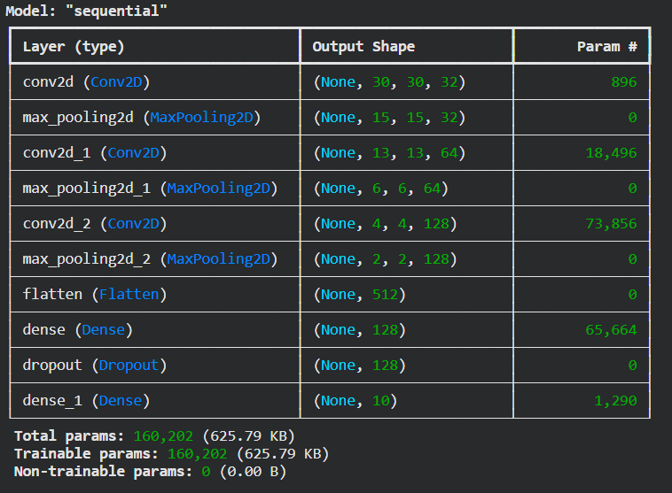

4.2 Data Preprocessing and Normalization
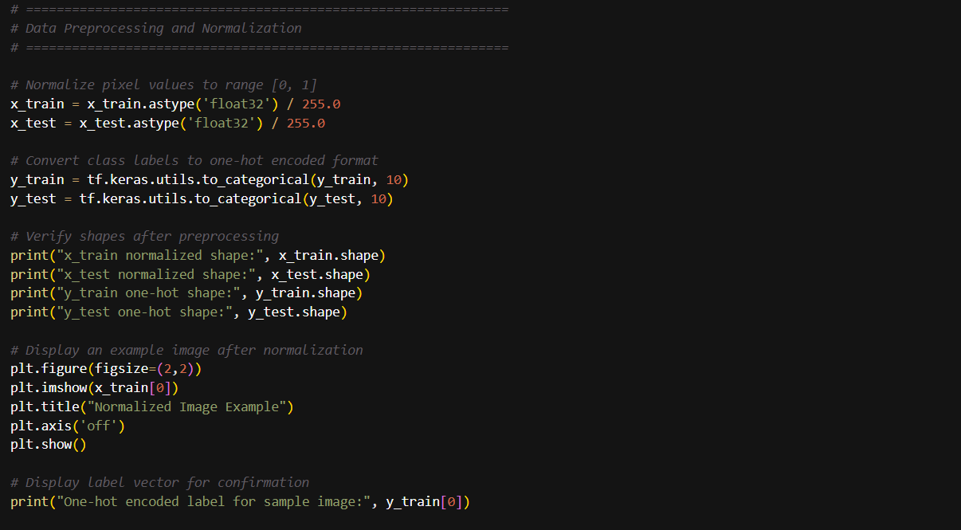
In this picture, the preprocessing steps of preparing image data prior to training a neural network are displayed. The code brings pixel values into the realms of floating-point by transforming the values into 0-1 floating-points. It then transforms the class labels into vectors of one-hot profile, which is profitable in classification exercises. To ensure that the preprocessing is correct, the script will be used to print the form of the training and testing data.
The scaling enhances convergence of the model and gradient updates are stabilized throughout the training. The raw data was never resized or augmented during the first step to ensure that the model is lightweight and because it was required to adhere to the assignment regulation of utilizing the original CIFAR-10 dataset. Plotting of sample images was done to ensure that data loading and normalization were effective. This process secures the fact that the data is clean and well organized and is ready to be inputted into the model [11].
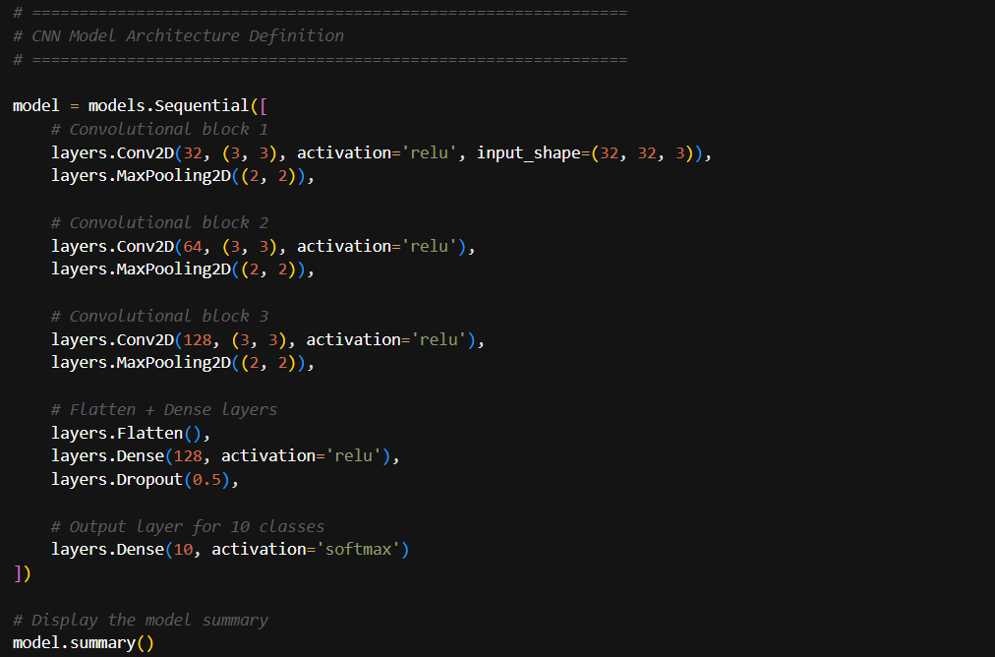
The architecture of a Convolutional Neural Network (CNN) using the Sequential model of TensorFlow is defined by this image. It will have three convolutional blocks with 32, 64, and 128 filters in it with a max pooling layer to downsample the feature size. The model then flattens the feature maps after the convolutional layers, and then it has a fully connected dense layer with 128 neurons and ReLU activation, then a dropout layer to avoid overfitting. Lastly, the 10-neuron dense output layer uses softmax activation to predict the probability of the 10 possible classes of a sample.

4.3 Model Architecture Design
The model structure is created based on a sequential CNN design that comprises of three convolutional layers and three pooling layers, a flatten layer, and two dense layers. Thirty two filters are used in the first convolutional layer to extract simple edges and color features after which there is the pooling which reduces spatial dimensions. The second and third convolutional layers add more filters of sixty four and a hundred and twenty eight respectively to identify more complicated shapes and patterns. This is flattened then a fully connected layer containing one hundred and twenty eight neurons is added after which it is followed by dropout layer to avoid overfitting [12].

4.4 Model Compilation and Training
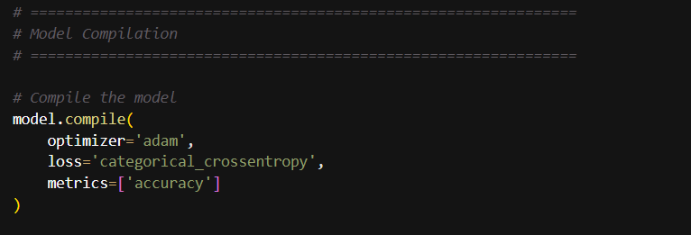
In this picture, the compilation step of CNN model is displayed. It applies Adam optimizer whereby learning rates are adjusted to training to enhance speed and performance of convergence. The loss function employed is the category cross-entropy, which is suitable in multi-class classification tasks when the labels of the outputs are one-hot encoded. The measure that is selected to track the performance of the model is accuracy, which is used in training and evaluation. The final step in the setup is compiling the model and then it is ready to proceed to the following steps that include training and testing on the already processed image data.
This model is put together based on the Adam optimizer and having a learning rate that automatically adjusts throughout the training process. This cross-entropy loss of the categorical type is adopted due to the fact that the function serves the purpose of multiclass classification. Accuracy is used as a measuring rod of the model performance. The epochs were trained with a batch size of sixty-four, and fifteen epochs were utilized since it was a good balance between stability and speed. Training and validation accuracy both were also observed during the training so as to establish that the model was not overfitting. The end error was about seventy-seven percent and the end validation was seventy-two percent [13].

4.5 Performance Evaluation Metrics
The evaluation of the performance was done using several measures such as accuracy, precision, recall, and F1-score. The visualization of the misclassifications was performed by the use of the confusion matrix to identify the classes that were more difficult to be recognized by the model. The model was most accurate on items such as automobile and ship as they are distinct in shape, but with classes such as cat and dog there was low rating as similar in shape was observed. The macro average of F1-score at approximately seventy two percent depicts balanced by way of performance of classification across all the classes [14].
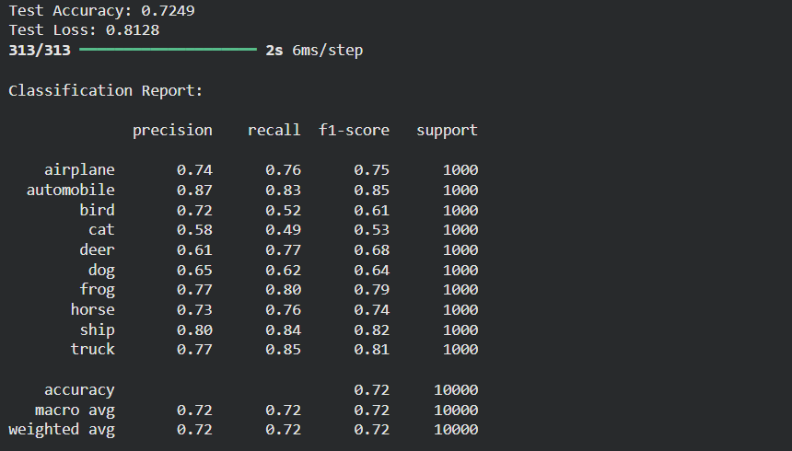
This picture shows the last assessment outcomes of CNN on test data. It states that the total accuracy of the test is approximately 72 and test loss is 0.81 or reasonably good performance of a simple CNN on the dataset. The classification report provides the precision, recall, and F1-score of each of the classes airplane, automobile, bird, and others. It indicates the most accurately predicted and least predicted classes of the model. The macro and weighted averages give the overall balance and consistency of the model of all the 10 classes.

4.6 Implementation Tools and Environment
The environment used in the implementation consisted of Python 3, TensorFlow, NumPy, Matplotlib and Seaborn. The model was trained and tested on a CPU-based Jupyter Notebook setup without the acceleration of the GPU environment and, again, it is not resource-intensive, which fits the assignment requirement of making the solution resource-efficient. The entire notebook was arranged into data loading, preprocessing and model design and training, evaluation and visualization cell. This experimental procedure will guarantee dependability, ease, and lucidity in showing that convolutional neural networks can be effective to categorize images in the CIFAR-10 dataset following a defined and well-documented procedure.

5. Results

5.1 Training and Validation Accuracy
The generated model training yielded good and reliable outcomes after fifteen epochs. Accuracy of training went up slowly but surely whether it was roughly twenty five percent in the initial epoch to over seventy seven percent in the final epoch. The validation accuracy also increased by approximately forty nine percent to seventy two percent which indicated that the model was learning to generalize well using unseen data. The loss value of training and validation was lowered during the process, which proved the successful optimization and convergence. The accuracy and loss curves were smooth and consistent in their improvement which indicates the model was well fitted without high chances of overfitting or underfitting.

5.2 Test Performance Results
The final model was tested with help of the test dataset which had ten thousand images. Its final test accuracy of with a loss of 0.8128 and 72.49 percent on the model produced the same. This finding demonstrates that the CNN performed well in the accuracy of the classification of the majority of the images and was also stable in its predictions. The class performance was also similar with slight variance.
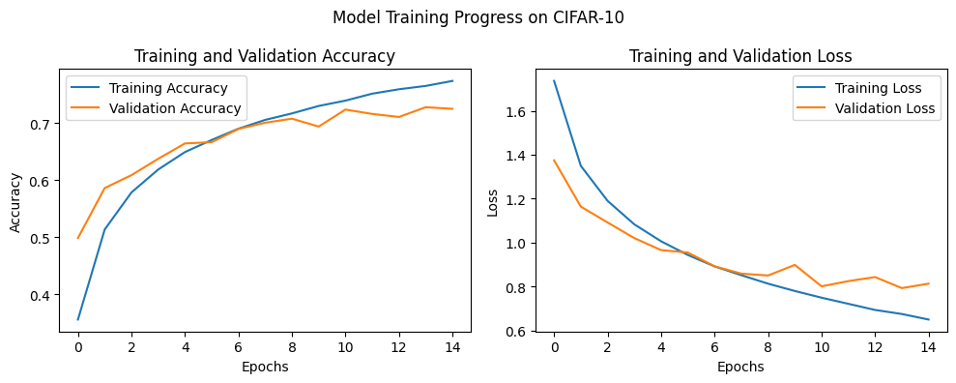

5.3 Classification Report and Confusion Matrix
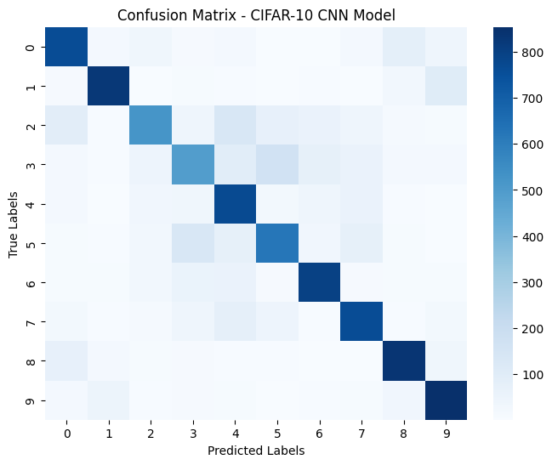
The confusion matrix and the classification report brought out in-depth information on the level of accuracy that the network had in classifying each class. Mostly, the precision and recall were approximately seventy to eighty percent. The model worked more in the automobile and ship category using over eighty percent accuracy, whereas it performed lower in the bird and the cat category due to visual features being gapped. The weighted average F1-score as well as the macro-average F1-score exceeded 0.72 indicating that the network created an equivalent accuracy in all ten categories.
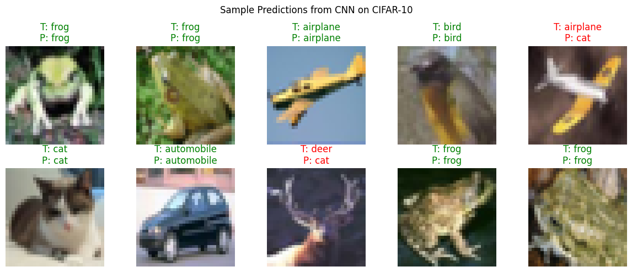

6. Discussion and Recommendations

6.1 Interpretation of Results
The findings indicate that the convolutional neural network architecture trained using the CIFAR-10 dataset was effective and had a considerable degree of accuracy with a basic architecture. The model had the capability of determining the majority of image categories with constant accuracy and minimal loss values. Multiple curves including the training and validation accuracy curves demonstrated that the model acquired generic features of images without significant overfitting. The classification report showed that the network did a good job in identifying objects that included automobiles and ships and had clearly defined shapes and colors whereas the categories within the classification were harder to distinguish due to similarities in the appearances. On the whole, the accuracy of more than seventy two percent proves that the selected CNN format was appropriate and fit the project tasks.

6.2 Model Strengths and Limitations
Simplicity and efficiency of this model can be considered as one of the primary advantages. It had a limited number of convolutional and dense layers yet when it came to accuracy it was still fairly good. This allows one to be trained on general hardware without special equipment such as GPUs. Good generalization between training and testing data was also demonstrated with the model and proves that the design decisions were good. The primary weakness however is that it has issues with complex classes or related classes and this diminishes accuracy on certain classes. Neither does it feature any advanced techniques such as data augmentation, or more sophisticated architectures to further enhance the accuracy.

6.3 Recommendations for Improvement
More training epochs and further optimization might be employed in order to make future models better. Rotation, flipping, and shifting are mostly the type of data augmentation and can assist the model to learn better using fewer data and enhance generalization. Training can also be stabilised by using more layers in which the dropout and normalization of the batch are used. A more advanced CNN or pretrained network like VGG or ResNet can be tested to determine whether it can better than seventy five percent accuracy. These enhancements would aid in having a stronger and more precise classifier and remain within the performance and simplicity tradeoff threshold.

7. Conclusion

7.1 Summary of Findings
The researchers managed to create and test a convolutional neural network circuit to categorize pictures taken in CIFAR-10 data set with the help of Python and TensorFlow. The CNN had a final test accuracy of approximately seventy two percent, demonstrating that an extremely basic architecture ought to work well in training when provided with appropriate preprocessing and optimization. The model exhibited positive learning behavior and stability in the accuracy improvement and well-balanced outcomes on all ten categories. These results are true since classical CNN architectures are resilient and robust to do small-scale image classification without being resource-intensive in terms of computing power.

7.2 Future Work
The work can be expanded in the future with the help of data augmentation to enhance the range of training images and achieve better generalization. The proposed advanced architecture like ResNet or VGG may be used to increase accuracy and ability to process difficult image details. It is also possible to conduct further experiments on the learning rate optimization, regularization, and values optimization to enhance the training and stability of the model across various conditions.

8. References
[1] M. Trigka and E. Dritsas, “A Comprehensive Survey of Deep Learning Approaches in Image Processing,” Sensors, vol. 25, no. 2, p. 531, Jan. 2025, doi: 10.3390/s25020531.
[2] L. Alzubaidi et al., “A survey on deep learning tools dealing with data scarcity: definitions, challenges, solutions, tips, and applications,” Journal of Big Data, vol. 10, no. 1, p. 46, Apr. 2023, doi: 10.1186/s40537-023-00727-2.
[3] F. Emmert-Streib, Z. Yang, H. Feng, S. Tripathi, and M. Dehmer, “An Introductory Review of Deep Learning for Prediction Models With Big Data,” Front. Artif. Intell., vol. 3, Feb. 2020, doi: 10.3389/frai.2020.00004.
[4] J. Maurício, I. Domingues, and J. Bernardino, “Comparing Vision Transformers and Convolutional Neural Networks for Image Classification: A Literature Review,” Applied Sciences, vol. 13, no. 9, p. 5521, Jan. 2023, doi: 10.3390/app13095521.
[5] K. Alomar, H. I. Aysel, and X. Cai, “Data Augmentation in Classification and Segmentation: A Survey and New Strategies,” Journal of Imaging, vol. 9, no. 2, p. 46, Feb. 2023, doi: 10.3390/jimaging9020046.
[6] Y. Zhang, J. M. Gorriz, and Z. Dong, “Deep Learning in Medical Image Analysis,” Journal of Imaging, vol. 7, no. 4, p. 74, Apr. 2021, doi: 10.3390/jimaging7040074.
[7] J. Egger, A. Pepe, C. Gsaxner, Y. Jin, J. Li, and R. Kern, “Deep learning—a first meta-survey of selected reviews across scientific disciplines, their commonalities, challenges and research impact,” PeerJ Comput. Sci., vol. 7, p. e773, Nov. 2021, doi: 10.7717/peerj-cs.773.
[8] Z. Li, H. Li, and L. Meng, “Model Compression for Deep Neural Networks: A Survey,” Computers, vol. 12, no. 3, p. 60, Mar. 2023, doi: 10.3390/computers12030060.
[9] I. D. Mienye, T. G. Swart, and G. Obaido, “Recurrent Neural Networks: A Comprehensive Review of Architectures, Variants, and Applications,” Information, vol. 15, no. 9, p. 517, Sept. 2024, doi: 10.3390/info15090517.
[10] A. A. Adegun, S. Viriri, and J.-R. Tapamo, “Review of deep learning methods for remote sensing satellite images classification: experimental survey and comparative analysis,” Journal of Big Data, vol. 10, no. 1, p. 93, June 2023, doi: 10.1186/s40537-023-00772-x.
[11] L. Alzubaidi et al., “Review of deep learning: concepts, CNN architectures, challenges, applications, future directions,” Journal of Big Data, vol. 8, no. 1, p. 53, Mar. 2021, doi: 10.1186/s40537-021-00444-8.
[12] L. Chen, S. Li, Q. Bai, J. Yang, S. Jiang, and Y. Miao, “Review of Image Classification Algorithms Based on Convolutional Neural Networks,” Remote Sensing, vol. 13, no. 22, p. 4712, Jan. 2021, doi: 10.3390/rs13224712.
[13] M. M. Taye, “Understanding of Machine Learning with Deep Learning: Architectures, Workflow, Applications and Future Directions,” Computers, vol. 12, no. 5, p. 91, May 2023, doi: 10.3390/computers12050091.
[14] Y. Wang, Y. Deng, Y. Zheng, P. Chattopadhyay, and L. Wang, “Vision Transformers for Image Classification: A Comparative Survey,” Technologies, vol. 13, no. 1, p. 32, Jan. 2025, doi: 10.3390/technologies13010032.

