Student Name: | Salime Sherif
Student Number: | 1712747
Module No: | (BMSK4003_LON)
Module Title | Digital Skills and Research Methods
Lecturer Name: | Anupam Mazumdar

The causes of Stress and its Management at the work place

CONTENT:

- ABSTRACT.......................................................................... 2
- AIMS &OBJECTIVE............................................................. 2
- BACKGROUND OF COMPANY (AMAZON)......................... 2
- INTRODUCTION.................................................................. 3
- LITERATURE REVIEW......................................................3-5
- THEORETICAL FRAMEWORK..........................................5-6
- RESEARCH DESIGN/METHODOLOGY...............................6
- SAMPLING AND SAMPLE...................................................7
- ANALYSIS AND EMPIRICAL DATA.....................................7
- PRIMARY DATA............................................................... 7-8
- FINDINGS/DISCUSSION:..................................................... 8
- CONCLUSION:....................................................................8-9
- REFERENCES:...................................................................... 9
- APPENDIX A

ABSTRACT
This research has proceeded to investigate the causes of stress and its management at the workplace. Stress at the workplace is becoming more and more a phenomenon owed to outside factors such as changes in the economy of a nation, technological advancement which may lead to redundancy etc. Stress can be seen as an inescapable condition that will definitely happen at some point in time, however it could be minimized also to the degree that the health and productivity of the employee is maintained that it will lead to an efficient and productive organization. Stress is also destined to happen even in multinational companies where the operation of the company is global and its employees come from a diverse different cultural background.

AIMS &OBJECTIVE
The purpose and objective for this study is to have a thorough understanding and knowledge of the causes of stress at a multinational company such as Amazon and why the employees feel stressed at the workplace and how stress by the employees of the company including the company’s management are handled or managed.
The rest of this research report will undertake an extensive literature review, analysing and exploring theoretical framework and also theoretical analysis of stress and stress management at the workplace. This piece will also go ahead to layout the research methodology and research design used, which will be accompanied by the findings, discussion and a concluding section. Finally, this piece will also provide any recommendation on this subject or research topic.

BACKGROUND OF COMPANY (AMAZON)
Amazon is one of the or if not the world’s largest tech online retailer in terms of market capitalization and revenue. It was founded in 1994, July 5 by Jeff Bezos and has its headquarters in Seattle, Washington. Worldwide it has a total of about 613,000 employees as of 2018 (Amazon, 2018). The company started off as a bookstore before diversifying in selling video streaming and downloads, software, video games, electronics, apparel, etc. Its business strategy is a hybrid of business diversification and cost leadership.

INTRODUCTION
Stress is now changing or transforming to a familiar or regular phenomenon among the employees and employers (Michie, 2002). The stress level is increasingly changing speedily among the employees due to different set of reasons. Employees feel and experience stress repeatedly and henceforth the response of stress at the workplace is not an unrelated aspect (Fairbrother & Warn, 2003). Being stressed at work is also on the rise due to outside or external factors such as technological advancement and has become even a huge problem due to globalization, restructure of job and the extra demand on the task at hand and this may lead to insecurity in job which would in turn make employees distressed and feel stressed (Tennant, 2002). Thus, the rise in stress level among employees was a motivating factor for me in becoming sensitive, curious and interested regarding how important the subject is. Its interesting to know that stress is not only related to a medical state of mind, instead it is the susceptibility to stress which leads to mental disorder or confusion. Melchior et al, (2007) discovered in their study that individuals who has high stressed jobs are more at risk in developing depression which can be serious or anxiety in comparism with others who have less stressful jobs and in addition, work stress can also affect employees irrespective of position, type of employment or gender.
To be able to further understand this subject I considered Amazon to be a good example as such due to the fact that Amazon is also involved in the ever changing work environment with its changing automated work styles and technological advancements rather than the hand operated way of doing things or getting things done, I relate aspect to stress in a way that the more automated and advanced Amazon’s products are, the less employees its going to be needing, thus this can cause work related stress in employees because they could feel they could be made redundant or may have to move somewhere else due to job restructure.

LITERATURE REVIEW
The ramification of stress is a lot, which includes the attrition, morale, poor productivity and overhead costs and thus there have been lots of studies and research that have investigated stress and its variables. Minter (1999) stated that stress as emotional and a harmful physical response that usually occur when the needs or requirements of a job does not match the resources or capabilities of the worker while Schuler (1982) highlights that stress is identified or recognized as a dynamic state that involves an uncertainty about something vital. Pestonjee (1992) on the other hand defined stress as occurrence when the demands on people or a person exceed his or her adjustment resources. He is of the opinion that whilst stress is normally believed to have a harmful or damaging effect of performance and health, research and studies recently has found out that there is a minimal level of stress that is important for functioning effectively. It is the person’s response or reaction to stress that makes all the difference and could prove to be damaging.
In many individuals, stress has been established as a constant condition and Sapolsky (2004) likewise highlighted how the anticipation of a stressful scenario or situation can become even a source of stress. Interestingly, there is a reaction from the body in the same predictable way to a situation or scenario that is actually stressful as it would to a situation that is stressful (Sapolsky, 2004). Frequently definitions that are accepted for stress have been provided by researchers on this topic earlier, such as Selye (1956) whose generalised adaptation theory defined stress as any form of response or reaction of the body to a demand and demands can be ranging from anything from extreme cold or heat, physical injury to tension.
According to Selye’s theory, the body reacts to stress conclusively, via three phases which are the alarm phase, resistance phase and exhaustion phase.

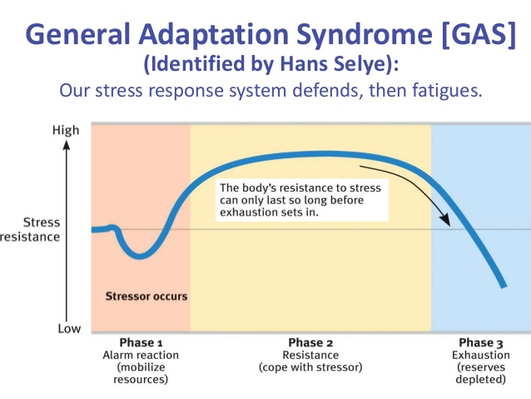

Having said all these, the workplace still stands out as a likely vital source of stress mainly because of the amount of time being spent in this environment. However, the stress levels of in the workplace does go beyond just the time involved. With the possibilities for advancement and financial security of individuals being made depending on their performance, the added pressure that follows to perform to your maximum ability frequently makes the work situation likely more stressful (Faulkner & Patiar, 1997).

THEORETICAL FRAMEWORK
- Stress as a whole: Stress has been explained and defined by many researchers and scholars. Fletcher (2006) defined the term as a process that is continuous which involves making appraisals of situations individuals find themselves in, and attempting to manage or cope with any problems or issue that may arise. Stress portrays a situation whereby an individual does not have enough ability to cope with it and is under pressure. Despite it causing problems to employee’s health and well being, it can also affect the organization or company’s reputation or status as well as its productivity. One of the downward aspect of stress is job dissatisfaction and employee’s unwillingness to their job or work.
- Causes of stress: There are different set of reasons why employees feel stresses and henceforth the reactions of it at the workplace are not unconnected (Fairbrother & Warn, 2003). Causes of stress can be work overload, conflict among employees or overcrowdings at the workplace. Furthermore, Michie (2002) linked factors in workplace with health risks and stress and this can be grouped as those that includes content of work and to do with the organizational and social context of work as highlighted on the diagram below (Figure 1). Those that are inherent to the job include work overload, time pressure, long hours, lack of breaks or complex and difficult tasks. If organizations want to reduce staff stress successfully, it is vital to understand the causes or factors which may in the first place influence staff morale and stress.
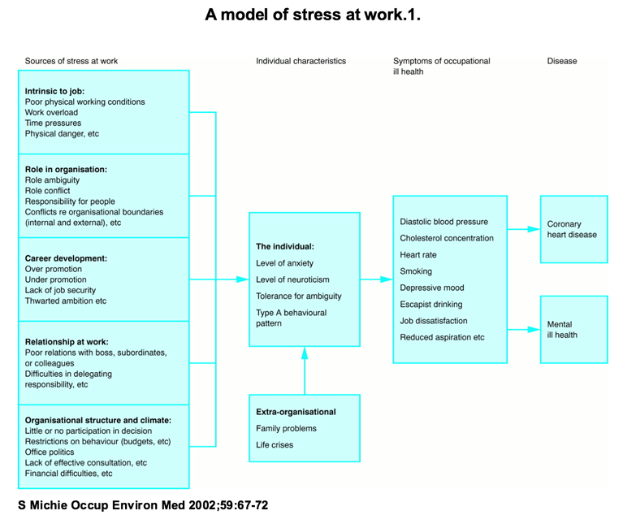Figure 1: Model stress at work, Source: Michie, S .2002. Work causes and management of stress at work

RESEARCH DESIGN/METHODOLOGY
Bryman & Bell (2011) stated that the process of analysing and collection of data using a qualitative method gives importance to word in contrast to quantification. However, since my objective is to study and have a deeper and detailed understanding of the issues regarding stress, I selected a combination of qualitative and quantitative method for analysis and collection of data. By using this combination of methods, it allowed me to analyse my findings thoroughly by interpreting the causes of stress, coping mechanism and consequences of employees in Amazon Uk, Tilbury distribution centre.

SAMPLING AND SAMPLE
According to Kumar (2014), he stated that a sample is a subgroup of a population that one is studying. For my study and research, participants were recruited via a snowball sampling. Bryman (2015) stated that the snowball sampling is a kind of method where the researcher from the onset samples a group of people that are small in number and are relevant to the research questions and participants that are sampled may be of help in recruiting or recommending other participants that fits to the features or characteristics of the research. In recruiting participants for my research, I selected the snowball sample where I had a conversation with some of my friends that work at Amazon Tilbury distribution centre, where I explained to them my criteria for my sample and if they want to be of help in my research. This worked as they led me to other possible participants they knew.
Immediately I had my sample which were four employees from the Amazon Tilbury distribution centre, I went on to explain to them carefully the purpose of my research topic to all the participants to reassert if they are keen to participate.

ANALYSIS AND EMPIRICAL DATA
The purpose of this research was to understand the causes and management of stress at the workplace specifically at Amazon Uk distribution centre by the employees. In order to analyse this subject, I used the quantitative and qualitative method for my data collection methods in the form of questionnaires/survey (APPENDIX).
Using this quantitative approach, it allowed for a greater objectivity and accuracy of results gotten and also it helped to eliminate any form of bias as it encouraged me to keep a short distance from the participants. While using the qualitative method for my data collection, it allowed me to digress from the interview guide and ask the interviewee to shed more light and to adjust the order of the questions. I conducted a semi structured interview for this study.

PRIMARY DATA
For my primary data collection, I designed a questionnaire survey with employees of Amazon Uk distribution centre. The respondents that participated in this research were from various departments of the company. I selected the employees from both genders and doing this primary data gave me information first hand of how the working conditions of a company are and how employees perceive stress in the company.
FINDINGS/DISCUSSION:
I had conducted an interview with two workers from the Amazon Uk distribution centre and done a questionnaire survey. After conducting the interviews, respondent 1 claimed that stress in a way happens because of various reasons in life but in relation to the workplace, he has never faced a serious stress during his work life to give up on his job. Although he stated during his employment he had sometimes felt stressed during the working hours, as he mentioned that the main cause of stress for him is the constant noise caused by the machines.
Respondent 1 attempts in trying to cope with stress, is trying to share his feelings with close friends and managing his time better.
Respondent 2 on the other hand believes that stress do arise during the working periods in most ways. She claimed that stress mainly rises during times when there are a lot of work to do in a limited period of time. She went on to claim that she feels stresses in two various ways, daily activity perspective and working perspective. For instance, she prefers sometimes to work more than 40 hours a week and that is not normal because it becomes very complicated to manage huge quantity of stuff and this increases stress level and this also disturbs the daily activity routine and normal sleeping hours, so it can be a source of stress. Since she works at the operation section, she also said the constant noises from the machines during the working hours can be annoying even though protecting ear devices are available at the workplace but she said that she is not used to using it properly.

CONCLUSION:
Based on the literature review and empirical study done at Amazon Uk distribution centre I reached the conclusion that my data is to an extent reliable in helping me attain my aim which was to find the causes and management of stress by employees at Amazon Uk. My research by considering Amazon Uk made even clearer to what the causes of stress are in an actual organization or company and how the employee including the management deals with it. The theoretical framework helped me to understand how stress can be managed and the causes of it, while the findings allowed me to see this from Amazon Uk employee’s views and the analysis created a connection between the findings and theories.
REFERENCES:
Ashforth, B.E. & Humphrey, R.H. (1995) Emotions in The Workplace: A Reappraisal. Human Relations, 48 (2), 97-125.
Bryman, A., & Bell, E. (2011) Business Research Methods, 3th Edition. New York: Oxford University Press.
Bano, B., & Jha, R.K. (2012) Organizational Role Stress Among Public and Private Employees. The Lahore Journal of Business. 1 (1), 23-36.
Fairbrother, K., & Warn, J. (2003). Workplace dimensions, stress and job satisfaction. Journal of Managerial Psychology, 18 (1), 8-21.
Faulkner, B. and Patiar, A., 1997. Workplace induced stress among operational staff in the hotel industry. International Journal of Hospitality Management, 16(1), pp.99-117.

Fletcher, D., Hanton, S. and Mellalieu, S.D., 2006. An organizational stress review: Conceptual and theoretical issues in competitive sport. Literature reviews in sport psychology, 321373.
Michie, S. (2002) Causes and Management of Stress at Work. An international peer-reviewed journal in all aspects of occupational & environmental medicine. 59 (1) 67-72.
Melchior, M., Caspi, A., Milne, B.J., Danese, A., Poulton, R. and Moffitt, T.E., 2007. Work stress precipitates depression and anxiety in young, working women and men. Psychological medicine, 37(8), pp.1119-1129.

Minter, S.G., 1999. Too much stress? Occupational Hazards, 61(5), pp.49-51.
Saunders, M., Lewis, P. & Thornhill, A. (2009). Research methods for business students. Fifth Edition, Harlow: Financial Times Prentice Hall. [E-book].
Sapolsky, R.M., 2004. Why zebras don't get ulcers: The acclaimed guide to stress, stress-related diseases, and coping-now revised and updated. Holt paperbacks.

Selye, H., 1956. The stress of life.

Schuler, R.S., 1982. An integrative transactional process model of stress in organizations. Journal of Organizational Behavior, 3(1), pp.5-19.

Tennant, C., 2002. Life events, stress and depression: a review of recent findings. Australian & New Zealand Journal of Psychiatry, 36(2), pp.173-182.

APPENDIX A
WORK-RELATED STRESS QUESTIONNAIRE

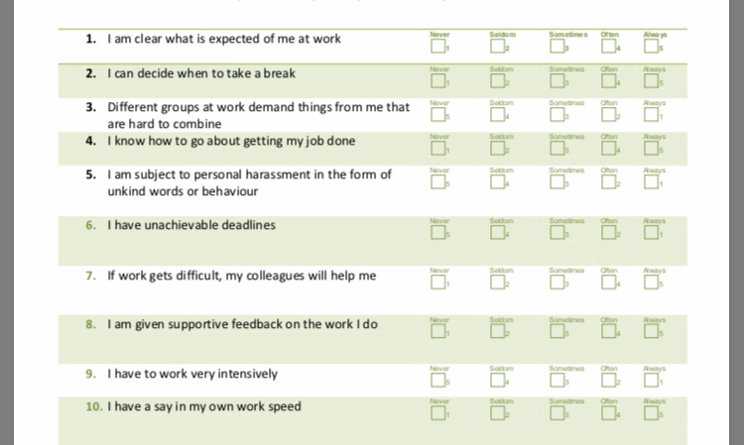

APPENDIX B

QUESTIONNAIRE RESULTS ANALYSIS



