[Date]
Callum Cross
STUDENT NUMBER: 1705149
Application Development
Module Code: ACCA5012
Date: 07/05/2019
Lecturer Name: Kemi Ademoye

Table of Contents
Introduction 1
Security Vulnerabilities 2
SQL Injection 2.1
Cross-Site-Scripting 2.2
Insecure Cryptographic Storage 2.3
Software Design Patterns 3
Provider Pattern 3.1
Requirements 4
Main Requirements 4.1
Project Purpose 4.2
Target Market 4.3
Design Principles 4.4
Implementation 5
Main Models 5.1
Book 5.2
BookLike 5.3
UserBook 5.4
Main Models 5.5
Seeder 5.6
Main Controllers 5.7
HomeController 5.8
FilterController 5.9
MyBooksController 5.10
Screenshots 6
Evaluation 7
Recommendations 7.1
References 8

Introduction (1)
This report will show the application concepts of a web application and will show the design and implementation the student has taken to develop a web application prototype that could be applicable for real world use. Additionally, this report will show the steps the student took and decisions they made to create the final concept of the web application. Finally, the report will include a summary of security vulnerabilities and the steps that could be taken to stop these exploits.
Security Vulnerabilities (2)
Within Computer Security and applications, a “Security Vulnerability” is normally a weakness that can be oppressed by a threat, such as a hacker, to accomplish unauthorised actions within a computer system. To exploit an application, an attacker must have at least one technique/tool that can connect to a system weakness and exploit that area.
In this section we will discuss the most common vulnerabilities that hackers will try and exploit in their everyday toolkit. [1]
SQL Injection (2.1)
SQL Injection is a type of injection attack that makes it possible to execute unauthorised SQL Statements. These statements are then controlled by a server that will execute these commands on the database and return the results of those proceeding statements. This can a very dangerous attack as hackers of any type both experienced and un-experienced can grab all types of private data that would normally not be seen by the end-user. These types of details can include, first names, surnames, hashed password and any data being held in the database. [2]
When dealing with SQL Injections you should never trust the end-user as this could give your system serious issues and could lead to injections like this as you are potentially giving the user a free-roaming access of your website. More options could be not using Dynamic SQL and not constructing queries with user-input without any validation of the queries being used. A very good way of being secure from SQL Injections is to make sure that all your software and applications are up to date and patched as exploitable methods are found daily. [2] [1]
Cross-Site Scripting (2.2)
Cross site scripting or as it’s normally referred to as ‘XSS’ is an exploit that targets scripts inside the embedded webpage that are executed on the client-side meaning that the script is only on the end-user’s browser. These scripts are normally exploited when the application takes untrusted data and send’s it to the web browser without proper validation.
Attackers can then use these scripts to access and export private data from the user’s website like passwords, emails, website’s accessed, card details. The script could also edit your cookies and send the user to malicious sites without any warnings.
The simplest ways of overcoming these risks are by white listing input fields that the users have access to, this stops attackers from creating cross-site scripts as these input fields will be checked before data is sent. [1]

Insecure Cryptographic Storage (2.3)
Insecure Cryptographic Storage is a vulnerability when data is not stored securely leading to data being easily accessible and accessed by an attacker. This data is normally stored in a application database, when this data is stored improperly by not using hashing and other hashing and encryption techniques it can lead to crucial data being left open to attackers.
One way you can remove this vulnerability could be encrypting communications between the client and server by using a secure connection like HTTPS. Hashing crucial information like passwords is very important because if an attack gets access to a hash, they still have to use an incredible amount of computer power to brute force password hashes instead of giving them the un-hashed information. [1]
Software Design Patterns (3)
In this section we will talk about software design patterns and how they can be essential in creating modern software and web applications. The main reason software design patterns were created was to allow developers to solve problems that could possible occur during development this would both time and money depending on if this software was being built for a company or as a project by one person. [3]
Provider Pattern (3.1)
The provider pattern was first introduced in ASP.Net 2.0, The main theory behind the pattern is it allows you to define a well-documented, easy-to-use API, such as ASP.Net 2.0 Application Users API’s, but at the same time give developers a lot of control over their internals of what occurs when an API method/function is called.
A provider is a link between an API and Data abstraction layer. The API its self does not contain any login for the business side, it instead pushes a call forward to the configured provider for it.
Using this pattern is great for creating ASP.Net 2.0 applications because it has most of the API Login built into the design pattern allowing a greater speed in development if followed correctly. The whole ASP.Net API is OOP (Object Oriented Programming) based leading to cleaner code for larger code bases and allowing bugs and exploits to be seen easily and fixed quickly.
There are some down-sides .Net Core is always being updated and some methods could be deprecated if new methods are brought in this leads to some areas of your application having to be updated to keep up with standards of ASP.Net. Additionally, another downside would be .Net Code is slower than native code meaning that if you do not have optimised code in large applications it could possibly slow down. [3]

Requirements (4)
The application that was require from the student was a web application that would a suitable and realistic version of a real-world web app. This meant the student had to undertake what requirements the web application needed and what design principles the student followed to come up with the design of the application and the implementation.
Main Requirements (4.1)
- Allow users to register on the website
- Allow users to login with their details they registered with
- Create a main page of books that users can see upon logging in
- Allow the user to add/remove books to their own collection so they can read those book
- Allow the user to read PDF Format of books online
- Allow searching title of books
- Allow filtering of certain genres of books
- Allow filtering of certain Age ranges when searching for books
Project Purpose (4.2)
The main purpose of the web application was to allow anybody to access a library of books without having to leave their home. This meant the student followed simple principles allowing them to add a wealth of books online and allowed the users to create their own library of books that they were interested in so they could read them.

Target Market (4.3)
The target market the student was aiming for was the public people as this allowed for children, teenagers and adults to access a huge base of material that could be expanded easily and could be accessible to anyone with an account on the website.
Design Principles (4.4)
When designing the user interface, the student wanted it to be easily navigated and made as simplistic as possible this meant that he wanted to create as little web pages as he could which would allow the user to easily navigate the website without getting lost.
When the student was creating unique libraries for each user the main purpose was to allow users to quickly access books that they had already started reading or that were interested in reading this allowed user to quickly click one link to their own library without having to go searching to find which book they were reading last.

Implementation (5)
This section will talk about the implementation classes and main scripts they used to implement their web application, additionally this section will provide the core functionality of the software.
Main Models (5.1)
Book (5.2)
The first main model the student used was the “Book” model this allowed the object to be used for both storing and retrieving data related to all the books in the web application. This model is also used as the data behind each book that is placed on the web application e.g. Images, Authors, BookTitles, BookID(PK).
BookLike (5.3)
The “BookLike” model was created to allow users to give feedback on a book if they liked it allowing the user to give a “thumbs up” so it would represent a good review and allow other users to see that people are enjoying that book so they could give it a try.
UserBook (5.4)
This model was used to allow users to uniquely add books to their own library so they could read them at the time they add or in the future, this also allowed users to find books that they had recently read and allowed them to quickly get back to reading in a short amount of time.
Main Classes (5.5)
Seeder (5.6)
This class was mainly used to fill the database with data and allowed the student to test the website with all types of scenarios e.g typing incorrect data.
Main Controllers (5.7)
Home Controller (5.8)
This controller controls all the user inputs that they do on the main home page and creates the necessary books on display for the user.
Filter Controller (5.9)
This controller controls all the functionality of the filter search bar and the category and age restrictions and will return the books needed to be shown on screen whilst the user is searching.
MyBooksController (5.10)
This controller controls all the user inputs that the user does to the books e.g liking a book, adding/removing from their own unique library

Screenshots (6)
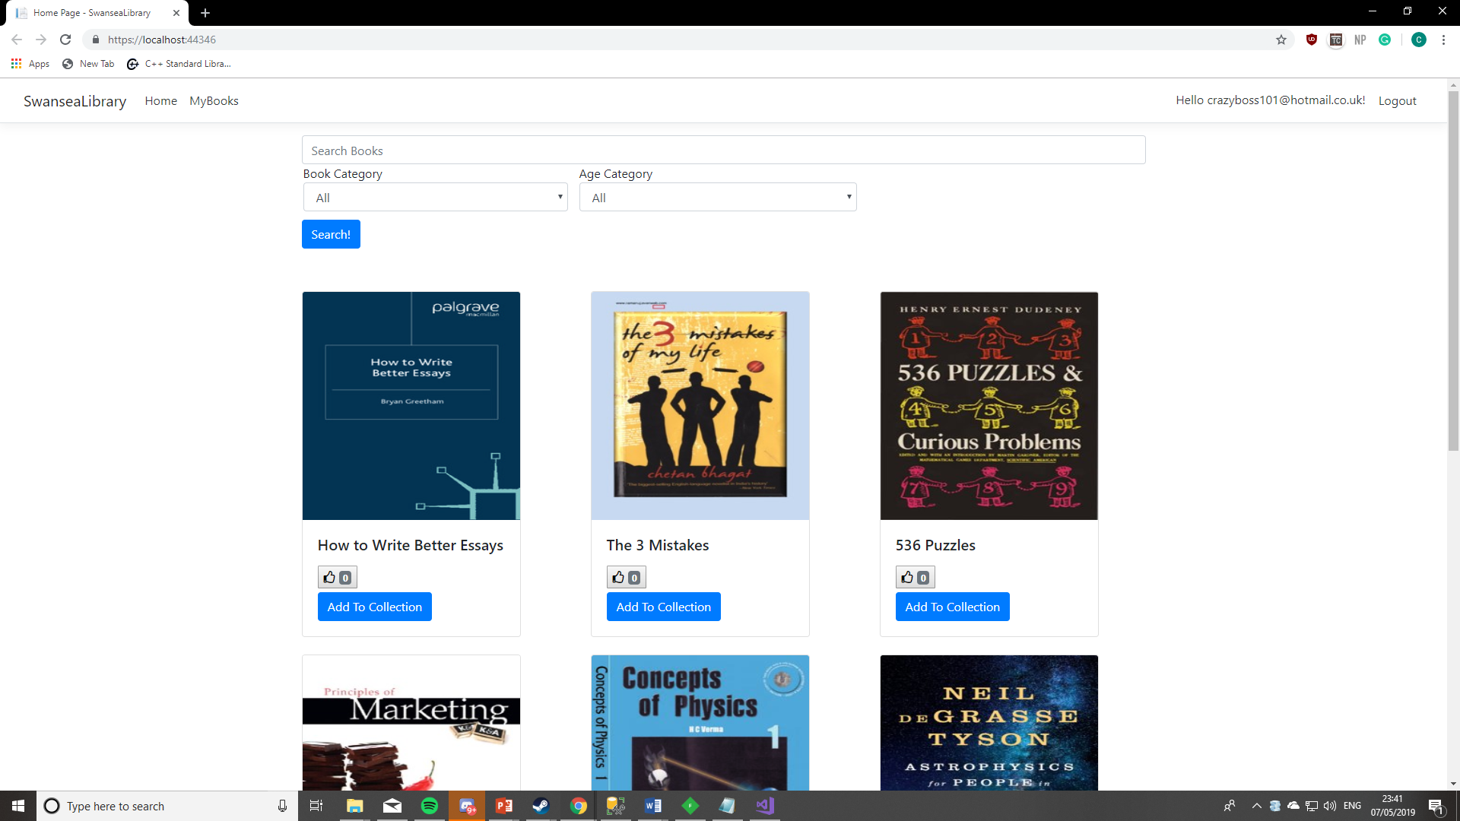

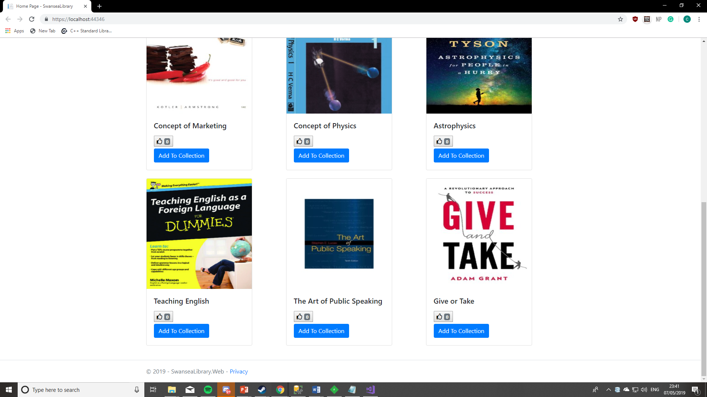
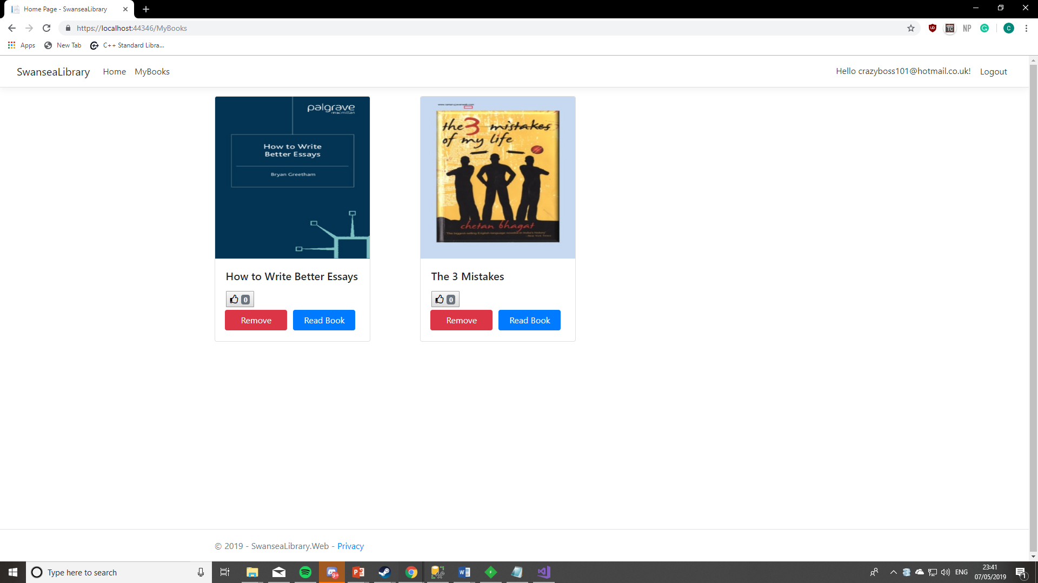

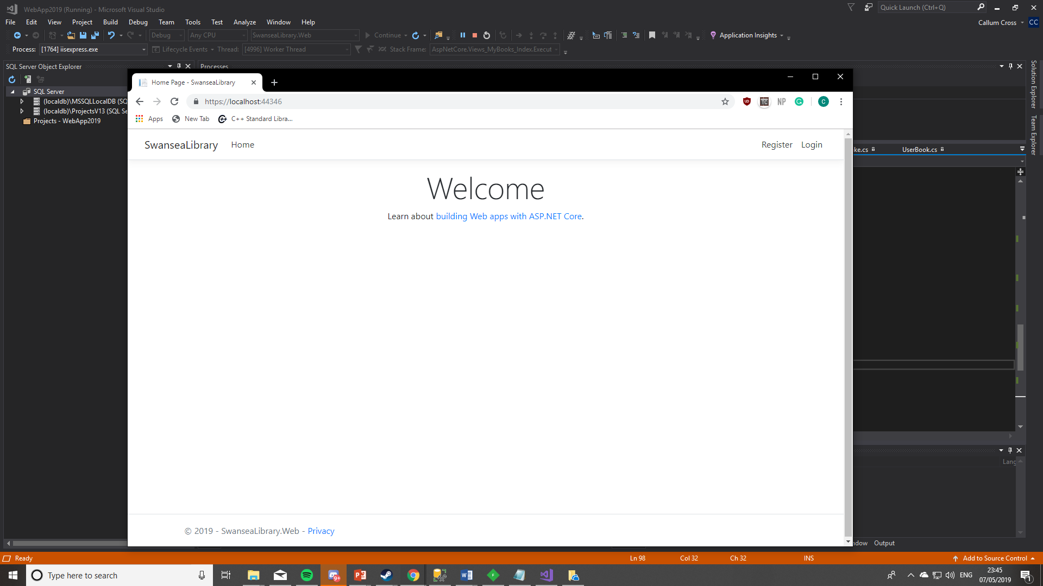
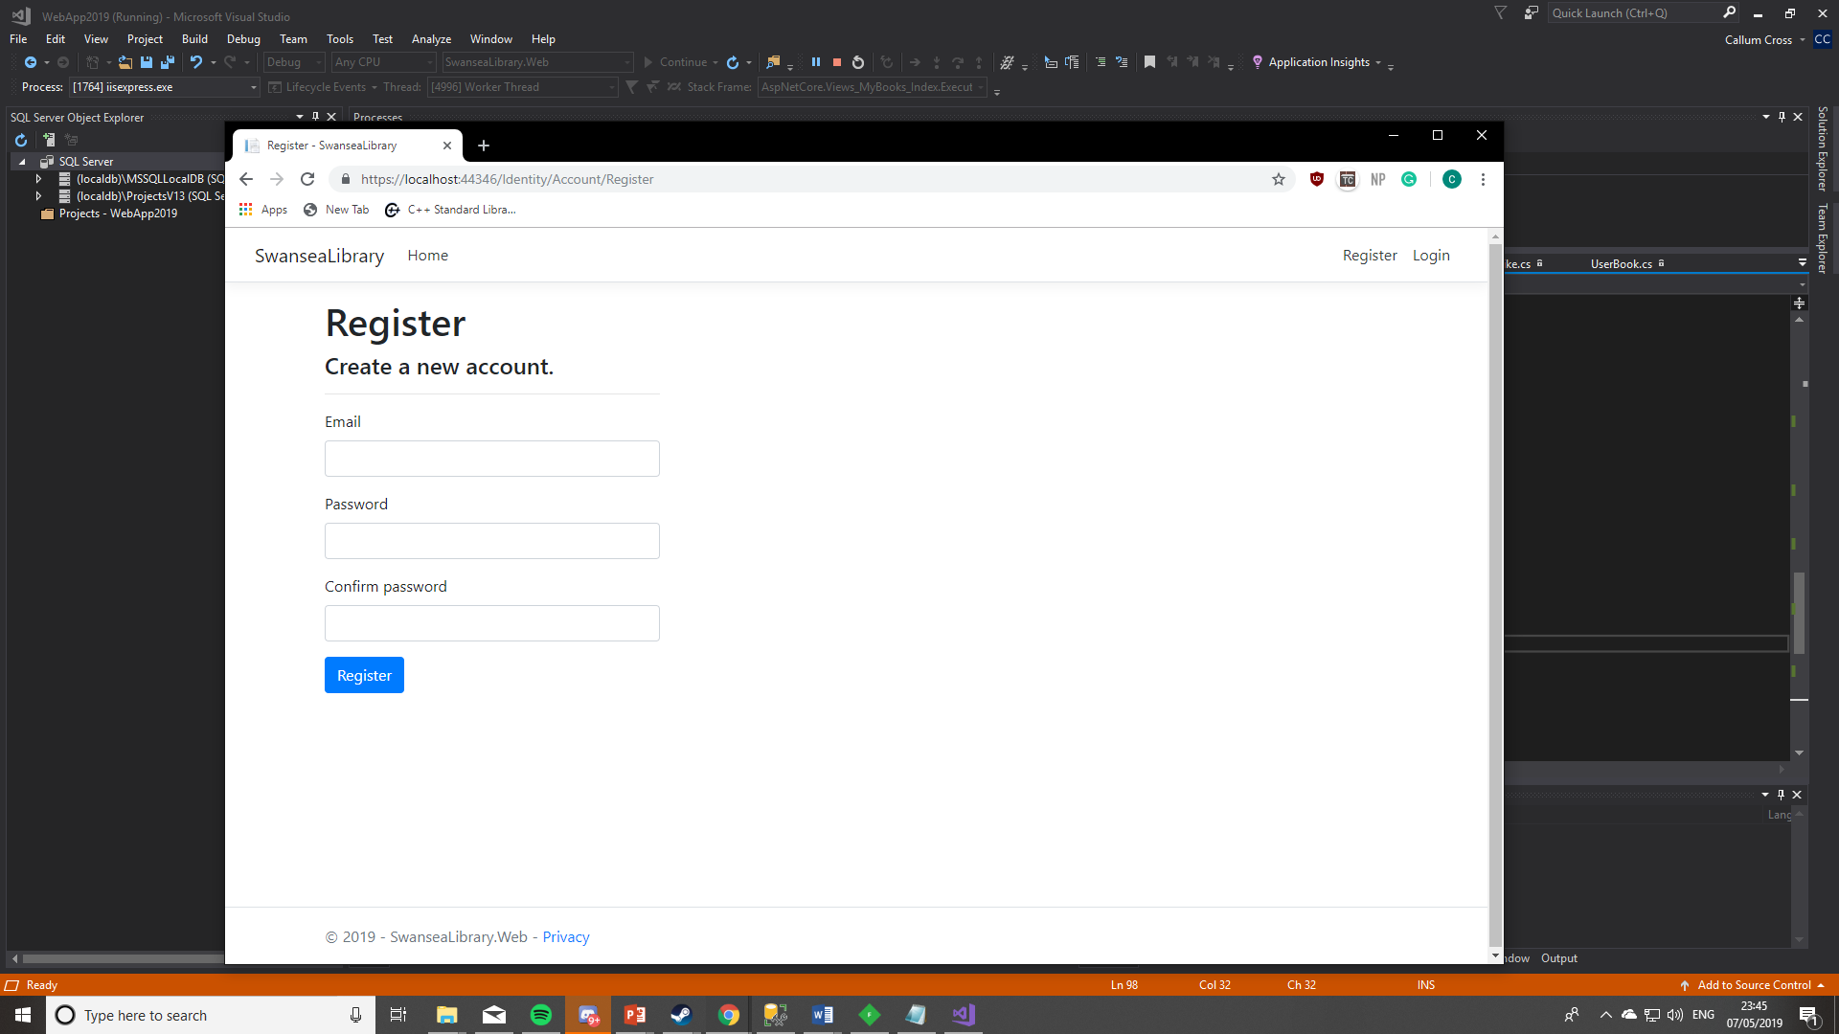
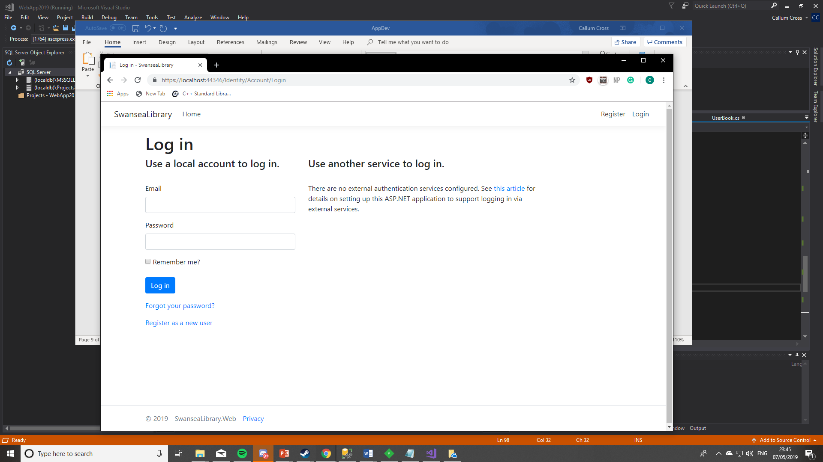

Evaluation (7)
Overall the student felt that they had completed everything that needed to be completed for the site from the requirements specification showing that the web application was fully functionating they believed it was a success with the little experience they had with a brand-new language.
Recommendations (7.1)
The student had created a web application that they believed was a success but there could have also been improvements. The first improvement the student thought they could take with them in the future if the website was to be continued to be developed.
The first improvement could have been a dislike button that allowed the users to dislike books, this would show other user that the book might not be for them if other users had searched and disliked it.
The second improvement would be to add more book categories in the search filter as only certain genres could be searched, this would remove a huge number of books that the user might have found interesting.

References (8)
[1] Acutenix. (2018, Mar 19). 10 Web application vulnerabilities [Online]. Available: https://www.acunetix.com/websitesecurity/sql-injection/
[2] P. Rubens. (2018, Apr 28). How to stop SQL Injections [Online]. Available: https://www.esecurityplanet.com/threats/how-to-prevent-sql-injection-attacks.html
[3] A. Javed. (2017, Jan 12). Beginners guide to Popular for Web Developers [Online]. Available: http://www.lucemorker.com/blog/beginners-guide-to-popular-design-patterns-for-web-developers

