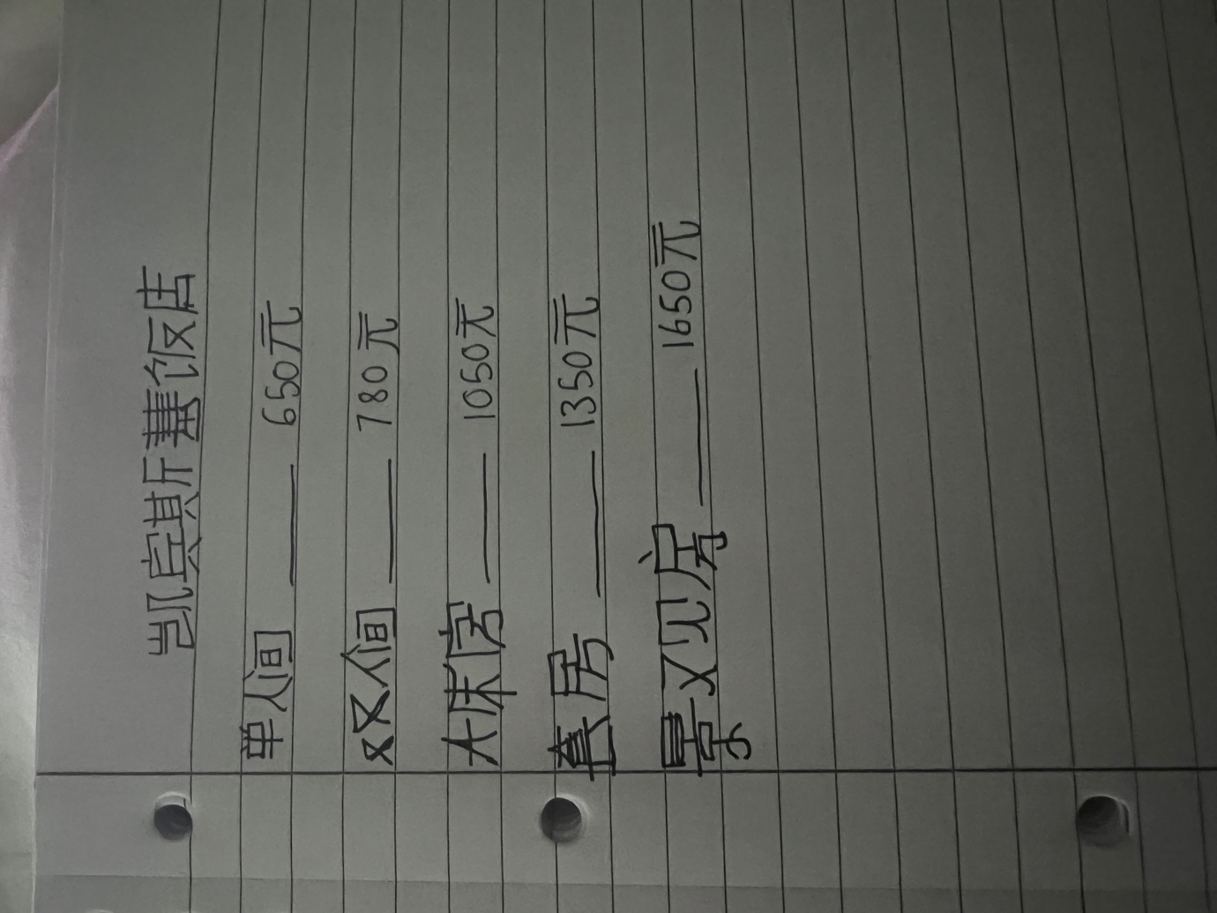

My name is Shabeena Khalil. I am submitting my assignment for the room board.
Due date is next Friday 2022. Thank you.

