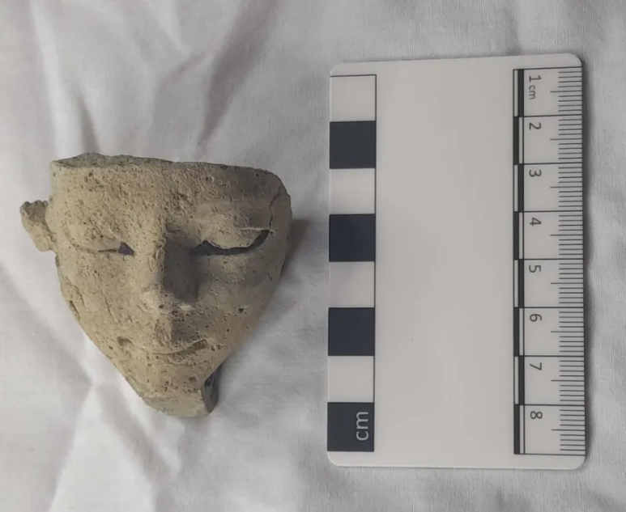
Catalogue entry
Figure 2, Egyptian head, I Lewis, 2025
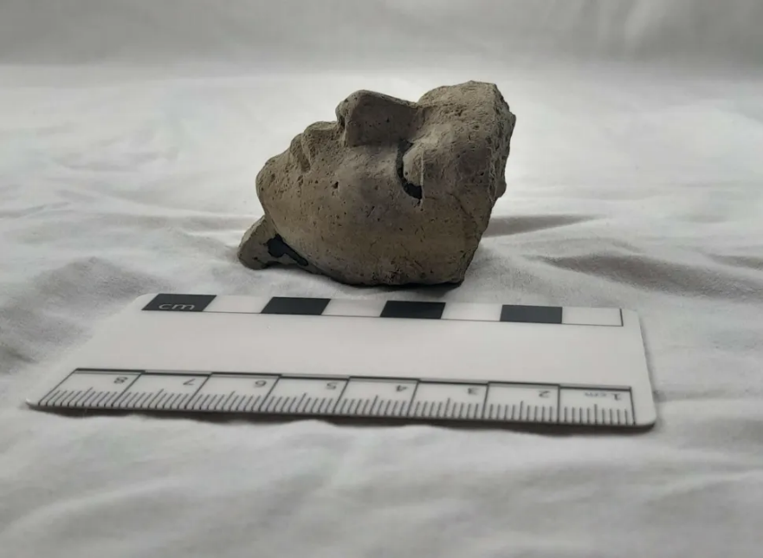
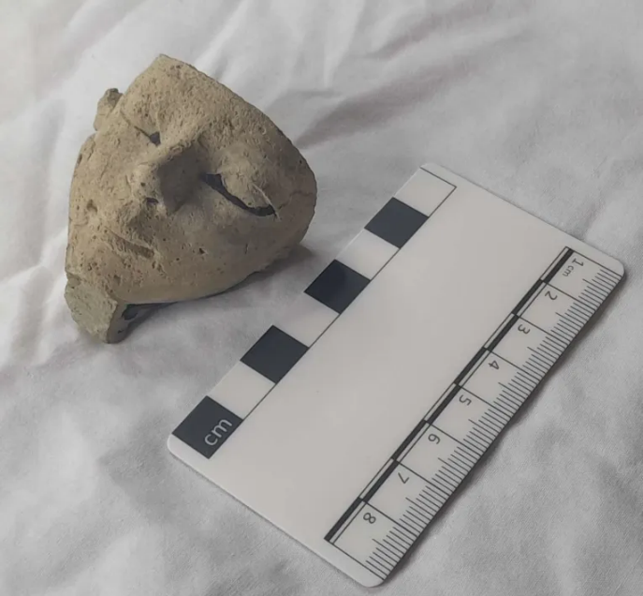
Figure 1 Egyptian head, I Lewis, 2025
Visual description
Figure 3, Egyptian head, I Lewis, 2025

Cyfarthfa Castle, Merthyr Tydfil CCM 175.996
Object type: Egyptian head figure
Material: Cartonnage
Period: Late 17th – Early 18th dynasty
Provenance: Egypt
Dimensions: 5.7cms height, 5.6cms width, 4.3cm depth
Object analysis by Iwa Lewis
The palm sized figure is shaped like a head, it has one ear-like shape on the right but not the left, the top of the head is chipped off leaving a rough, uneven edge. There is evidence of a beard attached to the chin, though the length has been chipped off. The front of the face is youthful and has a pointed nose and a smiling mouth with sculpted lips and eyes. There is a finger shaped notch in the back of the figure. The head is a yellow beige colour with speckled inclusions throughout the material; there are remnants of black paint on parts of the eyes as well as the righthand side of the face and lefthand side of the beard. The face is textured and appears to be smooth but course, similar to the feeling of sandpaper, the back and sides of the figure are rougher which suggests they were not intended to be viewed, with a more unfinished feeling to them.
The head shares some similarities with other Ancient Egyptian funerary figures, the most similar comparative object being figure 4. Figure 4 shows a similar shape and youthful appearance to the head. The nose of figure 4 has been chipped off, however you can still see the similar angle of the nose pointing outwards. The eyes of figure 4 are also painted with black which matches the remnants of the black paint on the eyes of our figure.
Figures 5 and 6 allow us a more detailed look at the elaborate larger mask the head may have been attached to, both figures also have the ear-like attachments seen on the head, linking it to the headdress.
Context of object
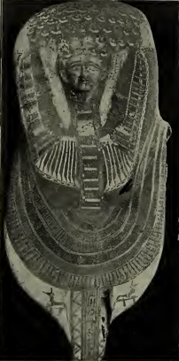
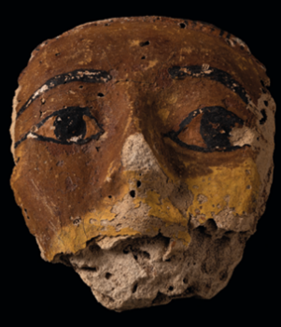
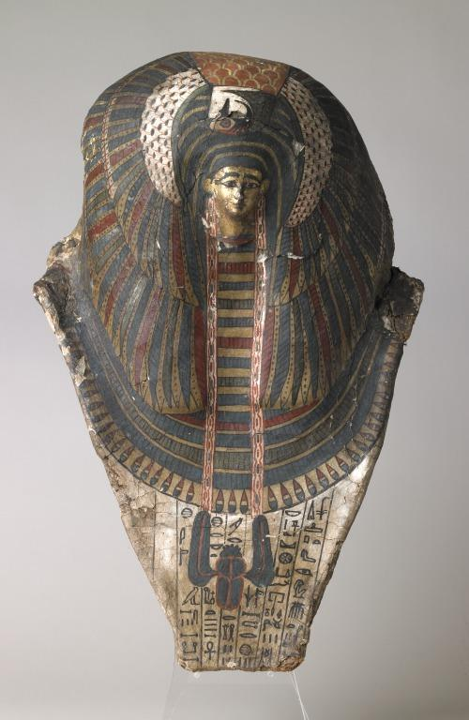
The head was likely used in the funerary sphere as it is similar to figures found in tombs such as the Beni Hassan tomb 287 [Figure 6], an unnamed tomb on the African continent [Figure 5], and tomb QH33 in Qubbet el-Hawa [Figure 4]. The figures from these tombs include a rishi style mummy mask, a full head cartonnage mask and another cartonnage mask featuring just the face. These objects all have a small face similar to this figure, and appear to be made of similar materials. Cartonnage is constructed using layered fabric (often linen) that is held together using plaster or resin and can look similar to clay. When dry the surface can be painted. Previous indications stated by several authors date the tomb objects above to the late 17th to early 18th dynasty, suggesting a similar date for this figure.
Figure 4, Cartonnage mask, University of Jaén, 2022
Figure 5, Mummy mask, Liverpool Museum, 2005
The location of the comparative items is strong evidence of the object’s potential funerary use. All objects were found in tombs and link back to the Ancient Egyptian concept of the Ka which was a figure of the person in the tomb which remained in the tomb in order to receive offerings. The figure could be a representation of the Ka. Another figure found in the tombs was named the Ba. This figure was often in the shape of a bird with the mummified individual’s face, but could take any form. The Ba was said to be able to leave the tomb and return to the tomb. Since the face is detached from its original setting it is difficult to identify it as Ka or Ba, although Ka is more likely as they have been more commonly found amongst the comparative items. One figure often painted on the walls of the tomb was called the shadow, the shadow was believed to protect the individual but also needed to be protected.
Figure 6, Cartonnage mask, Garstang, 1907
The figure was one part of a compound object, the back was rough, indicating it was where the face was attached to another object, most likely a mummified person’s mask. Similar masks found in tombs from the period include small cartonnage faces similar to this one. The cartonnage face would be painted to personalise the mask. The cartonnage face would be removeable, allowing the more elaborate mask to be repurposed. Alternatively, the larger mask and the smaller face may have been manufactured separately and then assembled to offer choice as part of the funerary industry of Ancient Egypt.

Bibliography
Afifi, H.A.M., Galal, H.S., Ali Hassan, R.R., 2020. Characterization of pharaonic cartonnage from a late period, Saqqara excavations. Pigment & Resin Technology 49, 255–264. https://doi.org/10.1108/PRT-07-2019-0061
Asante, M.K., 2014. The Idea of the Human Soul in Ancient Egypt. Gaudium Sciendi 43–52. https://doi.org/10.34632/gaudiumsciendi.2014.2728
Austrian Archeological Institute, 2025. Aswan: Pottery of the Middle Kingdom [WWW Document]. Austrian Archeological Institute. URL https://www.oeaw.ac.at/en/oeai/research/prehistory-wana-archaeology/archaeology-in-egypt-and-sudan/aswan-pottery-of-the-middle-kingdom (accessed 10.20.25).
De La Torre Robles, Y., Jiménez Serrano, A., 2022. Group of Cartonnage Masks. Presented at the A Decade of Excavations in Qubbet el-Hawa [Exhibition catalogue, University of Jaén.
Dodson, A., 2012. Rishi Coffins and the Funerary Culture of Second Intermediate Period Egypt [WWW Document]. URL https://journals.sagepub.com/doi/abs/10.1177/030751331209800120 (accessed 10.20.25).
Garstang, J., 1907. The burial customs of ancient Egypt as illustrated by tombs of the Middle Kingdom (Excavation report). University of Liverpool.
Hodel-Hoenes, S., 2000. Life and Death in Ancient Egypt: Scenes from Private Tombs in New Kingdom Thebes. Cornell University Press.
Knoblauch, C., 2018. The late Middle Kingdom in the cemeteries at Mirgissa: pottery and relative chronology, Cahiers de la céramique égyptienne 11, 47-72. Cahiers de la céramique égyptienne 11, 47-72.
Lythgoe, A.M., Lansing, A., Davies, N. de G., 1917. The Egyptian Expedition 1915-16. The Metropolitan Museum of Art Bulletin 12, 1–31. https://doi.org/10.2307/3253911
Miniaci, G., 2007. Some remarks on the development of rishi coffins, in: Grallert, S., Grajetzki, W. (Eds.), Life and Afterlife in Ancient Egypt during the Middle Kingdom and Second Intermediate Period. Golden House Publishing, London, pp. 94–99.
Mummy Mask, 1580.
Rzeuska, T.I., 2011. Grain, water and wine. Remarks on the Marl A3 Transport-Storage Jars from Middle Kingdom Elephantine. Cahiers de la céramique égyptienne 11, 461–530.
ZABKAR, L.V., 1958. A Study of the Ba. the Monistic Conception of Man in Ancient Egypt (Ph.D.). The University of Chicago, United States -- Illinois.

