

Program : MSC Data and Artificial Intelligence
Student ID : 2418784
Student Name: SADANAND TANNERU
Module Code : ACCA7026
Module : Artificial Intelligence
Lecturer : Malik Mehmood

Abstract
Intrusion Detection Systems (IDS) has become a mandatory tool in protecting the contemporary networks against more advanced cyberattacks. This study is a detailed machine-learning-based framework to classify network intrusions using the NSL-KDD dataset, which is a better benchmark that contains redundancy and imbalance problems in previous data sets. This study aims at assessing the capabilities of two popular ensemble learning algorithms namely, the Random Forest (RF) and Gradient Boosting (GB) to accurately detect a variety of network attacks such as Denial-of-Service (DoS), Probe, Remote-to-Local (R2L), User-to-Root (U2R), and Normal traffic. The approach combines a preprocessing procedure, such as attack mapping, categorical encoding, feature scaling, and the exploratory analysis of the data. High skewness, feature clusters correlated, and large imbalance between classes were detected by the statistical inspection. These properties emphasize the intricacy of intrusion detection and illustrate the need to have models that can simulate non-linear interactions and can withstand noise. RF and GB were then trained on the processed data, and the performance was systematically assessed by accuracy, precision, recall, F1-score, ranking of features in terms of importance and confusion matrices. Based on the experiment, Random Forest model achieved superior overall performance, with an accuracy of 99.76%, outperforming Gradient Boosting at 99.47%. RF also showed greater class-wise detection, especially in the majority classes like DoS, Probe and Normal. Both models performed worse on minority classes and U2R and R2L in particular because of excessive imbalance. The analysis of feature importance further determined important predictors, such as src-bytes, dst-bytes, same-srv-rate, and diff-srv-rate, which significantly contributed to normal and malicious activities. Future studies can cover potential hybrid deep-learning models and advanced imbalance-handling methods to raise the detection of rare attack types.

Table of Contents
Abstract ii
1. Introduction 1
2. Literature Review 1
3. Methodology 4
3.1. Dataset Overview 4
3.2. Exploratory Data Analysis 4
3.3. Attack Category Mapping 5
3.4. Data Cleaning and Handling Invalid Values 5
3.5. Categorical Encoding 5
3.6. Feature Scaling 5
3.7. Dataset Split 5
3.8. Model Development 6
3.9. Model Evaluation 6
4. Results and Analysis 6
5. Conclusion 12
References 13

Figures
Figure 1: Proposed Methodology 4
Figure 2: Correlation Heatmap 7
Figure 3: Outlier Detection Boxplots 9
Figure 4: Distribution of Intrusion Categories 10
Figure 5: Model Performance Comparison 10
Figure 6: Classification Reports 11
Figure 7: Confusion Metices 11
Figure 8: Feature Importance Analysis (Random Forest) 12

Tables
Table 1: Model Performance Comparison based on Accuracy 10

Introduction
Digitalisation of contemporary organisations, government agencies, and individual communication, in particular, has contributed greatly to the dependency on computer network interconnection. Although this connectivity improves the effectiveness of operations, it opens systems to an expanding range of cyber threats such as malware, denial-of-service (DoS) attacks, brute-force attacks, and complex multi-vector attacks (Craigen, Diakun-Thibault and Purse, 2014). The classical security tools, i.e. firewalls, signature-based filters and rule-based Intrusion Detection Systems (IDS), are no more efficient, because the attackers continuously develop their methods to avoid being detected by the existing set of rules (Ajagbe, Awotunde and Florez, 2024). Consequently, organisations are becoming more in need of smart, dynamic and data-driven IDS with the ability to process high volumes of network traffic and correctly react to legitimate and malicious network behaviour respectively.
Machine Learning (ML) and Deep Learning (DL) became the potent solutions to improve the process of intrusion detection (Ali et al., 2025). ML algorithms are able to learn patterns in labeled network traffic and, in general, can classify unseen events much more efficiently than DL models, which are able to extract hierarchical features in the raw data automatically, rather than have to perform vast amounts of manual feature engineering. The research indicates that the outcomes of certain ML methods are encouraging: certain binary and multiclass intrusion classifiers can be quite accurate, and recent deep learning models, like CNNs and LSTMs, can perform very well on the latest cybersecurity data (Vitorino et al., 2022; Khraisat et al., 2019).
The proposed study is devoted to the design of an intrusion detection pipeline based on the NSL-KDD data (Kiran, 2020), to the complete ETL, exploratory data analysis, and training supervised machine learning models. In comparing Random Forest and Gradient Boosting Classifiers, measuring feature importance, classification report and confusion matrices, the research shall seek to give a clear evaluation on classification performance in real-life network security application. The general objective is to establish how useful machine learning methods can be in identifying various cyber-attacks and assist in active cybersecurity defence systems.

Literature Review
IDS are one of the essential elements of cybersecurity that are installed to track network traffic and detect malicious behaviour (Tahri et al., 2022). Pioneer IDS depended on signature-based detection where the traffic is compared to the known attack patterns. Despite being useful in the case of familiar threats, signature-based IDS are not effective in how they deal with zero-day threats and have a high false-negative rate. In order to counter this, anomaly-based IDS was introduced, which identifies anomalies in normal behaviour by means of a statistical or rule-based model. Nonetheless, systems that are based on anomaly detection have a high false-positive rate and are hard to tune, which poses difficulties in online network settings. These weaknesses of conventional IDS have prompted more people to use data-driven methods, especially machine learning and deep learning, as they are able to learn the intricate patterns of attacks and keep up with the threats as they change.
The intrusion detection based on machine learning has developed considerably within the last 20 years, and scientists are constantly trying new algorithms, data sets, and test plans. Tait et al. (2021) performed an extensive experimental comparison between the state-of-the-art algorithms of ML algorithms in intrusion detection, comparing the performance of the algorithms in binary and multiclass classification tasks. The authors have discovered that the binary classifiers were very accurate (0.9938-0.9977) compared to the multiclass models like k -Nearest Neighbour which was even more accurate (0.9983). Their results support the fact that the use of appropriate ML algorithms depends on the application case.
Ajagbe, Awotunde and Florez (2024) examined the issues of unbalanced datasets and used the UNSW-NB15 dataset to compare the linear SVC, LR, RF, DT, and XGBoost models. The findings showed extreme disproportion of normal (92.71) and attack (7.29) traffic. They compared and found the best performance of the Random Forest and XGBoost in terms of accuracy, recall, precision, and F1-score. The analysis has found that ML models are still useful in the task of IDS, yet they should be accompanied by a set of careful preprocessing and balancing strategies to prevent biased forecasting.
Hamid, Sugumaran and Journaux (2016) compared a few ML classifiers based on the popular KDDCup99 dataset. Their analysis compared those models in the WEKA toolkit in terms of false-positive rate, true-positive rate, ROC, and precision. They discovered that some of the algorithms performed better with certain metrics whereas there is no one method that performed better in all performance measures.
Khan et al. (2024) studied ML and deep-learning to be used in detecting cyberattacks, considering the methods of CNN, LSTM, SVM, KNN, logistic regression, and Gaussian NB. It was demonstrated by their findings that deep-learning models, especially CNNs and LSTMs, obtained nearly perfect accuracy (≈100%). SVM and KNN were also found to be 100% accurate with lower results of LR and GNB. The authors highlighted the increasing supremacy of deep-learning methods because they have the capability of capturing intricate temporal and spatial interdependences in network traffic.
In all the studies reviewed, some major themes are identified. To begin with, machine-learning models are always ranked the highest in terms of intrusion detection, and Random Forest, XGBoost, and SVM frequently emerge as the highest-ranking models (Ajagbe, Awotunde and Florez, 2024). Second, multiclass classification is becoming increasingly seen as a more useful approach in comparison with basic binary detection because it allows operationally relevant distinction between attack categories (Tait et al., 2021). Third, deep-learning algorithms like CNNs and LSTMs are more accurate as they mine more sequential and spatial characteristics of network traffic (Khan et al., 2024). Lastly, the imbalance of datasets, feature engineering, and the problem of real-world deployment is another recurring issue, further stressing the necessity of the more robust and generalisable IDS frameworks (Ajagbe, Awotunde and Florez, 2024).

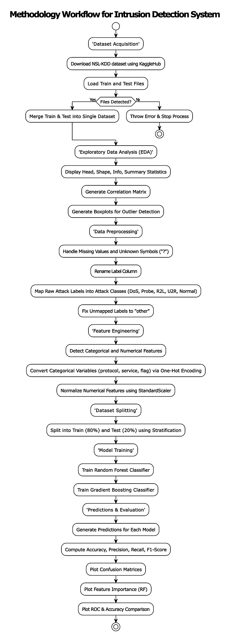
Methodology
In this study, the methodology framework of designing and testing an IDS based on machine-learning on the NSL-KDD dataset takes a systematic data-science process that includes data acquisition, exploratory data analysis, data preprocessing, features engineering, model building, and performance assessment (Figure 1). All the analyses were performed using Python-based tools and common machine-learning libraries.

Dataset Overview
NSL-KDD dataset, a collection acquired on the Kaggle repository, is a refined variant of the KDD Cup 1999 data collection aimed at eliminating redundancy and sampling bias (Kiran, 2020). The merged data (resultant of the combination of both training (KADDTrain+) and testing (KADDTest+) files has 148,517 instances and 42 attributes. These attributes cut across multiple categories such as the features of traffic flow, content based features, host level behaviours, and three categorical network identifiers such as protocol type, service or flag. The original label column has the attack names in detail that are mapped to larger attack families.

Exploratory Data Analysis
An in-depth exploratory analysis was carried out to learn about the structure and distribution of the data. Data information tables and summary statistics were checked to exclude the possibility of missing values and to investigate the type of variables. All numerical features were correlated in order to determine interdependencies and to indicate strong linear relationships between the variables. Each numeric attribute had a boxplot and a single consolidated boxplot in long form were created to identify extreme values and general spread of the variable. The distribution of classes was plotted to verify the innate disparity among the classes of attacks, where the normal and DoS classes were more common than the U2R and R2L attacks.
Figure 1: Proposed Methodology

Attack Category Mapping
NSL-KDD dataset has over 30 attack names. To construct a scalable and readable multiclass IDS, these attacks categories were put together into five standard classes: DoS, Probe, R2L, U2R, and Normal. This mapping adheres to standard NSL-KDD taxonomies and is necessary to minimize the granularity, enhance model generalization and align prediction with actual threat classification in the real world. Any attack that did not correspond to any of the existing categories was assigned to an additional category of other to guarantee that the whole mapping process would be complete. The distribution of these aggregated classes were visualised using a count plot.

Data Cleaning and Handling Invalid Values
Though the dataset did not include formal null values, some of the attributes had a default value of a place value like the value of a question mark (Preet, 2024). They were substituted with appropriate missing indicators and filled in with median imputation on numerical characteristics. This approach ensured consistency of datasets and avoided model training distortions. To verify the data reliability, the wider dataset particularly the numeric columns were checked to identify inconsistencies or out of range values.

Categorical Encoding
There were three categorical attributes, namely, protocoltype, service, and flag, which were one-hot encoded. This conversion turned categorical values into binary indicator values, making machine-learning models understand network protocol and type of service information. One-hot encoding was used instead of label encoding since it does not enforce an artificial sequence on the values of a category but fits into tree-based ensemble models.

Feature Scaling
Even though ensemble models like Random Forest and Gradient Boosting are not sensitive to feature scaling, it has variables with extremely different ranges in the dataset. Z-score scaling was used to standardise all numeric variables to ensure that large-valued features were not dominant and to ensure the modelling pipeline is consistent.

Dataset Split
The data were split into training and testing partitions in order to assess the generalisation of the models; an 80/20 split was used (Gen. David, 2023). The stratified sampling was carried out to maintain class proportion within both subsets. Such a method reduces the chance of bias of more common types of attacks and allows the moderate representation of minority classes like U2R and R2L.

Model Development
Random Forest and Gradient Boosting are two supervised machine-learning models, which were chosen to perform intrusion classification. The two models are both established ensemble methods that are robust to structured tabular data, and can model highly nonlinear decision boundaries.
Random Forest uses a parallel training set of bootstrapped decision trees. It can process high dimensionality and offers clues of the significance of features (Koehrsen, 2019).
Gradient Boosting is sequential in nature whereby each successive tree goes to correct the errors of the earlier trees, making it quite useful in multiclass classification (Saini, 2024).
Both models were trained on the cleaned and preprocessed data. These models were chosen using the results of the literature where ensemble approaches frequently manage to be superior to single-classifier approaches in the context of IDS.

Model Evaluation
The evaluation of the models was made on the basis of a complete set of performance measures appropriate to multiclass intrusion detection. These included:
- Accuracy, to give a general performance measure.
- Precision, Recall and F1-score of each attack type, which provides information about individual-class predictive strength (Novaković et al., 2017).
- Misclassification patterns to be visualized using confusion matrices represented as heatmaps.
- To determine the network behaviours that make the strongest contribution to decision-making, feature importance ranking (Random Forest only).
- To summarise and compare performance between the two ensemble algorithms an additional accuracy comparison chart was used.
The study uses a full-fledged machine-learning process pipeline adapted to intrusion detection. The method will provide the data with high-quality analysis and an evaluation that can be replicated by using data cleansing, feature transformation, categorical encoding, scaling, and robust ensemble modelling and evaluation.

Results and Analysis
The NSL-KDD dataset analysis started with a statistical investigation of its statistical characteristics and structural trends. The summary statistics showed that the majority of numeric characteristics, namely the duration, src_bytes, and destinations, have highly skewed distributions with most of the scores being extremely close to the minimum with few extreme values that can reach up to one billion bytes. This is the property common to intrusion datasets, in which abnormal sessions produce exceptionally big or complicated traffic patterns. The standard deviations also support a high level of variability in the features, especially those concerning the volume of data and the activity of the hosts, meaning that there exist considerably divergent behaviours of the attack classes.
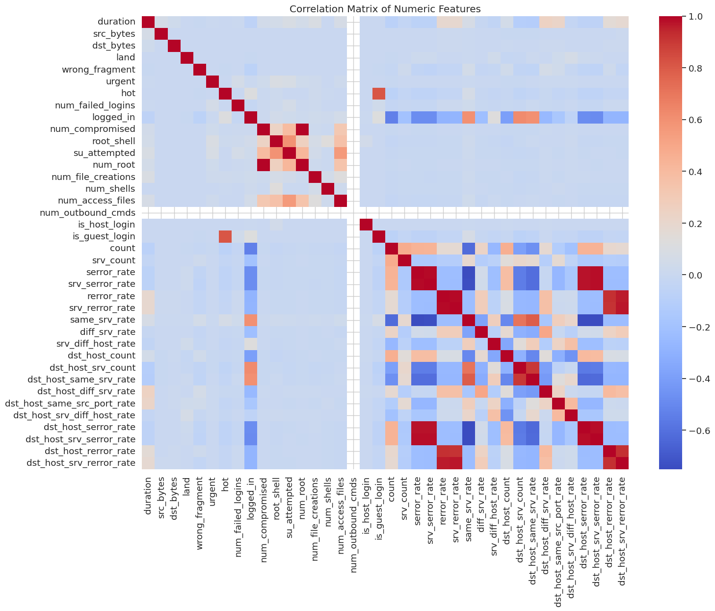
Figure 2: Correlation Heatmap
The correlation heatmap (Figure 2) was another informative tool in that it showed natural clusters of features. Attributes that describe similar behaviours (such as serror_rate, srv_serror rate and srv different host rate) were highly positively related, indicating that there are certain kinds of attacks that are always associated with a particular pattern of service and error. The other distinct cluster that can be seen was made up of the terms src_bytes and dst_bytes, which nontubitively co-occur, and are usually a part of legal traffic but also spike when there are DoS attacks. On the other hand, some of the characteristics like same srv rate and diff srv rate were negatively correlated which is also true scanning behaviour since connection repeatedly attacked the same service or continuously attacked on different ports. These correlation structures confirm the intricacy of the NSL-KDD information and the necessity of the models that can model the multi-variate associations.
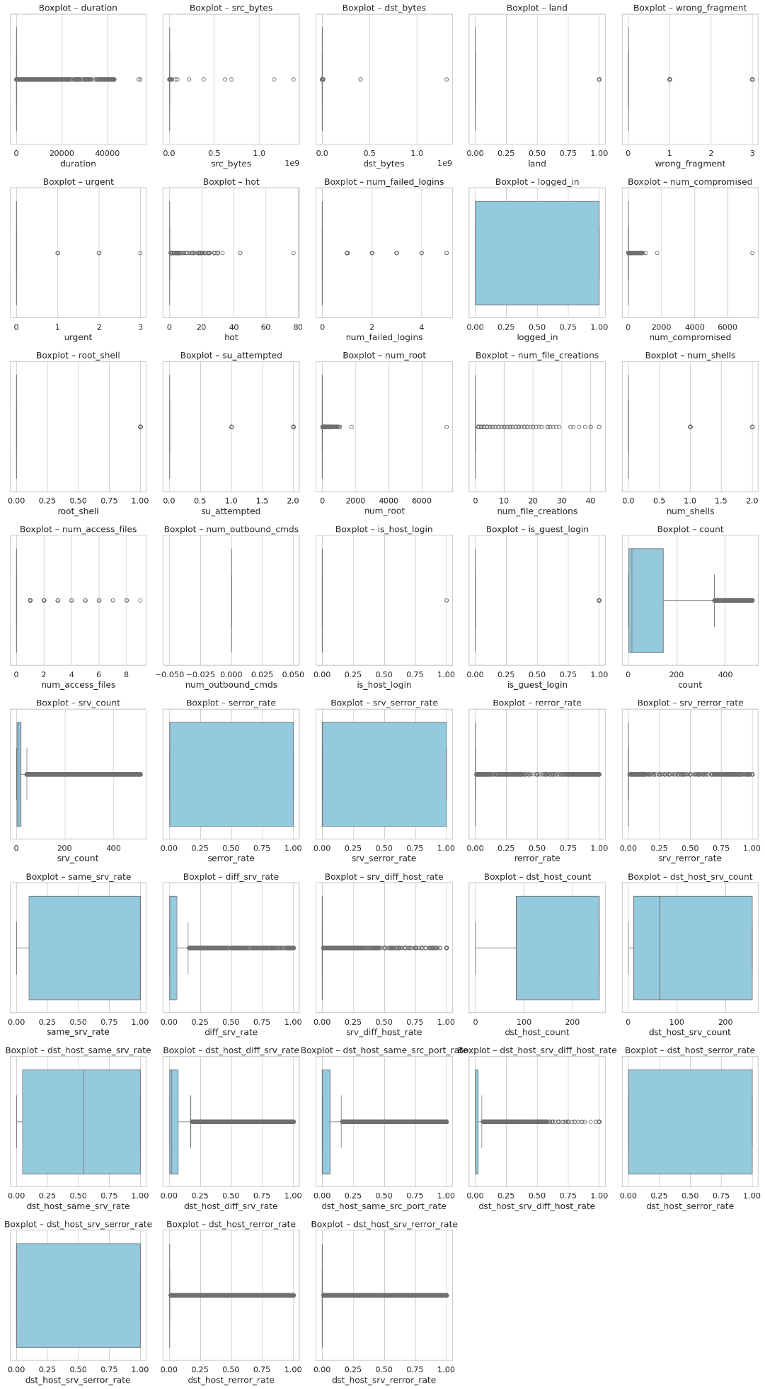
Figure 3: Outlier Detection Boxplots
The outlier analysis based on boxplots (Figure 3) revealed a large outlier population in nearly every numeric variable. These outliers do not represent errors but they denote malicious behaviors where malicious users intentionally modify the size of packets, the number of connections, or the pattern of interaction with the host. Random Forest (RF) and Gradient Boosting (GB) are ensemble models that have been known to be able to effectively address such irregularities, which is part of their high performance in subsequent tests.
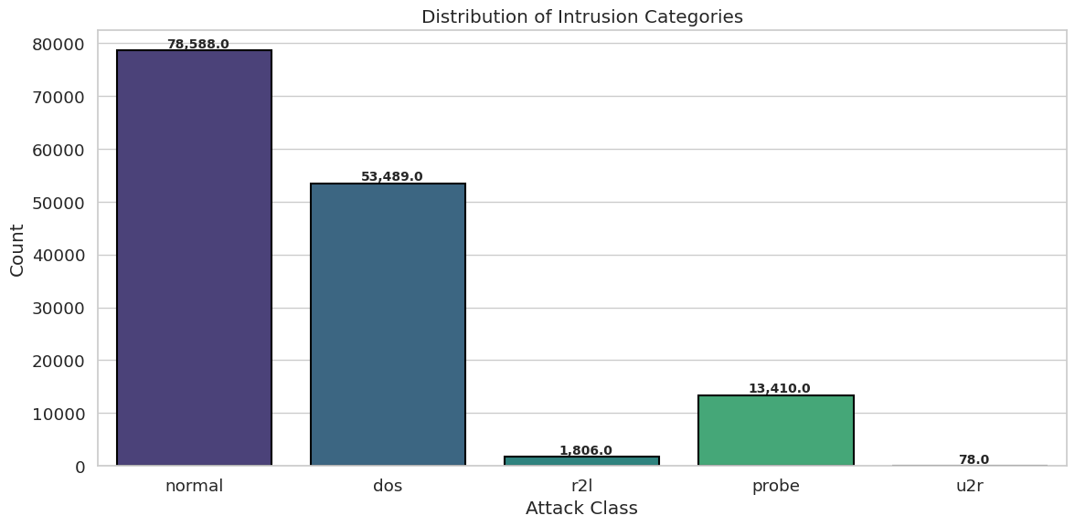
Figure 4: Distribution of Intrusion Categories
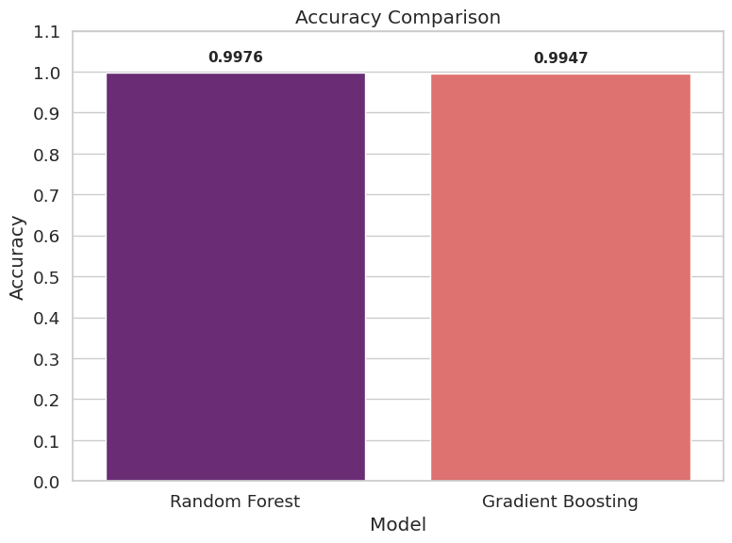
Distribution of intrusion categories (Figure 4) indicated that the dataset is also extremely unbalanced: Normal (78,588) and DoS (53,489) prevail with U2R (78) and Other (81) being incredibly uncommon. This imbalance inherently favors models in majority classes and causes worse results with more subtle attacks such as R2L and U2R. This imbalance can also be seen in the confusion matrices where both RF and GB confuse upon these minority classes on occasion despite excellent performance on the Normal, DoS and Probe attacks.
The models were then trained on 118,813 samples and tested on 29,704 samples after preprocessing. Random Forest had the best overall performance with a performance of 0.9976 and Gradient Boosting had a performance of 0.9947 (Figure 5 and Table 1). Results of the detailed classification are as follows:
Figure 5: Model Performance Comparison
Table 1: Model Performance Comparison based on Accuracy
Model | Accuracy
Random Forest | 0.9976
Gradient Boosting | 0.9947
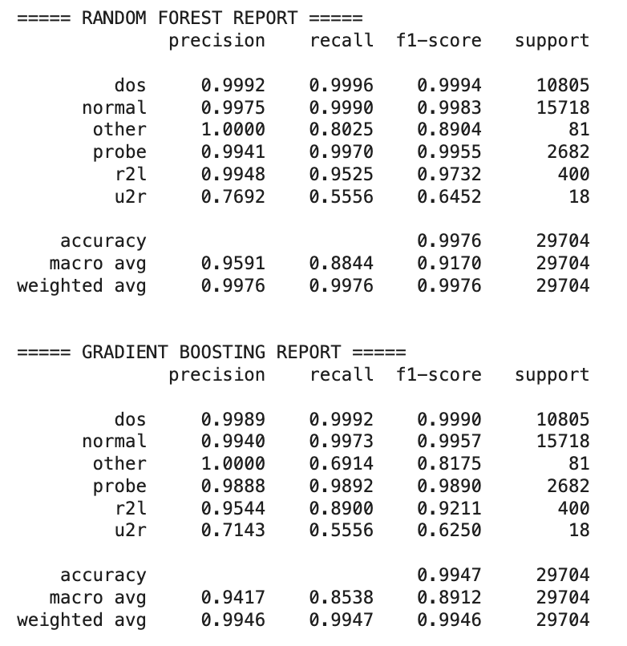
Random Forest model showed higher precision and recall by most of the attack classes. It scored highly on Normal, DoS attacks, and Probe attacks with F1-scores of more than 0.995 (Figure 6). But the minority classes declined in performance, most notably U2R which had the lowest recall at 0.5556 (Figure 5). Gradient Boosting tended in the same direction but only a little bit worse in terms of class-wise metrics, particularly with respect to R2L and U2R, where it fell out of predicting as many instances correctly as RF. The confusion matrices demonstrate that RF has better separation between similar classes than GB, which minimizes false positives in high-frequency attacks (Figure 7).
Figure 6: Classification Reports
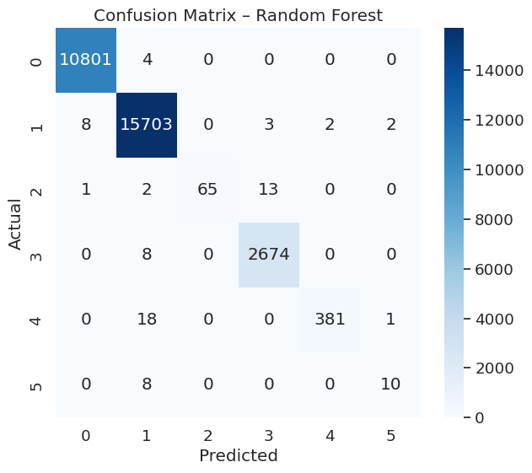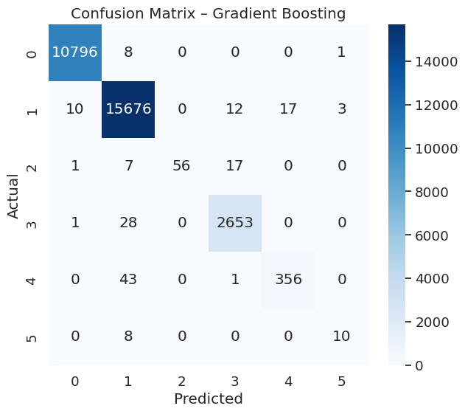
Figure 7: Confusion Metices
The analysis of feature importance (Figure 8) also showed that some of the strongest predictors were src_bytes, dst_bytes, same srv rate, diff srv rate and count. These characteristics are quite similar to the behaviours of scanning, probing, and flooding attacks, which supports the importance of these features in intrusion detection.
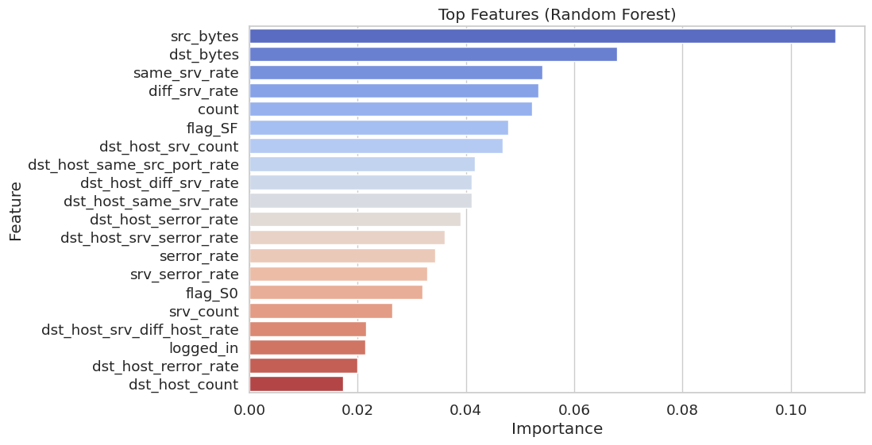
Figure 8: Feature Importance Analysis (Random Forest)

Conclusion
This paper showed that machine learning methods were effective in identifying network intrusions by using the NSL-KDD data. The benchmarking of the Random Forest and Gradient Boosting classifiers in terms of their predictive ability across various classes of attacks was conducted using extensive preprocessing, feature engineering, and model evaluation. The results indicated that Random Forest was the most accurate with a total accuracy of 99.76, surpassing the Gradient Boosting which had a total accuracy of 99.47. Random Forest also exhibited better recall and F1-scores on the majority of attack types, especially high-frequency ones like normal, dos, and probe. Despite their inability to handle minority classes such as u2r, both models produced competitive results as compared to the previous works. On the whole, this study confirms that tree-based ensemble models have been recognized as one of the most efficient tools of intrusion detection because of their robustness, scalability, and capability to deal with complex interactions between features. The study offers an excellent base of experimentation on deep learning and hybrid ensemble approaches in the future.

References
Ajagbe, S.A., Awotunde, J.B. and Florez, H. (2024) Intrusion Detection: A Comparison Study of Machine Learning Models Using Unbalanced Dataset. SN Computer Science 2024 5:8 [online]. 5 (8), pp. 1–10. Available from: https://link.springer.com/article/10.1007/s42979-024-03369-0 [Accessed 13 November 2025].
Ali, M.L., Thakur, K., Schmeelk, S., Debello, J. and Dragos, D. (2025) Deep Learning vs. Machine Learning for Intrusion Detection in Computer Networks: A Comparative Study. Applied Sciences 2025, Vol. 15, Page 1903 [online]. 15 (4), p. 1903. Available from: https://www.mdpi.com/2076-3417/15/4/1903/htm [Accessed 11 November 2025].
Craigen, D., Diakun-Thibault, N. and Purse, R. (2014) Defining Cybersecurity. Technology Innovation Management Review [online]. 4 (10), pp. 13–21. [Accessed 11 November 2025].
Gen. David, L. (2023) Five Methods for Data Splitting in Machine Learning. Medium [online]. Available from: https://medium.com/@tubelwj/five-methods-for-data-splitting-in-machine-learning-27baa50908ed.
Hamid, Y., Sugumaran, M. and Journaux, L. (2016) Machine learning techniques for intrusion detection: A comparative analysis. ACM International Conference Proceeding Series [online]. 25-26-August-2016. Available from: /doi/pdf/10.1145/2980258.2980378?download=true [Accessed 12 November 2025].
Khan, I., Khan, J., Hussain Bangash, S., Ahmad, W., Asad Iftikhar, M. and Hameed, K. (2024) Intrusion Detection Using Machine Learning and Deep Learning Models on Cyber Security Attacks. VFAST Transactions on Software Engineering [online]. 12 (2), pp. 95–113. Available from: https://vfast.org/journals/index.php/VTSE/article/view/1817 [Accessed 11 November 2025].
Khraisat, A., Gondal, I., Vamplew, P. and Kamruzzaman, J. (2019) Survey of intrusion detection systems: techniques, datasets and challenges. Cybersecurity [online]. 2 (1), pp. 1–22. Available from: https://cybersecurity.springeropen.com/articles/10.1186/s42400-019-0038-7.
Kiran (2020) NSL-KDD. Kaggle [online]. Available from: https://www.kaggle.com/datasets/kiranmahesh/nslkdd/code [Accessed 13 November 2025].
Koehrsen, W. (2019) Random Forest in Python - Towards Data Science. Medium [online]. Available from: https://towardsdatascience.com/random-forest-in-python-24d0893d51c0.
Novaković, J.D., Veljović, A., Ilić, S.S., Papić, Ž. and Tomović, M. (2017) Evaluation of classification models in machine learning. Theory and Applications of Mathematics & Computer Science [online]. 7 (1), p. 39. Available from: https://api.semanticscholar.org/CorpusID:125586327 [Accessed 13 November 2025].
Preet, A. (2024) Data Preprocessing Using PySpark’s DataFrame. Analytics Vidhya [online]. Available from: https://www.analyticsvidhya.com/blog/2022/04/data-preprocessing-using-pysparks-dataframe.
Saini, A. (2024) Gradient Boosting Algorithm: A Complete Guide for Beginners. Analytics Vidhya [online]. Available from: https://www.analyticsvidhya.com/blog/2021/09/gradient-boosting-algorithm-a-complete-guide-for-beginners.
Tahri, R., Balouki, Y., Jarrar, A. and Lasbahani, A. (2022) Intrusion Detection System Using machine learning Algorithms. ITM Web of Conferences [online]. 46, p. 02003. [Accessed 13 November 2025].
Tait, K.A., Khan, J.S., Alqahtani, F., Shah, A.A., Ali Khan, F., Rehman, M.U., Boulila, W. and Ahmad, J. (2021) Intrusion Detection using Machine Learning Techniques: An Experimental Comparison. 2021 International Congress of Advanced Technology and Engineering, ICOTEN 2021 [online]. Available from: https://ieeexplore.ieee.org/document/9493543 [Accessed 13 November 2025].
Vitorino, J., Andrade, R., Praça, I., Sousa, O. and Maia, E. (2022) A Comparative Analysis of Machine Learning Techniques for IoT Intrusion Detection. Lecture Notes in Computer Science (including subseries Lecture Notes in Artificial Intelligence and Lecture Notes in Bioinformatics) [online]. 13291 LNCS, pp. 191–207. [Accessed 13 November 2025].

