Usability Engineering

Assignment 1

BSc Hons Applied Computing

Tom McVeigh

250314

Word Count excluding References, Appendix and Contents: 3298

Contents
Introduction 3
Interface Design Research 3
Usability Engineering 3
Human Interface and interaction design 4
Stages of a usability engineering lifecycle 4
Design Principles 4
Target User Group Requirements 5
User Requirements 5
Task analysis 5
Human Factors 8
Inductive vs Deductive reasoning 8
Short Term Memory vs Long Term Memory 9
Theories of Perception 9
Gibson Visual Perception 9
Gregory Visual Perception 9
Paper Prototype Design 10
Language Select 10
Enter Details 10
Gender Select 11
Test Type 12
Select Payment Method 12
Enter Payment Details 13
Confirm Payment Details 13
Cash Payment 14
Payment Processing 14
Test Page 15
Print Type 15
Log Off 16
Paper Prototype Walkthrough 16
User Evaluation and Other System Design evaluation 16
Software Prototype 17
Selection of software 17
Application Screenshots/Feedback changes 17
Overall Evaluation 26
Conclusion 26
References 27
Appendix 27
Appendix 1 27
User Design Walkthrough Evaluation 27
Visibility of System Status 27
Match Between System and Real World 27
User Control and Freedom 28
Consistency and Standards 28
Error Prevention 28
Recognition rather than recall 28
Flexibility and Efficiency of use 29
Aesthetic and Minimalist design 29
Help Users Recognise, Diagnose and recover from errors 29
Help and Documentation 30
Appendix 2 30
1. Visibility of system status 30
2. Match between system and real world 30
3. User control and freedom 30
4. Consistency and standards 30
5. Error prevention 31
6. Recognition rather than recall 31
7. Flexibility and efficiency of use 31
8. Aesthetic and minimalist design 32
9. Help users recognise, diagnose, and recover from errors. 32
10. Help and documentation 32

Introduction
The software that will be developed is for a medical institution that will allow for blood tests, pregnancy tests, STD tests and blood chemical tests. After these tests are complete a report will be created to show the results and that can then be taken to doctors or pharmacists. There will also be a payment system for the user to pay for these tests.

Interface Design Research

Usability Engineering
Usability engineering is the process of creating a piece of software and refining its mechanics to improve its ease-of-use as well as improve its usefulness in the needed role. (1)

Human Interface and interaction design
HCI stands for human-computer interaction and is the design of computer technology, mainly looking at the interaction between the user and the computers. HCI started in the early 1980’s with the introduction of home computers and aimed to allow more people to use the computers. HCI evolved to include three disciplines, these being computer science, cognitive science and human factor engineering. UX design has recently overtaken HCI. One of the main reasons for this is as a result of HCI being more academically focused with studies and UX design being more focused on user experience and industry. (3)

Stages of a usability engineering lifecycle
There are three stages to the usability engineering lifecycle, these are Requirements analysis, Design testing and evaluation and installation.
The first stage is requirement analysis. This stage is where the user requirements are collected and analysed to get information on what the final product should provide and how the user should interact with the software. This stage can be further broken down in to five further sections, including User profile, where the users exact needs are looked at, Contextual text analysis, where the current tasks and workflow are examined to see how the user reacts to software, usability goal setting, to see if the user requirements can be achieved, platform capabilities, to see if the software is feasible and can be created using the available tools, and general design guidelines, to apply accepted guidelines in the interface designs.
The second stage is design, testing and development. This is the stage where the design, testing and development of the software in question is carried out. This stage can be split in to further sections these being level one, two and three design. Level one design is about the conceptual design, where the functionality, rules and workflow of the final product are designed. Level two design is where the standards for the project are created to allow for a uniform set of rules to be implemented when designing the software, improving the consistency of the final product. Level three design is where the actual interface design is carried out, including getting user feedback on the designs to provide the best possible interface. After this stage the development and testing of the software is carried out.
The third stage is Installation. This is the stage that takes place when the software has been installed for the client and allows for the client to provide feedback on any changes that they may want to the software. This can lead to this life cycle being infinite with more updates being released for the software when the client requests a new feature or bugs to be fixed. (2)

Design Principles
There are many principles that need to be considered when designing software. There are four people that have stated their own design principles, these being Dix, Norman, Nielsen and Schneiderman. This section will cover some of their principles and their similarities and differences.
The first similarity is a principle through all of the chosen guidelines. This is Consistency, Dix, Norman, Schneiderman and Nielson all state that the consistency of the system is extremely important. What is meant by this is that the colour scheme, button layout, fonts and text sizes are consistent throughout an application. This allows for a user to easily navigate their way through the system and learning what buttons are where on the pages.
The next similarity is between Dix, Schneiderman and Norman and this is system feedback. This is the principle that when the system is doing something, the user should be informed. This can be done through sound, movement, or colour.
Another similarity is of that of error handling, and this is shared between Nielson, Dix and Schneiderman. This is a principle that allows for the system to handle errors before they become the user’s problem or if it becomes, they user’s problem, the system must offer a simple way in which the user can solve the issue.
A similarity can also be drawn between Schneiderman and Dix with reversal of actions. This is for when errors occur, or accidental changes are made. Allowing for the previous state of the application to be recovered, saving the user from disastrous mistakes.
(4), (5), (6), (7)

Target User Group Requirements

User Requirements
The user requirements for this project are many. The main functions that are required of the new software is, to allow for three types of tests to be carried out, payment to be processed and accepted and for results to be printed off.

Task analysis
For the user requirements to be met the tasks need to be broken down further to see each step that will need to be completed to allow for the completion of the overall task. Below each task has been decomposed to show what sub tasks go into the overall completion of the main tasks.
The diagram below shows the overall task of the test that the user wants carried out. It shows all of the subtasks that need to be completed, each further diagram will break down each subtask further to show what goes into them.
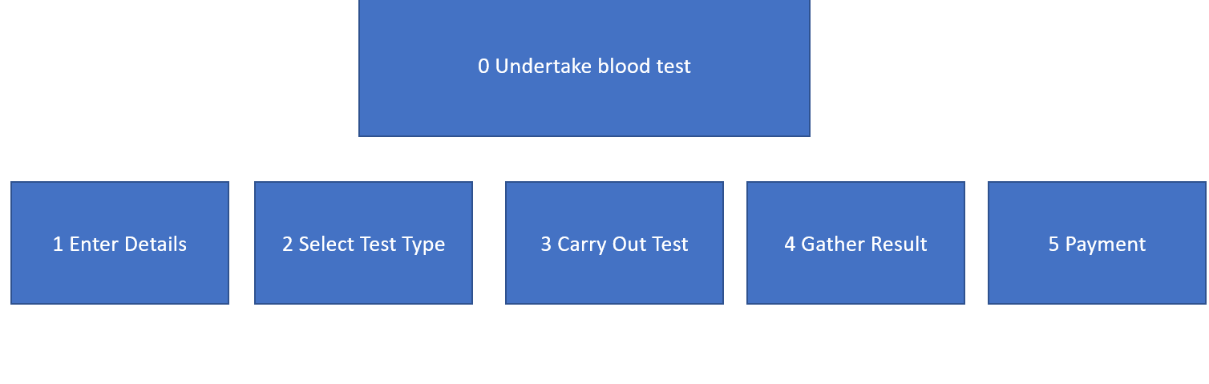
This diagram shows what needs to be done to complete the first task. On the right side of the diagram, you can see the plan of how the user would interact with the system and how the system would respond. First the user enters their details, upon pressing next they will be prompted to select their gender. When the select their gender, their response will prompt the system to either lock or unlock an option for the tests. This being a pregnancy test. After this the user will simply confirm their details.
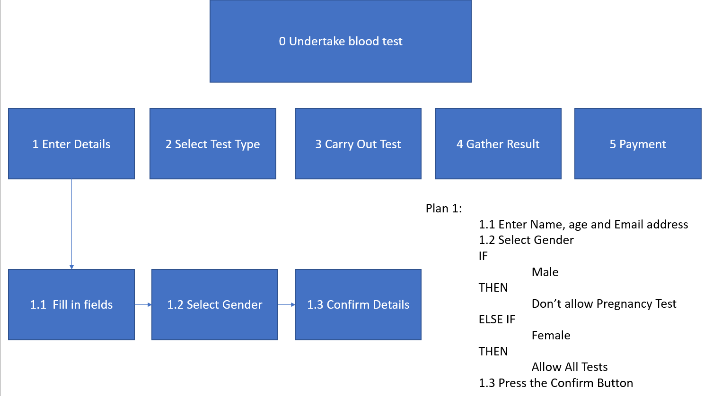
The next task is selecting test type. The user will select the test that they want carried out. Depending on the gender selected on the last test pregnancy may not appear. But the other options will always appear, and these are Blood test and STD test. Then the user would confirm their test.
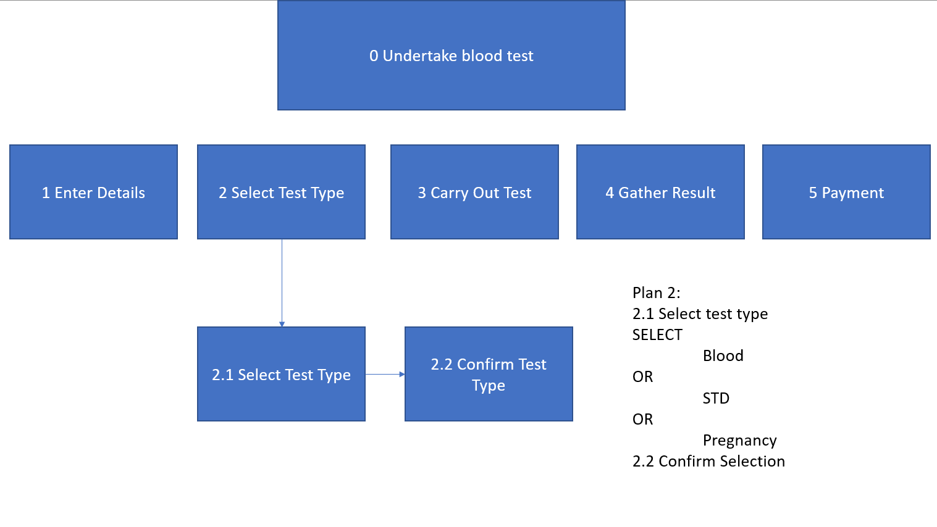
The third task is actually carrying out the test. The current task is broken down into 3 simple steps that the user will follow through prompts on the screen, they would need to clean their hands, place hand in receptacle and then the test would be conducted. Then after the test has been conducted the user can remove their hand.
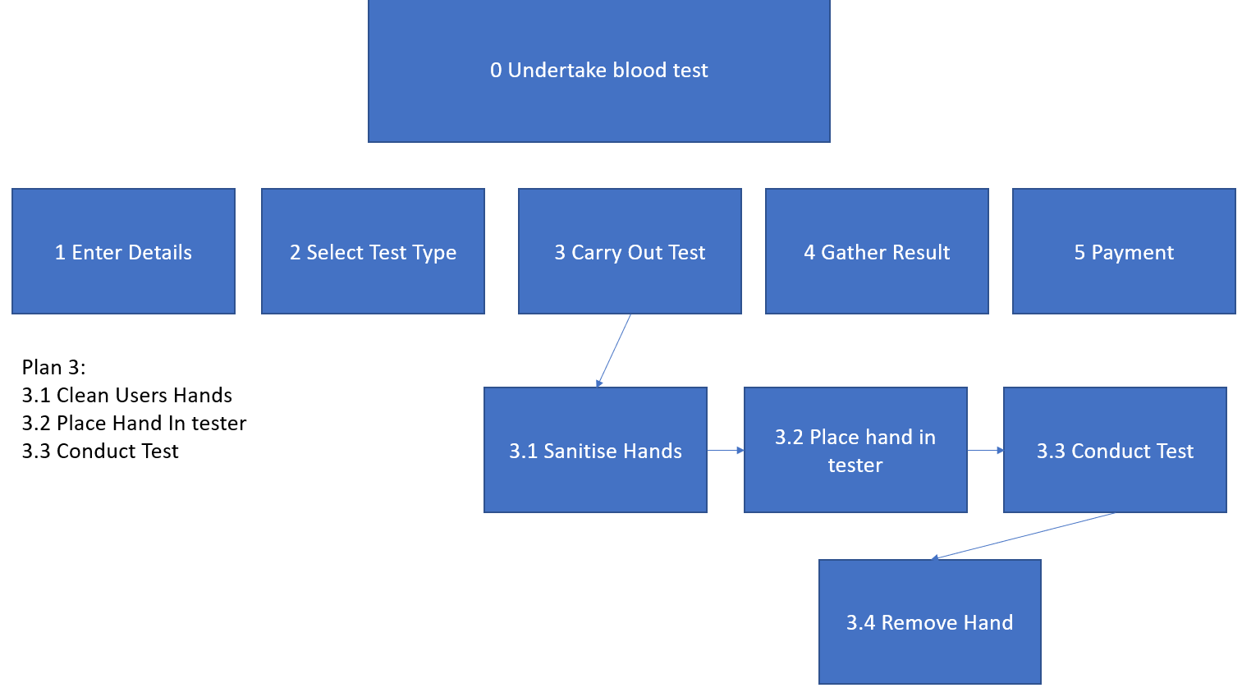

The fourth task is gathering the results. The user will be prompted to enter an email address or to have their results printed out. Then the user will be told to take their results to a doctor or pharmacist.
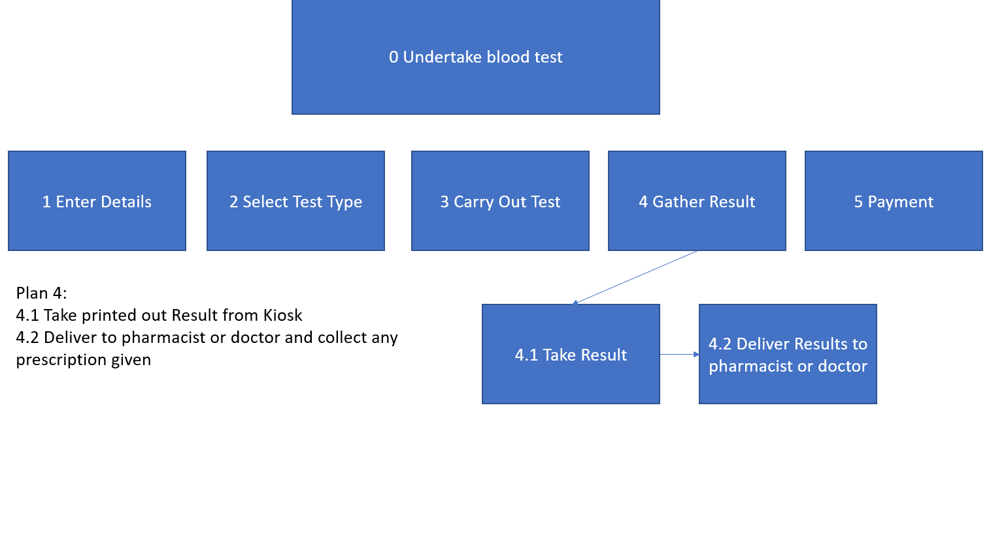
Before printing can commence the user will have to pay. They will be prompted to select card or cash. If card is selected then they would be asked to inter their card details, if cash is selected then they will be prompted to enter the correct amount to the machine. Then the user will confirm the transaction and log out of the machine ready for the next user.

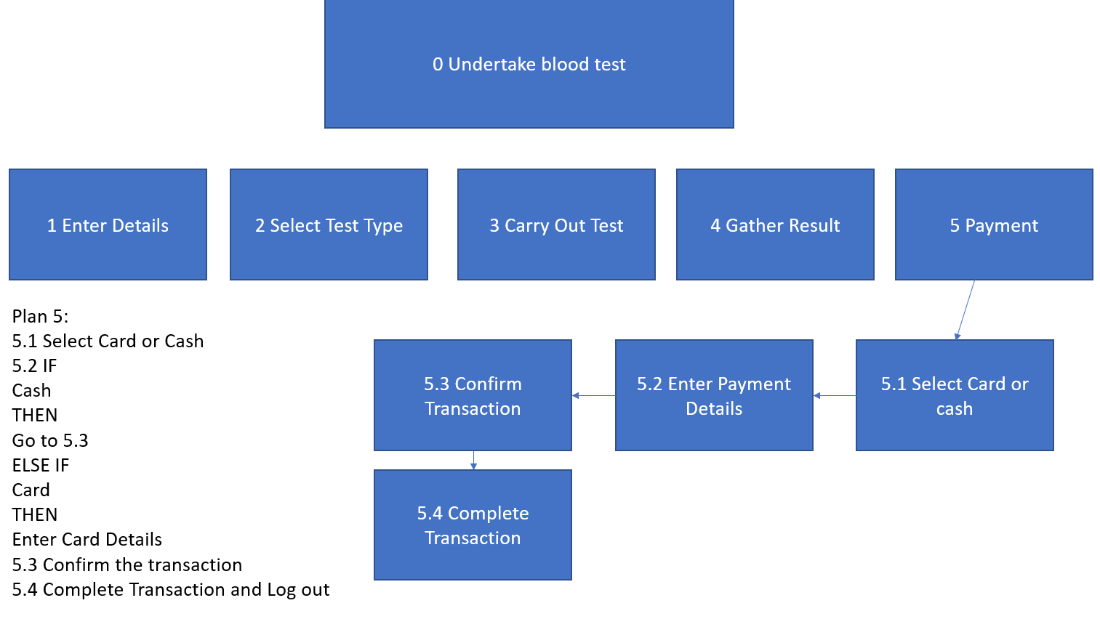

Human Factors

Inductive vs Deductive reasoning
Deductive reasoning is the form of reasoning or thinking that starts out with a hypothesis and then carries out research into the hypothesis question to come to a conclusion. A popular example of Deductive reasoning is that of "All men are mortal. Harold is a man. Therefore, Harold is mortal." This form of reasoning comes to more sound conclusion as more research is carried out to find how each part of the hypothesis is related. (8) In terms of the application that will be created a pregnancy test is an available option. Since a man cannot get pregnant, if the user selects male as their gender, the option for the pregnancy test can be removed from the available options.
Inductive reasoning is the opposite of Deductive reasoning. Inductive reasoning takes guesses from specific generalizations or in simpler terms there is data and conclusions are drawn from this data. An example of this is "The coin I pulled from the bag is a penny. That coin is a penny. A third coin from the bag is a penny. Therefore, all the coins in the bag are pennies." This may not be true but from the data gathered this is the overall conclusion that is drawn from the available data. (8) Applying this form of reasoning to an application could mean that a user may see buttons with flags on them and click on one to see that it changes the language of the application and from this can infer that the other buttons with flags on them will also change the language of the application.

Short Term Memory vs Long Term Memory
Long term memory is the general store of information that allows for people to remember information and events over a large period of time. An example of long-term memories can include remembering childhood to remembering friends faces, to remembering the tasks that are required to complete a certain activity. (9) Long term memory in terms of applications may refer to the user being able to apply knowledge from other applications to the one that they are currently using. From buttons using similar symbols to certain page layouts being similar.
Short term memory is the memory held by a person that is recent in time and in a highly accessible state. These memories are only kept for a very short amount of time but can vary in their complexity and length. These memories can include remembering a phone number or remembering details from a film or remembering where you parked your car. (9) Short term memory in terms of applications can refer to the user keeping track of what buttons on the current application do, meaning if they come across the same button later in the application, they have the knowledge of what that button will do when click.

Theories of Perception
Another part of human factors is that of how humans perceive things, multiple theories have been created by many theorists on how people perceive. The two that will be looked at is that of Gibson’s and Gregory’s Visual Perception theories.

Gibson Visual Perception
Gibson’s theory on Visual perception states that perception is not learned and what you see is what is there, no inferences have to be drawn. Since no interpretation needs to be carried out, people have enough information to navigate their environments without thought. This theory when applied to an application means that the user would be able to determine what each component of the application does from how the component looks. This theory does not take into account visual illusions and other misdirection’s meaning that using this theory could lead to confusion on the user of the application, with buttons being labelled with images that have multiple meanings or carry out a different function that the user did not intend. (10)

Gregory Visual Perception
Gregory’s theory of visual perception differs from Gibson’s by requiring the use of prior knowledge or experiences to make sense of what is being perceived to accurately determine what a thing is or how to carry out a process. Meaning unlike Gibson’s theory that states that reality is perceived the same as everyone else, Gregory states that reality differs between people as they have a hand in what they perceive. This means that conditions such as colour-blindness or hearing problems could make someone perceive something in a different way to another person. In terms of an application, Gregory’s theory could mean that someone can bring knowledge of previous applications in to the one that they are currently using or use knowledge of what certain symbols or images could mean in terms of what an application is doing. (10)

Paper Prototype Design

Language Select
This page of the app holds the language select. It prompts the user to click on the flag associated with their language. This page has the same design as the other pages that hold multiple buttons to enforce consistency through the design. This page follows an inductive approach and uses long term memory as the flags represent different languages.


Enter Details
Below is the enter details page of the app and it establishes the basic layout of all future pages that relate to holding or entering user details. Upon pressing continue if no data has been entered or the incorrect data has been entered an error message would appear informing the user of the incorrect data this uses the principle of error handling. Another principle is recoverability as a result of the continue and back buttons allowing for users to go back a page to change something or fix a mistake. The back and confirm buttons appear on almost every page.
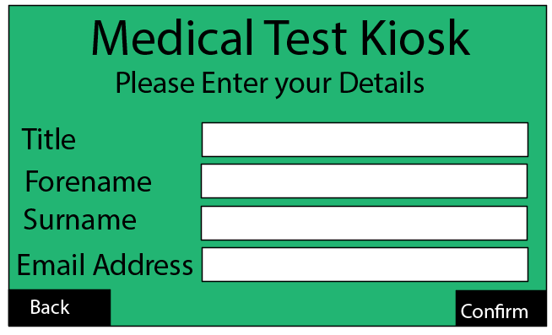

Gender Select
This is the page where the user selects their gender. Upon pressing the button with their gender on it the user will be taken to the next page. The pages that hold buttons offer another principle and this is system feedback as upon pressing a button the user will see a new page load and their cursor will turn in to a spinning blue disc.
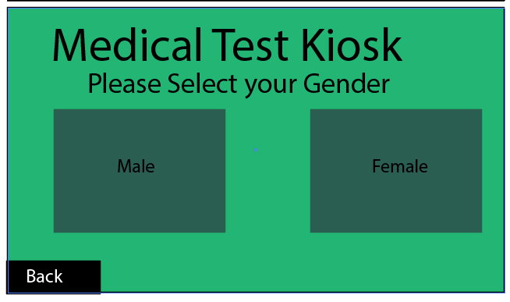

Test Type
This is the page where the user selects the type of test they want to be carried out. This change depending on the selected gender, there is also a back button.
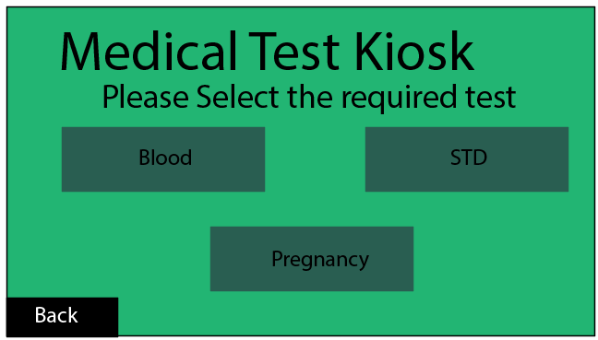

Select Payment Method
This is the select payment method screen, it is very simple, two buttons showing their options either card or cash.
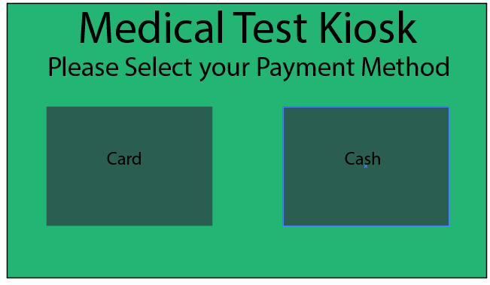

Enter Payment Details
This page only shows when card is selected as the payment method. It allows for the user to input the required information. There is a confirm and back button.
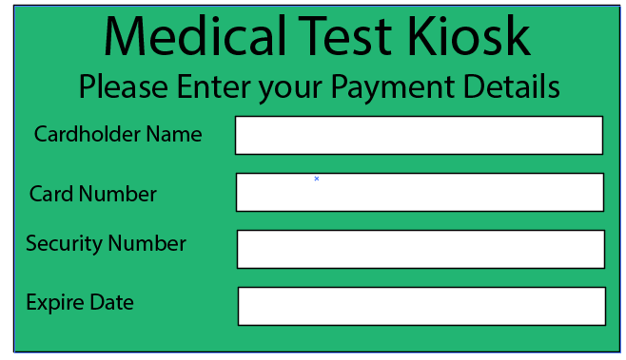

Confirm Payment Details
This page holds the previously entered details entered by the user to allow for the user to spot any errors and make any changes before confirming the purchase.
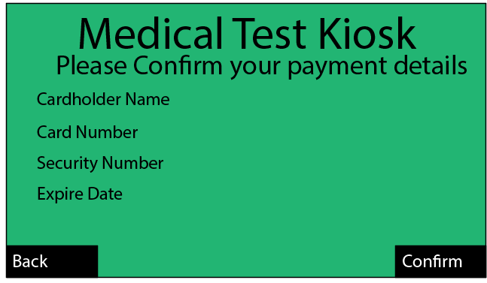

Cash Payment
This page waits for the user to enter the required amount of cash before the test can be carried out.
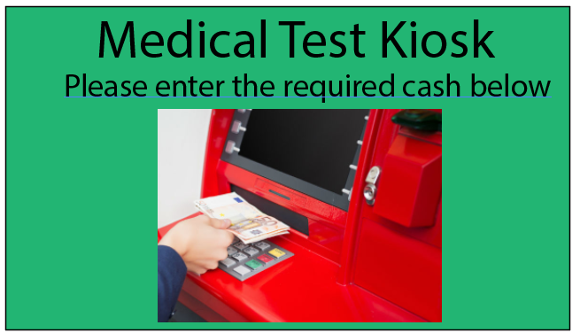

Payment Processing
This page shows the user that system is working on their request and is processing the payment for the test and shows the systems status as processing.
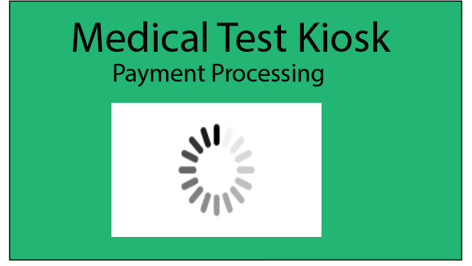

Test Page
This is the page that the user sees when they need to carry out the test. It waits for the user to follow the instructions; the test will be carried out and then it will move on to the next page.
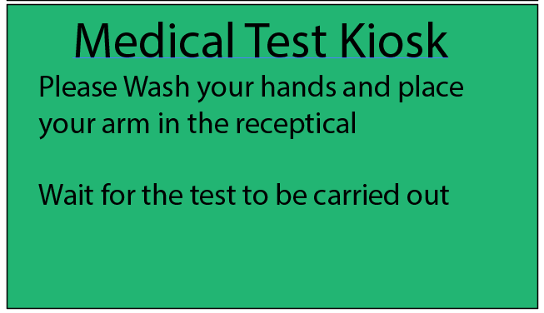

Print Type
This page allows the user to select what form their results will be delivered in, printing out of the kiosk, or sent to their email address given in the earlier page.
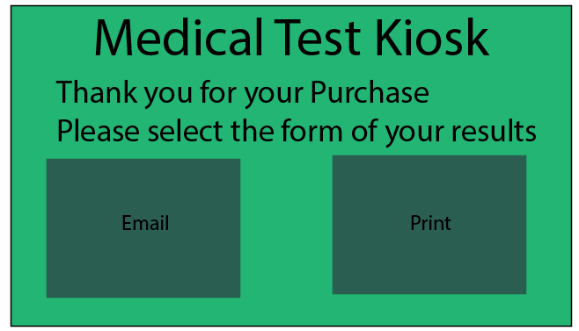

Log Off
This is the last page of the system where the system prompts the user to log off to allow the next user to use the kiosk.
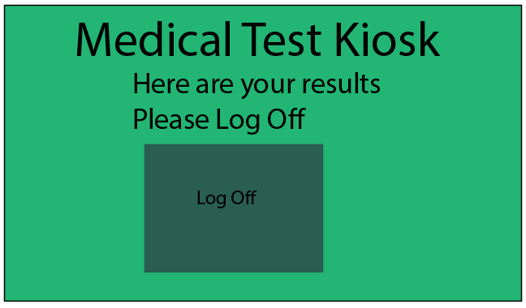

Paper Prototype Walkthrough
My Walkthrough of Jamie’s System - https://www.youtube.com/watch?v=aFKmtCATZ7g
Jamie’s Walkthrough of My System - https://www.youtube.com/watch?v=xT_lplWjYCY

User Evaluation and Other System Design evaluation
I have carried out an evaluation of Jamie Bragg’s System design through the paper walkthrough above and completed a Questionnaire to give him feedback about what is good and what should be changed. Jamie has also carried out the same process for me. The Questionnaires are included in the appendix as Appendix 1 (My system, Jamie’s questionnaire) and Appendix 2 (Jamie’s system, my questionnaire) These will be used to justify the changes made from the designs to the final application screens.

Software Prototype

Selection of software
The software used for the creation of this application will be Visual Studio, as this software allows for easy creation of forms and allows for the individual components to be altered in anyway needed. Visual studio also allows for multiple forms to be duplicated to enforce consistency across the application.

Application Screenshots/Feedback changes
This page was added to show that the app was not in use and waiting for a new user.
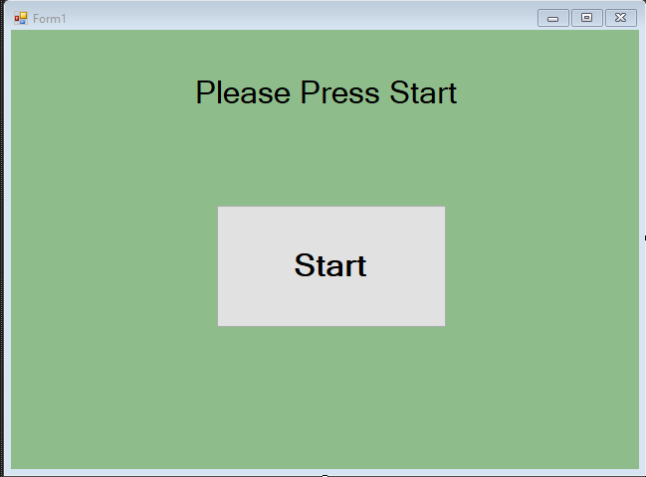
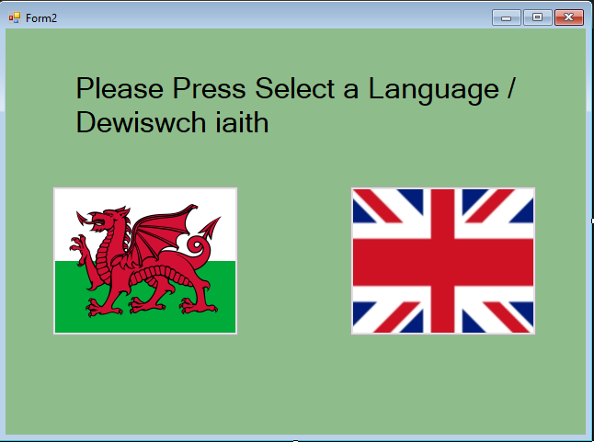

This page is mainly the same as the design except for larger buttons to improve usability and the title box has been replaced with a drop-down list.
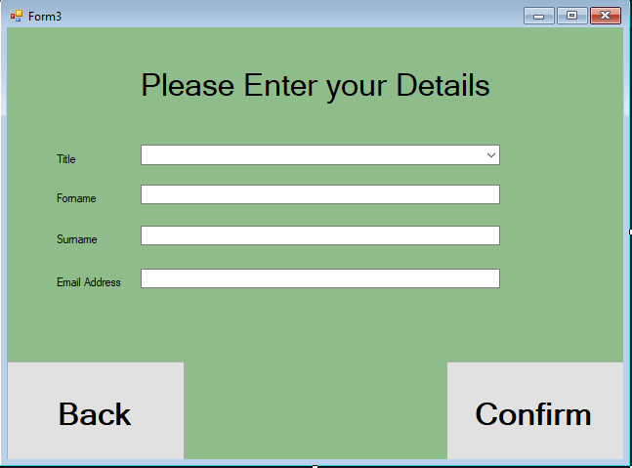
Based on user feedback a back button was added to the gender page to allow for mistakes on the previous page to be fixed.
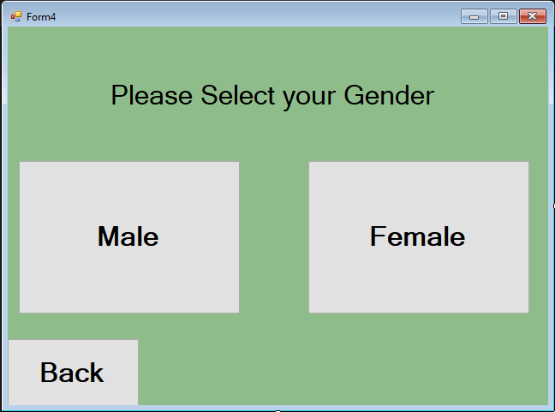

These pages were kept similar, new additions include prices, and a different layout for when pregnancy is there are when it is not. Also, a back button has been added.
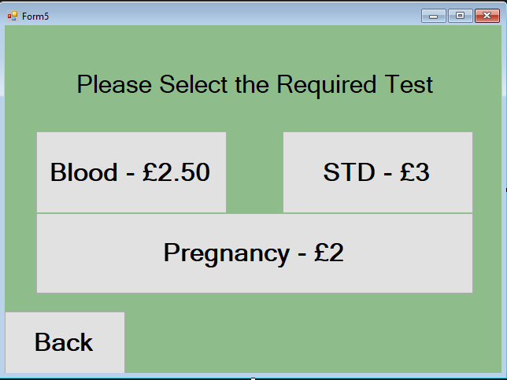
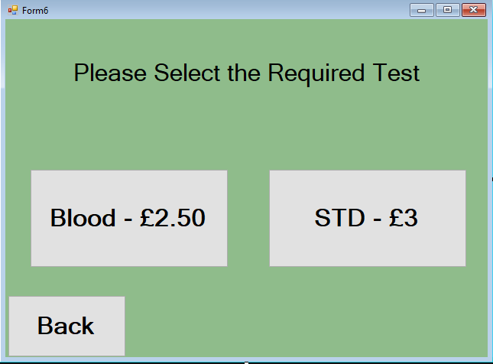

From user feedback another back button was added to allow for mistakes on previous pages to be fixed.
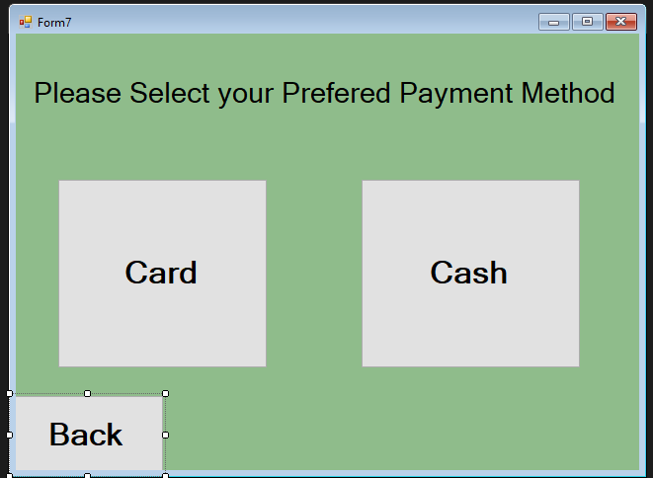
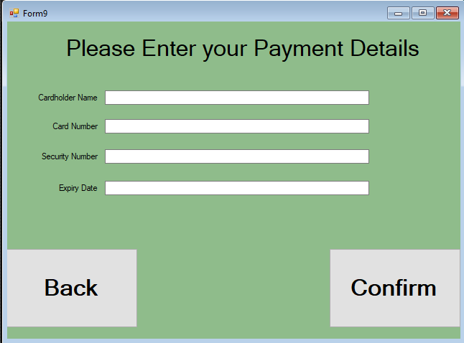

This page was changed to allow for the user to see the amount they had to pay. A back button was also added to allow for the payment type to be switched. These changes were made after using Jamie’s system.
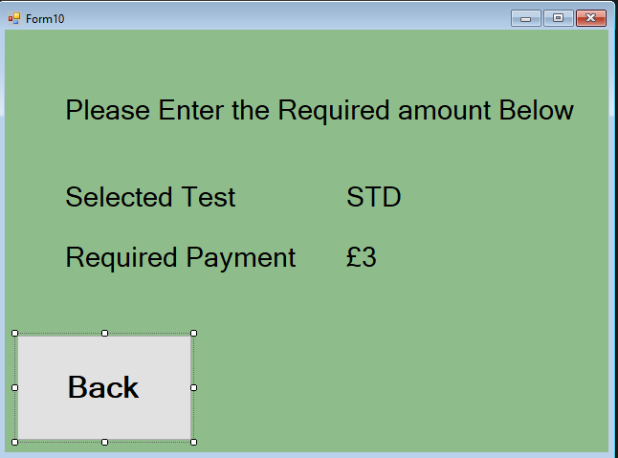
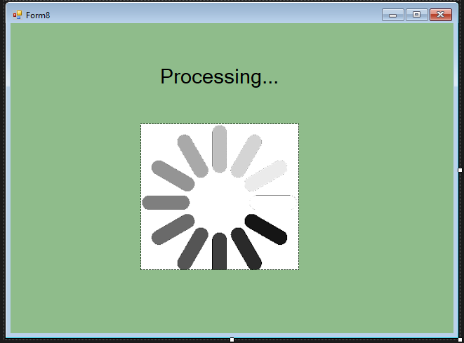
This page was changed off of user feedback to allow for the user to cancel the test and go back to previous pages. This would also refund the user if the payment was a success.
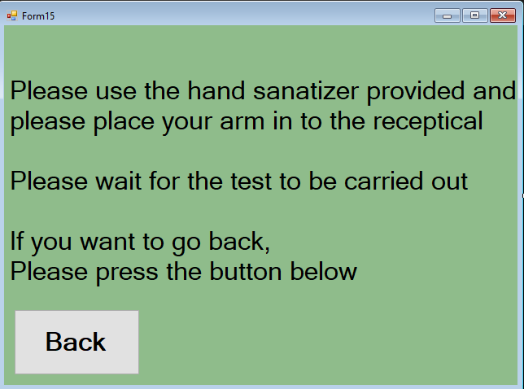

This page has been added as a result of the user feedback of the paper walkthrough as well as seeing that Jamie’s system had more of these screens telling the user exactly what is happening.
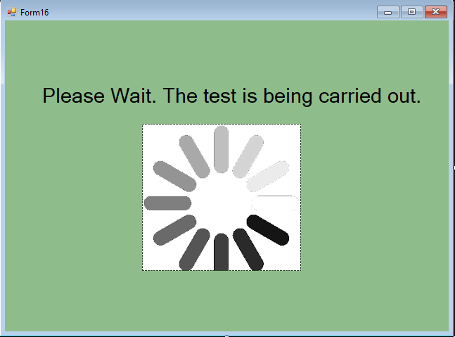
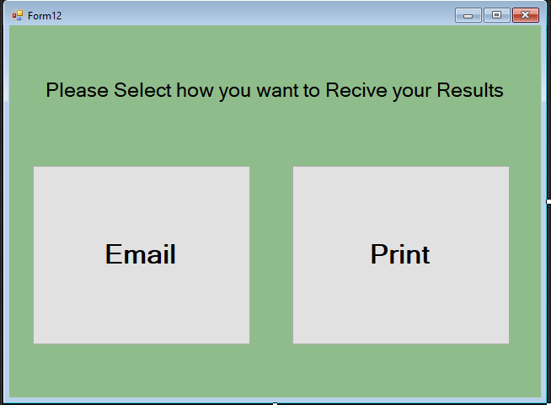
These processing pages were added to show the system status more clearly as a result of user feedback.
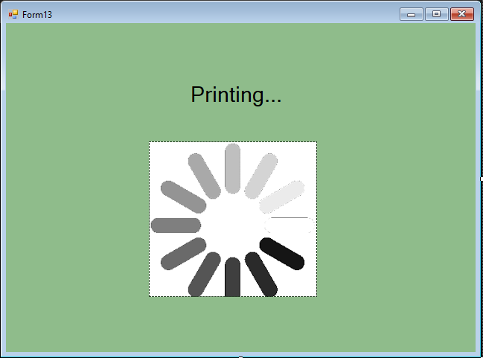
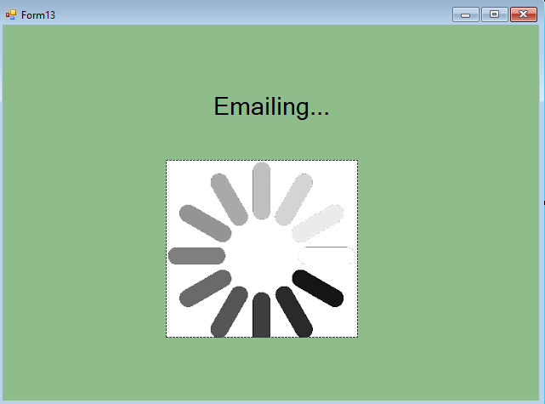

This page was changed based off of user feedback and also seeing it lacking from Jamie’s system, to allow a fast track to select another test while saving the users previously entered data to save time.
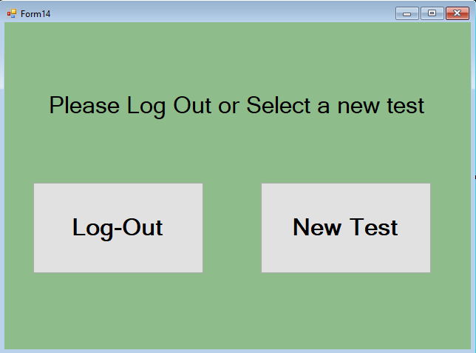

Overall Evaluation
During the design phase of this project there many parts of the project that went well and some that went more poorly. The designs, aesthetics wise, were well received by the user. There were no complaints in this area, but in the functionality there were. These being that during big processes being carried out there were no ways for the user to tell what was going on, as well as this there were no ways to leave the system after a certain point, leaving them stuck in the system if they made a mistake. These were improved upon as a result of the paper walkthrough carried out. This process allowed for another opinion to be brought into the project and for mistakes to be picked up on. This could have gone better if more users were brought into the project. From the user feedback changes were made to all of the design screens, these included more buttons and more pages. These changes were made to more closely adhere to human factors and design principles to allow for tasks to be more easily completed. This included back buttons to allow for recoverability, processing screens to show system status and a faster way for users to take another test.

Conclusion
From this project I can see just how important design principles and human factors are when designing a new system. As without them a system will be near unusable. From the paper walkthrough I can see that I had missed some important features making my application fall victim to some problems that made it difficult for the user to navigate the proposed system. After the walk through, the problematic components were changed for the final application, improving the usability of the system.

References
1. Assets.publishing.service.gov.uk. 2021. [accessed 09 Mar 2021] Available from: https://assets.publishing.service.gov.uk/government/uploads/system/uploads/attachment_data/file/960905/Human_Factors_Medical_Devices.pdf
2. The Usability Engineering Life Cycle | Making the Business Case for User Interface Design | InformIT. Informit.com. 2021. [accessed 09 Mar 2021] Available from: https://www.informit.com/articles/article.aspx?p=726420&seqNum=6
3. What is Human-Computer Interaction (HCI)?. The Interaction Design Foundation. 2021. [accessed 09 Mar 2021] Available from: https://www.interaction-design.org/literature/topics/human-computer-interaction
4. Shneiderman's Eight Golden Rules of Interface Design. Faculty.washington.edu. 2021. [accessed 10 Mar 2021] Available from: https://faculty.washington.edu/jtenenbg/courses/360/f04/sessions/schneidermanGoldenRules.html
5. User Experience: Jakob Nielsen’s 10 general principles for interaction design. Medium. 2021. [accessed 10 Mar 2021] Available from: https://medium.com/theagilemanager/user-experience-jakob-nielsens-10-general-principles-for-interaction-design-2593b0b53ddc
6. The 6 Principles Of Design, a la Donald Norman | Enginess Insights. Enginess.io. 2021. [accessed 10 Mar 2021] Available from: https://www.enginess.io/insights/6-principles-design-la-donald-norman
8. Human-computer Interaction. Google Books. 2021. [accessed 12 Mar 2021] Available from: https://books.google.co.uk/books?hl=en&lr=&id=IuQxui8GHDcC&oi=fnd&pg=PR14&dq=human+computer+interaction+third+edition&ots=I52exMEWYN&sig=XdZRfrY7zIN3E15VlsoqylAcvLU#v=onepage&q=human%20computer%20interaction%20third%20edition&f=false
8. Deductive Reasoning vs. Inductive Reasoning. livescience.com. 2021. [accessed 12 Mar 2021] Available from: https://www.livescience.com/21569-deduction-vs-induction.html
9. Cowan N. What are the differences between long-term, short-term, and working memory? PMC. 2021. [accessed 15 Mar 2021] Available from: https://www.ncbi.nlm.nih.gov/pmc/articles/PMC2657600/
10. Fordham.edu. 2021. [accessed 15 Mar 2021] Available from: https://www.fordham.edu/download/downloads/id/10984/course_materials-_part_5.pdf

Appendix

Appendix 1

User Design Walkthrough Evaluation

Visibility of System Status
Severity Rating: 1

Explanation: System always provides information about what it is doing when I have to wait. There is not enough feedback for when the system is processing the blood sample, however. There is just a line of text that says please wait for the test to be carried out. I have no way of knowing if the system is frozen during this time. When processing payments there is a twirling loading symbol on screen that informs me that the system is still operating when processing. Something similar for blood test processing would reduce confusion.

Match Between System and Real World
Severity Rating: 1

Explanation: There is only 1 minor issue I had when the controls on screen didn’t match with what I expected it to do. When entering cash payment there is an image of the kiosk clearly showing where the money should be inserted, which prevented me from trying to figure out the right slot on the kiosk. The only potential criticism I can give is maybe where I enter my Title should be a drop-down box with all of the options as that is what I expect from other screens.

User Control and Freedom
Severity Rating: 5

Explanation: Once I have entered my details, gender and desired blood test. I am asked to select a payment method. At this point there is no way for me to go back to the previous screens to change the details I have entered. This is highly problematic because if I select the incorrect blood test or enter my email incorrectly, I will need to pay, finish the blood test with the incorrect information then use the system again and pay a second time, this time with the information I actually want.

Another issue is that there is no button to return the cash that I have entered into the kiosk when paying by cash. There should be a way for me to back out of the payment and get my money back.

Also, there is no way for me to back out of using the kiosk in completely once I reach screen 6 (choose payment method). At this point there is way for me to cancel everything and quit using the kiosk. If I walk away at this time, then no additional users can use the kiosk.

Consistency and Standards
Severity Rating: 1

Explanation: The inconsistent areas of the system I have already explained in previous explanations. I expect the Title data entry form to be a drop-down list which is consistent with my experiences with entering this data on other systems. Also, there is a loading symbol when processing payment but not when processing blood.

Error Prevention
Severity Rating: 4

Explanation: I have given this a 4 severity rating even though I encountered no crashing errors. This is because I consider the lack of ability to back out and change my details without finishing the test to be a severe logical error as it costs the user their money.

Recognition rather than recall
Severity Rating: 0

Explanation: Because every screen is consistent with each other I easily recognised where the instructions would be, where the screen’s main controls would be and where the back and next buttons would always be.

Flexibility and Efficiency of use
Severity Rating: 3

Explanation: If I wanted to do multiple blood tests, I would need to enter my details every time. This is not a huge problem, but it does waste time. Having some way to skip entering details every time when doing multiple tests would make the kiosk more convenient.

Another minor issue is that I cannot change the language on any screen other than the start screen. If I choose the incorrect language, I would immediately know on screen 2 as I would not be able to read the language. I would then need to make an assumption as to where the back button would be so I can change the language to what I want. Having the back button on screen 2 also be bilingual would make it clear that users can go back and change the language.

A major issue with the system is that I cannot see the cost of each test. When asked to enter cash into the system it also does not show me how much I need to enter and how much I have left to enter.

Aesthetic and Minimalist design
Severity Rating: 0

Explanation: There is nothing on screen that is irrelevant to the task I need to perform. Clear evidence of this is the complete omission of the pregnancy test option if I were to select Male as my gender.

Help Users Recognise, Diagnose and recover from errors
Severity Rating: 4

Explanation: This is given a high severity again because of the issue of not being able to change my details without paying for a second test. There is no help here to aid me in overcoming this issue. I just have to accept it and move on.

Help and Documentation
Severity Rating: 3

Explanation: Instructions on screen are clear enough that the user does not need documentation to complete the tasks. However, if the payment processing fails, the system does not give any information about why the payment didn’t go through. There is no help to inform users how to back out of the kiosk if they decide they want to exit after they reach the choose payment option screen.

Appendix 2

1. Visibility of system status
- Severity Rating___0___

- Explanation
No issues found. Multiple Processing Screens tells me what the system is doing.

2. Match between system and real world

- Severity Rating___0___

- Explanation
Every component that is on the application relates to what I would think it relates to. This the same for every page on the application.

3. User control and freedom

- Severity Rating___0___

- Explanation
I feel like I am in full control of the system and can navigate as I like and even back out of the system no matter how far through the system I am.

4. Consistency and standards

- Severity Rating__0__

- Explanation
The application has a strong consistency in the colour scheme and location of the application components such as buttons and text boxes.

5. Error prevention

- Severity Rating___1___

- Explanation
The error message displayed after the payment failing tells me exactly what has happened and allows me to go back and fix the error to try the payment again. More error messages could be used in other pages that require data entry or in the page where the test is being carried out.

6. Recognition rather than recall

- Severity Rating__1___

- Explanation
Some buttons had spelling mistakes but otherwise they worked well and as expected. Fixing these spelling mistakes is not that important as I was able to understand what the system was trying to say but I could see how it could confuse another user.

7. Flexibility and efficiency of use

- Severity Rating__2___

- Explanation
Could allow for the user to take another test at the end without requiring the user to re-enter their details. This will allow the user to quickly take another test rather then entering all of their details again. It could be achieved by a simple, “New Test” button after the original test and result details have been selected.

8. Aesthetic and minimalist design

- Severity Rating_0_

- Explanation
The design of the application is easy on the eyes, looks good and is consistent on every page.

9. Help users recognise, diagnose, and recover from errors.

- Severity Rating__4___

- Explanation
Every page that errors can occur from data entry there are ways to get back and change the data before committing it. Only issue with this comes with the designs as there is no way to see what would happen if the user would enter incorrect data or no data at all into the text boxes. This may have already been thought of, but there are no clarifications in the designs.

10. Help and documentation

- Severity Rating__1___

- Explanation
There could be help buttons on the pages that help the user navigate the system or learn what each component does, but the system is laid out well enough that it is simple and easy to navigate. Any time images are used they are used in a way that clearly shows what they are trying to convey.

