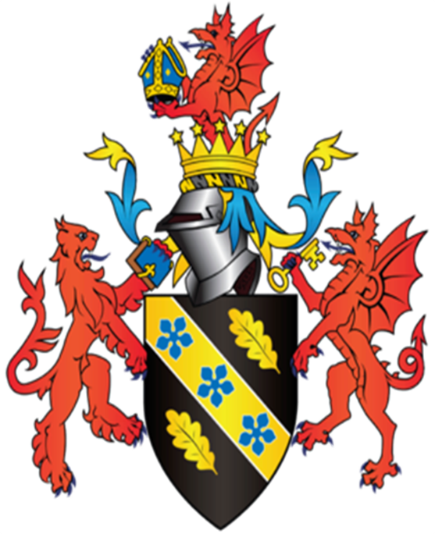

MODULE NAME: INTRODUCING THE MODERN WORKPLACE
PROJECT NAME: YSGOL CRUG GLAS TUCKSHOP
NAME: SAMUEL LOCKLEY
STUDENT NUMBER: 1704902

The subject of the study is a small local school called Ysgol Crug Glas.
In society there are various examples of structure and culture, however this is even more applicable with regards to business’, whether they be huge multinational supermarket chains or a local retailer.
According to the Brighton School of Business and Management, ‘’the organisational culture will not stand without structure.’’ (Brighton School of Business and Management, 2017.) This means that they can be heavily dependent on one another.

Mullins (Mullins, 2002 p,g, 530) defines a business structure as, ‘’Structure is the pattern of relationships among positions in the organisation and among members of the organisation.’’

Mullins (Mullins, 2002 p,g, 531), also states it is important to have a good structure because ‘’the structure of an organisation affects not only the productivity and economic efficiency but also the morale and job satisfaction of the workforce.’’ The structure affects how well the staff performs. For example, if a manager is lazy and unproductive, this will be seen by other members of staff who would lose confidence in the system and lead to lower levels of enthusiasm.

Blau (Blau, P. M. 1956) has a definition of bureaucracy, it is as follows, ‘’The type of organization designed to accomplish large-scale administrative tasks by systematically coordinating the work of many individuals’’
Ysgol Crug Glas, being a school, is very bureaucratic. This is typical of businesses in the public sector as they are run by governing bodies. These are often firmly set in their ways as it would take a huge shift in procedures for there to be change to an entire system.

Bureaucracy has its advantages and disadvantages, according the website of St. Thomas University Florida. ‘’The structure is highly repeatable. It allows a company to easily manage people who do repetitive tasks, like working on a manufacturing line or stocking shelves. It is a perfect management style for large companies, military organizations and government departments, who count on reliable results.’’ (St. Thomas University, 2017.) But it also says ‘’The bureaucratic leadership style does not work for start-up companies, where success depends on ingenuity and flexibility. It is not a management style for those who are expected to be free thinkers and think outside the box. This is not the management style for companies that are heart-based Foundations that serve others would want to choose a leadership style that is more people-oriented.’’ (St. Thomas University, 2017.)
This is clearly not suited for most businesses, limited primarily to the public sector as it only fits in with those who are already well established, like schools and hospitals.
There are three major forms of structure and each has its advantages and disadvantages.
Hierarchical – According to the Oxford English dictionary hierarchy means ‘’A system in which members of an organization or society are ranked according to relative status or authority.’’
Advantages
• Responsibility is more evenly spread over many people rather than just one.
• Opportunities for promotion motivate employees
Disadvantages
• Very costly to maintain
• Rate of communication through layers is slow

Flat – According to Forbes, ‘‘Unlike any other corporate structure that exists, flat companies are exactly that...flat. Meaning there are usually no job titles, seniority, managers, or executives.’’ (Morgan, 2015)
Advantages
• Information is communicated rather quickly.
• A much lower costing structure to maintain.

Disadvantages

• Responsibility is heavily on a singular person.
• A single person cannot be everywhere at once.

Matrix – Knight (Knight, 1976) states that a matrix structure is ‘‘structures which involve some form of dual or multiple authority.’’ Meaning that there is both a team leader responsible for multiple sectors i.e. finance team A, production team A, marketing team A and a dedicated manager specific for each of those sectors.
Advantages
• Employees have two people to turn to if there is an issue rather than one.
• It makes communication between different sectors easier.

Disadvantages

• There can be a conflict of interest between managers.
• It may cause confusion due to the complexity of the structure.

Ysgol Crug Glas can be considered a Hierarchical structure due it being a school.
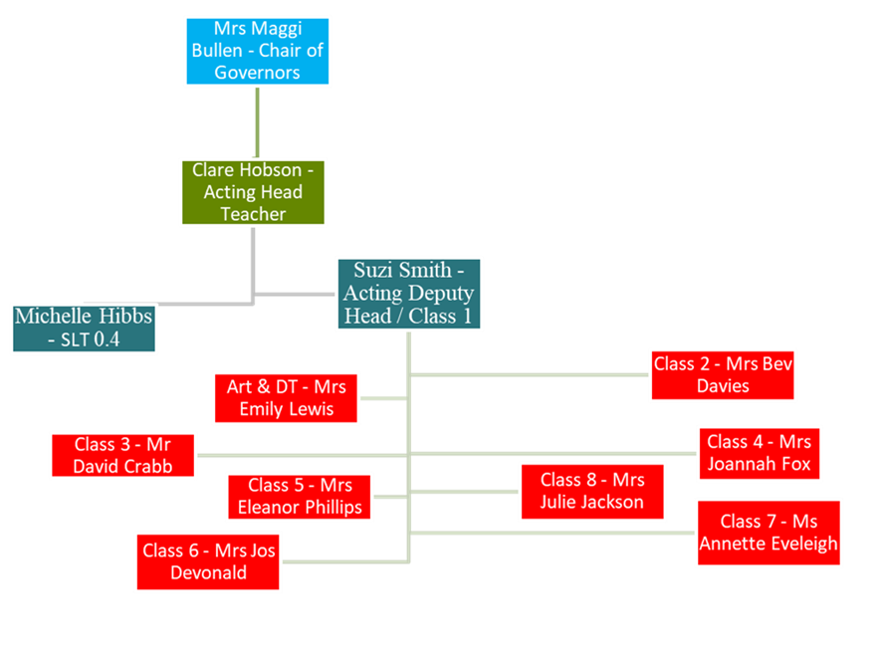

(Ysgol Crug Glas structure, information taken from website. https://hwbpluse.wales.gov.uk/en/6707008/Pages/Staff.aspx)

From the hierarchical structure, a single person is responsible for the teachers then working its way up from there. This would indicate that they have a wide span of responsibility. That however does not mean they have a wide span of control because when someone becomes responsible for many people it becomes more difficult to maintain control and order.
It can also be seen that Ysgol Crug Glas is not a particularly large school consisting of fewer teachers than you’d expect, this may be intentional as it means that the students develop a more personal interaction with them.

Currently, Artificial Intelligence is being used more and more in the modern world and threatening to put people out of work, however as the school specialises in children with special needs, the teachers could not be replaced by AI as the line of work requires a sense of compassion and human interaction which the children would not receive if the teachers were replaced with robots. For mundane tasks such as filing paperwork, printing, photocopying etc. AI may see a place in the school environment.

There are two types of structure that each of the above are sub structures;

Organic – According to Tom Burns and G.M. Stalker (Burns & Stalker, 2001), organic structure can be defined as ‘’one that is very flexible and is able to adapt well to changes. Its structure is identified as having little job specialization, few layers of management, decentralized decision-making, and not much direct supervision.’’ The advantages of such a structure is its ability to change to overcome any problems that may occur. However, depending on the market, it could lose out against mechanistic structures as it cannot be as efficient due to its nature.

Mechanistic – According to Mullins (Mullins 2002) ‘’The mechanistic system is a more rigid structure and more appropriate to stable conditions.’’ Businesses under this kind of structure are more efficient with their single-minded purpose. However, should something drastic or sudden happen, they may not be able to cope with what ensues.

Ysgol Crug Glas is primarily Mechanistic due to it having to comply with the regulations enforced on the governing body including slow movement regarding certain aspects. However, due to it being a school for children with special needs, it is also required to have a large amount of flexibility to be able to accommodate for the needs of each individual child. Despite its structural constraints it still tries its best for the children.

There is a model for business culture put forward by Edgard Schein, a notable professor in business management who made many changes in organisational development. According to Schein in his book Organisational Culture and Leadership he defines business culture as, ‘’A pattern of shared basic assumptions that the group learned as it solved its problems of external adaption and internal integration, that has worked well enough to be considered valid and, therefore, to be taught to new members as the correct way to perceive, think, and feel in relation to those problems.’’ (Schein, 2004)

Schein’s model consists of three factors;
Artefacts – These are the physical representations of the business which can be seen or even touched. According to the Oxford dictionary the definition of a cultural artefact is as follows, ‘’An object made by a human being, typically one of cultural or historical interest.’’ (Oxford Dictionary, n.d.) It is a mistake to think that all artefacts are ancient, there are in fact artefacts based on modern society.

Ysgol Crug Glas has many artefacts some of which the meaning behind them are not obvious. These Include;
A higher level of security measures such as double locks for doors. This ensures that the children are safe from hurting themselves by wandering into areas that may be dangerous. It could however be misconstrued as being there to stop the children escaping much like a prison but that is far from the case.

The school tuck shop, as well as displaying photographs of their various classes, shows a sense of inclusion and that the school is in fact an enjoyable place for these children to be.

The children are not forced to wear any form of uniform as might be expected in a regular school, instead they can wear what they feel like. This encourages the children to feel more motivated to start the day as well as to help develop individuality within the children.

There is artwork on nearly every wall of the school interior, some of which was made in collaboration with another school. This shows that they believe in an environment that encourages people to work together to achieve something. These pieces of art are typically colourful, showing off a cheery atmosphere. Some of the artwork also contains messages in other languages showing that they are accepting of all the children’s backgrounds.

Beliefs and Values – The beliefs and values of the school are deeply ingrained as the staff exercise them each day and are clear to see. These would include;

That staff want to ensure a sense inclusion so that all students are able to participate in activities and that no one feels left out.
Unlike most schools, Ysgol Crug Glas does not believe in segregating their students into various classes based on age. This could be because they feel that age should not matter to show that they are all equal regardless of their age.
They believe in making sure that the environment is comfortable for the students, so that they gradually gain the confidence to complete various tasks. This in turn coincides with their mission statement from their website, ‘’YES I CAN - SMALL STEPS EVERYDAY’’ (Ysgol Crug Glas, 2017) meaning that even though the children can not necessarily make the same vast improvements as other students, they will instead be making a small way towards what would be an even bigger impact on their lives.

Underlying Assumptions – This is what is generally believed about the school when the term special needs school is brought up with no context or knowledge beforehand. These can be good as well as bad.

It could be assumed that like other schools they must follow strict criteria regarding the curriculum they teach, however this is not the case. Some students must be taught things that are taken for granted such as catching and throwing.

People could think less of those children who attend the school as there was once a huge social stigma regarding disabilities which could still be deep in the mindset. Thankfully over time that stigma has changed and now people are more accepting of those with disabilities.

There is another model put forward by Johnson, Scholes and Whittington. It is known as The Cultural Web. It is made up of 6 factors.

• Stories
• Symbols
• Power & Organisational Structures
• Control Systems
• Rituals & Routines
• Organisational Structure

According to the website Mindtools (Mindtools, n.d.) ‘’Cultural Web helps you analyze your current culture, and identify what needs to stay, go or be added to if you're to achieve your strategic goals.’’

There are four types of organisational culture, they are as follows with a definition of each from businesscasestudies.co.uk.
Power Culture – ‘’A power culture is one based on the dominance of one or a small number of individuals within an organisation. They make the key decisions for the organisation. This sort of power culture may exist in a small business or part of a larger business.’’ (Business Case Studies., n.d.)
Role Culture – ‘’A role culture exists in large hierarchical organisations in which individuals have clear roles (jobs) to perform which are closely specified. Individuals tend to work closely to their job description, and tend to follow the rules rather than to operate in a creative way.’’ (Business Case Studies., n.d.)
Task Culture – ‘’task cultures exist when teams are formed to complete particular tasks. A distinct team culture develops, and because the team is empowered to make decisions, task cultures can be creative.’’ (Business Case Studies., n.d.)
Person Culture – ‘’the most individualistic form of culture and exists when individuals are fully allowed to express themselves and make decisions for themselves. A person culture can only exist in a very loose form of organisation e.g. an overseas sales person working on their own for a company, allowed to make their own decisions.’’ (Business Case Studies., n.d.)
Of these four forms of organisational culture, the school is a mixture of both role culture, due to its bureaucratic nature, as well as a person culture because high focus on each individual student needs and wants.

In conclusion, it is important to see that both culture and structure are important factors, especially for the school, as they are in place to help bring out the best in the children. The structure can be considered out-dated, however, according to Fiona Jebb, ‘’Hierarchy is not dead. It has merely changed its form. The trappings of power in the modern workplace may have been toned down but the boss is still the boss.’’ (Jebb, 1998) Referring to the shift in structures that businesses have taken to accommodate for the rapidly changing society.

References

Blau, P.M., 1956. Bureaucracy in modern society.
Brighton School of Business and Management, n.d. Is There a Relationship Between Organizational Structure and Culture?. [Online]
Available at: https://www.brightonsbm.com/news/relationship-organizational-structure-culture/
[Accessed 17 November 2017].
Burns, T. & Stalker, G. M., 2001. The Management of Innovation. New York: Oxford University Press.
Business Case Studies, n.d. Corporate and Oraganisational culture. [Online]
Available at: http://businesscasestudies.co.uk/business-theory/strategy/corporate-and-organisational-culture.html
[Accessed 20 Novemeber 2017].
Business Dictionary, n.d. What is Business Culture?. [Online]
Available at: http://www.businessdictionary.com/definition/business-culture.html
[Accessed 20 November 2017].
Jebb, F., 1998. Don't call me sir. Management Today, 01 August, p. 1.
Knight, K., 1976. Journal of Management Studies. Matrix Organization: A Review, 28 November, 13(2), pp. 111-130.
Mindtools, n.d. The Cultural Web. [Online]
Available at: https://www.mindtools.com/pages/article/newSTR_90.htm
[Accessed 20 November 2017].
Morgan, J., 2015. The 5 Types Of Organizational Structures: Part 3, Flat Organizations. [Online]
Available at: https://www.forbes.com/sites/jacobmorgan/2015/07/13/the-5-types-of-organizational-structures-part-3-flat-organizations/#7c38f386caa5
[Accessed 30 11 2017].
Mullins, L. J., 2002. In: Management and Organisational Behaviour 6th Edition. Harlow: Pearson Education Limited, p. 530.
Mullins, L. J., 2002. In: Management and Organisational Behaviour 6th Edition. Harlow: Pearson Education, p. 531.
Mullins, L. J., 2002. Management and Organisational Behaviour 6th Edition. In: Management and Organisational Behaviour. 6th ed. Harlow: Pearson Education Limited, p. 571.
Oxford Dictionary, n.d. Artefact. [Online]
Available at: https://en.oxforddictionaries.com/definition/artefact
[Accessed 30 November 2017].
Oxford English Dictionary, n.d. Hierachy. [Online]
Available at: https://en.oxforddictionaries.com/definition/hierarchy
[Accessed 30 Novemeber 2017].
Schein, E., 2004. Organizational culture and leadership. San Francisco: Jossey-Bass.
St. Thomas University, n.d. What is Bureaucratic Leadership? How Rules Can Guide People. [Online]
Available at: https://online.stu.edu/bureaucratic-leadership/
[Accessed 27 11 2017].
Ysgol Crug Glas, 2017. About Ysgol Crug Glas. [Online]
Available at: https://hwbpluse.wales.gov.uk/en/6707008/Pages/about.aspx
[Accessed 20 November 2017].

