MANAGING PEOPLE
LCBB5004

Assessment 1

Student: Denisa-Andreea Matei

Introduction
The Human Resources Management is the organization’s function that plans, recruits, coordinates and controls the people working in that organization.
There are certain improvements that happened in the latest years which also mean adaptability to the context of a pandemic world.
In this paper we will look at the way that planning, recruitment and selection is happening at Alter Domus (UK) LTD.
The Planning Phase
Planning is usually influenced by the Company’s short and long terms objectives.
The employees and stakeholders needs and aspirations also play a great role in shaping the human resource planning function of an organization (Roberts, 1997).
It has to set up the number of employees needed for a certain position, the position’s requirements in terms of qualifications and the timeline to bring the new people in.
The Recruitment Phase
The recruitment involves attracting and making a Company appealing for employees to submit their applications in terms of tasks, remuneration, options to development within the Company, as well as benefits and corporate events.
It involves the gathering of a group of applications suitable for a certain posted job role and performing the initial interview.
The suitable candidates are then booked for a technical interview with the team for which they are recruited.
The Selection Phase
The short-listed candidates following the initial interview are asked to perform a technical interview with the team they will work with.
Usually, this interview is carried out with specific questions about the industry, the past experience in a similar job, achievements and challenges.
As well, the person conducting the interview can get an idea if the interviewed candidate is a suitable social match to the rest of the team in terms of personal traits.
A sound working environment should be formed by both technical competent staff and socially sane individuals.

Alter Domus (UK) Limited
This is a financial services company headquartered in Luxembourg.
The London office was opened in 2011 and it has 60 employees at the moment, in 3 departments: Funds Accounting, Corporate Accounting and COSEC.
The HR Function
At Alter Domus (UK) Limited, the HR function is deserved by a team located in Cork, Ireland which serves all the offices located in UK, Ireland, Jersey and Guernsey.
Planning: The managers of each team will announce their recruitment needs to the head of office and a new role within the company is approved. A budget it set up for the new role as per the market requirements.
The Process
The Recruitment: The job post is advertised on the Company’s website in the Careers section where the applications are open, meaning that the website has the CV upload facility.
The job is also posted on LinkedIn, Indeed and the company is also working with recruitment agencies which have a data base of suitable candidates.
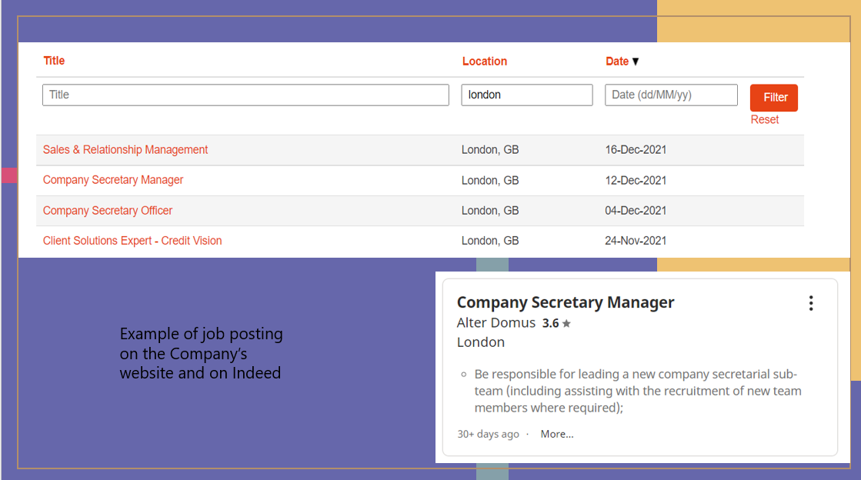

The Selection
The HR will conduct an initial interview with the most suitable candidates for the position and the technical meeting is booked for the selected ones.
The Team’s manager is preparing a knowledge test which is assigned to each candidate to sit.
Based on the answers, the candidates are selected for the next phase, the interview with the future Manager. This is going to be conducted face to face and previous experiences would be discussed.
The Team manager will keep into account the social profile of the candidate as well, because he wants to make sure the best fit is selected for the job and for the Company overall.
The selected candidate is communicated to HR and the offering is starting. The selected candidate will receive a job offer for which it has 7 days to accept. Sometimes, the offer can be negotiated or rejected. Should a rejection happen, the second most suitable candidate will be selected.
Pandemic implications:
The Company has moved its activity 100% from home office.
The planning and recruiting suffered no change, but the selection process has changed significantly: the initial interview is held using Zoom platform. The technical test is given using an online tool with multiple-choice options.
The interview with the Team’s Manager is also held using Zoom.
Unfortunately, welcoming new employees is postponed until after the pandemic and the social behaviour will be then assessed.
Conclusion
The Human Resources Management is a very important resource of an organization.
Choosing the right candidate for a Team involves work from many people and coordination, all this process will need to be concluded by a competitive job offer.
The HR function can be setup in various ways in the organizations: a separate department, one person or even each Team’s manager can get recruiting responsibilities.

References:

- uk.indeed.com. (n.d.). Alter%20domus Jobs | Indeed.com. [online] Available at: https://uk.indeed.com/jobs?q=alter%20domus&l&vjk=8609573c7399659c [Accessed 18 Dec. 2021].
- Alterdomus.com. (2021). [online] Available at: https://jobs.alterdomus.com/go/All-jobs-at-Alter- Domus/2829501/?q=&q2=&alertId=&title=&location=london&date= [Accessed 18 Dec. 2021].
- Chron.com. (2013). Planning Recruitment & Selection of Human Resources. [online] Available at: https://smallbusiness.chron.com/planning-recruitment-selection-human-resources-68708.html.
‌

