
Module Title: Entrepreneurship
Module Code: BMIH5001
Individual Business Model Canvas with Entrepreneurial Reflection using appropriate academic models.
Lecturer Name: Ka Po Chong
Student Name: Nargis Begum
ID Number: 2212000

The aim of this essay is to apply Business Model Canvas to conceptualise the new hospitality venture. BMC and hospitality venture visioning are covered in this essay. Entrepreneurs receive BMC business plan advice. The BMC analysis framework has nine sections “Customer Segments, Value Proposition, Channels, Customer Relationships, Revenue Streams, Key Resources, Key Activities, Key Partnerships, and Cost Structure” (Williams, 2021). The BMC enhances hospitality firm concepts. This essay will help "HappyInn." with BMC. The small hotel "HappyInn" offers personalised and immersive experiences. The BMC will evaluate each aspect to develop the HappyInn strategy. Modern examples and market insights will enhance this research, showing how the BMC may inform business concept decisions (Barringer and Ireland, 2018). This essay will demonstrate how hospitality balances customer needs, value development, income generation, and operational efficiency using BMC elements. It will show how the BMC helps entrepreneurs start, assess, and enhance hospitality enterprises for changing markets.
HappyInn requires to develop key partnerships with potential partners. Local growers supply fresh produce and infrastructure for farm-to-table. HappyInn uses seasonal and local food from a neighbouring organic farm to improve dining (Fissi, Romolini and Gori, 2020). For cleanliness and safety, HappyInn hires maintenance and repair. Due to increased sanitation difficulties in the hospitality industry, working with reputed cleaning services provides a clean environment and shows a dedication to health and hygiene. Travel agents bring HappyInn guests. HappyInn may improve reservations and revenue by promoting globally on Expedia and Booking.com. Event planners help HappyInn host events. Working with wedding planners or corporate event organisers can help HappyInn promote its wedding, meeting, and conference facilities and attract consumers. Local attraction collaborations make HappyInn customers happy. For longer stays, HappyInn offers accommodation and theme park or museum access packages (Similarweb.com, 2024). In conclusion, HappyInn's strategic collaborations with local suppliers, service providers, travel agencies, event organisers, and tourist attractions improve its value proposition and hospitality industry competitiveness. These agreements allow HappyInn to offer unique experiences, excellent service, and unforgettable stays.
To have success HappyInn must know about the key activities needed to perform. Hospitality is about guest satisfaction. Personalisation and hospitality may help HappyInn attract clients. Luxury hotels like The Ritz-Carlton attract repeat guests with great service (Breier et al., 2021). Increase occupancy and revenue by easily managing bookings, reservations, and visitor queries. Marriott and other hotels use innovative reservation systems and online booking platforms to speed up and improve visitor satisfaction. Guest happiness and safety depend on facility cleanliness and quality. Hilton's meticulous cleaning and maintenance pampers guests. Effective marketing and promotion are needed to attract and keep guests in a competitive market. Boutique hotels like Ace Hotel use digital and traditional marketing to attract the right customers (Ntounis et al., 2021). Staff need constant training to provide excellent service and meet evolving client expectations. Leading hospitality firms like Four Seasons provide continuing training and skill improvements to assist staff provide excellent service and remain ahead of industry trends.
Key resources will fuel HappyInn's success. Hotels need highly trained staff to serve well. Mandarin Oriental trains its staff extensively to maintain personalised service and mindfulness. Facility design and maintenance affect guest satisfaction (Mintel, 2024). Like boutique hotels like The Standard, modern amenities and design enhance guest satisfaction and repeat business. Advanced tech boosts efficiency and guest satisfaction. Tech-savvy hotels like Yotel use guest management systems and mobile apps to boost productivity and convenience. Strategic collaborations with dependable suppliers and service providers enable a smooth supply chain and high-quality products. Westin Hotels & Resorts and Heavenly Bed work on amenities and linens to improve guest satisfaction and brand reputation. Expansion costs money (Dube, Nhamo and Chikodzi, 2020). Marriott International suggests that HappyInn engages in renovations, marketing, and new property acquisitions to compete and capitalise on market shifts.
Guest satisfaction will distinguish HappyInn which is an important value proposition. Personalised service and a welcoming atmosphere boost guest’s stay. Boutique hotels like Kimpton Hotels & Restaurants have personalised service and decor. Conveniences please guests. Value and convenience are improved by modern fitness, wellness, and business centres like Hyatt Regency (Ahmad, 2014). The unique services and engaging experiences at HappyInn leave guests with lasting memories. Ace Hotel's themed rooms and local experiences make stays unforgettable. Attentive service and concentration satisfy guests. Fast service and reaction earn Peninsula Hotel good evaluations and repeat business. Value-added services and low prices attract guests. Budget hotels like Holiday Inn Express retain clients with loyalty programmes, free breakfasts, and other incentives.
HappyInn will thrive by developing an effective customer relationship. Phone, email, and online chat show our rapid guest service. To please clients, Hilton Hotels prioritises fast response times and personalised service. HappyInn's personalised service, welcome packages, and touches stand out (Ferreri and Sanyal, 2018). Four Seasons hotels greet guests by name and offer tailored amenities to make them feel unique. Our services are improved by visitor surveys and online reviews. Boutique hotels like The Hoxton show visitors they value their thoughts by improving with feedback. Awards and loyalty programmes encourage repeat bookings and referrals, building visitor relationships. For future points, Marriott Bonvoy recommends direct bookings. Events and promotions are announced via emails, updates, and exclusive deals. Email marketing and personalised promos boost Kimpton Hotels & Restaurants bookings.
Channels will draw guests to HappyInn. Booking.com and Airbnb serve travellers worldwide. These platforms give HappyInn a large guest pool and higher occupancy. Social media ads target demographics, interests, and travel inclinations. Instagram and Facebook may promote HappyInn's unique offers and attract tourists seeking unforgettable experiences (Le and Phi, 2020). Booking online simplifies and controls the process. User-friendly websites and unique deals may help HappyInn reduce third-party commissions and increase direct bookings. Travel agency agreements and industry recommendations benefit HappyInn. To increase reservations and develop into group travel and packages, partner with Expedia or TUI (Akbar and Tracogna, 2018). Promotion and cross-selling with local businesses boost guest experiences and the economy. HappyInn offers unique, immersive experiences and discounts with surrounding restaurants, activities, and tours.
HappyInn will focus on diverse customer segments. Leisure travellers want unforgettable experiences abroad. HappyInn, like The Ace Hotel, offers immersive experiences and tailored care for adventurers and cultural enthusiasts. Quality housing is very vital for business travellers (Brown et al., 2017). HappyInn, like Marriott Courtyard, may attract consultants and corporate leaders with high-speed internet, business centres, and convenient locations. Vacationers seeking convenient, family-friendly hotels boost the sector. HappyInn, like Great Wolf Lodge, may attract this demographic with spacious accommodations, kid-friendly activities, and closeness to attractions. A minor but considerable market is couples seeking romantic getaways with specific amenities and services. Like Sandals Resorts, HappyInn may target this sector with romance packages, couples' spa treatments, and private meals (Williams, 2021). HappyInn may charge event organisers for flexible venues. Like Hilton, HappyInn offers adaptable event venues, catering, and planning for weddings and conventions.
HappyInn's success will be dependent on its cost structure. Salary, compensation, and benefits motivate and train employees, ensuring excellent service. Marriott International boosts guest happiness and loyalty by focusing on staff well-being and delivering competitive salaries and benefits to recruit and retain talent (Similarweb.com, 2024). Guest safety and comfort depend on facility maintenance and utilities. HappyInn cleans and secures like The Ritz-Carlton to satisfy guests. Advertising costs enhance the company and attract customers. Social, print, and digital marketing increase awareness and bookings. Hilton Hotels' unique marketing boosts income and market share by attracting new customers. Operations and guest management IT investments boost workflows and visitor satisfaction. Superior property management and guest booking platforms enhance operations and guest relations (Ntounis et al., 2021). Technology streamlines check-in and customises guest experiences at Hyatt Regency, increasing happiness and loyalty. Guest facility rates include food, spa, and recreation. HappyInn, like The Peninsula Hotels, manages sourcing and pricing for profit and value.
HappyInn will diversify its revenue streams for financial stability and profit. Overnight bookings and fees generate the most revenue. Airbnb and Marriott book guests and make money using their brands and distribution networks (Mintel, 2024). Dining, wellness, and leisure boost guest earnings. Luxury resorts like The Four Seasons increase guest satisfaction and revenue with premium dining, spa packages, and guided tours. HappyInn rents event and special occasion spaces. HappyInn, like Hilton, may increase revenue and occupancy by offering flexible event facilities and catering for weddings, conferences, and other events (Le and Phi, 2020). Partners and collaboration commissions make HappyInn passively profitable. HappyInn may increase revenue and customers by collecting commissions from travel agencies, internet booking platforms, and local businesses. Sell guests branded items to profit and market. Like Hard Rock Hotels, HappyInn may sell branded clothing, accessories, and souvenirs to boost brand loyalty and revenue.
The Business Model Canvas (BMC) helped to design and assess HappyInn, a potential hospitality business. Examining the BMC from Customer Segments to Revenue Streams yielded a compelling value offer and sustainable business model (Fissi, Romolini and Gori, 2020). HappyInn prioritises visitor pleasure with tailored service, handy conveniences, and immersive activities. HappyInn serves leisure tourists, businesspeople, families, couples, and event organisers. HappyInn's hospitality industry competitiveness stems from strategic alliances with local suppliers, service providers, travel agencies, event organisers, and tourist attractions (Fissi, Romolini and Gori, 2020). These agreements help HappyInn stand out and offer unique experiences and packages. HappyInn invests in qualified staff, well-designed facilities, innovative technology, and financial resources to provide high-quality service. HappyInn survives on room bookings, extra services, venue rentals, commissions, and branded items. In the dynamic and competitive hospitality industry, BMC alignment positions HappyInn for long-term success. HappyInn must adapt, innovate, and prioritise guests to succeed.

The GET2 and Entrepreneurial Questionnaire indicated entrepreneurial and management motivations, preferences, behaviours, and development areas (Aliekperova and Aliekperov, 2023). Gibbs' reflecting model explained this. The Entrepreneurial Questionnaire emphasised risk, challenge, and responsibility. Question 1c "Responsibility and challenge" and Question 7d "Challenge" show professional engagement and determination to overcome challenges. A proactive and resilient professional mind-set pushed by harsh workplace challenges explains this preference for challenging work. They identify motivations and guide human progress by identifying improvement opportunities.
GET2's 67% score confirmed similar ideas, showing an ardent desire for achievement and autonomy. Making decisions and setting ambitious goals is rewarding. A low locus of control indicates a complex emotional response and a focus on external variables and control. Personal performance requires a more balanced self-control (Zuriak, Kelly and Dyck, 2020). Both exams accurately assessed entrepreneurial potential, providing insights. The Entrepreneurship Questionnaire assessed risk nuance. It focused on risk-taking minimization and strategic decision-making. This strategy encourages balanced and informed risk-taking in entrepreneurship. These assessments emphasise performance, autonomy, and strategic risk management in entrepreneurial and managerial motives.
The robust performance and autonomy scores of GET2 support McClelland's Need Theory that ambitious people like independence and challenges (Park and Kim, 2021). These attributes indicate a fervent desire for personal and professional progress. My review showed both regions' improvement push. Planning Theory contextualises incentives. Questionnaires reflect this theory's subjective standards and perceived behavioural control. Strategic entrepreneurship prioritises risk, external opinions, and perceived decision-making control. Entrepreneurial Questionnaire balances risk-taking and risk-reduction. Balance helps make smart decisions that minimise risks and maximise opportunities. External opinions or subjective norms reflect social and cultural entrepreneurship effects. Social norms can change with this understanding. Controlling behaviour demonstrates decision-making confidence. High ratings in this category show confidence in overcoming obstacles and achieving goals, supporting responsible entrepreneurship.
Motivation from hard goals and autonomy supports McClelland's Need Theory in GET2. Start-ups and management require autonomy; therefore, these entrepreneurial abilities complement each other (Radović, 2020). This analysis is explained by Planned Behaviour Theory. Attitudes, subjective norms, and behavioural control balance choices. Threat assessment, external knowledge (Question 3c), and perceived control over actions (Question 5) inform strategy. Using internal and external motives is smart entrepreneurship. Risk assessment identifies challenges and decision-making opportunities. Peer and social expectations affect entrepreneurship through subjective standards. Entrepreneurial management improves with perceived behavioural control.
Understand managerial and entrepreneurial motives for personal and professional success. The Entrepreneurial Questionnaire and GET2 show determination, autonomy, and strategic risk-taking (Williams, 2021). Our action plan develops these strengths. Understanding how emotions, evaluations, and analyses interact improves self-awareness and business readiness. Self-awareness helps entrepreneurs adjust to future possibilities and obstacles. Setting ambitious yet achievable entrepreneurial goals and pursuing successful and autonomous companies fosters success. Entrepreneurs must risk properly. Risk-tolerant techniques are cautious and innovative. Mindfulness, strategic planning, and mentoring reduce uncertainty.
Entrepreneur networking will be emphasised. Networking with successful entrepreneurs, industry events, and relevant communities will help you make wise choices. Networking gives entrepreneurs new perspectives (Barringer and Ireland, 2018). Industry changes, best practices, and recent technology require ongoing learning. Continuous learning improves business decisions. This initiative-taking approach to self-improvement and adaptation can help entrepreneurs seize new opportunities and solve challenges.

References
Ahmad, S.Z. (2014). Entrepreneurship in the small and medium-sized hotel sector. Current Issues in Tourism, 18(4), pp.328–349. doi:https://doi.org/10.1080/13683500.2014.934211.
Akbar, Y.H. and Tracogna, A. (2018). The sharing economy and the future of the hotel industry: Transaction cost theory and platform economics. International Journal of Hospitality Management, [online] 71, pp.91–101. doi:https://doi.org/10.1016/j.ijhm.2017.12.004.
Aliekperova, N. and Aliekperov, A. (2023). Leadership traits as the basis for effective interaction between the leader and the team. Journal of Leadership in Organizations, 5(1). doi:https://doi.org/10.22146/jlo.75402.
Barringer, B.R. and Ireland, R.D. (2018). Entrepreneurship : Successfully Launching New Ventures. New York, Ny: Pearson.
Breier, M., Kallmuenzer, A., Clauss, T., Gast, J., Kraus, S. and Tiberius, V. (2021). The role of business model innovation in the hospitality industry during the COVID-19 crisis. International Journal of Hospitality Management, [online] 92(92), p.102723. doi:https://doi.org/10.1016/j.ijhm.2020.102723.
Brown, N.A., Rovins, J.E., Feldmann-Jensen, S., Orchiston, C. and Johnston, D. (2017). Exploring disaster resilience within the hotel sector: A systematic review of literature. International Journal of Disaster Risk Reduction, 22, pp.362–370. doi:https://doi.org/10.1016/j.ijdrr.2017.02.005.
Dube, K., Nhamo, G. and Chikodzi, D. (2020). COVID-19 cripples global restaurant and hospitality industry. Current Issues in Tourism, [online] 24(11), pp.1–4. doi:https://doi.org/10.1080/13683500.2020.1773416.
Ferreri, M. and Sanyal, R. (2018). Platform economies and urban planning: Airbnb and regulated deregulation in London. Urban Studies, 55(15), pp.3353–3368. doi:https://doi.org/10.1177/0042098017751982.
Fissi, S., Romolini, A. and Gori, E. (2020). Building a business model for a new form of hospitality: the albergo diffuso. International Journal of Contemporary Hospitality Management, 32(1), pp.307–323. doi:https://doi.org/10.1108/ijchm-01-2019-0047.
Le, D. and Phi, G. (2020). Strategic responses of the hotel sector to COVID-19: Toward a refined pandemic crisis management framework. International Journal of Hospitality Management, 94, p.102808. doi:https://doi.org/10.1016/j.ijhm.2020.102808.
Mintel (2024). UK Hotels Market Report (Updated 2020). [online] store.mintel.com. Available at: https://store.mintel.com/report/uk-hotels-market-report [Accessed 19 May 2024].
Ntounis, N., Parker, C., Skinner, H., Steadman, C. and Warnaby, G. (2021). Tourism and hospitality industry resilience during the covid-19 pandemic: Evidence from england. Current Issues in Tourism, 25(1), pp.1–14.
Park, M. and Kim, S. (2021). Effects of Personality Traits and Team Context on Individual Innovative Behavior (Exploitation and Exploration). Sustainability, 14(1), p.306. doi:https://doi.org/10.3390/su14010306.
Radović, S. (2020). Personality Traits Composition and Team Performance. Management: Journal of Sustainable Business and Management Solutions in Emerging Economies, [online] 25(3), pp.33–42. Available at: https://www.ceeol.com/search/article-detail?id=913193 [Accessed 13 May 2024].
Similarweb.com (2024). Top Accommodation and Hotels Websites in United Kingdom Ranking Analysis for April 2024. [online] Available at: https://www.similarweb.com/top-websites/united-kingdom/travel-and-tourism/accommodation-and-hotels/ [Accessed 19 May 2024].
Williams, S. (2021). The Financial Times guide to business start up 2021/2023 : the most comprehensive guide for entrepreneurs. Harlow, England ; London ; New York: Pearson.
Zuriak, A., Kelly, L. and Dyck, L.R. (2020). INDIVIDUAL INNOVATIVE WORK BEHAVIOUR: EFFECTS OF PERSONALITY, TEAM LEADERSHIP AND CLIMATE IN THE US CONTEXT. International Journal of Innovation Management, p.2050078. doi:https://doi.org/10.1142/s1363919620500784.

Appendices

Business Model Canvas
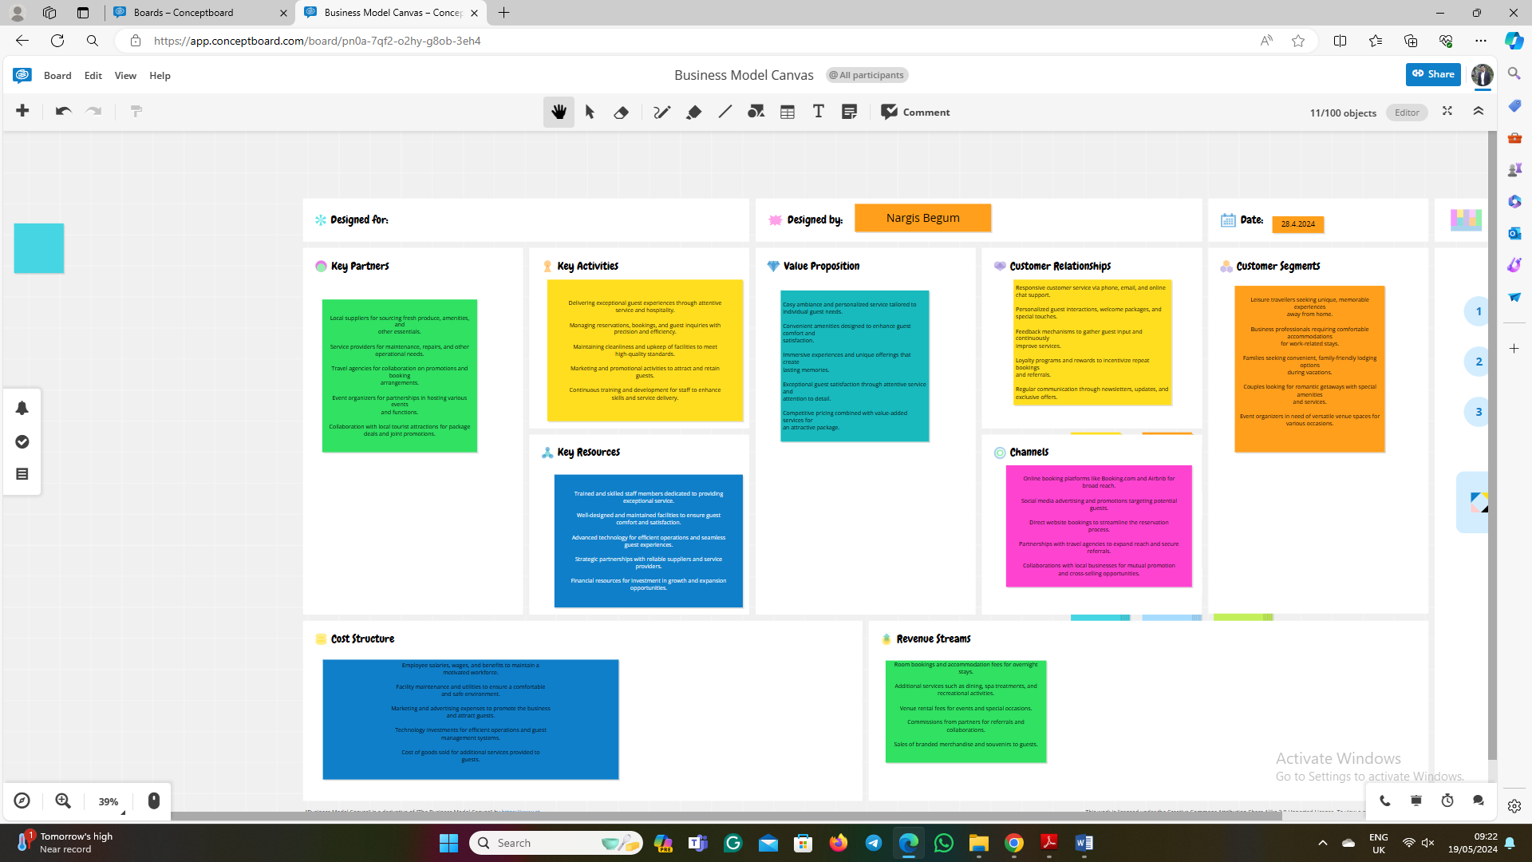
Key Partnerships:
- Local suppliers for sourcing fresh produce, amenities, and other essentials.
- Service providers for maintenance, repairs, and other operational needs.
- Travel agencies for collaboration on promotions and booking arrangements.
- Event organizers for partnerships in hosting various events and functions.
- Collaboration with local tourist attractions for package deals and joint promotions.
Key Activities:
- Delivering exceptional guest experiences through attentive service and hospitality.
- Managing reservations, bookings, and guest inquiries with precision and efficiency.
- Maintaining cleanliness and upkeep of facilities to meet high-quality standards.
- Marketing and promotional activities to attract and retain guests.
- Continuous training and development for staff to enhance skills and service delivery.
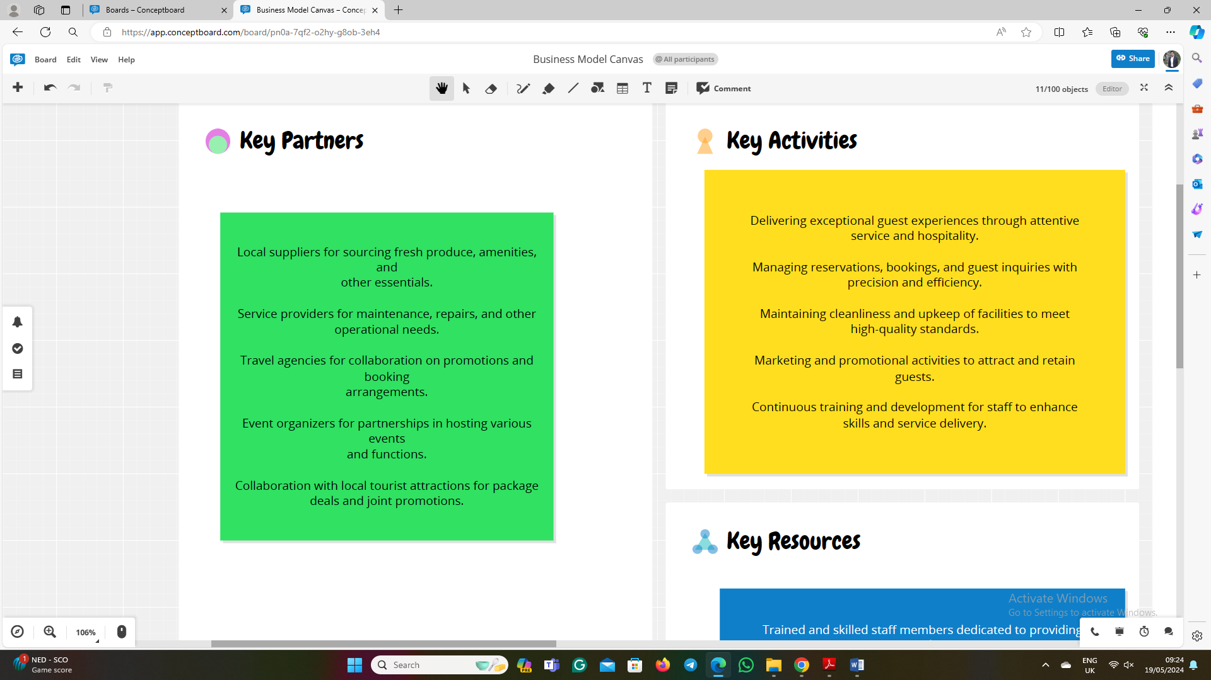
Key Resources:
- Trained and skilled staff members dedicated to providing exceptional service.
- Well-designed and maintained facilities to ensure guest comfort and satisfaction.
- Advanced technology for efficient operations and seamless guest experiences.
- Strategic partnerships with dependable suppliers and service providers.
- Financial resources for investment in growth and expansion opportunities.
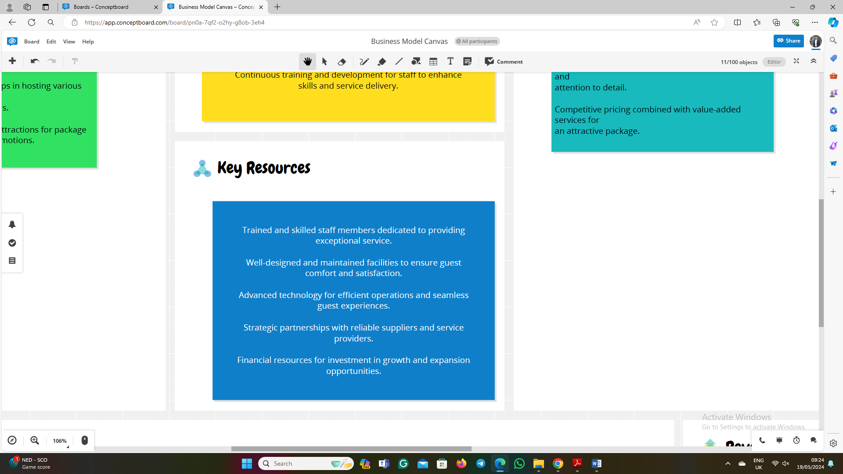
Value Proposition:
- Cosy ambiance and personalized service tailored to individual guest needs.
- Convenient amenities designed to enhance guest comfort and satisfaction.
- Immersive experiences and unique offerings that create lasting memories.
- Exceptional guest satisfaction through attentive service and diligence.
- Competitive pricing combined with value-added services for an attractive package.
Customer Relationships:
- Responsive customer service via phone, email, and online chat support.
- Personalized guest interactions, welcome packages, and special touches.
- Feedback mechanisms to gather guest input and continuously improve services.
- Loyalty programs and rewards to incentivize repeat bookings and referrals.
- Regular communication through newsletters, updates, and exclusive offers.

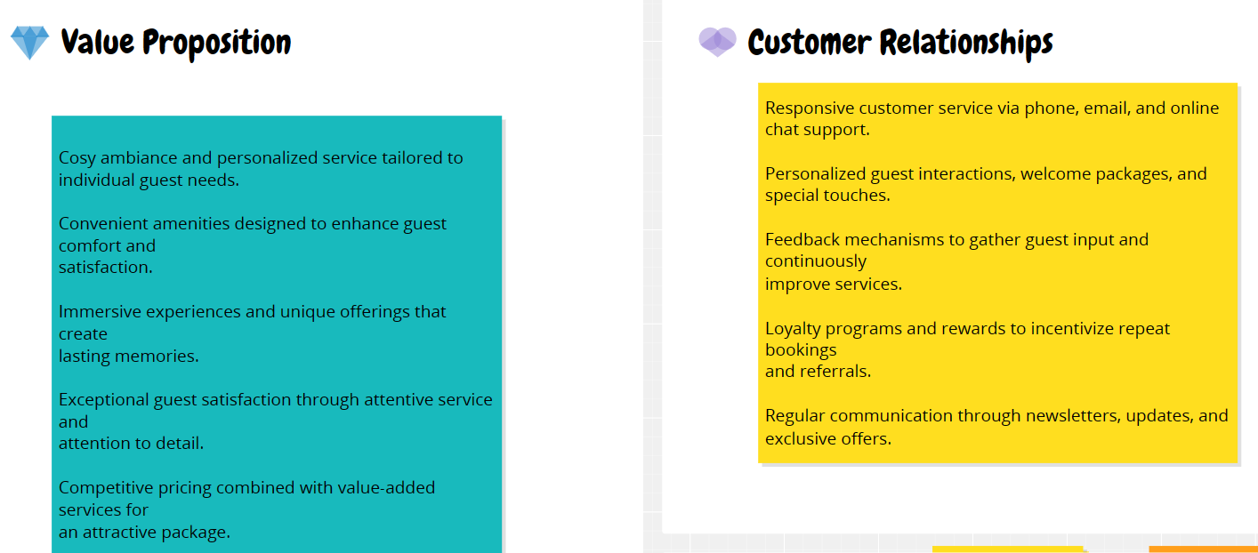
Channels:
- Online booking platforms like Booking.com and Airbnb for broad reach.
- Social media advertising and promotions targeting potential guests.
- Direct website bookings to streamline the reservation process.
- Partnerships with travel agencies to expand reach and secure referrals.
- Collaborations with local businesses for mutual promotion and cross-selling opportunities.
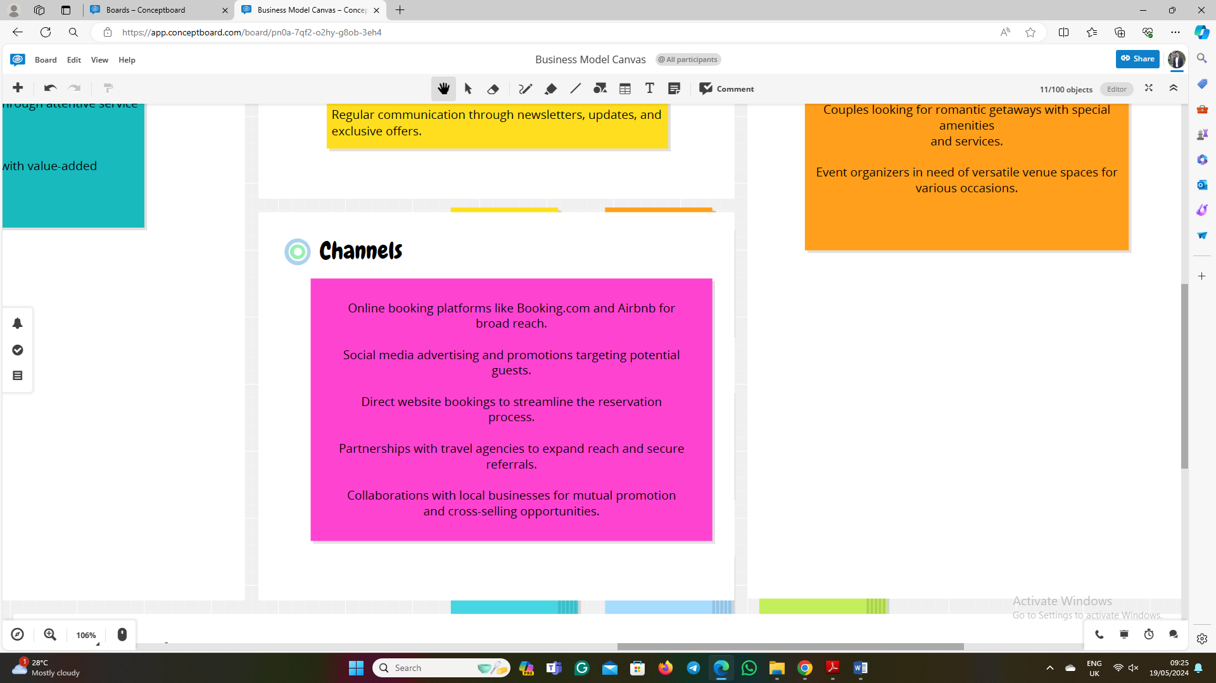
Customer Segments:
- Leisure travellers seeking unique, memorable experiences away from home.
- Business professionals requiring comfortable accommodations for work-related stays.
- Families seeking convenient, family-friendly lodging options during vacations.
- Couples looking for romantic getaways with special amenities and services.
- Event organizers in need of versatile venue spaces for various occasions.
Cost Structure:
- Employee salaries, wages, and benefits to maintain a motivated workforce.
- Facility maintenance and utilities to ensure a comfortable and safe environment.
- Marketing and advertising expenses to promote the business and attract guests.
- Technology investments for efficient operations and guest management systems.
- Cost of goods sold for additional services provided to guests.
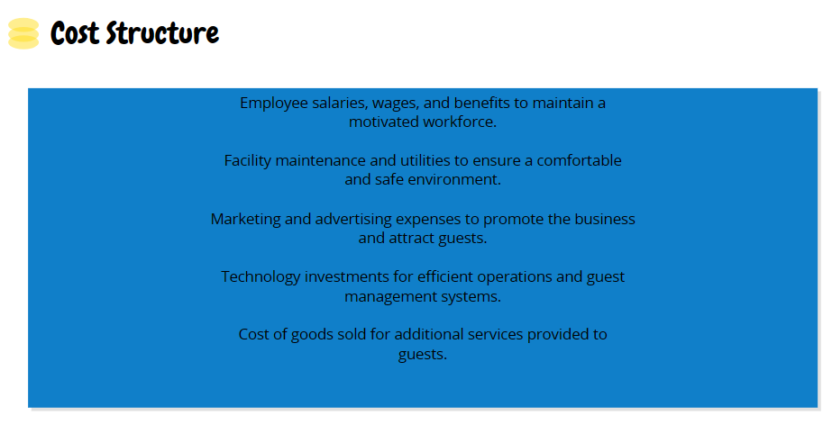
Revenue Streams:
- Room bookings and accommodation fees for overnight stays.
- Additional services such as dining, spa treatments, and recreational activities.
- Venue rental fees for events and special occasions.
- Commissions from partners for referrals and collaborations.
- Sales of branded merchandise and souvenirs to guests.
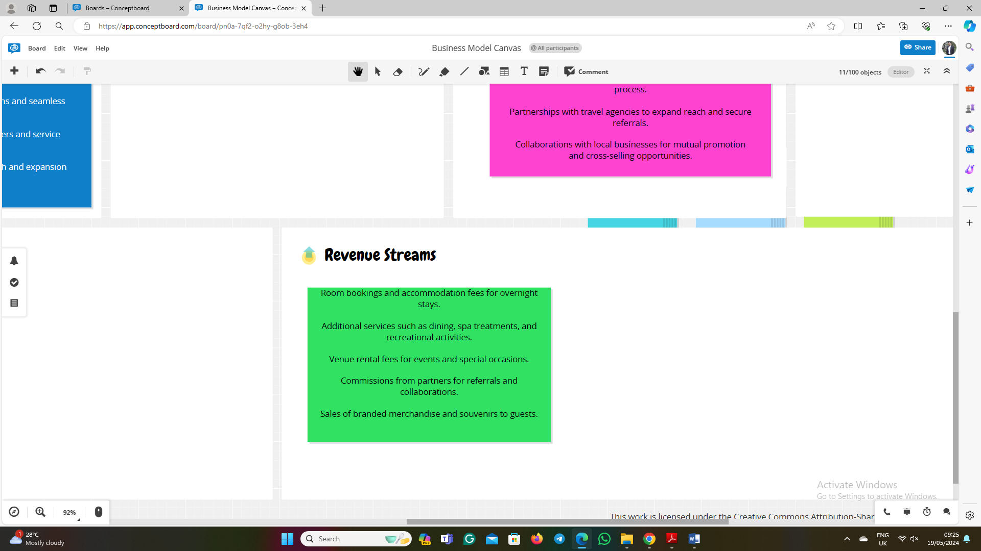
GET2 Results
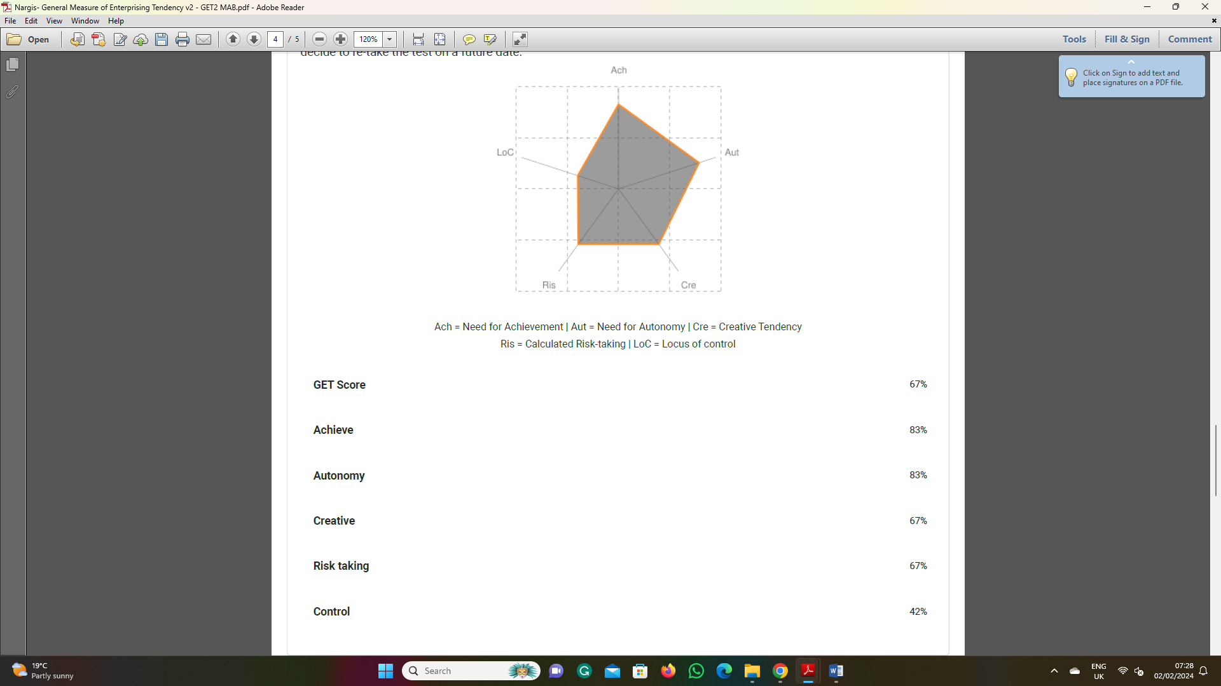

Entrepreneurial Questionnaire


