ASP.Net Web Development
Kemi Ademoye
James Holmson P150037

Table of Contents
Introduction 1
Implementation 1
Description 1
Requirements 1
Development and Screenshots 3
Evaluation 7
Reference List 7
Bibliography 7

Table of Figures
Fig 1. The database tables required for Oxwich Bay Books 2
Fig 2. New ASP project screen for Oxwich Bay Books 5
Fig 3. Book Table 5
Fig 4. Author Table 5
Fig 5. Customer Table 6
Fig 6. Order Table 6
Fig 7. The error produced attempting to create a new scaffolding controller. 6
Table of Tables
Table 1. The fields for the Book Table. 3
Table 2. The fields for the Author Table. 3
Table 3. The fields for the Customer Table. 3
Table 4. The fields for the Order Table. 4

Introduction
This report outlines the pre-set requirements of the ASP.NET application. Moreover, it analyses the final implementation, evaluating the effectiveness of the application, if it were to be published online.

Implementation
The following section provides an overview of the development process for the site created for the The Oxwich Bay Book Shop case study.

Description
The web application was designed to provide a platform to advertise and sell second-hand and new books. With the database storing details of the bookshop's products for sale, and their customers and the orders placed. Both new and existing customers of Oxwich Bay Books are the target audience and will be able to login to access their accounts. Furthermore, the company will be able to expand their reach, making sales throughout the United Kingdom and abroad.

Requirements
This section establishes the requirements prior to commencing the project. The following headings are the MoSCoW method provided by Haughey [1] who establishes the need to develop achievable goals in order of their importance.
- Must Have
- Display details of all books in stock in the same format, in thumbnail and expanded view.
- The books should be subdivided into different categories.
- Consistent layout and styling used throughout in terms of headers, footers, and any additional menus.
- Should Have
- There are pre-set fields indicating the condition of the book, for example, if there is any damage to pages.
- An ‘About Us’ web page for the company.
- If there any forms, they should incorporate validation.

- Could Have
- A search bar to assist the user with finding the correct book.
- A return form for any books purchased.
- A way to highlight books on the homepage, for example, those that are newly released or if there is a promotion running.
- Customers can adjust the quantity, which results in an alteration of the amount charged.
- Would Like
- A database designed to handle stock management.
- A content management system for staff add, edit, or delete products.
- A checkout cart system to complete their purchase.
Bootstrap 4 has been chosen for the front-end of the website, as it provides pre-determined classes for handling the layout and styling of the web pages. Penberthy [2] advises ASP.NET provides a framework to implement the same layout throughout. On any input fields, Ragupathi [3] (p.134) recommends setting constraints such as compulsory fields or setting a minimum or a maximum number of characters a user can enter.
In summary, the system is reliant upon the Book Table. Thus, from these requirements, it is established that there will be four primary tables and the suitable columns are seen in Figure 1.
Fig 1. The database tables required for Oxwich Bay Books.
Although there is no link between the order table and the book table, it should meet the minimum requirements of displaying the books on the finished website. A customer accounts table could be populated to create orders, to trial this side of the system.

Development and Screenshots

In the following tables, the required information for each field has been identified for the database tables.
Book Table
Column | Attribute Doman Requirements
BookID | Auto Increment Integer, PK
BookTitle | String, Size 100, Required
AuthorID | Auto Increment Integer, FK
BookEdition | BookEdition Enum, Required Enum Data Type
BookCategory | BookCategory Enum, Required, Enum Data Type
BookCondition | BookCondition, Enum, Required, Enum Data Type
CoverImage | String, Size 100 Required
Price | Decimal, Required, Data Type: Currency
PublishedDate | DateTime, Data Type: Data
Table 1. The fields for the Book Table.

Author Table
Column | Attribute Doman Requirements
AuthorID | Auto Increment Integer, PK
FirstName | String, Size 50, Required
LastName | String, Size 50, Required
Table 2. The fields for the Author Table.
Customer Table
Column | Attribute Doman Requirements
CustomerID | Auto Increment Integer, PK
FirstName | String, Size 50, Required
LastName | String, Size 50, Required
Email | String, Size 100, Required
ContactNo | String, Size 15, Required
Table 3. The fields for the Customer Table.
Order Table
Column | Attribute Doman Requirements
OrderID | Auto Increment Integer, PK
CustomerID | Integer, Required FK
OrderDateTime | DateTime, Data Type: Data
TotalCost | Decimal, Required, Data Type: Currency
OrderStatus | OrderStatus, Enum, Required, Enum Data Type
Table 4. The fields for the Order Table.

As the development work primarily included creating the entity modal classes and the database with some test data, the focus is on the backend of the site. Therefore, there are only the basic web pages that are created by default in a new asp.net project as seen in Figure 2. Furthermore, attempts to setup Bootstrap were unsuccessful, ergo no changes were applied to the menu.
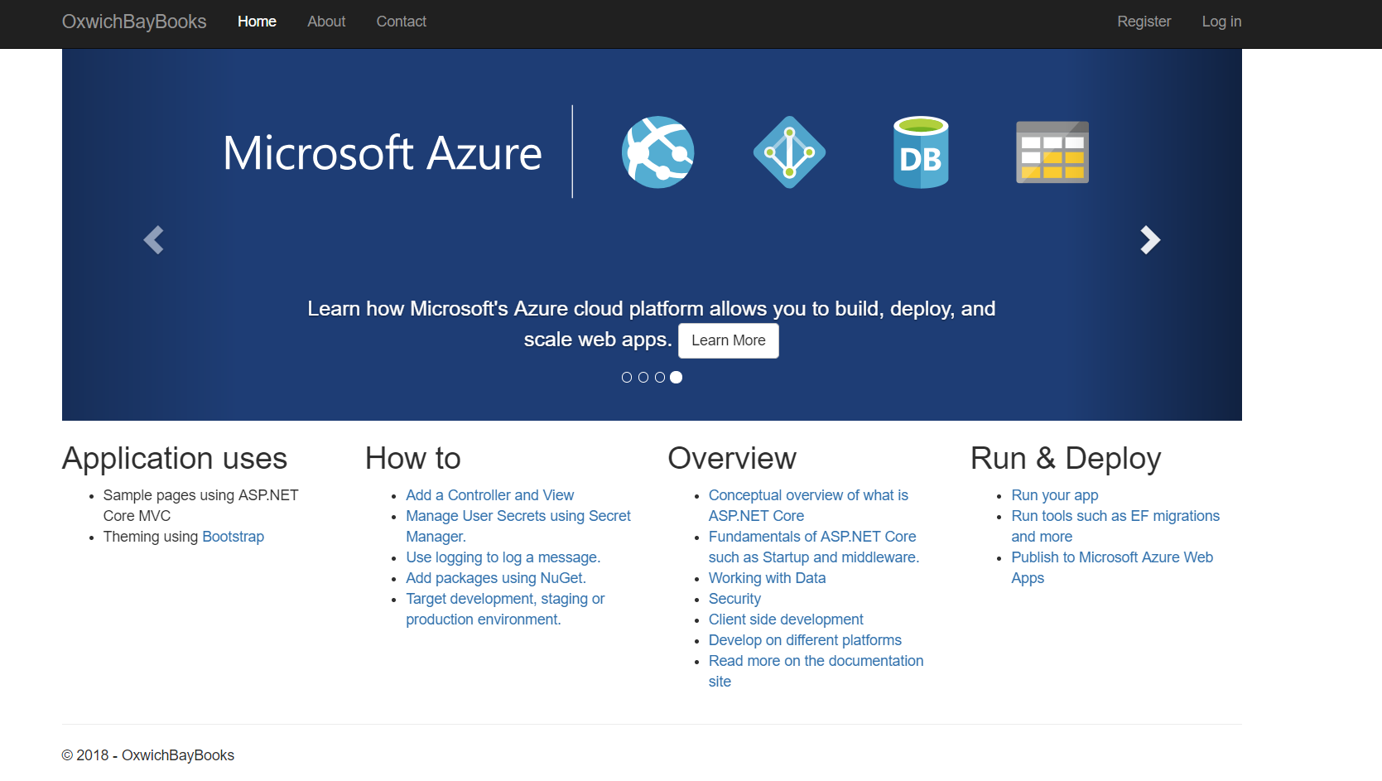
Fig 2. New ASP project screen for Oxwich Bay Books.
However, the database tables were created and populated with test data as seen in Figures 3 - 6.
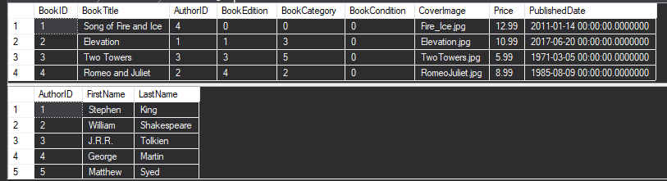
Fig 3. Book Table.
Fig 4. Author Table.
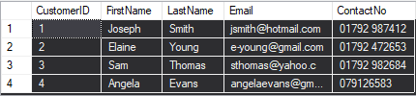
Fig 5. Customer Table.
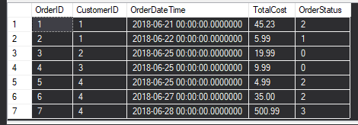
Fig 6. Order Table.

The next stage involved displaying the data on the web page. However, progress was halted when attempting to scaffold a controller for the ‘Book Class’, with the error seen in Figure 7. The matter was unresolved despite a further investigation into users experiencing similar problems.
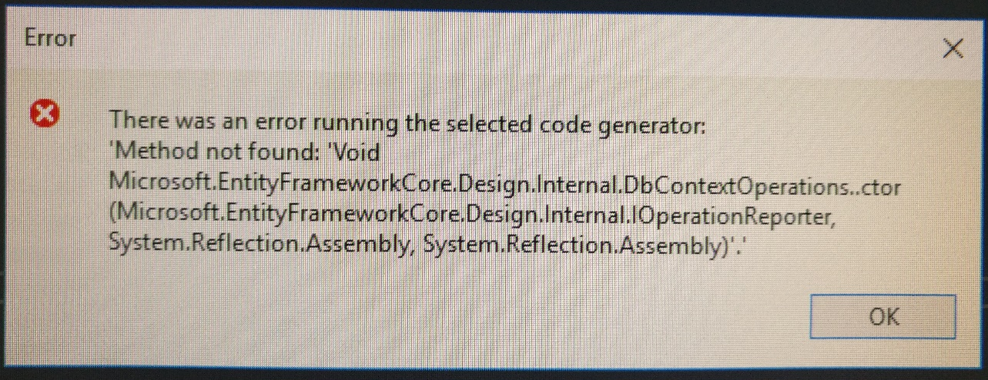
Fig 7. The error produced attempting to create a new scaffolding controller.

The error highlighted in Figure 7, restricted completing the MoSCoW requirements highlighted for this project. Thus, although, enums could be used to display information regarding category, condition, and edition, it was not possible to proceed with doing so.

Evaluation
Unfortunately, the web application is incomplete, due to problems during development and constraints on the amount of time available. The main challenge involved creating a controller to connect to the database. As this was incomplete, it meant the visual dynamic element of the application was non-operational. Consequently, no products could be displayed. However, the entity model classes were identified in Figure 1 and were subsequently expanded using enums could have served as a basis for the application. Unit testing was the preferable method due to being unfamiliar with ASP.NET, it would have allowed the opportunity to test each stage of the development, offering some assurance to the novice developer.
To conclude, further practice is needed using this method of development to create a fully functional application. Following which, this case-study can be re-attempted to build skills in this type of web development work.

Reference List
[1] D. Haughey, “MOSCOW METHOD,” 2014. [Online]. Available: https://www.projectsmart.co.uk/moscow-method.php. [Accessed: 01-Jul-2018].
[2] W. Penberthy, Beginning ASP.NET for Visual Studio 2015. Indianapolis: Wiley-Blackwell, 2016.
[3] M. T. S. Ragupathi, Learning ASP.NET Core MVC Programming: . Packt Publishing, 2016.

Bibliography
“ASP.NET Core Tutorial.” [Online]. Available: https://www.tutorialspoint.com/asp.net_core/index.htm. [Accessed: 05-Jul-2018].
D. Roth, R. Anderson, and S. Luttin, “Introduction to ASP.NET Core,” 2018. [Online]. Available: https://docs.microsoft.com/en-us/aspnet/core/?view=aspnetcore-2.1. [Accessed: 05-Jul-2018].

