
ACCOUNTING FUNDAMENTALS
LCBB4001
ASSESSMENT 2


UNIVERSITY OF WALES TRINITY SAINT DAVID
LECTURER: DR RITA UKACHI-LOIS
STUDENT NAME AND ID: AMNA MASAUD 2113737
SUBMISSION DATE: 11TH OF MAY 2022

TABLE OF CONTENTS

LEGEND 2
QUESTION 1 2
POINT a) 2
POINT b) 2
POINT c) 3
POINT d) 3
QUESTION 2 3
POINT a) 3
POINT b) 4
REFERENCES 6

LEGEND
‘ X ’ = MULTIPLIED
‘/ ‘ = DIVIDED

QUESTION 1

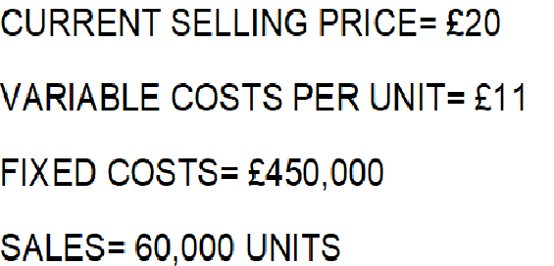

POINT a)

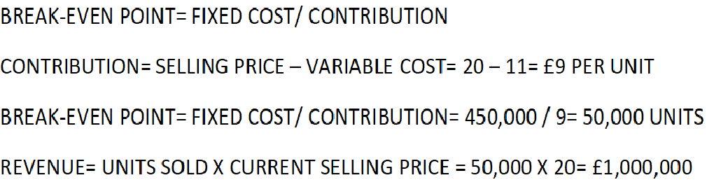

POINT b)

POINT c)

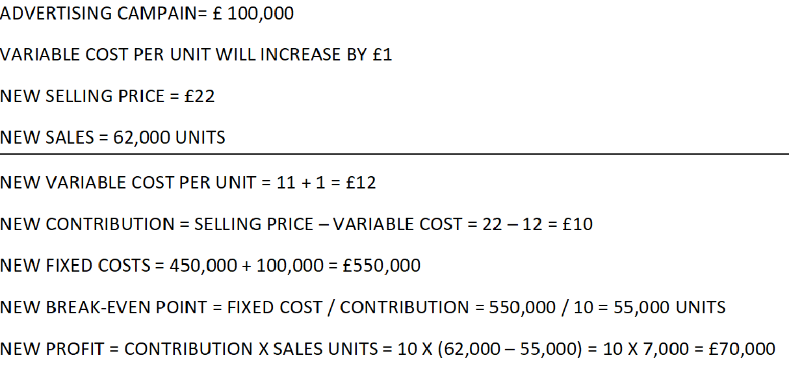

POINT d)

According to Conway (1957), break-even analysis is corelated with certain limitations, such as:
- It cannot consider multiple products, situations, or companies and it is extremely hard for the large firms to use it as are providing more than one product or service
- Difficulty in indicating the measure of volume, becoming meaningless if more than one product is involved
- Profit will no longer represent a function of the total volume and product mix, becoming a non-linear connection
- If it’s being used by businesses, will limit their opportunities, potential and usefulness
- It is not relevant if only one part of the production is sold, as the analysis aim to sell the entire stock

QUESTION 2

POINT a)

Management accounting is managed by internal users, such as managers and provides relevant information for decision making. It involves analysing and interpreting the accounting information and it covers the prices and costs. As part of its contribution, it aims to increase the quality of the information for managers that will make smarter and better decisions and to forecast long-term business commitments.
Management accounting will always be important for the business, because:
- Helps mangers to discover which products are bringing profit and what financial impact will have towards the business
- Provides a realistic view of the market: what is missing from the market, what can be launched and which are the stages
- Providing data in terms of affordability for new hiring positions and regulate wages
- Provides tracking for expenditures and income
There are significative differences between the two areas of accounting: management and financial. One of the most acknowledgeable is that management’s accounting functions are: planning, controlling and decision making, while financial’s accounting are totally different: processing, recording and presenting. On the other side, financial accounting is recording for the external users all the transactions of a business, preparing financial statements that are reflecting the performance of an entity and analysing the financial position. It has numerous objectives, but the most important are: analysing if a company is making a profit or a loss, the amount of cash available, how much a business owns and owes and how wealthy it is. Taking all the objectives mentioned before into consideration, the main aim of financial accounting is to provide relevant information that will contribute towards the decision-making process. As the records are containing extremely important and sensitive information that is hard to remember, must be kept safe.

Source: Sangster (2018); Wood (2011)

POINT b)

The three main objectives of management accounting are: budgeting, break-even analysis and capital investment. Accountants’ actions are directly corelated with these objectives and their actions are leading towards achieving them.
Budgeting represents the support in achieving organisation’s objectives. The process can be formal for big organisations, where the committees are performing the tasks or informal, where the owner decides the budget for a small business. Normally, budgets are settled by management and recorded by management accountants. Accountants are running systems that are helping managers to plan and control and are the first ones involved to track the costs involved. One of the systems is variance analysis and compares the allocated budget and what was the cause of any rises encountered. Trough relevant formulas, they are identifying the causes of any irregularities and are sharing them with the management.
At the same time, management accountants’ activity is in synergy with the capital as are the ones that are evaluating the assets of the business and how have been obtained. They are measuring and increasing the wealth by advising on ways for capital investment. As the information about capital’s structure is found in the balance sheet, someone capable, with relevant knowledge, such an accountant, need to analyse it.
In terms of safety, management accountants are using break-even analysis to examine the connected costs and revenues. Before a company starts spending and covering its costs, there is realised a report of the number of sales and demand that need to be achieved to cover all the expenses. Break-even analysis is developed only for management and the external users are not entitled to access it. Accountants are obtaining the result by dividing the fixed costs to the number of contributions for each unit that is aimed to be sold.
However, their responsibilities are different compared with the ones of a financial accountant as are not restricted by regulations but need to take in consideration that will be used as well for financial analysis.
Source: Hayes (2021); Wood (2011)

REFERENCES

Conway, R. W. (1957). Breaking Out of the Limitations of Break-Even Analysis. National Association of Cost Accountants. NACA Bulletin (pre-1986), 38(10), p. 1265.
Hayes, A. (2021). Investopedia. [Online]
Available at: https://www.investopedia.com/terms/b/breakevenanalysis.asp [Accessed 11 05 2022].
Sangster, A. (2018). Frank Wood's business accounting 1. 14th ed. Harlow: Pearson.
Wood, F. (2011). Frank Wood's Business accounting 1. 14th ed. Harlow: Financial Times Prentice Hall/Pearson.

