12/04/2021 Mark Williams - 20222279

Introduction to Web and Database Concepts
ACCA4023 + ACCA4018 IT&S
Gareth

Walking trails in Wales

Table of contents

1. Introduction ……………………………………………………………………………….p.3
2. Requirements …………………………………………………………………………….p.4
3. Implementation ……………………………………………………………………..….p5-8
- Screen shots ……………………………………………………………………….p5-7
- Validation of HTML & CSS ……………………………………………………P8
4. Evaluation …………………………………………………………………………….…. P9-11
- Part A ………………………………………………………………………………..P9
- Part B ………………………………………………………………………………...P10-11
5. References ……………………………………………………………………………...P12-13
6. Appendices ……………………………………………………………………………...P14-35
- HTML …………………………………………………………………………….…..P14-23
- CSS ……………………………………………………………………….…………..P23-25

Introduction
Creating a website to demonstrate my understanding of the HTML and CSS that I have learned throughout lectures and what I continued to learn and develop whilst building the website that displays one of my hobbies which is walking through wilderness trails. Throughout the report I will go over what requirements were set by my tutor and myself along with the struggles and learning curves that I had to overcome. This report will also include Validating both my HTML and CSS code and an evaluation which will break my website into details and discuss how accessible, the ease of navigating and how optimised the website is for search engines.

Requirements

“Walking trails” is a website I created that is about walking trails within Wales, it shows multiple walking trails with imagery, events that people are able to look up and attend with other people that also interested in walking trails. The website also allows for users to get in contact with the members who run the events and find out more information about the team.
The purpose and relevance of my website is to bring people with similar interests of walking trails, together to build a community and explore the vastness Wales has to offer. The sites relevance to this subject is shown on each page as it pours information of Walking trails, the colours of the site match that of nature and the imagery picked to match that colour scheme which appeals and grabs the attention of the user.

Implementations
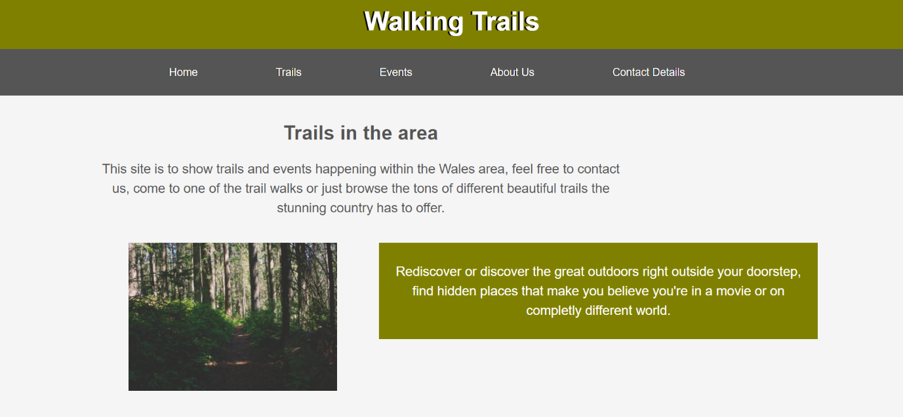
Home page

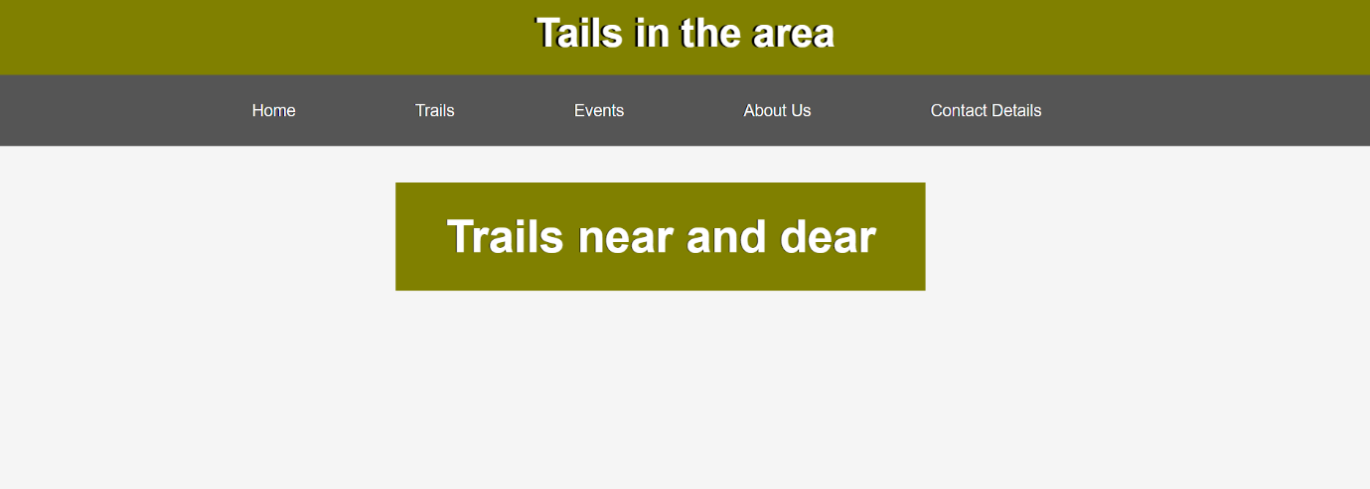
Trails in the area 1/3
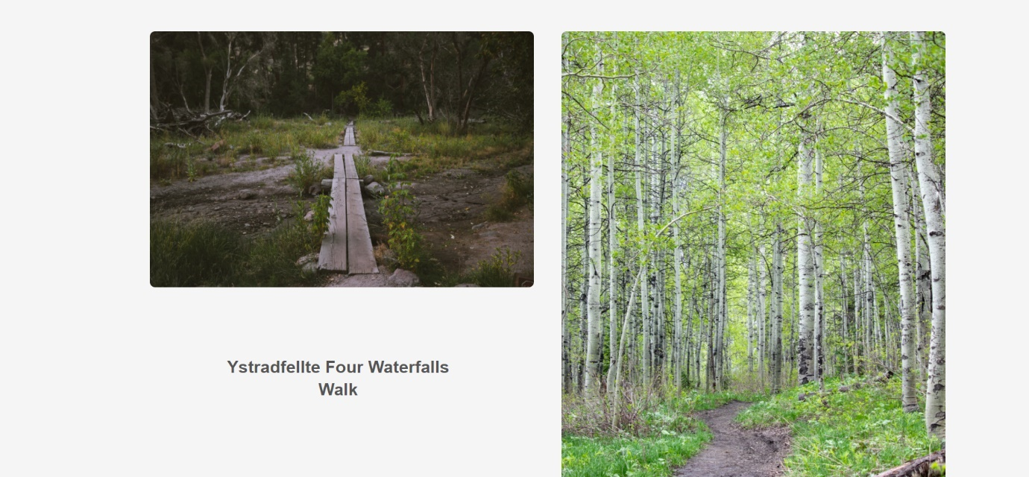
Trails in the area 2/3
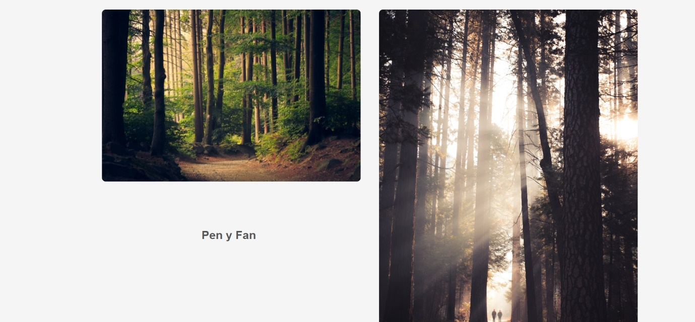
Trails in the area 3/3
Events
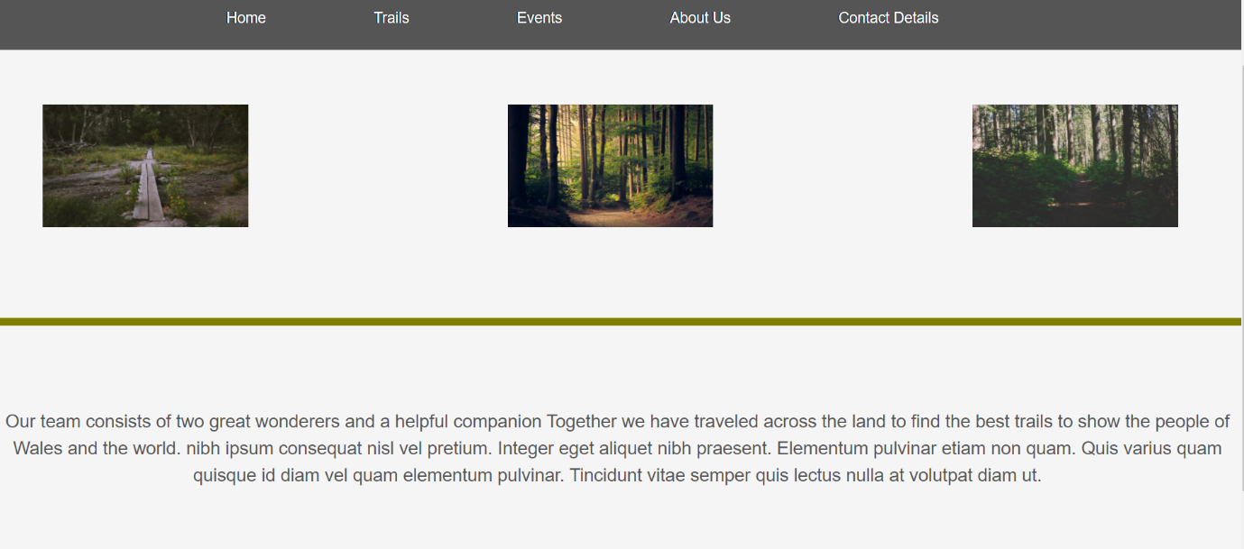
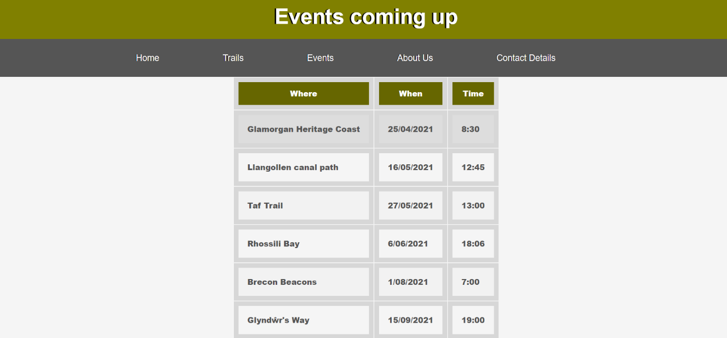
About us
Contact details
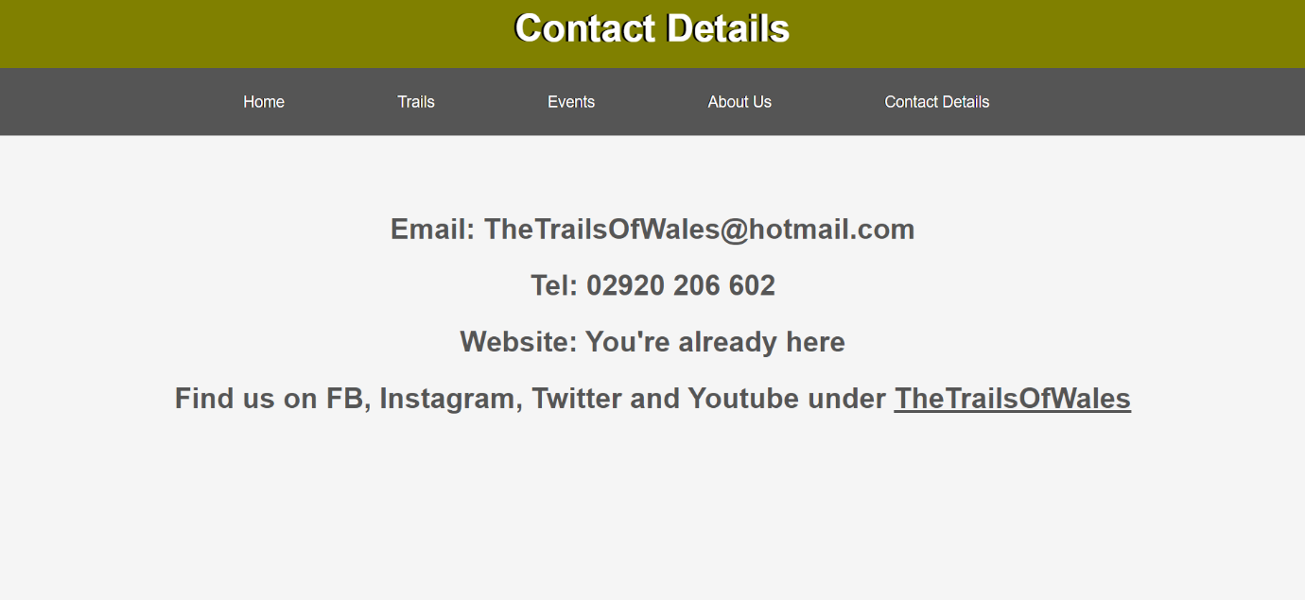
.

Validation of HTML [7]
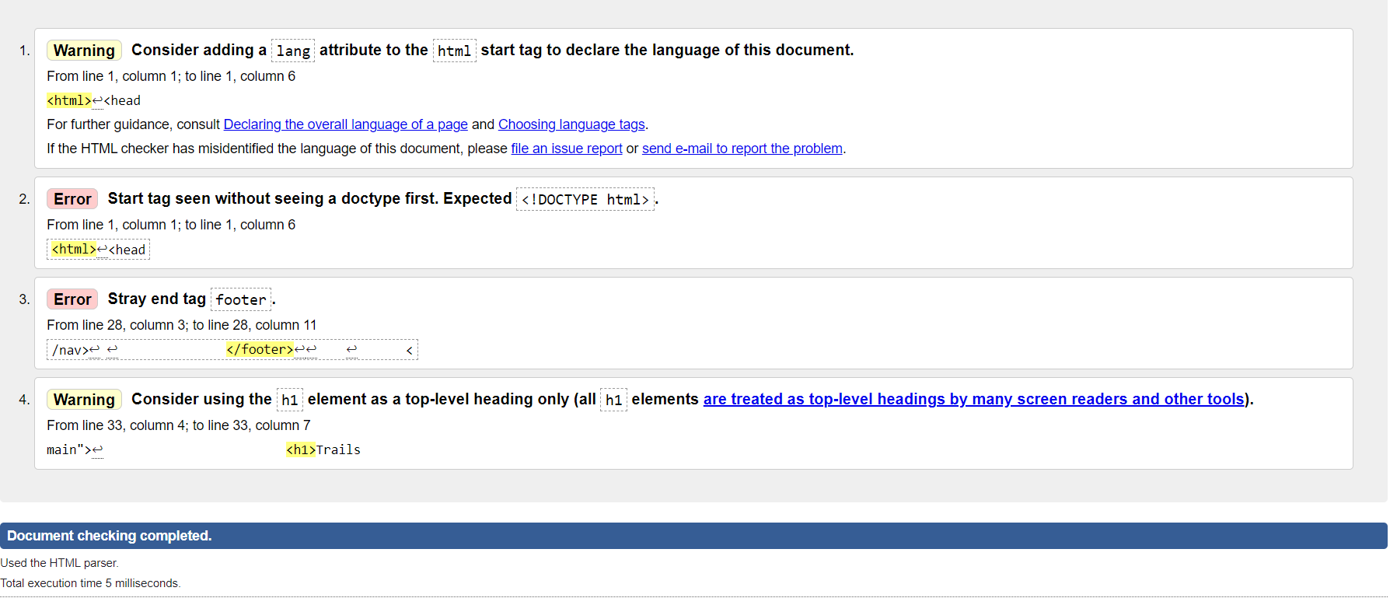
As seen in the picture above I validated my HTML code that I used to create my website and it has presented 4 issues it has found with my code one of the issues the validation program found was a “Stray end tag” </footer>. Going back into my code I found the issue and was able to remove the stray tag with no additional problems to my work, once I ran my html code back through the validator this error had been resolved as seen by the image below.
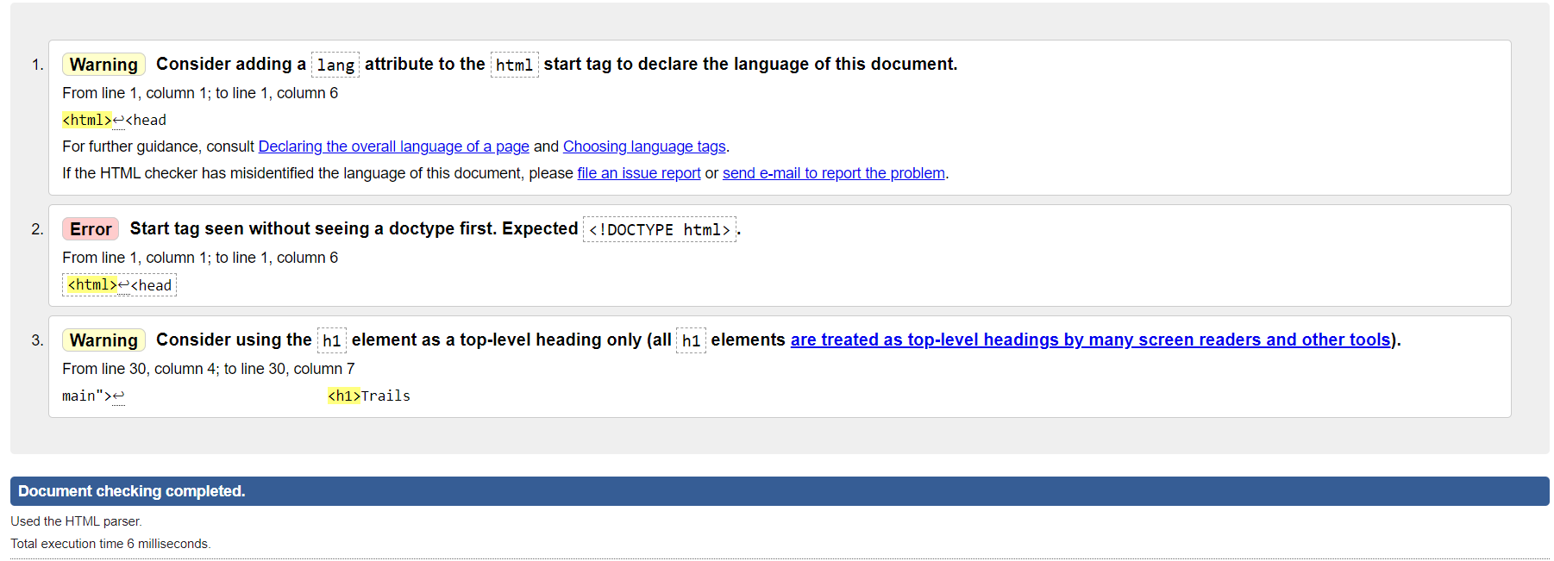
Validation of CSS [8]
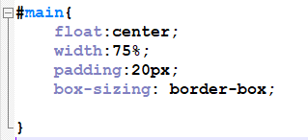
As seen by the image above the validation for my CSS code came back with an error where a value did not have a purpose. Going through my code I found the issue which was a few lines of code shown on the left. The code had no purpose on the website and once I removed this and ran the CSS code back through the validation it was no longer an issue. The reason it was there was from when I first created my page and the design was different, it had a box with a border around the outside of it.
Evaluation a.
Website useability is a fundamental ingredient to all website development, it allows for users to gracefully navigate the website without issues such as large changes for different pages for example the navigation bar changing colour or all of the links to different pages of the website swapping around. An article on Online recruiting [1] stated that useability could be what keeps the user coming back to the page which is why its essential to develop a website that has a navigation bar which is simple and does not need explanation to use, clean colour theme, which allows for easy-to-read articles, navigation tools and overall allows for the user to not have to use their brain to use the page to find what they are searching for.
Throughout my lectures and own study, I have gained a deeper understanding of how to make a website user friendly and implemented that into my website “Walking trails” by adding a colour scheme that allows for imagery added to fit in nicely with the rest of the page and also a consistency throughout the pages allowing for the user to feel familiar and not like they are on a completely different webpage.

Everyone who visits a website should be able to read what has been placed on the page and navigate to different sections with no issues between the navigation. “Promoting Web accessibility is critical to creating an inclusive environment because it addresses structural information disadvantages experienced by people with disabilities.”[2] The article shows that a study was done to see how websites lacked in accessibility for people of different disabilities and language barriers.
The way websites have solved some of these issues have been creating pages that are accessible through multiple devices which allow for people to access the site through computer, mobile or tablet devices giving more people access to the site not only does it make it more helpful for the user but increases traffic to the site. I have given my site the ability to be used through mobile as well as computer and laptop giving users more accessibility to the site and they are not missing out on information.

To gain higher traffic to my page I used methods I researched through an article which was “estimating googles search engine ranking functions” [3]. The article states to get a higher traffic to a web page there are key features that optimises the search and allows for the webpage to appear higher up in the list when looking for relevant key topics. Some of the key features mentioned are key words, colour scheme used and relevant information to the search.
When creating my website on walking trails I took this information and applied it to my website making sure I used words that users might search for when looking for related sites, trying to boost my search engine ranking to bring in a higher traffic.

Evaluation b.

The design on my website is built to compliment the writing, topic and imagery placed in the page so it all looks neat and coordinated and professional I have done this by selecting a colour scheme of Olive, grey, brown and greens that represents the theme of the site which is walking trails and nature. This not only looks professional but as stated in the evaluation above is a key ingredient for developing traffic to the page and giving the user a website that is easy to navigate, understand and overall, just use with ease.
I have made the navigation and useability of the site easy to manoeuvre with a navigation bar at the top of each page that stays the same throughout all pages giving the user a sense of familiarity and an understanding of where they can go for certain information. The rest of the pages follow a colour scheme which also allows the users to use the site with easy and nothing out of place that might interrupt the user or pull away from the main information presented.
This was the first time I have created a website and the overall experience was pleasant, with the skills I developed throughout the lectures and self-studying the code became familiar and more comfortable to work through. One of the major issues I had to begin with was understanding the difference between CSS and HTML which took a few tries to get used to but after researching different codes and techniques using W3Schools [4] I was able to find a comfortable ground and it shows within my website that I was able to navigate both HTML and CSS to work together. To conclude in the future I believe the issues I had with this assignment will be less visible as I develop my skills throughout my lectures and self-educating.

List of Search engine Optimisation (SEO) – on-page techniques that I have used on my website. [5]
- Keywords and phrases – I have used multiple key words on the front page so that users that are looking for relevant pages have a higher chance of locating my page. These key words and phrases are “Trails in the area”, “rediscover or discover the great outdoors” and “wales” these words and phrases can be searched by users looking for multiple related things and that is what will boost my websites search optimisation.
- Images – The images I have used on my website are all relevant to the topic and scheme of the website which will not only boost search optimisation but makes the website feel more professional and entices the user to come back for further image updates.
- Authorship, informatic data – The information on the page is from myself the author and is all experiences I have had and seen, there is room for users to add to the website by contacting the team which builds community and allows for the user to feel heard and share stories of their own all while developing traffic and a high search optimisation for my website.

Creating a website that was accessible to all users this meant I had to make sure I stuck with the four principles of website accessibility while also implementing a way for users with disabilities to have the same experience from using my website. I did this by following guidelines from WCAG 2.1 making me website a certain colour scheme I was able to check to see if the colours were suitable for users with disabilities using a website that allowed me to upload images of my website called “contrastchecker” [6] which advised on me on what needed changing to fit in with the criteria to make it more accessible to all users.
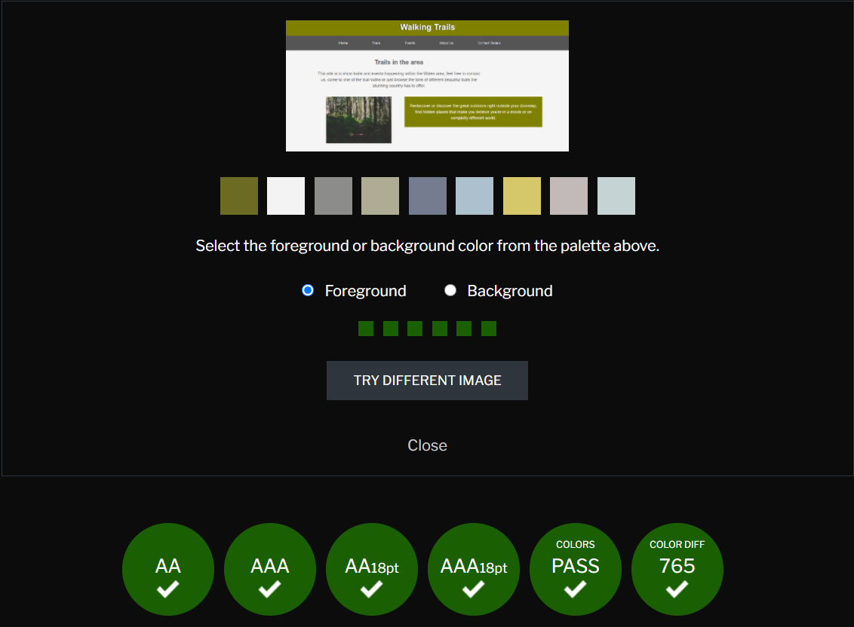

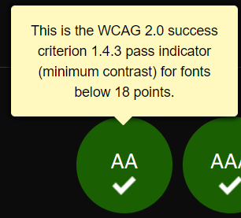
The above image shows my home page and the colour schemes that are present, below this it shows is the colour scheme has passed the checks of the WCAG 2.0 criteria. This allowed me to change my websites colour scheme, text font and size to make sure that my site was easily accessible for all users.

Ref page
[1] https://www-sciencedirect-com.ezproxy.uwtsd.ac.uk/science/article/pii/S0747563208001027
Article, Online recruiting: The effects of organizational familiarity, website usability, and website attractiveness on viewers’ impressions of organizations, Braddy, Phillip W ; Meade, Adam W ; Kroustalis, Christina M, Oxford: Elsevier Ltd, Computers in human behaviour, 2008, Vol.24 (6), p.2992-3001, Introduction 2nd Paragraph.

[2] https://www-sciencedirect-com.ezproxy.uwtsd.ac.uk/science/article/pii/S0740818816302158
An exploratory study of library website accessibility for visually impaired users, Yoon, Kyunghye ; Dols, Rachel ; Hulscher, Laura ; Newberry, Tara, Elsevier Inc, Library & information science research, 2016-07, Vol.38 (3), p.250-258, 2.Problem statement, 1st Paragraph.

[3] https://search-proquest-com.ezproxy.uwtsd.ac.uk/docview/1776786007?accountid=130472&pq-origsite=primo
estimating Google’s search engine ranking function from a search engine optimization perspective, Luh, Cheng-Jye ; Yang, Sheng-An ; Huang, Ting-Li Dean, Bradford: Emerald Group Publishing Limited, Online information review, 2016-04-11, Vol.40 (2), p.239-255, Introduction, 1st paragraph.

[4] Code: https://www.w3schools.com/css/default.asp
Used for multiple code and assistance throughout the website.
- https://www.w3schools.com/css/css_margin.asp - Margins
- https://www.w3schools.com/css/css_padding.asp - Padding
- https://www.w3schools.com/css/css_table.asp - Table
- https://www.w3schools.com/css/css_image_gallery.asp - Image gallery
- https://www.w3schools.com/css/css3_shadows.asp - shadows on text
- https://www.w3schools.com/css/css3_images.asp - image curves

[5] https://moz.com/learn/seo/on-page-factors - On-Page Ranking Factors, used for viewing different forms of SEO

[6] https://contrastchecker.com/ - used for checking criteria of website against WCAG 2.0.

[7] Validation HTML: https://validator.w3.org/nu/#file
[8] Validation CSS: http://jigsaw.w3.org/css-validator/validator

Ref page for images on website

Forest1: https://unsplash.com/@ibidsy
Trail’s pic 1: https://unsplash.com/@austinedwards
Trail’s pic 2: https://unsplash.com/@eklect
Trail’s pic 3: https://unsplash.com/@szmigieldesign
Trial’s pic 4: https://unsplash.com/@mischievous_penguins

Appendices

HTML
Main page
<html>
<head>
<meta charset="utf-8" />
<title>Walking Trails</title>
<link rel="stylesheet" type="text/css"
href="AssignmentCSS.css">
</head>

<body>
<header id="main-header">
<div class="container">
<h1>Walking Trails</h1>
</div>
</header>

<nav id="navbar">
<div class="container">
<ul>
<li><a href="Assignment%20.html">Home</a></li>
<li><a href="Trails.html">Trails</a></li>
<li><a href="Events.html">Events</a></li>
<li><a href="AboutUs.html">About Us</a></li>
<li><a href="ContactDetails.html">Contact Details</a></li>
</ul>
</div>
</nav>

</footer>

<div class="container">
<section id="main">
<h1>Trails in the area</h1>
<p> This site is to show trails and events happening within the Wales area, feel free to contact us, come to one of the trail walks or just browse the tons of different beautiful trails the stunning country has to offer. </section>

<img src="Forest1.jpg" alt="Forest1.jpg"
style="width:350px;height:250px;"/>

<aside id="sidebar">
<p> Rediscover or discover the great outdoors right outside your doorstep, find hidden places that make you believe you're in a movie or on completly different world. </aside>
</div>
</body>
</html>

Trails
<html>
<head>
<meta charset="utf-8" />
<title>Trails</title>
<link rel="stylesheet" type="text/css"
href="TrialsCSS.css">
</head>

<body>
<header id="main-header">
<div class="container">
<h1>Tails in the area</h1>
</div>
</header>

<nav id="navbar">
<div class="container">
<ul>
<li><a href="Assignment%20.html">Home</a></li>
<li><a href="Trails.html">Trails</a></li>
<li><a href="Events.html">Events</a></li>
<li><a href="AboutUs.html">About Us</a></li>
<li><a href="ContactDetails.html">Contact Details</a></li>
</ul>
</div>
</nav>

</footer>

<div class="container">
<section id="main">
<aside id="sidebar">
<h2>Trails near and dear </h2>
</div>

<div class="gallery">
<a target="Trail1.jpg" href="Trail1.jpg">
<img src="Trail1.jpg" alt="Trail1" width="20" height="20">
</a>
<div class="desc">Ystradfellte Four Waterfalls Walk</div>

</div>

<div class="gallery">
<a target="Trail2.jpg" href="Trail2.jpg">
<img src="Trail2.jpg" alt="Trail2" width="20" height="20">
</a>
<div class="desc">Snowdonia Slate Trail</div>
</div>

<div class="gallery">
<a target="Trail3.jpg" href="Trail3.jpg">
<img src="Trail3.jpg" alt="Trail3" width="20" height="20">
</a>
<div class="desc">Pen y Fan</div>
</div>

<div class="gallery">
<a target="Trail4.jpg" href="Trail4.jpg">
<img src="Trail4.jpg" alt="Trail4" width="20" height="20">
</a>
<div class="desc">Gwydir Mawr & Bach</div>
</div>

</html>

Events

<html>
<head>
<meta charset="utf-8" />
<title>Events</title>
<link rel="stylesheet" type="text/css"
href="EventsCSS.css">
</head>

<body>
<header id="main-header">
<div class="container">
<h1>Events coming up</h1>
</div>
</header>

<nav id="navbar">
<div class="container">
<ul>
<li><a href="Assignment%20.html">Home</a></li>
<li><a href="Trails.html">Trails</a></li>
<li><a href="Events.html">Events</a></li>
<li><a href="AboutUs.html">About Us</a></li>
<li><a href="ContactDetails.html">Contact Details</a></li>
</ul>
</div>
</nav>

</footer>

<body>

<center>
<table id="customers">
<tr>
<th>Where</th>
<th>When</th>
<th>Time</th>
</tr>
<tr>
<td>Glamorgan Heritage Coast</td>
<td>25/04/2021</td>
<td>8:30</td>
</tr>
<tr>
<td> Llangollen canal path</td>
<td>16/05/2021</td>
<td>12:45</td>
</tr>
<tr>
<td>Taf Trail</td>
<td>27/05/2021</td>
<td>13:00</td>
</tr>
<tr>
<td>Rhossili Bay</td>
<td>6/06/2021</td>
<td>18:06</td>
</tr>
<tr>
<td>Brecon Beacons</td>
<td>1/08/2021</td>
<td>7:00</td>
</tr>
<tr>
<td> Glyndŵr's Way</td>
<td>15/09/2021</td>
<td>19:00</td>
</tr>
<tr>

</tr>
</table>
</center>
</body>
</html>

AboutUs
<html>
<head>
<meta charset="utf-8" />
<title>About us</title>
<link rel="stylesheet" type="text/css"
href="AboutUsCSS.css">
</head>

<body>
<header id="main-header">
<div class="container">
<h1>About the team</h1>
</div>
</header>

<nav id="navbar">
<div class="container">
<ul>
<li><a href="Assignment%20.html">Home</a></li>
<li><a href="Trails.html">Trails</a></li>
<li><a href="Events.html">Events</a></li>
<li><a href="AboutUs.html">About Us</a></li>
<li><a href="ContactDetails.html">Contact Details</a></li>
</ul>
</div>
</nav>
<br>
</br>
<div>
</footer>

<body>
<img src="Trail1.jpg" alt="Trail" width="250" height="150"" style="margin: 1px 60px 1px 60px;" >
<img src="Trail3.jpg" alt="Trai3" width="250" height="150"" style="margin: 1px 60px 1px 250px;" >
<img src="Forest1.jpg" alt="Forest1" width="250" height="150"" style="margin: 1px 60px 1px 250px;" >
</body>

<aside id="sidebar">
<p>
<center>
Our team consists of two great wonderers and a helpful companion Together we have traveled across the land to find the best trails to show the people of Wales and the world. nibh ipsum consequat nisl vel pretium. Integer eget aliquet nibh praesent. Elementum pulvinar etiam non quam. Quis varius quam quisque id diam vel quam elementum pulvinar. Tincidunt vitae semper quis lectus nulla at volutpat diam ut.
</center>
</P>

</html>
Contact Details

<html>
<head>
<meta charset="utf-8" />
<title>Contact Details</title>
<link rel="stylesheet" type="text/css"
href="ContactDetailsCSS.css">
</head>

<body>
<header id="main-header">
<div class="container">
<h1>Contact Details</h1>
</div>
</header>

<nav id="navbar">
<div class="container">
<ul>
<li><a href="Assignment%20.html">Home</a></li>
<li><a href="Trails.html">Trails</a></li>
<li><a href="Events.html">Events</a></li>
<li><a href="AboutUs.html">About Us</a></li>
<li><a href="ContactDetails.html">Contact Details</a></li>
</ul>
</div>
</nav>

</footer>
<BR> </BR>
<center>
<h2> Email: TheTrailsOfWales@hotmail.com
<br> </br>
Tel: 02920 206 602
<BR> </BR>
Website: You're already here
<BR> </BR>
Find us on FB, Instagram, Twitter and Youtube under <u> TheTrailsOfWales </u>
</h2>
</center>
</html>

Appendices
CSS

Main page
body{
background-color:#f5f5f5;
color:#555;
font-family:Arial;
font-size:22px;
line-height:1.5em;
margin:0;
}

.container{
width:80%;
margin:auto;
overflow:hidden;
text-align: center;
}

#main-header{
background-color:olive;
color:#fff;
text-shadow: -3px 0 black;
}

#navbar{
background-color:#555;
text-shadow: -1px 0 black;
}

#navbar li{
display:inline;
}

#navbar a{
font-size:18px;
padding-right:125px;
}

a{
color:white;
text-decoration:none;
text-align:center;
}

#main{
float:center;
width:75%;
padding:20px;
box-sizing: border-box;

}

#sidebar{
float:right;
width:60%;
background:olive;
color:#fff;
padding:10px;
box-sizing: border-box;
}

Trials
body{
background-color:#f5f5f5;
color:#555;
font-family:Arial;
font-size:22px;
line-height:1.5em;
margin:0;
}

.container{
width:80%;
margin:auto;
overflow:hidden;
text-align: center;
}

h2{
font-size: 50px;
width: 100%;
color:dark-gray;
text-shadow: -1px 0 black;
text-align: center;
}

#img{
padding: 100px;
}

#img2{
padding: 105px;
}

#sidebar{
float:right;
width:70%;
background:olive;
color:#fff;
padding:2px;
box-sizing: border-box;
}

#main-header{
background-color:olive;
color:#fff;
text-shadow: -3px 0 black;
}

#navbar{
background-color:#555;
text-shadow: -1px 0 black;
}

#navbar li{
display:inline;
}

#navbar a{
font-size:18px;
padding-right:125px;
}

a{
color:white;
text-decoration:none;
text-align:center;
}

#main{
float:center;
width:75%;
padding:40px;
box-sizing: border-box;

}

div.gallery {
margin: 50px;
float: left;
width: 140px;
padding: 180px ;
}

div.gallery img {
width: 400%;
height: auto;
border-radius: 8px;
}

div.desc {
padding: 100px;
text-align: center;
width: 250%;
font-size: 25px ;
font-weight: bold ;
}
Events

body{
background-color:#f5f5f5;
color:#555;
font-family:Arial;
font-size:22px;
line-height:1.5em;
margin:0;
}

.container{
width:80%;
margin:auto;
overflow:hidden;
text-align: center;
}

#main-header{
background-color:olive;
color:#fff;
text-shadow: -3px 0 black;
}

#navbar{
background-color:#555;
text-shadow: -1px 0 black;
}

#navbar li{
display:inline;
}

#navbar a{
font-size:18px;
padding-right:125px;
}

a{
color:white;
text-decoration:none;
text-align:center;
}

#main{
float:center;
width:75%;
padding:20px;
box-sizing: border-box;

}

<style>
#customers {

font-family: Arial;
border-collapse: collapse;
width: 100%;
}

#customers td, #customers th {
border: 10px solid #D7D7D7 ;
padding: 18px;
font-weight: 900;
}

#customers tr:nth-child(even){background-color: #f2f2f2;}
#customers tr:hover {background-color: #ddd;}
#customers th {
padding-top: 12px;
padding-bottom: 12px;
text-align: center;
background-color: #666600;
color: white;

}
</style>

About us

body{
background-color:#f5f5f5;
color:#555;
font-family:Arial;
font-size:22px;
line-height:1.5em;
margin:0;
}

.container{
width:80%;
margin:auto;
overflow:hidden;
text-align: center;
}

#main-header{
background-color:olive;
color:#fff;
text-shadow: -3px 0 black;
}

#navbar{
background-color:#555;
text-shadow: -1px 0 black;
}

#navbar li{
display:inline;
}

#navbar a{
font-size:18px;
padding-right:125px;
}

a{
color:white;
text-decoration:none;
text-align:center;
}

#main{
float:center;
width:75%;
padding:20px;
box-sizing: border-box;

}
p{
font-size: 50px ;
}

p {
float:center;
width:100%;
background:olive;
color:#fff;
padding:5px;
font-size: 100px;

}
</style>

<style>
img {
width: 200px;
height: 300px;
object-fit: cover;
padding: 10px ;
}

Contact details
body{
background-color:#f5f5f5;
color:#555;
font-family:Arial;
font-size:22px;
line-height:1.5em;
margin:0;
}

.container{
width:80%;
margin:auto;
overflow:hidden;
text-align: center;
}

#main-header{
background-color:olive;
color:#fff;
text-shadow: -3px 0 black;
}

#navbar{
background-color:#555;
text-shadow: -1px 0 black;
}

#navbar li{
display:inline;
}

#navbar a{
font-size:18px;
padding-right:125px;
}

a{
color:white;
text-decoration:none;
text-align:center;
}

#main{
float:center;
width:75%;
padding:20px;
box-sizing: border-box;
}

<style>
div {
height: 200px;
width: 50%;
background-color: red;
}
</style>

