fatima elabgari

Id 1708382

The Body Shop

Innovative marketing strategies that raised awareness of the brand

Table of Contents
1. Introduction 3
2. Strategy 1: Globalisation and a changing business environment with digitalisation 5
3. Strategy 2: Increasing brand awareness and competitiveness 8
4. Strategy 3: Managing reputation 10
5. Strategy 4: Retaining customers by managing the information and behaviour of the customers 12
6. Conclusion 15
References 16
Appendix 18

1. Introduction
Branding and marketing is the most important factor that helps to attract numbers of customers in the market. In this competitive world, each of the organisations is working hard to secure their competitive market at domestic level and at international level. In this detailed report, the learner would discuss the various issues and challenges faced by an organisation due to globalisation. The learner would target the nation India in the context to understand the challenges faced as well as facing by this organisation in the emerging market. The learner would discuss over the strategies related to the globalisation and changing business environment with digitalisation, brand awareness in emerging market, managing reputation and retention of customers in emerging market in the context of The Body Shop in Indian market.

Figure 1: The Body Shop Innovative Marketing Strategies
(Created by Author)
The Body Shop was founded in the year of 1976, by Dame Anita Roddick in Brighton. The Body Shop is one of the small sector organisation in the UK, which deals in cosmetic products. The organisation has been established with the limited variety of beauty products as well as women's and men’s fragrances (Thebodyshop.com, 2017). In the year of 1985, the organisation engaged the CSR activities by launching an event named Save the Whale. In the year of 1989, The Body Shop has launched its new branch in New Zealand. In 1990, the organisation has launched a charitable trust for human rights after entering in the market of USA. At the end of the year of 1993, The Body Shop reached 48 states of USA. By the end of the 20th century, The Body Shop has reached to its maturity period. In the year of 1997, the organisation celebrated the 50th anniversary of Universal Declaration of Human Rights 1998. In the earlier part of the 21st century, the organisation launched a customer reward programme in US. Then later on the organisation boosted up their market growth and won the award of honour, PETA’s (progress) award. In the year of 2006, on 12th July the organisation became part of the giant beauty care product’s organisation Loreal (Thebodyshop.com, 2017). In the year of 2006, the organisation launched their brands in India. At the earlier stage, the organisation introduced limited products into the marketplace. By the end of 2015, the Body Shop introduced more than 1,500 products In India (Bhattacharya, 2011).

SWOT ANALYSIS: The Body Shop
Strengths | Weaknesses
- More than 100 stores in India  - Good supplier network  - Attractive showroom and window presentation | - Not enough advertising of products or brand so much  - The organisation followed the franchising market system in emerging market
Opportunities | Threats
- High demand for herbal beauty products in India  - The increasing numbers of online customers for the beauty products in India | - Strong competition from other large sector organisations such as Lakme, Maybelline, Avon etc.
Tale 1: SWOT Analysis
(Source: Bhattacharya, 2011)

2. Strategy 1: Globalisation and a changing business environment with digitalisation
International business incorporates any sort of business activities that cross national outskirts (Hollensen, 2015). It is characterized as the organisation that purchases and additionally offers products and enterprises crosswise over at least two national limits, regardless of whether the administration is situated in a solitary nation. Global business, on the other hand, is defined by huge ventures which have working units outside their own particular nation. The chosen organisation, The Body Shop, is an international organisation. From the earlier stage to the current stage, the organisation faced several ups and downs, not always in the monetary but also non-monetary form.
Globalisation in real sense means integration of culture, communication and economics across the globe. The Body Shop has sensed this that in present business environment it is essential for every firm to go global. As a result the organisation has started expanding its business boundaries. This will help the company in survival and will ensure sustainability and success. However, with this, the firm will also have to face challenges as it is not easy to compete in the global market that too with local players of different nations. In this regards The Body Shop has devised a strategic marketing strategy. It not only focused on entering into rich and niche market, but has planned to expand its business even in those areas where people are fashion conscious and lead a vogue fashion lifestyle.
The strategic marketing strategy of the company is properly supported by its management styles, corporate culture, organisational structure and well controlled and regulated franchise system. The company has successfully expanded its business under the cosmetic giant L’Oreal. Moreover, to penetrate in the isolated market such as under developed or less developed countries of Asia and Africa, the company used its strong brand image. For penetrating in the Indian market, the company slashed the prices of around 800 products by more than 35%. It has sensed that Indian market has great potential as cosmetic industry in India is still in it nascent stage. As a part of its global policy, the company resist major advertisement investment and focus more on pricing markdown to reach smaller cities of India (Sharma, 2010).
With globalisation, companies have started facing many problems. One of the biggest problems the companies are facing is suitability of their products in new market. Since every country has different culture, it is important for the company to formulate its marketing strategy accordingly. In this regards, it is important for The Body Shop to innovate its products. They are coming up with the concept of nanotechnology in cosmetic industry. Thus, the four major globalisation strategies of the Body Shop consist of its four P’s; product, price, place and promotion.
Among the above four, product is the most important part of the company’s marketing strategy. The Body Shop is trading in economies which are different from each other. With the passage of time it is investing in its research and development wing. Moreover, the company has also invested in its team of chemists. This significant helps the company in meeting the needs of its diversified customer base. The second strategy is its pricing. The country has different price band for different geographies. For example, in Asian market, the company tend to have products in the rage of moderate to low price. On the other hand, in the US, its products are placed under very high price band. The third global marketing strategy of the Body Shop is in its place. It has a worldwide presence and thus has a huge employee base. The company spends a lot on their training and development which in turn makes its operations successful. As a result the company is able to deliver best products to the customers. The most successful recruitment strategy of the company lies in selecting local talent and training them. Finally, it is very important for any company to increase its market size. As a result in 2006 the company collaborated with L’Oreal and thus succeed in expanding its market. This strategy ultimately enhanced the brand image of The Body Shop. Further, since the company is further planning to expand its business, the best marketing strategy for it could be standardized-adaptation marketing strategy. It means that the company should apply uniform marketing strategy or marketing mix elements across different international market. On the other hand, adaptation strategy focuses on implementing different exceptional marketing mix elements for different countries. This should focus much on needs and demands of the consumers. Apart from this, since it is an era of digitalisation, taking help of certain digital technology or marketing strategy will be also fruitful for the company.
Digitalisation: The Digital Marketing (SEO, SMO, PPC and ECRM)
The digital marketing or digital advertising can be characterized as the strategy for advancing the items and administrations benefited to the clients by the organisation. The Body Shop has utilised certain instruments that enabled the organisation to advance its administrations and items and furthermore to connect with the most extreme clients (Bhimani and Willcocks, 2014). The presentation of displaying apparatuses in the advertising has made a simple method for advancement of the administrations and the results of the organisation. SEO is a web crawler that is utilized for ordering the page in the web indexes. Web optimization created takes a shot at a site page or site keeping in mind the end goal to produce the positioning of the website page. Search engine optimization can likewise be named as the device that expands the numbers of guests of the site (Bufe and Repique, 2014). The chosen organisation The Body Shop has followed the concept of digital marketing in the international market. This is the reason the organisation is enjoying the growth and popularity of the global market. Anita Roddick, the founder, has stated that their SEO designer creates all the required data or subtle elements of the items and the administrations and clarifies it on the official site of the organisation that is seen by the clients (Bhimani and Willcocks, 2014). SEO engineers are consistently expanding the substance of the items and administrations keeping in mind the end goal to build its positioning on Google search. The risk associated with the described digital marketing is the security and internet connection. Anita had added that for digital marketing the organisations need high-frequency internet speed in the workplace (Chaffey and Ellis-Chadwick, 2016). The statement has deduced that for an organisation, the digital marketing would not be risky or any issue if they have procurement plan for cybercrime (The Guardian, 2017).
Further, The Body Shop is already indulged with this technology at their workplace. It has been defined that the online networking sites have additionally helped the organisations to connect with greatest clients with least exertion. The organisation The Body Shop have to utilize SMO more perspectival way to advance its administrations and items and connect with greatest clients (The Guardian, 2017).

3. Strategy 2: Increasing brand awareness and competitiveness
Keller’s Brand Equity Model
For an organisation, brand awareness amongst consumers is very important. Keller (2016) commented that brand awareness is proactively done by an organisation in the market in order to create a position of their brand in the mind of their target consumers.
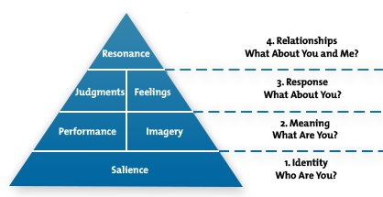
Figure 1: Keller’s Brand Equity Model
(Source: Keller, 2016)
Keller has defined a model of brand equity that helps any organisation create brand awareness in the society or the targeted market. According to this model, a brand is representing an entire organisation in the market. In addition, it makes a relationship between the customers and the organisation. Therefore, the marketing team has to present the brand in such a way that customer can get familiar with the organisation and its products. Çifci et al., (2016) commented that in the market, the organisation has to display the theme and purpose of the brand, and why the customer should go for it. The statement has deduced some reciprocal factors about the Keller’s Brand Equity Model. According to the statement as well as the proposed model, the organisation has to decide why to go with a particular brand. They need to be clear about the brand which they are planning to launch in the market.
The Body Shop has clearly defined its brand in the market, communicating the identity and meaning to their target consumers. The self explanatory brand and organisation name of The Body Shop, clearly helps define the nature of the business to customers. The organisation is very much defined by their name and the products they offer to their customers. The Body Shop has more than 17,000 outlets in all over the world, indicating they well settled in the international market (McNeish, 1999).
Apart from this, as per the concept of brand awareness and competitiveness, a large sector organisation has to be focused on their organisational goals as well as their business strategy. The business strategy of an organisation must consider the factors of brand awareness and competitiveness. It has been stated that for an organisation, success is partially measured by how far their target customers are aware of their brand or the product they are offering. Thus, the organisations must study brand awareness and competitiveness in the market at the time of framing up a business strategy. In 2006, the company collaborated with L’Oreal and thus succeed in expanding its market. This strategy ultimately enhanced the brand image of The Body Shop. Moreover, to penetrate in the isolated market such as under developed or less developed countries of Asia and Africa, the company used its strong brand image. For penetrating in the Indian market, the company slashed the prices of around 800 products by more than 35%. It has sensed that Indian market has great potential as cosmetic industry in India is still in it nascent stage. However, there are several international and local players already operating in this industry such as Himalaya, Maybelline, Revlon India, Lotus, Lakme, Biotique, Shahnaz Husain, etc. this has really made the Indian cosmetic market competitive.
In the year of 2010, the organisation has won the award of best performance in an event of Asia-Pacific awards. The body shop has been aquisized by L’Oreal in the year of 2006 but after the acquisition L’Oreal was failed to meet its customer requirements. Hence in the year of 2016, L’Oreal has been separated The Body Shop from the bonding. On the other side, The Body Shop got string level of competition from the brand L’Oreal after the acquisition because in the nation like India, L’Oreal was present since from past 15 years with its herbal and unhygienic hair therapies products. It was quite difficult for The Body Shop to compete with other hair products organisations and hence, the organisation has decided to reduce down their price range by 35%, which has made a favourable market for The Body Shop. The management has focused over the customer’s engagement process and hence implemented price skimming pricing strategy in the market. For The Body Shop it is still quite challenging to mould the buyers of L’Oreal towards them because of their quality as well as hygienic hairs colours but their pricing strategy has helped them to regain their market potentials (Bhattacharya, 2011).

4. Strategy 3: Managing reputation
It is imperative for an organisation to maintain it’s reputation in the market. Reputation has been categorised into several factors such as perception, reality, image, identity and personality. Gow et al. (2016) commented that for an organisation its reputation is all about its quality services and products that help to create an image in the market. The statement has deduced that the organisation is at either the small level or at large scale; it needs a reputation in the markets so that it can be able to enjoy the loyalty from its targeted customers in the market. The market competition factor is another element that needed to be maintained by an organisation in the market if that organisation wants to maintain its reputation.
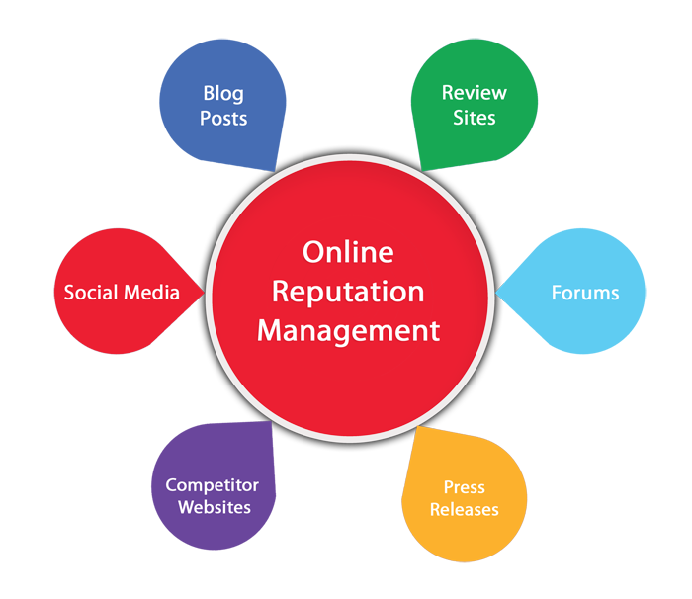
Figure 2: Online Reputation Management
(Source: L2TMedia, 2017)
As per the above figure, it has been described that an organisation can maintain its market reputation over the internet by focusing on these designed factors. As per the above discussion, it has been deduced that digital marketing is the modern marketing tool or techniques that help organisations to maintain and control their business activities easily with limited cost. The tool digital marketing is the cost-effective tool for any of organisation also this tool is affordable for both small-scale and large-scale organisation. According to the online reputation management model, an organisation has the possible chance to control its market position as well as the image in the better way. In the research paper of Hartman and Beck-Dudley (1999) it has been stated that the online marketing is a comfortable tool for an organisation and any type of business can use this tool for promoting its business and the organisation The Body Shop has made their marketing strategy in that manner. The statement has deduced that for an organisation, it is important that, the organisation’s products and services are should be in the mind of their customers and for that, digital marketing or online marketing is the best option. The blog and press release is one of the most effective factors that help an organisation to attract a customer towards them. The fact has been presented in the form that, customers are now more educated and hence they are visiting the official websites of the organisation before purchasing any product. As per the perception of the customers, most of the customers are looking for the awards and the prizes won by the organisation. Thus, it is necessary for the Body Shop to focus more on digital marketing as it is cheaper and has a wide reach.

5. Strategy 4: Retaining customers by managing the information and behaviour of the customers
Managing Information
Information management is the concept that is important to manage by an organisation in order to reduce or control the gap of information. Communication is the essential part of an organisation as has been defined by scholars in their theories. Laudon and Laudon (2013) stated that without proper information, an organisation never being able to perform its business functions in the workplace. The statement has deduced that for an organisation, the information is like essential nutrients that helps the organisation to energies its functions and produce better products and services for their targeted customers.
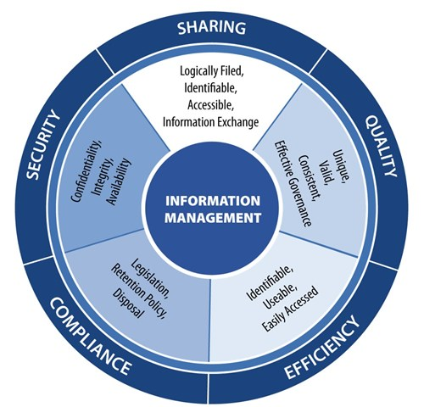
Figure 3: Information management
(Source: Klscottassociates.com, 2017)
From the above figure, it has been derived that for an organisation the information are important for an organisation. Nehler et al. (2016) stated that the end to end journey of the customers are entirely dependable over the information management system of the organisation. The statement has deduced that for an organisation the information regarding the customers are so much important by the help of which further the organisation can proceed to the next stage. The end to end journey of the customers has been stated as the reviews and the responses that are being collected by the customer care department of the organisation that includes their experience and queries regarding offered products and services.
Bhattacharya, (2011) commented that for an organisation as the information are so much important, hence they have to manage their information as per the type of the information. The statement has deduced that as same as any resources, the information also counted as an important resource for the organisation. Thus, the management has to take some step in order to secure that information as per the importance and the value of the information. The statement has also deduced that the information in the organisation is the key factors that are responsible for providing relevant information to the different departments of the organisation. In the international market, sharing of information is the bigger challenge for an organisation because they have to deal with their international customers.
In the case of the chosen organisation, The Body Shop, the organisation has already used a systematic flow of communication channel under the principle of Scalar chain. From the strategic report of the organisation, it has been noted down that the organisation is currently present in more than 20 nations and by the help of this formal communication channel, it is transferring all kinds of information from one department to other or from one branch to other (Willcocks, 2013). If complete and correct information will be available at all the stores and branches of the company, the executives will be in better position to communicate the USP of the products to the potential customers and thus it will help in enhancing the brand image of the company.
Rising expectations of customers etc.
Customers are the keychain people of the marketing function of an organisation at both domestic and international level. Customers or consumers are the end users who actually use the products and services produced by the producers. Hence, their perception is the must for an organisation especially in the international market in order to decide the future business plan.
For an organisation, buyers are the value producer and market maker. They have the full energy to set up a business in nature of best need. Bhattacharya, (2011) expressed that if an organization neglects to pull in a solitary client in the market then it will be neglected to assume control over that market from the distance. The statement has uncovered that for an organisation, every shopper is essential thus, they need to maintain concentration on the need and request of the buyer in the market. It has been characterized that consumers are the genuine resource in the outer condition of an organisation that is in charge of choosing the assembling or creation of a solitary item in the coveted market.

6. Conclusion
From the discussion, it has been articulated that the chosen organisation The Body Shop has well organised its geographical boundaries in UK as well as in the global market including emerging market. The learner has discussed about the BRICS nations in order to justify the nature of the emerging market. This discussion has deduced that, The Body Shop has faced strong level of competition from L’Oreal, well established organisation since from 15 years in India. In order to control that competition level the organisation had used price-skimming strategy and reduced down the prices as well. It is recommended that the company should adopt adaptive marketing strategy and should focus on understand the socio-economic conduction of the country where it want to expand its operations. This will significant help the company in gaining competitive edge over its rivals.

References
Armstrong, G., Kotler, P., Harker, M. and Brennan, R., 2015. Marketing: an introduction. Pearson Education.
Bhattacharya, P., 2011. The Body Shop gets closer to mass market in India. GCI Magazine, 9(3), pp.10-13.
Bhimani, A. and Willcocks, L., 2014. Digitisation,‘Big Data and the transformation of accounting information. Accounting and Business Research, 44(4), pp.469-490.
Bufe, G.M. and Repique, R.J.R., 2014. Toward a meaningful electronic health record: Tapping the expertise of the psychiatric mental health clinical nurse specialist. Journal of the American Psychiatric Nurses Association, 20(1), pp.55-57.
Chaffey, D. and Ellis-Chadwick, F., 2016. Digital marketing. Pearson.
Çifci, S., Ekinci, Y., Whyatt, G., Japutra, A., Molinillo, S. and Siala, H., 2016. A cross validation of Consumer-Based Brand Equity models: Driving customer equity in retail brands. Journal of Business Research, 69(9), pp.3740-3747.
Crane, A. and Matten, D., 2016. Business ethics: Managing corporate citizenship and sustainability in the age of globalization. Oxford University Press.
Gow, I.D., Wahid, A.S. and Yu, G., 2016. Managing reputation: Evidence from biographies of corporate directors.
Hartman, C.L. and Beck-Dudley, C.L., 1999. Marketing strategies and the search for virtue: A case analysis of the body shop, international. Journal of Business Ethics, 20(3), pp.249-263.
Hollensen, S., 2015. Marketing management: A relationship approach. Pearson Education.
Keller, K.L., 2016. Reflections on customer-based brand equity: perspectives, progress, and priorities. AMS review, 6(1-2), pp.1-16.
Klscottassociates.com. (2017). Information Management | K.L. Scott & Associates, LLC.. [online] Available at: https://klscottassociates.com/portfolio/information-management/ [Accessed 23 Dec. 2017].
L2TMedia. (2017). The Business Case for Reputation Management. [online] Available at: https://www.l2tmedia.com/2015/02/the-business-case-for-reputation-management/ [Accessed 23 Dec. 2017].
Laudon, K.C. and Laudon, J.P., 2013. Management Information Systems 13e.
McNeish, J., 1999. HRD in a values-driven business: The Body Shop International plc. Human Resource Development International, 2(3), pp.283-287.
Maechler, N., Nehler, K. and Park, R., 2016. From touchpoints to journeys: Seeing the world as customers do. McKinsey and Company. Available at: http://www. mckinsey. com/business-functions/marketing-and-sales/our-insights/fromtouchpoints-to-journeys-seeing-the-world-as-customers-do.
Renfro, W. and O’Reilly, M., 2014. Decline or Not: America’s Continued Primacy in the Persian Gulf. In The American Election 2012 (pp. 215-227). Palgrave Macmillan US.
Ryan, D., 2016. Understanding digital marketing: marketing strategies for engaging the digital generation. Kogan Page Publishers.
The Guardian. (2017). Interview: Anita Roddick, Body Shop founder. [Online] Available at: https://www.theguardian.com/business/2006/nov/03/ethicalliving.environment [Accessed 29 Dec. 2017].
Thebodyshop.com. (2017). About Us | The Body Shop. [online] Available at: https://www.thebodyshop.com/en-gb/about-us [Accessed 23 Dec. 2017].
Willcocks, L., 2013. Information management: the evaluation of information systems investments. Springer.
Sharma, A. 2010. India is a pillar of future growth: The Body Shop. [Online]. Available through: < https://economictimes.indiatimes.com/opinion/interviews/india-is-a-pillar-of-future-growth-the-body-shop/articleshow/5841771.cms> [Accessed on 11th January, 2018].

Appendix
Poster
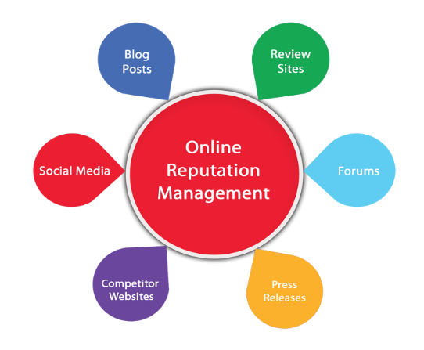
Globalisation and a changing business environment
The Body Shop, the organisation has started its journey in the year of 1976. From the earlier stage to the current stage, the organisation has faced several ups and down, not always in the money but also non-monetary form. In the centre are institutional plans that accommodate some administrative bearing of financial movement occurring abroad yet hold back before controlling responsibility for business carrying on the action, for instance, joint endeavours with privately claimed business or with remote governments.
Continual rise of digitalisation
SEO
SMO
PPC
ECRM

Increasing brand awareness and competitiveness
Keller’s Brand Equity Model

Managing reputation

Information management
Rising expectations of customers etc.
Customers are the keychain people of the marketing function of an organisation at both domestic and international level. Customers or consumers are the end users who actually use the products and services produced by the producers. Hence, their perception is the must for an organisation especially in the international market in order to decide the future business plan.

