4/28/2026
University of Wales Trinity Saint David
london campus
Code Link: https://github.com/IgorZ121103/Sample-Project1.git
SPC Assignment 1
Student Equipment Booking System
Module Name: Scripting and Programming Concepts
Module Code: ACCA 5036
Student Name: Igor Zabolotnii
Student ID: 2414255
Lecturer’s Name: Koushik Modak

Introduction 3
Main Body 4
Analysis 4
Requirements Analysis 4
Functional Requirements: [2] 4
Non-Functional Requirements: [3] 5
Software Design and Development 6
Design 6
Flowchart 6
Pseudo-code 8
Implementation Decisions 12
Data Structures 12
Programming Constructs 13
Python Modules and Libraries 15
Source Code 15
Testing and Debugging Report 17
The importance of program testing in software development 17
Types of errors in programming 17
Test cases 19
Evaluation 20
Challenges Faced 21
Future Improvements 22
Self-Reflections 22
Conclusion 24
References 25

Introduction
The development of educational software systems is an essential area in the context of the digitalization of academic institutions, where efficient management of resources and equipment becomes an operational necessity. The Student Equipment Booking System project is part of this direction, with the main objective of creating a functional, intuitive and easy-to-use application that allows the management of equipment reservations in an organized and transparent manner. In a university environment, where laptops, tablets and projectors are frequently used for teaching activities, such a system contributes to the optimization of administrative processes and the reduction of human errors associated with manual inventory management.
This paper presents the entire process of analysis, design, implementation and testing of the application, emphasizing how the functional and non-functional requirements were identified and translated into a coherent software solution. The initial analysis allowed the clear definition of essential functionalities, such as adding equipment, registering reservations, checking stock, searching and deleting records, as well as managing access through a simple authentication mechanism. In parallel, the non-functional requirements guided the development of a reliable, accessible and easily extensible system, capable of meeting user needs without compromising performance or data security.
The software design included the creation of a detailed flowchart and the related pseudocode, which contributed to the logical structuring of the application and the clarification of data flows. These tools facilitated the transition to the implementation stage, where appropriate data structures (dictionaries and lists), efficient control constructs and rigorous validations of user input were used. The choice of the Python language was justified by the simplicity of the syntax, the flexibility offered and its relevance in the academic environment.
Testing and debugging were critical stages in ensuring the quality of the application. By identifying and correcting syntactic, logical and runtime errors, the system was refined to provide a stable and predictable user experience . The tests included both positive and negative scenarios to evaluate the application's behavior under various conditions and to prevent unforeseen situations.
Overall, the project not only allowed the development of a functional application, but also provided a valuable learning opportunity, strengthening analysis, design, programming and testing skills. This paper documents the entire process, highlighting both the results obtained and personal reflections on my evolution as a developer.

Main Body

Analysis
The project proposes the development of a simple reservation management system, implemented in Python, that would allow adding equipment, recording reservations, viewing and searching for them, as well as alerting staff when they want to reserve an item, but it is already out of stock. This analysis explores in detail the functional and non-functional requirements of the system, justifies its need, and establishes the conceptual framework for further implementation.

Requirements Analysis
The requirements analysis is the foundation of the project. Id defines what the system must do and how it must behave. By clearly defining functional and non-functional requirements, the project establishes a solid foundation for subsequent implementation in Python. These requirements are detailed below along with their justification [1].

Functional Requirements: [2]
- Add new equipment and check the stock
The system allows new equipment to add in inventory. Each equipment has:
- a name (e.g. “Laptop1”)
- a quantity (0 or 1)
This functionality is essential for maintaining an updated record. Since the center may periodically purchase new equipment, the system must be flexible and easy to expand. It also allows viewing all equipment in stock.
- Record booking
The system allows recording a reservation. A reservation contains:
- the student’s name
- the type of equipment reserved
- the date of the reservation
In addition, the system automatically checks if the equipment is in stock before confirming the reservation.
- View booking records
The user can view all existing reservations. The display includes:
- A complete listing of reservations
This function provides transparency and allows the user to quickly check the status of reservations.

- Simple search and delete record
The system includes a search function to quickly identify a reservation by:
- name
- equipment
It also allows deleting a reservation, if it was canceled or entered incorrectly.
- Low-Booking Alerts
The system warns users when the stock of an equipment is not available when the reservation is made.
- User-Friendly Interface
The application is simple, the interface is intuitive. In the case of this project, the interface is:
- console-based
- structured in clear menus
- easy to navigate
Users are not programmers, the system is created to be accessible and easy to use.
- Scalability
Even if the system is simple, it must be designed so that it can be expanded in the future. Possible extensions:
- database integration
- graphical interface
- user authentication
- report export
As an example, I created an authentication to enter the system.

Non-Functional Requirements: [3]
- Reliability
The system worked correctly and did not lose data. Since the data is stored in lists and dictionaries, the program correctly handles errors and prevents the entry of invalid data. Examples of measures:
- input validation
- stick checking before booking
- exception handling

- Performance
The application responds quickly to commands. Since the data volume is small, performance is not a major problem, but the code structure is efficient. Examples:
- quickly list searches
- simple and optimized operations
- Security
Even is the system does not manage sensitive data, it is important to prevent:
- invalid data entry
- unauthorized access
- accidental data modification
- Accessibility
The system is accessible to all users, regardless of their technical level. The interface is clear, readable and does not require advanced knowledge. Examples:
- explicit messages
- numbered menus
- clear instructions

Software Design and Development

Design
Software design is the foundation of implementation. In this stage, the logical structure, data flows, and how the user interacts with the system are defined. For this project, the design is represented by [4]:

Flowchart
The diagram begins with “Start”, followed by the authentication process. The program asks for the password and checks if it is “admin”. In the flowchart, this appears as a decision block: if the password is wrong, the user is sent back to the same step; if it is correct, the flow continues to the main menu.
After authentication, the flowchart enters a main loop, represented by the while True: in the code. This loop keeps the program active until the user selects the exit option. Inside it is the main menu, which offers five options: manage the equipment list, register a reservation, view reservations, search and delete a reservation, and exit the program. In the diagram, each option is represented by a numbered decision node (IF 1 – IF 5).
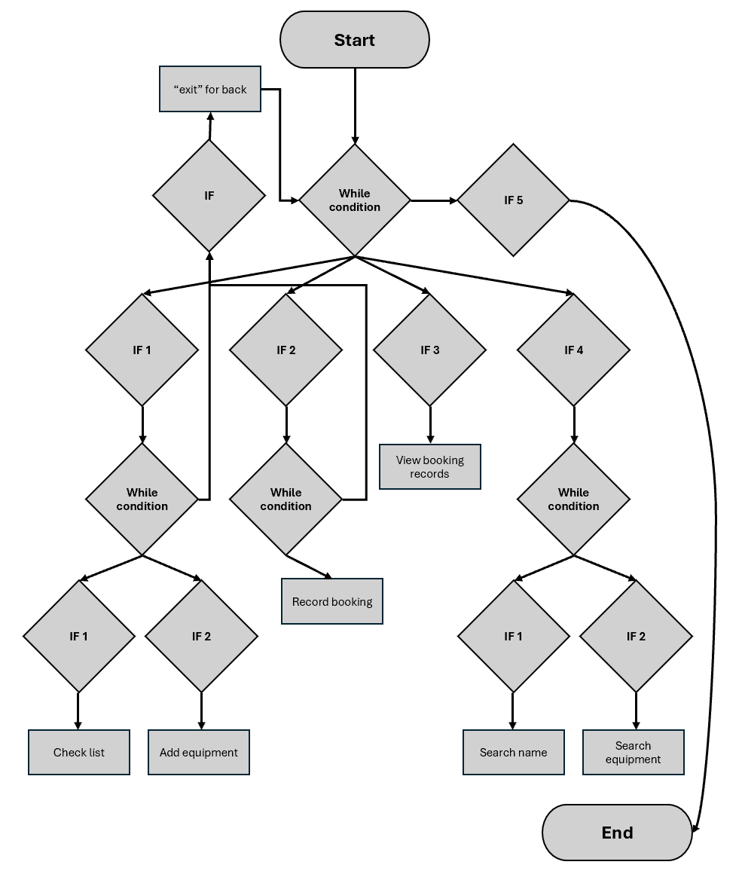
The first option leads to a submenu where the user can view the complete list of equipment or add a new item. The flowchart shows this bifurcation by an additional decision block. If the list view is chosen, the flow goes through the “Check list” action, corresponding to the check_list() function. If the equipment is chosen, the flow goes through the “Add equipment”, reflecting the add_equipment() function. In both cases, the flow then returns to the main menu.
The second option, “Record booking”, leads to the process of recording a booking. The flowchart shows an action block for entering the name, item and date, followed by a check for the availability of the item. If the stock is zero, the flow leads to the message “Not in stock”. If the item is available, the flow continues to decrease the stock and confirm the booking, then returns to the main menu.
The third option, “View booking records”, is simply represented by a block for displaying all existing bookings, after which the flow returns to the main loop.
The fourth option, “Search Person and delete”, is more complex and includes a submenu with two directions: search for a person or search for an item. The flowchart shows this choice through a decision block. If a person is being searched for, the flow goes to the search_name(s) function; if an item is being searched for, the flow goes to the search_item(s). In both cases, the flowchart includes an “IF found?” check. If there are no matches, the appropriate message is displayed. If there is a match, the reservation details are displayed, followed by a decision loop that asks if the user wants to delete the record. If the answer is “YES,” the flow goes to “Delete record,” which deletes the reservation and updates the inventory. If the answer is “NO,” the flow returns directly to the main menu.
The last option, “Exit,” is represented by an end block that breaks the main loop and leads to “End.”

Pseudo-code
The process of turning your Python code into clear pseudocode begins with analyzing the list initialization section. In this step, the goal is to strip away the language-specific syntax and keep only the logical structure of the data. Python dictionaries are converted to pseudocode as collections of key-value pairs, because the pseudocode must be independent of any programming language [5].
For the add_equipment function, the pseudocode must clearly reflect the inventory update logic. We start by identifying the main action: checking whether an item exists in the list. In the pseudocode, the condition “if name in list” is transformed into a natural sentence such as “IF name EXISTS in equipment_list”. Python operators such as += are replaced with descriptive expressions, such as “quantity = quantity + stock”, to avoid technical details.
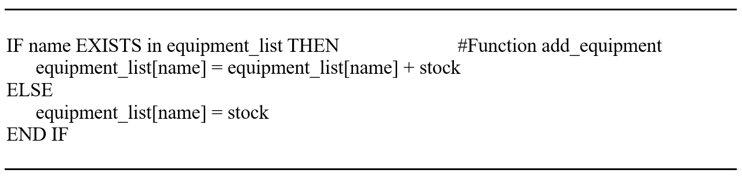
The record_booking function requires pseudocode that captures both the booking record and the availability check. In pseudocode, assigning a reservation is simply expressed as “SET booking_list[name] = (item, date)”. The condition that checks for the existence of the item in the list is transformed into a clear statement, without Python syntax. The stock check is expressed as a straightforward logical condition, and the messages are preserved for clarity, even though the pseudocode does not use specific display functions. The stock decrease is described naturally, without technical operators.
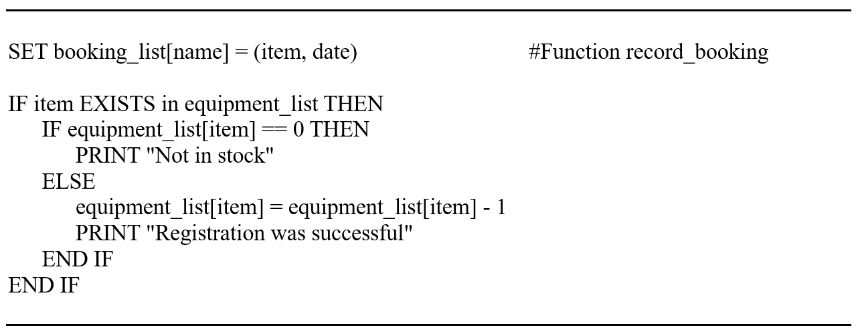
The search_name function is transformed into pseudocode by simplifying the iteration structure and the inner confirmation loop. In pseudocode, the “for n in bookinglist” loop becomes a natural formulation like “FOR EACH name IN booking_list”. The name comparison is expressed as a logical statement, without Python method calls. Infinite loops are given a clear description, like “LOOP FOREVER”, to preserve the original behavior.
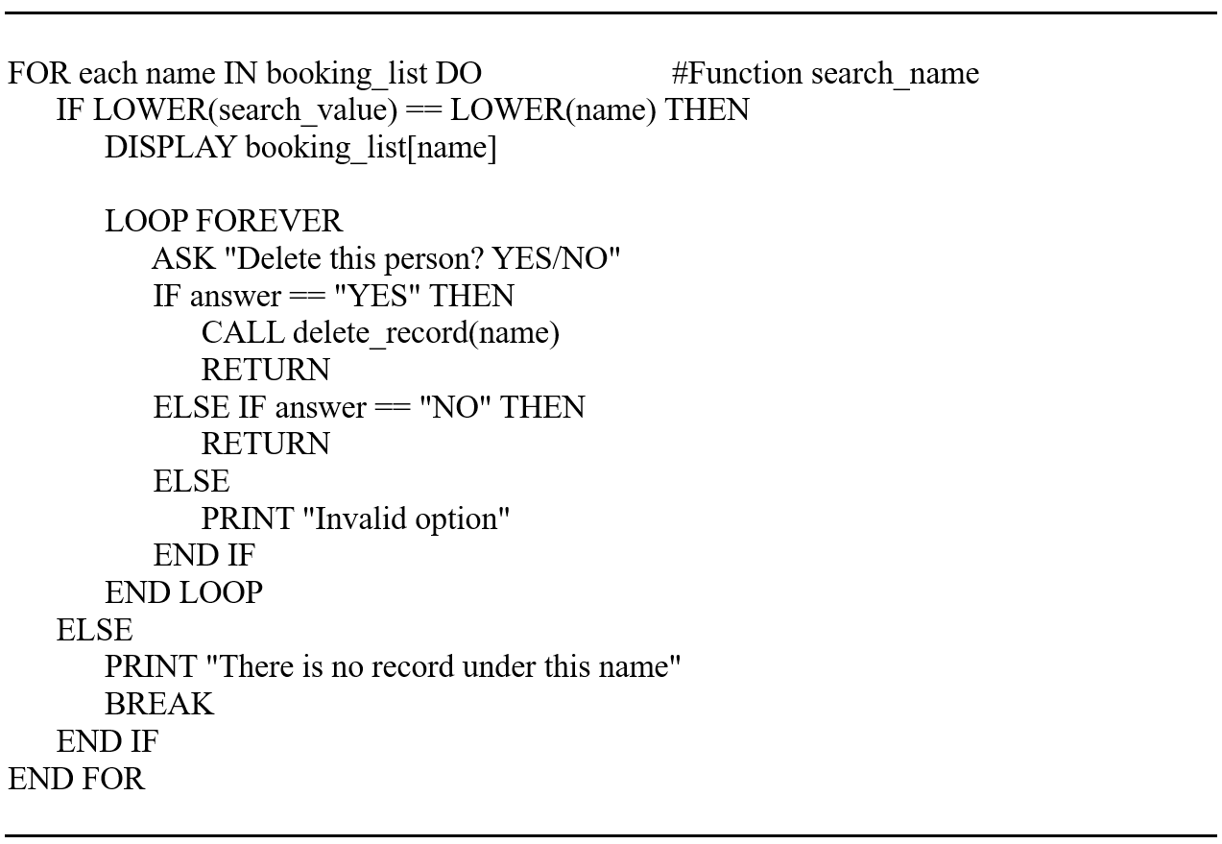
The search_item function is treated similarly, but with the emphasis on iterating over both the name and the booking elements. In pseudocode, this double iteration is expressed as two consecutive loops, described naturally.
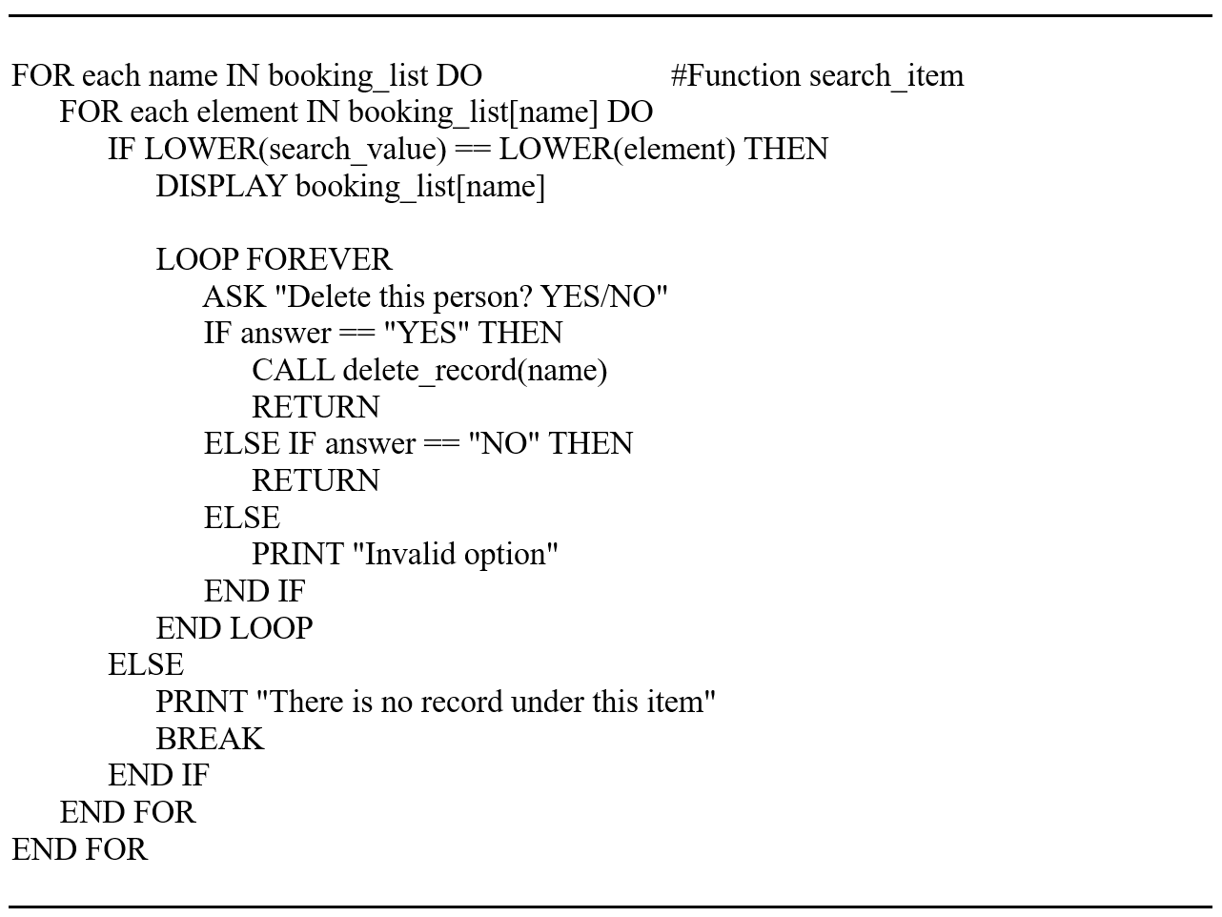
The delete_record function is transformed into pseudocode by simplifying the operations of deleting and updating the inventory. In pseudocode, removing a record is expressed as “REMOVE booking_list[name]”, without technical details. Checking the existence of the item in the list is formulated naturally.
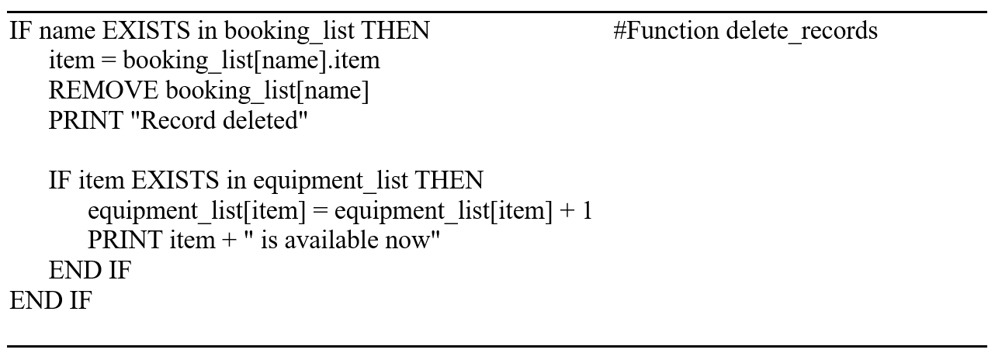
The check_list function is simplified into pseudocode by transforming the loop into a natural formulation. In pseudocode, the list traversal becomes “FOR EACH item, quantity IN equipment_list”. The pseudocode is to make it clear that the function only lists the contents of the inventory. Thus, this part becomes a simple and clear sequence.
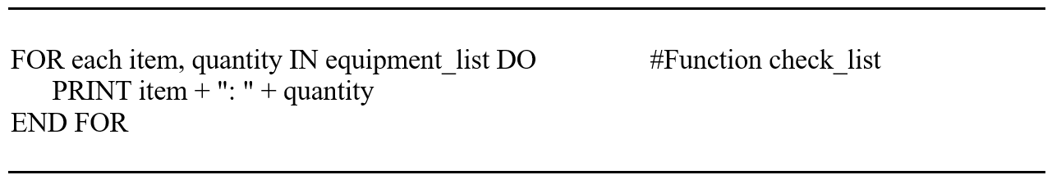
The authentication section is transformed into pseudocode by removing the Python syntax and preserving the loop logic. In pseudocode, the loop becomes “WHILE password != admin”.
The main menu is transformed into pseudocode that reflects the structure of the infinite loop and decision branches. In pseudocode, the menu is described by a sequence of displays and an option reading. The submenus are described as separate logical sequences, but integrated into the main flow. The pseudocode clearly shows when the program continues, when it returns to the menu, and when it stops. Thus, the entire program becomes a coherent, easy-to-follow, and programming language-independent logical description.
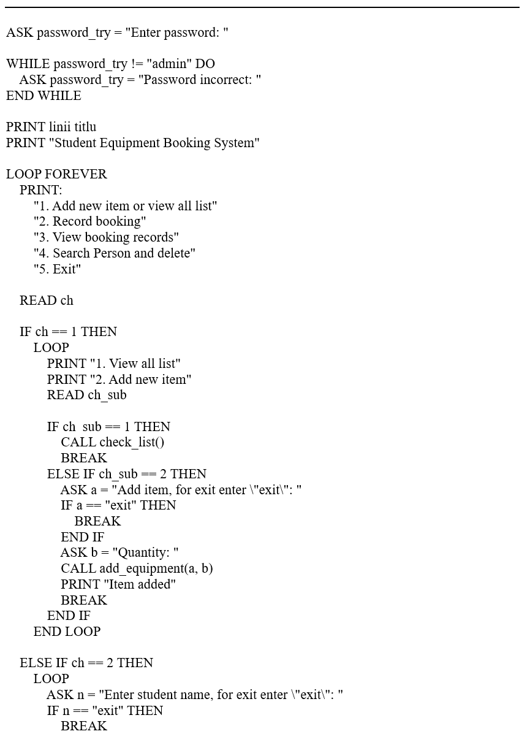
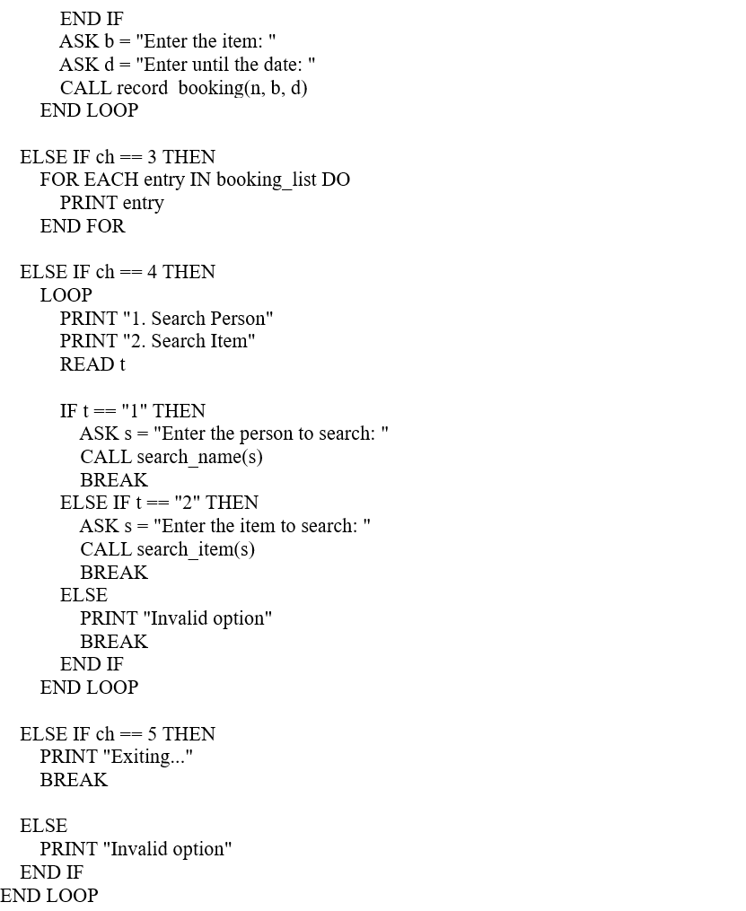

Implementation Decisions

Data Structures
The choice of data structures was guided by the need to store simple, easy to access and modify information, without using a database.
The program manages two main types of information [6]:

- Equipment list
I used a list-type structure to store the names of the available equipment.
Advantages:
- Allows sequential browsing with for.
- Allows quick display of all equipment.
- It is easy to modify (add/remove).
- Reservation list (dictionary list)
Each reservation is represented by a dictionary, of the form:
{
"student": "...",
"equipment": "...",
"data": "..."
}
Advantages:
- The dictionary allows accessing values ​​by clear keys (student, equipment, data).
- The structure is flexible and can be extended (e.g. adding an ID, status, etc.).
- The list allows you to store multiple reservations and browse through them easily.
- Variables used
Your program uses simple variables for:
- username / password – for authentication.
- choice – for menu options.
- student_name, equipment_choice, booking_date – for collecting user input.
- found – Boolean variable used for searches (e.g. checking for the existence of a reservation).
These variables are simple, clear, and suitable for a procedural program.

Programming Constructs
- Control Structures (if, elif, else)
I used branches to:
- verify authentication;
- validate menu options;
- check for the existence of equipments
- check for the existence of a reservation before deleting.
Justification:
- if/elif/else is the most suitable structure for decision logic.
- Allows clear control over the program flow.
- Avoids errors and ensures correct validations.
- Loops (while, for)
While True
Used for:
- main menu;
- repeating the program until the user chooses the exit option.
Why I used:
- Interactive menus naturally use infinite loops controlled by break.
- Allows the user to perform multiple actions without restarting the program.
For loops
Used for:
- displaying equipment;
- browsing reservations;
- searching for a reservation to delete.
Advantages:
- Simple and efficient for browsing lists.
- Reduces code complexity.
- Lack of functions (def)
I chose not to use functions, and the program remains procedural.
- For a simple educational project, a procedural style is acceptable.
- The logic is linear and easy to follow.
- Avoids additional complexity for beginners.
However, in a larger project, functions would improve modularity.
- Error Handling
Even if you didn't use try/except, you implemented error handling logic by:
- checking for invalid menu options;
- checking for the existence of the device before booking;
- checking for the existence of the reservation before deleting;
- validating the date format using the datetime module.
This type of error handling is suitable for a simple program [7].

Python Modules and Libraries
- The datetime module
You used datetime to:
- validate the format of the date entered by the user;
- prevent the entry of invalid dates (e.g. 02/31/2024).
Justification:
- datetime is a standard, robust and secure module.
- It avoids logical errors related to dates.
- It allows for further extension (e.g. checking if the date is in the future).
- Why didn't you use other modules
Your program does not require:
- databases,
- graphical interfaces,
- advanced processing.
The choice to use only datetime is justified by the simplicity of the project [8].

Source Code
Testing and debugging are two of the most important phases in the software development lifecycle, ensuring that the final product is reliable, functional, and capable of handling real-world usage. In the context of the Student Equipment Reservation System, testing was essential to verify that the program correctly handles user authentication, equipment listing, reservation creation, reservation deletion, and data validation. Debugging complemented this process by identifying and correcting issues that could compromise the program's behavior. This report explains the importance of testing, describes the types of programming errors encountered, and presents the test cases used to validate the system's functionality under both correct and incorrect user input conditions [9], [10].
Importance of Programme Testing in Software Development
In this project, testing played a key role in confirming that the reservation system responds appropriately to user actions, prevents invalid operations, and maintains data integrity.
Testing also improves the user experience. A system that handles errors gracefully, provides clear feedback, and prevents invalid inputs is more intuitive and reliable. For example, the program must reject invalid data, prevent booking nonexistent equipment, and ensure that menu options outside the valid range do not cause unexpected behavior. Through systematic testing, these aspects were verified and refined.
Another important benefit of testing is identifying edge cases—situations that may not occur frequently but can cause failures if not handled. Examples include empty input fields, incorrect date formats, or attempts to delete a reservation that does not exist. By testing these scenarios, the program becomes more robust and resilient.
Types of Errors in Programming and How to Fix Them
During development, two main categories of errors were encountered: syntax errors and logical errors. Understanding these types of errors and how to fix them is essential to producing a working program.
Syntax Errors:
Syntax errors occur when code violates the rules of the programming language. These errors prevent the program from running and are usually caught immediately by the Python interpreter. Examples include missing colons, incorrect indentation, misspelled keywords, or incorrect parentheses.
In this project, typical syntax errors included:
- missing a colon after an if or elif statement
- incorrect indentation inside loops
- missing quotes around strings
These errors were fixed by carefully reviewing the error messages provided by Python, which indicate the line number and type of syntax problem. Correcting the code structure quickly resolved these issues.
Logical errors
Logical errors occur when a program runs without crashing, but produces incorrect or unexpected results. These errors are more difficult to detect because the code is syntactically correct, but the logic behind it is flawed.
Examples of logic errors encountered in this project include:
- allowing a reservation to be created even if the equipment name was misspelled
- failing to observe when a reservation did not exist during deletion
- accepting an invalid date format before implementing validation
- displaying incorrect menu messages due to misplaced conditions
Logic errors were fixed through debugging techniques such as:
- printing variable values ​​to track program flow
- testing each menu option individually
- verifying conditions inside loops and if statements
- validating user input before processing it
By analyzing the program's behavior and comparing it to the expected results, these logic problems were identified and corrected.

Testing and Debugging Report

The importance of program testing in software development
Program testing is one of the most important stages of software development, as it ensures that the application works correctly, is stable, secure and provides a predictable user experience. Without testing, even a well-written program can contain hidden errors that lead to crashes, data loss or unexpected behavior. In practice, testing is the process of verifying that the program does exactly what it is supposed to do, in all possible situations [11].
A program can work perfectly under ideal conditions, but it can fail when the user enters incorrect data, when unforeseen situations arise or when the internal logic does not cover all cases. Therefore, testing is not limited to checking the main functionalities, but also includes testing of limits, error behavior, input validation and interactions between different components of the application.
In modern software development, testing is integrated into every stage: from testing small units of code (unit testing), to integrated testing, system testing and acceptance testing. The ultimate goal is the same: reducing risk and increasing the quality of the final product.
In the case of my student equipment management application, testing is essential to prevent situations such as:
- duplicate reservations for the same equipment,
- stock dropping below zero,
- searches returning the wrong results,
- accidental deletion of records,
- displaying incorrect messages to the user.
Without testing, these issues could go unnoticed until real users experience difficulties, which affects trust in the system.

Types of errors in programming
- Syntax errors
These occur when the programmer writes code that does not follow the rules of the language [12]. For example:

- missing parentheses,
- missing colon after an if,
- incorrect indentation in Python,
- using the wrong keyword.
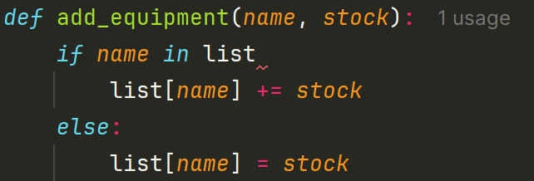
Missing : after condition “if”→ the program does not even start.
Correction: careful syntax checking, using an IDE with highlighting and auto-complete.
- Logical errors
The First:
These are the most dangerous, because the program runs, but produces wrong results.
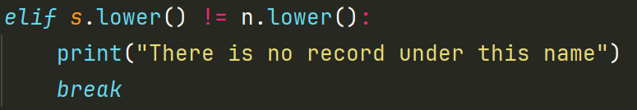
This condition is executed on the first name that does NOT match, even if there is a match later.
Consequence:
If you have records for "Igor" and "Maria", and you search for "Maria", the program may say "There is no record under this name" before it reaches Maria.
Fix:
Use a flag, or exit the loop only after all elements have been checked. Such as "for n in list bookinglist"
The Second:
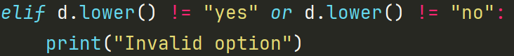
This condition is always true, because a string cannot be both "yes" and "no".

Correction:
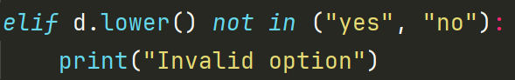
The Third
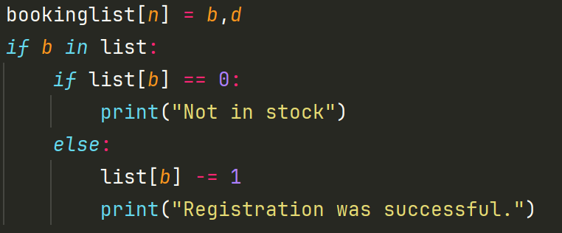
If the item does not exist in the list, an invalid booking is still created.
Correction:
First check if the item exists, then create the booking.
- Runtime errors
ValueError
If the user enters "abc", the program crashes.
KeyError
For example if try to access an item that does not exist in the dictionary
TypeError
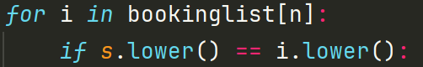
bookinglist[n] is a tuple → the elements can be strings, but if the structure changes, a TypeError occurs.

Test cases
Testing the search_name() function
Test 1 – Search for an existing name
Input: “Igor”
Expected result: Display the item and date
Ask if you want to delete
Possible wrong result:
If there are multiple records and the first name does not match, the program displays: “There is no record under this name” and exits the loop.
Test 2 – Search for a non-existent name
Input: “Andrei”
Expected result: “There is no record under this name”
Possible wrong result:
If the first name does not match, display the correct message, but if there are multiple records, do not check the rest.
Testing the main menu
Enter a letter instead of a number
Input: “abc”
Expected resu lt:Error message
Re-enter option
Current result: The program crashes with ValueError.
Testing the delete_record() function
Correct deletion
Input: “Igor”
Expected result: Deletes the record
Increases the item’s stock
Possible wrong result: If the item does not exist in the list (e.g. it was misspelled), a KeyError occurs [13].

Evaluation
The realization of the Student Equipment Booking System project represented a significant opportunity to deepen my skills in programming, logic analysis and software design. The development process involved both technical activities and reflections on how to build a functional, robust and easy-to-use system.

Challenges Faced
One of the first difficulties encountered was related to the data structure and the optimal way to organize the information. I chose to use a dictionary for managing equipment and reservations, an efficient solution for a small project. However, as I expanded the functionalities, I noticed that this structure required increased attention in terms of accessing and manipulating data. For example, reservations were stored as tuples, and accessing their elements in the search or delete functions required carefully constructed logic to avoid errors or incorrect accesses.
Another major challenge was the management of logical errors. Unlike syntax errors, which are easy to identify because they prevent the program from running, logical errors are much more subtle. The program may run seemingly normally, but may produce incorrect results. A relevant example is the name search function, where the program displayed the message "There is no record under this name" even though the record existed, because the comparison was performed incorrectly within the loop, now it is correct. This situation led me to carefully analyze the logical flow of the program and understand the importance of checking all conditions before generating a final message for the user.
Also, validating user input was a constant source of difficulty. The program relied on entering numeric values ​​to navigate the menu, and accidentally entering an invalid character would generate a ValueError, causing the program to stop. This problem taught me that robust software must be prepared for unforeseen situations and handle errors gracefully, without compromising the user experience.
Another challenge was related to the reservation logic. Initially, the reservation was created before checking the availability of the equipment, which could lead to situations in which a student appeared registered with an unavailable equipment. This problem forced me to rethink the order of operations and understand the importance of prior data validation. It was a useful exercise in logical discipline and understanding how workflows should be structured to prevent inconsistencies.
Ultimately, systematic testing was a challenge in itself. At first, I was testing the program with just a few manual runs, but as the project grew, I realized that testing needed to be a continuous and rigorous process. I started creating test cases for each function, checking behavior in boundary conditions, and identifying scenarios where the program behaved unexpectedly. This stage helped me understand the importance of testing in software development and its role in preventing errors before they reach the end user.

Future Improvements
Although the project fulfills its basic functions, there are many directions in which it can be expanded and improved. One of the most obvious improvements would be the implementation of a graphical interface. Currently, the application works exclusively in the command line, which limits accessibility for ordinary users. A graphical interface made with Tkinter, PyQt or even a web application would transform the system into a much more intuitive and user-friendly tool.
Another important direction is the introduction of a database for persistent storage of information. In its current form, data is stored in memory and is lost when the program is closed. Using an SQLite database or JSON files would allow for long-term data retention and would facilitate the expansion of the system with additional functionalities, such as reservation history or report generation.
The system could also benefit from more advanced data validation. In the future, I could implement checks for date format, prevention of duplicate reservations, automatic checking of equipment availability or notifications for returned equipment. These improvements would significantly increase the robustness and professionalism of the application.
Finally, the system could be extended to include different roles (administrator, student, teacher), secure authentication and a reporting module. These functionalities would transform the project into a complete application, usable in a real educational environment [14], [15].

Self-Reflections
Looking back, this project was an important milestone in my development as a programmer. I learned that programming is not just about writing code, but also involves rigorous logical thinking, the ability to anticipate unforeseen scenarios, and attention to detail. I understood that a functional program is not necessarily a robust program, and that testing is essential to identify and correct hidden errors.
I also learned to adopt a more structured approach to writing code. I started to pay more attention to modularity, function reuse, and code clarity. I understood the importance of comments, meaningful names, and logical organization of functions. These skills are fundamental for any developer, and I feel like I made significant progress in this direction.
Another important aspect of the learning process was developing a problem-solving mindset. Every error I encountered became a learning opportunity, and every challenge helped me improve my technical skills and analytical ability. I learned not to rush into implementation, but to carefully analyze each step and anticipate the consequences of my decisions.
Ultimately, this project strengthened my confidence in my own abilities. I started with a basic set of knowledge, but through perseverance, testing and reflection I managed to create a functional and extensible system. The experience I gained motivates me to continue learning, exploring new technologies and improving my skills as a software developer.

Conclusion
The realization of the Student Equipment Booking System project represented an important stage in my development as a programmer, giving me the opportunity to apply fundamental concepts of software analysis, design and implementation in a practical context. By going through all the stages — from defining the requirements to the final testing — I managed to build a functional, coherent system adapted to the needs of an educational environment.
The project highlighted the importance of a rigorous analysis of the requirements, which allowed for a clear structuring of the functionalities and avoiding ambiguities in the implementation. Also, the design process, carried out through flowcharts and pseudocode, contributed to a deeper understanding of the logical flows and to the prevention of errors before the actual writing of the code. The implementation in Python demonstrated the usefulness of simple data structures, such as dictionaries and lists, in the efficient management of information.
Testing and debugging played an essential role in strengthening the quality of the application. The identification of logical errors and input validation issues highlighted the fact that a seemingly functional program can hide significant vulnerabilities. Through systematic testing, I was able to improve the stability of the system and ensure predictable behavior in various scenarios.
From a personal perspective, the project contributed to the development of analytical thinking and a structured approach to problem solving. I learned to anticipate unforeseen situations, analyze the causes of errors, and adopt effective solutions. This experience strengthened my confidence in my ability to design and implement functional software applications and prepared me for more complex future projects.

References

[1] | K. Wiegers and J. Beatty, Software Requirements, Redmond, WA: Microsoft Press, 2013.
[2] | S. Robertson and J. Robertson, Mastering the Requirements Process: Getting Requirements Right, Boston, MA: Addison-Wesley, 2012.
[3] | K. Wiegers and C. Hokanson, Software Requirements Essentials: Core Practices for Successful Business Analysis, Seattle, WA: Process Impact, 2022.
[4] | I. Sommerville, Software Engineering, Boston, MA: Pearson, 2016.
[5] | R. S. Pressman and B. R. Maxim, Software Engineering: A Practitioner’s Approach, New York, NY: McGraw-Hill, 2015.
[6] | M. Lutz, Learning Python, Sebastopol, CA: O’Reilly Media, 2013.
[7] | J. Zelle, Python Programming: An Introduction to Computer Science, Franklin: Franklin, Beedle & Associates, 2016.
[8] | P. S. Foundation, “Python Standard Library Documentation,” 2024. [Online]. Available: https://docs.python.org/3/library.
[9] | P. Ammann and J. Offutt, Introduction to Software Testing, Cambridge: Cambridge University Press, 2016.
[10] | G. J. Myers, C. Sandler and T. Badgett, The Art of Software Testing, Hoboken, NJ: Wiley, 2011.
[11] | S. McConnell, Code Complete, Redmond, WA: Microsoft Press, 2004.
[12] | A. Hunt and D. Thomas, The Pragmatic Programmer, Reading, MA: Addison-Wesley, 1999.
[13] | R. Black, Foundations of Software Testing: ISTQB Certification, Boston, MA: Cengage Learning, 2012.
[14] | R. S. Pressman and B. R. Maxim, Software Engineering: A Practitioner’s Approach, New York, NY: McGraw-Hill, 2015.
[15] | I. Sommerville, Software Engineering, Boston, MA: Pearson, 2016.

