March 1, 2024
Lecturer: Kathryn Flynn

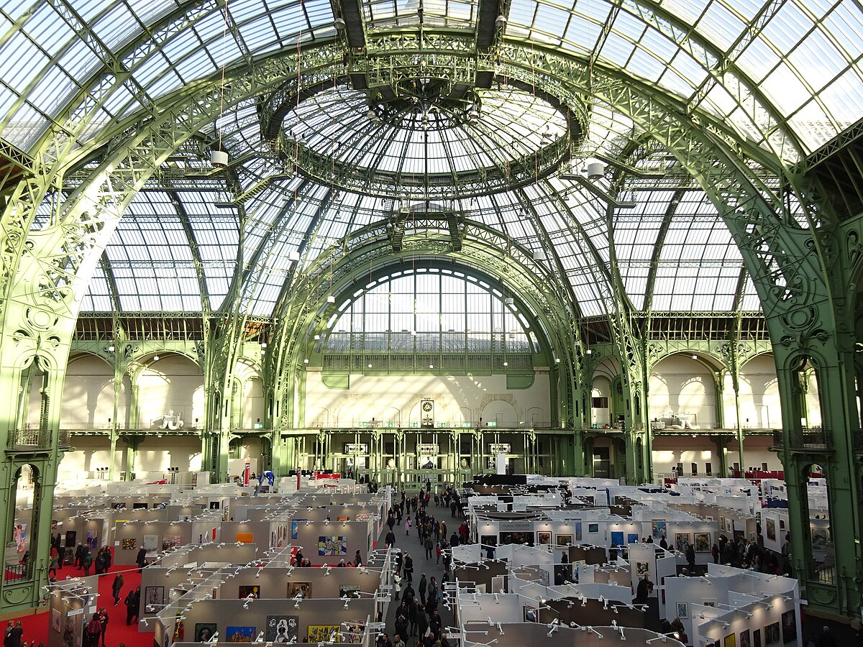  ENHANCING ENVIRONMENTAL SUSTAINABILITY EVENT PLANNING AND DELIVERY CONSIDERATIONS FOR AN INTERNATIONAL MEETING  Name of Event Theme: Sustainability | Mohammad Shahidul Islam Chowdhury (Student ID:2026960)  Module: International Meetings Management for the Hotel Industry BMIH6007

Lecturer: Kathryn Flynn
[Company address]

Lecturer: Kathryn Flynn
[Company address]

Lecturer: Kathryn Flynn
[Company address]
Table of Contents

1. Introduction .........................................................................................................1
2. EMBOK Model ……………...................................................................................2
3. The Event Cycle ..................................................................................................3
4. Event Concept .....................................................................................................4
5. Aim and Objectives of the Meeting / Event ......................................................5
6. Event Operations ................................................................................................6
7. Event Budget …………………..............................................................................7
8. Industry Trends/Impacts ...................................................................................8
9. Cultural and Situational Considerations …………………................................8
10. Conclusion ......................................................................................................10
11. Reference List .................................................................................................11

- Introduction
The global fashion industry, renowned for its vibrant dynamism and trendsetting designs, is also a significant contributor to environmental degradation, making sustainability not just a choice but a necessity. Recognizing this critical challenge, the proposed international meeting, a sustainable garments exhibition event, aims to serve as a beacon of change within this sector. Scheduled to take place in London, United Kingdom—a nation celebrated for its commitment to innovation, sustainability, and green initiatives—this event is strategically positioned to draw attention from industry leaders, fashion designers, environmental activists, and the global community alike.
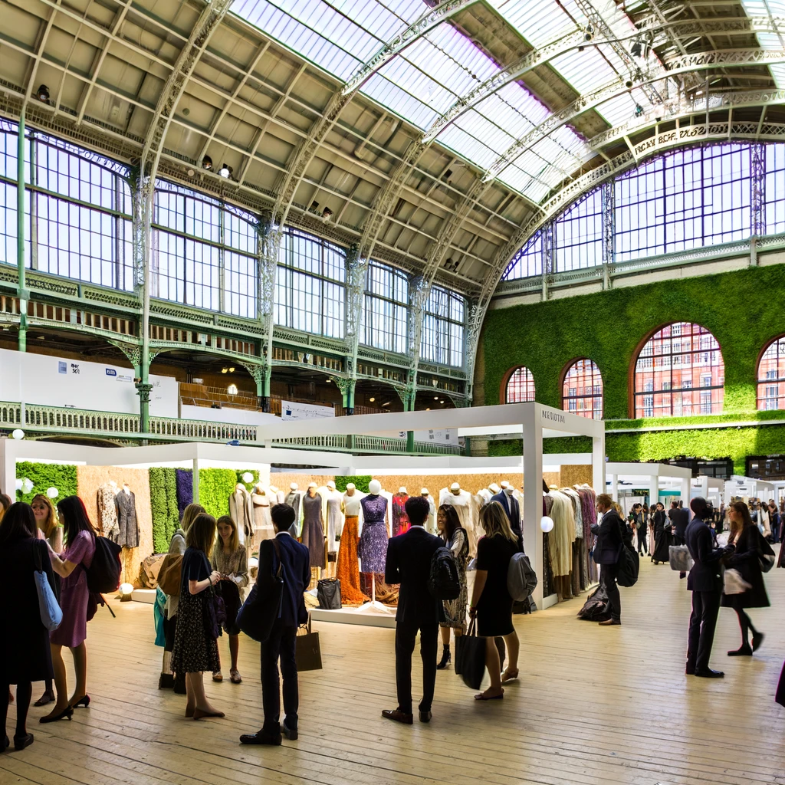
By focusing on sustainability, the event seeks to showcase the latest in eco-friendly fashion, promoting practices that reduce waste, lower carbon footprints, and encourage the recycling and upcycling of materials. This gathering is chosen not only for its potential to foster a shift towards more sustainable fashion practices but also to highlight the hospitality industry's role in facilitating environmentally responsible events. Through this exhibition, we aim to create a platform for dialogue, innovation, and collaboration, driving forward the agenda for a more sustainable future in fashion and beyond. This introduction sets the stage for a comprehensive exploration of the event's strategic planning and delivery considerations, underpinned by a commitment to environmental stewardship and sustainable development.

- EMBOK Model
The EMBOK (Event Management Body of Knowledge) model provides a structured framework essential for the efficient and effective management of our sustainable garment exhibition. By integrating EMBOK's five key domains—Administration, Design, Marketing, Operations, and Risk Management—we ensure a comprehensive approach to the event's planning and delivery, focusing on sustainability at every stage.
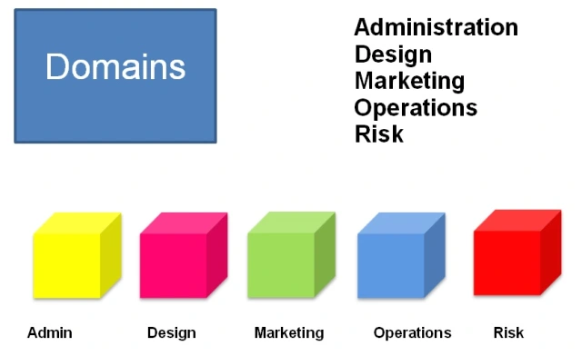
Administration focuses on the foundational aspects of event planning, such as budgeting, scheduling, and compliance. For the sustainable garment exhibition, this involves establishing a clear organizational structure, defining roles and responsibilities, and ensuring all activities align with sustainability objectives.
Design encompasses the creative elements, including theme development, content programming, and the attendee experience. The event will feature eco-friendly fashion showcases, interactive workshops, and keynote speeches from sustainability leaders, all designed to engage and educate attendees on sustainable practices in the fashion industry.
Marketing aims to promote the event to the target audience, utilizing eco-conscious marketing strategies. This includes digital marketing campaigns on social media platforms, partnerships with eco-friendly brands, and outreach to sustainability-focused communities to maximize attendance and impact.
Operations involve the logistical aspects of executing the event, such as venue management, technology setup for hybrid participation, and coordination with vendors. Emphasizing sustainability, operations will focus on minimizing waste, using renewable energy sources, and ensuring all materials are recyclable or compostable.
Risk addresses the identification and management of potential challenges and threats. This includes environmental impact assessments, health, and safety measures, especially in a post-pandemic context, and contingency planning to ensure the event is resilient to unforeseen disruptions.
Integrating these domains, the sustainable garments exhibition event is meticulously planned and executed, showcasing a commitment to sustainability while providing a blueprint for future eco-conscious events in the fashion industry.

- The Event Cycle
The Event Cycle, serving as a strategic framework in event management, is instrumental in orchestrating the successful planning, execution, and evaluation of events. Tailored to guide organizers through a holistic process, it aims to amplify the success and impact of an event. When applied to a garment exhibition with a focus on sustainability, the Event Cycle adopts a specialized approach, emphasizing environmental consciousness throughout its five key stages: Plan, Organise, Measure, Analyse, and Share. Each phase is pivotal, ensuring the event not only achieves its immediate objectives but also contributes to the broader dialogue on sustainable practices within the fashion industry.
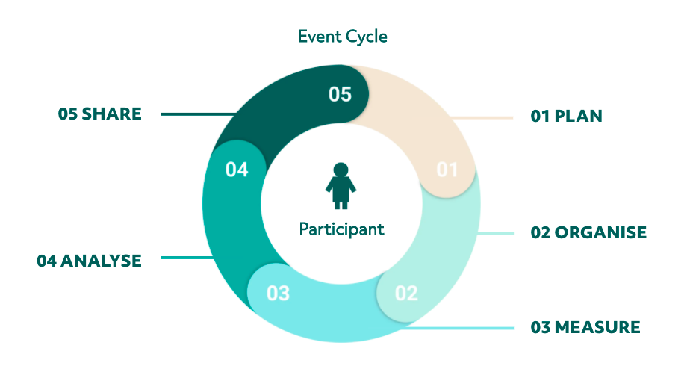
- Plan
This initial stage is where the foundation of the sustainable garment exhibition is laid out. Detailed planning involves setting clear objectives that align with the overarching goal of promoting sustainability in the fashion industry. This includes deciding on the event format, and content, and identifying key sustainability themes to be highlighted. Planning also involves selecting a venue that adheres to green practices, establishing a budget that prioritizes eco-friendly solutions, and developing a marketing strategy that appeals to environmentally conscious attendees.
- Organise
In the organisation phase, the plans start to materialize. Tasks include securing speakers known for their contributions to sustainable fashion, contracting vendors that supply eco-friendly products and services, and coordinating with participants and exhibitors on logistics. Effective organization ensures that every aspect of the event, from registration to waste management, is designed with sustainability in mind, reinforcing the event's commitment to minimizing environmental impact.
- Measure
Measurement involves setting up systems to track the event's performance against its sustainability goals. This could include quantifying the reduction in waste generated compared to similar events, calculating the carbon footprint of the event, and monitoring participant engagement with sustainability topics. Establishing these metrics beforehand allows for real-time monitoring and adjustments during the event to ensure sustainability objectives are met.
- Analyse
Post-event, the analysis phase is crucial for understanding the impact of the sustainable garment exhibition. This involves reviewing the data collected during the measure phase to evaluate the event's success in promoting sustainable practices. Analysis helps identify what worked well and areas for improvement. It assesses the effectiveness of the sustainability initiatives implemented and provides insights into how they influenced attendee behaviour and perceptions.
- Share
Finally, sharing the results and learnings from the event is vital for broader impact. This includes publishing a post-event report detailing the sustainability outcomes achieved, lessons learned, and recommendations for future events. Sharing also involves engaging with the wider community through social media, industry forums, and presentations at other events to spread the knowledge gained. By sharing successes and challenges, the sustainable garments exhibition can inspire and guide other event organizers in adopting sustainable practices.

- Event Concept
"Eco Trend 2024" in London is a pioneering event dedicated to sustainable fashion, merging eco-consciousness with style in a day filled with innovation and learning. Targeting designers, industry insiders, and eco-advocates, this exhibition showcases the latest in sustainable fashion, from green materials to ethical production methods.
Delegates/Guests Experience:
Participants will dive into a vibrant day of discovery and networking, with activities ranging from enlightening keynotes to interactive workshops, all designed to spark dialogue and action towards sustainability in fashion.
Itinerary Highlights:
9:00 AM: Guests arrive, greeted by organic refreshments in an eco-decorated setting.
9:30 AM: A leading innovator opens the event with a keynote on sustainable fashion's bright future.
10:30 AM: The Designer Showcase presents the newest eco-friendly collections from top and emerging talent.
11:30 AM: A panel on "Material Innovation and Sustainability" explores the latest eco-material breakthroughs.
12:30 PM: Lunch offers a chance for attendees to connect over local, plant-based dishes.
1:30 PM & 2:30 PM: Afternoon workshops and discussions delve into ethical fashion basics and sustainable branding, followed by expert-led breakout sessions on pressing industry topics.
3:30 PM: The day's discussions culminate in a panel forecasting the sustainable practices shaping fashion's future.
4:30 PM: An Eco-Innovation Exhibit displays pioneering sustainable materials and startups.
5:30 PM: The event closes with a Green Carpet Reception, an opportunity for guests to network over organic cocktails, and reflect on the insights gained.
Promising inspiration and actionable insights, "Eco Trend 2024" positions itself as a catalyst for sustainable evolution within the fashion industry.

- Aim and Objectives of the Meeting / Event
The sustainable garments exhibition is crafted to promote sustainability across the global fashion industry, aiming to spark a worldwide conversation on eco-friendly practices. It strives not only to display sustainable fashion but also to drive significant change within the sector.

Event Aims and Objectives:
Increase Awareness: We aim for a 50% increase in attendees' understanding and appreciation of sustainable fashion, measured through surveys. This objective focuses on educating the audience about the environmental downsides of traditional fashion and the advantages of sustainable alternatives, shifting perceptions towards more responsible consumption and production within the industry.
Establish Partnerships: A key objective is to forge at least five new alliances with suppliers of eco-friendly fabrics, supporting the creation, production, and distribution of sustainable garments. These partnerships will help integrate sustainability into the supply chain, encouraging wider adoption of green practices.
Reduce Carbon Footprint: We're committed to reducing the event's carbon emissions by 30% compared to standard fashion exhibitions, showcasing our commitment to sustainability. By minimising waste, enhancing energy efficiency, promoting online participation, and choosing a venue with strong environmental credentials, we aim to set a new standard for the industry, proving that large events can be both influential and eco-conscious.

- Event Operations
The success of the sustainable garment exhibition, set in the eco-conscious city of London, relies on detailed planning and execution that champions eco-friendly operations. Each aspect of this international event, from venue choice to technology use, logistics handling, and stakeholder involvement, is designed to minimise environmental impact while enhancing the guest experience.
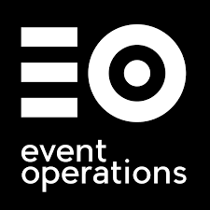
Venue Choice: Selecting a venue that meets our sustainability criteria is crucial. The chosen London venue holds green certifications, utilising renewable energy, waste reduction schemes, and water-saving measures, all accessible via public transport to lessen travel-related carbon emissions.
Technology Use: Embracing technology for a hybrid event model is vital. Live streaming, digital networking platforms, and electronic materials not only improve participant experience but also reduce the event's ecological footprint by cutting down on travel and paper use.
Logistics Handling: Eco-friendly logistics are central to our operations, including catering with local, organic fare and waste systems favouring recycling and composting. We'll use recyclable or biodegradable materials for all signs and decorations to further decrease our environmental impact.
Stakeholder Involvement: Engaging stakeholders committed to sustainability is key. This involves partnering with green-minded suppliers, sponsors, and exhibitors. Training for our team and volunteers will underscore sustainable practices, ensuring the event fully embodies its green ethos.

- Event Budget
The financial plan for our sustainable garment exhibition is carefully crafted to ensure a balance between anticipated income and strategic spending, reflecting the event's commitment to both financial and environmental sustainability.

Expected Income:
Ticket Sales: Our main revenue source, with varied pricing for professionals, students, and online participants. Revenue projections are based on venue capacity, online infrastructure, and past event attendance.
Sponsorships: Partnering with eco-friendly brands and organisations will significantly boost our income, with sponsorship levels designed to match the event's green ethos.
Grants: We'll seek funding from bodies that support green initiatives, targeting support for events that enhance environmental and sustainable awareness in the industry.
Expenditures:
Venue Hire: It's vital to choose a venue that reflects our sustainability values, considering its green credentials, accessibility, and hybrid event capabilities.
Technology Outlay: A substantial budget allocation for technology will support online participation, using streaming services, digital tools, and a comprehensive event app to reduce our carbon footprint.
Marketing Spend: Our marketing budget will focus on digital strategies, employing online advertising and social media to minimise paper usage and engage a broad audience.
Carbon Offsetting: Acknowledging the event's environmental impact, we're dedicating funds to carbon offsetting efforts, such as renewable energy investments and tree planting, to neutralise our carbon output.

8. Industry Trends/Impacts
The sustainable garments exhibition stands at the vanguard of adapting and embracing pivotal industry trends, shaping the future of events against the backdrop of a global shift towards sustainability. These trends mirror a broader societal move towards environmental care and technological advancement, significantly influencing event planning, execution, and experience.
Virtual and Hybrid Events: Accelerated by the COVID-19 pandemic, the uptake of virtual and hybrid formats continues to rise, favoured for their flexibility, accessibility, and smaller environmental footprint. The exhibition capitalises on this trend, offering a hybrid model that broadens global participation whilst curtailing travel-related carbon emissions. This strategy not only extends the event's reach but also affirms its commitment to reducing its ecological impact.
Focus on Sustainability: With both consumers and businesses increasingly demanding sustainable practices, the fashion industry is responding with growing urgency. The exhibition epitomises this shift, spotlighting sustainable fashion innovations and fostering eco-friendly practices across its operations, thereby advancing the sustainability dialogue within the industry.
Advanced Event Technology: The employment of state-of-the-art technology to boost engagement and operational efficiency marks another key trend. From interactive mobile applications enhancing personalised event experiences to digital platforms facilitating networking, the exhibition integrates technology to refine event management and encourage attendee interaction, supporting sustainability objectives by reducing material use and waste.

- Cultural and Situational Considerations:
In orchestrating the sustainable garments exhibition, delving into the broader cultural and situational nuances becomes indispensable, particularly as the event aspires to cultivate a worldwide discourse on sustainable practices within the fashion industry. The exhibition, set against the cosmopolitan backdrop of London, is inherently international in its outreach and seeks to bridge diverse perspectives on sustainability, underscoring the importance of cultural inclusivity and situational responsiveness.

Cultural Considerations:
The fabric of the global fashion industry is richly diverse, woven from myriad cultural threads that each contribute unique sustainability narratives and challenges. Acknowledging this tapestry is crucial; the exhibition must serve as a confluence where these diverse traditions and innovations in sustainable fashion are not only showcased but celebrated. This celebration of diversity is pivotal in fostering a sense of global solidarity and shared endeavour among participants hailing from disparate backgrounds. It ensures the event's agenda and discussions are comprehensive, reflecting a wide array of sustainable practices and perspectives from around the globe. Such an approach not only amplifies the exhibition's relevance but also bolsters its mission to inspire meaningful change across the fashion industry's international spectrum.
Situational Awareness:
The event's situational landscape is marked by a constellation of contemporary challenges and opportunities—from the ongoing ramifications of the COVID-19 pandemic to the rapid pace of technological innovation and the pressing exigencies of climate change. Each of these factors exerts a significant influence on the fashion industry and, by extension, on the planning and execution of the exhibition. The pandemic, for instance, underscores the need for adaptable formats that can accommodate virtual participation, ensuring inclusivity and engagement amidst global health concerns. Similarly, technological advancements present opportunities to enhance the exhibition experience through digital platforms, while also spotlighting innovations sustainably.
The local context of London, with its own unique cultural heritage and environmental ambitions, further enriches the exhibition's situational considerations. Integrating local sustainability initiatives and cultural elements into the event not only enriches the attendee experience but also aligns with London's broader environmental goals, showcasing the city as a leader in sustainability.

10. Conclusion
The sustainable garments exhibition emerges as a potent exemplar of how thoughtful event planning and execution can influence the fashion sector positively. By embedding environmental consciousness at its heart, the exhibition not only displays the potential of sustainable fashion but also catalyzes industry-wide transformation. Grounded in the Event Management Body of Knowledge (EMBOK) model, the strategic and operational planning of this exhibition crucially aligns every facet of the event with the overarching aim of endorsing sustainability. Through meticulous administration, creative event design, and comprehensive operational strategies, all finely tuned to cultural and situational nuances, a balance is struck between minimising environmental impact and enhancing educational and networking opportunities. Consequently, the exhibition demonstrates the viability of sustainable practices in fashion and sets a benchmark for future industry events, inspiring attendees, igniting designer creativity, and prompting industry leaders towards a more sustainable and environmentally considerate approach, showcasing the influence of collective endeavour and strategic insight in effecting substantial, positive change.

References

Anie (2023). 8 Reasons Why Companies Should Embrace Advanced Event Technology. [online] In Event Blog. Available at: https://inevent.com/blog/tech-and-trends/simple-steps-to-embrace-advanced-event-technology.html.
‌
Anon, (n.d.). What Is ‘Event Operations’? 7 Key Duties Explained! - J. Shay Event Solutions. [online] Available at: https://jshay.events/event-operations-key-duties/.

Baumann, B. (2017). Event Budget Basics: Everything You Need to Know – EventMobi. [online] EventMobi. Available at: https://www.eventmobi.com/blog/event-budget-basics/.
‌Black, S. (2013). The sustainable fashion handbook. New York; London: Thames & Hudson.
Black Ties & Blackjack. (2014). Critical Evaluation of The Event Design And Experience. [online] Available at: https://blacktiesandblackjack.wordpress.com/critical-evaluation-of-the-event-design-and-experience-from-various-stakeholders-perspectives/.
Bridges, J. (2019). How to Plan an Event (Checklist Included). [online] ProjectManager.com. Available at: https://www.projectmanager.com/training/how-to-plan-an-event.
Dowson, R. and Bassett, D. (2015). Event Planning and Management. Kogan Page Publishers.

Events Management. (n.d.). [online] books.google.com. Available at: https://www.google.co.uk/books/edition/Events_Management/mT5lEAAAQBAJ?hl=en&gbpv=1&dq=Event+Management:+Theory+and+Practice+by+Razaq+Raj.
expressassignment.com. (n.d.). Prepare a report that critically outlines the strategic planning and delivery considerations for that event. [online] Available at: https://expressassignment.com/planning-and-delivering-an-international-meeting/.
Fletcher, K. and Grose, L. (2012). Fashion & Sustainability. Laurence King Publishing.

French, K. (2023). How To Design the Best Creative Event Concept. [online] Julia Charles Event Management. Available at: https://www.juliacharleseventmanagement.co.uk/how-to-design-the-best-creative-event-concept/.

Geneva Environment Network (2023). Environmental Sustainability in the Fashion Industry. [online] Geneva environment network. Available at: https://www.genevaenvironmentnetwork.org/resources/updates/sustainable-fashion/.
Getz, D. and Page, S.J. (2024). Event Studies: Theory and Management for Planned Events. [online] Google Books. Taylor & Francis. Available at: https://www.google.co.uk/books/edition/Event_Studies/677mEAAAQBAJ?hl=en&gbpv=1&dq=Measuring+and+Managing+the+Environmental+Impact+of+Events+by+Donald+Getz.
Hoyle, L.H. (2002). Event marketing: how to successfully promote events, festivals, conventions, and expositions. New York: Wiley.
Humphries, K. (2021). Event Sustainability: 25 Sustainable Event Ideas for Enterprise. [online] SpotMe. Available at: https://spotme.com/blog/sustainable-events/.
Jennifer Farley Gordon and Hill, C. (2014). Sustainable fashion: past, present, and future. London: Bloomsbury Academic.
J. Robert Rossman and Duerden, M.D. (2019). Designing Experiences. Columbia University Press.
Jones, M.L. (2011). Sustainable Event Management: A Practical Guide. [online] Google Books. Routledge. Available at: https://www.google.co.uk/books/edition/Sustainable_Event_Management/KpczenjvsnEC?hl=en&gbpv=1&dq=Sustainable+Event+Management:+A+Practical+Guide+by+Meegan+Jones+-+the+EMBOK+model&printsec=frontcover.
Julia Rutherford Silvers (2009). Risk Management for Meetings and Events. Routledge.

Meegan Lesley Jones (2011). Sustainable Event Management. Routledge.

Notermans, M. (2023). Effective Partnership Strategies to Promote Events. [online] Think Orion. Available at: https://www.thinkorion.com/blog/partnership-strategies-to-promote-events.

Peguero, M. (2023). Tips for managing event logistics and operations. [online] One Way Event Productions. Available at: https://onewayeventproductions.com/tips-for-managing-event-logistics-and-operations/.
Raj, R., Walters, P. and Rashid, T. (2017). Events Management. SAGE.
Sass Brown (2010). Eco fashion. London: Laurence King.

Sindu (2024). Virtual Events Trends in 2024. [online] Virtual Days. Available at: https://www.virtualdays.com/virtual-event-trends-in-2024/#.

SmartWorks. (2019). The 3 Stages to Organizing an Event. [online] Available at: https://www.smartworksevents.com/the-3-stages-to-organize-an-event/.
trace_admin (2023). 6 ways to reduce your event’s carbon footprint. [online]

Trace. Available at: https://traceyour.events/six-ways-to-reduce-your-event-carbon-footprint/.

Tutorchase.com. (2023). Available at: https://www.tutorchase.com/answers/ib/geography/what-cultural-considerations-are-key-for-international-event-planning.

Visit Monmouthshire. (n.d.). Stakeholder identification and management. [online] Available at: https://www.visitmonmouthshire.com/information/events-management/stakeholders#.

wadhwa, virgil (2021). How to Define Goals & Objectives for a Successful Online Event | Airmeet. [online] Airmeet HUB. Available at: https://www.airmeet.com/hub/blog/virtual-event-goals-objectives-planning/.
Waechter, F.M. (2015). Conference Planning: How to organise an international conference. [online] Congrex Switzerland. Available at: https://congrex.com/blog/how-to-international-conference-planning/.
Wagen, L.V. der and White, L. (2018). Event Management: For Tourism, Cultural, Business and Sporting Events. [online] Google Books. Cengage AU. Available at: https://www.google.co.uk/books/edition/Event_Management_For_Tourism_Cultural_Bu/1vtTDwAAQBAJ?hl=en&gbpv=1&dq=inauthor:%22Lauren+White%22&printsec=frontcover.

Wednesday, C.V. on, January 3rd and 2024 (n.d.). The Ultimate Guide to Event Partnerships | Event Espresso. [online] Available at: https://eventespresso.com/2024/01/ultimate-guide-to-event-partnerships/.

www.cvent.com. (n.d.). Creating Sustainable Events: 5 Steps for Success | Cvent Blog. [online] Available at: https://www.cvent.com/uk/cvent.com/uk/blog/creating-sustainable-events.

www.embok.org. (n.d.). EMBOK Facets and Applications. [online] Available at: https://www.embok.org/juliasilvers/embok/Facets_Aps.html.
www.eventstop.co.uk. (n.d.). How to budget for your event | EventStop. [online] Available at: https://www.eventstop.co.uk/knowledge_hubs/How-to-budget-for-your-event.

www.linkedin.com. (n.d.). Mastering Event Logistics: Ensuring Smooth Operations and Guest Satisfaction. [online] Available at: https://www.linkedin.com/pulse/mastering-event-logistics-ensuring-smooth-operations-guest.

www.linkedin.com. (n.d.). Mastering Event Planning: 5 Key Considerations from the organiser’s perspective. [online] Available at: https://www.linkedin.com/pulse/mastering-event-planning-5-key-considerations-from-organisers-mirle?trk=organization_guest_main-feed-card_feed-article-content#.
www.lyyti.com. (n.d.). Introducing the Event Cycle – The Core of Event Success Management. [online] Available at: https://www.lyyti.com/en/blog/introducing-the-event-cycle-the-core-of-event-success-management?gclid=undefined.

‌

