3/24/2025
University of Wales Trinity Saint David
London campus
LDE Assignment 1
E-Portfolio
E-Portfolio Link:
Module Name: Learning In the Digital Era
Module Code: ACCA 4025

Student Name: Ersal Nezhdet Rashid
Student ID: 2530425
Group: 1

Lecturer’s Name: Koushik Modak

Table of Contents
Introduction 2
Main Body 2
Task 1: Essential Academic and Employment Skills for the future career Path 2
Task 1 (a): Report on Essential Academic and Employment Skills 2
Task 1 (b): Evaluation of Task 1 (a) based on Similarity report 2
Task 2: Collaborative Mind Map and Individual Poster 2
Mind Map (Collaborative) 2
Poster (Individual) 2
Task 3: Virtual Collaboration and RefWorks 2
Report on Virtual Collaboration 2
Step-by-step process of using RefWorks with visuals 2
Task 4: E-Portfolio Creation and Evaluation 2
Task 4 (a): E-Portfolio Creation 2
Task 4 (b): Illustrative Review of E-Portfolio tool Selection 2
Conclusion 2
References 2
Task 1 References: 2
Task 3 References: 2

Introduction

Main Body

Task 1: Essential Academic and Employment Skills for the future career Path

Task 1 (a): Report on Essential Academic and Employment Skills

1.INTRODUCTION
The purpose of this report is to analyse how fundamental skills that support academic achievement are transformed into professional future career journey it is a field where technical knowledge alone is not sufficient; personal skills must also contribute enabling individuals to transfer their abilities such as problem solving through accurate analysis and decision making or devising the right strategy into the business world Academic education is the most significant factor supporting this endeavour.

2. CORE ACADEMIC SKILLS AND THEIR PROFESSIONAL VALUE
In today's business world, only academic and technical knowledge may not be enough. Employers and industry requirements creativity, flexibility and self-efficacy, problem solving, empathy and social skills have been the factors that determine the professional value of the individual. The report of the world economic forum has explained this example in the best way.
The core skills required by workers today. As in 2020, Analytical Thinking is a core skill by more companies than any other skill and constitutes on average 9% of the core skills reported by companies. Another cognitive skill, creative thinking, ranks second, ahead of three self-efficacy skills – resilience, flexibility and agility; motivation and self-awareness; and curiosity and lifelong learning – in recognition of the importance of workers ability to adapt to disrupted workplaces. (Forum, 2023)

-Core skills in 2023
Share of organizations surveyed which consider skills to be core skills for their workforce. Estimated average composition of the skill sets of workers in organizations surveyed. Skills are ranked and ordered by the share of organizations surveyed which consider the skill as core to their workforce. (Forum, 2023)

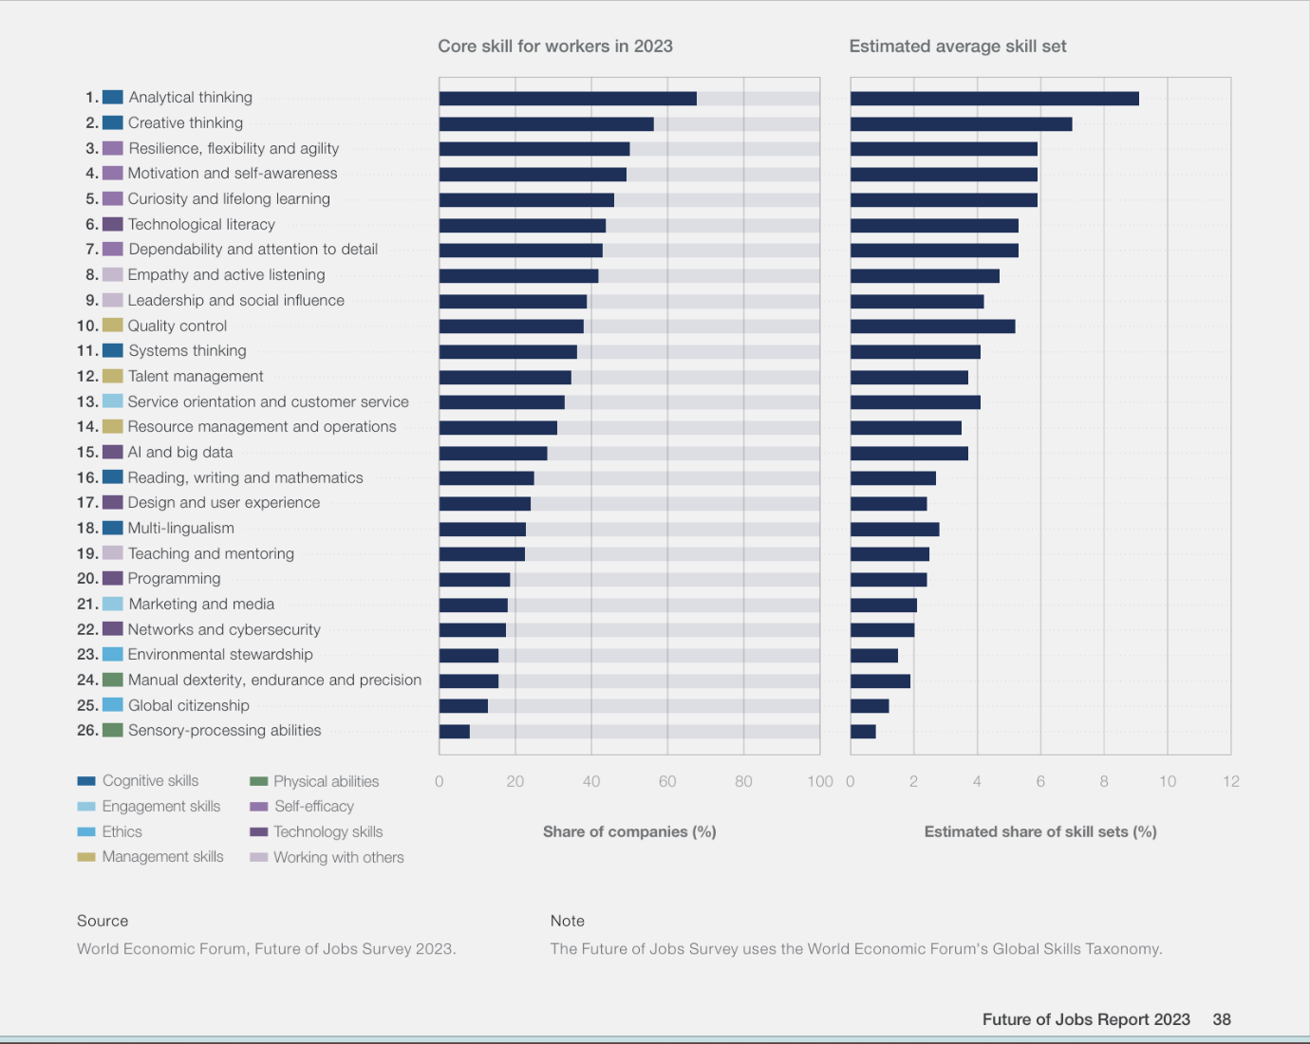

In this analysis, we can see that mental skills take precedence over technical knowledge, the importance of technological literacy and the importance of lifelong learning.

3. ANALYSIS OF CORE COMPETENCES FOR THE FUTURE

According to the conclusion I reached from the reports and research, I would like to specify the most important skills in a more explanatory way.

-Analytical Thinking:
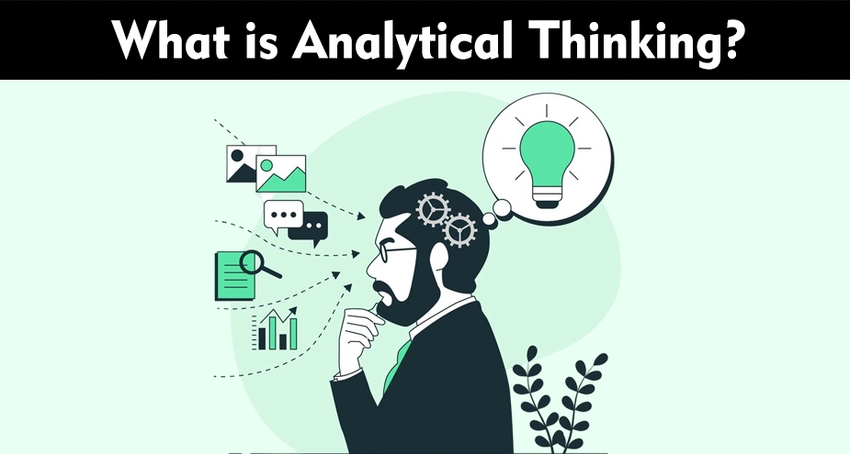

Analytical thinking is to approach a piece of information or a problem from many angles and reach the conclusion correctly and in the most appropriate way.
Analytical thinking involves using a systematic approach to make decisions or solve problems. By breaking down information into parts, analytical thinkers can better understand it and come to a sensible conclusion. (Staff, 2026)
For instance, once analytical thinkers identify a problem, they typically gather more information, develop practical solutions, evaluate them, and analyse which works best. Solving complex problems often requires analytical reasoning, which may involve:
- Determining causation (if and how one event causes another)
- Examining similarities, differences, and relationships
- Predicting the next event by following a sequence
- Recognizing patterns or trends
- Using conditional and converse (if-then) statements (Staff, 2026)

-Creative Thinking
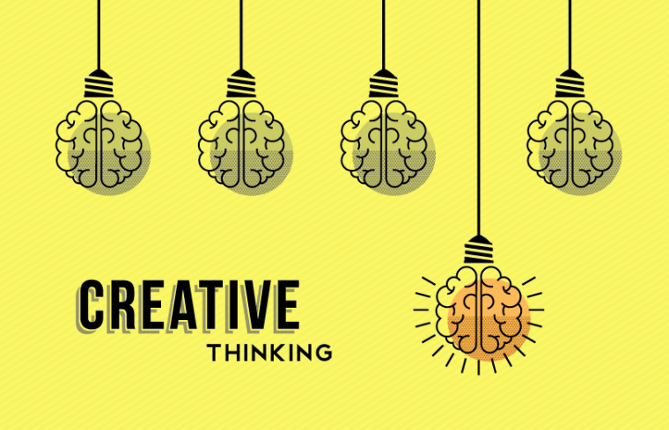
Creative thinking is reaching the result in the most appropriate way by adding different perspectives to information or problems in connection with analytical thinking.
Creative Thinking, as opposed to Analytical Thinking, promotes out-of-the-box ideas and renders the art of creation. But what is Creative Thinking? Haven’t we all heard this from our favourite artists? Creative Thinking primarily stems from the right hemisphere of the brain and is often linked to tasks related to arts, music, and spatial reasoning. (Academy, n.d.)

-Resilience, flexibility, and agility


In the world of modernism, skills play the most key role around uncertainty. They represent an employee's ability to stand firm in a storm and to change direction.
The ability to bounce back from setbacks, adapt to changing circumstances, and quickly navigate new challenges is essential. These qualities – resilience, flexibility, and agility – are critical for thriving in a role that requires constant multitasking, quick decision-making, and unwavering support for high-level executives. According to the World Economic Forum, these skills rank among the top five most important for 2027. (Haig, 2025)

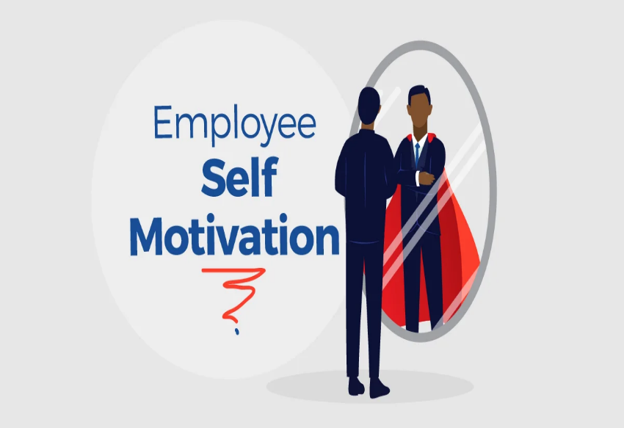
-Motivation And Self-awareness

The work environment of our day and future is reinforced by remote work. In this case, it brings a situation where not only external motivations but also a person's internal motivation becomes more important. Like working towards a service and a purpose, like adding value to one's work.

The ability of individuals to understand their own strengths, weaknesses, values, and emotions and how these affect their behaviour and interactions with others at work is an asset. When we have a strong sense of self-awareness, we can better understand how we come across to others, communicate more effectively and make more thoughtful and strategic decisions. (Augusta, 2023)

References
Academy, T. K. (n.d.). The Knowledge Academy. Retrieved from https://www.theknowledgeacademy.com/blog/what-is-creative-thinking/
Augusta, L. (2023, March 15). Forbes. Retrieved from Forbes: https://www.forbes.com/councils/forbescoachescouncil/2023/03/15/how-to-increase-self-awareness-in-the-workplace/
Forum, W. E. (2023). Future of Jobs Report. Cologny/Geneva: World Economic Forum.
Haig, D. (2025, September 25). Executive Support Magazine. Retrieved from Executive Support Magazine: https://executivesupportmagazine.com/resilience-flexibility-and-agility/
Staff, C. (2026, Jan 15). Coursera. Retrieved from Coursera: https://www.coursera.org/articles/analytical-thinking

Task 1 (b): Evaluation of Task 1 (a) based on Similarity report

Task 2: Collaborative Mind Map and Individual Poster

Mind Map (Collaborative)

Poster (Individual)

Task 3: Virtual Collaboration and RefWorks

Report on Virtual Collaboration
Put your Chosen topic here

Step-by-step process of using RefWorks with visuals

Task 4: E-Portfolio Creation and Evaluation

Task 4 (a): E-Portfolio Creation

Task 4 (b): Illustrative Review of E-Portfolio tool Selection

Conclusion

References

Task 1 References:

References
Academy, T. K. (n.d.). The Knowledge Academy. Retrieved from https://www.theknowledgeacademy.com/blog/what-is-creative-thinking/
Augusta, L. (2023, March 15). Forbes. Retrieved from Forbes: https://www.forbes.com/councils/forbescoachescouncil/2023/03/15/how-to-increase-self-awareness-in-the-workplace/
Forum, W. E. (2023). Future of Jobs Report. Cologny/Geneva: World Economic Forum.
Haig, D. (2025, September 25). Executive Support Magazine. Retrieved from Executive Support Magazine: https://executivesupportmagazine.com/resilience-flexibility-and-agility/
Staff, C. (2026, Jan 15). Coursera. Retrieved from Coursera: https://www.coursera.org/articles/analytical-thinking

Task 3 References:

