Student name: Anat Dranciuc-Georgescu
Student Id: 2125394
Module: Sustainable Hospitality & Tourism
Management (BMIH5006)
Lecturer name: Ruth Taylor Davies
Word Count: 2211

Green Key certificate and Corporate Social Responsibilities within the hospitality industry.

Executive Summary
The topic of tourism is diverse, with categories such as domestic, inbound, outbound, internal, national, regional, and international tourism. It also includes various forms like ecotourism, geo-tourism, green tourism, sustainable tourism, pro-poor tourism, alternative tourism, responsible tourism, and adventure tourism. There has been a significant growth in international tourism, especially in emerging economies, surpassing that in developed nations.
While environmental protection may seem more vital in visibly polluting sectors, creating service products, though intangible and perishable, often requires several physical elements and natural resources. The hospitality industry, which relies heavily on energy, food, and clean water, impacts communities through employment, working conditions, and supply chain use. This report will analyze the main factors that affect the environment through the hostility industry perspective, analyze and provide CSR practices and examples, and provide solutions for urban and rural tourism and salvaging heritage and forgotten sites.

Contents
0
Executive Summary 1
Introduction 3
Main Body 3
Pollution and Tourism impact. 3
Consumers' preferences change 5
Luxury in hospitality. 6
India’s Forgotten Heritage 6
Environmental changes and their global effects 8
Corporate Social Responsibility 9
Green Key certificates and how hotels obtain them. 10
Transportation and decluttering an overpopulated tourist area. 12
Conclusion 12
Reference List 12

Introduction
The topic of tourism is diverse, with categories such as domestic, inbound, outbound, internal, national, regional, and international tourism. It also includes various forms like ecotourism, geo-tourism, green tourism, sustainable tourism, pro-poor tourism, alternative tourism, responsible tourism, and adventure tourism. There has been a significant growth in international tourism, especially in emerging economies, surpassing that in developed nations. The United Nations World Tourism Organization (UNWTO) advocates for responsible, sustainability. The UNWTO describes tourism as a key contributor to international trade and a crucial source of income for many developing countries, with its growth paralleling an increase in destination diversification and competition (Birău, F. R. p. 124-125, 2019).
Tourism is one of the main sources of the economy today and supports and sustains thousands of jobs worldwide. At the same time, tourism is one of the main sources of pollution and environmental problems.

Main Body

Pollution and Tourism impact.
While environmental protection may seem more vital in visibly polluting sectors, creating service products, though intangible and perishable, often requires numerous physical elements and natural resources. The hospitality industry, which relies heavily on energy, food, and clean water, impacts communities through employment, working conditions, and supply chain use.
The industry has notable environmental effects, including air and water pollution, waste, and greenhouse gas emissions. Hotels are among the most energy-consuming commercial buildings, with consumption varying based on location, facilities, and amenities. This energy use contributes to carbon emissions, with an average of nineteen kgCO2e per occupied room reported for US hotels (Legrand et.al, p. 18, 2022).
No one should compromise the future of the planet for the sake of a holiday, and as it turns out more and more people/ clients chose to support sustainable practices and business instead of just accepting bad CSR practices or greenwashing. 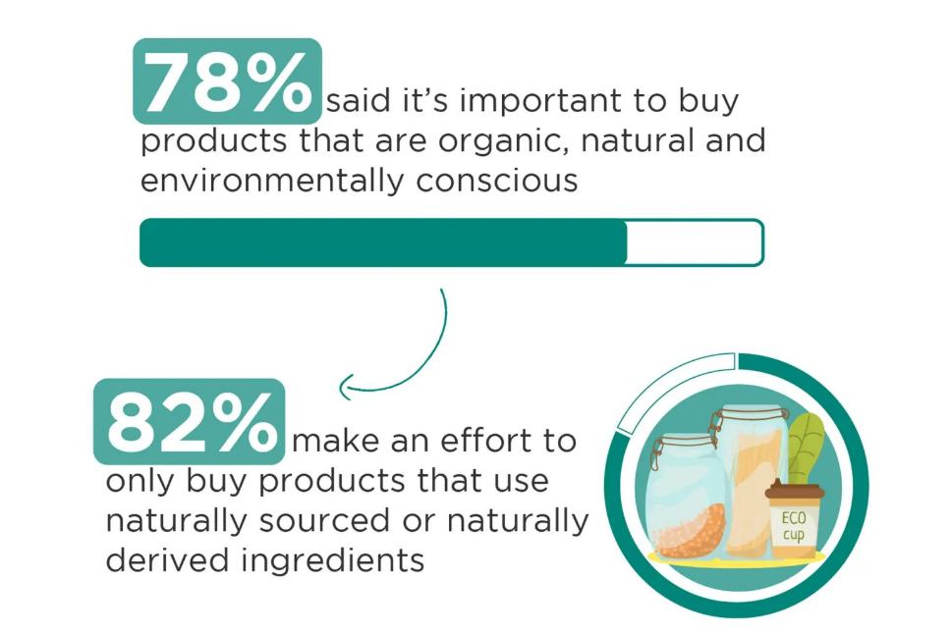(SWNS,2023a) Most Gen Z and Millennials base purchases on a brand’s mission: poll.
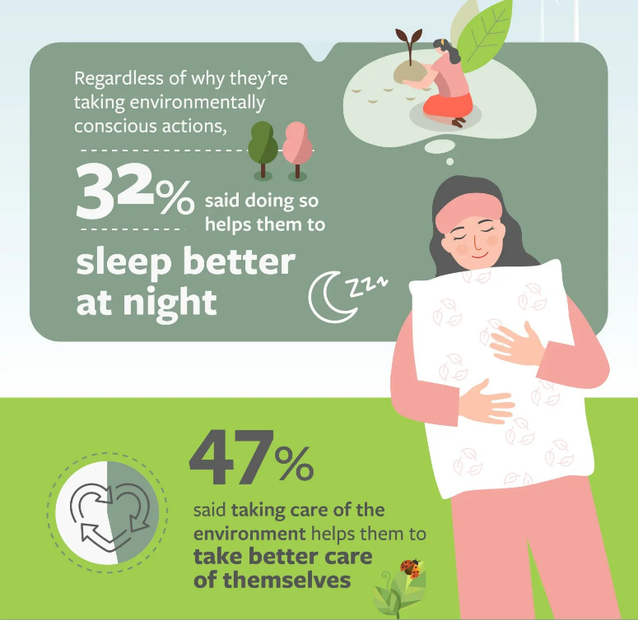 (SWNS, 2024). Half of Americans think climate change will destroy the planet in their lifetime: poll.

Consumers preferences change
Beon (2023) discusses the fact that, among rising global concerns about climate change, there’s a growing consumer demand for sustainable practices and brands. This is particularly noticeable in the hospitality industry, where an increasing number of guests, especially the younger generation, prefer sustainable hotels. Sustainable hotels actively implement eco-friendly measures to reduce their environmental impact, promoting corporate social responsibility. These measures range from energy-efficient lighting and intelligent water management to recycling and ecotourism promotion.

Sustainable hotels are the future of the hospitality industry for several reasons. They promote revenue growth due to their cost-effectiveness and appeal to a growing market segment. They enhance customer value perception as travellers increasingly value transparency and sustainability. Furthermore, with sustainability becoming a legal requirement worldwide, it’s not just a marketing strategy but a necessity for all business operations. By adhering to sustainability regulations, hotels can secure their long-term brand positioning and generate sustainable revenue growth, as well as following the Corporate Social Responsibility guidelines.
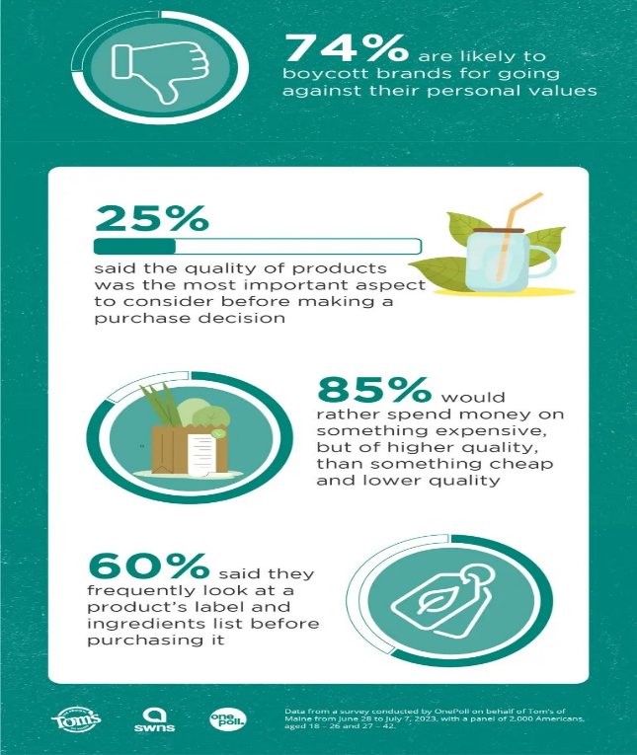(SWNS,2023b) Most Gen Z and Millennials base purchases on a brand’s mission: poll.

Luxury in hospitality.
The concept of “luxury” has evolved from being associated with material possessions to a state of mind reflecting one’s ethical, creative, and tasteful identity. With growing environmental concerns, luxury and sustainability are becoming synonymous. Sustainable hotels, like Castello di Reschio in Perugia, are setting new standards for luxury by implementing eco-friendly practices and employing local staff. The wasteful excess associated with traditional luxuries, such as daily linen changes and excessive amenities, is being recognized as unsustainable. The future of luxury lies in smaller, sustainable practices that respect local resources and communities (Mariani, 2022).
Besides changing the habits that consumers have, hotels need to keep an eye on old buildings as well while considering business expansion, it is a better idea to renovate a castle or a farm instead of adding more and more new buildings to an already overpopulated place.

India’s Forgotten Heritage
An example of old buildings, and sites is Mahabalipuram, a UNESCO heritage site, that attracts tourists worldwide due to its promotional campaigns. While it benefits the local economy, it also leads to environmental issues, increased traffic, and coordination challenges among local people, tourism providers, and ASI officials. Many hoteliers focus on tourists without considering environmental practices, raising sustainability concerns. To address these, studies have been conducted to understand residents’ and tourists’ perceptions of guiding sustainable tourism development. The research aimed to evaluate tourists’ motivations, expectations, and perceptions of Mahabalipuram. The study also assessed the destination’s competitiveness and the gap between tourists’ perceptions and expectations (V. T. Nair, B. & K., S., p. 195, 2020).
 (Dola RC, 2015).
After carefully analysing the video and several customer reviews (Mahabalipuram,2024), one can clearly understand why some locations suffer from either overpopulation or lack of support from the local authorities and the hospitality industry.
One of the many challenges that such sites face are lack of support from their community, local businesses and government, these sites and buildings have been made tourist attractions, but no one seems to put enough effort into decluttering the whole situation and properly protecting the environment within the premises.
Sustainable tourism, requiring strong political leadership and stakeholder participation, is a significant challenge. However, the focus on short-term profitability often overlooks the long-term sustainability of natural resources. The industry’s rapid growth and reluctance to change travel behaviour or engage in fundamental operational changes contribute to its unsustainability.
Climate change poses a serious challenge, the industry must adapt to minimize environmental impact. Challenges include reducing energy and greenhouse gas emissions, water consumption, waste management, loss of biodiversity, effective cultural heritage management, and poverty alleviation. Tourism spending often leaks away from local communities, with estimates showing significant leakage in countries like Nepal and Thailand. Strengthening the relationship between local communities and sustainable tourism, particularly for the social welfare of indigenous peoples, is crucial. New business models are needed as current ones depend on energy-intensive transportation, making them less sustainable (Herath, G., p. 276-277, 2019).
Over the years some of these issues disappeared and the government understood its assignment. More locations have been lifted and supported either financially or by being inclusive towards local merchants, farmers etc.
Arora, M. & Walia, S. K. (p.4-5, 2019) discuss the fact that every economic sector contributes to development, with sustainability being key as per the UN definition. The tourism sector in India offers numerous opportunities for sustainable development, with the ethos of “Atithi Devo Bhava” treating every guest as divine. Various programs have been launched to promote social responsibility, with a significant portion of foreign exchange earnings spent on environmental protection and safeguarding tourist destinations. These initiatives have uplifted rural communities, reducing migration and diversifying income sources. The adoption of sustainable tourism policies has addressed issues of inclusive growth, leading to the development of rural artisans, farmers, and communities. Tourists visiting India now enjoy authentic experiences of rural Indian lifestyle, art, culture, and heritage, benefiting local communities and fostering a deep connection between visitors and hosts.

Environmental changes and their global effects
Sustainability in the hospitality industry is becoming more regulated. Key points include UK Hospitality’s Commitment: Aims for net zero by 2040, eliminating unnecessary single-use packaging by 2025, and reducing food waste by 50% by 2030 (UK HOSPITALITY, 2022). Government Initiatives: Worldwide initiatives like carbon taxes and restrictive water policies are being introduced. The UK’s Environment Act of 2021 and the EU’s CSRD promote sustainability. Standards and Criteria: Hotels must follow established sustainability standards, verified through independent audits (SiteMinder, 2024). Employment Laws: Hospitality businesses must ensure fair treatment of staff and legal operation. Increasing Legal Requirements: CSR disclosures, currently voluntary in the US, are becoming mandatory, following the EU’s lead (Hardigree, J.D., 2018).
As such, sustainability is becoming a legal requirement, necessitating its incorporation into all hospitality operations and more and more hotels have been questioned about their sustainability practices.
All these drastic changes are due to previous events, since 2016, the tourism sector has seen significant changes in sustainable tourism development, introducing new concepts like “over-tourism” and initiatives like the Strong Universal Network (SUNx) for climate resilience. The United Nations declared 2017 as the International Year of Sustainable Tourism for Development, and the Responsible Tourism Institute launched the “#TOURISM17” campaign. The Swedish concept of “plogging,” or picking up trash while jogging, gained popularity in 2018. In 2019, climate change became a priority in sustainable tourism following reports of rising global temperatures (Edgell, p. 15, 2020).

Corporate Social Responsibility
The three pillars of sustainability and CSR rules are as follows: 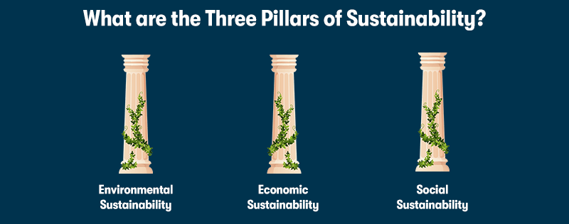(Lawless, 2024a).
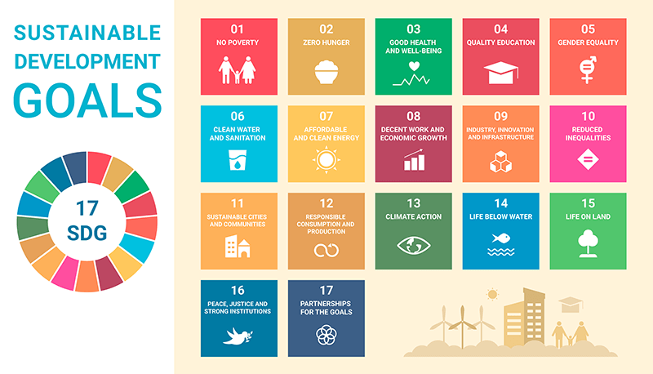(Lawless, 2024b).
Corporate Social Responsibility (CSR) enables businesses to effect positive change, balancing profitability with ethical conduct to build customer trust. The efforts of large corporations can influence global issues like hunger, health, and climate change. Some major brands have successfully implemented CSR, while others have had to reassess their strategies due to criticism (Digital Marketing Institute, 2024).
CSR can enhance customer trust, raise awareness, and stimulate social change. It is a set of rules, regulations and suggestions for a better and more sustainable environment and world, thinking for the present and future generations.

Green Key certificates and how hotels obtain them.
The hospitality industry contributes significantly to environmental pollution, primarily through greenhouse gas emissions and unsustainable resource consumption. Despite a growing preference for eco-friendly hotels, the actual stay rate remains low, indicating a gap between environmental attitudes and behaviours. Green hotels, such as the Hilton group and the ITC group of hotels in India, have implemented successful waste management strategies and reduced their resource consumption. These efforts have led to recognitions like the Ecotel certification for the Orchid hotel chain in India (Sadiq et.al., p.1-2, 2022).
In other words, a Green Certificate is proof that a hotel or a business has achieved most of the required regulations by CSR, including water waste reduction and carbon footprint reduction besides other social and economic factors and it is not just pretending for the sake of marketing competitivity to be a sustainable business.
Green certification is a crucial aspect of green hospitality. It signifies that a hotel has been rigorously assessed for its environmental friendliness, including energy efficiency, water use, waste management, and environmental preservation. Obtaining this certification requires a significant commitment and investment from hotel operators genuinely dedicated to sustainable practices. It validates a hotel’s green credentials and differentiates it from those merely claiming to be green (Glion, 2024).
After carefully assessing the state of the hotel, resort or business and making sure that all the CSR rules have been applied a company can receive the green certificate.
Tourism 2030 DestiNet Services (2024) points out that Green Key is a leading voluntary eco-certification programme in the tourism industry, promoting environmental responsibility and sustainable operations. It maintains high sustainability standards through strict criteria, rigorous documentation, regular audits, and third-party verification. It applies to various establishments including hotels, hostels, campsites, conference centres, and restaurants. Managed by the Foundation for Environmental Education, it’s recognised by the UNWTO and UNEP, with its criteria acknowledged internationally.
Green Key certification provides several advantages: Quality Assurance: Ensures adherence to strict environmental standards. Global Recognition: Acknowledged worldwide. Cost-Effective: Low participation costs due to its non-profit nature. Guidance: Offers support throughout the certification process. Community Engagement: Balances interests of the tourism industry and non-profit organizations. Business Growth: Facilitates environmental improvements and cost savings. Reputation Enhancement: Demonstrates an establishment’s commitment to sustainability (Keep Britain Tidy, 2024).
Green Key certification requires establishments to meet high environmental standards across 13 sustainability categories, including energy efficiency, water conservation, waste management, and environmental preservation. These criteria apply to various establishments, such as hotels, hostels, campsites, and restaurants. Compliance with most criteria is mandatory, while others are guidelines that depend on the establishment’s years in the Green Key programme. The criteria and explanatory notes for various types of accommodations have gained international recognition (Green Key, 2024).
There are several other awards and accreditations that companies can achieve while applying sustainable practices: The Altair Enlighten Award, Cleantech Open Global Ideas, The Electric Vehicle Innovation & Excellence Awards, World Car Awards, (Adams, 2024).
These awards are only a small list of achievements that a hotel or a company can achieve, most of these awards are offered at a global scale but some awards are rewarded within the country for a hotel or business that performed well while tackling sustainability issues.

Transportation and decluttering an overpopulated tourist area.
Poppy Stringer (2024) suggests that is promoting eco-friendly transportation options like local buses, trains, and on-site bike stations can help hotels reduce their carbon footprint. Additionally, offering electric vehicle charging stations and using fuel-efficient shuttles are effective measures. Embracing these sustainable practices not only contributes to environmental conservation but also meets the increasing demand for eco-friendly travel.
Leading by example as a manager or even a CEO and using bicycles, scooters, and even walking to work if it is within a decent distance can promote a good example towards employees and guests.

Conclusion
Following CSR practices and achieving as many sustainable goals as possible in a short period of time helps not only the environment but hotels and businesses as well. As for the Green Key certification, it only provides extra proof to the marketing audience that the hotel/business is doing everything in its power to be as eco-friendly and sustainable as possible while supporting the local community.

Reference List
Arora, M. & Walia, S. K. (2019). From Earning Profits to Sustainability: A Critical Evaluation of CSR Initiatives in Tourism Sector. In I. Management Association (Ed.), Sustainable Tourism: Breakthroughs in Research and Practice (pp. 229-235). IGI Global. [Online] Available at: https://doi-org.ezproxy.uwtsd.ac.uk/10.4018/978-1-5225-7504-7.ch012 (Accessed: 2 June 2024).
Beon (2023) Reasons why sustainable hotels are the future of the industry. [Online] Available at: https://www.beonx.com/knowledge/articles/sustainable-hotels/ (Accessed: 2 June 2024).
Birău, F. R. (2019). The Global Implications of Ecotourism in Emerging Economies. In I. Management Association (Ed.), Sustainable Tourism: Breakthroughs in Research and Practice (pp. 121-143). IGI Global. [Online] Available at: https://doi-org.ezproxy.uwtsd.ac.uk/10.4018/978-1-5225-7504-7.ch007 page 125 (Accessed: 2 June 2024).
Christian E. Hardigree, J.D. (2018). Sustainability In Hospitality? How Legality and Authenticity Impact the Rationale for Integrating Sustainable Practices. [Online] Available at: https://www.bu.edu/bhr/files/2018/06/Sustainability-In-Hospitality.pdf (Accessed: 3 June 2024).
David L. Edgell, Sr. (2020) Managing Sustainable Tourism. A Legacy for the Future [BibliU version] 3rd ed. [Online] Available at: https://bibliu.com/app/#/view/books/9781000701197/epub/OEBPS/xhtml/Ch01.html#page_1 (Accessed: 2 June 2024).
Digital Marketing Institute (2024) 16 Brands Doing Corporate Social Responsibility Successfully. [Online] Available at: https://digitalmarketinginstitute.com/blog/corporate-16-brands-doing-corporate-social-responsibility-successfully (Accessed: 3 June 2024).
Dola RC (2015). Mahabalipuram [Online] Available at: https://www.worldhistory.org/Mahabalipuram/ (Accessed: 3 June 2024).
Green Key (2024). Green Key criteria and explanatory notes 1 January 2022 – 31 December 2025. Available at: https://greenkey.abaae.pt/wp-content/uploads/sites/6/2021/10/Green-Key-criteria-and-explanatory-notes-2022-2025-final-version.pdf (Accessed: 3 June 2024).
Glion (2024). Eco-friendly Hotels Explained: Why they matter. HOSPITALITY UNCOVERED -The magazine of Glion Institute of Higher Education. [Online] Available at: https://www.glion.edu/magazine/eco-friendly-hotels-explained/ (Accessed: 2 June 2024).
Helen Sydney Adams (2024) Top 10: Sustainability Awards 2024. [Online] Available at: https://evmagazine.com/sustainability/top-10-sustainability-awards-2024 (Accessed: 3 June 2024).
Herath, G. (2019). Sustainable Tourism Development in Asia: Evaluation of the Potential and Challenges: In I. Management Association (Ed.), Sustainable Tourism: Breakthroughs in Research and Practice (pp. 271-294). IGI Global. [Online] Available at: https://doi-org.ezproxy.uwtsd.ac.uk/10.4018/978-1-5225-7504-7.ch015 p 6 -7 (Accessed: 2 June 2024).
James Lawless (2024). What is Sustainability and Why is it Important? | Purple Griffon [Online] Available at: https://purplegriffon.com/blog/what-does-it-mean-to-be-sustainable (Accessed: 3 June 2024).
John Mariani (2022). How Sustainability Has Become a Marketing Necessity in Luxury Hotels. [Online] Available at: https://www.forbes.com/sites/johnmariani/2022/07/19/how-sustainability-has-become-a-marketing-necessity-in-luxury-hotels/?sh=334a22c3306d (Accessed: 2 June 2024).
Keep Britain Tidy (2024) - Green Key England (2024). [Online] Available at: https://www.greenkeyengland.co.uk/criteria (Accessed: 3 June 2024).
Legrand, W., Chen, J.S., & Laeis, G.C.M. (2022). Sustainability in the Hospitality Industry: Principles of Sustainable Operations (4th ed.). Routledge. Sustainability in the Hospitality Industry. [Online] Available at: https://www.taylorfrancis.com/books/mono/10.4324/9781003081128/sustainability-hospitality-industry-willy-legrand-joseph-chen-gabriel-laeis (Accessed: 2 June 2024).
Mahabalipuram (2024) | For UNESCO World Heritage Travellers. Group of Monuments at Mahabalipuram. [Online] Available at: https://www.worldheritagesite.org/list/Mahabalipuram (Accessed: 3 June 2024).
Mohd Sadiq, Mohd Adil, Justin Paul (p.1-2, 2022). Eco-friendly hotel stay and environmental attitude: A value-attitude-behaviour perspective. International Journal of Hospitality Management, Volume 100. [Online] Available at: https://www.sciencedirect.com/science/article/pii/S0278431921002371 (Accessed: 2 June 2024).
Poppy Stringer (2024) Green hospitality: 5 sustainable practices for eco-friendly hotels. [Online] Available at: https://skoot.eco/articles/5-sustainable-practices-for-eco-friendly-hotels (Accessed: 2 June 2024).
SiteMinder (2024) Hotel sustainability: A full guide for hotel owners. [Online] Available at: https://www.hospitalitynet.org/explainer/4120392.html (Accessed: 3 June 2024).
SWNS (2023) Most Gen Z and Millennials base purchases on a brand’s mission: poll. [Online] Available at: https://nypost.com/2023/08/22/most-gen-z-millennials-base-purchases-on-brands-mission-poll/ (Accessed: 3 June 2024).
SWNS (2024). Half of Americans think climate change will destroy the planet in their lifetime: poll. [Online] Available at: https://nypost.com/2024/05/20/us-news/half-of-americans-think-climate-change-will-destroy-planet-in-their-lifetime-poll/ (Accessed: 3 June 2024).
Tourism 2030 DestiNet Services (2024) Green Key. [Online] Available at: https://destinet.eu/resources/certificates/green-key (Accessed: 3 June 2024).
UK HOSPITALITY (2022) Environmental Sustainability Commitment. [Online] Available at: https://www.ukhospitality.org.uk/insight/environmental-sustainability-commitment-2/ (Accessed: 3 June 2024).
V. T. Nair, B. & K., S. (2020). Visitor Perception and Expectation of Heritage Tourism at Mahabalipuram Monuments. In M. Korstanje, B. George, & A. Nedelea (Eds.), Strategies for Promoting Sustainable Hospitality and Tourism Services (pp. 191-210). IGI Global. [Online] Available at: https://doi-org.ezproxy.uwtsd.ac.uk/10.4018/978-1-7998-4330-6.ch012 (Accessed: 2 June 2024).

