BA (Hons) International Hotel Management
Personnel Resourcing and Development
BMIH5005
Assesment 1

DISCUSS HOW THE EVOLUTION OF HRM FACILITATES THE STRATEGIC DEVELOPMENT OF AN INTERNATIONAL HOTEL BRAND THROUGH WORKFORCE PLANNING, RECRUITMENT AND SELECTION, PREMIER INN

Lecture name: Helen Lee
Name: Daniel Fieraru
Student ID: 2232199

Introduction
The significance of “Human Resources Management (HRM)” has played a vital role in shaping the strategic operations of the international brands, such as Premier Inn, and it specifically signifies the dynamic and competitive hospitality brands. HRM has mainly justified the potential changes over the years and transitioned from the traditional administrative functions to a major strategic partner in the potential organizational success (George, 2022). This evolution is particularly vital for the global hotel brands like Premier Inn, where the effective recruitment and selection process and workforce planning are the main integral factors in establishing a strong international presence.
In this essay it explores how the changing roles of HRM contribute to the strategic composition of Premier Inn. This case study analysis basically focuses on workforce planning, recruitment, and employees selection processes, to highlight their significance in ensuring the organizational variability and it has stated the right talent to meet organizational goals and thrive into the value of global context (Anthonisz, 2021). As the hospitality industry becomes increasingly competitive and diverse, the most effective HRM practices are vital for Premier Inn to attract skilled and culturally adept workforce (Úbeda-García et al. 2021). The discussion of this case study analysis aims to illustrate the symbiotic connection between HRM and strategic development in the context of Premier Inn, showcasing the integral role HRM plays in building a sustainable and successful global brand.

Main body
The strategic evolution of HRM within Premier Inn reflects an effective transformation from a traditional personnel work engagement to a strategic business partner. Premier Inn is the leading international hotel brand, and it has recognized the critical factors of HRM that align with its workforce and signify the strategic objectives within the organization (Bardukova, 2023). The entire evolution can be understood through different key points,
The aspect of HRM at Premier Inn signifies the organizational value that primarily focused on the basic administrative tasks that related to employee records, staff payroll, and regulatory compliance (Giousmpasoglou and Hua, 2020). The HRM function is properly reactive, to deal with issues and proactively contributing to the strategic vision of the company. As the business field, there is a basic shift from personnel management to human resources (Atasoy et al. 2022). Premier Inn began to signify the organizational value of its employee’s assessment, and it contributed to the overall success of the organization. HR practices started to emphasize employee development, engagement, and satisfaction.
The Premier Inn's HRM mainly embraced a strategic role, aligning human capital measures with the organization's business goals (Reyes-Gómez et al. 2024). HR professionals at Premier Inn, mainly involved in strategic planning, and ensuring that the workforce is probably equipped with the potential skills and capabilities that are needed to achieve the company's objectives. With Premier Inn effectively expanding in the international field, HRM properly evolved to address the issues of managing a diverse workforce (Papadopoulos et al. 2021). The emphasis on cultural competence, and understanding the local labor markets, and adapting HR practices to the different regions have become crucial in ensuring the success of the international expansion.
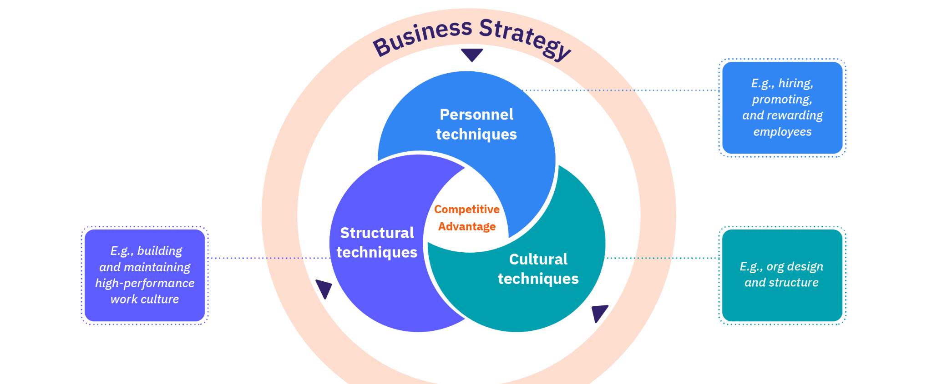
Figure 1, Premier Inn strategic HR roles
(Source, Aihr.com 2023)
Premier Inn, as a leading and modern organization, leveraged technology to streamline the HR processes (Ghani et al. 2022). The integration of HRIS and other effective technological tools enables more efficient talent acquisition, data analytics for decision-making, and it improves the communication process between HR and other employees. The evolution of the HRM value at Premier Inn also involved a major heightened management on the base of employee experience and well-being (Kloutsiniotis and Mihail, 2020). HRM Initiatives related to employee engagement, and work-life with stable wellness programs are becoming the integral part to attracting top talent. Premier Inn's HRM strategy basically prioritizes a continuous learning and development process to keep the management of the workforce in a competitive and adaptable manner. Training programs, skill development initiatives, and leadership development have become key factors of HR strategies.

The strategic role of HRM functions as Vital for Premier Inn's success as an international hotel brand (Djajasinga et al. 2021). HR functions extend beyond the traditional administrative tasks, and it plays a vital role in aligning the workforce with the state of the organization's management goals. The key aspects of the strategic role of HR functions at Premier Inn, Workforce Planning Talent Forecasting All HR engage in the management of strategic workforce and planning to anticipate the management skills and competencies that are required for Premier Inn's growth and the international expansion (Rusmingsih et al. 2021). This functions properly assessing the current staffing needs, and taking into consideration major market trends, industry changes and technological advancements. Premier Inn's HR team properly identifies the core ideas of potential leaders within the organization and ensures key positions of each leader. Succession planning minimizes the disruptions and facilitates a smooth transition during leadership expansions.
Premier Inn's international brand presence demands a diverse workforce enhancement. HR develops global recruitment strategies that attract talent from the different regions and ensures a mix of skills and perspectives that align with the brand's objectives (Ohunakin et al. 2020). HR employs the basic strategic recruitment processes and is focusing on management competencies, and it is aligned with Premier Inn's values and business objectives. These HR functions signify new hires who contribute effectively to the brand's success.
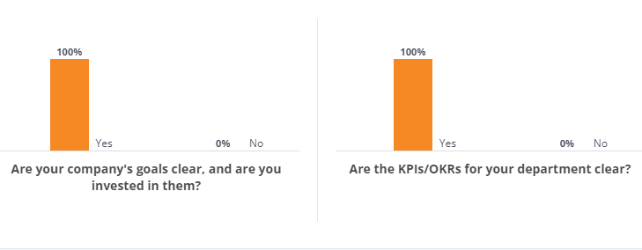
Figure 2, Employees satisfaction metrics of premier Inn
(Source, Comparably.com 2023)
Training and Skill Enhancement, HR at Premier Inn invests in continuous learning and development sessions to enhance the leaders’ skills of the workforce. This includes cross-cultural training for the international assignments and specialized training to keep pace with industrial trends. Leadership Development, Premier Inn's HR functions effectively identify leaders' core values, fostering a leadership culture and it aligns with the brand's strategic vision. These management initiatives include mentorship programs, leadership training, and working exposure to diverse experiences. Employee Engagement and Retention, Cultural Alignment, HR functions mainly ensure that Premier Inn's workforce that culturally aligned with the potential brand values and fosters a sense of working commitment among the employees. Recognition and Rewards, Strategic HR functions properly designed to recognize and reward programs that motivate all talent (Yusoff et al. 2020). These functions signify performance-based incentives and opportunities for career advancement.
Adaptability and Flexibility, In the growing observation of the hospitality industry, HR at Premier Inn plays a vital role in managing change by promoting working flexibility among employees. Data-Driven Decision Making, HR roles leverage data analytics to make informed decisions and it is related to workforce planning, and other recruitment strategies of employee engagement Comparably.com (2023). This enhances the working effectiveness of HR initiatives and contributes to the strategic success of Premier Inn. Strategic HR planning Forecasting Labor Demand and Supply, Scenario Analysis, Premier Inn mainly engages in state of scenario analysis to predict potential engagement in the hospitality industry, and it considers the factors such as technological advancements, economic trends, and global events (Premierinn.com 2024). Data-Driven Forecasting, utilizing past market research, and industry analysis, Premier Inn's HR team employs quantitative models to forecast the demand for different job roles in different locations.
Premier Inn's HR goals are closely aligned with the broader range of business objectives, and it contributes to the overall strategic plan. For example, if the company plans to expand into new global markets, HR strategies focus on recruiting talent with cultural adaptability and language skills. Competency Frameworks, The HR department establishes this framework, and it sets out the skills, knowledge, and working behaviors that are required for organizational success within Premier Inn (Premierinn.com 2024). This goal setting for each individual and employee ensures their proactive development, and it aligns with the company's strategic priorities.
Premier Inn specifically employs a diverse recruitment strategy, and it is tailored to specific markets. The strategic partnerships with the local educational institutions are utilizing online platforms, and it is conducting targeted management drives. The main success of these HR programs is continuously evaluated to refine the future initiatives. Employee Development Programs, Premier Inn basically invests in proper training and development programs that enhance the value of employee skills. Regular evaluations measure on the business effectiveness set the programs in meeting the strategic goals within the organization. At Premier Inn, employees believe that their Key Performance Indicators (KPIs) and Objectives signify the results of 100% agreement (George, 2022). With major understanding and investment in the company's strategic goals are expressed clarity and working commitment. Hence, concerning managerial feedback, employees reported receiving helpful feedback once a year, and this is a notable value around 100% indicating a statement to the receiving feedback on a more regular basis. Recognition for the employees' accomplishments varied, with 50% receiving acknowledgment and around 25% once a week (Anthonisz, 2021). These findings signify a need for increased feedback mechanisms to enhance employees' understanding of their performance metrics and foster continuous improvement.
Analyzing the HR roles, Premier Inn applies the human capital theory by recognizing employees' valuable assets. Proactive Investments in proper employee training, skill development, and well-being contribute to enhanced human capital, ultimately driving the company's success (Reyes-Gómez et al. 2024). Balanced Scorecard Approach, The HR department at Premier Inn uses a balanced scorecard approach, incorporating financial, customer and learning and growth perspectives. This function ensures a comprehensive evaluation of HR programs’ effects on the overall strategic success of the organization.
Premier Inn engages in comprehensive HR planning to align its workforce that signifies the strategic goals. This involves forecasting, setting future staffing needs, identifying skill gaps, and understanding the major market trends (Anthonisz, 2021). Premier Inn plans to expand its business presence in a new international market, HR planning would basically involve assessing the demand for skilled employees, considering cultural values, and ensuring compliance with local labor laws.
Premier Inn basically conducts a thorough job analysis for each job role. For a state of managerial position in different international locations, the analysis may involve understanding the specific responsibilities, and it requires qualifications, and other cultural competencies (Pelit and Katircioglu, 2021). The potential management value ensures the recruitment process, and it tailored the unique requirements of the specific job role. Premier specifically utilizes various networks for job postings and advertising to attract the candidates (Premierinn.com 2024). Hence, through their own career portal, international job boards and other strategic partnerships with local recruitment agencies, the hotel brand ensures visibility across the different platforms. This approach is crucial to expand internationally, and it helps to reach potential employees' value in diverse markets.
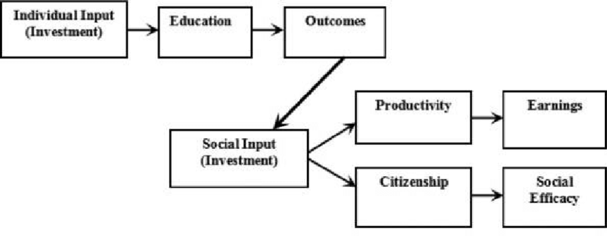
Figure 3, Human capital theory
(Source, researchgate.net, 2023)
Premier Inn's HR team analyzes applications to shortlist the candidates who align with the brand's values and job requirements (Reyes-Gómez et al. 2024). Hence, hiring for customer-facing job roles in a new market, and state the review process may include assessing cultural awareness, language proficiency and customer service experience. Premier Inn conducts structured interviews and assessments to evaluate the candidates' skills, working competencies, and other cultural fit (Haldorai et al. 2022). These working assessments may include scenario-based observations and role-playing, that especially signify the hiring process for leadership roles in a new international business unit. These factors ensure that candidates are required to resonate with the brand's ethics. Premier Inn mainly conducts thorough reference, and it checks to verify the candidates' professional backgrounds. These are vital factors, especially recruiting for the key positions in an international setting, as it helps to ensure the reliability of the selected individuals.
Premier Inn provides competitive offers in different onboarding processes for new hires engagement (Premierinn.com 2024). The onboarding process includes cultural orientation, training on various company policies, and introductions to the brand's values. Hence, Premier Inn ensures the international business units, and it is staffed with qualified individuals who contribute to the brand's success while respecting the local cultures and meeting the specific market demands. HR planning, cultural sensitivity, and a comprehensive selection process are vital for the sustained growth and development of Premier Inn continuity in the global hospitality industry.

Conclusion
It can be concluded that Premier Inn's strategic development is influenced by the evolution of its (HRM) practices, and it particularly signifies the value of workforce planning, recruitment, and selection. The hotel brand's commitment to aligning HR strategies with the business objectives and ensures effectively navigate the complexities of the international hospitality industry. HR planning to the diverse markets, conducting thorough job analyses, and implementing comprehensive recruitment and selection processes, and it helps Premier Inn secure a culturally aware workforce. The structured interviews, reference checks, and robust onboarding contribute to the brand's development maintaining a strong international presence. Through the effective relationship between strategic development, and HRM. Premier Inn not only meets the challenges of global expansion but also fosters a dynamic organizational culture and is essential for sustained growth within the field of competitive landscape in the hospitality sector.

Reference
Aihr.com (2023) Available at, https,//www.aihr.com/blog/strategic-human-resource-management/ [Accessed on, 31.1.24]
Anthonisz, A., (2021). Strategic Alignment or Non-alignment; The Management of Human Capital in 5-star Hotels in Dubai (Doctoral dissertation, University of Derby (United Kingdom)).
Atasoy, B., Türkay, O. and Şengül, S., (2022). Strategic responses of chain hotels to COVID-19 from a situational crisis communication theory perspective. Journal of Hospitality and Tourism Insights, 5(5), pp.1118-1136.
Bardukova, L., (2023). Navigating the Hospitality Horizon, Current Trends and Strategies for Customer Attraction and Retention in the Hotel Industry. Economics and computer science, (2), pp.88-103.
Comparably.com (2023) Available at, https,//www.comparably.com/companies/premier-inn/kpi-okr [Accessed on, 31.1.24]
Djajasinga, N.D., Sulastri, L., Sudirman, A., Sari, A.L. and Rihardi, E.L., (2021), June. Practices in Human Resources and Employee Turnover in the Hospitality Industry. In 2nd Annual Conference on blended learning, educational technology and Innovation (ACBLETI 2020) (pp. 113-117). Atlantis Press.
George, R., (2021). Tourism and Hospitality Marketing Principles. In Marketing Tourism and Hospitality, Concepts and Cases (pp. 3-31). Cham, Springer International Publishing.
Ghani, B., Zada, M., Memon, K.R., Ullah, R., Khattak, A., Han, H., Ariza-Montes, A. and Araya-Castillo, L., (2022). Challenges and strategies for employee retention in the hospitality industry, A review. Sustainability, 14(5), p.2885.
Giousmpasoglou, C. and Hua, T.T., (2020). The use of self-service technologies in budget hotels, the case of Bournemouth. European Journal of Tourism, Hospitality and Recreation, 10(3), pp.251-261.
Haldorai, K., Kim, W.G. and Garcia, R.F., (2022). Top management green commitment and green intellectual capital as enablers of hotel environmental performance, The mediating role of green human resource management. Tourism Management, 88, p.104431.
Kloutsiniotis, P.V. and Mihail, D.M., (2020). High performance work systems in the tourism and hospitality industry, a critical review. International Journal of Contemporary Hospitality Management, 32(7), pp.2365-2395.
Ohunakin, F., Adeniji, A.A., Ogunlusi, G., Igbadumhe, F. and Sodeinde, A.G., (2020). Talent retention strategies and employees’ behavioural outcomes, empirical evidence from hospitality industry. Business, Theory and Practice, 21(1), pp.192-199.
Papadopoulos, O., Lopez‐Andreu, M. and Jamalian, M., (2021). Violation and lack of awareness of employment rights in the United Kingdom's hotel industry, Isolation, fragmentation and barriers to labour enforcement. Industrial Relations Journal, 52(4), pp.315-330.
Pelit, E. and Katircioglu, E., (2022). Human resource management studies in hospitality and tourism domain, a bibliometric analysis. International Journal of Contemporary Hospitality Management, 34(3), pp.1106-1134.
Premierinn.com (2024) Available at, https,//www.premierinn.com/gb/en/home.html [Accessed on, 31.1.24]
researchgate.net, (2023) Available at, https,//www.researchgate.net/figure/Model-of-human-capital-theory_fig1_317836736 [Accessed on, 31.1.24]
Reyes-Gómez, J.D., López, P. and Rialp, J., (2024). The relationship between strategic orientations and firm performance and the role of innovation, a meta-analytic assessment of theoretical models. International Journal of Entrepreneurial Behavior & Research.
Rusmingsih, D., Widarni, E.L. and Bawono, S., (2021). Human psychological factors in the success of human capital investment in driving financial performance, case study of the hotel industry in Indonesia and Malaysia. HOLISTICA–Journal of Business and Public Administration, 12(1), pp.69-75.
Úbeda-García, M., Claver-Cortés, E., Marco-Lajara, B. and Zaragoza-Sáez, P., (2021). Corporate social responsibility and firm performance in the hotel industry. The mediating role of green human resource management and environmental outcomes. Journal of Business Research, 123, pp.57-69.
Yusoff, Y.M., Nejati, M., Kee, D.M.H. and Amran, A., (2020). Linking green human resource management practices to environmental performance in hotel industry. Global Business Review, 21(3), pp.663-680.

