Gio
Journey experts
Marche Italy
Trip Planning

  - Context
Context | 1
- Introduction | - 2
- Aims and Objectives | - 2
- Website and Brochure document links | - 2
- Cost Summary | - 2
- Timings | - 2
- Itinerary | - 3-4
- Funding | - 4
- Gender Room divide | - 5
- Students with disability | - 5
- Marketing | - 6-7
- Abta & Atol | - 7
- Booking Conditions/ Terms and Conditions | - 7
- Cancellation policies of Ryanair | - 8
- Insurance | - 8
- Emergency Plan/health and safety | - 8
- Covid | - 9
- Payments | - 9
- Data Protection | - 9
- Brexit | - 9
- Reviews | - 10
- Appendix 1 | - 11-14
- Appendix 2 | - 15-18
- Appendix 3 | - 19-20
- Images | - 20
- References | - 21

  - Introduction
This document is an overview of a short-haul trip to central Italy. The trip is to the central small town of Urbino, known for its medieval history, culture, and arts. Alongside the wine, cuisine, and beauty of Italy. The trip duration is four days and is aimed at ten university students, plus staff (with the idea in mind staff is paid for by the university). These numbers can be adjusted but for research purposes have been kept to ten. As not all students in a 20-30 class size will wish to go. It could be linked to assignments or used as an incentive trip.
The trip is mainly targeted with women in mind as women tend to take more of an interest in art courses. (Brewer,2017) However, the is an understanding that men also study art and this is factored in. the focus will be on women but not excluded anyone else.
  - Aims and Objectives
- To provide an educational but enjoyable trip to a path less travelled in Italy. A home for art
- To provide inspiration for those studying art with UWTSD .
- To use public transport to not only make the trip more accessible but more sustainable. The scenic route to see more Italy’s every day.
- To help Marche become a muse for the up and coming artists of Swansea future.
- To align this document and planning with a website and brochure that perfectly captures what the trip has to offer.
  - Website - https://bethlew01.wixsite.com/website
Brochure - https://1drv.ms/p/s!ArColXnxnShciWbFhEttwSbSaBkQ?e=LvqJMf
  - Cost summary
  - Timings
Flight- 2 hours 20 minutes
1st bus- 25 minutes
Train- 25 minutes (one hour 45 minutes + 30 minutes wait for timings)
10 minute walk
2nd bus- 45 minutes

Total Travel time= 4 hour 35 minutes

Flights- £142
Hotel- 872/10 = £87.20

Airport Transfer -One Person
-Bus to train station - £1.80 (€2.10)
-Bus from Pesaro - £1.58 (€1.35)
-Train to bus station - £13.15

Excursions -Entry prices and Train fare
Day one -Caves – £8.75
-Train= £7.78
Total= £16.53
Day two- Walking Tour - £23.89
-bus- £1.58 (€1.35) x2
-Gallery + palace = £10.38

Prices (rounded to nearest ten)
Flights and transfer - £180
Hotel - £90
Caves= £20
Walking tour- £30
Total- £310

  - Itinerary
Day one (Friday) -
-Arrive at London STN airport at 4 am to check in, go through security and drop off any check in bags.
-6:05 flight departs for Italy
-Arrive at Federico Fellini international airport in Rimini RMI at 9:15 local time. Aim to leave airport around 10:45.
- Make way to Aeroporto bus station for 11 (bus leaves every 15 minutes to the hour) and Take the Celletta-Cupa number 9 bus for 25 minutes (27 stops) to 4 Rimini’s Fs bus stop.
-Arrive at train station for 11:25
-Take the 11:40 (train leaves every twenty minutes) train to Pesaro.
-Arrive at Pesaro for 12:00/12:10 (duration varies)
-Walk to bus station (ten minutes)
- Change to Pesaro Stazione bus stop and take the 12:30 (bus leaves every half an hour) bus to hotel
-Arrive at Hotel La Meridiana 1:20 .
-Check in
- Free day (No Excursions) -chance to explore the nearby area.
- On site restaurant opens for evening meals at 7:30

Day two (Saturday)-
-Breakfast available from hotel
-packed lunch options form hotel for days excursions
-Take the 11:25 LR bus from Apicoltura
-Arrive in Pesaro at 12:15
-Walk to meeting point for tour
-‘Stop At: Oratorio di San Giovanni Battista, Via Federico Barocci 31, 61029 Urbino Italy.
Inside a fresco cycle of the Salimbeni Brothers. (Duration: 20 minutes)
-Stop At: Casa Natale di Raffaello, Via Raffaello 57, 61029 Urbino Italy.
Historic home of the Santi family where Raphael learns the first rudiments to art. (Duration: 30 minutes
-Stop At: Fortezza Albornoz, Viale Bruno Buozzi Parco della Resistenza, 61029 Urbino Italy. Panoramic point on the medieval city.(Duration: 10 minutes)
-Stop At: Palazzo Ducale di Urbino, Piazza Rinascimento 13, 61029 Urbino Italy.
Facade of the turrets, piazza renaissance, piazza duke Federico, (Duration: 30 minutes’)
(TripAdvisor)

-Tour finishes for 1:45
-Walk to gallery for 2pm entry
-Take the LR bus back back to the hotel once finished in gallery
- On site restaurant opens for evening meals at 7:30

Day three (Sunday) –
-Breakfast available from the hotel
-Leave at 9:10 to catch the LR bus from Apicoltura to Pesaro
-Catch the 10:30 train to Genga-S.Vittore Terme
-Walk for about ten minutes to caves
-Arriving at 12 for 12:30 to caves (must arrive at least 15 minutes before ticket entry time)
-Enjoy caves
- Take the train home whenever finished with caves
-Food in restaurant or nearby eateries

Day four (Monday) –
-Breakfast available from the hotel
-Have a free afternoon
-Lunch at hotel (12pm-3pm)
-Take the LR bus from Apicoltura at 4:10
-Arrive in Pesaro at 4:55 pm (Bus leaves every 10 and 35 past the hour)
-Walk to the Train station (Ten minutes)
-Take the 5:20 train to Riccione (train leaves twenty minutes)
-Take the Metromare bus to Miramare airport stop (bus leaves every 30 minutes)
-Walk to airport (Ten minutes)
-Arrive at airport for 6pm to check in and go through security
-19:40 flights departs for London STN
-Arrive in London for 21:00 local time

  - Funding – a list of possible available funding relevant to the trip and it’s subject matter of the arts and culture.
The Classical Association – provides funding for teachers, students academics and organisations to allow them to offer a wide range of learning experiences about the classical world.
DM Thomas Foundation for Young People- provides a grant for improving the education of young people and to improve their health .
Turing Scheme School Funding- ‘Apply for funding to send your pupils learn abroad; a life-changing experience to learn new skills, raise aspirations and get a better understanding of other cultures.’ (Council for Learning Outside the Classroom).
Taith Funding –
-Pathway one- Mobility of Participants
Funding for those with mobility issues to have opportunities to learn, study or work abroad. Providing both short term and long term opportunities
Pathway two – Partnership and Strategic Collaboration
Enhancement led international learning exchange activists and practices led by Welsh education and training organisations.
Pathway three- Capacity Building
Supports capacity building fo international exchanges. To develop structures, knowledge based experiences and increase international learning experiences. (Taith)
  - Gender Room Divide
A separation of men and women would be ideal however given that they are university students and over eighteen there is an element of independence with the fact that they are adults. There is also the argument of gender expression and sexual orientation. Should one not feel comfortable sharing a room with a specific gender or the same gender as themselves they should be given the opportunity not to. Where possible the genders should be divide but should there be any issues individual comfort should be taken into account. There is no issues with room sharing being mixed as long as everyone agrees both on an individual and authoritative level.
  - Students with Disability
UWTSD provides a range of support to any students that may have extra needs. Offering a range of tools to help student work to their potential and their true level of their abilities .Trinity also aims to help students develop their self-confidence regardless of their level of ability and extends this to the trips and excursions. The aim is to give all students the same opportunities.
Grotte Di Frasassi
Given the nature of the excursion it is difficult to provide access to those who have limited mobility. There is access possible in the beginning of the second room , the room 200. For those in wheelchairs there is accessible possible in the first room. There is also disabled parking available.
Gallleria Nationale Delle Marche
There are lifts available
  - ‘Excluding pupils from school visits
The Equality Act 2010 and the Special Educational Needs and Disability Act 2001 (SENDA) have simplified and strengthened the discrimination laws which protect school pupils from unfair treatment. It is unlawful for a school or other education provider to treat a disabled student unfavourably. Such treatment could amount to:
• direct discrimination
• indirect discrimination • harassment.
Every effort should be made to make school journeys accessible to all who wish to participate, irrespective of disability. Teachers should plan for inclusion from the outset, and should make appropriate ‘reasonable adjustments’ to enable the participation of disabled pupils.
In some cases, particularly where poor behaviour is an issue, this may not be possible. Where the behaviour is a direct consequence of a child’s disability, however, schools will need to demonstrate that they have considered such reasonable adjustments that could have been made, in order to comply with the law. Pupils should not be permitted to participate in school visits where their behaviour may be such that they present a danger to themselves or to others, until such time as their behaviour can be modified. For more information on taking pupils with special educational needs on school trips.’ (National Eduction Union)

  - Marketing
The target market is university students which gives a pretty standard idea of the type of person we are marketing this trip to. The trip is designed with art students mind again giving an idea of the type of segmentation.

  - Geographic Segmentation
-Cities
Possibly wish to escape city life. Won’t be as attracted by city breaks as that is their every day. Culture melting pots, more open minded to other cultures than small towns.
-Wales, Swansea
Known for the waterfront and marina.

Demographic Segmentation

-Age
- Young people (18-30)
-Gender
- Female dominated degree but not excluding men. Focus on targeting women.
-Education level
- University students. Post graduate, undergraduate
-Family
- some students may have children but is not marketing towards children.. Not excluding potential parents due to financial impacts.

-Occupation and income

- Students- student finance, paying placements, parents
- Part time work -minimum wage.

  - Psychographic Segmentation
-behaviour and lifestyle

- Alcohol - students have a stereotype for drinking. There is the societal norm that university is the years where you have fun in your younger years often with drinking. This ties into Italy with their wines and aperol spritz.
- Social media- the digital age that younger people have grown up with has social media at the forefront. Every trip will now social media posts alongside it. This can be useful for marketing and spreading the word.
- Artsy- Given that they are art students this introduces another idea of their interest that would align with the interest in the arts. The type of hobbies that usually come along with art such as culture and history.

  - Product
The product we are offering is the service of travel packaging. The service of packaging together the short haul trip to central Italy with the intention of excursions that would help art students learn about art history and natural beauty.
  - Price
The pricing we aim to offer is that of low cost. Given the financial situation of students and the fact, it is an educational trip. Not that of luxury or leisure. The aim is to be as low-cost as possible.
  - Promotion
The promoting of the trip shall be done through the means of a digital brochure, website, social media and just general word of mouth from tutor to student.
  - Place
The services can be found online through the website and social media.

  - ABTA

ABTA is an Association of Trade for British travel agents and the travel industry. It has been around for 70 years and helps provide guidance and support to travellers. It is important to have this when packaging trips together. (ABTA, About us)

- It’ll help you understand the importance of financial protections

- it is important to read the code of conduct prior to confirming your booking as it gives accurate information and is changed regularly.

  - ATOL Protection

ATOL protection stands for Air Travel Organiser’s Licence it is a financial protection scheme which helps protect you when you book a trip that includes flights. It is run by the Civil Aviation Authority . This is extremely important to have as a travel company could go into liquidation and you would be out of pocket. (ATOL, About us)
- You will then receive ATOL certificate.
- If your flight has been delayed or cancelled this will protect you.
- Help get you a refund to return home

  - Booking Conditions/ Terms and Conditions

By booking with us your monies will be protected as we have a bond held with ABTA and financially protected with the ATOL Scheme if you have a certificate.( Ryanair, Booking terms and conditions)
- You will be required to fill out your personal details correctly. If filled out wrong, there will be an additional charge.
- Once you have given your deposit, you will need to pay the rest of the money. If you no longer want to go on the trip, you will not get your deposit back.
- Usually in hotels there is a damage policy which means if anyone damages or loses anything then you will be liable to be charged an extra amount.

  - Cancellation policies of Ryanair
- Ryanair state that once a flight is in operation with no delay exceeding 5 hours, there will be no refund.
- There will be no refund if you decide to not go on the trip
- If your flight has been cancelled, then there is an opportunity to apply for a refund or change your flight for free.

  - Insurance
Booking insurance is an essential part of any holiday it can help cover you if you are no longer able to go and costs if anyone falls ill whilst away. Holiday extras is a perfect and easy page to use if you are looking for travel insurance quickly. Ranging from £7.81- £16.75 if you want more protection. ( see appendix)

  - Emergency Plan/health and safety

An emergency plan/ health and safety procedures are put in place to help those looking after a group of people. It can be relatively basic but intends to cover many health and safety issues if problems arise, some of these issues include.
- Illnesses/diseases(Heatstroke, food poisoning)
- injuries to students on trip ( transport incident/falling off platforms, falls in streets)
- Weather conditions
- Damage to property (fire hazards)
- Criminal activity (terrorist threats/ pickpocketing/ robbery)
- Getting lost and not staying in a pair
- Getting kidnapped
- Road safety
- Train safety (crime on trains is significantly high)
- Make sure you use padlocks on luggage to keep it safe
- Do not misplace valuables and be aware of surroundings
- Behave appropriately throughout the trip to avoid problems.
- If you have any health issues these will need to be documented and looked at before the trip.
- What medication people take
- Any allergies

It will include roles and responsibilities to include exit locations from the hotel, meet up points , staff who are able to provide first aid and medical assistance as well as additional assistance to anyone with a disability. Student phone numbers and next of kin will be given to staff to be able to contact family if anything were to happen. A paper copy of everyone’s passports and confirmation of the whole trip is also essential.

Emergency numbers in ITALY are:
112- police
118-ambulance
115- fire department

A risk assessment will be fully taken.

  - COVID in Italy
Italy no longer requires visitors to wear face coverings however it is still encouraged in indoor spaces. You will still be required to take a mask and keep an eye out for any signs where you may need to wear a mask. Although, it is still compulsory in healthcare settings like care homes and hospitals. (UK Government, FTA)

  - Payments
A deposit of £150 will need to be paid 12 weeks prior the holiday with 3 other payments of £50 which can either be done separately or as a big chunk.

  - Data Protection
Personal Data will be recorded and processed in accordance with the Data Protection Act 2018. It should not be kept longer than necessary once the trip is over this will be deleted.
You have the rights to enquire what information will be stored about you and how it is being used. ( UK Government, Data Prorection)

  - Brexit
When travelling to Italy following Brexit your passport cannot be more than 10 years old. You are recommended to take a European Health Insurance Card that is valid if you have one. If not, you are able to apply for one on the website and get a UK Global Health Insurance Card instead. (ABTA, Brexit)

  - Bethan Review

Strengths
Bethan has many strengths that travel operations has shown to be an opportunity to display. Ranging from organisational skills to digital literacy. She has taken on a new level of leadership skills by under taking more a business role. She has tackled the policies and legislations very well. Her digital literacy skills have prevailed during these roles using a range of search engines, websites and general digital spaces.

Weakness
Bethan’s weakness were in time management, given the extent of the content of the project and the time it was done in. Bethan also shows a lack of creative confidence and does not portray skills in areas such as advertising.

  - Shauna Review

Strengths
Shauna has used this project to utilise her creativity and express her artistic vision. She handled the more personal aspects of the project well and has even improved on her digital literacy skills. In this project she also took on more numerical roles with costings and finance. She has shown great improvements in this area.

Weakness
Shauna lacked in time management, of the deadline for this project. Shauna also showed a strain on her self-efficacy and perfectionism within the project which has has partly been the cause of her delays.

  - Appendix 1- Costs
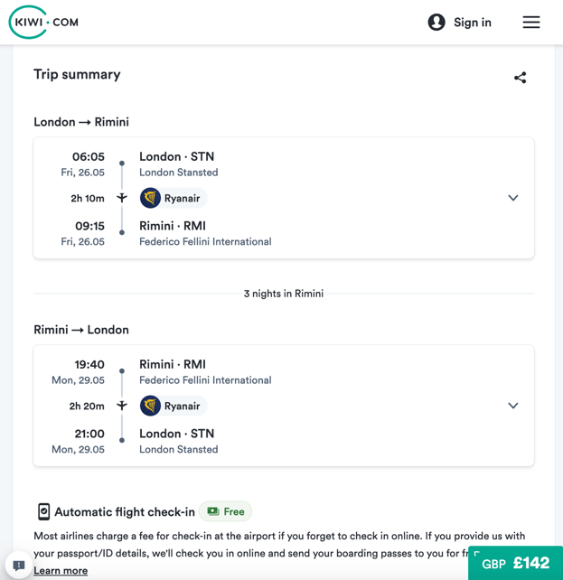
Figure 1- Flight Prices
-
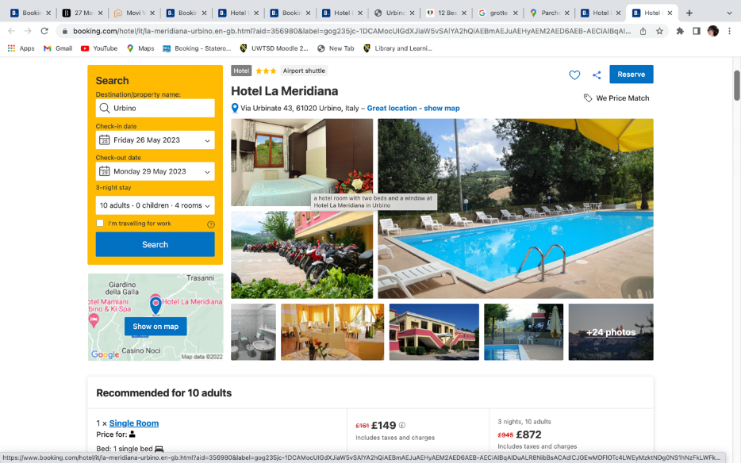
Figure 2-Hotel La Meridiana

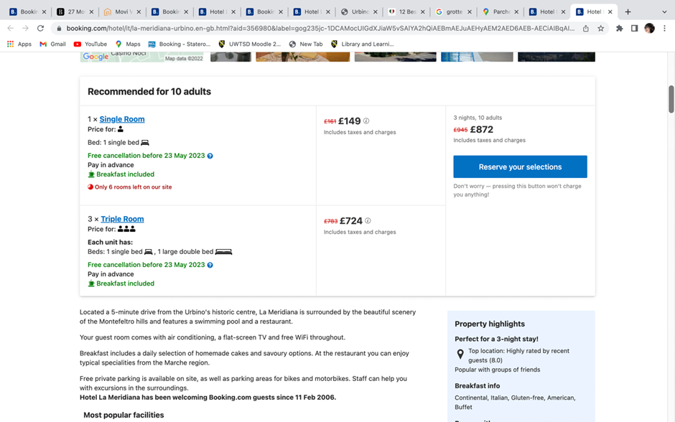
Figure 3-Hotel La Meridiana room prices
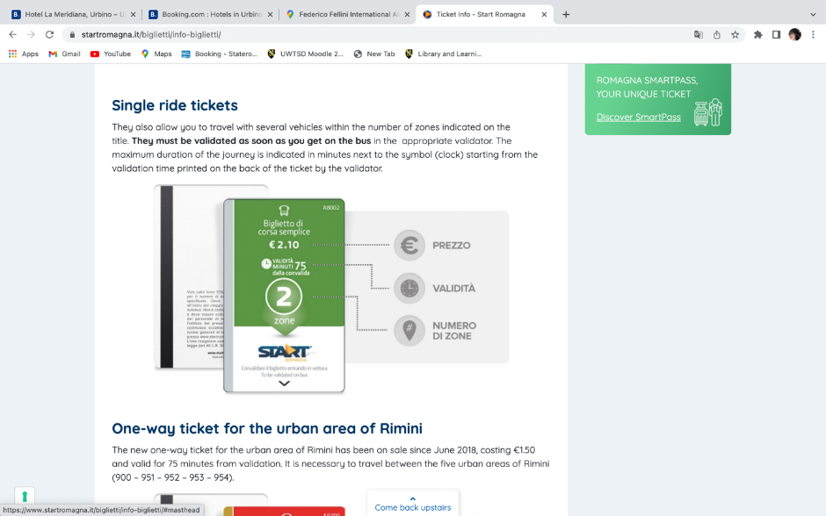
Figure 4-Bus to train station from airport- £1.80 (€2.10)
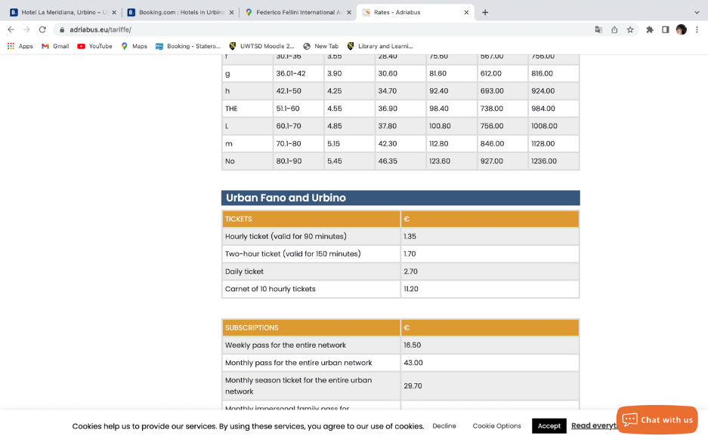
Figure 5- Bus from Pesaro - £1.58 (€1.35)
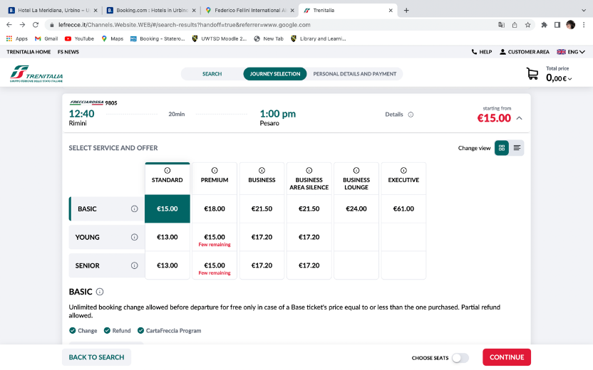
Figure 6 -Train to bus station- £13.15
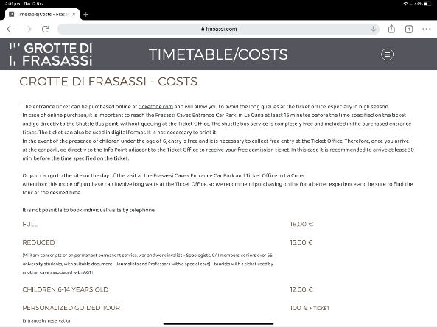
Figure 7-Caves – £15.77

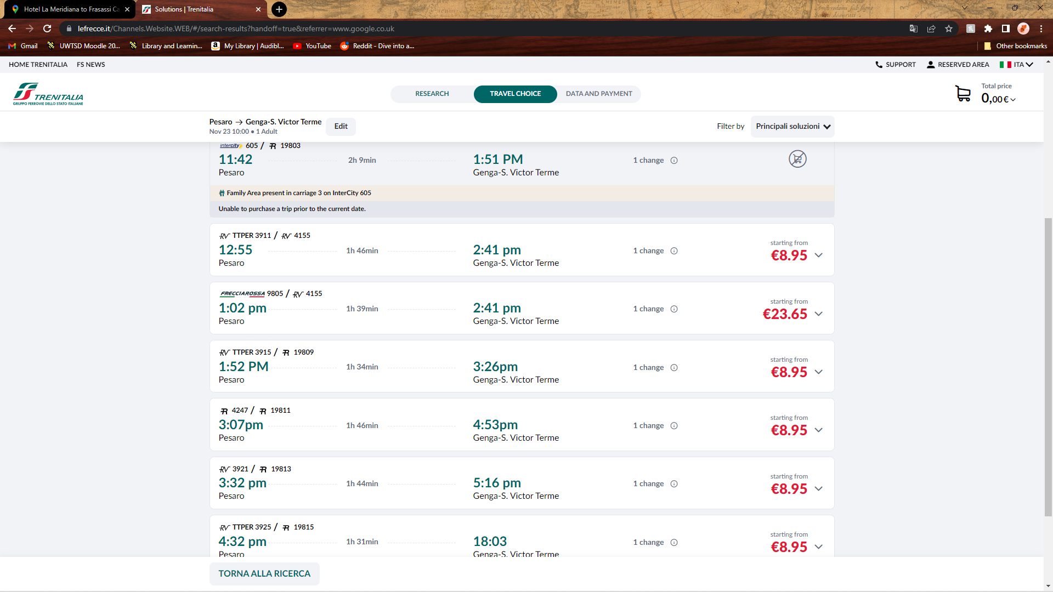
Figure 10-Train= £7.78
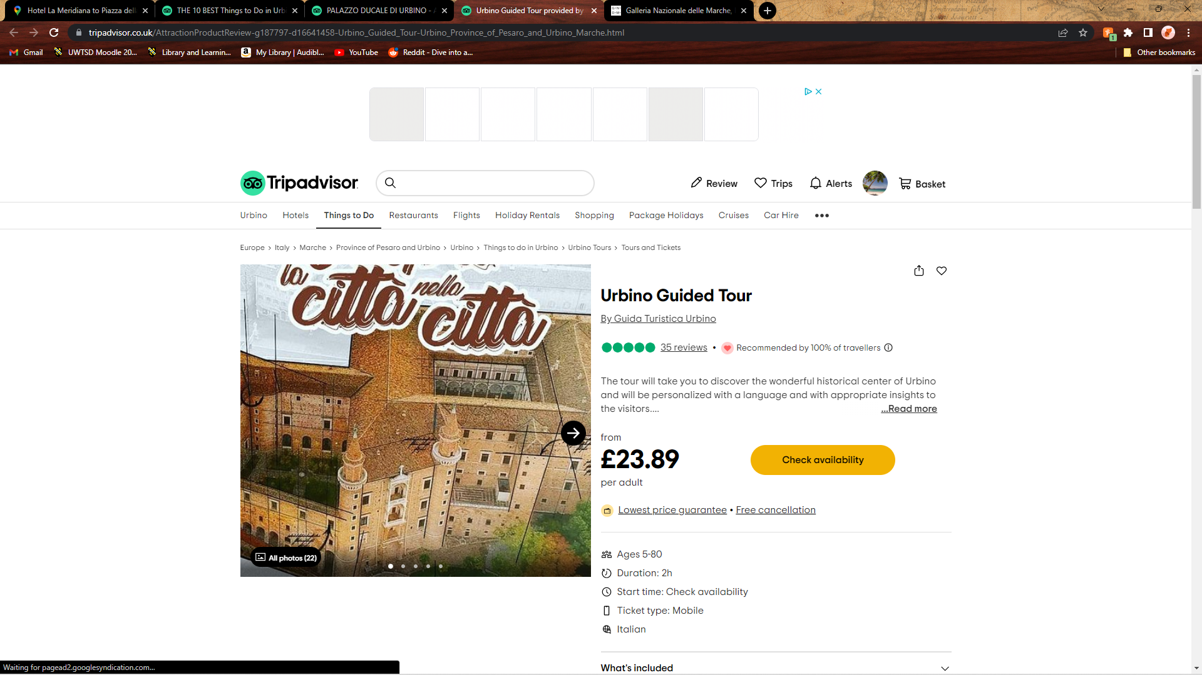
Figure 11- Walking Tour - £23.89
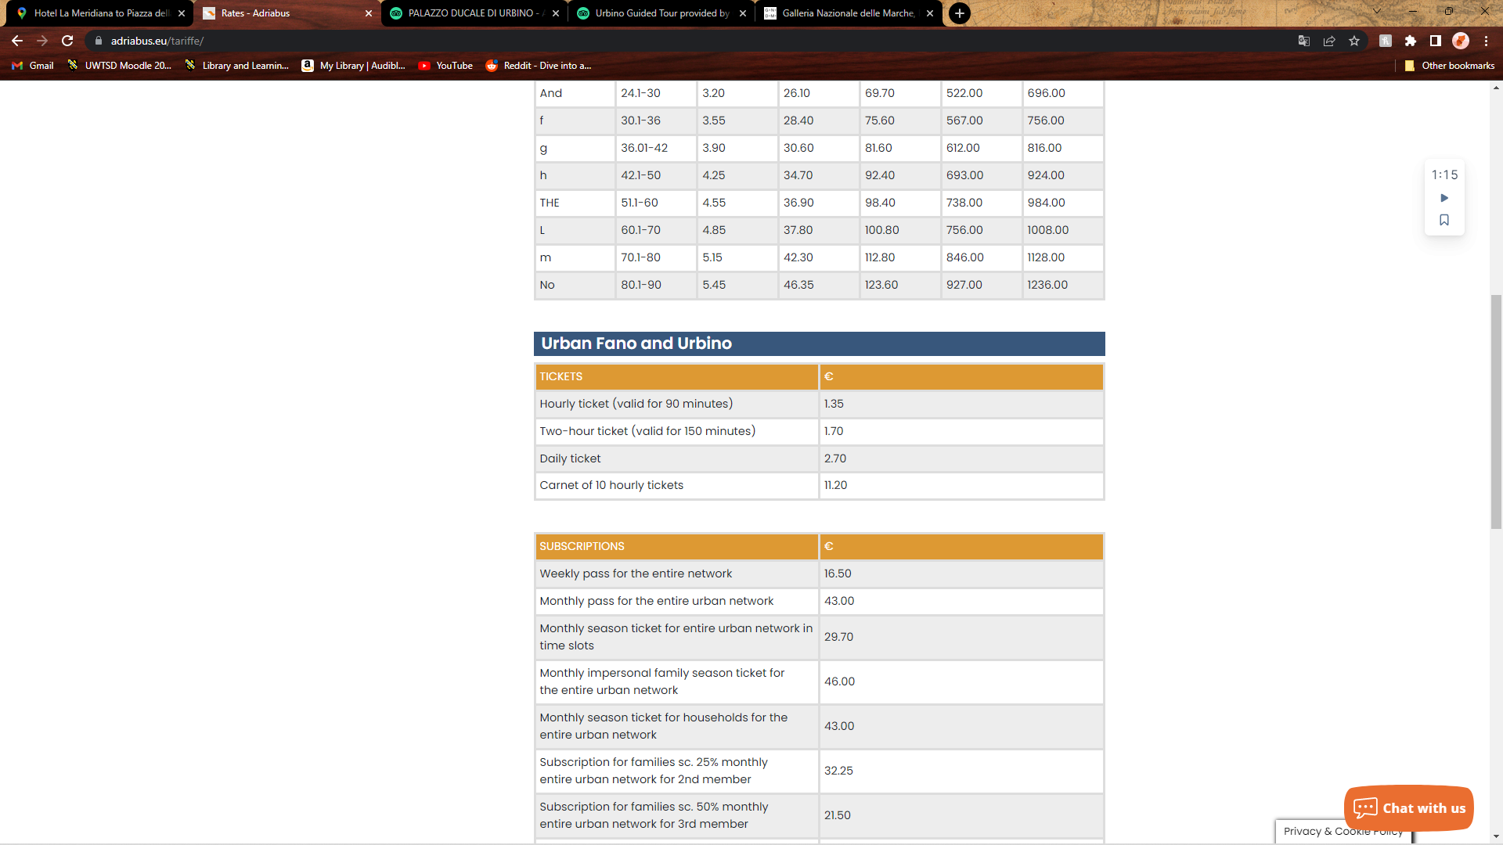
Figure 12- bus- £1.58 (€1.35) x2

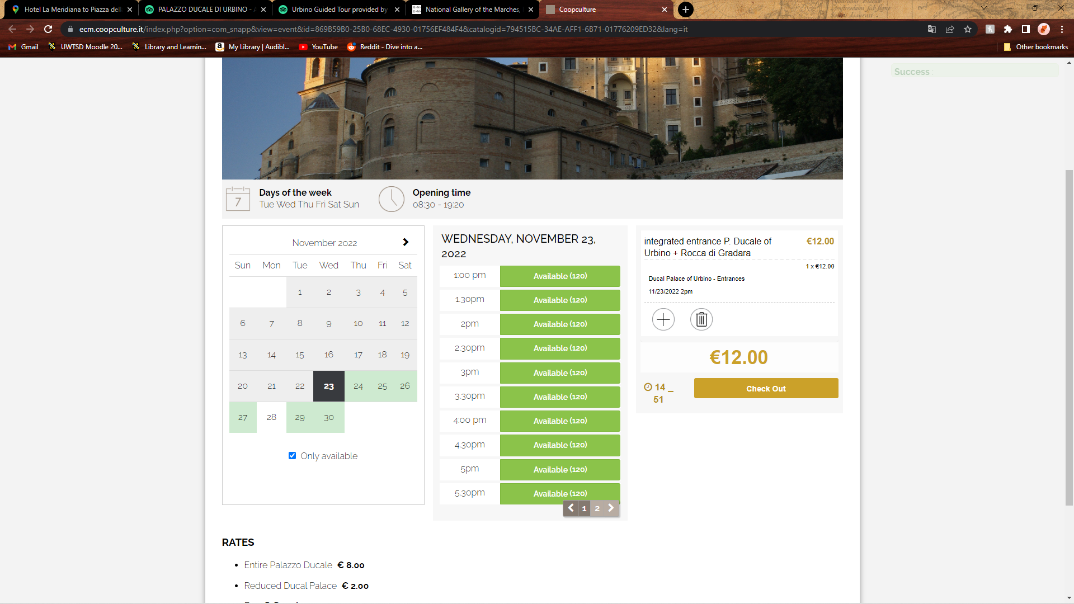
Figure 13-Gallery + palace = £10.38
  - Appendix 2 -Travel Timings
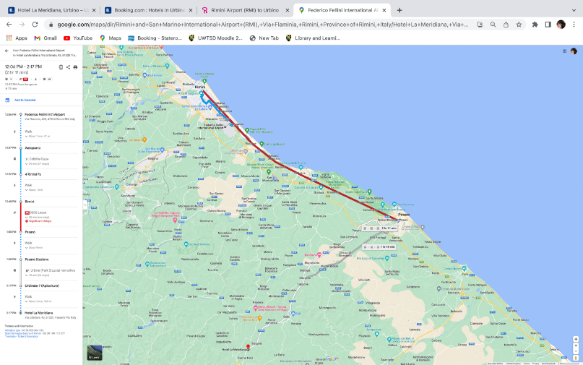
Figure 14-airport transfer (one hour 45 minutes + 30 minutes wait for timings)
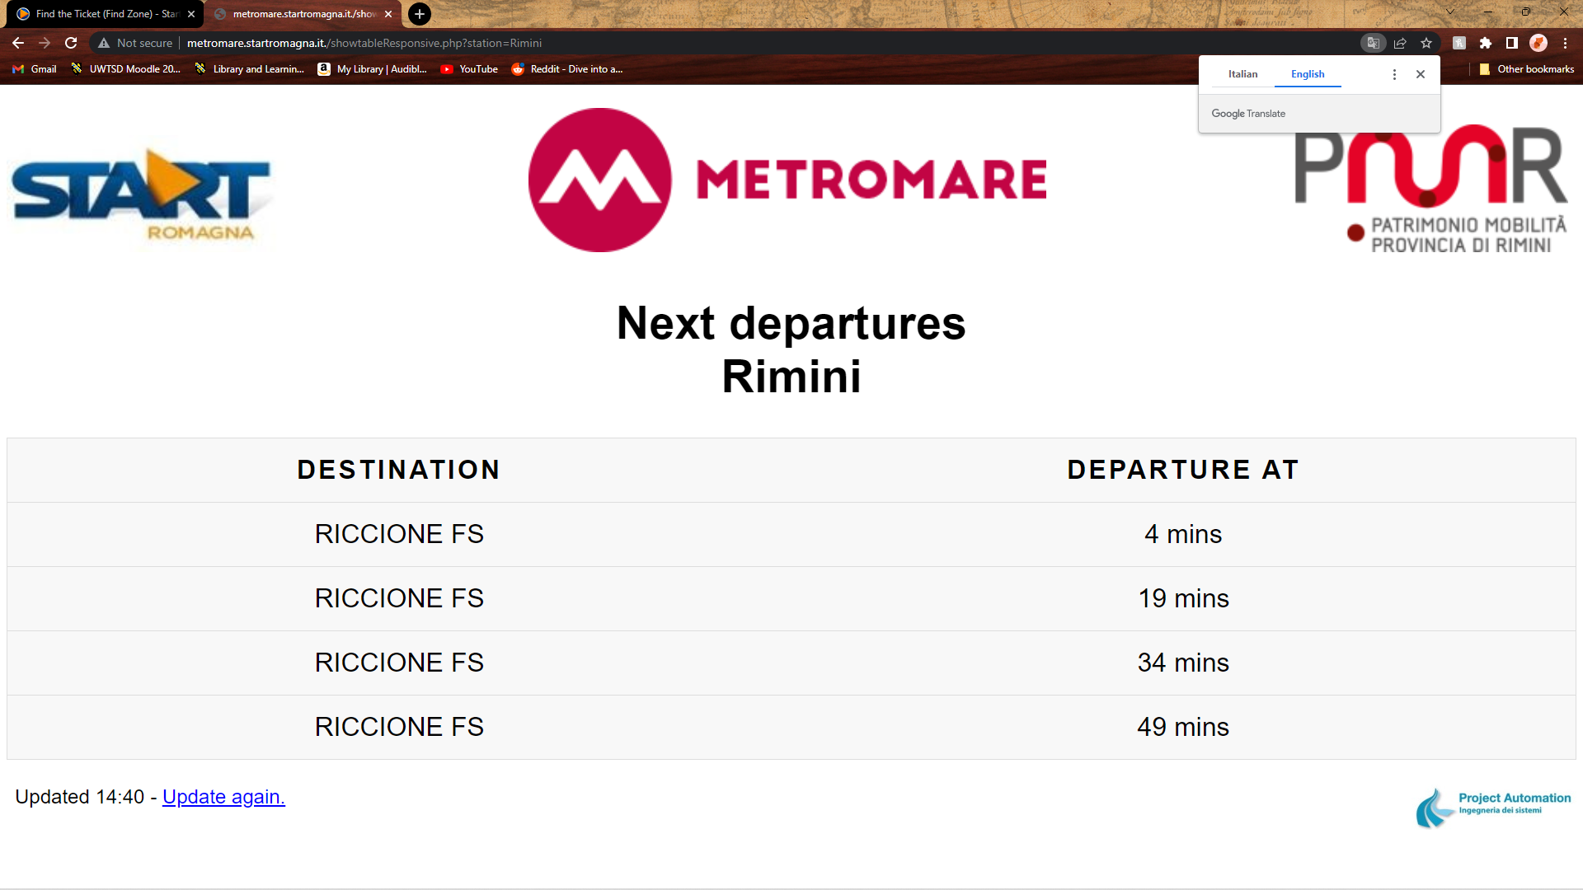
Figure 15- 1st Bus timetable
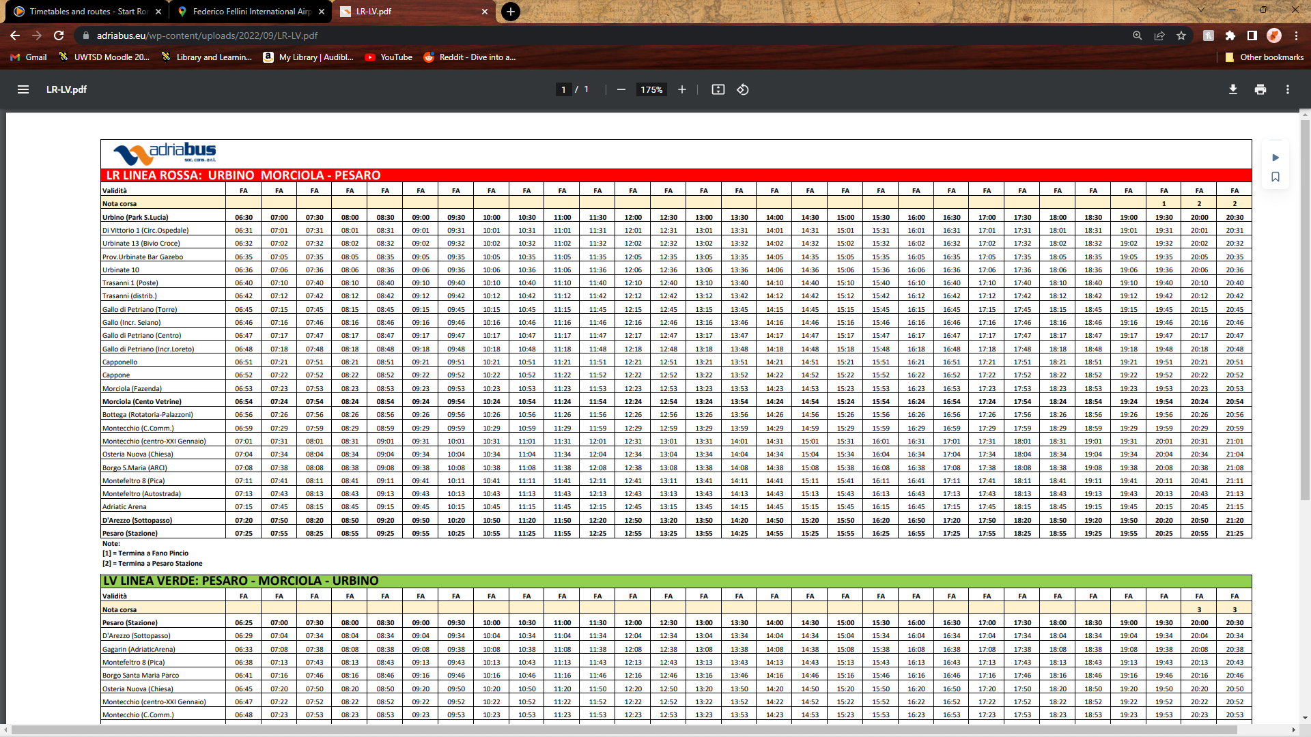
Figure 16- 2nd Bus Timetable
Figure 17 bus to walking tour
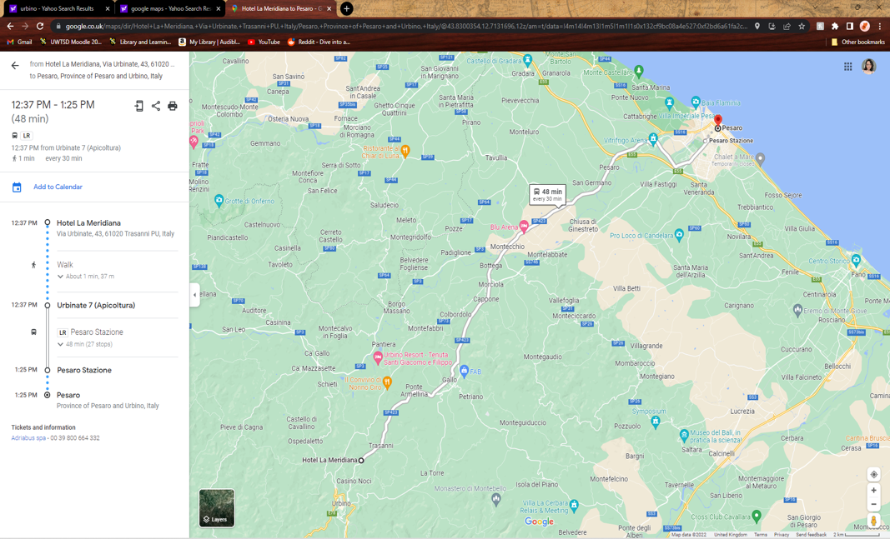

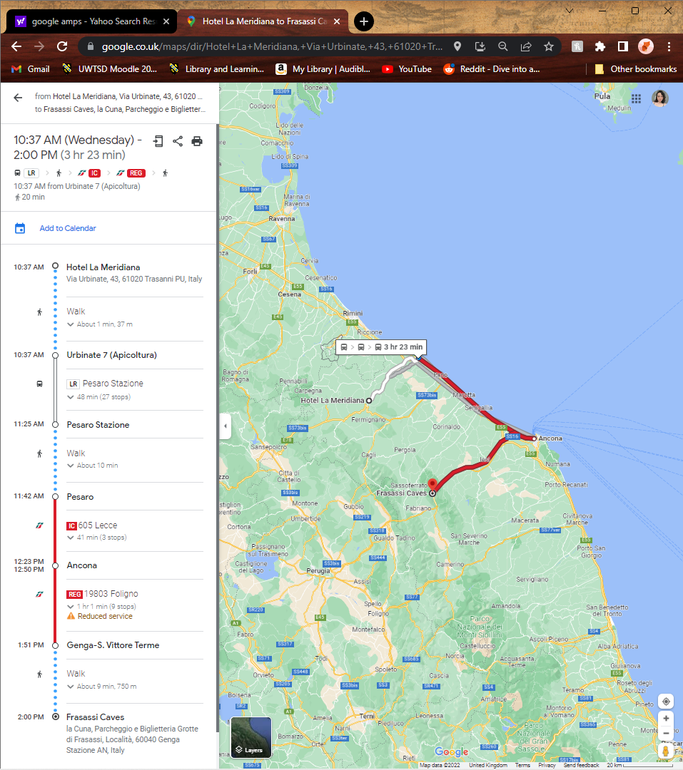
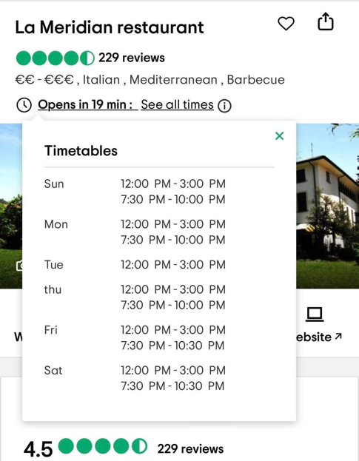
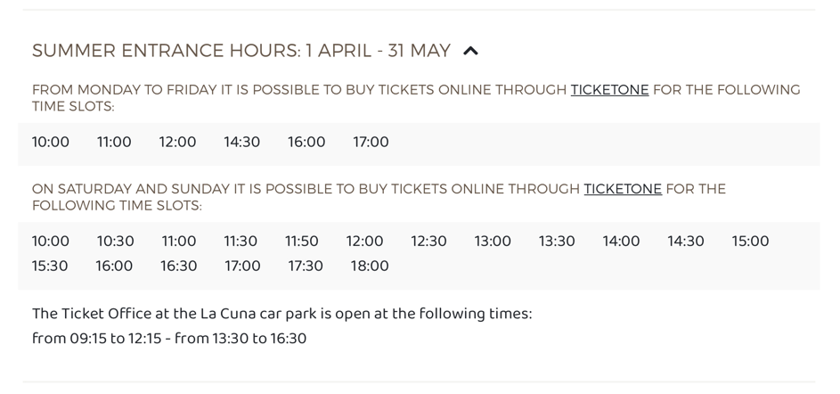
Figure 18- Travel to caves
Figure 21- Hotel restaurant times
Figure 20- Cave opening times
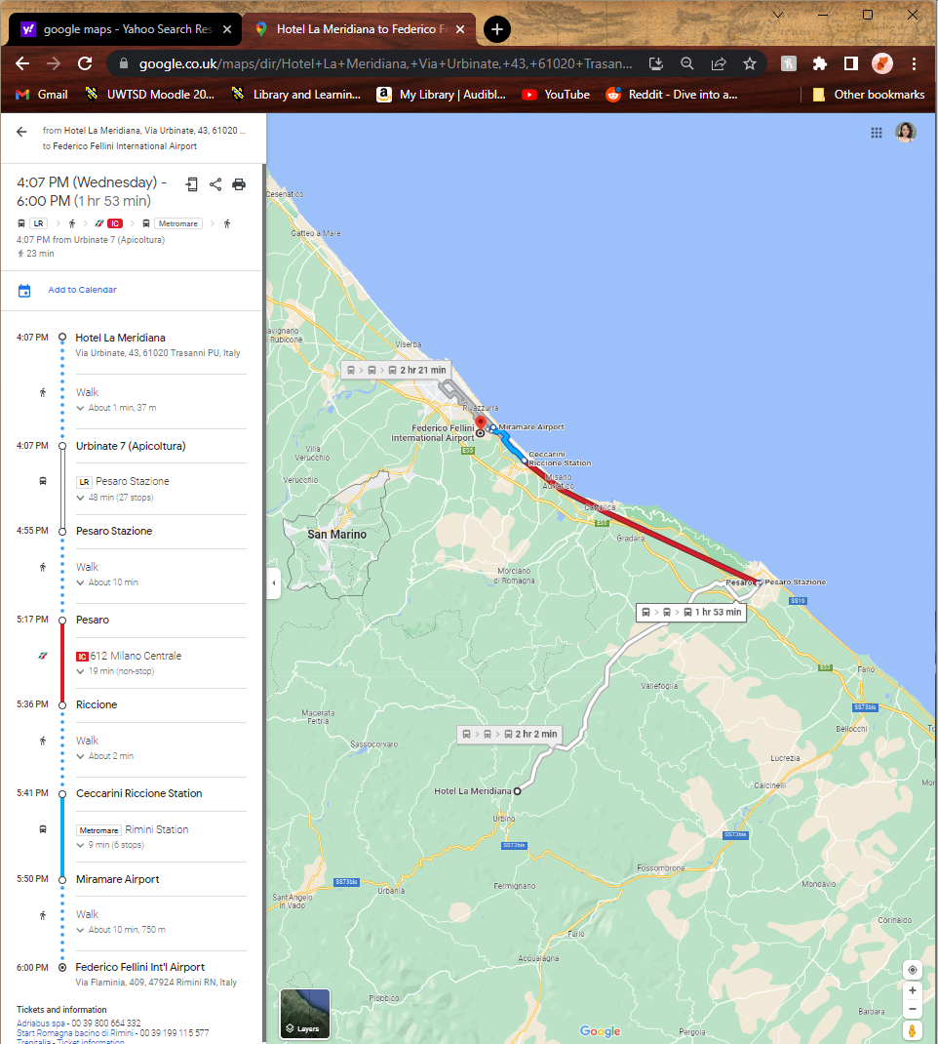
Figure 22-Hotel to airport
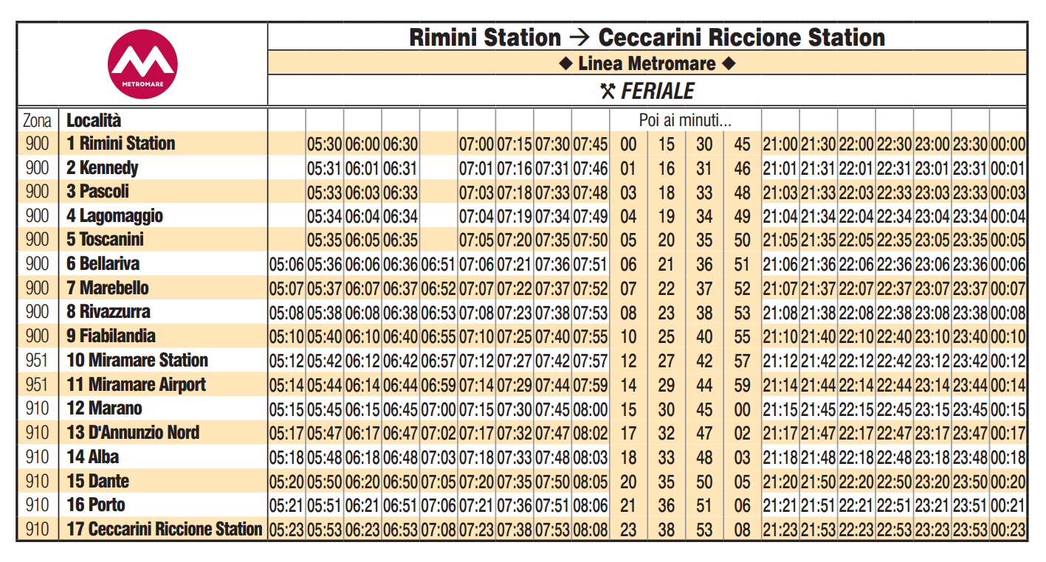
Figure 9- bus to airport from train station
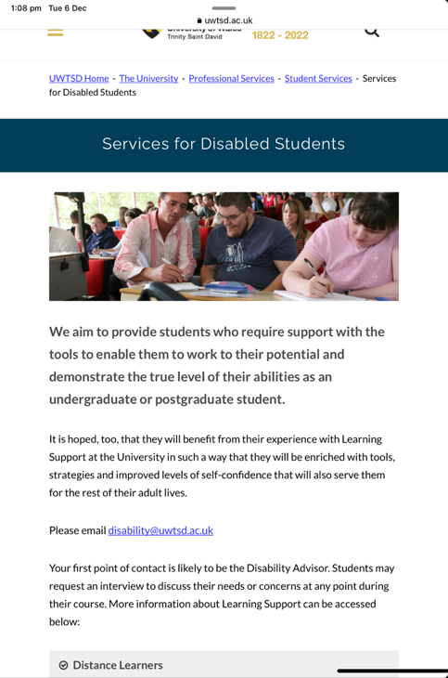
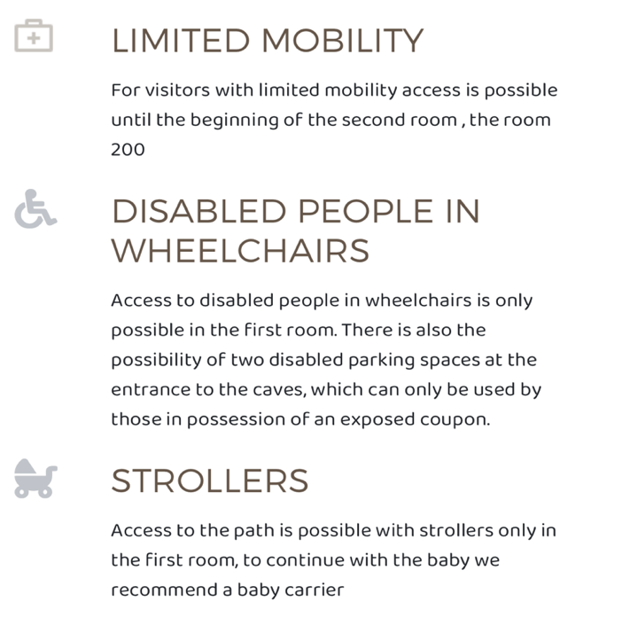
  - Appendix 3 – Policies and Values

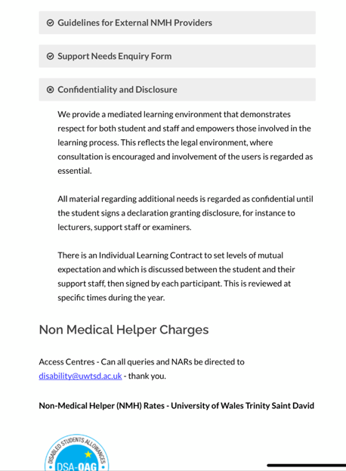
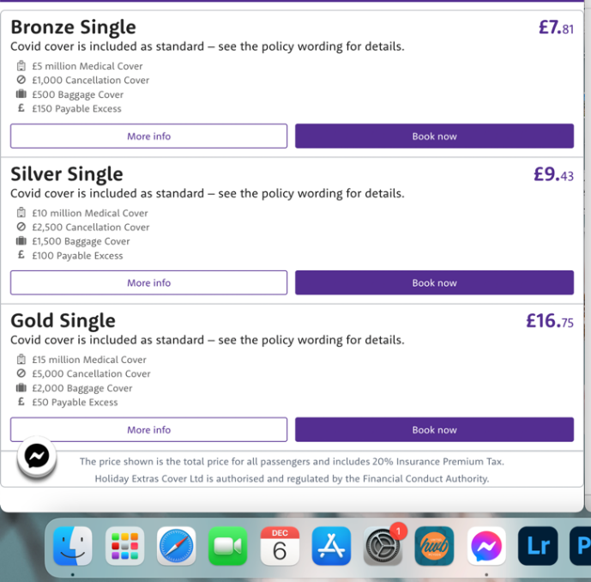
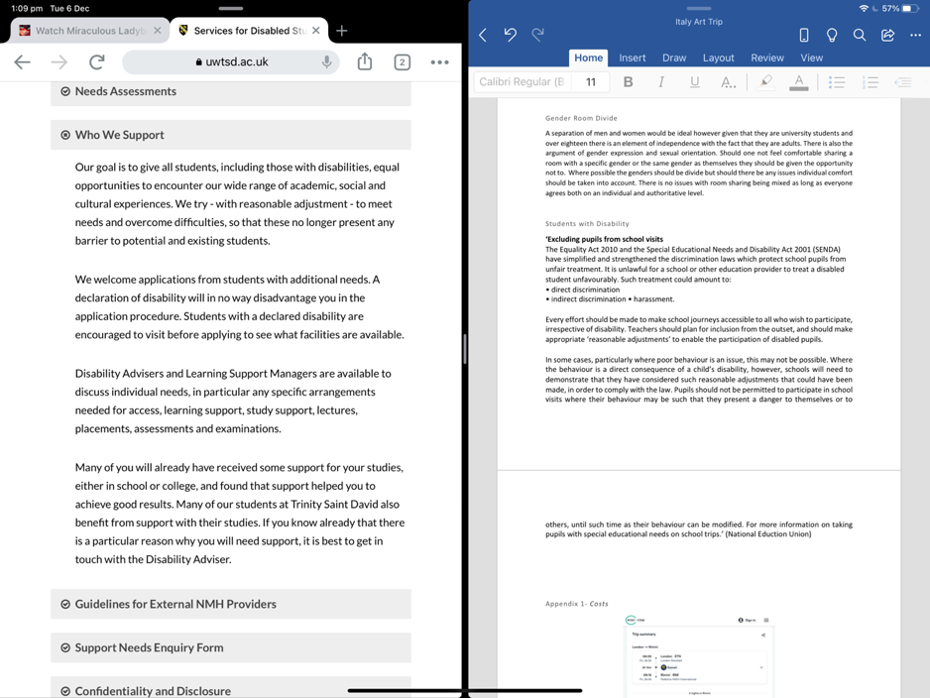

Available At:
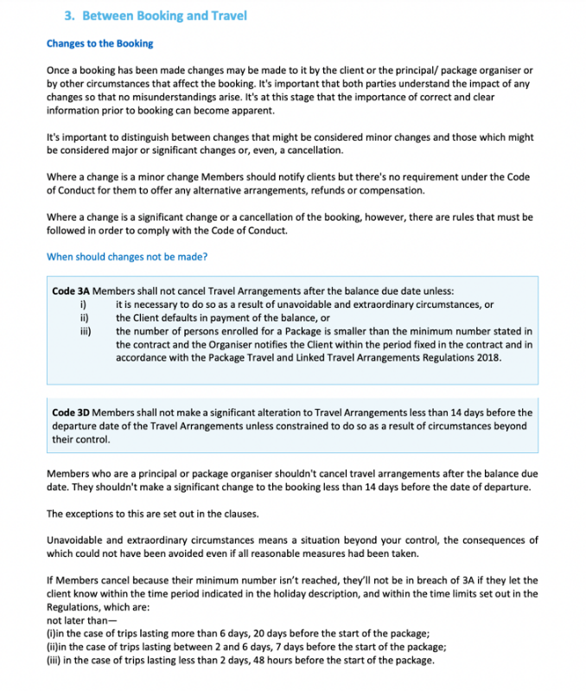

Images
Booking.com, ‘Building view from hotel, [Online], Available At: https://www.booking.com/hotel/it/la-meridiana-urbino.en-gb.html , (Accesssed:06/12/2022)
Booking.com, ‘ Balcony view’,[Online], Available At: https://www.booking.com/hotel/it/la-meridiana-urbino.en-gb.html, (Accesssed:06/12/2022)
Booking.com, ‘Bed with coffee’, [Online], Available At: https://www.booking.com/hotel/it/la-meridiana-urbino.en-gb.html, (Accesssed:06/12/2022)
Booking.com, ‘Building’, [Online], Available At: https://www.booking.com/hotel/it/la-meridiana-urbino.en-gb.html, (Accesssed:06/12/2022)
Italian Notes, ‘Street View’, [Online], Available At: https://italiannotes.com/adorable-hill-towns-italy/, (Accesssed:06/12/2022)
Touring in Rome, ‘Tour to Urbino’, [Online], Available At: https://www.touringinrome.com/wp-content/uploads/2016/11/urbino.jpg , (Accesssed:06/12/2022)

References
ABTA, 2022.’About us’. Available at: https://www.abta.com/about-us/who-we-are (Date Accessed: 3/12/22)
ABTA,2022. ‘Brexit- Advice for Travellers’. Available at: https://www.abta.com/tips-and-advice/brexit-advice-for-travellers ( Date Accessed:5/12/22)
Adriabus, (2022), ‘Rates’, Available at: https://www.adriabus.eu/tariffe/, (Accessed:21/11/2022).
Adribus,(2022), ‘Red Line (LR) - Green Line (LV )’,Available At: https://www.adriabus.eu/wp-content/uploads/2022/09/LR-LV.pdf, (Accessed:1/12/2022).
ATOL, 2022. ‘What does ATOL Protection mean’. Available at: https://www.atol.org/about-atol/what-does-atol-protection-mean/ (Date Accessed: 4/12/22)
Booking.com, (2022), ‘Hotel La Meridiana’, Available At:https://www.booking.com/hotel/it/la-meridiana-urbino.en-gb.html, (Accessed:21/11/2022).
British Airways, 2022. ‘ Booking terms and conditions.’ Available at: https://www.britishairways.com/en-gb/information/legal/package-booking-terms-and-conditions (Date Accessed: 3/12/22)
Coop culture, (2022), ‘DUCAL PALACE OF URBINO – ENTRANCES’, Available At:, https://ecm.coopculture.it/index.php?option=com_snapp&view=event&id=869B59B0-25B0-68EC-4930-01756EF484F4&catalogid=794515BC-34AE-AFF1-6B71-01776209ED32&lang=it, (Accessed:21/11/2022).
Council for Learning Outside the Classroom, (2022), ‘Funding’, Available At: https://www.lotc.org.uk/category/funding/ (Accessed: 21/11/2022)
Department for Education, 2022. ‘Emergency planning and response for education, childcare, and children’s social care settings’. Available at: ‘https://assets.publishing.service.gov.uk/government/uploads/system/uploads/attachment_data/file/1114577/Emergency_planning_and_response_for_education__childcare_and_children_s_social_care_settings.pdf ( Date Accessed:2/12/22)
file:///Users/bethlewis/Downloads/PGL+Adventure+Holidays+Additional+Needs+Policy.pdf
Galleria Nazionale Delle Marche, (2022), ‘Home Page’, Available At:, http://www.gallerianazionalemarche.it/ ,(Accessed:21/11/2022).
Hotel Meridiana, 2022. Pictures on hotel facilities page. Available at: http://www.hotelmeridianaurbino.com/en/fotogallery.html
IMAGES
Jenny Brewer, (2017), ‘Women outnumber men at art school, yet underrepresented in industry, finds report’, Available at: https://www.itsnicethat.com/news/freelands-foundation-report-female-representation-in-art, (Accesssed:06/12/2022)
METROMARE, (2022), ‘Next departures Rimini’, Available At: http://metromare.startromagna.it./showtableResponsive.php?station=Rimini , (Accessed:01/12/2022).
National Education Union, (2017), School Visits, NEU guidance for members, reps and local officers’, Available At: https://neu.org.uk/media/926/view, (Accessed:21/11/2022).
PGL, 2022. ‘Booking terms and Conditions’. Available at: https://www.pgl.co.uk/en-gb/adventure-holidays/parents/our-parent-guide/booking-terms-and-conditions ( Date Accessed: 2/12/22)
Ryanair,2022. ‘Flight Cancellations’ Available at: https://help.ryanair.com/hc/en-gb/articles/360017824958 (Date Accessed: 2/12/22)
Skyscanner, (2022),’Cheap flights from London to Rimini’, Available At: https://www.skyscanner.net/transport/flights/lond/rmi , (Accessed:21/11/2022)
Start Romagna, (2022), ‘Info tickets’, Available at: https://www.startromagna.it/en/tickets/info-tickets-2/ , (Accessed:21/11/2022).
TripAdvisor, (2022), ‘La Meridian restaurant’, Available At:https://www.tripadvisor.it/Restaurant_Review-g187835-d2229178-Reviews-Ristorante_La_Meridiana-Como_Lake_Como_Lombardy.html, (Accessed:21/11/2022).
TripAdvisor, (2022),’ Urbino Guided Tour’, Available At:, https://www.tripadvisor.co.uk/AttractionProductReview-g187797-d16641458-Urbino_Guided_Tour-Urbino_Province_of_Pesaro_and_Urbino_Marche.html ,(Accessed:21/11/2022).
UK Government, 2022. ‘Data Protection’. Available at: https://www.gov.uk/data-protection (Date Accessed: 4/12/22)
UK Government, 2022. ‘Foreign Travel Advice’. (Accessible at:) https://www.gov.uk/foreign-travel-advice/italy/coronavirus#:~:text=Public%20spaces%20and%20services (Date Accessed:4/12/22)
UK Government,2022. ‘Safety and security’. Available at: https://www.gov.uk/foreign-travel-advice/italy/safety-and-security (Date Accessed: 5/12/22)
UWTSD, (2022),’ Services for Disabled Students’, Available at: https://www.uwtsd.ac.uk/services-for-disabled-students/, (Accesssed:21/11/2022)
Weloveyouitaly, 2018. picture of Marche .Available at: https://www.italyweloveyou.com/visit-le-marche-italy/

