
Name: Zakariyya Imran
Student ID: 2319033
Lecturer: parese Ahmed
Module: Change makers: Building your Personal Brand for sustainable Employment
Module Code: BMHP5015
Assignment Title: Component 1: Online Portfolio

Task 1 – Personal Brand

Introduction
Developing a strong personal brand is an essential aspect of professional growth, particularly in a values-driven field such as social work. A personal brand communicates an individual’s strengths, values, and professional identity, helping establish credibility and employability.

My Personal Brand
My personal brand is built on being analytical, dependable, and committed to continuous learning. These qualities shape how I engage in academic work, professional relationships, and practice settings. Shepherd (2005) describes personal branding as a strategic process of communicating one’s unique qualities to potential employers, which supports career progression and goal attainment.

Developing My Brand for Employment Goals
To strengthen my employability in social work, I aim to ensure that my personal brand reflects the core values of the profession, including empathy, cultural competence, anti-discriminatory practice, ethical decision-making, integrity, and advocacy for social justice. Professional identity in social work grows through reflective practice and alignment with sector values (Wilkinson & Aspinwall-Roberts, 2020). Developing a professional digital footprint—such as a reflective LinkedIn profile highlighting community involvement, placements, and voluntary work—supports this. Seeking constructive feedback from mentors, supervisors, and peers will further help refine how I am perceived and ensure my actions consistently reflect social work principles.

Conclusion
By aligning my personal brand with the core values and expectations of the social work profession, I can enhance my credibility and position myself as a capable and ethical future practitioner.

Task 2 - Network Map and Rationale

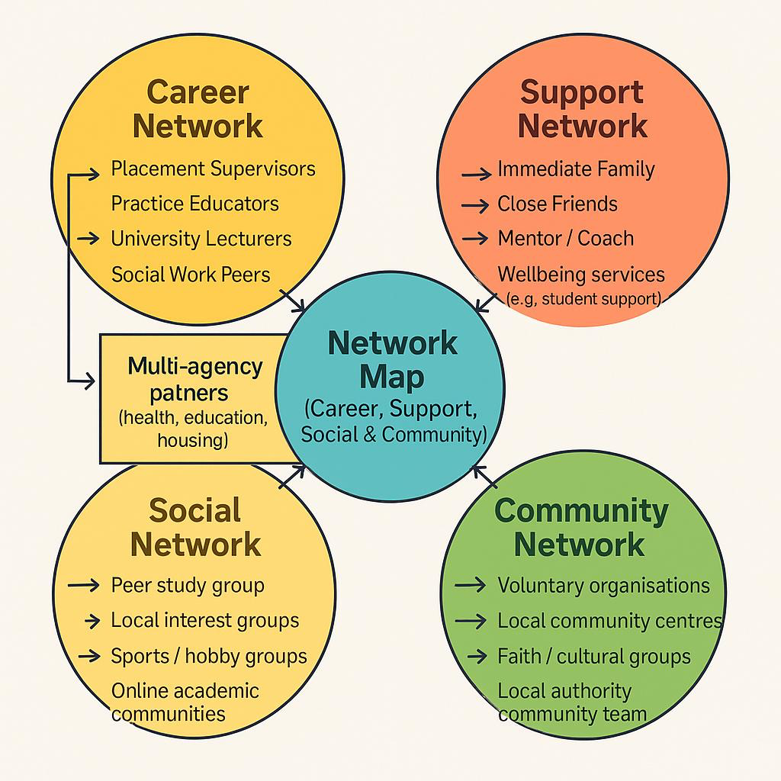

Me
Stronger tie ---------------
Career
Support
Weaker tie --------------
Social
Community ………….
Potential tie

My personal and professional network includes community highlights the range of relationships that contribute to my development as a reflective and resilient social worker. Engaging with supervisors, lecturers, and multi-agency professionals strengthens my learning and supports the development of key competencies aligned with Social Work England’s Professional Standards. Lave and Wenger’s (1991) concept of communities of practice suggests that learning is shaped through shared participation, and my career network provides these essential collaborative spaces.

My support and social networks play a crucial role in maintaining emotional wellbeing (BASW, 2021). which is vital in a demanding profession. Grant and Kinman (2014) argue that personal resilience is enhanced by strong supportive relationships, helping practitioners manage stress, avoid burnout, and sustain professional effectiveness. These networks allow me to reflect, regulate emotions, and stay grounded outside of practice settings.

Community networks further strengthen my cultural awareness, social connectedness, and understanding of the local context. They provide exposure to diverse experiences, which informs anti-oppressive and culturally sensitive practice. Overall, this network map demonstrates how professional, personal, and community relationships collectively enhance my resilience, reflective capacity, and ongoing professional development.

Strengths of My Network
- Strong professional support from supervisors and educators
- Reliable emotional and practical support from family and friends
- Good access to community groups and voluntary organisations

Weaknesses
- Limited connection with specialist practitioners (e.g., mental health, safeguarding)
- Confidence in professional networking still developing.
- Some community links are not consistently maintained.

Areas for Improvement
- Attend more multi-agency meetings and local networking events.
- Build stronger relationships with specialist services.
- Engage more regularly with community groups and reflective peer networks.

Task 3- Blog

Blog Title: The Unsung Role of Social Workers in the UK’s Health and Social Care System
Target Audience: Social Workers
Social workers play an essential yet often overlooked role within the UK’s health and social care system. Although public attention frequently centres on medical professionals, social workers provide the relational, holistic, and rights-based support that enables individuals to navigate complex social circumstances. In today’s climate of rising poverty, housing insecurity, and growing mental health needs, the social worker’s role has never been more critical (BASW, 2022).
A key challenge is increasing complexity of need. Service users are often affected by intersecting issues—trauma, disability, social exclusion, and economic hardship—requiring skilled assessment, advocacy, and multi-agency collaboration. However, social workers continue to face high caseloads, recruitment shortages, and limited resources, conditions which can undermine practitioner wellbeing and contribute to burnout (Skills for Care, 2023). Despite this, social workers maintain their commitment to safeguarding, empowerment, and person-centred practice.
Another ongoing issue is system fragmentation. Social workers regularly act as the bridge between health, social care, voluntary services, and community networks. Yet structural barriers—such as inconsistent communication between agencies and bureaucratic processes—often hinder the delivery of seamless, integrated support (The King’s Fund, 2022). Reform is needed to ensure that social workers can focus more on relationship-based practice rather than administrative pressures.
Despite these systemic constraints, the resilience, creativity, and compassion demonstrated by social workers remain central to preventing crisis and promoting long-term wellbeing. Our work in mental health, children and families, adult safeguarding, hospital discharge, and community development continues to create meaningful change. By advocating for improved working conditions, promoting our professional identity, and supporting one another through reflective practice, we can continue to strengthen our impact. Social workers are not simply part of the system—we are vital to its success. Our work matters, and it transforms lives every day.
Task 4- NHS Equality, Diversity, and Inclusion Quiz

1.What is the primary goal of the NHS Equality, Diversity, and Inclusion Improvement Plan?
The primary goal of the NHS Equality, Diversity and Inclusion Improvement Plan is to strengthen EDI across the NHS workforce by improving staff experience, tackling discrimination, and fostering a greater sense of belonging for all employees (NHS England, 2023).
2. How does the NHS EDI Improvement Plan propose to tackle the gender pay gap?
The NHS EDI Improvement Plan proposes to tackle the gender pay gap by increasing transparency, requiring targeted action plans, and improving career progression opportunities for women—especially in senior roles (NHS England, 2023).
3. What is meant by the term ‘intersectionality’ as used in the NHS EDI Improvement Plan?
In the NHS EDI Improvement Plan, intersectionality refers to the way multiple aspects of a person’s identity—such as race, gender, disability, or sexuality—interact to shape their experiences of inequality or discrimination within the workplace (NHS England, 2023).
4. Why is it important for the NHS to create a psychologically safe work environment?
Creating a psychologically safe work environment is essential in the NHS because it enables staff to speak up about concerns, reduces fear of blame, and improves teamwork and patient safety outcomes (NHS England, 2023).
5. How does the NHS EDI Improvement Plan suggest improving the experience of internationally recruited staff?
The NHS EDI Improvement Plan suggests improving the experience of internationally recruited staff by providing tailored support, ensuring fair treatment, addressing barriers to career progression, and promoting inclusion within teams and organisational culture (NHS England, 2023).
6. What role does leadership play in advancing EDI objectives according to the NHS Improvement Plan?
According to the NHS EDI Improvement Plan, leadership plays a critical role in advancing EDI objectives by modelling inclusive behaviours, holding teams accountable for progress, and embedding equality, diversity, and inclusion into organisational culture and decision-making (NHS England, 2023).

7. Identify one way the NHS EDI Improvement Plan aims to reduce health inequalities within the workforce.
One way the NHS EDI Improvement Plan aims to reduce health inequalities within the workforce is by monitoring and addressing disparities in recruitment, promotion, and career development opportunities for underrepresented groups (NHS England, 2023).
8. Why does the NHS EDI Improvement Plan emphasise the importance of collecting and analysing data on protected characteristics?
The NHS EDI Improvement Plan emphasises collecting and analysing data on protected characteristics to identify inequalities, monitor progress, and inform targeted actions that promote fair treatment and inclusion across the workforce (NHS England, 2023).
9. Explain how flexible working policies can contribute to equality and inclusion in the NHS workforce.
Flexible working policies contribute to equality and inclusion in the NHS workforce by enabling staff to balance work with caring responsibilities, health needs, or personal commitments, helping to remove barriers that disproportionately affect women, disabled staff, and other underrepresented groups (NHS England, 2023).

10. What is one strategy mentioned in the NHS EDI Improvement Plan to combat bullying and harassment in the workplace?
One strategy mentioned in the NHS EDI Improvement Plan to combat bullying and harassment is the implementation of clear reporting mechanisms and zero-tolerance policies, supported by training and leadership accountability to create a safe and respectful work environment (NHS England, 2023).

Task 5- A Letter to Yourself
Dear younger me
Looking back, I remember feeling overwhelmed and uncertain during a particularly challenging time when I struggled to balance personal pressures with academic and professional responsibilities. At that point, I did not fully recognise the importance of emotional intelligence and resilience. If I had nurtured these skills earlier, I could have responded to stressful situations with greater clarity and empathy, both towards myself and others (Serrat, 2017).
Emotional intelligence would have allowed me to identify my feelings, regulate my reactions, and understand the perspectives of those around me, improving my relationships and reducing conflict. Resilience, on the other hand, would have helped me adapt to setbacks without losing motivation, reframing challenges as opportunities for growth rather than obstacles. One of the most valuable lessons from this module is that both emotional intelligence and resilience are not innate traits—they can be learned and strengthened over time (Serrat, 2017).
By practising reflection, mindfulness, and self-awareness, I now understand how to manage stress more effectively and maintain wellbeing even in difficult circumstances. These skills are essential not only for personal growth but also for professional development as a social worker, where empathy, adaptability, and emotional regulation are critical.

My advice to my younger self would be to invest in emotional awareness and resilience from the start. Doing so would have made navigating challenges more manageable and allowed me to approach life and social work practice with confidence, compassion, and perseverance.
Keep growing. You are doing better than you think.
With love and wisdom,
Your Future Self

Task 6- GANTT Chart

Gantt Chart Overview: Career Pathway to Health Manager

Task | Start Date | End Date | Duration | Dependencies
Complete Level 4 Coursework | Sep2023 | May2024 | 9 months | None
Complete Level 5 Coursework | Sep2024 | May2025 | 9 months | Following Level 4 completion
Complete Level 6 Coursework | Sep2025 | May2026 | 9 months | Following Level 5 completion concurrent with/after
Gain Relevant Work Experience | Jun2025 | July2026 | 7 months | Level 6 coursework starts
Attend Professional Workshops | Feb2026 | July2026 | 6 months | Overlaps with work experience
Develop CV and Cover Letter | Jun2026 | July2026 | 2 months | After work experience begins
Apply for Jobs | Aug2026 | Oct2026 | 3 months | After CV and cover latter preparation
Prepare for Interviews | Aug2026 | Oct2026 | 3 months | Runs concurrently with job applications

Key Milestones
- May 2026: Completion of Level 6 coursework
- Jul 2026: Completion of work experience and CV development
- Oct 2026: Job interviews secured and potential employment start.
Job Role: Health Manager
The role of a Health Manager is central to the effective delivery of health services, combining leadership, operational management, and strategic planning to ensure safe, efficient, and patient-centred care (NHS Employers, 2023). Health Managers coordinate teams, manage budgets, and monitor service performance while ensuring compliance with national health standards and organisational policies. They bridge the gap between clinical and administrative functions, contributing to quality improvement and workforce development (Skills for Health, 2022).
My career pathway to becoming a Health Manager involves progressing through Level 4, 5, and 6 coursework, gaining relevant work experience, attending professional workshops, and developing key employability skills such as CV writing and interview preparation. This structured pathway, outlined in my Gantt chart, demonstrates how academic development, practical experience, and professional development are integrated to prepare me for this role.
By understanding the responsibilities of a Health Manager, I can strategically plan my future learning and experiences to acquire the required skills in leadership, communication, problem-solving, and equality, diversity, and inclusion. This approach ensures that I am well-equipped to meet the demands of the role and make a meaningful contribution to the NHS workforce.

Task 7- Making Changes- Report

Report: Implementing Digital Record-Keeping in a Care Home
Effective documentation is critical for delivering high-quality care (CQC). Reliance on paper records can result in illegibility (legislation. Gov. UK,2014). misplacement, or outdated information, leading to miscommunication during shift handovers and potentially compromising care quality (Health Foundation, 2020). To address this, I propose implementing a digital record-keeping system in the care home.
Using Lewin’s (1951) change management model will guide the implementation of 3 steps unfreeze, and refreeze (Cummings, et., al. 2016).
The unfreeze stage will involve raising awareness among staff about the benefits of digital records, highlighting risks of current practices, and engaging staff in discussions about improvements. The change stage will include structured, modular digital skills training, allowing staff to become confident in using electronic systems. IT infrastructure, access to devices, and clear data management policies are essential during this phase. The unfreeze, change, and freezing stage will focus on embedding digital practices into daily routines through continuous feedback, recognition of early adopters, and monitoring compliance.
Key skills required for successful implementation include digital literacy, communication, leadership, and problem-solving. Potential barriers include staff resistance to modern technology, varying levels of digital competence, and cybersecurity concerns (GDPR). These can be mitigated through mentoring, ongoing technical support, and clear guidance on data protection protocols (DHSC,2021).
In conclusion, adopting digital record-keeping can enhance accuracy, efficiency, and patient safety, while supporting a culture of continuous improvement. Structured change management, appropriate training, and initiative-taking engagement are crucial to overcoming challenges and ensuring sustainable success

Using model of unfreezing and refreezing structuring my report.
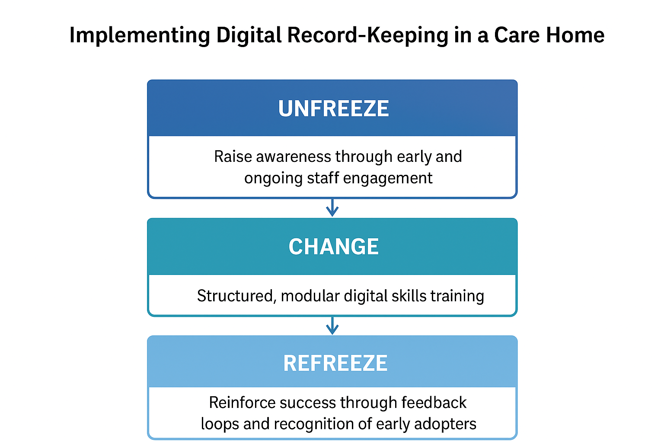

Figure 2: Kurt Lewin’s Change Management Model (1951).

Task 8 – Self-Reflection Using Gibbs’ Reflective Cycle

Using Gibbs Reflective Cycle (1988, as cited in jasper, 2013) provides a clear structure for evaluating my experiences throughout this module.


Figure 1: The Gibb’s reflective cycle (Jasper, 2013).

Description & Feelings:
During the module, I engaged in activities that required project planning, leadership, communication, and change management in care settings. Initially, I felt confident in my organisational skills but uncertain about applying leadership theories in practice. I also felt challenged when coordinating group tasks, as balancing different perspectives required careful communication.

Evaluation & Analysis:
As the module progressed, I recognised strengths in analytical thinking and planning, particularly when developing project timelines and evaluating service improvements. However, Gibbs’ model encouraged me to examine areas of weakness, such as hesitancy in decision-making during group work. Using concepts from leadership and change theory helped me understand that effective practice relies on adaptability and reflective thinking (Northouse, 2021). I also learnt the importance of communication for achieving shared goals, aligning with literature emphasising collaborative practice in health and social care (Bate & Robert, 2016).

Conclusion:
Reflecting through Gibbs’ cycle highlighted that I have grown in confidence and developed a more proactive approach to leadership and change management. I now recognise the value of critical reflection in improving professional competence.

Action Plan:
Going forward, I aim to strengthen my leadership skills by seeking opportunities to lead small projects and practising clearer communication strategies. I will continue using structured reflection to refine my practice and ensure continuous development, particularly when managing change within care environments.

Reference

Gibbs, G. (1988). Learning by Doing: A Guide to Teaching and Learning Methods. Oxford: Oxford Polytechnic.

Jasper, M. (2013) Beginning reflective practice. 2nd end. Andover: Cengage Learning.

Brookfield, S.D., 2017. Becoming a critically reflective teacher. John Wiley & Sons.

Lewin, K. (1951) Field Theory in Social Science. New York: Harper & Row.
The Health Foundation (2020) Using technology to improve care in care homes. Available at: https://www.health.org.uk/publications (Accessed: 28 October 2025).

Cummings, S., Bridgman, T., and Brown, K.G., 2016. Unfreezing change as three steps: Rethinking Kurt Lewin’s legacy for change management. Human relations, 69(1), pp.33-60.

Department of Health and Social Care (2021). Data saves lives: reshaping health and social care with data. [online] Available at: https://www.gov.uk/government/publications/data-saves-lives .

Lewin, K. (1947). Frontiers in Group Dynamics: Concept, Method, and Reality in Social Science. Human Relations, 1(1), pp.5–41.

NHS Digital (2022). Digital Transformation in Social Care. [online] Available at: https://digital.nhs.uk/services/social-care.

SCIE (2021). Digital capabilities in social care. [online] Available at: https://www.scie.org.uk/digital-capabilities.

England, N.H.S., 2023. NHS equality, diversity, and inclusion improvement plan. Available at: NHS England» NHS equality, diversity, and inclusion improvement plan Accessed, 25(07), p.2023.

British Association of Social Workers (2021) Code of Ethics for Social Work. Available at: https://www.basw.co.uk/about-basw/code-ethics (Accessed: 21 October 2025).

CIPD (2023). Learning and development strategy. [online] Available at: https://www.cipd.co.uk/ [Accessed 28 October 2025].

Bate, P. & Robert, G. (2016) Bringing User Experience to Healthcare Improvement. London: CRC Press.

Health Foundation (2020) Digital health and care: Improving quality through technology. London: Health Foundation.

NHS Employers (2023) Roles in the NHS: Health Manager. Available at: https://www.nhsemployers.org (Accessed: 7th November 2025).

NHS England (2023) NHS Equality, Diversity, and Inclusion Improvement Plan. Available at: https://www.england.nhs.uk (Accessed: 7th November 2025).

Northouse, P. (2021) Leadership: Theory and Practice. 9th ed. London: SAGE.

Serrat, O. (2017) Understanding and developing emotional intelligence. Knowledge Solutions. Available at: https://www.adb.org/sites/default/files/publication/357651/understanding-developing-emotional-intelligence.pdf (Accessed: 7th November 2025).

Skills for Health (2022) Healthcare management: Skills framework. Leeds: Skills for Health.
Skills for Care (2023) The state of the adult social care sector and workforce in England. Leeds: Skills for Care.
The King’s Fund (2022) Integrated care systems: What do they mean for social care? London: The King’s Fund.
Grant, L., & Kinman, G. (2014). Developing resilience for social work practice. Palgrave.
Lave, J., & Wenger, E. (1991). Situated learning: Legitimate peripheral participation. Cambridge University Press.

