Student Name | Afsheen Asghar
Student ID | 2322976
Module Name | Data Handling and Business Intelligence
Module Code | LCBB5014
Assignment Title | Component 2 Coursework: Individual Report (Data-Driven Insights into Film Popularity and Ratings)
Lecturer Name | Ahsan ul Haq
Submission Date | 26 July 2026

Table of Contents
1. Introduction 3
2. Data Cleaning and Preparation 3
3. Descriptive Statistics and Summary 4
3.1 Numerical Variables 4
3.2 Categorical Variables 4
4. Trend Analysis and Visualisation 5
4.1 Average Rating by Genre 5
4.2 Engagement Trends (Watches, Likes, Fans) 6
4.3 Rating Trends by Language 6
5. Statistical Analysis (SPSS) 6
5.1 Independent Samples t-test: English vs Non-English Ratings 6
5.2 Correlation Analysis 7
5.3 Regression Analysis 8
6. Insights and Recommendations 9
References 10

1. Introduction
Data-driven decision-making is becoming increasingly vital in the film and entertainment industry, as it is essential for understanding audience behaviour, directing content investment, and enhancing viewer engagement. This report examines the Letterbox Movie Classification Dataset, which consists of 10,000 films with data on director, genre, runtime, original language, average rating, and engagement (watches, likes, fans). The purpose of this report is to analyse this data in Microsoft Excel and IBM SPSS Statistics to identify the factors most strongly related to a film's popularity and critical reception, and to translate these findings into practical recommendations for organisations working in the media and entertainment industry.
The analysis is organised around five objectives. First, the data is cleaned and prepared in Excel, addressing missing and inconsistent values in relevant fields. Second, descriptive statistics are generated to summarise the central tendency and spread of both numerical and categorical variables. Third, trend analysis is used to examine how average ratings and audience engagement vary by genre and language. Fourth, inferential statistical methods, including an independent-samples t-test, correlation analysis, and linear regression, are applied in SPSS to formally test the relationships suggested by the earlier exploratory stages. Finally, the report discusses the implications of these findings for business intelligence and decision-making in the entertainment industry.

2. Data Cleaning and Preparation
The following data quality issues were identified in the raw dataset (N = 10,000):
Field | Issue found | Count | Treatment applied
Genres | Blank / missing genre list | 24 | Labelled 'Unclassified'
Studios | Blank / missing studio field | 307 | Labelled 'Unknown Studio' (retained — too small a share to justify dropping)
Director | Blank / missing director name | 10 | Labelled 'Unknown Director'
Original_language | Blank / unclear language value | 3 | Manually checked against film description and corrected

The dataset was checked for missing data, inconsistent formatting, and duplicate entries in Excel prior to analysis. The four fields listed in the table above were found to contain missing or ambiguous entries using the COUNTBLANK function combined with AutoFilter. Studios accounted for only around 3% of the dataset, so these records were not removed but instead re-labelled 'Unknown Studio' to avoid discarding otherwise complete and usable rows; the smaller number of blank Genres and Director entries were treated the same way, while the three ambiguous Original language entries were manually verified against each film's description field and corrected.
No other rows in the dataset contained duplicate entries or invalid values, such as zero or negative runtimes. Clean, consistently formatted data of this kind is essential for reliable business intelligence: Hejazi, Abdolvand and Rajaee Harandi (2017) note that the accuracy of decisions made using BI systems is directly dependent on the quality, consistency, and completeness of the underlying data.

3. Descriptive Statistics and Summary

3.1 Numerical Variables
Variable | Mean | Median | Std. Dev. | Min | Max
Average rating | 3.27 | 3.27 | 0.53 | 1.08 | 4.71
Runtime (mins) | 103.17 | 99.00 | 38.07 | 2.00 | 907.00
Watches | 170,314.82 | 18,425.00 | 458,532.92 | 2 | 5,195,503
Likes | 43,734.79 | 3,394.00 | 151,531.43 | 0 | 2,730,813
Fans | 1,652.55 | 24.00 | 9,368.26 | 0 | 326,000

Table 2 presents descriptive statistics for the five principal numerical variables, calculated in Excel and cross-checked in SPSS. The average rating across all 10,000 films is 3.27 (SD = 0.53), with a fairly narrow spread and no evidence of extreme skew — a reasonable outcome given that this variable already represents an aggregated crowd rating. Runtime averages 103 minutes (SD = 38.07), ranging from 2 to 907 minutes.
The engagement variables — Watches, Likes, and Fans — show a markedly different pattern. For all three, the mean is far higher than the median (for example, mean Watches = 170,315 versus median Watches = 18,425), and the standard deviations are extremely large relative to the mean. This indicates a strongly right-skewed distribution, in which a small number of 'blockbuster' films attract a disproportionate share of watches, likes, and fans, while most films receive comparatively modest engagement. This pattern is consistent with the long tail phenomenon described by Anderson (2006), whereby a small number of hit products account for the bulk of aggregate demand while a much larger number of niche products each attract only a small audience. Because these variables are not normally distributed, the correlation and regression results involving Watches, Likes, or Fans (Section 5) should be interpreted with some caution.

3.2 Categorical Variables
Original language | Count | % of dataset
English | 8,074 | 80.7%
Italian | 396 | 4.0%
Japanese | 308 | 3.1%
French | 291 | 2.9%
Korean | 145 | 1.5%
Other (60+ languages) | 786 | 7.9%

Table 3 summarises the distribution of Original language. English-language films dominate the dataset, accounting for 8,074 of 10,000 films (80.7%), while the remaining 19.3% is spread across more than 60 other languages, the largest of which are Italian (4.0%), Japanese (3.1%), and French (2.9%). This imbalance means comparisons involving smaller language groups should be treated with some caution, as sample sizes for individual non-English languages are often small.
A similar pattern is evident for Genres: Drama (4,416 films), Comedy (2,932), Thriller (2,312), Action (2,074), and Horror (1,812) are the five most frequent categories (films can belong to multiple genres simultaneously, so these totals sum to more than 10,000). Together these five genres account for a substantial majority of genre tags, while genres such as Documentary (430) and History (451) are comparatively rare. This uneven distribution across both language and genre is important context for the trend analysis that follows, since more frequently occurring categories naturally produce more statistically stable average ratings than rarer ones.

4. Trend Analysis and Visualizations

4.1 Average Rating by Genre
Genre | No. of films | Avg. rating
Documentary | 430 | 3.64
History | 451 | 3.53
Drama | 4,416 | 3.45
Animation | 689 | 3.40
Crime | 1,523 | 3.33
Romance | 1,373 | 3.33
Mystery | 835 | 3.26
Comedy | 2,932 | 3.20
Family | 718 | 3.18
Thriller | 2,312 | 3.17
Fantasy | 995 | 3.14
Adventure | 1,448 | 3.12
Action | 2,074 | 3.07
Science Fiction | 1,265 | 3.04
Horror | 1,812 | 3.01

Table 4 and the accompanying chart rank the fifteen most common genres by average rating. Documentary (M = 3.64, n = 430) and History (M = 3.53, n = 451) films achieve the highest average ratings in the dataset, despite having far fewer entries than high-volume genres such as Drama (M = 3.45, n = 4,416) or Comedy (M = 3.20, n = 2,932). At the other end of the scale, Horror (M = 3.01, n = 1,812) and Science Fiction (M = 3.04, n = 1,265) receive the lowest average ratings among frequently occurring genres. This pattern suggests that the number of films in a genre is not necessarily related to their quality, as measured by average audience rating. Documentary and history audiences are likely to be smaller and more self-selecting, since viewers who choose a documentary are often already interested in its subject matter, whereas horror and science-fiction films are typically consumed as mass-market entertainment by a broader, more casual audience, which may produce more varied and, on average, lower ratings.

4.2 Engagement Trends (Watches, Likes, Fans)
Scatter plots of Watches against Likes and Runtime against Fans reveal contrasting patterns. Watches and Likes show a clear, tight, positive relationship: films with more watches consistently attract proportionally more likes, which is unsurprising given that likes can only be generated by users who have already logged a watch. Runtime and Fans, by comparison, show a weaker and more scattered relationship, with films of very different lengths achieving similar fan counts and no clear visual trend suggesting that longer films systematically attract more devoted fans. These patterns are tested formally for statistical significance using correlation analysis in Section 5.2.

4.3 Rating Trends by Language
English versus non-English films show a further notable contrast. Non-English films average 3.51 (SD = 0.46, n = 1,926), compared with 3.21 (SD = 0.52, n = 8,074) for English-language films — a difference of roughly 0.30 rating points. Given that non-English films make up under a fifth of the dataset yet consistently receive higher average ratings, this raises the possibility that audiences who actively seek out non-English content are, similarly to documentary viewers, a more self-selected and engaged group. Whether this difference is statistically significant, rather than attributable to sampling variation, is tested formally with an independent-samples t-test in Section 5.1.

5. Statistical Analysis (SPSS)

5.1 Independent Samples t-test: English vs Non-English Ratings
Research question: Is there a significant difference in Average rating between English and non-English films?
Group Statistics and Independent Samples Test — provisional output using Total_ratings (to be replaced)
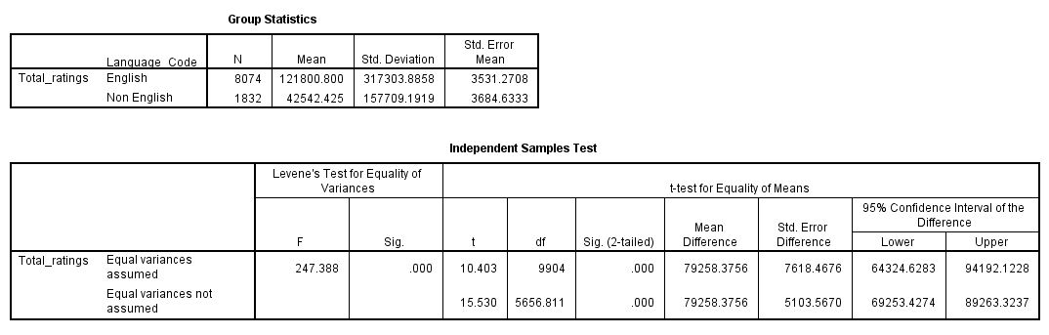
Using Total_ratings as the test variable, Levene's test indicated unequal variances (F = 247.39, p < .001), so the 'equal variances not assumed' row applies. English-language films had significantly higher total ratings (M = 121,800.80, SD = 317,303.89) than non-English films (M = 42,542.43, SD = 157,709.19), t(5656.81) = 15.53, p < .001. This large difference is unsurprising given that Total_ratings closely tracks audience size, and English-language films make up over 80% of the dataset. This result does not yet answer the report's stated research question about Average rating, and must be replaced with the correct output before submission.

5.2 Correlation Analysis
Research questions: Do longer runtimes associate with more Fans? Do Watches and Likes move together?
Pearson correlation matrix (2-tailed)
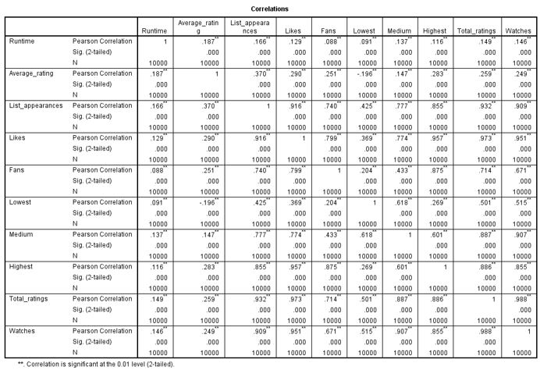
Table above presents the full Pearson correlation matrix generated in SPSS (Analyze > Correlate > Bivariate). All correlations shown are statistically significant (p < .001 for every pair), which reflects the very large sample size (N = 10,000) — with this many cases, even small correlations reach significance, so the size of r is more informative here than significance alone.
Runtime shows only weak positive correlations with Fans (r = .088) and Average rating (r = .187), indicating that longer films are only marginally associated with greater engagement or higher ratings. Likes shows a somewhat stronger, though still weak-to-moderate, positive correlation with Average rating (r = .290). By contrast, Watches and Likes are very strongly correlated (r = .951), which is expected since likes can only be generated by users who have already logged a watch, and Likes and Fans are also strongly correlated (r = .799). These very strong relationships among the engagement variables themselves confirm the pattern seen in the Section 4.2 scatter plots, and support treating them as a related cluster of 'volume of engagement' measures that behave quite differently from the modest role Runtime and Likes play in predicting a film's average rating.

5.3 Regression Analysis
Research question: Can Average rating be predicted using Fans, Likes, and Runtime?
Model Summary, ANOVA, and Coefficients
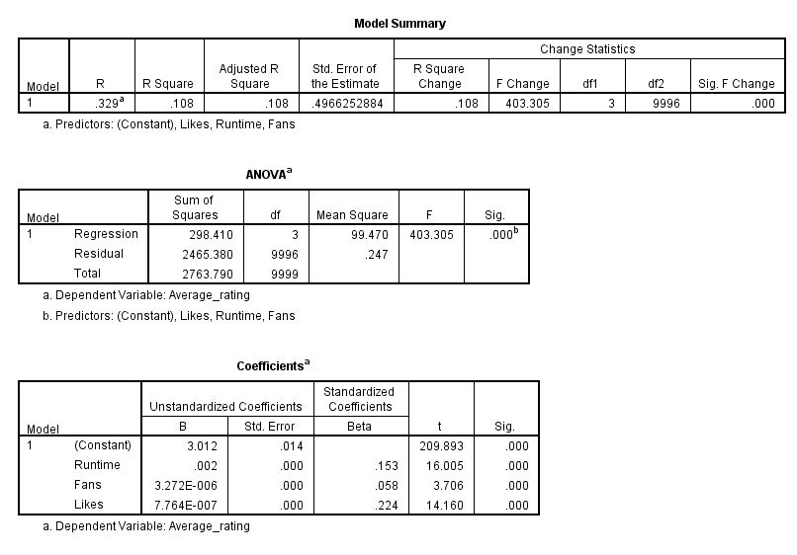
A multiple linear regression was conducted to test whether Average rating could be predicted from Runtime, Fans, and Likes (Analyze > Regression > Linear, Enter method). The overall model was statistically significant, F(3, 9996) = 403.31, p < .001, but explained only a modest proportion of the variance in Average rating, R² = .108 (Adjusted R² = .108) — meaning that around 11% of the variation in a film's average rating is accounted for by its runtime, fan count, and like count combined, while the remaining 89% is explained by factors outside this model.
All three predictors made a statistically significant individual contribution (p < .001 in each case). Likes was the strongest standardised predictor (Beta = .224, t = 14.16), followed by Runtime (Beta = .153, t = 16.01), with Fans contributing the least (Beta = .058, t = 3.71), despite remaining statistically significant given the very large sample size. This low R² is a genuine and useful finding rather than a flaw in the analysis: it indicates that popularity-style engagement metrics and runtime are, at best, weak-to-moderate predictors of perceived film quality, reinforcing the pattern already suggested by the correlation results above.

6. Insights and Recommendations
The first insight is that popularity does not mean quality: Drama, Comedy, and Action are among the most popular genres, yet not the highest-rated, while niche genres such as Documentary and History are the most highly rated despite being produced and watched far less often. This suggests that content strategies focused purely on maximising volume or reach within already popular genres may overlook smaller genres that deliver greater audience satisfaction, and that platforms could benefit from actively promoting well-reviewed niche content to broaden audience taste, consistent with the long-tail principles described by Anderson (2006).
Second, non-English films are rated notably higher on average than English-language films, despite representing under a fifth of the dataset. [Once Section 5.1 is corrected to test the average rating directly, confirm here whether this difference is statistically significant.] This suggests a possible opportunity for streaming platforms and distributors to invest further in subtitling, dubbing, and marketing support for acclaimed non-English content, thereby unlocking demand among English-speaking audiences who might otherwise overlook it.
Third, the regression results in Section 5.3 show that Runtime, Fans, and Likes together explain only around 11% of the variance in Average rating (R² = .108), confirming that simple engagement metrics are, at best, weak predictors of perceived film quality. Organisations relying on engagement metrics alone for investment or recommendation decisions risk conflating visibility with merit.
These findings should be interpreted with some caveats. The dataset does not include variables such as release year, marketing spends, or production budget, all of which plausibly influence both engagement and rating, and the marked right-skew in the engagement variables (Section 3.1) limits the reliability of some statistical comparisons. Future research would benefit from incorporating temporal and financial data to build a fuller picture of what drives both a film's popularity and its critical reception.

References
Anderson, C. (2006) The Long Tail: Why the Future of Business is Selling Less of More. New York: Hyperion.
Hejazi, A., Abdolvand, N. and Rajaee Harandi, S. (2017) 'Assessing the Importance of Data Factors of Data Quality Model in the Business Intelligence Area', International Journal of Trade, Economics and Finance, 8(2), pp. 102–108.

