BMIH4005

Marketing Essentials
Essay

Student Name :Lacramioara Maria Tiuca
Student ID:2230072
Table of contents
Introduction 3
Situation Analysis 3
Objectives 9
Strategy 9
Tactics 9
Action 10
Control 10
Conclusion 10
Reference list 12

Introduction
A marketing plan is a type of written document that is responsible for defining the goal of an organisation. Additionally, it provides an action plan for achieving the goals and provides proper guidelines for accessing the plan towards achieving the goal (Chernev, 2020). The main purpose of a marketing plan is to set up different strategies for an organisation by which customers can be engaged. This, as a result, can help that company to accomplish its business goals or objectives. For this study, a marketing plan will be prepared for Moxy Hotels. In this study, a situation analysis will be presented, and under that 5Cs analysis will be performed. In addition, SMART objectives will also be presented. Apart from that, the strategy, tactics, action plan, and control process of the company will be illustrated with the help of this study.

Situation Analysis
Strength
Moxy Hotel charges premium rates for every single room. It mainly offers rooms for 149 GBP per night (Marriott, 2023). This is because Moxy Hotels is a chain of Marriott. Premier Inn, its competitor charges 56.7 British pounds per night.
Another strength of Moxy Hotels is its customer relationship, It provides business account cards to its consumers, for making their life easy during their visit.
Weakness
Lack of global presence as it operates in around eight European countries, which includes Belgium, France, Germany, Italy, the Netherlands, Norway, Poland, and the UK with about 40 hotels.
Another weakness is that it lacks in providing updated facilities to its consumers including, proper room services, concierge services and porters services.

Opportunities
Expanding its business internationally in countries including, Canada, New Zealand, Australia, and others.
Another opportunity is collaborating with partners including existing brands
Threats
Covid-19 has affected the hotel industry there was a fall in revenues per hotel room in London to around £29 in 2020 (Jolly, 2020).
It has strong competitors including Premierinn, Travelodge, and others.
Customers
Segmentation: Moxy Hotels of the UK can focus on demographic segmentations, as it targets its consumers based on their age, gender, class, race and others. Demographic segmentation mainly focuses on diving groups depending upon different variables including age, sex, gender, caste, and race (Tynan and Drayton, 1987).
Targeting: The hotel can target people between the age group of 18-65 and can give priority to the high-medium class people. With the help of these groups, Moxy Hotels can gain profit with success.
Competitors
Perceptual map
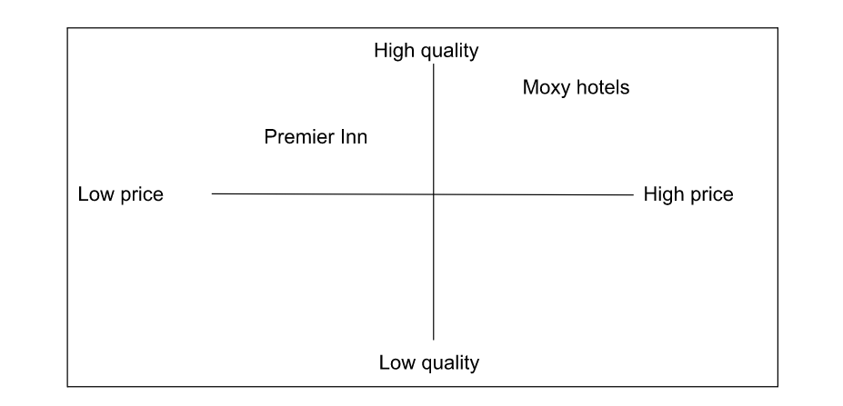
Figure 1: Perpetual map of Moxy hotels
(Source: Created by the learner)
Moxy Hotels concentrates on a high quality and high pricing strategy, by which consumers can be attracted and stratified too.
Bowman's strategy clock

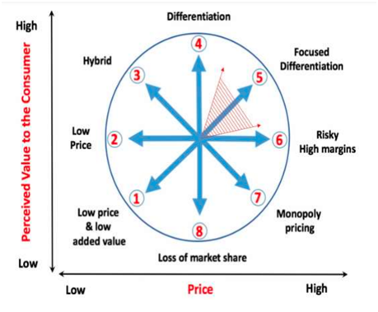
Figure 1: Bowman’s strategy clock
(Source: Mihajlović and Miletić, 2022)
From the above figure, Moxy Hotels is going to focus on a high pricing strategy, as with the help of its maximum number of consumers it can be satisfied. Additionally, a high pricing strategy can even help the brand to get loyal consumers.
Collaborators
In this case, the UK-based Moxy Hotels can consider making partnerships with different hotels including Premier Inn, Grand Hyatt, and other local communities, and other international brands and agencies including JoJo International, HRC International and others. The hotel can do this to get extra financial support by which they can expand the business.
Climate
Political
Corruption perception rate: In 2022, it was 73 points, which was a decrease from 78 points in 2021(transparency, 2023). As the corruption rate of the country has decreased from 73 points to 78 points, the industry may find it difficult to run its business corruption free. As there will be the presence of external inferences. In this case, being a medium-scale company Moxy Hotels is going to face issues regarding the interferences of external sources.
Economical
Unemployment rate: The unemployment rate of the UK is 3.9%, which is an increase of 0.2% (ons, 2023). As the unemployment rate within the country has decreased so the industry will have an opportunity to hire more employees. As per the UK unemployment statistics, payrolls of UK workers have increased by 69,000 to 29.7 million between August to September (Economictimes, 2022). The industry will have an opportunity to increase their employees in number so the company will be able to hire more skilful and dedicated employees.
Social
Literacy rate: The UK has a literacy rate of 16.4% which means it has more illiterate people (Literacy Trust, 2022) As the literacy rate within the country is low, the industry will get fewer educated employees. Being a medium-scale industry sometimes it lacks literate employees. In this scenario, due to the low literacy rate, the company will get less educated employees.
Technological
Internet penetration rate: The Internet penetration rate is 92.74% (Petrosyn, 2022). As the internet penetration rate has decreased so the industry will face issues connecting with global consumers. As the industry will face difficulties, it will affect the company being a medium-scale company.
Legal
Employee rights act 1996: This act was introduced by the UK government to reduce the effect of pollution from different organisations (Legislation, 2022). In this case, according to the National Minimum Wage Rate, the country provides wages of £7.49 to adults (18-20) (Gov, 2022). Hence, the company is also following the same protocol.
Environmental
Environment Act 2021: This act helps employees to get full wages rather than getting unfair treatment (Legislation, 2022). The hospitality industry of the UK gets different waste management services from the UK government. Hence, it proves that the industry is positively influenced by this act. Marriott considers green initiatives and as Moxy Hotels is a division of Marriott, it follows the same initiatives (Marriott, 2023).
Marketing mix
Product: The company provides quality accommodation services along with a unique experience. The hotel chain mostly attracts cost-conscious clientele.
Place (Distribution): Consumers of the hotel can easily locate the area as the hotel chain has a presence in many countries. At present, Moxy Hotels is serving only a few countries including the UK, Belgium, France, Germany, Italy, the Netherlands, Norway, and Poland.
Price: In this area, the hotel management can make use of a value-based pricing strategy, by which consumers’ needs can be fulfilled. As targeted consumers are belonging to the aged of 18-65 and are mostly belonging to high-medium classes. Hence, the price will be set up according to the value-based pricing.
Promotion: In this case to attract consumers the brand can make use of both offline and online platforms. In the case of offline platforms, Moxy Hotels can take the help of print media and for online platforms, the hotel can use social media sites for promoting its brand.
As per the SMART objectives strategies set up by the hotel management, concentrating on the RACE model will be effective. At the reach, stage brand visibility and awareness will be presented on both online and offline platforms (Fedoryshyna et al., 2021). In the act stage, Moxy Hotels will try to interact with its global consumers. In the third stage of the RACE model sales with be converted with the help of online platforms and stores, At the final stage, consumers will be engaged to build up a strong relationship.

Objectives
Specific | Measurable | Achievable | Realistic | Time-bound
To increase website traffic. | It will be measurable by increasing the number of website visits reach to 5000. | It is completely achievable, with the help of Organic Search Volume and Website Traffic Lead Ratio. | Yes, it is realistic, as with the help of this marketing plan Moxy Hotels can achieve better customer acquisition. | This goal will be achieved within 3 months.
Table 1: SMART objectives
(Source; Created by the learner)

Strategy
The value proposition of Moxy Hotels is to increase website traffic by 5000 visits. Mainly, to improve overall business performance this value proposition has been chosen. In addition, with the help of this consumer or buyers rate will also be increased which as a result will help in increasing the profit percentage. Market Development is a strategy through which a company sells their existing product in a new market to capture that. It is a less risky strategy for a popular company as they already have brand value and product popularity. Moxy Hotels can apply this strategy by opening new hotels in new markets so that they can enhance their profit through different channels. They want to cover specific regions outside of the UK that are in neighbouring European nations.

Tactics
Moxy Hotels values consumers by providing the best facilities at affordable rates, which makes it different from other hotel organisations. In order to communicate the value proposition, the hotel can make use of the brand promotion method by which consumers can be attracted. This, as a result, can help in increasing the consumer retention rate. The value proposition of the brand will be delivered through the help of social media communication.
From the above analysis, it has been identified that the targeted group of consumers are belonging to the age group of 18-65 and high-medium class people. Hence, the price selected for this group is value-based pricing.

Action

Figure 2: Gantt chart
(Source: Created by the learner)
From the above figure, it has been identified that marketing channel schedules will undergo a process of several steps. In the beginning, a survey will be conducted to identify consumers, stakeholders and market gaps. After those promotional advertisements will be prepared to connect with consumers, and after entire observations, services will be launched.

Control
In order to measure the overall success of the hotel, Moxy Hotels' overall profit and loss percentage can be measured. To check out about the new customers' consumer retention rate can be checked. In order to measure the positive attitude of consumers towards the brand, consumers' personal experiences can be gathered. To gather the personal experiences of consumers, feedback from the customers can be collected. To check out the increased profit overall sales percentage needs to be measured by the brand.

Conclusion
This study has helped in understanding that while developing a marketing plan different challenges include a lack of updated technologies, a shortage of relevant employees and a lack of global expansion. All these challenges are creating difficulties for the brand to grow and expand its business globally. In this case, to resolve these challenges recommendations can be followed by the brand.
Using updated technologies: As the hotel is lacking updated technologies like room services, they need to make them use immediately to satisfy consumers. Besides, to increase its profit percentage and top attract consumers the hotel needs to use the latest technologies.
Expanding globally: At present, Moxy Hotels only serves in the UK, and a few other European countries, to target global consumers and improve its overall sales company needs to expand globally. The hotel can expand its business in countries like Canada, New Zealand, and Australia. As in these countries, the hotel will get more competitive advantages by which their revenue can be improved.

Reference list
Chernev, A., 2020. The marketing plan handbook. Cerebellum Press.
Economictimes (2022). UK unemployment rate at a 48-year low, with rise in long-term sickness. Read full story here. [online] Available at:<https://economictimes.indiatimes.com/news/international/uk/uk-unemployment-rate-at-48-year-low-with-rise-in-long-term-sickness-read-full-storyhere/articleshow/94785588.cms?from=mdr.> [Accessed on 21 may 2023]
Fedoryshyna, L., Halachenko, O., Ohiienko, A., Blyznyuk, A., Znachek, R. and Tsurkan, N., 2021. Digital marketing in strategic management in the field of the tourism. Journal of Information Technology Management, 13(Special Issue: Role of ICT in Advancing Business and Management), pp.22-41.
Gov (2022). National Minimum Wage and National Living Wage rates. [online] Available at: <https://www.gov.uk/national-minimum-wage-rates> [Accessed on 22 May 2023]
Jolly, J., 2020. Covid-hit UK hotels unlikely to recover for four years, says PwC. [online] Available at:<https://www.theguardian.com/business/2020/oct/27/covid-hit-uk-hotels-unlikely-to-recover-for-four-years-says-pwc>[accessed on 23 may 2023]
Legislation (2022). Employment Rights Act 1996. [online] Available at: <https://www.legislation.gov.uk/ukpga/1996/18/contents> [Accessed on 20 May 2023]
Legislation (2022). Environmental Protection Act 1990. [online] Available at: <https://www.legislation.gov.uk/ukpga/1990/43/contents> [Accessed on 20 may 2023]
Literacytrust (2022). Adult Literacy Statistics. [online] Available at: <https://literacytrust.org.uk/parents-and-families/adult-literacy/> [Accessed on 23 may 2023]
Marriott, 2023. Flexible Dates Total Room Cost. [online] Available at:<https://www.marriott.com/reservation/availabilityCalendar.mi.>[accessed on 23 may 2023]
Marriott, 2023. Green Initiatives. [online] Available at:<https://www.marriott.com/en-gb/hotels/hotel-information/details-3/bcnmd-le-meridien-barcelona/> [Accessed on 23 may 2023]
Mihajlović, V. and Miletić, V., 2022. Limiting factors of strategic positioning within established businesses. Ekonomski signali: poslovni magazin, 17(1), pp.107-119.
Ons, 2023. Unemployment. [online] Available at:<https://www.ons.gov.uk/employmentandlabourmarket/peoplenotinwork/unemployment> [Accessed on 23 may 2023]
Petrosyn, A., 2022. Internet usage in the United Kingdom (UK) - Statistics & Facts. [online] Available at:<https://www.statista.com/topics/3246/internet-usage-in-the-uk/> [Accessed on 23 may 2023]
transparency, 2023. Country data. [online] Available at:<https://www.transparency.org/en/countries/united-kingdom> [Accessed on 23 may 2023]
Tynan, A.C. and Drayton, J., 1987. Market segmentation. Journal of marketing management, 2(3), pp.301-335.

