
Dissertation
The impact of Integrated Marketing Communications on consumer buying behavior: A case study analysis of Nike

MBA - MARKETING management
Student: GABRIELA VASILEVA
STUDENT ID: 2011883
SUPERVISOR: TUSHARA BALENDRAN


Master’s Degrees by Examination and Dissertation
Declaration Form.
1. This work has not previously been accepted in substance for any degree and is not being concurrently submitted in candidature for any degree.
Signed……. Gabriela Vasileva……………………………………………………………………...
Date….14.10.2021…………………………………………………………
2. This dissertation is being submitted in partial fulfilment of the requirements for the degree of Master in Business Administration.
Signed ……Gabriela Vasileva……………………………………………………………………….
Date…14.10.2021…………………………………………………………….
3. This dissertation is the result of my own independent work/investigation, except where otherwise stated.
Other sources are acknowledged by footnotes giving explicit references.
A bibliography is appended.
Signed candidate: Gabriela Vasileva……………………………………………….…………….…….
Date: 14.10.2021…………………………………………………….….
4. I hereby give consent for my dissertation, if accepted, to be available for photocopying, inter- library loan, and for deposit in the University’s digital repository
Signed (candidate)…Gabriela Vasileva……………………………….………….……………………………....
Date……14.10.2021…………………………………………….…………….

Supervisor’s Declaration.
I am satisfied that this work is the result of the student’s own efforts.
Signed: …Tushara Balendran……………………………………………………………………….
Date: ……………14/10/2021………………………………………………………………...

University of Wales: Trinity Saint David
E-Thesis Deposit Agreement

Details of the Work
I would like to deposit the following item in the digital repository maintained by the University, and/or in any other repository authorized for use by the University:

Title: The impact of Integrated Marketing Communications on consumer buying behavior: A case study analysis of Nike

This item is a product of my own research endeavors and is covered by the agreement below in which the item is referred to as “the Work”. It is identical in content to that deposited in the Learning Resources Centre, subject to point 4 below.

I agree that the University of Wales: Trinity Saint David may electronically store, copy, or translate the Work to any approved medium or format for the purpose of future preservation and accessibility. The University is not under any obligation to reproduce or display the Work in the same formats or resolutions in which it was originally deposited.

UW: TSD Digital Repository
I understand that work deposited in the digital repository will be accessible to a wide variety of people and institutions, including automated agents and search engines via the World Wide Web.

I understand that once the Work is deposited, the item and its metadata may be incorporated into public access catalogues or services, such as national databases of electronic theses.

I agree as follows:
- That I am the author or have the authority of the author/s to make this agreement and do hereby give the University of Wales: Trinity Saint David the right to make available the Work in the way described above.
- That the electronic copy of the Work deposited in the digital repository and covered by this agreement, is identical in content to the paper copy of the Work.
- That I have exercised reasonable care to ensure that the Work is original, and to the best of my knowledge, does not breach any laws including those relating to defamation, libel and copyright.
- That I have, in instances where the intellectual property of other authors or copyright holders is included in the Work, gained explicit permission for the inclusion of that material in the Work, and in the electronic form of the Work as accessed through the open access digital repository, or that I have identified and removed that material for which adequate permission has not been obtained and which will be inaccessible via the digital repository
- That University of Wales: Trinity Saint David does not hold any obligation to take legal action on behalf of the Depositor, or other rights holders, in the event of a breach of intellectual property rights, or any other right, in the material deposited.
- That I undertake to indemnify the University of Wales: Trinity Saint David against all actions, suits, proceedings, claims, demands and costs occasioned by the University in consequence of any breach of this agreement

Signature …Gabriela Vasileva……………………………………………….

Date …14.10.2021……………

Contents
Abstract 6
Acknowledgment 6
Chapter One 7
1. Introduction 8
1.1 Background of Nike 8
1.2 Rationale of the study 8
1.3 The research objectives 9
1.4 Research questions 9
1.5 The research aim 9
1.6 Chapters overview 10
Chapter two 10
2. Literature Review 11
2.1 Marketing Communication 11
2.2 Shannon and Weaver Model 12
2.2.1 Advantages and Disadvantages of the Model 14
2.2.2 Relating the Shannon and Weaver model to Nike company 14
2.3 Consumer Response - Hierarchy Models 16
2.3.1 Relating the Aida model to Nike company 17
2.4 Consumer Behavior 18
2.5 Maslow’s hierarchy of needs 18
2.5.1 Relating the Maslow’s hierarchy of needs model to Nike 19
2.6 Decision-making process 20
2.6.1 Relating the Decision-making process to Nike consumers 21
2. 7 Integrated Marketing Communication 21
2.7.1 Nike’s Promotional Mix 22
Chapter three 24
3. Research Methodology 24
3.1 Research Philosophy 25
3.2 Research approach 26
3.3 Research strategy 26
3.4 Type of investigation 26
3.5 Research Choice 27
3.6 Time Horizons – Cross - sectional 28
3.7 Data collection 28
3.7.1 Data Sampling 29
3.7.2 Questionnaire design 29
3.8 Data Analysis Tool 30
3.9 Ethical considerations 30
Chapter four 30
4.Analysis of the data collection 30
4.1 First question from the Survey 31
4.2 Second question from the Survey 32
4.3 Third question from the Survey 33
4.4 Fourth question from the Survey 34
4.5. Fifth question from the Survey 35
4.6 Sixth question from the Survey 36
4.7 Seventh question from the Survey 38
4.8 Eight question from the Survey 39
4.9 Ninth question from the Survey 41
4.10 Tenth question from the Survey 43
Chapter five 45
5. Discussion 45
5.1 Research question one: What motivate people to keep purchasing from Nike? 46
5.2 Research question two: How does the sport giant Nike influence the customer decision-making process? 47
5.3 Research question three: How the IMC strategies of Nike increase the overall performance of the brand? 47
5.1 Conclusion 48
5.2 Recommendation 48
5.3 References 49
Bibliography 49

Abstract
This study is aimed to present the academic research of the impact of Integrated Marketing Communications on the consumer buying behavior, particularly analyzing the case study of the sports brand leader Nike. The conceptual framework of the dissertation is to demonstrate a high level of understanding, the key Integrated Marketing Communication strategies, theories and practice which influence the consumer decision and affect the business performance. The research achieves that by critically examining different authors and by analyzing all categories of Marketing Communication of the sports brand and messages that they send to customers. The research is designed to collect only primary quantity data directly from the brand customer by face-to-face survey. It is an examination of 50 participants using the Non-Probability Sampling Methods. Regarding the investigation, the fundamental part is the data collection method and data analysis using visual representation of the answers of the participants followed by detailed explanation.

Acknowledgment
I would like to take this chance to express my gratitude to all lecturers from the Business Administration Program at Trinity Sand David University and particularly to thank my supervisor Tushara. for her constant effort and motivation during the year. Without her guidance this research would have been problematic to complete. Her knowledge and suggestions were extremely valuable to my final work. Also, I would like to use this opportunity to thank my parents and partner Radoslav for their constant love and support during the time of investigation.

Table of Figures
Figure 1 Shannon and Weaver Model of Communication (Egan, 2019) 9
Figure 2 Consumer response - Aida Model 12
Figure 3Maslow's hierarchy of needs Model 15
Figure 4 Decision-making process 16
Figure 5 Research Onion Model 21
Figure 6 Age of the participants presented in pie chart 28
Figure 7 Gender of the participants presented in Histogram chart 29
Figure 8 Yes and No opinion about Nike online advertisement presented with histogram chart 30
Figure 9 Yes and No responses of Nike advertisement presented with pie chart 31
Figure 10 Type of promotion pie chart presentation 32
Figure 11 Impact of Nike to consumer decision process in Pie chart 34
Figure 12 Factors motivating to buy from Nike in Pie chart 35
Figure 13 Consumer side of Nike communication chart 36
Figure 14 Consumer Buying decision chart 38
Figure 15 Marketing side of Nike communication 39

Tables
Table 1 Age of the partisipants 27
Table 2 Gender of the participants 28
Table 3 Yes and No opinion about Nike online advertisement 29
Table 4 Yes and No responses of Nike advertisement 30
Table 5 Type of promotion 32
Table 6 Impact of Nike to consumer decision process 33
Table 7 Factors motivating to buy from Nike 34
Table 8 Consumer side of Nike Communication 36
Table 9 Consumer Buying decision 37
Table 10 Marketing side of Nike communication 39

Chapter One

1. Introduction

1.1 Background of Nike
Nike is currently the most famous athletic company and largest sports brand in the world. As a company they have a very rich history and have dominated the sports market aiming to become a household name worldwide.
The initial name of the company is known as Blue-Ribbon Sport and was established by a student named Bill Bowerman with the participation of his university coach Phil Knight in 1964. The history of Nike begins in America, United States where the founders combined their skills and knowledge to design and distribute their unique Nike shoes. It was an idea, that to this day, has helped to shape the world we live in. The business idea to manufacture the products in Asia, where the cost for production is lower compared to America, lead to great value and profits. This idea would allow the growth of the company and its evolving in a way that would not have been possible otherwise. To this day, many other companies have followed Nike’s example and the brand has allowed the growth of those companies as well. The sport brand quickly became very popular due to its actions of targeting athletes, and in doing so, the brand was gradually able to be shown worldwide. As athletes wore their trainers, the brand quickly became associated with sport and fitness itself. It wasn’t just for athletes, the wider public wanted to wear what their role models were wearing, in a sense that made people feel more popular and trendier. This was, and still is, in many people’s view, Nike’s strongest marketing strategy. The great number of sales of the shoes lead to expansion of the business. Over the years, the brand successfully developed and manufactured many types and variations of designed sports shoes, apparel, and equipment. Everywhere you would look within the sports spheres, you would see the signature of Nike’s tick. The biggest sports stars in the world would be targeted to represent and be sponsored by the company (Willigan, n.d.). As for those athletes, they would be rewarded financially, while the company and brand - with huge amounts of publicity, which would ultimately lead to increased profits as well. It was a win - win situation for everyone involved. Other companies as competitors of Nike have attempted to keep up and evolve to reach its level of growth, but even to this day, Nike is the company that is on top. From humble beginnings, the company has evolved and managed to adapt to make sure that it is their brand, logo, name, that is associated most heavily with sport. Main key factors of the brand include the function of the design, sourcing, and consumer experience. The unique selling points of Nike are based on product features, innovative technology, high quality, and stylish products (Grawe, 2021).
Nike’s mission is “to bring inspiration and innovation to every athlete in the world.” This statement shows the company’s strategic objectives to reach customers internationally.
1.2 Rationale of the study
Integrated Marketing Communication is part of the overall Marketing strategies of the company and can also be determined as a long process of planning and exchanges of value. Integrated Marketing Communications is an important part of the marketing communication between the company and its customers. The process is very challenging and includes different types of advertisement and understanding of how the brand message can influence the customer buying behavior.
IMC has an impact on the consumer psychology and perception around the sports brand. The idea of the research is to focus on Nike’s combined and synchronized marketing communication, its target audience and customer behavior. This will be realized by strictly following the set of research objectives and by answering the research questions.

1.3 The research objectives

- To determine customer motivates to keep purchasing from Nike.
- To investigate how the sports giant influences the customer decision making process.
- To analyze how the IMC strategies of Nike increases the overall performance of the brand.

1.4 Research questions
- What motivates people to keep purchasing from Nike?
- How does the sports giant influence customer decision-making process?
- How the Integrated Marketing Communication strategies of Nike increase the overall performance of the brand?

1.5 The research aim
The idea of the research, as mentioned above, is to focus on Nike’s combined and synchronized marketing communication, its ‘dialogue’ with its target audience and therefore the results of its marketing actions regarding its customer behavior. It aims to explain why, in the end, people choose Nike’s brand and no other to wear and to complete their appearance.
The research work is aimed to cover all the above (1.2, 1.3 and 1.4) as well as different marketing models and strategies. One of the examples of those marketing models is the Consumer Buying Behavior Model. It refers to the consumer behavior when they’re searching, purchasing, and using brand products which they expect to satisfy their needs and wants (M. Saunders, 2018). Another major model is the Communication Process, which is divided into two models, known as the Macro Model of communication, and Micro Model of consumer response. The Macro Model of communication represents the effective ways of any communication. The Micro Model of consumer response describes the response process and is based on three major stages which are cognitive, affective, and behavioral. Another model - The Problem and Recognition Model - includes identification of the needs and wants as well as applying the theory of Maslow’s Hierarchy of Needs.
The areas that this work covers are particularly aimed to support the investigation tasks and find some answers that the dissertation topic suggests. The advantage of this research is that it brings value to the reader’s knowledge of the Integrated Marketing Communication. It is important to mention that this paper will not cover all types of marketing activities and strategies known to us, just the ones that are needed to achieve the research aims. The disadvantage of the work may be expressed as the lack of discussion on Nike’s competitors and no comparisons with them.

1.6 Chapters overview
The research is structured in a logical way in five main chapters, which include smaller sections within. Chapter one contains the introduction, including the background of Nike as a company, rationale of the study and the research objectives. Chapter two represents the literature review of the chosen topic. In Chapter three shows the Research methodology structure and full details of the data collection method of the dissertation. Chapter four demonstrates the analysis section which contains the visual representation and interpretation of the data collection results. In the final chapter five is the discussion review, conclusion of the work and recommendation.

Chapter two

2. Literature Review
This section of the study will present analysis of well selected literature from different authors. The mentioned literature is focused to explain the main topic: Impact of the Integrated Marketing Communications on consumer buying behavior by examining the case study of Nike as a company. The analysis presents different models for consumer response, consumer behavior, and decision-making process. Also, it shows applied theories for marketing communication including the communicational process and the transmission of the brand message using the Shannon and Weaver model. It also reviews the concept of the Integrated Marketing Communication and performance of the sports brand. The final part of the review will give critical analysis on the relationship between all models and the impact that they have individually and overall. (Aveyard, 2021).

2.1 Marketing Communication
Marketing communication can be determined as a process of exchanging information about a product or services between companies and their audience. In the past it was a commonly spread thesis that the purpose of marketing communication is mainly concerned to increase the sales and profitability of the company by advertising products or services. The sale promotion is a short-term marketing strategy aimed to increase the demand and thus the sales of the company’s products. The advertisement consists of paid messages aimed to increases the overall sales and profitability of the company in the long run (Egan, 2019). However, in recent years the appliance of the contemporary marketing communication shows that it has broader concept and application, some of which can also be described as exchanging the values between two or more parties or the ability and willingness to exchange. Some authors have a theory and consider the role of marketing communication to be described as an engagement between the organization and their customers. This engagement is considered to have two components including intellectual and emotional elements. In this case the marketing communication should balance the rational needs for information and also the emotional expression of different target customers. Better quality of communication and interaction will lead to greater level of customer engagement (S. Angeloni, 2021).
According to other theories the marketing communication can be introduced as a process of reinforcement, information, and persuasion of the audience to buy the brand product. In this case the marketing communication is accomplished by delivering a brand message through different channels of media. The aim of the message is to bring brand awareness throughout informing the people about the new or existing product and its benefits. The marketing message can also include information about what the product is, suggestions on how to use it and when it is designed to perform at its best. The effective marketing communication should target the audience depending on their needs and wants and should be able to differentiate the company’s products from the other competitors on the market. Understanding the consumers and offering them what they need increases the engagement and influences the customer decision process. Moreover, the perception of marketing communication can be used to persuade people to purchase the brand product. Indeed, the power of advertisement can build desirable force aimed to persuade the current and potential consumers to buy a good that they don’t need now or don’t even want. Product purchasing is one of the many tasks that marketing communication can reach. Besides, it is crucial to mention that the marketing communication is a part of the overall marketing planning and activities of the company and needs to be linked together with the above for better performance and effectiveness.

2.2 Shannon and Weaver Model

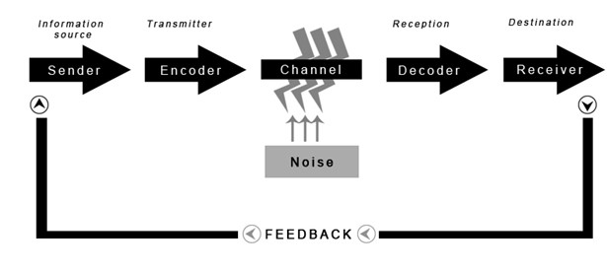
Figure 1 Shannon and Weaver Model of Communication (Egan, 2019)

Reviewing the role of the marketing communication is just the beginning of this research. The next thing it discusses and critically analyses is how the marketing communication works or in other words how the message really influences the audience. For this purpose, we need to apply different communicational models and compare their similarities and differences. Further, in this section we will try to reach the research objective and answer those questions on what motivate people to keep purchasing from Nike (Juneja, n.d.).
The first model known as ‘the mother of the models’ is the Shannon and Weaver Model of communication which is very popular and fundamental in the marketing management. This macro-Model of the communicational process was developed in 1948 to present the standard ways of any form of effective communication. This model is very important because it explains the basic way of transmission of the information from the organization to the audience (PR Smith, 2019). Also, it reviews the factors that can affect the company’s message and what is the response of the customer back to the sender. All elements of this communicational model are Sender, Encoding, Media, Decoding, Receiver, Respond and Noise. These various components in the communication process determine whether a communication event will be successful or not. The transition of information begins with the Sender which is the main body sending the information. In this first stage it is important to establish the target audience, product characteristics and purpose of the communicational message. This is necessary for the success of any marketing communication. The Sender needs to highlight the focus group of people that is aimed to be reached with the message and address the product for specific needs. For example, the marketer needs to know the product specification, and to address it to the customers. The purpose of the message is also very important because it needs to inform what is the main goal of the organization that needs to be achieved with the message. Examples of that are brand awareness, sales promotion, and brand differentiation or in other words the purpose of the message needs to increase new customers, as well as knowledge about the brand and also increase the sales of the products. The next element is the Encoding which is named like that because it plays the role of a transmitter of the signal from pictures, symbols, words, music, or data provided from the Sender to the Channel. The organizational message or signal needs to be created in way that the receiver can understand and therefore influence them to act. This task is not easy because in addition to the content of the message the sender needs to consider which media to be used for the target group of communication. For example, if the target groups are people passionate about fitness, then the brand message should be encoded with information trying to influence and highlight the brand product and its performance in the fitness sphere. Media is the component of the model which describes the channels of distribution of the brand messages. Here are important the financial resources of the company and the selection of right media. This means that the brand message is created and send to the audience using the most appropriate channel. Example of this can be advertisement of the sport product in a sport magazine. In this case the magazine is the selected channel of distribution to present the information from the message to the consumers. The types of media can be newspapers, magazines, television, radio, cinema, outdoor and by online channels. Whatever the format of the message is, it needs to be decoded by the receiver. The Decoding is the next element which translates the meaning of the message and explains how the information from the signal was received from the target audience. The Receiver is the main body for whom the message was created at the beginning and whom it is trying to influence. The Decoding process is not an easy part of the marketing communication, but the success of the message depends on it. The understanding of the meaning of the message depends on the individual perception in the target group and the ability of the marketer to address the product to them in the best way. The Response component shows the set of reactions that the consumer gives after receiving the message from the sender. This stage demonstrates how effective all the previous components of the model are and what is the consumer action after decoding the message. The strength of the message can influence the people to purchase the product, to search for more information and opinion of others and etc. Whatever the response from the audience is, the sender needs to analyze them. The feedback is the element that monitors the responses from the audience and sends back information to the sender on how effective the message was. This is very an important part of the successful performance of this communicational model because the sender can learn from the good and from the bad feedback. We should bear in mind that collecting data is not an easy process because people are usually not willing to provide opinion. However, knowing what people like and dislike or what they want is the key part of the planning of the marketing communication and of the appliance of a marketing strategy. Noise is the factor that occurs to reduce the quality of the message or to reduce the influence of the message by moving the attention away from it. A major source of noise can be another sender of message which distracts the focus and the attention. Examples include communicational message from competitor or different organization.

2.2.1 Advantages and Disadvantages of the Model
To sum up, the advantage of the Shannon and Weaver model is the simplicity of the communicational process which makes it easy to be applicable in practice. Understanding every element of the theory makes its application very effective and a useful way to a better planning of the message in general communication. Besides, knowing from where the Noise is coming can help the marketer remove the factors that potentially reduce the attention from the initial message. Critical analysis of the model shows some disadvantages which are important to consider as well. The main one is that the human communication is not mathematical in nature and some different barriers from the Noise can reduce the influence of the message. Examples of those communicational barriers can be the psychological, philosophical, physical, language differences, or not active listening (C. Keates, 2018). The Shannon and Weaver model does not provide many details on the communicational process, the simplicity of the elements can lead to misjudgment and the benefits from the model can be less than the cost of the message.

2.2.2 Relating the Shannon and Weaver model to Nike company
Relating the communicational model to the marketing communication of Nike will help us find answers to the questions in this study. In order to be able to do that, first we need to identify the channels of communication of the sports brand and then explain how the company distributes its message to the audience, so they are motivated to buy their products (Juneja, n.d.). The analysis of the company shows that the brand messages are focused on the mass communication by using different online and offline tools and technologies. The brand messages are in form of paid advertisements in the traditional and digital Media. Examples are the national television, radio, sports newspapers, magazines, outdoor banners, and online. Looking closer in the advertisement using that variety of media, we can see that the company applies the same strategy in their communicational messages. By doing this they are reaching more people with different interests and motivate them to buy the brand products. Comparing the Shannon and Weaver model to Nike’s communication shows that all components of the message are planned very systematically and are related to their organizational goals. Analysis of the content of the messages shows that Nike has strong focus on promoting physical exercises and healthy lifestyle by telling their customers a story. The brand messages are created in a very simple but effective way that touches the people emotionally and influences their feelings. The target group is everyone who wants to be fit and successful. To support that are their famous slogans “Just DO it” and “Be a better athlete and If you have body, you are an athlete” (Willigan, n.d.). The purpose of the message is to increase the brand awareness and boost the sales of the sports brand products. Nike is a champion brand builder and often shows pain and victory of famous athletes and ordinary people in order to challenge the audience to try and never give up on their dreams. The Sender in Nike’s message transmits the content to visualization focused on the final goal of winning instead of the brand products themselves. In fact, the company presents the messages with motion and light music which make them unique and emotionally powerful. The financial stability of the company allows them to spend a lot of money to transmit the brand message via the most popular channels. This is very important because this way they reach many people. In recent years the digital media has become a very popular and efficient way to communicate with younger audience and Nike knows that. Nowadays the main digital channels the company is using to distribute the brand messages are in Facebook, Instagram, YouTube, Google, and Twitter. Millions of people are using those channels and they are a great example of where the brand audience usually receives the message and decodes the meaning. The simplicity of Nike’s advertisement creates an easily understandable message. Depending on the individual perception the customer decides what action to take next. In Nike’s case consumers are inspired to go and look for information about the brand products and make a purchase. Different factors such as Nike's competitors can try to reduce the influence of the message but the noise from them is not so powerful and their effect on Nike’s message is considered low (Willigan, n.d.). The final element of the communicational model is the feedback which related to Nike’s message is an instant action. People share their opinion, like and dislikes in the social media in many ways. Examples of those include shares, like buttons, discussion in the forums and email surveys. The feedback is a very important part of Nike’s communication because it shows what people really think and feel about the brand advertisement and the brand products. Nike efficiently learns from the consumers experience and this helps the company to evolve and be even more productive (Nike, 2020).

2.3 Consumer Response - Hierarchy Models
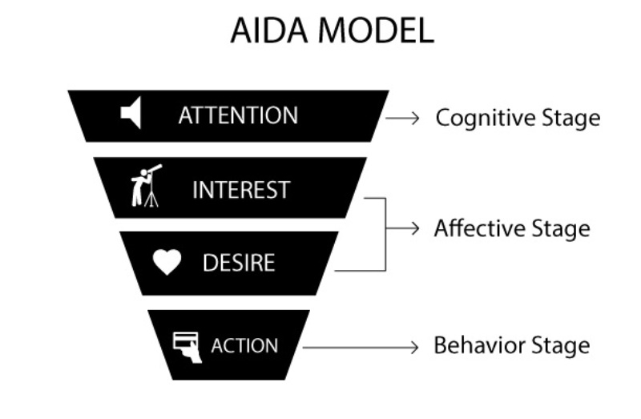

Figure 2 Consumer response - Aida Model
The theory of the communicational process which we are going to analyze is the Micro Model of consumer response or known to us as the Hierarchy Models. Those models explain how the message in the advertisement works and how it can affect the customer buying decision. For any message to be successful, it needs to be designed to be meaningful for the receiver and to fit the cognitive capability of the target group. Focusing on the consumers respond as part of the marketing communication we will discuss the three main stages throughout the buyer cross. The stages during with the people are processing information are cognitive, affective, and behavioral. The cognitive stage is where the thinking process is happening. In the affective stage consumers feel and evaluate the goods. And in the behavioral stage also known as Conative stage occurs the actual purchasing. Each of those stages discusses the customer’s motivation starting from the unawareness about the product to the final stage of purchasing it. The desire to understand this relationship between the attitude and the psychological behavior led to the need to explore the AIDA model. This model stands for Attention, Interest, Desire and Action and those define the stages that stimulate different emotions in the consumer. The first point of interaction here is the attention of the customer who becomes aware of the nature of the company or the advertised product. It is followed by the stage of interest where the customer already knows the product’s benefits and learns more about how to adopt them to his lifestyle. Desire is stage three and convinces the audiences to want to buy the advertised product. The final step is the action stage where the customer takes the decision to purchase the advertised goods.
To summarize, the product awareness and attention occur in the cognition stage, the potential interest and desire occur in the affective stage and the action happens in the last conative stage. According to McGuire the AIDA model as well as the other Hierarchy effects models cannot lead to immediate response from the consumers, but they can lead to series of mental consideration that eventually over the time in future initiate a purchase decision process. Considered as a disadvantage of this theory is the fact that the models are based on logical, rational movement of people’s behavior, and not on feelings, and other such stages which cannot be described as general buying behavior.

2.3.1 Relating the Aida model to Nike company
The consumer response is a very important part of the communicational process and relating the Aida model to the case study of Nike will bring insight about the how the brand influences the decision-making process. Analysis of the marketing campaigns of Nike shows that the Aida formula is strongly corporate in the brand message. The Attention, Interest, Desire, and Action are the steps that we are going to interpret. They are happening from the time when customers enter the marketing funnels of the brand and end with the effect of the final decision to buy. Creating the advertisement is the first step of the marketing of the products and Nike uses the Attention element to capture the attention of the target people. Here the customer perceives Nike’s products. This happens using the strong content of the company’s message which drives the audience to feel that Nike can help them expand their human potential (Nike, 2020). Also, to increase the Attention Nike uses famous athletes and high-profile celebrities which are wearing the brand’s products and advertise the new models of trainers and clothing. In the next step Nike captures the interest of the customers by telling them motivational stories of other people (Erkilic, 2018). The emotional content of the sports message is about the pain and the victory of other people, and this challenges the audience to not be afraid of failure when using the brand’s products. Besides, the image of the people in the Nike’s advertisements leads to strong interest in the products and this is visible in the social medias. Increasing the audience Interest and engaging them is the very important part of the success of the message in Nike’s communication (Brown, J. P., 2020). The strong influence of the advertisement makes people desire to be more physically active and be fit with the help of the brand products. Examples of that are the advertisement messages: ‘Find your greatness; Just Do it; Freedom for your feet; You can’t be stopped’ and more (Nike, 2020). The desire is built on a deeper psychological level and creates in the people’s minds the need for Nike’s products. Moreover, the brand messages show the innovative technologies that increase the desire element using the features of the products that are unique in the market and benefit the physical performance of the people. The final stage of the model is the Action which is the logical way that customers go through. Nike increases the Action by sending promotional offers such as push notifications in the social medias, in Nike’s app and by emails. Another method that the brand uses to stimulate the action is working in close partnership with different sports influencers who get paid to review Nike’s products and share their opinion about them with other audiences. In summary, the application of the AIDA model to Nike’s performance creates strong brand awareness, increases the followers in the digital media and helps the brand increase the sales of the products (Namburi, 2021).

2.4 Consumer Behavior
Consumer behavior is a long process which describes the stages people are going through in order to purchase a product or service for personal consumption. This decision making can happen in different ways and different factors can influence the final action. Understanding the nature of how the buyer makes decision will increase the effectiveness of the marketing communication of the organization (Szmigin, 2018). Building a solid knowledge of this model is very important for the answering of the research questions of this dissertation. Analyzing the factors that influence the customer behavior will help define what consumer buy and why. The main factors are the Environmental, Personal and Psychological ones. The major driving forces of the individual are the cultural and social factors because they determine the personal identity, and they are things like nationality, social class, education, religion, income, and age preferences. The political situation, the economy can also impact the consumer decision. The personal factors are related to individual personal preferences, interest, customer lifestyle and previous experiences. The psychological factors are very important for the buyer behavior because they are unique for every individual and can be influenced by motivation, perception, learning, belief, and attitude (Dr. Sachs, 2019).

2.5 Maslow’s hierarchy of needs


Figure 3Maslow's hierarchy of needs Model (Hoppers, 2020)

Different theories examine how the psychological factors affect the consumer behavior but the main one of them is the Maslow’s hierarchy of needs. The scientist Abraham Maslow developed the psychological theory in 1943 in order to explain the human motivation based on satisfaction into different stages or levels of needs. The Maslow’s hierarchy of needs has the shape of a pyramid and presents five main layers designed to work from the bottom to the top. The bottom is where the most basic needs are while on the top is where the self- fulfilment needs are. The lowest level shows the physiological needs people have and include concerns such as the need to survive – having food, water, and shelter. The second level of the pyramid are the safety needs which are related to personal needs to be safe and secure. Motivation here comes from the need to have protection from uncertainty (M. R. Solomon, 2017). The next level represents the love and belonging needs and here the outline is the need for family, friendship, and receiving of love. The fourth level of the Maslow’s hierarchy are the esteem needs which describe the need for respect form others and the need to respect oneself. The final level shows the self-actualization needs which are associated with the full realization of the individual potential. Understanding the factors that affect the consumers will help the organization to target the people more efficiently and to create marketing messages that can reach different individuals and influence their buying decisions (M. R. Solomon, 2019). The benefits of the Maslow’s theory are the understanding of the nature of human motivation and therefore consumer behavior. This model is very relevant to present times and helps the organizations create better engagement with customers by addressing their needs. The main limitation of the model are the cultural differences between the people and their individual preferences. People think differently and it is really difficult to measure the consumer behavior.

2.5.1 Relating the Maslow’s hierarchy of needs model to Nike
The hierarchy of the human needs is a very applicable theory in the marketing management of the company of Nike. Analysis of the model shows that the five stages that lead to self-actualization influence people to make a purchase decision. The Self-actualization messages are incorporated in many marketing communicational campaigns of Nike. The slogan “Just Do it” goes above and beyond the level of needs and responds to higher organizational purposes (Donald, 2017). People are the core center of the brand focus and embracing their needs is fundamental. Determination and relating Nike to the Maslow’s needs will happen in three main categories which combine Basic, Psychological and Self-fulfillment needs. In the first stage Nike satisfies the Basic needs when offering and supplying trainers and sports gear. This is also important for the protection and safety performance during workouts or sports games. In the next level Nike satisfies the psychology needs by the emotional messages that are created with the purpose to build feelings and belongings for something bigger than the physical brand products. Nike understands very well the sports cultures and supports the need for prestige and social recognition of its customers. They do that in a very effective and emotional way with stories of others. This pushes the people to do more like participate in sports. The connection of the company with its audience affects in positive way the purchase decisions (M.Esselstrom, 2020). Nike understands that different cultures have different needs, and they simply deploy separate multiple advertisements to fulfill them (MasterClass, 2020).

2.6 Decision-making process
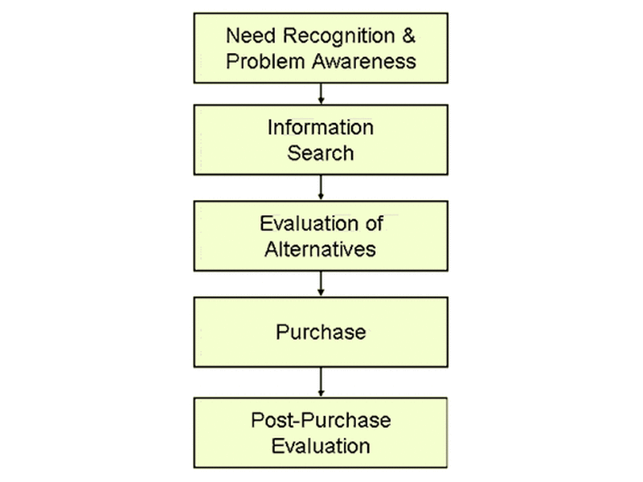

Figure 4 Decision-making process
The decision-making process is a complex model that analyzes five different stages during which the buyer decides to make a purchase. Those stages are described in a logical order beginning with need recognition for the product all the way through the post-purchase evaluation. Marketing communications can impact any of these stages, so it is very important to monitor and discuss all of them. The first stage of decision-making process is called the need recognition or in other words when the consumer realizes that they need or want to buy a new product or service. This need can be stimulated from external and internal sources such as marketing campaign or individual instant need. Once the need is established the potential customer starts looking for more information and moves to the second stage which is called information search. Those activities involve online searching for extra information, watching advertisements, or asking members of the family or friends about the product (M. R. Solomon, 2017). The next stage is evaluation of alternatives and refers to the ability of the consumer to choose the right product for them and to differentiate the companies evaluating their unique propositions. Customer decision can be made very quickly or may take a longer time. Everything is very individual and depends on the evaluation criteria. Stage fourth from the model is the actual purchase decision where the consumer knows what product they want to buy, they are ready to buy it and the payment is in process. This happens when the motives to buy certain item match the evaluation criteria of it. The final stage is the post-purchasing evaluation and represents a very important part of the model because the feedback from the customer is available to the marketer. Once establishing positive connection, the organization can learn from its customers and can keep the long-term relationship as well as update the product features to increase the overall satisfaction. Advantages of the model are that the stages follow logical order and the marketer can easy navigate the customer decision by applying a lot of information and investing in good advertisement for brand awareness. Disadvantages of the model are few such as not all individuals go through the same rational order when purchasing and that sometimes external influence or person may make the buying decision instead of the actual consumer (Kahneman, 2012).

2.6.1 Relating the Decision-making process to Nike consumers
Decision making process is another very important theory that helps us understand what the brand does to influence people before, during and after purchasing the brand products. Relating the process to Nike practice will bring answers about how the brand navigates the people to buy from them. Analysis shows that in the first stage which is the need recognition and problem awareness the brand Nike’s messages are focused to stimulate the consumers to desire its brand products (Bikart, 2019). For example, the emotional message of the athlete Michael Jordan wearing new pair of sneakers that make him faster and better in the sports game stimulates Nike’s audience to desire those shoes and aspire in sports themselves. The next stage is the information search which can be from external and internal sources. Here Nike’s consumers read comments in social media or ask friends for advice to make sure they are taking the right decision to buy the brand product. Of course, the experience of others is not always enough, and Nike’s consumers may need to make an evaluation of alternatives which is stage three. Examples for that are the comparison between Nike and other sports brands or comparing the shoes to other models at Nike. Once the decision has been made the customer moves to the purchase stage in which Nike also influences people’s choice. For example, on the till in the store a member of the staff makes a comment on how nice the product is or with a message via the online order which content confirms that the chosen products are the best choice for you. The last stage is the post purchase evaluation where the brand has touchpoints with the customers and can communicate with them. For examples after the consumer buys sneakers from Nike and begins to use them, they often compare the expectation for the product to how satisfied their needs are in the end. The feedback consists of comments, rating and survey which are the most common way that Nike learns from people about their experience after purchasing the brand products. Here often the cognitive process occurs in consumer’s mind and influences the next purchase decision. If the consumer is satisfied with Nike’s products, they are most likely to purchase again from the brand in the near or far future depending on their needs and desires (Petro, 2016).

2. 7 Integrated Marketing Communication
The role of Integrated Marketing Communications is to secure that all forms of information and messages are discussed together in order to maximize the efficiency of the strategy. When establishing IMS, the first thing is to select a target group of people which one wants to influence and then to analyze the consumer’s behavior. Having done that, according to the customer’s needs and desires, the company needs to set promotional objectives for their products. Next step is creating a brand message and a design, also creating a promotional mix which informs the audience about what the company is offering and also highlights the benefits. Business should determine the overall budget and channels of communication with the target customers (Percy, 2018). Finally, the company needs to assess the results from the communication process and therefore based on those results should form effective marketing strategies.

2.7.1 Nike’s Promotional Mix
From the foundation level in Marketing, we know that the 4Ps Marketing mix includes product, price, place, and promotion. Each of those elements needs to be planned and integrated in a strategic manner in order to support the general marketing goals of the organization. The element promotion represents the main part of the marketing communication and needs to be integrated with the other marketing strategies. The special attention of the promotion and the advertisement of Nike was to find the answers on how the brand convinces the consumers or target the market to buy their products. The communicational mix includes eight different kinds of promotions that Nike’s company uses to target and influence the people in the sport industry (Percy, 2018). The following promotion activities explain how the company promotes the brand products and increase the brand image.
Advertisement
In order to explained what the nature of advertisement we need to provide clear definition. Advertisement is type of promotions which are used to promote organizational products or services in order to attract more people to buy it. Also, advertisement is the most popular and effective way that Nike uses to reach the target audience. This type of marketing communication is non personal promotion, and the brand messages are paid by the organization. Nike’s advertisement creates attention by presenting the brand mission and its products via different popular media, also showing celebrities and sports stars. Some of them are Tiger Woods, Roger Federer, Cristiano Ronaldo, Serena Williams and Lebron James (Nike Inc., 2021).

Sales promotions
Briefly the definition of Sales promotion is type of promotion used in marketing to instantly increase the sales of the companies. Nike uses this kind of promotion for short-term incentives. An example is the different forms of discounts for limited time on brand products. Nike applies sales promotion in its marketing strategies to increase the overall sales, to introduce new products to the market or to clear out old collections (Nike, 2020).

Events and experiences
The Events and experience are another type of promotion used in marketing strategies to create engagements with customers and offer brand product. Nike’s online events offer a variety of opportunities for the people to be healthy in a fun and active way. The company delivers great experience for kids and adults through engaging the brand community to participate in sports games such as football, basketball, golf, tennis, marathons and more. The brand strategy using this way of promotion is to build deep relationships with Nike’s consumers, to promote physical exercise using the brand products (Petro, 2016).
Public relations and publicity
The simplest way to describe the public relation and publicity is like a strategic communicational activity that support the companies and work in close relationship with customers. Nike’s public relations is focused on communicating with its audience by addressing social problems to the stakeholders of the company. For example, the global climate changes are an issue that makes Nike build strategies in order to maintain a sustainable environment. Also, the brand’s public relations increase the brand awareness of the company by sponsoring different events. This allows Nike to communicate with target audience, reach new customers, and establish better perception about brand mission and products (Maida, 2019).

Online and social media marketing
We can define the online and social media advertisements as a form of electronic communications that where the people create communities and share information or experience one to other. This type of promotion has been extremely powerful and influential in the last couple of years. Online and social media marketing creates the two-way street of communication between the companies and the people. Nike uses the most popular social media to increase the brand image in the consumers’ mind, to create lifestyle trends and to better manage the brand communities (Cole, 2018).

Mobile marketing
Mobile marketing is another way or promotion that is used to target and connect many users in one please. In recent years the mobile applications are more frequently applied in the products’ search and purchase. The Mobile marketing of Nike represents a very important part of the promotional strategy of the company because the modern technology allows customers to directly shop from the Nike’s app. Besides, there are more customized tools for delivering a great experience to the consumer and tracing the consumer activities for organizational purposes (McKinnon, 2020).
Direct marketing
The Direct Marketing is kind of promotion that is directly presenting or marketing the company in front of the people without the help of middlemen. The promotional method helps the Nike brand to directly communicate with customers and receive their response which happens through telephone such as text messages, email, and website. The main source of information is Nike’s website where the customers can find everything that they need to know about the company, available products and features and new technology.
Personal selling
Personal selling is a classical way of promotion where the company interacts face to face with its customers and tries to convince them to buy their products. The advantage of this form of promotion is its effectiveness to reach the target customers and increase sales of the brand products but the disadvantages include the cost of the employees and the long time spent convincing the people to buy. Examples of personal selling can be the staff in Nike’s stores who are trained to promote the brand products and to deliver great customized experience during the time the customer stays in the store. Also, Nike does personal selling by sending company representatives who are focused on creating new relationships with sports organizations, schools, colleges, sports teams and etc.

Chapter three

3. Research Methodology
This chapter is going to explain how the researcher investigates the research topic of this work and how they find the answers the research objectives and questions suggest. The research methodology is a long process which applies different philosophies and methods. This process is very rational and consists of a variety of phases which can be described such as identification of what is the needed data, how it will be collected, the collection methods, how the data will be analyzed and the methods by which the results will be interpreted. This dissertation will cover the methodological choice of the author and for this purpose will apply the Research onion model. This is a model developed in 2007 by Saunders aimed to help the researchers determine the stages that they need to go through in order to apply an effective methodology. According to the book: ‘’Research Methodology for Business Students’’ the Research Onion is a model considered as an extension of the model of the Research Methodology Tree (M. Saunders, 2018). The purpose and main aim of the model is to clearly explain to the future writers of dissertations what the different layers are and how systematically to apply them to form an organized methodology. The method illustrates six different layers which start with the philosophies, then the types of approaches, then the strategies, choices, time horizons and finish with the techniques and procedures of data collection. For the successful accomplishment of the study it needs to pursue clear objectives in a very organized and narrow direction and to apply facts supporting the main thesis of the research (Flick, 2020).

Figure 5 Research Onion Model

3.1 Research Philosophy
The first layer of the Research onion is the Philosophy and is presented by positivism, interpretivism, pragmatism and realism. According to Kothari the definition of the Research philosophy is an overarching term in relation to the development of set of belief, knowledge, and the nature of that knowledge (R.Kothari, 2020). In this work there are applied fundamental principles of the Ontology which refer to the origin of the information and to the Epistemology which requires the validation of the information. The research philosophy of this study will follow the initial goal of the researcher to investigate the impact of the IMC on the consumer buyer behavior in the case study of Nike. For this purpose, the chosen research philosophy will be the positivism. According to this philosophy the trustworthy results are only achieved by actual knowledge, effective data collection and measurement through independent observation. The role of the researcher here is described as testing different hypothesis, data collection and analysis of the results in an objective manner. Applying this method, the research finding depends on the statistical analysis from the initial observation. The Positivism philosophy is widely used and applied in the academic works because it allows the researcher to demonstrate his or her viewpoint regarding the collected facts and figures of the study judged by the literature review.

3.2 Research approach
The research approach is the second layer of the Saunders model and includes two methods being the Deductive and the Inductive method. Influenced from the first layer here the researcher is going to choose and apply the Deductive research method. The reason for that is the aim to find the answers about the initial questions which were set in the beginning of this study. This method will also help the researcher to scan different theories concerning the research questions and to revise them in order to be able to complete the final objectives of this dissertation (Flick, 2020).

3.3 Research strategy
The third layer of the model are the research strategies which describe the choice of the research style for data collection and data analysis. Options here vary between Experiment, Survey, Case study, Action Research, Grounded theory, Ethnography, and Archival Research. The appropriate and selected research strategy for this dissertation’s investigation is using survey. This strategy is considered to be fast and low-cost in the Marketing sphere and collects data from a large group of people. The survey is generally used to answer the research questions that concern the research aim. There mean to answer those and thus lead to specific goals including the evaluation of the results. Also, the Survey can be conducted from distance, online or directly, offline. According to Flick the advantages of this strategy are the large number of questions that can be set and processed (Flick, 2020). They are an excellent way of gathering demographic data which in Marketing is very important and a reliable measuring method to gather the information from the sample group. According to Kothari (R.Kothari, 2020) the survey is a process where the main instrument for collecting information is the questionnaire. The researcher can use different questions for one or more topics with closed-ended or open-ended answers to gain the best accurate information and to interpret the responses from them (Cartlidge, 2017). However, in this study only close type answers will be applied which means the sample group will have to select a response between few options. The key to this kind of questionnaire is it is easy to respond to and can be analyzed pretty fast. The disadvantage of this decision can be the limitation of expression of the individual opinion on the given topic.

3.4 Type of investigation
In the research methodology only two sources from where the data can be collected are available, and they are the primary and secondary data. The primary data can be defined as the extract response directly from the individual. This type of firsthand source of information is usually collected through survey or interview. In the Marketing Management this is a very effective way to gain information directly exploring the opinion of the consumers. The secondary data is information gathered from other work or can be describes as the opinion of the literature review. What is characteristic about this source of information is that it has been used before by another research.
The detailed analysis shows that the benefits of the primary data are that the collection of data can be very specific and unique for the needs of the investigation. Also, the selection of participants, method and strategies can be controlled by the researcher. However, the limitations of this data collection method are the cost for materials and study procedures and needed time (Flick, 2020). Critical analysis of the secondary data present that they have great benefits which include saving time and money, it supports the understanding of the research problems and provides data for comparison with collected primary data. The limitation of this type of investigation shows that sometimes the secondary data which we can find is not relevant to the area of the research, it is not accurate and can be out of date (M. Saunders, 2018).
In this academic research we are going to use a combination of primary and secondary data. Both types of investigation are very useful because they fulfill different sections of this investigation and support the research thesis of one another.

3.5 Research Choice
The fourth layer of the Research Onion is the research choice which is concerned with the research methodology. The available types here are qualitative research and quantitative research. This is a very fundamental part of the model and will be critically analyzed. Qualitative research is used to describe variations, express individual opinion and relationships. This type of scientific research is concerned with investigation that seeks to answer questions regarding a specific research problem. It is a very effective way to provide data from people about their experience, behavioral traits or beliefs. Also, the qualitative research helps the researcher to understand the information better and to interpret it when in a certain situation. The quantitative research describes certain characteristics of the population and is related to numbers and measurement of quantity (R.Kothari, 2020). Generally, this type of research is used to confirm specific hypothesis through extract and classified responses to given questions. Characterization of the data collection is done by the questioner via the questionnaire in a survey format with closed-ended questions. The main difference between the two researches is the level of flexibility. The qualitative method uses a more flexible style compared to the quantitative one where questions are identical for all participants. General advantages of the qualitative research include the application of open-ended questions which allows the participants to respond with their own words and opportunity for the researcher to ask additional questions such as ‘’how’’ and ‘’why’’. The disadvantages of this method can be the long time for analysis of the information and the influence of the participants’ responses. It is important to mention that depending on the choices that are made we will need to follow a specific structure of methods and tools. Also, we need to choose one of the three existing methods in this layer which are the Mono-method, the Mixed-method, and the multi-method. Briefly defined, the Mono-method applies one type of data, either qualitative or quantitative. When using the Mixed-method or the multi-method the researcher combines both types of data (Wittek, 2013).
Moving to the choice of the author in this investigation. The type of data that we are going to use is only quantitative and the applied method will be the Mono-method. This choice is based on the previous decisions in the research onion combined with the aim of the study and the research objectives. The reason for that is the need to analyze only the customer opinion for Nike’s company. This research method will allow the researcher to monitor and analyze participants’ point of view of the sports brand and the reasons why people buy from them. The main advantages of the quantitative research are the closed-ended questions which allow the researcher to analyze the responses of a large group of people in a fast, easy, and numerical data format. Disadvantages of the quantitative research include the missing individual opinion and that the answers represent too general characteristics (Gardiner, 2015).

3.6 Time Horizons – Cross - sectional
In the research onion the time horizons layer is the fifth layer and is presented of two sublayers which are named cross-sectional and longitudinal. They present the time frame of the research and are important part of the research methodology. According to the nature of this research the time horizons will be cross-sectional. They are aimed to assist the monitoring and investigation of the behavior of the individual or the group of people at the specific time (Brown, 2006).

3.7 Data collection
The final layer of the Research Onion model is the data collection and data analysis. Those two data tasks describe in detail what the researcher is doing to collect data and how they are going to analyze the results from it. Also, this layer is very important because here the researcher demonstrates the ability to apply different tools and techniques to achieve the research aim of the study. The data takes the central part of the research attention because the overall study depends on the reliability and validity of the information and therefore it needs to be analyzed very carefully. As it was stated in the previous lines, the chosen type of data collection will be from primary sources and the method used - survey questionnaire. Additionally, when using this method (R.Kothari, 2020) we need to decide on the design of the questionnaire, the place and time of the survey and the selection of the participants. The chosen place of the survey is the main entrance of Nike’s shop located on the famous Oxford Street corner in the central part of London. This place is an inspiration for many people to visit and to shop from because it offers a huge variety of products which are positioned in 4 floors. The data collection is planned to happen approximately throughout two days in August. In this investigation the participants will be randomly selected from the visitors of Nike’s store. The plan is stopping and asking Nike’s customers for a willingness to participate in the academic research. The questionnaire will be handed out to the volunteers. The approximate time for answering the selected questions will be around 5 minutes . The questionnaire will be completely anonymous (Biggam, 2021).

3.7.1 Data Sampling
In Research methodology the sample is used for the measurement of a large group of people who represent the population. The data sampling is an essential element of this research and it is important to select the most effective method for that. Characteristic for the sample process is the large number of available sampling techniques which can be divided into two subgroups being probability sampling and non-probability sampling. Briefly the first one is representative and the second one is judgmental (R.Kothari, 2020). The right choice depends on the choice for sample size. In this investigation the chosen sampling method will be the non-probability sample which will apply the judgment (or Purposive) sampling for the survey’s data collection. This means that the participants will be selected though the judgment of the researcher which will depend on the need of the study. The expected sample size will be targeting a group of 50 participants including females or males who are Nike’s consumers. The main reasons for the selected method were the suggestions from Saunders (M. Saunders, 2018) that probability sampling is not suitable for the small sample size and is very difficult to be executed because people are not willing to take part in the survey. Advantages of the Judgmental method are the effective way to collect relevant data and the little time to do that. Disadvantages may be possible lack of representation of all population circles and uncontrolled variability in the estimation.

3.7.2 Questionnaire design
This section is an important part for the success of the final dissertation because it explains how the researcher designs the questions to collect valuable data from the participants. The questionnaire is focused on collecting quantitative data from primary sources which is needed for the analysis section and interpretation of the research thesis (R.Kothari, 2020). For this purpose, the researcher has prepared a survey with 10 close-ended questions created specifically to investigate the opinion of the customers, the consumer buying behavior and the marketing communications regarding Nike’s consumers. To extract that necessary information the questionnaire was divided into several sections. Their design includes the format of two demographic questions, two YES or No questions, three questions with selection of one possible answer and three questions with 5-point Likert scale. The benefits of this design are the variety of formats to collect feedback from a large sample group. Each of the questions brings different point of view. For example, the demographic questions are an effective way to collect background information for the participants which can be a very useful tool for the better understanding of the people participating in the survey (Johnson, n.d.). The one-choice questions are a very popular way to collect instant responses and are easy to analyze. The questions with Yes and No answers are required to give accurate answers and they take only little effort to be completed. The Liker scale questions are a great way to capture the participants’ opinion and feelings as they use a large scale of options from strongly agree to strongly disagree.

3.8 Data Analysis Tool
The collected data from the survey will be analyzed using one of the best programs which is Statistical Package for the Social Sciences (SPSS) software. Concerning the research only quantitative data will be used. This statistical data editor will easily allow the analysis of a large quantity of social science data for a short period of time. The statistical analysis is easily accessible, exceptionally organized and can be presented in different ways such as interactive figures (Kinnear, 2007).

3.9 Ethical considerations
The brief definition of research ethics can be described as a system of moral principles. The research ethics is an important asset to be considered because it affects the way people live their lives and how they make daily decisions. This moral philosophy is concerned not only with what is good for society but also with what is good for the individual (Eagle, 2015). Examples of ethical consideration in the research of this dissertation will be the responsibility for the collected data and the legal rights regarding the data. Hence, the survey will be anonymous and all the primary data which will be collected during the research process will be used only for the purpose of this dissertation’s research and the materials will be kept in private in a secure place (Enago Academy, 2020).

Chapter four

4.Analysis of the data collection
Chapter four presents the results from the study and the interpretation of its findings regarding the consumer motivation to purchase from Nike’s products, brand’s influence on the consumer-decision making proses and Integrated Marketing Communication strategies. The data was collected through survey of Nike’s consumers in London. The participants responded to all questions from the academic research. The collected data was summarized with statistical programs and the results were visualized. The following presentation includes numeric tables for every question, plus statistical graphics, and analysis of the final numbers (CallMiner, 2017).
In the first section of the analysis there are questions which collect demographic information about the participants. Second section includes questions which require a Yes or No response. The third section of the research contains questions which have six available options - five of them are different and the last selection is of all mentioned options. The tables from those sections include statistical summary of the Frequency, Percent, Valid Percent, Cumulative Percent of the collected data. Section four is different and includes questions which consist of responds that are rated and presented using the five-point Liker scale. The tables there include only the percentage. All results show the opinion of the participants while the research was conducted.

4.1 First question from the Survey
With the first question from the survey the researcher measures/pictures the age group of the average Nike’s consumers. The following Table 1 and figure 6 visualize the data collection. The results show that from 50 participants 29 answered that their age is between 25 and 34 years, 14 are answered to be between 18 and 24 years, then we have 4 participants of the age group 35 to 44 years,2 for 45 to 54 years and only 1 for 55 plus years. In percentage the share of the dominating group is 58% represented by 25- 34-year-old, followed by 28% 18 – 24-year-old, 8% 35 -44-year-old, 4% 45 – 54-year-old and 2% of people over the age of 55 years old. Analyzing these results, we can state that the target group of Nike’s company are the young people in their physically active age.

What is your age?
 |  | Frequency | Percent | Valid Percent | Cumulative Percent
Valid | 18 - 24 years old | 14 | 28.0 | 28.0 | 28.0
Valid | 25 - 34 years old | 29 | 58.0 | 58.0 | 86.0
Valid | 35 - 44 years old | 4 | 8.0 | 8.0 | 94.0
Valid | 45 - 54 years old | 2 | 4.0 | 4.0 | 98.0
Valid | 55 + | 1 | 2.0 | 2.0 | 100.0
Valid | Total | 50 | 100.0 | 100.0

Table 1 Age of the partisipants

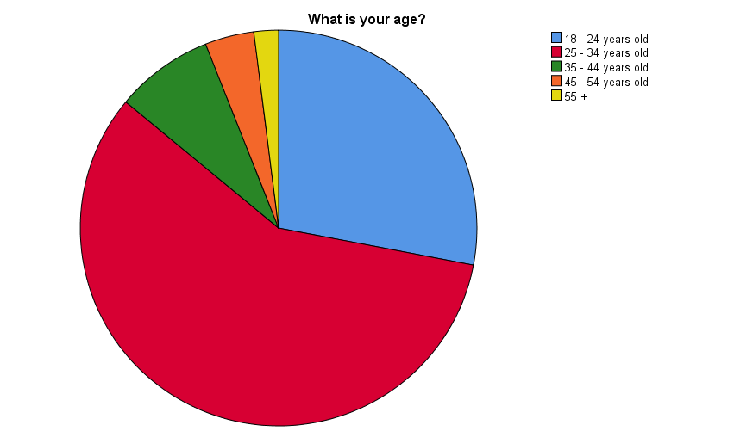

Figure 6 Age of the participants presented in pie chart

4.2 Second question from the Survey
The second question from the survey measures the percentage of female and male participants. Table 2 and figure 7 present the statistics of the gender of the participants which is 44% for women and 56% for men. The results are not surprising because the sports brand markets many sports games which are more popular among males. Also, the company offers a wide variety of brand products for this gender, and this explains the numbers.

Table 2 Gender of the participants
What is your gender?
 |  | Frequency | Percent | Valid Percent | Cumulative Percent
Valid | Female | 22 | 44.0 | 44.0 | 44.0
Valid | Male | 28 | 56.0 | 56.0 | 100.0
Valid | Total | 50 | 100.0 | 100.0
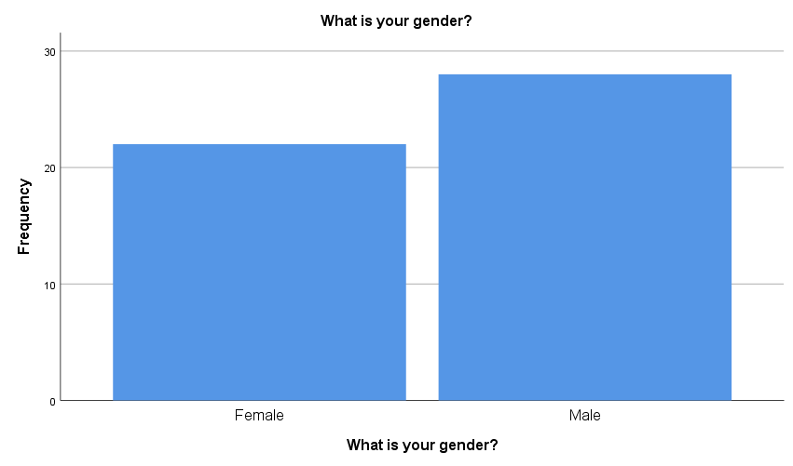

Figure 7 Gender of the participants presented in a Histogram chart

4.3 Third question from the Survey
The third question from the survey measures the opinion of Nike’s consumers on the effect of the online advertisements of the sports brand. Table 3 and Figure 8 present the results which show that in frequency 34 of the participants selected the Yes option compared to the answers of 16 participants who chose the No option. This means the majority of the group think that the online marketing campaigns of Nike affect their decision to buy from the brand.

Do you think the online advertisements affect your decision to buy from Nike?
 |  | Frequency | Percent | Valid Percent | Cumulative Percent
Valid | Yes | 34 | 68.0 | 68.0 | 68.0
Valid | No | 16 | 32.0 | 32.0 | 100.0
Valid | Total | 50 | 100.0 | 100.0

Table 3 Yes and No opinion about Nike’s online advertisements
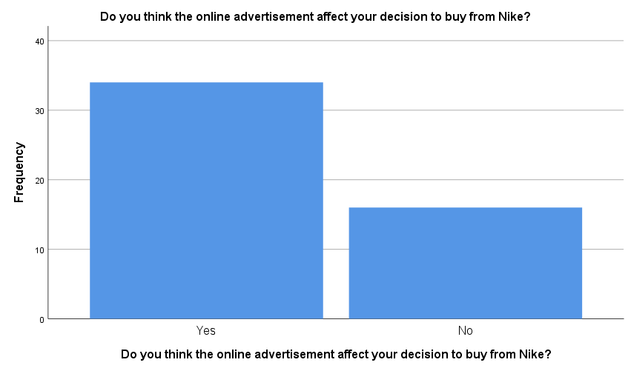

Figure 8 Yes and No opinion about Nike’s online advertisements presented with histogram chart

4.4 Fourth question from the Survey
The fourth question of the survey is very similar to the previous ones but here the researcher wants to receive the general opinion on Nike’s advertisements. With the simple and instant Yes and No respond we can see and track if the people actually like Nike’s advertisements. The results from Table 4 and Figure 9 present that 86% of the responders answer with Yes and only 14% choose the answer with No. This high number of positive responds confirms that the marketing campaigns Nike uses are very popular, and the brand consumers really like them.

Do you like Nike’s advertisements?
 |  | Frequency | Percent | Valid Percent | Cumulative Percent
Valid | Yes | 43 | 86.0 | 86.0 | 86.0
Valid | No | 7 | 14.0 | 14.0 | 100.0
Valid | Total | 50 | 100.0 | 100.0

Table 4 Yes and No responses of Nike’s advertisements

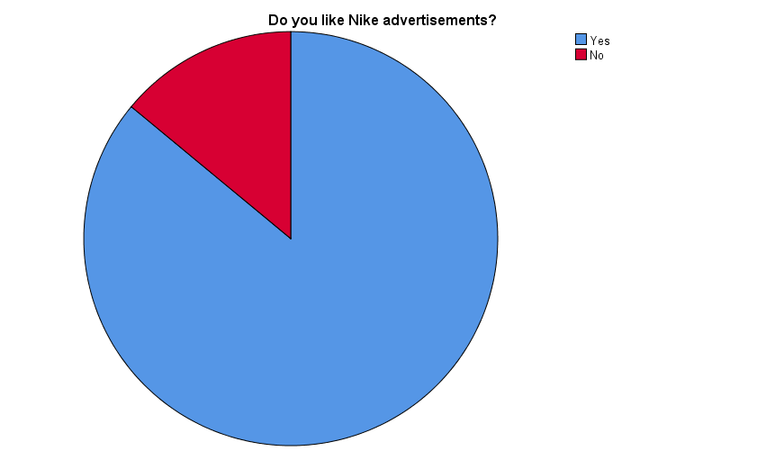

Figure 9 Yes and No responses for Nike’s advertisements presented with pie chart

4.5. Fifth question from the Survey
The response from the fifth question of the survey shows that one opinion in particular dominates when compared to other options which are similar to one another. Table 5 and Figure 10 visualize the results given from questioning the participants which measure what type of promotions are the most influential when considering Nike’s customers. In conclusion, 36% of the responders answer that the Sales promotion best describes their motivation to purchase from Nike, followed by 20% for Advertisement, 16 % of the customers select all the mentioned options, 14% of them choose Direct marketing, 8% support the public relations and 6% the Personal Selling. The high percentage of the Sales promotion shows that people like Nike’s promotional offers and discounts.

What type of promotion best describes your motivation to purchase from Nike?
 |  | Frequency | Percent | Valid Percent | Cumulative Percent
Valid | Advertising | 10 | 20.0 | 20.0 | 20.0
Valid | Personal Selling | 3 | 6.0 | 6.0 | 26.0
Valid | Direct marketing | 7 | 14.0 | 14.0 | 40.0
Valid | Sales promotion | 18 | 36.0 | 36.0 | 76.0
Valid | Public relations | 4 | 8.0 | 8.0 | 84.0
Valid | All mentioned options | 8 | 16.0 | 16.0 | 100.0
Valid | Total | 50 | 100.0 | 100.0

Table 5 Types of promotion

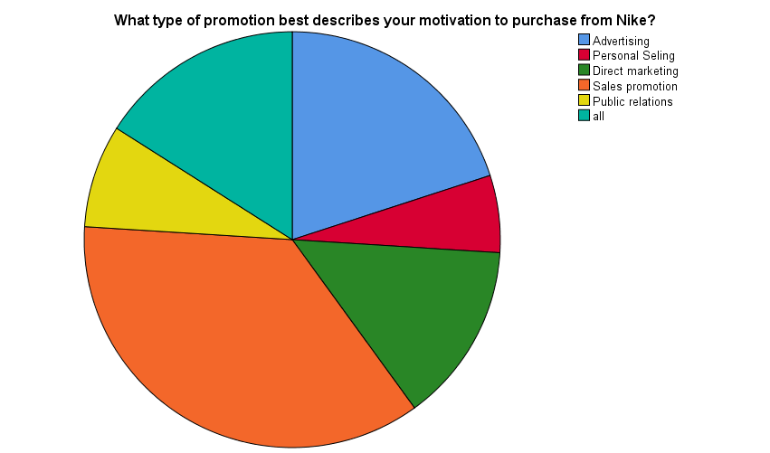

Figure 10 Types of promotion pie chart presentation

4.6 Sixth question from the Survey
The sixth question of the Survey is where the researcher measures how the Marketing communication of Nike’s company affects the customer decision-making process. On Table 6 and Figure 11 we can see the results from the responses of the 50 participants. Analyzing the numbers in percentage shows that the majority of people which is 44% think the positive brand image associated with elite sports performance has had the dominating impact on their decision to buy. The following 20% select that Nike’s Marketing reminds them of their needs and wants, 8% think that Nike’s advertisements create deep emotions, another 8% think that the Social-media channels create online communities, 6% state the increase of their desire to spend money and 14% select all the mentioned options.

How has the Marketing Communication of Nike impacted your decision-making process?
 |  | Frequency | Percent | Valid Percent | Cumulative Percent
Valid | Nike’s advertising creates deep emotions | 4 | 8.0 | 8.0 | 8.0
Valid | Social-media channels create online communities | 4 | 8.0 | 8.0 | 16.0
Valid | Positive Brand image associated with elite sports performance | 22 | 44.0 | 44.0 | 60.0
Valid | Nike Marketing reminds me of my needs and wants | 10 | 20.0 | 20.0 | 80.0
Valid | Increase my desire to spend money | 3 | 6.0 | 6.0 | 86.0
Valid | All | 7 | 14.0 | 14.0 | 100.0
Valid | Total | 50 | 100.0 | 100.0

Table 6 Impact of Nike on the consumer decision process

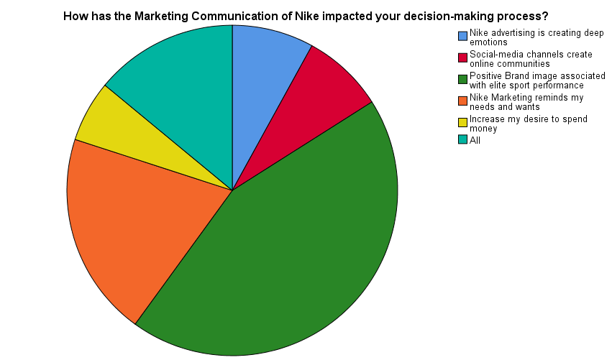
Figure 11 Impact of Nike on consumer decision process in Pie chart

4.7 Seventh question from the Survey
Question seven from the research measures what are the main factors motivating Nike’s consumers to buy from the brand. Table 7 and Figure 12 present the results from the collected data. The analysis of the results shows that 40% of the group respond that the quality and the design are the most important factors for them. Then 28% select the answer including all options, 12% choose previous experience, 10% choose reputation of the company, 6% of them answer that it is the easy way to order/buy brand products and only 4% choose that answer price of the product. In summary the interpretation of those numbers means the quality and design are the most important and the driving motivation to buy from Nike and that the least important factor is the price of the brand products.

Determine what is the main factor motivating you to buy from Nike?
 |  | Frequency | Percent | Valid Percent | Cumulative Percent
Valid | Price of the product | 2 | 4.0 | 4.0 | 4.0
Valid | Quality and design | 20 | 40.0 | 40.0 | 44.0
Valid | Reputation of the company | 5 | 10.0 | 10.0 | 54.0
Valid | Previous experience | 6 | 12.0 | 12.0 | 66.0
Valid | Easy way to order/buy brand products | 3 | 6.0 | 6.0 | 72.0
Valid | All | 14 | 28.0 | 28.0 | 100.0
Valid | Total | 50 | 100.0 | 100.0
Table 7 Factors motivating to buy from Nike
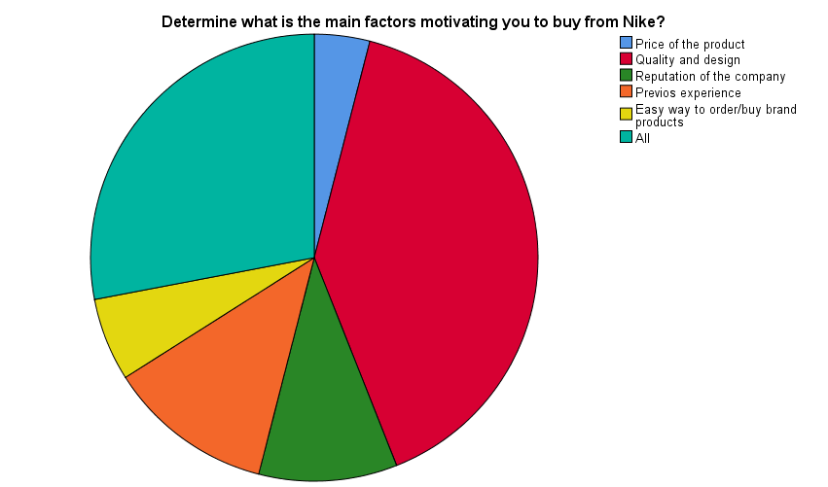

Figure 12 Factors motivating to buy from Nike in Pie chart

4.8 Eight question from the Survey
This question of the Survey contains four different statements with which the researcher has captured what consumers think about Nike’s communication. The level of agreement will state what customers think and feel about given statements about the company. The results from the 50 participants are presented individually for every statement in percentages. On Table 8 and Figure 13 we can see that around half of the participants agree with the given statements and another half has a hesitant answer. Interpretation of every statement will be given separately in order to analyze the results in a summary.

 | Strongly Agree | Agree | Neither agree/nor disagree | Disagree | Strongly Disagree
1. I follow Nike in social media because they have good content and promote the latest technology and products | 16.0% | 36.0% | 20.0% | 20.0% | 8.0%
2. I prefer Nike’s brand because my favourite athletes wear the brand products | 2.0% | 46.0% | 32.0% | 14.0% | 6.0%
3. I think Nike’s advertisements motivate me to be a better version of myself | 2.0% | 42.0% | 34.0% | 14.0% | 8.0%
4. I visit Nike’s stores because they always have good customer service and promotional offers | 14.0% | 42.0% | 26.0% | 14.0% | 4.0%

Table 8 Consumer side of Nike’s Communication

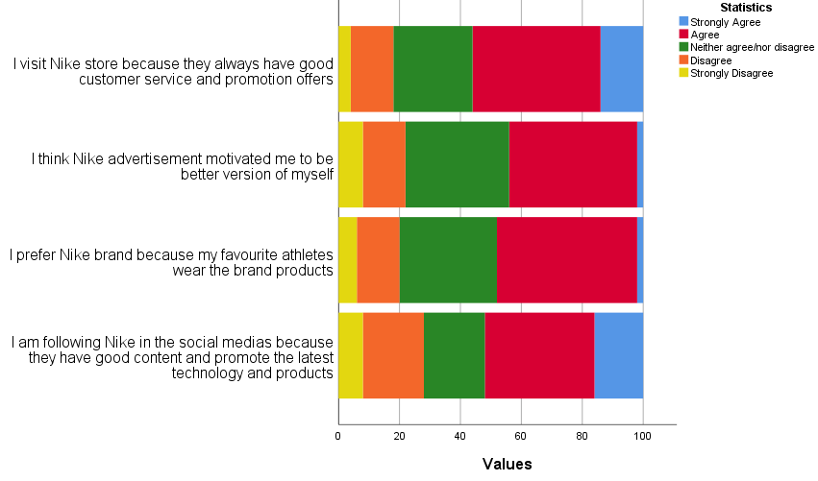

Figure 13 Consumer side of Nike’s communication chart

The first statement in numbers shows that 16% select the strongly agree option, 36% select agree, 20% state that they neither agree/nor disagree, 20% disagree and 8% strongly disagree. This statistic tells us that people have different reasons why they follow Nike in social-media and that the content in just one of them. However, the information about the latest product features represents an interest in 52% of the customers which is still a large number. The results regarding the second statement show that 2% strongly agree, 46% agree, 32% neither agree/nor disagree,14% disagree, and 6% strongly disagree. Analyzing those responses, it can be conducted that a large percentage prefer Nike’s brand because their favorite athletes wear the brand. But the majority of the people asked have different preferences and different association with the brand. The third statement shows that 2% strongly agree, 42% agree, 34% neither agree/nor disagree,14% disagree, and 8% strongly disagree. Interpretation of the responses presents that Nike’s advertisements motivate large percentages of the people to be more physically active compared to those who can’t identify this influence and those who disagree with the given statement. In summary, the share for the last allegation is 14% that strongly agree, 42% that agree, 26% that state that they neither agree/nor disagree, followed by 14% disagreeing and 4% strongly disagreeing. As a result, the majority of the participants follow Nike on social media.

4.9 Ninth question from the Survey
The ninth question of the Survey contains four statements with which the researcher has captured what affects the consumer decision to buy from Nike. The level of agreement indicates what customers think and feel about given statements about the sports brand. The results given by the 50 participants are presented individually for every statement in percentages. On Table 9 and Figure 14 we can see that the numbers dramatically change for every allegation. The interpretation of every statement will be given separately in order to analyze the responses.

 | Strongly agree | Agree | Neither agree/nor disagree | Disagree | Strongly disagree
1. The price, place and promotions are the most important for me when I decide to buy Nike’s products | 24.0% | 54.0% | 14.0% | 6.0% | 2.0%
2. I buy from Nike because I am loyal and emotionally connected to the brand | 10.0% | 40.0% | 22.0% | 18.0% | 10.0%
3. The last TV advertisement influenced me to order more products from Nike | 2.0% | 26.0% | 34.0% | 28.0% | 10.0%
4. Nike affects my decision to purchase with their motivational marketing campaigns | 6.0% | 30.0% | 50.0% | 8.0% | 6.0%

Table 9 Consumer Buying decision

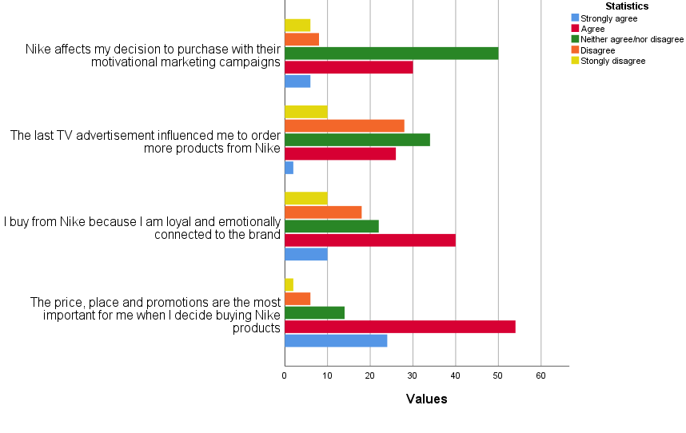
Figure 14 Consumer Buying decision chart

Regarding the first given statement most of the responses show that Nike’s consumers strongly agree or agree that price, place, and promotions are the most important factor to buy from the brand and only a minor percent of the participants state the opposite. In Table 10 and Figure 14 there are numbers and statistical share derived from the data collection. The shares show that 24% select the strongly agree option, then 54% select agree, followed by 14% neither agree/nor disagree, 6% disagree and 2% strongly disagree. In the next statement which measures the brand loyalty of Nike’s consumers we can see again that half of the participants responded positively agreeing with the statement and half of them selected other options. In numbers 10% strongly agree, 40% agree, 22% neither agree/nor disagree, 18% disagree and 10% strongly disagree. Interpretation of the results is that a lot of Nike’s consumers are highly loyal to the brand, but still, they have a high percentage of people that cannot describe what their opinion is regarding the matter or they state that they are not loyal to the brand. Third statement from question nine measures how the TV advertisements of Nike influence the consumers to spend more money for brand products. Analysis from the data presents surprising numbers. Responses are that 2% strongly agree, 26% agree, 34% neither agree/nor disagree, 28% disagree, 10% strongly disagree. The majority of the participants are not influenced from the television marketing that Nike uses, large number of the people state they can’t describe this influence and only minor number state that they are influenced by TV ads to buy more from the sport brand. The fourth statement monitors the consumer opinion about the motivational campaigns of Nike. The results here are completely different compared to the previous responds because the majority of the group are participants who do not agree with the given statement. In numbers the share is 6% strongly agree, 30% agree, 50% neither agree/non disagree, 8% disagree and 6% strongly disagree.

4.10 Tenth question from the Survey
The last question from the Survey is focused on the Marketing side of Nike’s communications and it includes four statements which measure the consumer opinion. The level of agreement indicates what customers think and feel about given statements about the sports brand. The results from the 50 participants are presented individually for every statement in percentages. On Table 10 and Figure 15 we can see that numbers are very similar for every allegation and that in this question no one selected the strongly disagree option. The interpretation of every statement will be given separately to analyze the responses.

 | Strongly agree | Agree | Neither agree/nor disagree | Disagree | Strongly disagree
1. Nike is a leader in the market because they invest in sales and promotions | 26.0% | 50.0% | 20.0% | 4.0% | 0.0%
2. Nike’s advertisements are focused on creating feelings and deeper desire to take action | 26.0% | 50.0% | 22.0% | 2.0% | 0.0%
3. Nike use direct marketing to create strong relationships with its customers | 18.0% | 62.0% | 18.0% | 2.0% | 0.0%
4. Nike are successful because they have good brand awareness and brand image | 56.0% | 40.0% | 4.0% | 0.0% | 0.0%

Table 10 Marketing side of Nike’s communication

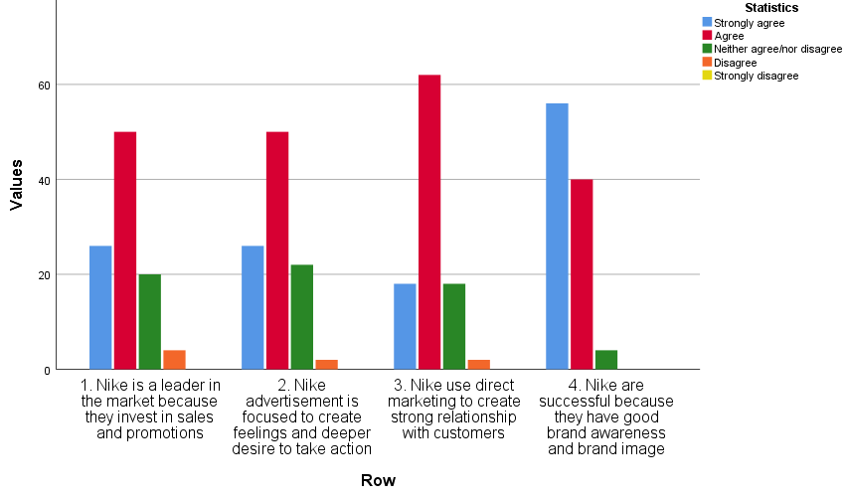

Figure 15 Marketing side of Nike’s communication

Results regarding the first statement show that the majority of the participants strongly agree and represent 26%, followed by 50% that agree that Nike is a leader in the market because they invest in sales and promotion. The participants that are neither agree/nor disagree were 20% and only minor number of 4% state that they are disagree. In the second statement the majority of the responders are positive and agree that Nike’s advertisements create desire which leads the customers to act or in other words to buy brand products. In numbers the analysis is identical with the previous statement, the only difference being the disagree share which is reduced to 2%. The next statement measures the role of the direct marketing of Nike to create relationships with its customers. Here the response rate presented that 18% strongly agree, 62% agree, 18% neither agree/nor disagree, and 2% disagree. Interpretation of those shares show that the majority consider this statement for a right one and only minor number select other options. In the last statement the research monitors the responses regarding the brand awareness and brand image. Results here are surprising, since the level of agreement of all participants dominates. In numbers 56% strongly agree, 40% agree, and only 4% neither agree/nor disagree. Analysis of the fourth allegation shows that Nike consumers think that the brand is successful because they have strong positive public image, people are aware of the brand products and easily recognize the company’s name.

Chapter five

Chapter five is the last chapter of this dissertation and is presented in three main sections. The first one is the discussion part where the research is directly putting down all research objectives and main answers to the research questions. Also, here is explained what was found in the literature review and results from the conducted survey. The second main section is the conclusion which is presenting the summary of the research findings. The last section of the chapter is the recommendation which is completely based on the findings of the research and is giving suggestion what Nike brand can do to improve the future performance of the company. The recommendation contains different strategies with which the brand can increase their business success. (Donald, 2017)

5. Discussion
This section is focusing on the research findings and the link to how they are related the research aims. The is very important part of the research because is explaining in summary the connection between the theory and results. The extracted quantitative data provide the point of view of the 50 participants which ware real sample of the population. Examining the findings will emphasize on what is new, different, and important in this research. At the begging of this investigation, we state the main research aims, objectives and questions but now will review them for one last time to support the overall conclusion. The main research goals were to identify the impact of the Integrated Marketing Communication to the consumer buying decision by analyzing Nike company (Nicolas, 2021). The research objectives and research questions had the role to navigate the research process in right direction of this investigation. The findings of the literature review have shown the theory of many models which help to understand the principals of the creation of the brand messages, marketing communication, consumer behavior, decision making process and the role of the integrated marketing communications. (50Minutes.com , 2015)

5.1 Research question one: What motivate people to keep purchasing from Nike?

Referring to the first research question we need to determine what motivate people to purchasing from Nike. From the analysis of the theory in Literature Revie chapter and the interpretation of the survey results we can process answer the question. This will be not an easy job because they are different facts that can affect the people motivation. The Marketing communication of Nike is very well created in way that target the sports people and persuading them to be part of something bigger. According to the Shannon and Weaver Model the brand messages are very important part of the communication with audience and can be very powerful. Nike know that and create the brand message specifically for their target audience to stimulated people to purchase the sport brand products. Of course, Nike understand very well the human motivation and they purposely incorporate a motivational contend in their advertisements. The Maslow’s hierarchy of need is model that explained to us the main psychological levels that human goes through to reach the fulfillment level in the life. Offering the people products according to their needs is the key element for the company. Nike are good at solving the customers problems by creating innovative products to satisfy the customers’ needs and wants (Petro, 2016). But how this is motivating the people to keep purchasing from Nike is the question. According to the results from the questioner the most motivational factor to purchase from Nike was the price range of the products, good quality and design. The company is offering variety of products like sport snickers, apparel and accessories for different ages, gender, and sport activities. The price range is also very wide because the brand uses different price strategies to better engagement with the customers. During the years Nike become one of the best sport brands because they differentiate the company from competitors, they increase their brand image and brand awareness and rely on the emotional marketing campaigns.

5.2 Research question two: How does the sport giant Nike influence the customer decision-making process?

To provide answer on the second research question we need to relate the theoretical models and the results of this investigation. The investigation of how the sport giant Nike influences the customer decision making process is not a simple task. Analysis of Nike showed that whatever they do in the company they are focusing for the people. They are the core of Nike’s business strategies and for them the products are created. Through advertisements the sport brand is influencing the audience to like them and can impact the buying decisions. Here can apply the theory of the Decision-making process which explained to us the stages in which people go through before making a purchase. This model is fundamental part of the success of Nike. They understand very well the consumers’ needs and problems and they are simply offering them what they want. Also, is important to mention the Consumer Respond theory which includes another’s major models such as the AIDA model. Linking the model to the marketing communication of Nike we can see that brand messages are created in a way that led the consumer to process the information and make action. In fact, Nike invest a lot of money to promote the brand messages and for sponsorships with different sports teams and celebrities. This is increasing the popularity of the brand or in other words increase the brand awareness and imagery. In this way Nike make attention and interest in people’s minds and this reflect on their desire to buying the brand products. The results from the survey show that majority of the participants prefer the Nike products in front of others brand because they want to be associated with the elite sport image of the Nike. Furthermore, some people of the sample group think that the brand advertisement is remind for their needs to be healthier and do more physical exercise which is a sign that the brand influencing their decisions. In conclusion to this research question, we can add that the touchpoints of Nike with customers create positive image in consumers’ minds which is happening in deep psychological level and that influence them to continue buying their products. The Nike touch points are covering all area of the contact with customers like begins with the well selected content for their target people in the brand messages, go through the store or website experiences and end up with after purchasing feedback.

5.3 Research question three: How the IMC strategies of Nike increase the overall performance of the brand?

The last research question in this study is analyzing the role and strategies of the Integrated Marketing Communication to Nike company. The importance here is to determine how the brand is increasing the overall performances. To answer this question, we need to link the theory and practice. In the chapter two we had introduce what IMC means and what the promotional mix include and, we had discussed the practice of Nike brand. Now in summary we can state that the IMC is used to describe all types of messages that the brand is sending to the people. The purpose of those messages is to convince the target group to buy the brand products. The promotional strategy which is used here is to synchronize all marketing activities to work in one direction and to maximize the marketing results (Bouchrika, 2021). This is extremely important to Nike because they crate and sell unique products with amazing features. They work hard to design and manage the marketing campaigns and to apply marketing strategies to increase their overall performance. Nike are very old brand and with the years they build strong competitive advantages which is helping them to sell more sport products than any other competitor. The results from the collected data show the different opinion of 50 participants but majority of them state that they like Nike advertisements and that they are affecting their decision to buy brand products. Also, we found that some participants like one kind of promotions and some of them prefer others. In summary the IMC of Nike is reaching many more people from different background and with different interest and is persuading them to choose the brand products.

5.1 Conclusion
In summary this academic research provides great knowledge and deep understanding of the marketing communication process and influence. The analysis of Nike company had showed that the marketing process is very complex and require serios of rational actions based on the customer’s needs and wants. We found that the sport brand is using those needs to create the brand products and brand messages with which to engage the audience. In the case of Nike, we can see that company is targeting the same time people who love physical exercise and people who are not active at all. By the marketing campaigns and different channels, the brand is reaching the target group and manage to influence all of them to have more healthier lifestyle. Through observing the Nike advertisements, we found that the brand is using emotional stories of famous athletes and regular people to motivated other to never give up of their dreams. In any Nike advertisement the company is presenting the brand products but never talk about them. In fact, the brand rarely advertises the Nikes products and features, what they do is to focus more on the people emotions. Also, the content of the messages is very creative and reason of that is because they use less words to maximize the influence on the audience. What we found from the collected data was slightly surprising and different from the marketing analysis of the company. Reasons to think that is the fact that half of the participants show that they are love the brand advertisements and they think is motivating them to buy more of Nike. The other part of the participants show that they buy Nike's product, but they can't really determine the reasons why. Also, they even state that brand advertising is not the main factor that influence their decisions. Findings of the conducted questioner was showing the natural responds of the selected sample group. The results from the survey supported the investigation and help to answers to the main research objectives, research questions and also, assist the researcher to make future recommendation to the company (Haider, 2021). In the final of this course work we will stated that behind the success of the company stay many marketing strategies, psychological influence, and integration of all channels of communication.

5.2 Recommendation
In this section of the investigation, we are going to make recommendation for Nike company and suggest what they can do better in future. The information here is based on the data results and research findings. They are in couple of areas where the brand can focus and implement new strategies. The negative respond from the survey shows small percentage of participants which don’t like Nike advertisements, or they state that Nike messages are not influencing them in the decision-making process (Neumeier, 2005). This is leading to think that they don’t really understand the messages or that their perception is processing the information in different way. Of course, we are talking for minor number of people but still their behavior and opinion need to be observed. What Nike can do in future is to include more research strategies with which to monitor the people’s responses and percentage of them (Sumeet, 2020). Another strategy that the sport brand can implemented is to target people from different group age. The research showed that they are less customers from 35 years old which means demographic population on that age is not engaged to the sport activities. Here Nike can use the opportunities to create more advertisements targeting elderly people by highlighting the benefits of physical activities and exercises for their age and also, can be the first offering them the best comfortable products for their needs. Through variety of marketing campaigns, the brand can educated and influence the people from different age including elderly population and increase their desire to do more sport activities (Hougaard, 2018).

5.3 References

Bibliography
50Minutes.com , 2015. Maslow's Hierarchy of Needs: Gain vital insights into how to motivate people: Understand the true foundations of human motivation. s.l.:50Minutes.com .
Aveyard, H. a. P. N., 2021. A Post-Graduate's Guide to Doing a Literature Review. 2nd ed. s.l.:Open University Press.
Biggam, J., 2021. Succeeding With Your Master's Dissertation. 5th ed. s.l.:Open University Press.
Bikart, J., 2019. The Art of Decision Making: How we Move from Indecision to Smart Choices. s.l.:Watkins Publishing.
Bouchrika, I., 2021. How to Write a Research Question: Types, Steps, and Examples. Research.
Brown, J. P., 2020. FY20 NIKE, Inc. Impact Repor, s.l.: Nike, Inc - Purpose.
Brown, R., 2006. Doing Your Dissertation in Business and Management: The Reality of Researching and Writing. 1st ed. s.l.:Sage Publications Ltd.
C. Keates, P., 2018. The Five C's Of Effective Communication. Forbes.
CallMiner, 2017. Marketing Data Analysis Tips: 51 Marketing Data Analysis Tips and Tricks, Analysis Techniques, and More. CallMiner.
Cartlidge, D., 2017. Quantity Surveyor's Pocket Book. 3rd ed. s.l.:Routledge.
Cole, S., 2018. How Nike uses Facebook and Instagram. Econsultancy.
Donald, M., 2017. Building a StoryBrand: Clarify Your Message So Customers Will Listen. s.l.:Thomas Nelson.
Dr. Sachs, H., 2019. The Tiers Of Maslow's Hierarchy Of Needs, How Maslow's Hierarchy Of Needs Theory Is Relevant To The Workplace Environment, And How Maslow's Hierarchy Of Needs Can Impact An Individual’s Life. s.l.:Kindle Edition.
Eagle, L. D. S., 2015. Marketing Ethics & Society. 1st ed. s.l.:SAGE Publications Ltd.
Egan, J., 2019. Marketing Communications. 3th ed. s.l.:SAGE Publications Ltd.
Enago Academy, 2020. What are the Ethical Considerations in Research Design?. Enago Academy.
Erkilic, G., 2018. 5 Brilliant Nike Campaigns Created With Effective Digital Marketing Strategies. Digital Agency Networking.
Flick, U., 2020. Introducing Research Methodology: Thinking Your Way Through Your Research Project. 3rd ed. s.l.:SAGE Publications Ltd.
Gardiner, P., 2015. Approach, Project Management: A Strategic Planning. 2nd ed. s.l.: Palgrave Macmillan.
Grawe, S., 2021. Nike: Better is Temporary. s.l.:Phaidon Press.
Haider, A., 2021. What your sneakers say about you. BBC.
Hoppers, E., 2020. Maslow's Hierarchy of Needs Explained. ThoughtCo.
Hougaard, R. C. J., 2018. The Mind of the Leader: How to Lead Yourself, Your People, and Your Organization for Extraordinary Results. s.l.:Harvard Business Review Press.
Johnson, H., n.d. 10 tips to improve your online surveys. Survey Monkey.
Juneja, P., n.d. Shannon and Weaver Model of Communication. Management Study Guide.
Kahneman, D., 2012. Thinking, Fast and Slow. s.l.:Penguin.
Kinnear, P. a. G. C. D., 2007. SPSS 15 Made Simple. 1st ed. s.l.:Psychology Press.
M. R. Solomon, R. R.-B. a. J. P., 2017. Consumer behaviour. 4th ed. s.l.:Pearson.
M. R. Solomon, S. A. M. H. K. a. G. J. B., 2019. Consumer Behaviour: A European Perspective. 7th ed. s.l.:Pearson .
M. Saunders, F. A. T., 2018. Research Methods for Business Students. 8th edition ed. s.l.:Pearson.
M.Esselstrom, 2020. Embracing Human Needs: Applying Maslow’s Theory to Your Brand. Savy.
Maida, J., 2019. Sports Sponsorship Market 2019-2023| Evolving Opportunities with adidas and Nike, Inc | Technavio. BUSINESS WIRE.
MasterClass, 2020. A Guide to the 5 Levels of Maslow’s Hierarchy of Needs. MasterClass.
McKinnon, T., 2020. How Nike is Using Mobile Apps to Significantly Increase Sales. Indico Digital.
Namburi, V., 2021. How To Use AIDA Marketing Like Apple Or Nike And Convert Strangers To Customers. SmartWriter.
Neumeier, M., 2005. Brand Gap, The: Revised Edition. 2ND ed. s.l.:New Riders.
Nicolas, A., 2021. How to Write Dissertation Discussion Chapter. Research Prospect.
Nike Inc., 2021. LONDON: ON AIR. Nike website.
Nike Inc., 2021. Nike - Official website. [Online]
Available at: https://www.nike.com/gb/
Nike, 2020. About us. Nike company.
Percy, L., 2018. Strategic Integrated Marketing Communications. 3rd ed. s.l.:Routledge.
Petro, G., 2016. Nike Just Does It - Keeping An Eye On The Customer. Forbes.
PR Smith, Z. Z., 2019. Marketing Communications: Integrating Online and Offline, Customer Engagement and Digital Technologies. 7th ed. s.l.:Kogan Page.
R.Kothari, S., 2020. Research Methodology: Methods and Techniques. s.l.:Oxford Book Co.
S. Angeloni, C. R., 2021. An analytical model for comparing the profitability of competing online marketing channels: Search engine marketing versus e-commerce marketplace. Journal of Marketing Theory and Practice.
Sumeet, A., 2020. Marketing Research Strategies: Ideas and Approaches to Conducting Research for Marketing Purposes. CoSchedule.
Szmigin, I. P. M., 2018. Consumer Behaviour. 2nd ed. s.l.:OUP Oxford.
Willigan, G. E., n.d. High-Performance Marketing: An Interview with Nike’s Phil Knight. Harvard Business Review.org.
Wittek, R. T. A. S. N. V., 2013. The Handbook of Rational Choice Social Research. s.l.:Stanford Social Sciences.

------------------------------------------------------------------------------------------------------------------------------------------
Survey
The main aim of this survey is to help the researcher explore the impact of Integrated Marketing Communications on the consumer buying behavior regarding Nike’s company. The researcher is a student at the London campus of University of Wales Trinity Saint David in the MBA program. The collected data will be used for a MBA Dissertation. This survey contains 10 close-ended questions in several sections. The answers will be completely anonymous and will be used only for the analysis for the purpose of the academic research. The participants are required to respond to all questions in an appropriate and honest manner. The success of the research depends on the validity of the responses.

Section 1. Demographic questions

1.What is your age?
- 18 – 24 years old
- 25 – 34 years old
- 35 – 44 years old
- 45 – 54 years old
- 55 +

2. What is your gender?

- Female
- Male

Section 2. Yes or No questions

3. Do you think the online advertisements affect your decision to buy from Nike?
- Yes
- No

4. Do you like Nike’s advertisements?
- Yes
- No

Section 3. Select one from the following options

5. What type of promotion best describes your motivation to purchase from Nike?
- Advertising
- Personal selling
- Direct Marketing
- Sales promotion
- Public relations
- All
6. How has the Marketing Communication of Nike impacted your decision-making process?
- Nike advertising creates deep emotions
b) Social-media channels create online communities
c) Positive Brand image associates the brand with elite sports performance
d) Nike Marketing reminds me of my needs and wants
e) Increases my desire to spend money
f) All

7.Determine what is the main factor motivating you to buy from Nike?
- Price of the product
b) Quality and design
c) Reputation of the company
d) Previous experience
e) Easy way to order/buy products
f) All

Section 4. Five-point scale questions

Please express your opinion for every statement by ticking one of the following boxes.

8. Consumer side of Nike’s Communication
Statements | Strongly Agree | Agree | Neither agree/ nor disagree | Disagree | Strongly Disagree
I follow Nike in social media because they have good content and promote the latest technology and products
I prefer Nike because my favorite athletes wear the brand products
I think Nike’s advertisements motivate me to be a better version of myself
I visit Nike’s stores because they have good customer service and promotional offers

9. Consumer Buying decision
Statements | Strongly Agree | Agree | Neither agree/ nor disagree | Disagree | Strongly Disagree
The price, place and promotion are the most important factors for me when I decide to buy a Nike’s product
I buy from Nike because I am loyal and emotionally connected to the brand
The last TV advertisement influenced me to order more products from Nike

Nike affects my decision to purchase with their motivational marketing campaigns

10. Marketing side of Nike’s communication
Statements | Strongly Agree | Agree | Neither agree/ nor disagree | Disagree | Strongly Disagree
Nike is a leader in the market because they invest in sales and promotions

Nike’s advertisements are focused on creating feelings and a deeper desire to take action

Nike uses direct marketing to create strong relationships with its customers

Nike is successful because it has good brand awareness and brand image

