Ana Carden-Coyne, David Morris and Tim Wilcox, eds., The Sensory War, 1914–2014(Manchester Art Gallery: Manchester, 2014)
Images from section entitled ‘Rupture and Rehabilitation’
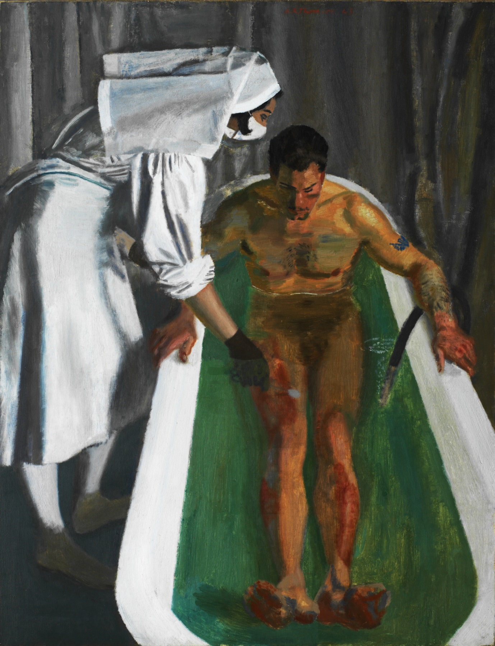
Alfred Reginald Thomson, A Saline Bath, Royal Air Force Hospital, 1943
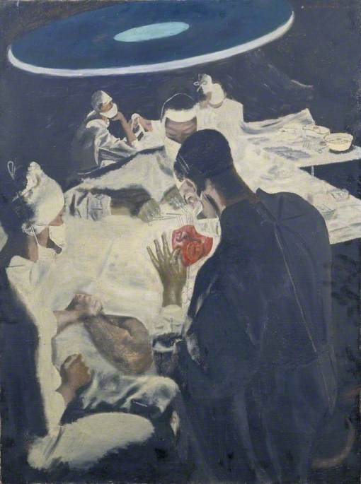
Alfred Reginald Thomson, Grafting a New Eyelid, 1943
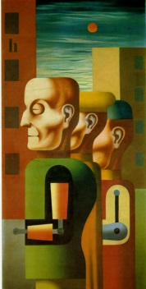
Heinrich Hoerle, Drei Invaliden (Three Invalids), 1930

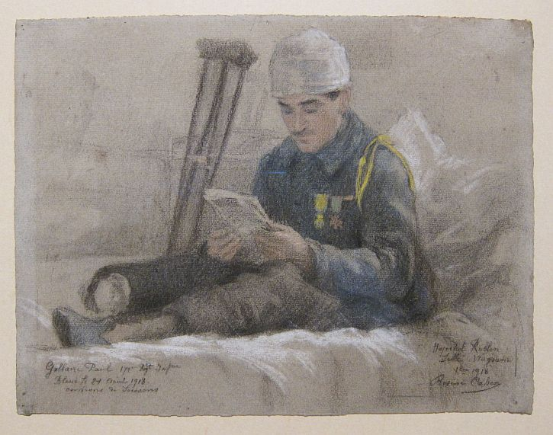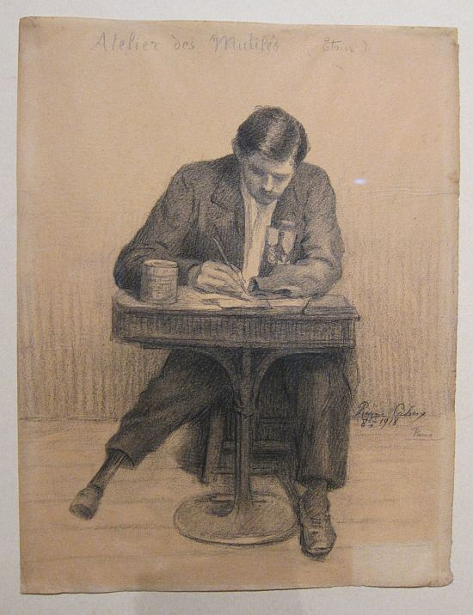
Rosine Cahen, Hospital Rollin (October 1918), 1918
Rosine Cahen, The Amputees’ Workshop, 1918
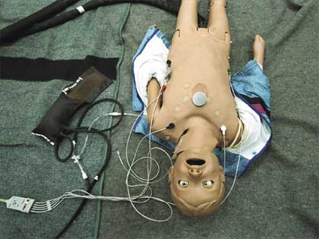
Tomer Ganihar, Hospital Party: You Are Hurting Me, 2006

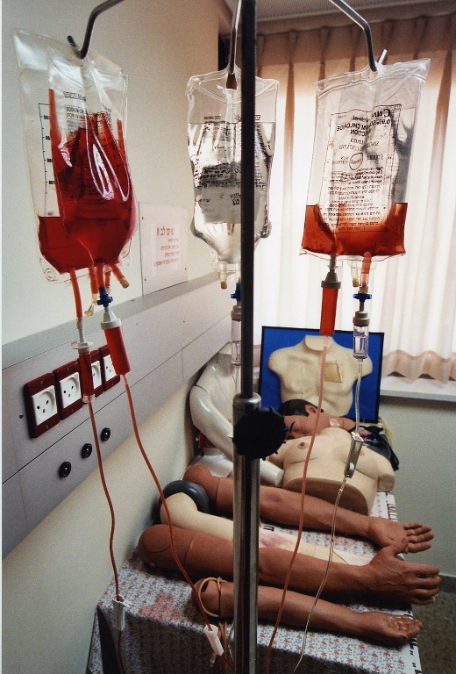
Tomer Ganihar, Hospital Party: Blood, 2006

