

Name of student: Alexandra Alina Tinca
Student number: 2028610
Module name: The Global Business Environment
Date: 12/01/2022

Assessment 1: Environmental Analysis of Automobile Industry

Table of Contents
Introduction 3
Assignment tasks 4
Recognise the major forces shaping the global business environment and gain an understanding of the changing global business environment. 4
Major forces shaping the global business environment 4
Changing global business environment 5
Apply relevant business models within the context of an international environmental analysis. 6
PESTLE Analysis 6
SWOT Analysis 10
Identify and critically evaluate the reasons why organisations engage in international trade. 12
Assess markets in action, understanding their microeconomic and macroeconomic foundations, different market structures and their influence on firm strategy, long-run and short-run changes, and major features of the current international economy. 13
Conclusion 14
References 15

Introduction
A global business is an organisation that operates factories, distribution centres, and similar facilities in various countries in the world. Global Business and international businesses are different terms as the focus of international business is to sell products globally but the facilities are concentrated in the home country. Global Business Environment is the environment in different countries with exogenous factors in regard to the domestic environment of the business organisation. Global Business Environment affects the capability, operations, decision making and resources of the organisation. Automobile industry is a splendid example of Global Business that operates factories and distribution centres in the service area. The automobile industry is an enterprise that produces and sells a range of vehicles including commercial vehicles, trucks, cars, and farm equipment. For this assignment, the case study of Toyota, an automobile company based in Japan, is discussed using environmental analysis tools, along with outlining and recognising reasons, major forces, different market structures and influence on the international economy with regard to the automobile industry.
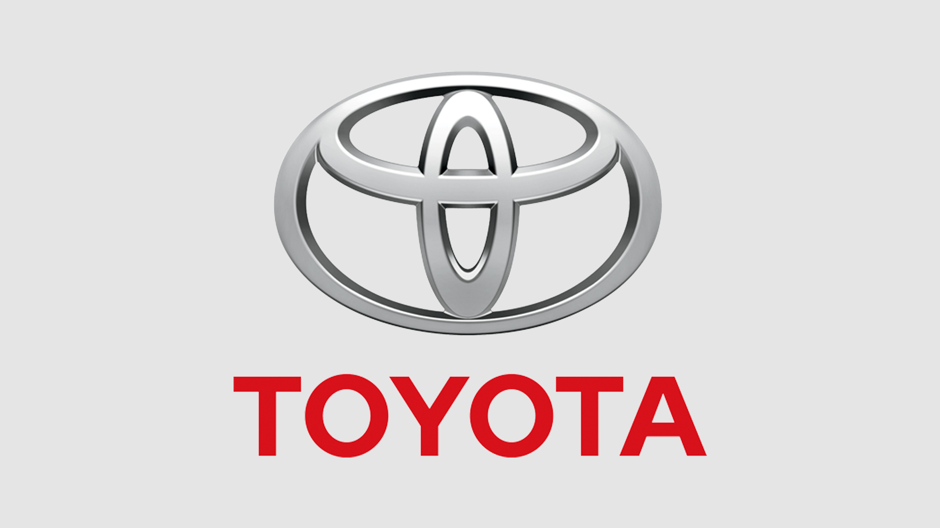
Figure 1: Toyota
(Source: Toyota Corporation, 2022)

Assignment tasks

Recognise the major forces shaping the global business environment and gain an understanding of the changing global business environment.

Major forces shaping the global business environment
Businesses are influenced by various forces operating in the Global Business Environment. The economic, legal, competitive, technological, and social environment are the external forces that shape global business.
- Economic systems: The economic environment has a direct influence on business. The different types of economic search has capitalist, socialist, and influencers economic development of the company. The economic policies such as monetary policy, labour policy, employment policy, and industrial policy of the government influences the business environment.
- Competitive factors: Businesses in global context operate under extreme competition. The competitive factors are challenging for businesses. The companies have to manage and provide various services to the consumers to survive in the markets.
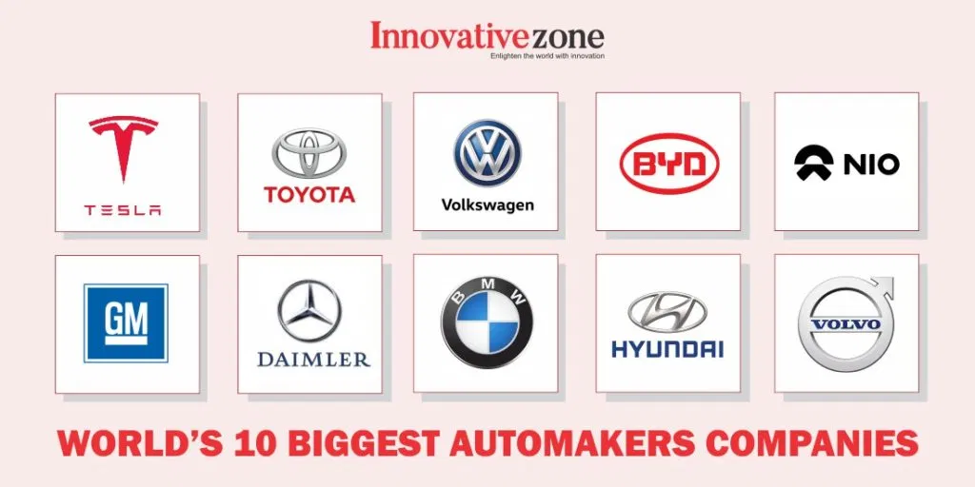
Figure 2: World’s biggest automobile companies
(Source: Innovative Zone, 2021)

- Social, cultural and demographic factors: The social factors Global Business involves beliefs, desires, values and attitude of the consumers. The demographics of ethnicity, location, income, occupation, and location are constantly influencing the business. Further, “Corporate Social Responsibility (CSR)” is an integral part of social factors.
- Technological factors: Technology is an indispensable part of Global Business which enables businesses to reach consumers and provide their services and products. In regard to Business Technology business tools such as telecommunication, Big Data Solution, cloud computing, the internet and similar innovative Technologies and tools are involved (Google Sir, 2021).

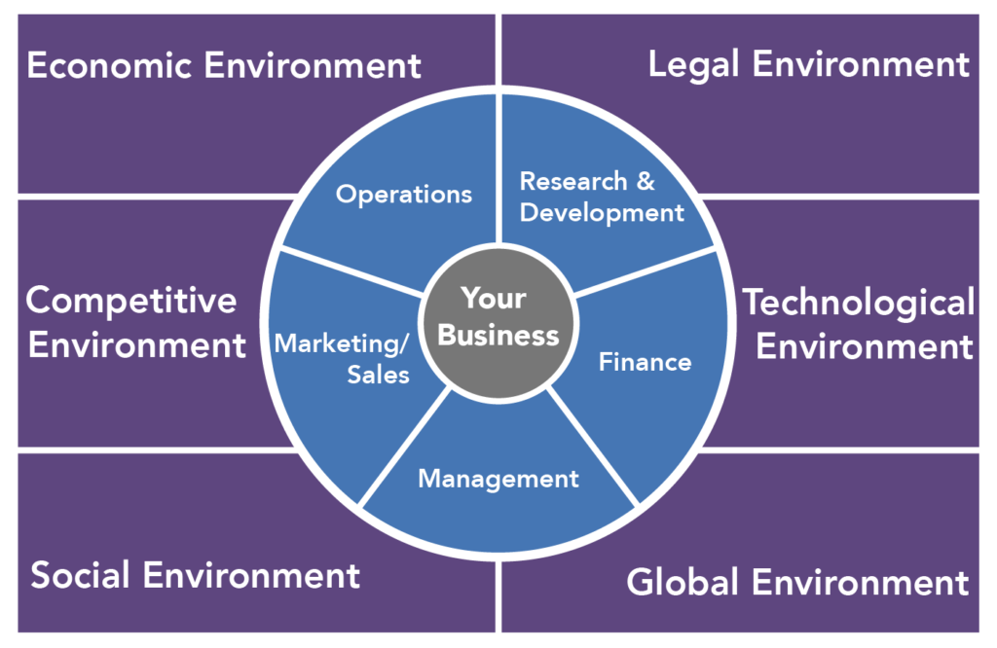
Figure 3: Business environments
(Source: Ghauri, Strange, and Cooke, 2021)

Changing global business environment
The global business environment involves internal and external factors that affect the business environment and impact the activities and processes of business. The business environment directly or indirectly influences the economy of businesses. The major changes in the Global Business Environment are due to various elements, factors, and components such as natural resources, human resources, economic system, policies, technological development and innovation, investment, fiscal policies, market situations, international conditions, communication, and entrepreneurship (Google Sir, 2021). The changes in the Global Business Environment has provided businesses with the opportunity to grow and expand in emerging markets with increased commitment and creativity.

Apply relevant business models within the context of an international environmental analysis.
Toyota Motors is a multinational automotive company based in Japan. It was founded in 1937 by Kiichiro Toyoda, and it is headquartered in Toyota City Japan. Toyota provides its services worldwide under the guidance of chairman Takeshi Uchiyamada and President Akio Toyoda. The company has around 366,283 employees working in four divisions of the company. It is one of the largest automobile companies domestically and internationally, and it operates in more than 170 countries in the world (Motor1, 2021). The environmental analysis of Toyota discusses various factors that affect the internal and external business of the company using swot and pestle analysis.

PESTLE Analysis
The pestel analysis is a tool of macro environmental analysis that focuses on political factors, economic factors, social factors, technological factors, legal factors and environmental factors that affect organisation. The pestel analysis of Toyota is presented below:
- Political factors
Toyota is a global brand that operates in more than 170 countries and due to its wide area of service the company is influenced by government regulations and political factors. The stable political conditions in countries provide Toyota better working conditions (Patel, 2021). On a similar note, conflicts with countries and unstable political conditions of the country destabilise the operation of the company.
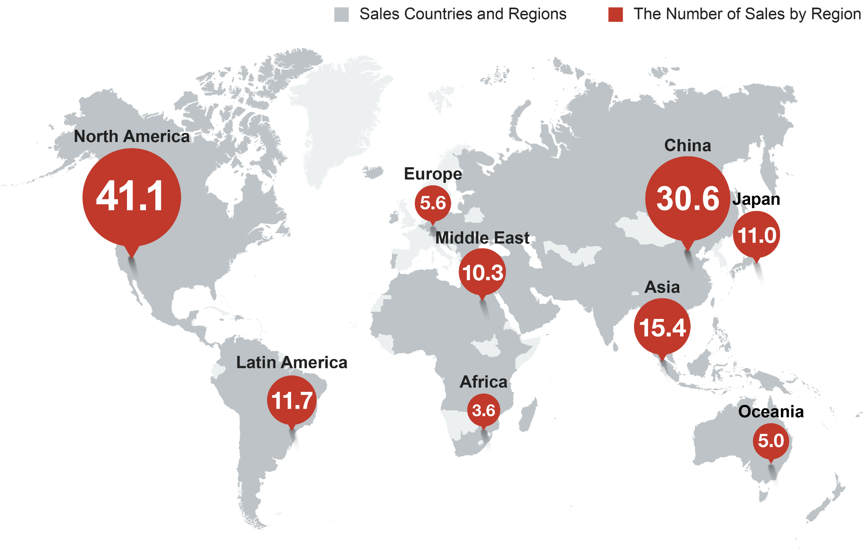
Figure 4: Sales regions of Toyota
(Source: Innovative Zone, 2021)

- Economic factors
The economic factors such as competition, economic stability, and prices of raw materials for manufacturing automobile vehicles, and fuel for powering the vehicles are some of the economic factors that influence Toyota Motors. With the arrival of various new companies the competition between companies in the automotive industry has increased in recent years. The major competitors of Toyota are BMW, Ford and Tesla. The economic recession and slowdown due to the covid-19 pandemic has also resulted in low sales (Google Sir, 2021). From figure 5, it can be observed that from the last two years the total revenue of Toyota has decreased as a negative effect of the pandemic and economic recession.
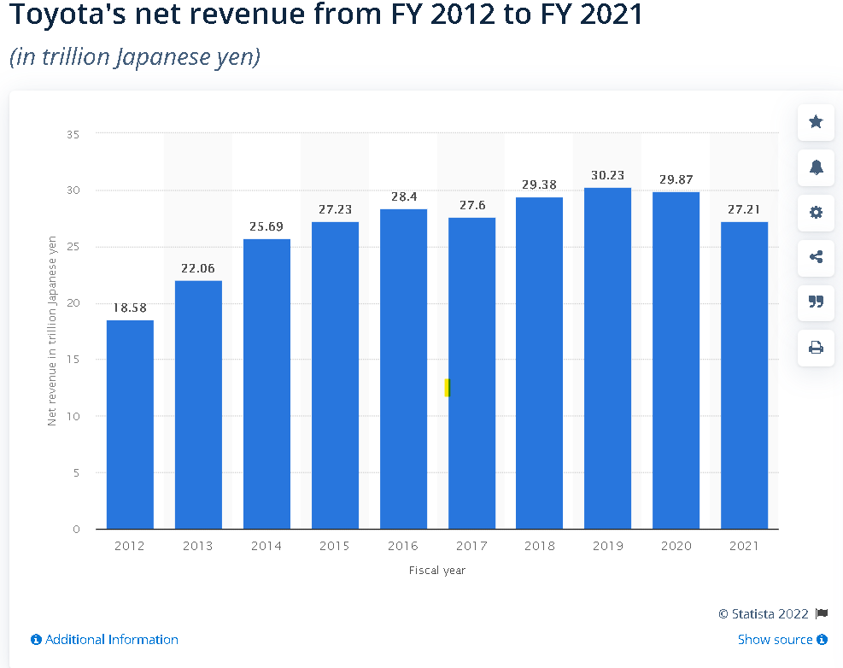
Figure 5: Total net revenue of Toyota 2012 - 2021
(Source: Statista, 2021)

- Social factors
The company has benefited from social factors over the years such as recalling of vehicles, safety issues, economical markets, and the manufacturing of electric vehicles due to environmental consciousness. According to Motor1 (2021), Toyota is the most searched car brand in the world, according to the data of 158 countries.
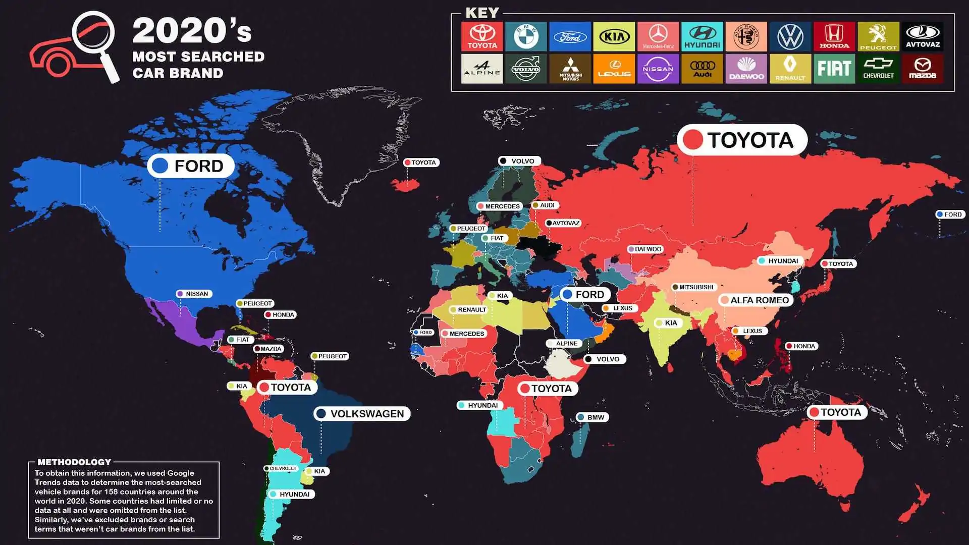
Figure 6: Most popular car brand
(Source: Motor1, 2021)

- Technological factors
The inclination towards innovation and technology in the automobile industry due to sustainable practices, and research and development technological factors play a key role in Toyota. Toyota was the first brand that introduced hydrogen ka in the automobile industry, and the company is working on electric cars fuelled by renewable energy for clean and sustainable environmental practices. The company also manufactures plug-in hybrids and autonomous vehicles (Toyota Corporation, 2022)
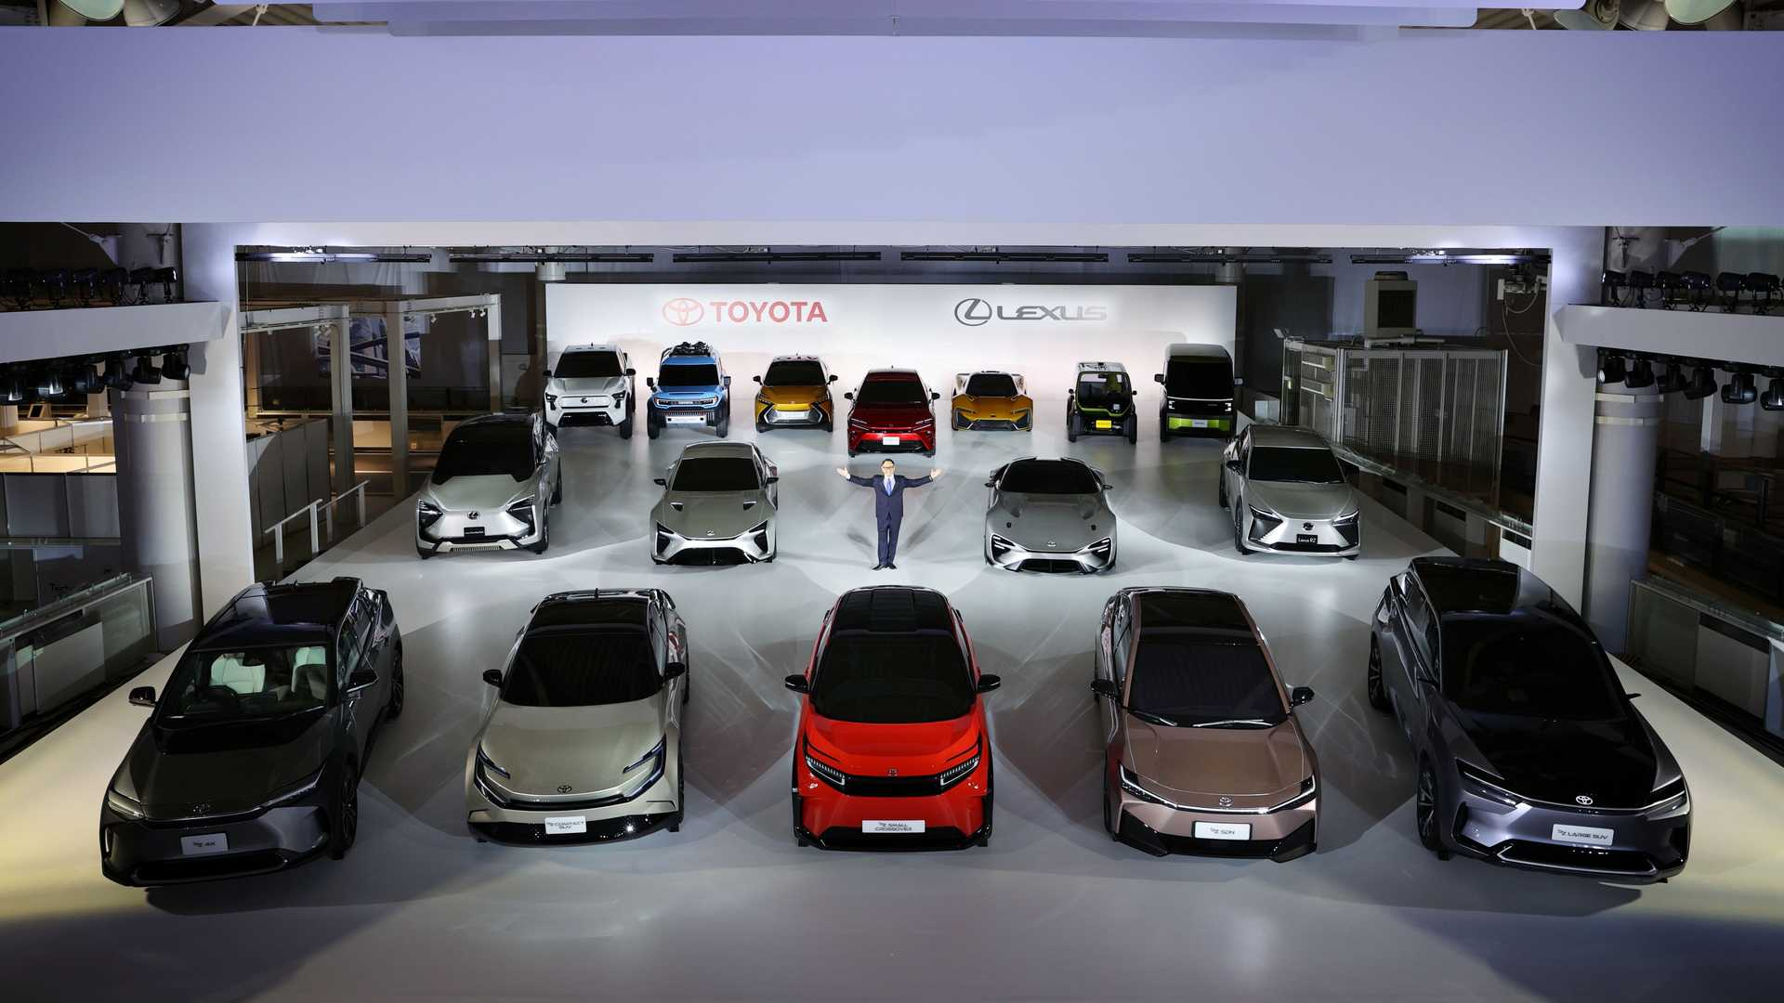
Figure 7: Electric vehicles of Toyota
(Source: Toyota Corporation, 2022).
- Legal factors
The company has been involved in some legal conflicts and lawsuits related to settlement issues of recalling cars, and lawsuits due to trademark conflict (Innovative Zone, 2021). Legal factors are crucial as these factors have the possibility of damaging the reputation of Toyota globally.
- Environmental factors
The research and development investments made by Toyota are working on producing automobile vehicles powered by electricity or hydrogen. The companies are working on manufacturing hybrid vehicles that can be powered by both electricity and hydrogen. The company has an environmental plan that focuses on recycling, optimising use of materials for a Sustainable Society. The other environmental focus of the company is on introducing vehicles with negligible carbon emission (Toyota Corporation, 2022).

SWOT Analysis
The SWOT analysis is used to analyse the internal and external factors of a business enterprise. The analysis considers strengths, weaknesses, opportunities, and threats to the company in the analysis. Here follows the swot analysis of Toyota:
- Strengths
Brand value of Toyota, high value of Toyota stocks and the popularity of Toyota automobiles in the world are the major strengths of the company. According to Marketing Charts (2021), Toyota is the seventh most valuable brand in the world and the net worth of Toyota is £ 198.29 billion. In 2021, the total automobile sales made by the company was 852,926 (Toyota Corporations, 2021).
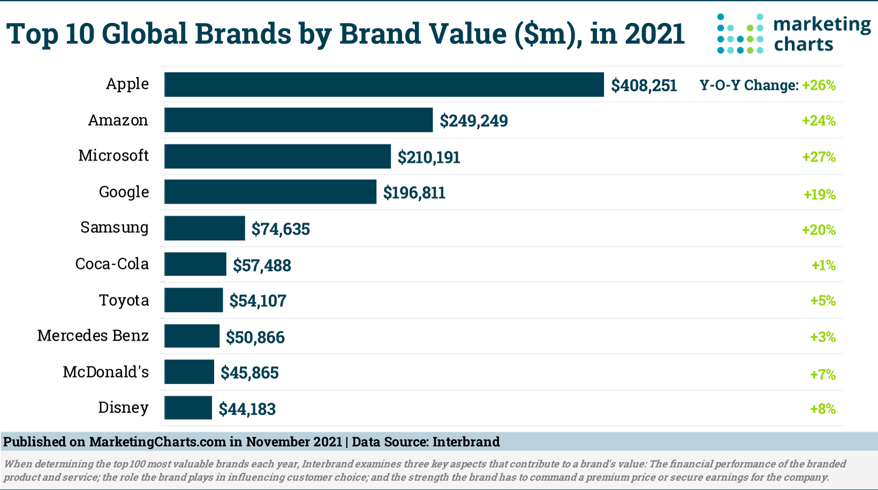
Figure 8: Most Valuable brands 2021
(Source: Marketing Charts, 2021)
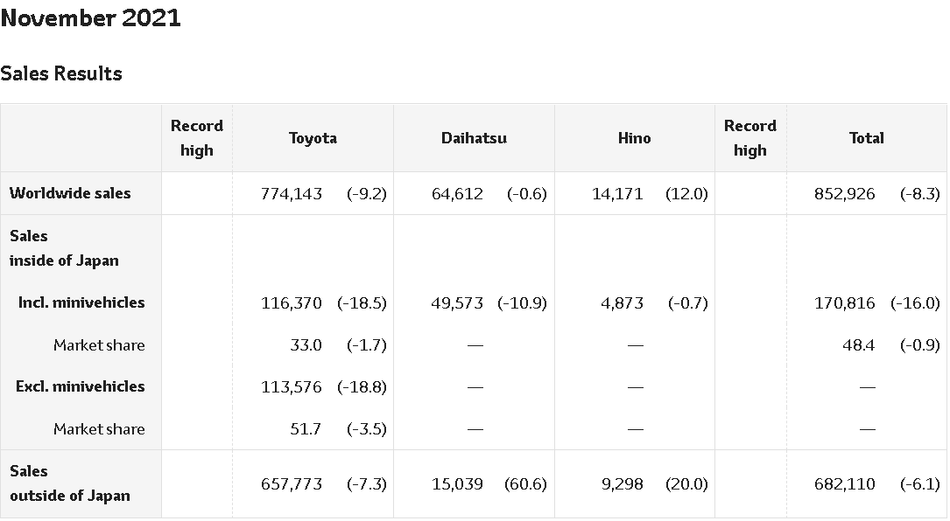
Figure 9: Sales results of Toyota
(Source: Toyota Corporation, 2022)

- Weaknesses
From figure 8, it can be observed that the total sales made by Toyota in 2021 decreased by 8.3%. The sales of the company have consecutively decreased for 3 months. Toyota has faced a technological gap in relation to its competitors for electric vehicles. The company has an imbalanced presence, as it is more successful in the European, Japan and US market, while it does not have a strong presence in Africa, South America, and the Middle East (LeBaron, 2021).
- Opportunities
Toyota has the capital and the medium through which it can exploit the available opportunities. The company has various opportunities such as increasing presence in emerging markets in Asia, developing vehicles, establishing partnerships and more.
- Threats
Emerging companies in the automobile industry, instability in economic conditions, uncertain events and the covid-19 pandemic are some of the threads that have the likelihood to negatively influence Toyota.

Identify and critically evaluate the reasons why organisations engage in international trade.
The following are some of the reasons due to which organisations engage in international trade:
- To increase sales: There are various reasons due to which business organisations expand and engage in international trade. The increase in sales is the primary reason due to which companies expand and acquire market share in new regions for impressive growth. The companies operating in the automobile industry have the opportunity to increase their presence in the market and increase revenue and profitability (Amankwah-Amoah, Khan, and Wood, 2021). Due to this reason, the business enterprises require new markets in which they can offer their products and services. The engagement in international trade and business provides companies the exposure to New Market to increase sales opportunity.
- Acquire resources: By involving in international business, organisations benefit by acquiring resources in the new regions. There are various developing, underdeveloped, and developed countries in the world. The organisations acquire various resources such as natural resources, and human resources. Thus, in this way both the organisation and the market in which they operate benefit from the mutual trade relations (Plugge, and Nikou, 2021). The companies are able to increase their share in the market, increase revenue and profitability while on the other hand with international trade there is sophisticated development of the country's economy.
- Minimise risk: The imaging in international trade businesses are able to expand globally and minimise the risk of a stagnant economy. The characteristics of new markets provide various benefits and companies are able to manage societal, economic, and political risk better.

Assess markets in action, understanding their microeconomic and macroeconomic foundations, different market structures and their influence on firm strategy, long-run and short-run changes, and major features of the current international economy.
Micro economy is the branch of economics that deals with the behaviour of companies and individuals in making decisions, managing price, supply and demand along with other factors (Li et al. 2021). Macroeconomics deals with performance, structure, and decision making of the economy. Based on economics, the market can be divided into four categories: monopolistic competition, monopoly, oligopoly, and perfect competition. Market structure understanding is crucial for businesses to analyse market outcomes and evaluate the different economic factors that impact the opportunities, motivation and decision making of the organisation. Market structure is an important concept based on which companies create strategies for marketing and decision making. Based on the different types of market structure the rates and prices of products and services are determined.
Different International factors are shaping and changing the business world and simultaneously creating opportunities for different firms. The digitisation and technological innovation have helped in improving communication, transportation and payment systems that have reduced trade barriers and made it easier for businesses to engage in international trade (Huang, Zhu, and Wang, 2021). Interconnectivity has increased in the international economy. The major features of the international economy in the contemporary period are enhanced relevance of networking, regionalisation, production options, increased probability of creating new markets, electronic Commerce, and structural capabilities.

Conclusion
The automobile industry is one of the most valuable industries that contributes to the global economy. There are some key players in the automobile industry, and one of the key players is Toyota with presence in over 170 countries. Toyota has been in the market for more than 8 decades, and during its operational years the company has created a strong brand image and market share globally. The company has iglobal business which is affected by various forces both internal and external. The company engages in a global business environment for increased exposure in the international market.

References
Amankwah-Amoah, J., Khan, Z. and Wood, G., (2021). ‘COVID-19 and business failures: The paradoxes of experience, scale, and scope for theory and practice’. European Management Journal, 39(2), pp.179-184.
Ghauri, P., Strange, R. and Cooke, F.L., (2021). ‘Research on international business: The new realities’. International Business Review, 30(2), p.101794.
Googlesir, (2021). [online] Googlesir.com. Available at: <https://www.googlesir.com/factors-affecting-economic-environment-business/> [Accessed 6 January 2022].
Huang, X., Zhu, S. and Wang, J., (2021). ‘Optimal Emission Reduction and Pricing in the Tourism Supply Chain Considering Different Market Structures and Word-of-Mouth Effect’. Sustainability, 13(7), p.3893.
Innovative Zone, (2021). ‘World’s 10 Best Automobile Companies’. [online] InnovativeZone. Available at: <https://innovativezoneindia.com/worlds-10-best-automobile-companies/> [Accessed 6 January 2022].
LeBaron, G., (2021). ‘The role of supply chains in the global business of forced labour’. Journal of Supply Chain Management, 57(2), pp.29-42.
Li, H., Qing, Q., Wang, J. and Hong, X., (2021). ‘An analysis of technology licensing and parallel importation under different market structures’. European Journal of Operational Research, 289(1), pp.132-143.
Marketing Charts, (2021). [online] Available at: <https://www.marketingcharts.com/brand-related/top-brands-118855> [Accessed 6 January 2022].
Motor1, (2021). ‘The World Has Spoken: Toyota Is Most Searched Car Brand Globally’. [online] Motor1.com. Available at: <https://www.motor1.com/news/485723/toyota-most-searched-car-brand/> [Accessed 6 January 2022].
Patel, R.K., (2021). ‘Role of Information Technologies in Global Business Successes’. In Culture in Global Businesses (pp. 45-61). Palgrave Macmillan, Cham.
Plugge, A. and Nikou, S., (2021, January). ‘Implementing Global Business Services in a Plural Sourcing Context: Conceptualizing Modes of Service Governance’. In Proceedings of the 54th Hawaii International Conference on System Sciences (p. 5944).
Statista, (2021). ‘Toyota worldwide vehicle production 2021’ | Statista. [online] Statista. Available at: <https://www.statista.com/statistics/267272/worldwide-vehicle-production-of-toyota/> [Accessed 6 January 2022].
TOYOTA CORPORATION, (2022). トヨタ自動車株式会社 公式企業サイト. [online] トヨタ自動車株式会社 公式企業サイト. Available at: <https://global.toyota/> [Accessed 6 January 2022].

