University Of Wales Trinity Saint David

Wales institute of science and arts



Tensile Test of Materials

Materials And Manufacturing (ACMA4005)

Jacob Christian Jones

2005053

May 2022

1 Contents

Table of Contents
1 Contents 2
2 Introduction 3
3 Experimental Procedure 4
4 Results 6
5 Analysis 7
6 Conclusion 9
7 Evaluation 10
8 Further Work 11
9 References 12

2 Introduction

This investigation will be carried out to see how non-identical materials have different tensile properties when being stretched under a controlled force. In theory all the materials used in this experiment should have different tensile properties as steel is a hard metal whereas aluminium is a soft metal. Therefore, they should produce different results and break under individual forces. The experiment that would be carried out to achieve these results would consist of a test piece being placed into the tensile testing apparatus. This test piece would then be stretched under a force until it reaches its ultimate tensile strength and break. This would show the maximum stress a material could withstand before eventually breaking (G.Company, 2022). From this experiment it should be clear to see that steel has a higher tensile strength than aluminium but a lower UTS.

3 Experimental Procedure

Figure 1. Equipment List

Equipment Used: | Quantity:
Tensile tester | 1
Aluminium test piece | 1
Steel test piece | 1
Allen key | 1
Dial calliper | 1
Worksheet | 1
Pen/Pencil | 1

The first task to be carried out in this experiment would be to read the guidance notes to have a clear understanding of what would be needed to complete the task. The next step would be to measure the thickness and width of the test pieces to find the cross-sectional area. This measurement will be needed after all the data is collected to calculate the stress of each material. To fit the test pieces to the tensile tester an Allen key will be needed to undo and tighten the fasteners holding the specimens in place. Before carrying out the experiment the safety guard must be fitted to ensure the test piece does shoot out as it breaks.

Once the tensile tester is setup the load nut located at the top will need to be turned slowly clockwise in small increments of 0.2mm. On the equipment that will be used in this experiment there will be 10 small engravings on top of the load. Each engravement symbolises 0.1mm therefore for each result the load nut would need to rotated 2 engravements. Once the load nut movement reaches 5mm the increments will be increased to 1mm movements (1 full rotation). If the load nut movement reaches 10mm which is highly unlikely, the increments would then jump up to 10mm movements (10 full rotations). By this point the test piece should have broken. After each movement of the load nut, the results showed on the dial indicator should be noted down on the worksheet handed out by the lecturer. Once the results are noted down, the dial indictor must be zeroed to ensure the correct results are entered into the worksheet. These steps should then be repeated for each test piece

After the experiment is completed, it will be required to enter all the correct results into an excel spreadsheet to calculate the data needed to create the graphs plotting stress over strain.

Figure 3. Dial indicator
Figure 2. Tensile Tester setup correctly

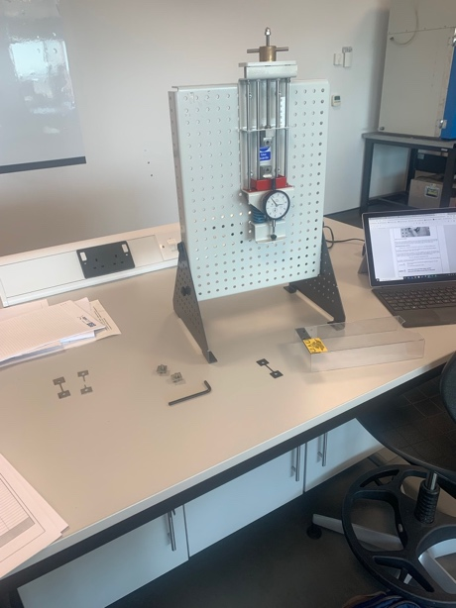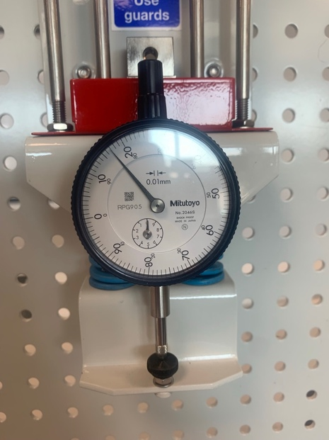

Figure 5. Test pieces
Steel (left) Aluminium (right)
Figure 4. Close up of tensile tester

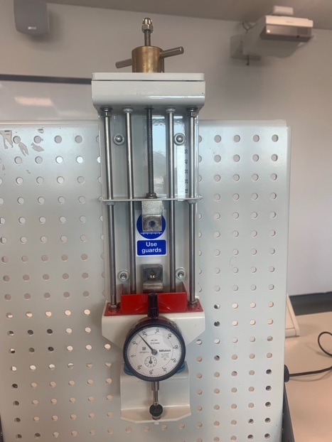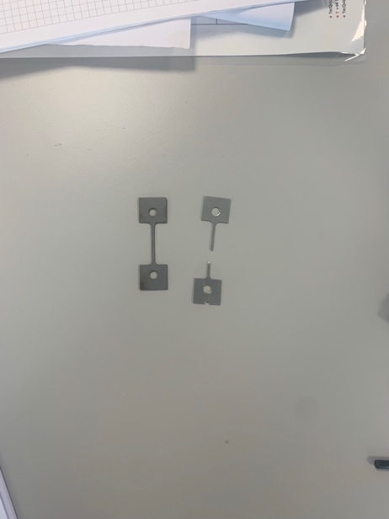

4 Results

Figure 6. Aluminium test piece results
Figure 7. Steel test piece results

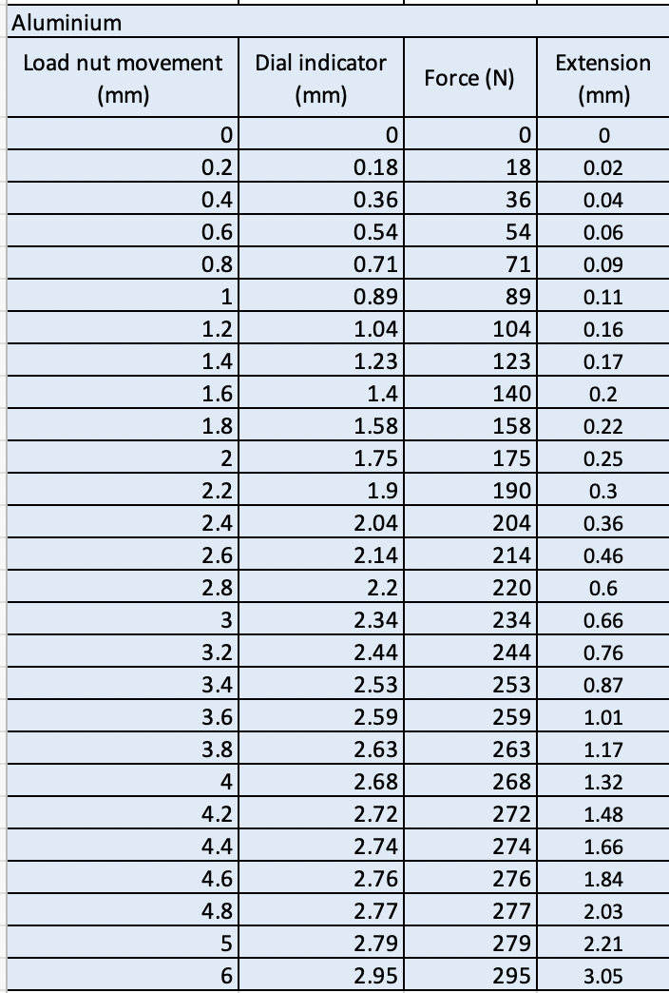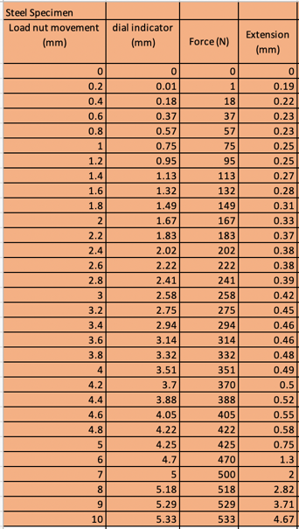

These are the raw data results from the tensile test carried out on the aluminium and steel test pieces. This set of data is only a brief part of what is needed to create the appropriate graphs. The graphs require the Stress and Strain values of each material to calculate their yield point and tensile strength. From these graphs it will be possible to locate the gradient of the plastic region to compare the different stiffness of each material. The plastic region on a stress strain curve graph is the portion where permanent deformation mainly occurs even after the load is removed. This happens just before the fracture point of the material (Toppr, 2020). From the results recorded in figure 6 and 7, it shows that the aluminium test piece needed less force to be fractured (295 N) in comparison to the steel that needed 533N of force to be fractured.

5 Analysis

Aluminium Specimen:

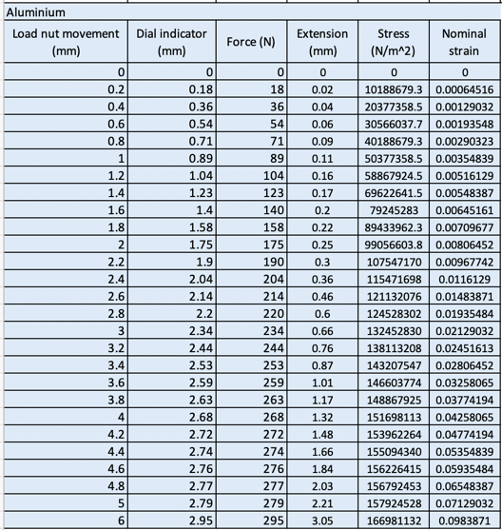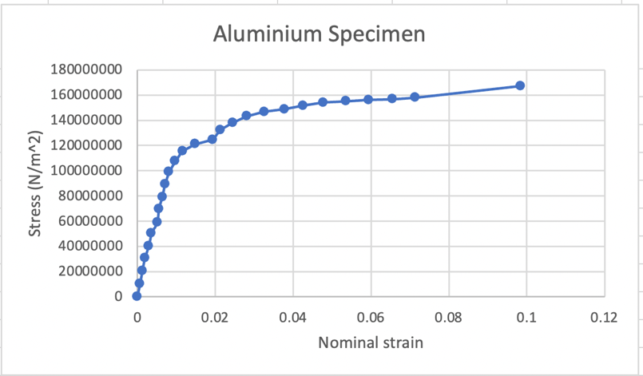
Figure 9. Stress-Strain curve graph for the Aluminium test piece
Figure 8. Aluminium test piece results with Stress and Nominal strain calculated.

Figure 10. A graph showing the plastic region, young’s modulus and gradient of the Aluminium test piece

Steel Specimen:

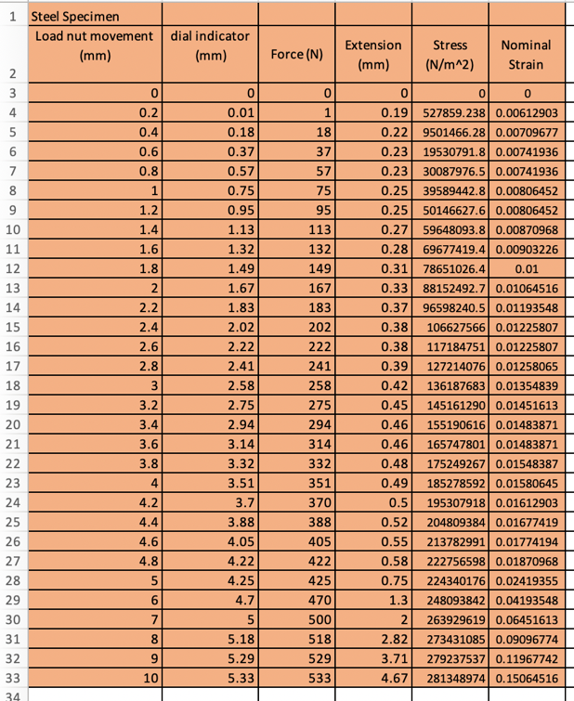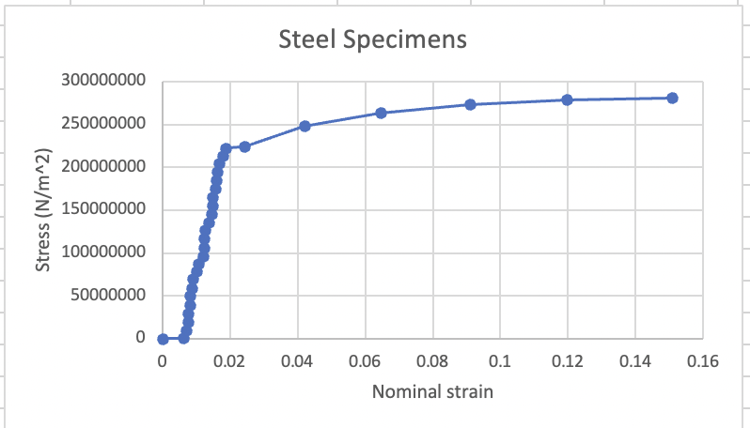

Figure 12. Stress-Strain curve graph for the steel test piece
Figure 11. Steel specimen with Stress and Nominal strain calculated

Figure 13. A graph showing the plastic region, young’s modulus and gradient of the steel specimen. (The accuracy of this graph will be noted in the conclusion section of this technical report.)

6 Conclusion

The main aim of this experiment is to determine which material (Aluminium or Steel) has the highest stiffness value. This was done by locating the plastic region from the graphs produced. To do this It was required to locate on the graphs where the results started to curve off from a straight line. This would be slightly difficult to observe from the steel specimen graph as there are no clear straight lines. This would not be the case for the aluminium specimen as the first 4 markers on the graph created a linear trend line.
From this another graph was needed to be made to highlight said results. Once these graphs were created (Figure 10 and 13) the gradient could then be calculated. In theory steel should have a much higher young’s modulus than aluminium. The correct and accurate results show that steel should have a young’s modulus of 29PSI, and aluminium should have a young’s modulus of 10PSI. Thus, meaning that 2 objects of exact dimensions, 1 aluminium and 1 steel, should have a different stiffness. Steel should be almost 3 times as stiff as Aluminium. (Schaeffler.D. J, 2015). From the results in this experiment, it is shown that the aluminium and steel test pieces have very different gradients but not what was expected. According to the results aluminium has a gradient of y=2E+10X+1.5802 whereas the results for steel show a gradient of y=1.1208X – 0.0006. These results clearly don’t match what is said in theory. This anomaly is clearly down to human error in the result reading and the inaccuracy of the test as it is only a very simple tensile tester used in classrooms and workshops.

In conclusion, the steel specimen was able to withstand over 250N more force before fracture. Was able to be extended 1.5mm larger than the aluminium and also was able to be subjected to a significantly higher load of strain therefore making it a much stiffer material than aluminium.

7 Evaluation

For this experiment to operate smoothly, the procedure must be performed precisely to minimise any errors that could occur. Obviously, there will be some errors in every experiment, but all efforts should be made to eliminate as many as possible. To ensure these errors do not occur, the step-by-step guide should be followed perfectly. One way of minimizing errors in the experiment would be to have more than one student operating the tensile tester. This could be done by having one student turning the load nut, another student reading the force shown on the dial indicator and have the final student noting down all the appropriate figures. This method of working could be repeated for every test piece but have the students swap roles each time. By doing so, it would give a fair set of results as one student could be making small errors in the readings etc. Another way of reducing the number of errors would be to have the students operate the experiment twice. From the 2 sets of results recorded it would give them an average which in theory would produce more accurate results. This would obviously take twice the time but it would give them much more of an insight on how the tensile testing of materials takes place.

8 Further Work

If this experiment could be performed with an unlimited amount of time and money, it could be performed on a much larger scale with highly advanced equipment. In industry it is more than likely that companies use machines such as 5980 Series Universal system. Such a machine can produce up to 600kN force (Instron, 2020). By using better equipment, the results would be significantly more accurate. This would eliminate almost all possibilities of human error as it would be fully automated. Another substitute that could be used to make this experiment more accurate would be to repeat the process 4-5 times. By having so many results, the average of all the data would be extremely accurate creating clear and precise graphs.

9 References

- Company, G., 2022. Understanding Tensile Strength - The Gund Company. [online] The Gund Company -. Available at: <https://thegundcompany.com/understanding-tensile-strength> [Accessed 10 May 2022].

- 2020. [online] Available at: <https://www.toppr.com/ask/en-gb/content/concept/stress-strain-curve-208787/> [Accessed 14 May 2022].

- Schaeffler, D., 2015. The differences between stiffness and strength in metal. [online] Thefabricator.com. Available at: <https://www.thefabricator.com/thefabricator/article/metalsmaterials/the-differences-between-stiffness-and-strength-in-metal> [Accessed 14 May 2022].

- Instron.com. 2020. [online] Available at: <https://www.instron.com/-/media/literature-library/products/2020/08/high-force-universal-testing-machines.pdf?la=en-GB> [Accessed 14 May 2022].

